Identifying the Model by Examining the ACF and PACF Plots

Ananya Kaushal

1940233

Practical 7

2022-03-08

**INTRODUCTION:**

An autoregressive (AR) model predicts future behavior based on past behavior. It’s used for forecasting when there is some correlation between values in a time series and the values that precede and succeed them. In time series analysis, the moving-average (MA) model, also known as moving-average process, is a common approach for modeling univariate time series. The moving-average model specifies that the output variable depends linearly on the current and various past values of a stochastic term.

This is a model that is combined from the AR and MA models. In this model, the impact of previous lags along with the residuals is considered for forecasting the future values of the time series.

**AIM:**

To identify the model by examining the ACF and PACF plot of the stationary data and to fit the model using auto.arima function.

**ABOUT THE DATASET:**

We choose the dataset ‘Globtemp’ for this part as we observe that it does not have a seasonal nature but only a trend factor.

It is a time series data that contains Global mean land-ocean temperature deviations from 1951-1980 average, measured in degrees centigrade, for the years 1880-2015

**PROCEDURE:**

library(astsa)  
library(tseries)

## Warning: package 'tseries' was built under R version 4.1.2

## Registered S3 method overwritten by 'quantmod':  
## method from  
## as.zoo.data.frame zoo

library(forecast)

## Warning: package 'forecast' was built under R version 4.1.2

##   
## Attaching package: 'forecast'

## The following object is masked from 'package:astsa':  
##   
## gas

#Elimination of trend in the absence of seasonality  
plot(globtemp,main="Global mean land temperature Deviations")

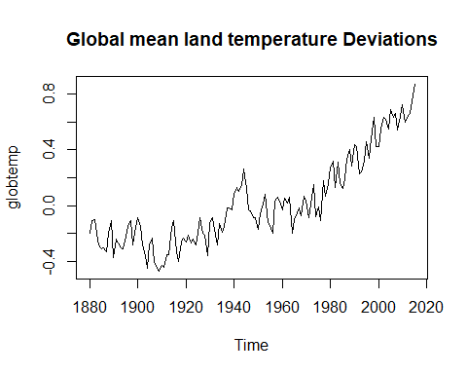

Figure 1.Time series Plot of Globtemp

#We have a trend Component but it is free from a seasonal component.  
#We can transform this series into a Stationary series using Method of differencing  
  
dd=diff(globtemp)  
plot(dd)

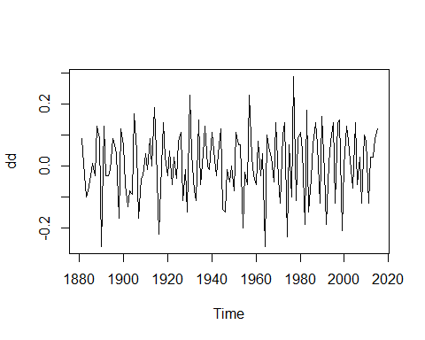

Figure 2Time Series plot of Gobtemp after removing trend

adf.test(dd)

## Warning in adf.test(dd): p-value smaller than printed p-value

##   
## Augmented Dickey-Fuller Test  
##   
## data: dd  
## Dickey-Fuller = -6.79, Lag order = 5, p-value = 0.01  
## alternative hypothesis: stationary

#Since the p-value is less than 0.5 we can reject the null hypothesis and   
#conclude that our differenced data is Stationary.  
  
#Plotting ACF and PACF Plots  
acf(dd)

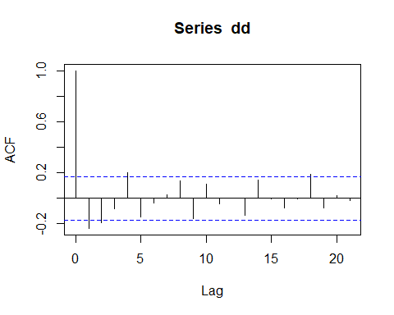

Figure 3. ACF Plot

pacf(dd)

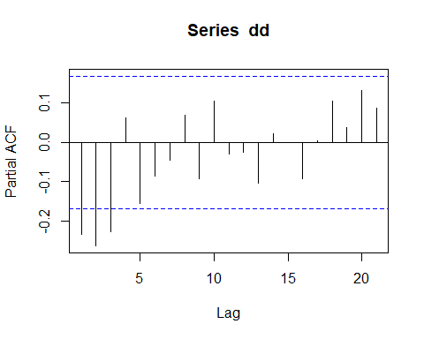

Figure 4. PACF Plot

**INTERPRETATION:**

From the above ACF and PACF plots, we can infer that our model is a MA Model. The PACF plot is gradually decreasing and the ACF model we see a cut after the first lag. This indicates that the model is a Moving Average Model.

#Fitting an ARMA Model  
auto.arima(dd,seasonal="False")

## Series: dd   
## ARIMA(1,0,3) with non-zero mean   
##   
## Coefficients:  
## ar1 ma1 ma2 ma3 mean  
## -0.9449 0.6081 -0.5680 -0.3091 0.0072  
## s.e. 0.0562 0.0971 0.0856 0.0804 0.0032  
##   
## sigma^2 = 0.009775: log likelihood = 123.06  
## AIC=-234.12 AICc=-233.47 BIC=-216.69

**CONCLUSION:**

From Figure 1, we can conclude that the data has a trend but no seasonality.

We also observe that the data is non-stationary. To make the data stationary, we differentiate the data once and conducting the adf test to confirm. Since the observed p-value is 0.01, which is less than 0.05, we can reject the Null Hypothesis and accept that the data is stationary.

From Figure 3, we observe the ACF plot and conclude that it cuts off after the first lag. The PACF plot in Figure 4 shows a gradual decrease. This tells us that the model is a Moving Average Model and indicates towards it being a MA (1) model.

We finally fit an ARMA Model using auto.arima to make the Moving Average Model an ARMA Model.