Run the collection remotely using collection URL

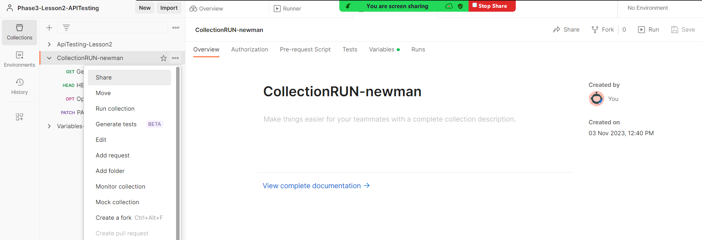

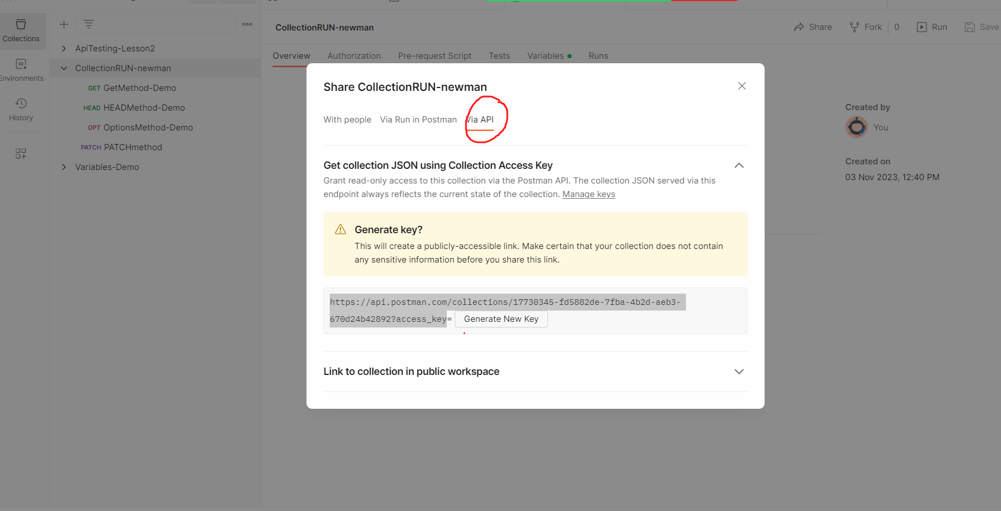

Click on Generate new key and copy the URL

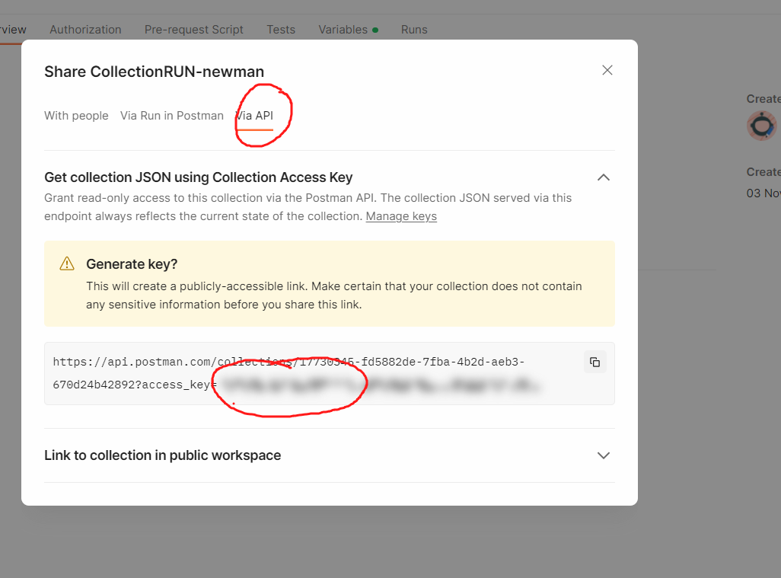

Carefully copy the URL.

<https://api.postman.com/collections/17730345-fd5882de-7fba-4b2d-aeb3-670d24b42892?access_key=PMAT-01HEHC9FSVM75BXYDXEH31D95V>

Now go to cmd prompt of windows and execute the newman command

# newman run <Copied URL>

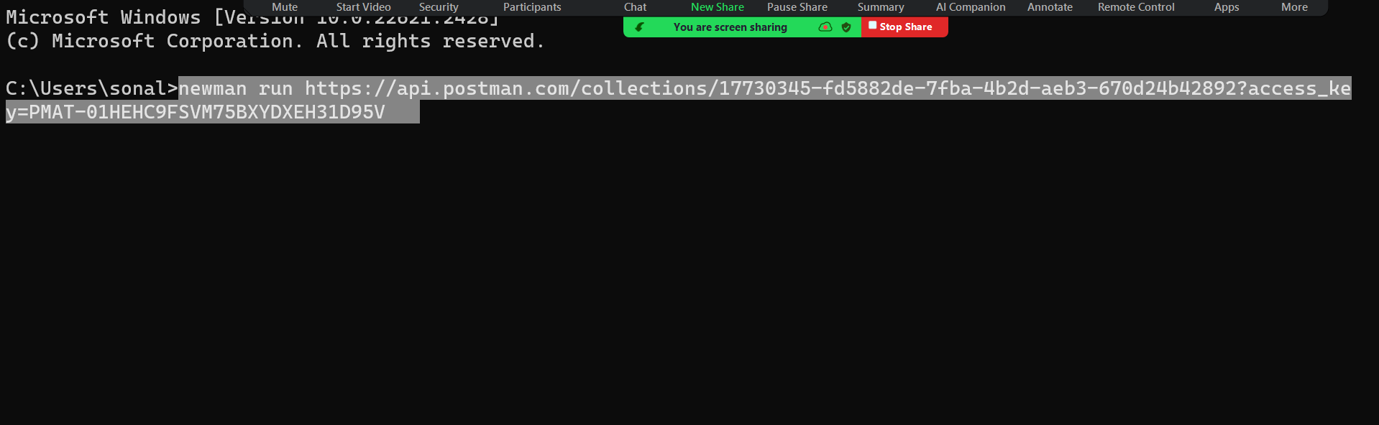

It will run the collection successfully.

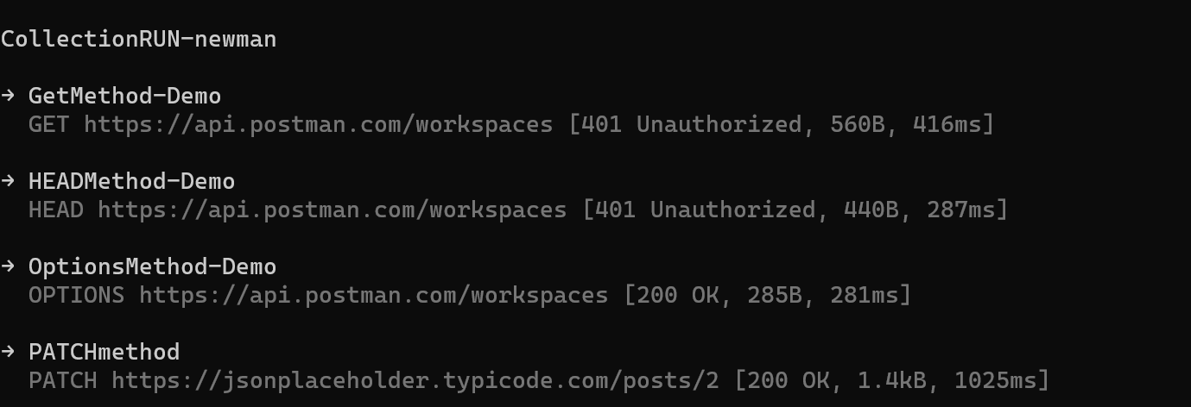

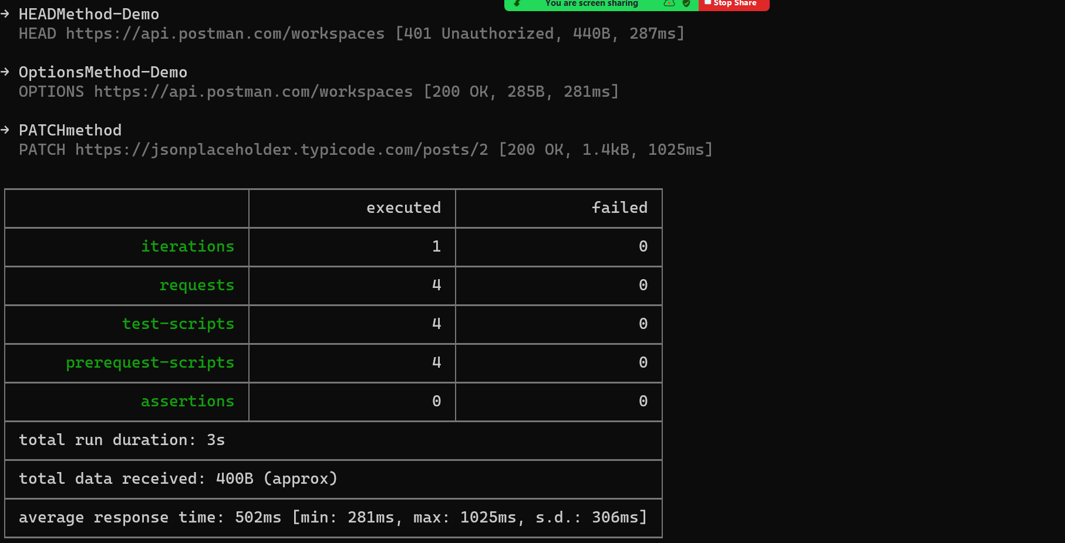

Run collection with Jenkins using postman CLI

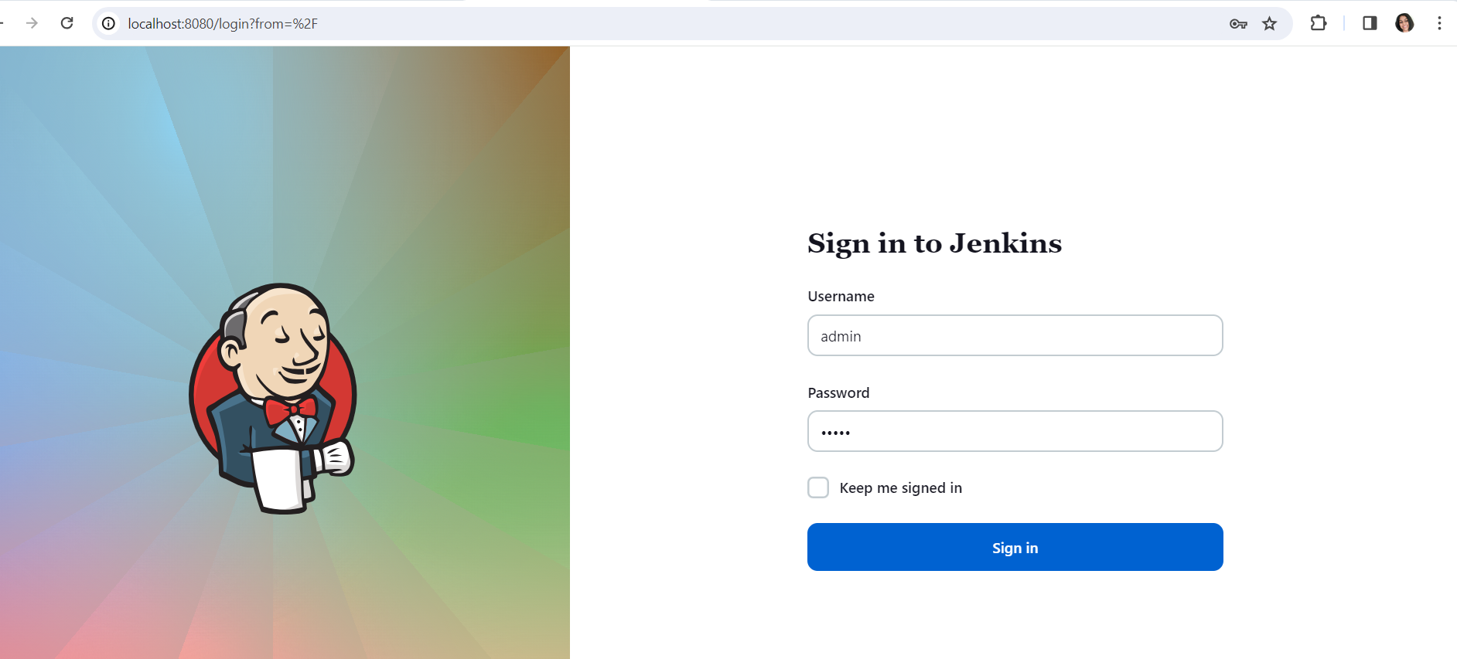

Download nodejs plugin in Jenkins

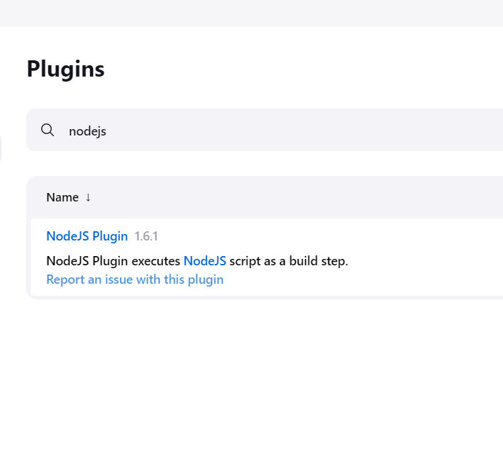

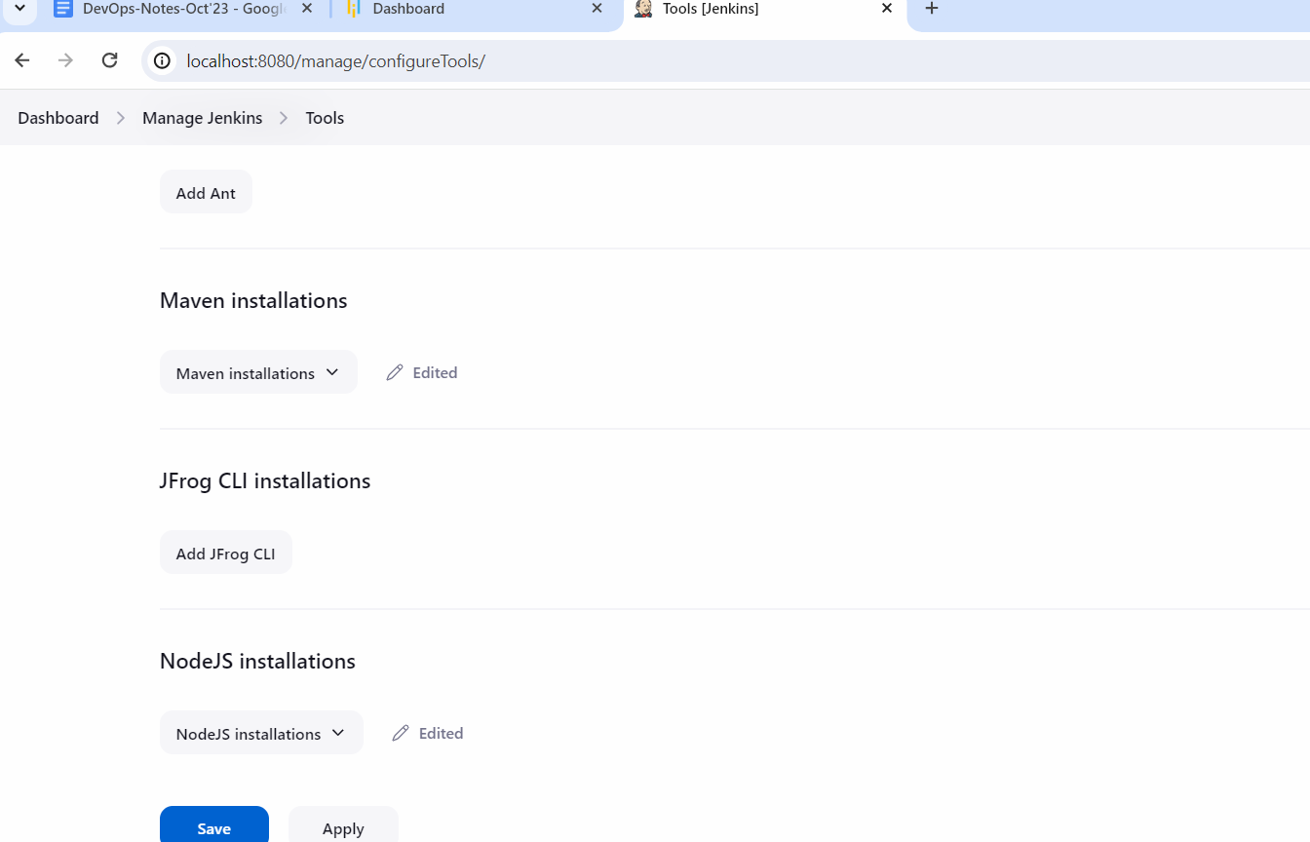

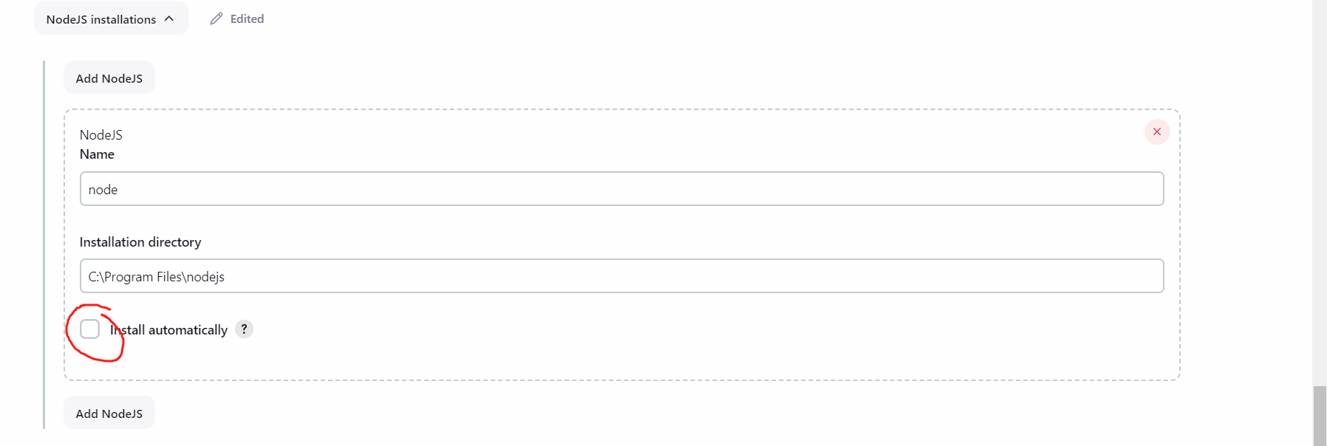

Now go to collection runner

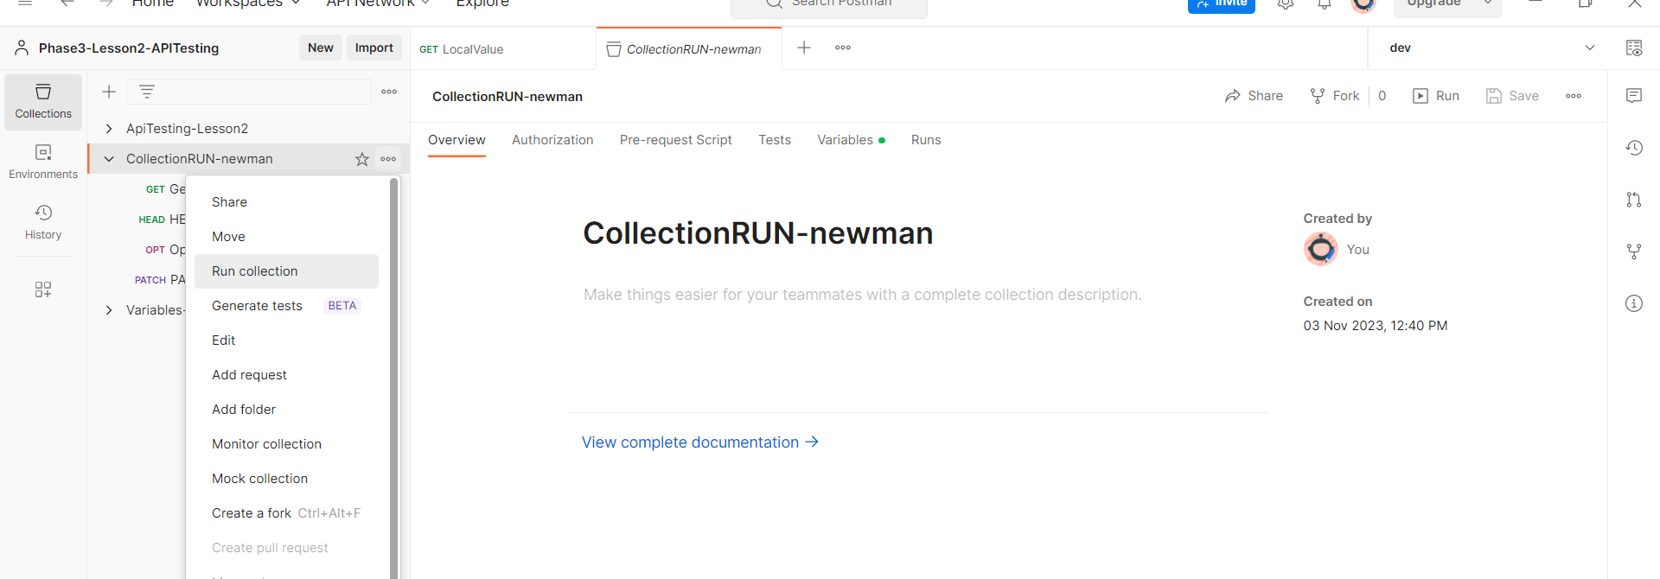

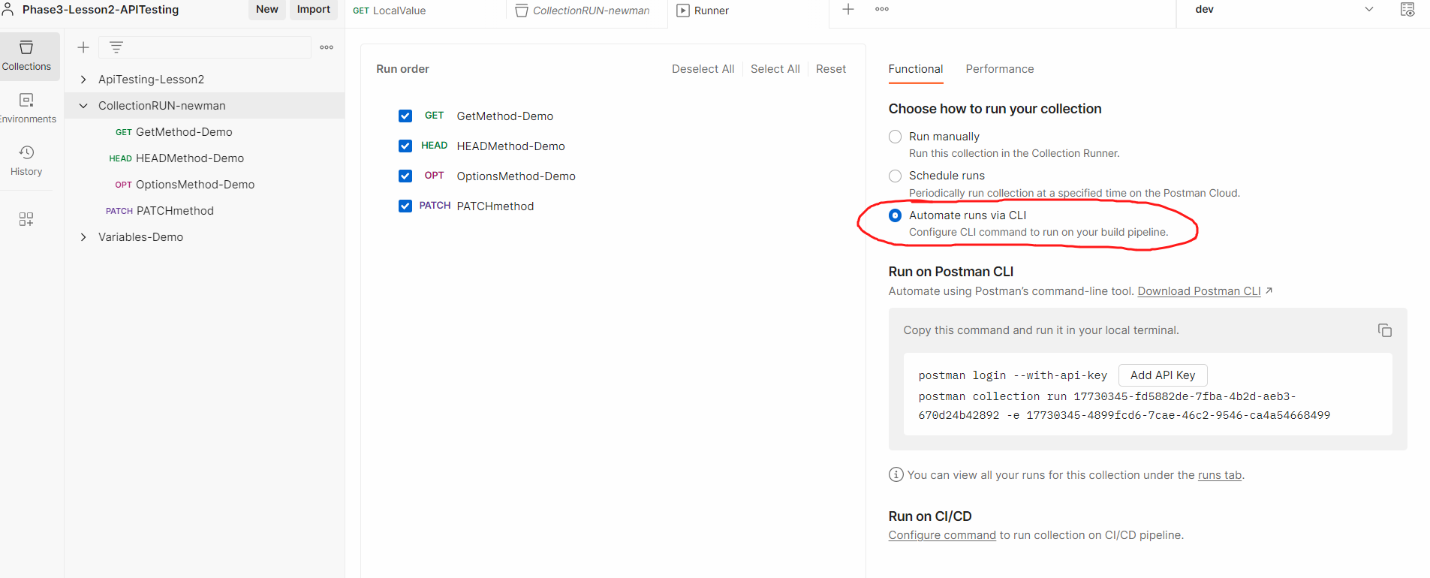

Click on configure command

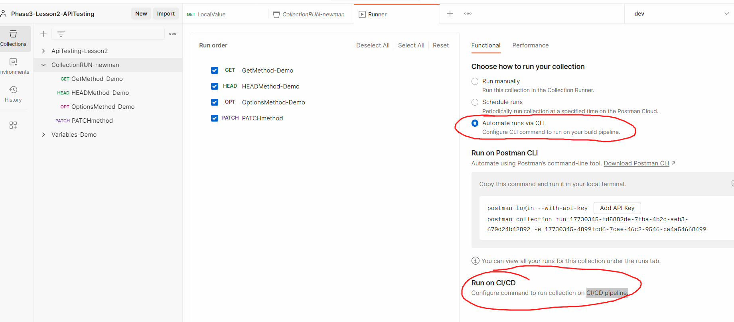

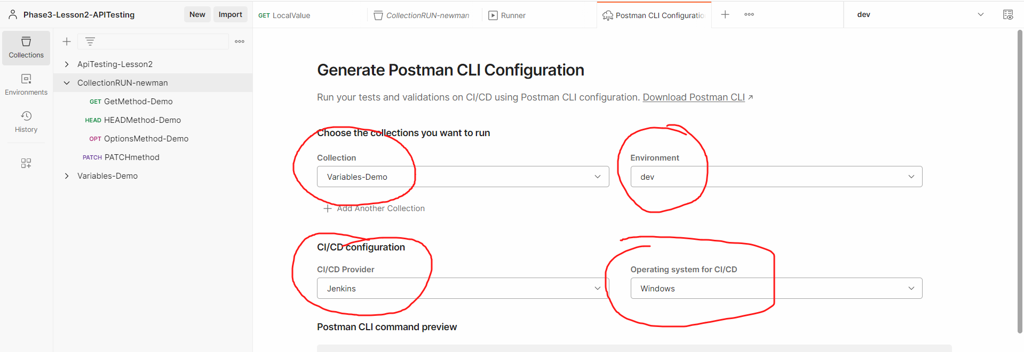

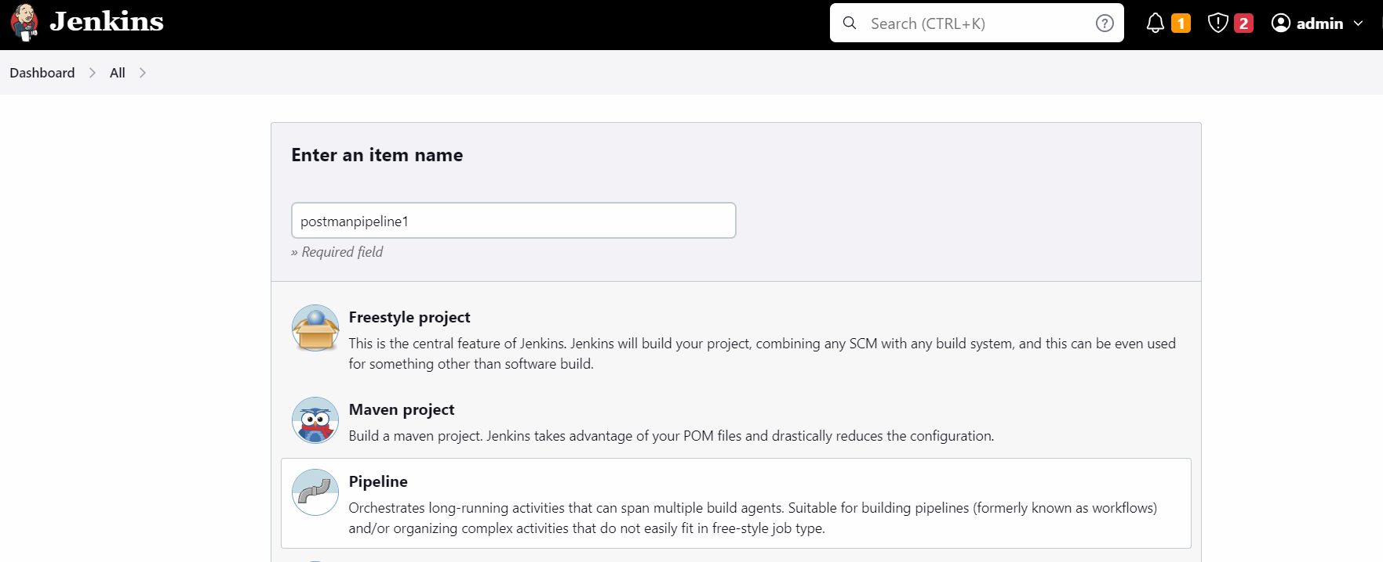

Now copy the entire script form postman

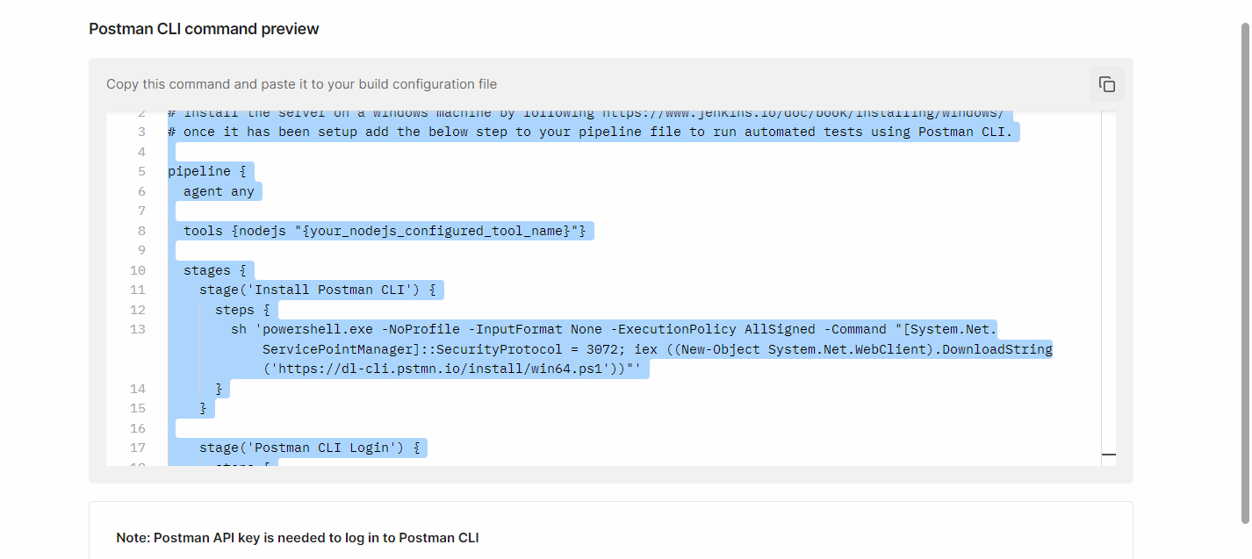

Copy this pipeline in Jenkins Job

Click on Pipeline syntax

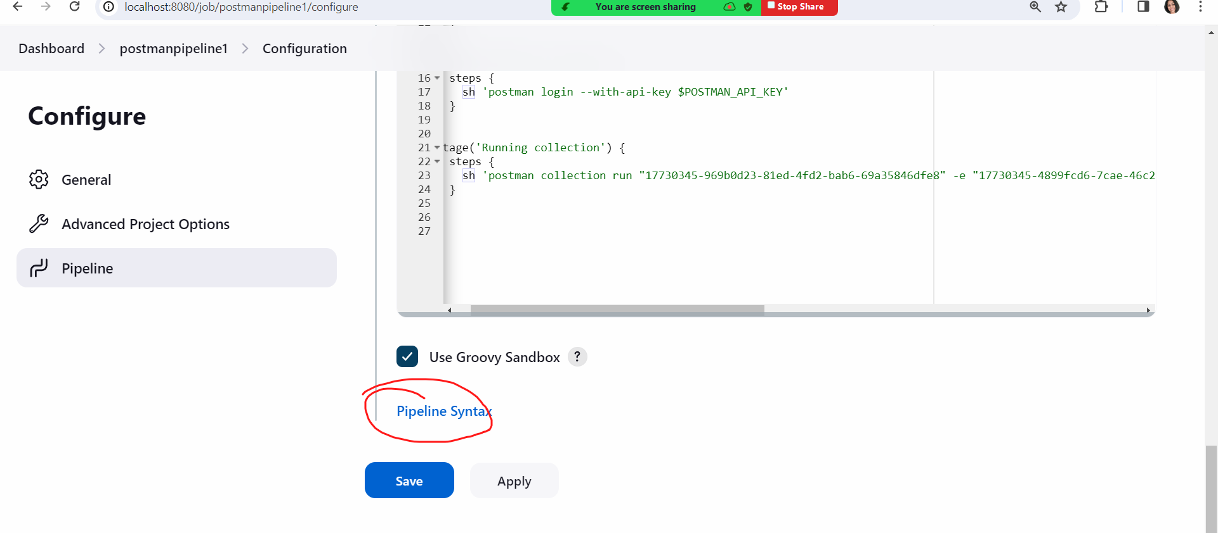

Here select windows batch script

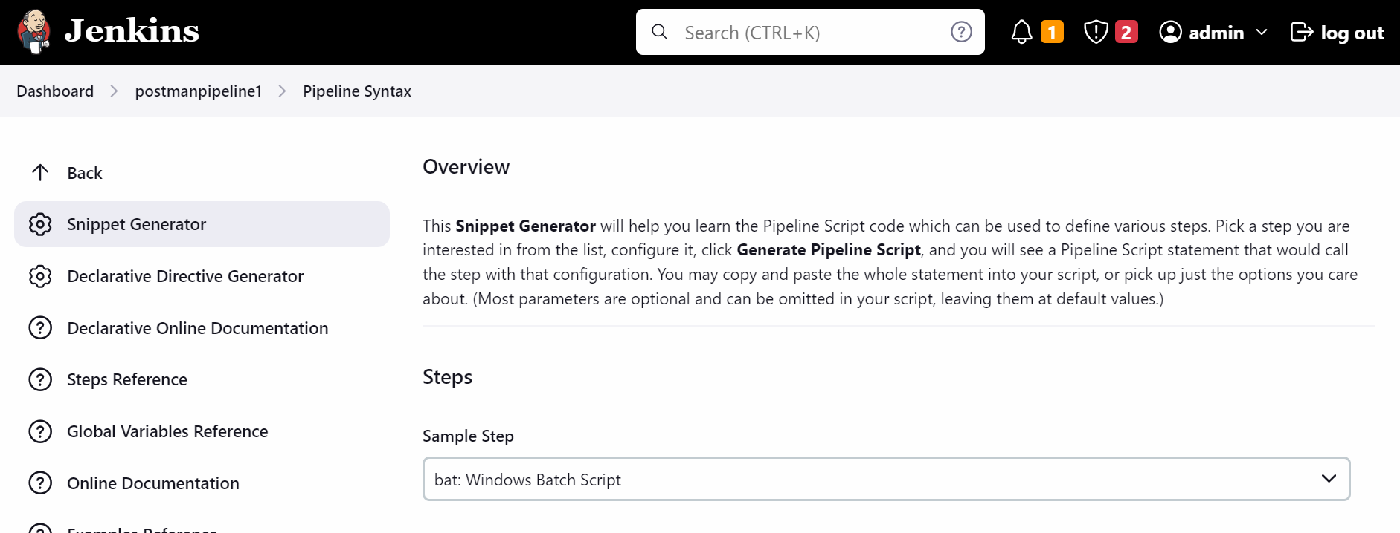

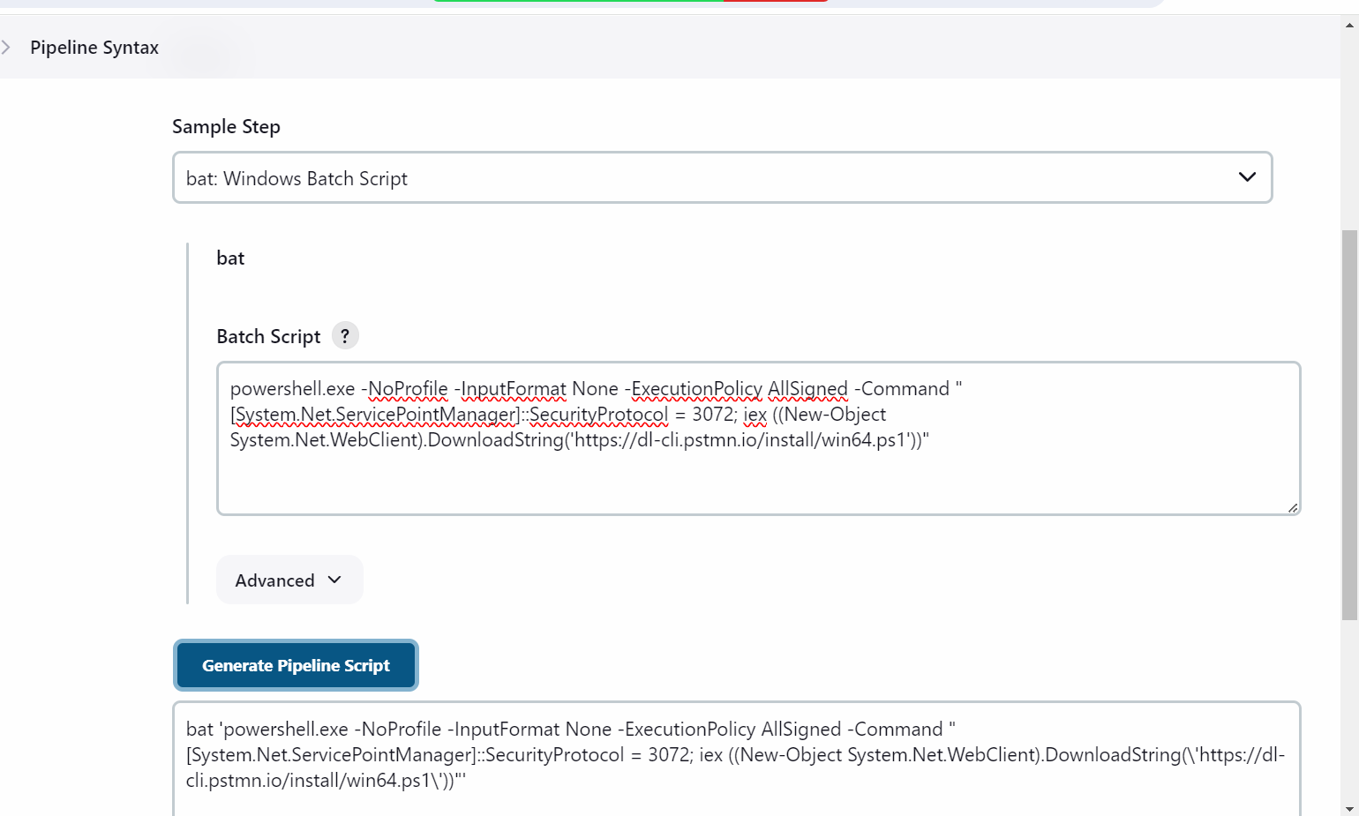

Now go to jenkisn job.. remove the sh command in first stage and add the bta command

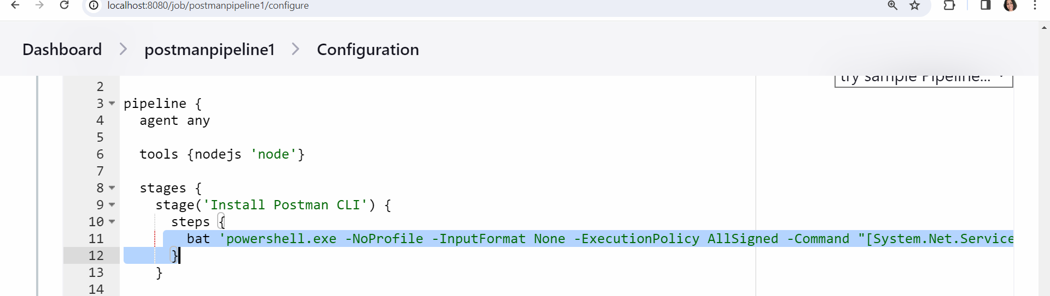

Get the api key from postman

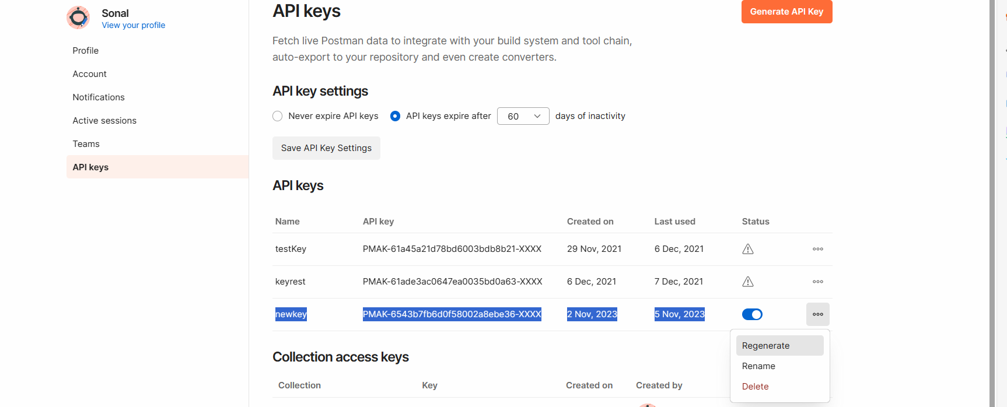

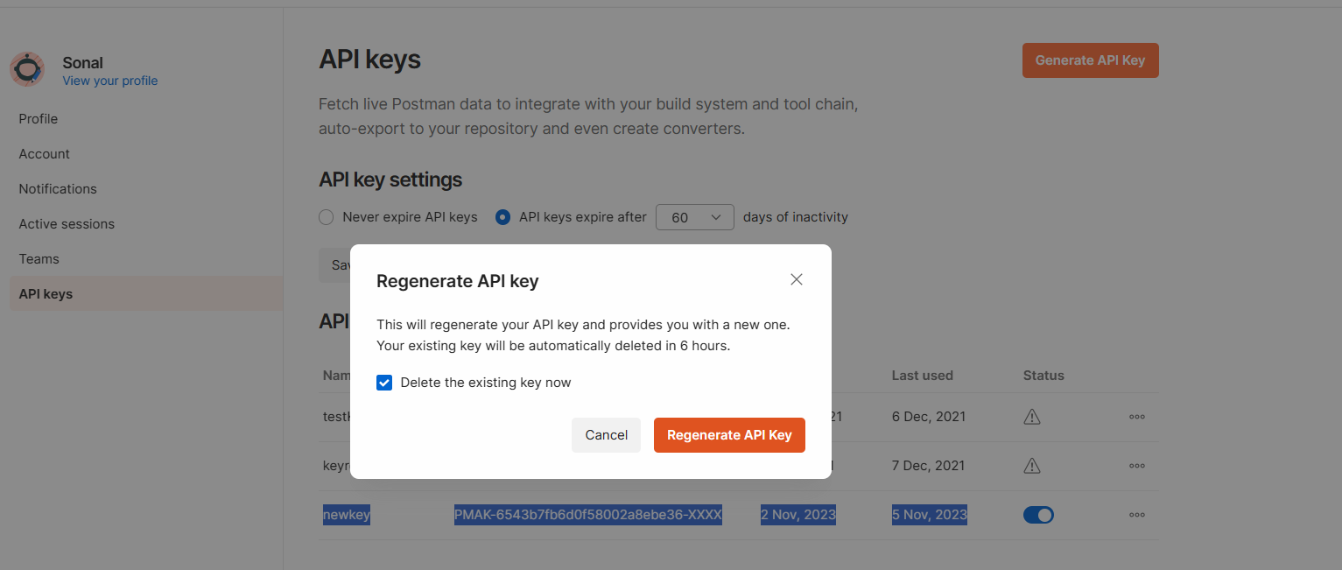

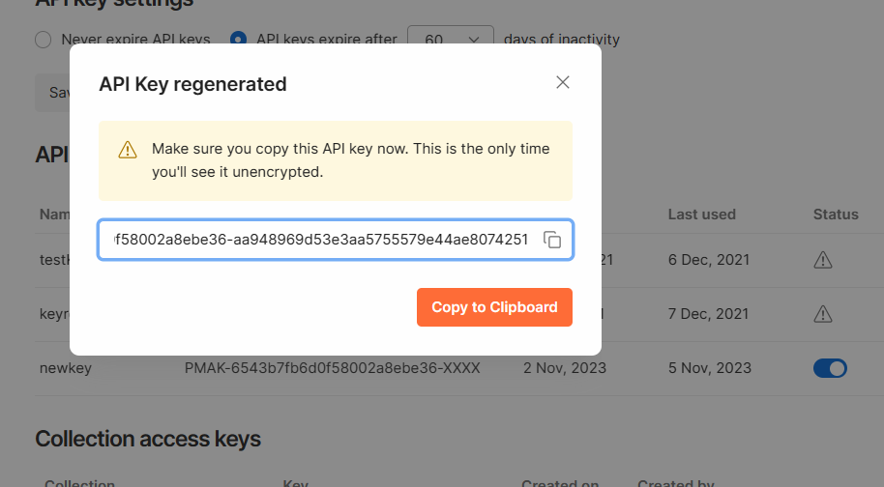

Go to Jenkins pipeline code

Stage 2 -> change sh to bat

And replace $POSTMAN_API_KEY to the actual postman apikey value

