Take a decimal number from user. Convert it to different bases (e.g.: 2,8,16 etc.) and send those values to message queue. Write three separate programs to read and display the binary, octal and hex value from the message queue distinctively.

Sender:

#include<stdio.h>

#include<stdlib.h>

#include<string.h>

#include<sys/types.h>

#include<sys/ipc.h>

#include<sys/msg.h>

#define datasize 32

#define BUFSIZE sizeof(int) * 8

typedef struct MsgQueue

{

long mtype;

char mdata[datasize];

}MQ;

MQ mq1,mq2,mq3;

char* decToBase(int number, int baseLg)

{

char* converted_number_str = malloc(BUFSIZE + 1);

for(int i = BUFSIZE - 1; i >= 0; i--)

{

int digit = number & (1 << baseLg) - 1;

number >>= baseLg;

if(digit > 9)

converted_number_str[i] = 'A' + (digit - 10);

else

converted_number_str[i] = '0' + digit;

}

converted_number_str[BUFSIZE] = '\0';

return converted_number_str;

}

int main()

{

int mqid, n;

mqid=msgget(1234,0666|IPC_CREAT);

printf("\nEnter a positive decimal value: ");

scanf("%d",&n);

strcpy(mq1.mdata,decToBase(n,1));

strcpy(mq2.mdata,decToBase(n,3));

strcpy(mq3.mdata,decToBase(n,4));

mq1.mtype=1;

mq2.mtype=2;

mq3.mtype=3;

msgsnd(mqid,&mq1,datasize,0);

msgsnd(mqid,&mq2,datasize,0);

msgsnd(mqid,&mq3,datasize,0);

msgctl(mqid,IPC_RMID,NULL);

return 1;

}

Receiver1(dec to binary):

#include<stdio.h>

#include<stdlib.h>

#include<sys/types.h>

#include<sys/ipc.h>

#include<sys/msg.h>

#define datasize 32

typedef struct MsgQueue

{

long mtype;

char mdata[datasize];

}MQ;

MQ mq1;

int main()

{

int mqid;

mqid=msgget(1234,0666|IPC_CREAT);

msgrcv(mqid,&mq1,datasize,1,0);

printf("Binary value = %s\n",mq1.mdata);

msgctl(mqid,IPC_RMID,NULL);

return 1;

}

Receiver2(dec to octal):

#include<stdio.h>

#include<stdlib.h>

#include<sys/types.h>

#include<sys/ipc.h>

#include<sys/msg.h>

#define datasize 32

typedef struct MsgQueue

{

long mtype;

char mdata[datasize];

}MQ;

MQ mq1;

int main()

{

int mqid;

mqid=msgget(1234,0666|IPC_CREAT);

msgrcv(mqid,&mq1,datasize,2,0);

printf("Octal value = %s\n",mq1.mdata);

msgctl(mqid,IPC_RMID,NULL);

return 1;

}

Receiver3(dec to hex):

#include<stdio.h>

#include<stdlib.h>

#include<sys/types.h>

#include<sys/ipc.h>

#include<sys/msg.h>

#define datasize 32

typedef struct MsgQueue

{

long mtype;

char mdata[datasize];

}MQ;

MQ mq1;

int main()

{

int mqid;

mqid=msgget(1234,0666|IPC_CREAT);

msgrcv(mqid,&mq1,datasize,3,0);

printf("Hex value = %s\n",mq1.mdata);

msgctl(mqid,IPC_RMID,NULL);

return 1;

}

OUTPUT:

(decimal to binary)

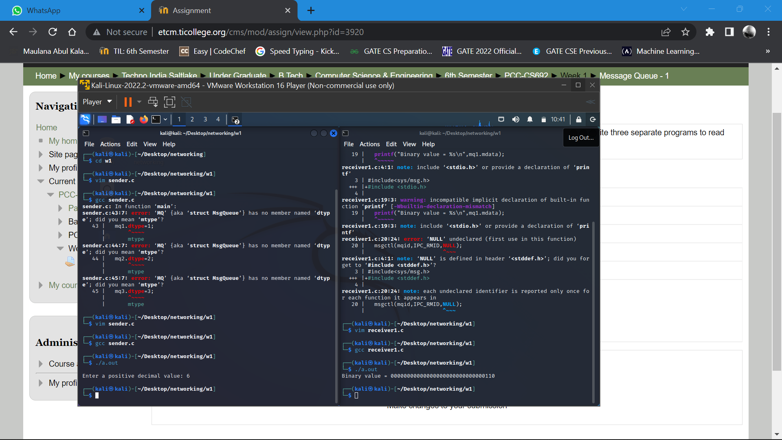

(decimal to octal)

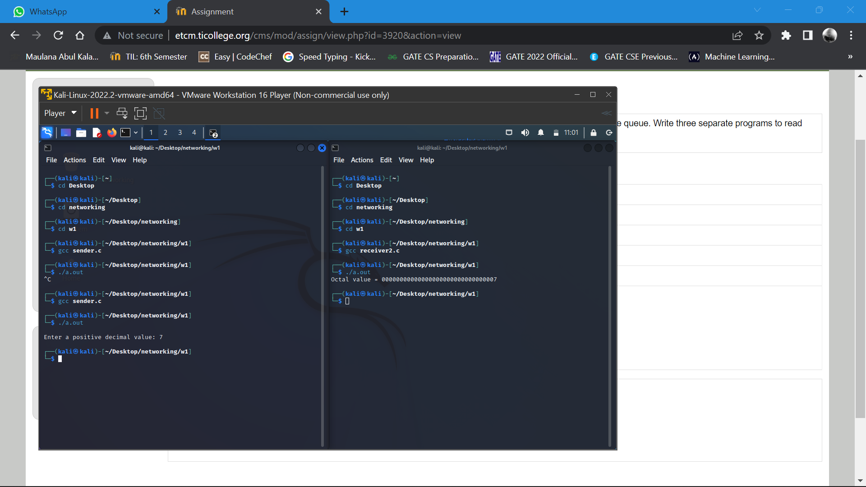

(decimal to hex)

