NestProof AI
Track C submission case study | WealthNest.AI | 10 October 2026
GitHub repository and working prototype
NestProof helps a family decide whether an uploaded fixed-deposit document represents a new asset, another record of an existing asset, or a conflict requiring review. The working local prototype combines source evidence, targeted clarification and reversible ledger updates. It addresses Document Intelligence and Evaluation & Reliability.

1 Problem identified
Accurate extraction alone does not guarantee an accurate family ledger. A certificate and a later statement may describe the same deposit using different labels or masked references. Adding both can double-count wealth; merging unrelated deposits can hide an asset. Confusing principal with maturity proceeds introduces another error even when the amount was read correctly.
The chosen problem is the uncertain decision between document extraction and an accepted holding. The intended users are family members importing records and reviewers resolving ambiguous matches.

2 Investigation and reasoning
Public product research and synthetic document experiments suggested this integration opportunity. It is not a verified defect in WealthNest’s authenticated workflow; firsthand product observation and user validation remain outstanding. Investigation focused on masked identities, unfamiliar labels, changing dates, conflicting amounts and access to shared records.
A useful failure shaped the design: improving recognition of capital labels briefly introduced a false same-deposit decision because maturity-value extraction remained incomplete. The failed experiment is retained in the repository. The fix separates financial roles and adds a regression case, rather than treating a higher extraction score as proof of a safer decision.
AI is appropriate for interpreting varied field labels. A local word and character TF-IDF classifier with logistic regression supports this task. Explicit rules handle roles, arithmetic, identity and permissions. The model does not generate monetary values; values remain traceable to source text.

3 Proposed solution
For each import, NestProof shows the extracted fields and their source lines, compares them with accepted visible holdings, and asks for missing identity evidence when needed. It selects the field that best separates candidate deposits. User answers are labeled as assertions; unresolved evidence can remain unresolved.
The distinguishing workflow is a small, decision-relevant clarification followed by an inspectable, reversible decision. A preview shows the principal change before confirmation; history and a downloadable receipt explain the accepted change. This is a focused application of established reconciliation techniques, not a claim of global novelty.
Example: after accepting a new INR 1,80,000 deposit, principal rises from INR 4,00,000 to INR 5,80,000. A later masked statement can be linked to an existing deposit after clarification, adding evidence without counting its principal twice.

4 Technical and product approach
Architecture: PDF or text upload → page and line evidence → local classifier and role constraints → typed validation → permission-scoped ledger matching → clarification or abstention → revision-bound preview → human confirmation → SQLite transaction → receipt and undo.
FastAPI serves a JavaScript interface and SQLite storage. Supported input is an English digital PDF or text file describing one INR fixed deposit; uploads are limited to 3 MB and PDFs to 10 pages. Training uses 85 authored labels and 32 calibration labels. The prototype needs no paid inference API or real financial records.
Previews bind to the actor, evidence version and ledger revision. Stale or repeated commits are rejected; access is checked again when committing or exporting a receipt. Undo creates a new revision for the latest unchanged decision. The frontend includes source inspection, clarification, previews, history, receipts, an Evidence lab and a maturity tracker that keeps projected proceeds separate from principal.
Failure handling: scans, unsupported layouts, misleading labels, forged documents and incorrect user answers remain risks. Confidence is not a probability of financial truth. Demo persona switching is not production authentication, and receipts are not cryptographic attestations. Real deployment needs independently labeled bank formats, consent, authentication, retention controls and monitored user pilots.

5 Supporting implementation and evaluation
Evidence | Recorded result | Interpretation
Automated and browser checks | 64 tests; 3 grouped browser checks passed | Covers supported safety and interaction paths
Development regression | 64/64 labels; 48/48 document pairs | Cases informed iterative development
Fresh synthetic challenge | ML/rules 30/30; exact/rules 11/30; fuzzy/rules 12/30 | Same author and generator; not independent validation
Clarification simulation | 1.0 questions vs 2.0 fixed order and 3.0 all fields | 30 constructed cases; truthful answers assumed
These results establish behavior on bounded synthetic cases, not real-bank accuracy or measured user savings. The repository includes evaluation scripts, detailed outputs, sample PDFs, intermediate failures and browser checks for reproducibility.
Judge demonstration: upload a sample; inspect its evidence; preview and confirm a new deposit; resolve a masked duplicate with no extra principal; inspect a conflict; export the receipt and undo. Reviewers can alter a synthetic reference, amount or date and test whether the system resolves or abstains.
Implementation overview and screenshots
Verification results and reproduction details
Proposed WealthNest integration: place this review step before canonical holdings updates. Accepted facts and provenance could later support WealthGPT; no chatbot or live WealthNest integration is claimed in this prototype.

Architecture and reliability
The implemented flow separates interpretation from the authority to change accepted holdings. Uncertain evidence returns to human review; supported decisions still require a revision-bound preview and confirmation.
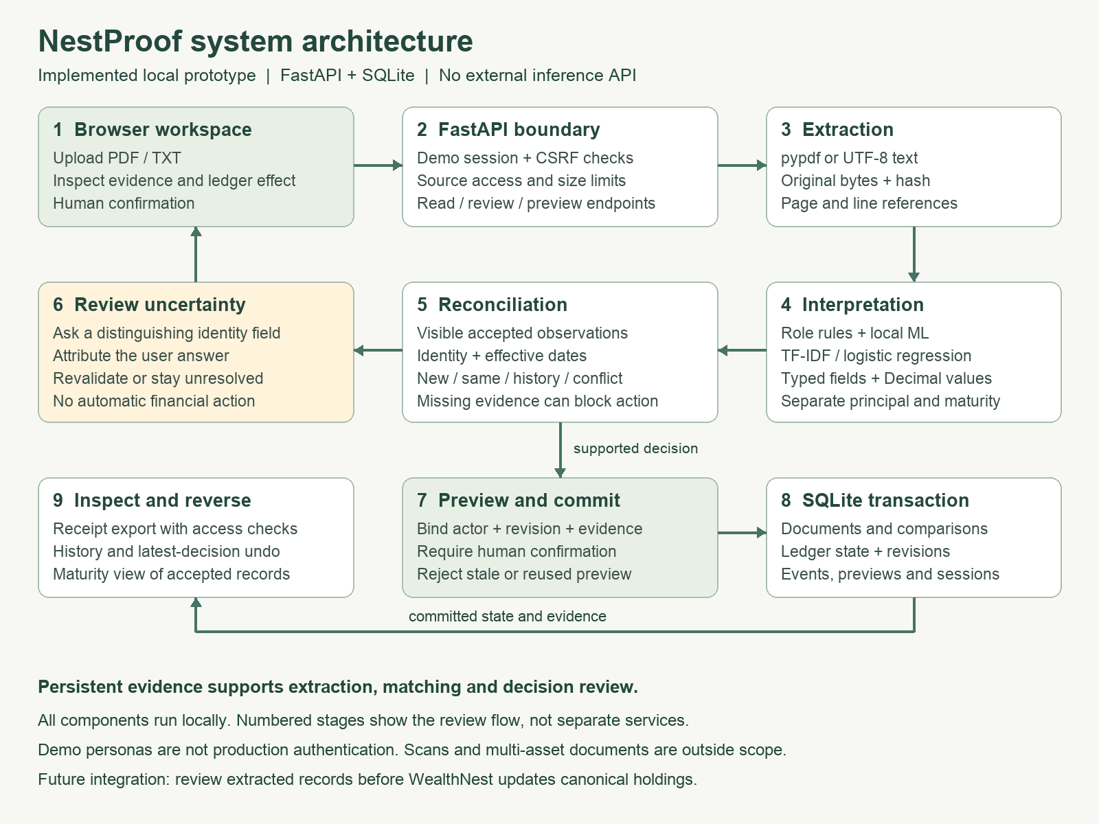

Implementation map
nestproof/engine.py — extraction, label classification, normalization, relation checks and clarification selection.
nestproof/app.py — API, permission checks, preview tokens, transactions, ledger revisions, receipts and undo.
static/ — the working review interface. evaluation/ and tests/ — reproducible synthetic comparisons and regression checks.
The diagram describes the current local application. Production identity, bank integrations and a WealthGPT retrieval layer are future work, not hidden dependencies.

Prototype evidence review
Actual desktop capture from the earlier working build. It illustrates source inspection, an attributed clarification and a zero-change duplicate preview. Current navigation additionally includes FD maturities and downloadable receipts.
