1.Python Pandas Program: Select Distinct Department IDs
Code:
import pandas as pd
# Create DataFrame directly
df = pd.DataFrame({
"DEPARTMENT_ID": [10,20,30,40,50,60,70,80,90,100,110,120,130,140,150,160,170,180,190,200,210,220,230,240,250,260,270],
"DEPARTMENT_NAME": [
"Administration","Marketing","Purchasing","Human Resources","Shipping",
"IT","Public Relations","Sales","Executive","Finance","Accounting",
"Treasury","Corporate Tax","Control And Credit","Shareholder Services",
"Benefits","Manufacturing","Construction","Contracting","Operations",
"IT Support","NOC","IT Helpdesk","Government Sales","Retail Sales",
"Recruiting","Payroll"
],
"MANAGER_ID": [200,201,114,203,121,103,204,145,100,108,205,0,0,0,0,0,0,0,0,0,0,0,0,0,0,0,0],
"LOCATION_ID": [1700,1800,1700,2400,1500,1400,2700,2500,1700,1700,1700,1700,1700,1700,1700,1700,1700,1700,1700,1700,1700,1700,1700,1700,1700,1700,1700]
})
# Select distinct department IDs
print("Distinct Department IDs:")
print(df["DEPARTMENT_ID"].unique())

Output:
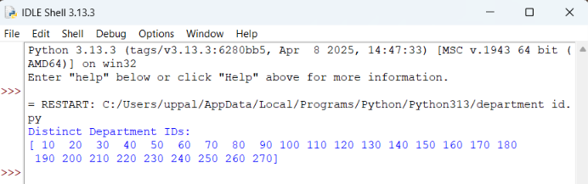

2.Display the IDs of Employees Who Have Done Two or More Jobs in the Past Using Pandas
Code:
import pandas as pd

# Create DataFrame
df = pd.DataFrame({
"EMPLOYEE_ID": [102,101,101,201,114,122,200,176,176,200],
"START_DATE": ["2001-01-13","1997-09-21","2001-10-28","2004-02-17","2006-03-24",
"2007-01-01","1995-09-17","2006-03-24","2007-01-01","2002-07-01"],
"END_DATE": ["2006-07-24","2001-10-27","2005-03-15","2007-12-19","2007-12-31",
"2007-12-31","2001-06-17","2006-12-31","2007-12-31","2006-12-31"],
"JOB_ID": ["IT_PROG","AC_ACCOUNT","AC_MGR","MK_REP","ST_CLERK",
"ST_CLERK","AD_ASST","SA_REP","SA_MAN","AC_ACCOUNT"],
"DEPARTMENT_ID": [60,110,110,20,50,50,90,80,80,90]
})
# Find employees with two or more jobs
result = df.groupby("EMPLOYEE_ID").filter(lambda x: len(x) >= 2)
# Display unique employee IDs
print("Employees who have done two or more jobs:")
print(result["EMPLOYEE_ID"].unique())

Output:
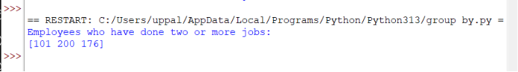

3.Display the Details of Jobs in Descending Order of Job Title Using Pandas
Code:
import pandas as pd
# Create DataFrame
df = pd.DataFrame({
"JOB_ID": ["AD_PRES","AD_VP","AD_ASST","FI_MGR","FI_ACCOUNT","AC_MGR","AC_ACCOUNT", "SA_MAN","SA_REP","PU_MAN","PU_CLERK","ST_MAN","ST_CLERK","SH_CLERK",
"IT_PROG","MK_MAN","MK_REP","HR_REP","PR_REP"],
"JOB_TITLE": ["President","Administration Vice President","Administration Assistant",
"Finance Manager","Accountant","Accounting Manager","Public Accountant",
"Sales Manager","Sales Representative","Purchasing Manager",
"Purchasing Clerk","Stock Manager","Stock Clerk","Shipping Clerk",
"Programmer","Marketing Manager","Marketing Representative",
"Human Resources Representative","Public Relations Representative"],
"MIN_SALARY": [20080,15000,3000,8200,4200,8200,4200,10000,6000,8000,2500,5500,2008,2500,4000,9000,4000,4000,4500],
"MAX_SALARY": [40000,30000,6000,16000,9000,16000,9000,20080,12008,15000,5500,8500,5000,5500,10000,15000,9000,9000,10500]
})
# Sort by JOB_TITLE in descending order
result = df.sort_values(by="JOB_TITLE", ascending=False)
# Display result
print(result)

Output:
