Vision Based Real Time Indian Sign Language (ISL) Detection
Rhucha Deodhar*, Tanya Gadwal*, Ananya Bhat*, Aditi Hinge* and Shilpa Pant2
Comp Dept. Cummins College of Engineering for Women, Pune, India
ORCID ID: 0000-0002-6709-5548
Abstract. This paper presents a real-time, vision-based system for Indian Sign Language (ISL) recognition and translation, aimed at enhancing communication between the deaf community and non-signers. The system combines a CNN-LSTM architecture for static gesture recognition, achieving an accuracy of 98.47% and introduces GestureNet, a bidirectional LSTM model trained on a custom dynamic gesture dataset, which attains 96.83% recognition accuracy. Additionally, a Generative AI framework is integrated to convert recognized gestures into semantically coherent and contextually appropriate sentences. By emphasizing real-world applicability and high recognition performance, the proposed system advances sustainable and accessible communication technologies, with potential impact in education, public services, and digital inclusion, particularly in developing regions.
Keywords: Indian Sign Language (ISL), Computer Vision, Real Time Detection, CNN-LSTM, GestureNet Model, Gesture Recognition, MediaPipe, Static and Dynamic Gestures, Assistive Technology, Inclusion, Communication, Generative AI
- Introduction
The earliest humans communicated with one another by simple sounds and gestures, but with time, languages evolved and became more complex. Humans were able to work more successfully, share knowledge and ideas, and create sophisticated communities because of their capacity to communicate through language. Simultaneously, corresponding sign languages started developing across the globe which helped people with hearing impairments to communicate. However, these started gaining a more structural form in only recent history and has thus proved to be a big challenge due to less resources and little representation of the hearing-impaired community in the world.
While a considerable amount of research has been conducted on recognition of American Sign Language (ASL), disproportionately less work has been done on the Indian counterpart. There are currently roughly 63 lakh people with hearing disabilities in India and very few systems are targeted towards this populus. Under NEP, Indian Sign Language has also been standardized, meaning that in a few years, it should be taught across schools to all students. This makes systems that bridge the gap between the hearing impaired and non-impaired people an important domain requiring innovation. We propose a recognition system that could be used as an educational tool, leveraging the recent GenAI boom to have a sentence level recognition system compared to currently existing static recognition systems.
- Related Work
Sign language detection can be categorized into two approaches- vision-based and glove-based. Vision based approaches are typically software solutions which depend on webcams to capture data and are dependent on quality of the camera along with lighting conditions. Glove-based systems on the other hand utilize sensor data which is obtained from gloves that are used for signing.
According to research by Chandarana et al. (2023) [4] “The system uses Random Forest Classifiers to achieve an accuracy of 99.6% for Indian Sign Language, converting the recognised gestures into text and audio in both English and Hindi. This study emphasizes the capabilities of machine learning models to handle bilingual outputs efficiently.” The implementation of Mediapipe with a Gated Recurrent Unit (GRU) model by Subramanian et al. (2022) [7] marked a significant improvement in real-time ISL gesture tracking. Their model showed promising results in enhancing recognition accuracy while optimizing processing time, making it suitable for real-time applications.
Singh et al. (2022) [2] used “Convolutional Neural Networks (CNNs) for the recognition of dynamic ISL gestures, achieving a training accuracy of 70%. The study highlights the challenges of recognizing complex and fluid gestures that vary in speed and shape.” Similarly, Das et al. (2022) [6] introduced a hybrid approach that fused deep learning techniques with manually crafted features to boost recognition accuracy, stressing the importance of integrating diverse feature extraction techniques for better results.
Further advancements in real-time ISL gesture recognition were presented by Soni et al. (2023) [5], who unveiled a refined CNN architecture that amalgamated image classification and skin segmentation to improve gesture recognition accuracy. Their framework successfully processed both static and dynamic gestures for real-time applications. Kolkur et al. (2024) [1] presented “YOLOv3 for Real-time ISL Gesture Detection: This system employs object detection techniques to recognize hand gestures in real time and translate them into speech. YOLOv3's fast processing capabilities make it an ideal candidate for real-time ISL systems, delivering accurate results in dynamic environments. It is observed that the model gives 99.93% accuracy on test data.”
DenseNet models were used by Beulah et al. (2023) [3] for ISL classification. Specifically, DenseNet169 was used for classifying static gestures. Their technique recorded an impressive accuracy of 99.95%, indicating the effectiveness of employing deeper network architectures to enhance gesture recognition.
However, challenges persist in the arena of sign language detection. Many existing systems struggle with accurately recognizing continuous sequences of dynamic gestures, which results in lower accuracy compared to static gesture recognition. Handling of temporal dynamics and variability in real-time signing is a very big gap in the research. Furthermore, enhancing the efficiency in processing data without trading off accuracy remains a challenge. Most ISL-to-speech systems function at the word level, with limited advancements to convert these into semantically accurate sentences and subsequently into speech. Further research should thus be conducted in this direction in order to build ISL recognition systems that are capable of facilitating natural sign language communication in real-world scenarios.
- Methodology
  - System Architecture
The Indian Sign Language Recognition System processes both, static gestures and dynamic gestures and converts them into speech and text. A dataset of statically signed images and sequential files for dynamic data is used to train deep learning models. During real-time recognition, the system captures live video input through the device’s webcam and detects hand landmarks using computer vision techniques. For static signs, the extracted features are normalized and passed through a trained CNN-LSTM model to predict the corresponding letter or number. For dynamic gestures, a sequence of frames is analysed using the GestureNet model to identify words or phrases. The text, which is recognized from the signs, is then displayed on an interface and is then either converted into a word or into a semantically accurate sentence. This is then converted into speech for audio output, enhancing accessibility for users.

  - Dataset

Static
Indian Sign Language consists of a set of 26 signs for letters from A to Z and numbers from 0 to 9 as shown in Figure 1. We downloaded a dataset from Kaggle containing the gestures for these classes. This dataset contains approximately 79200 images where each class has around 2200 images each.

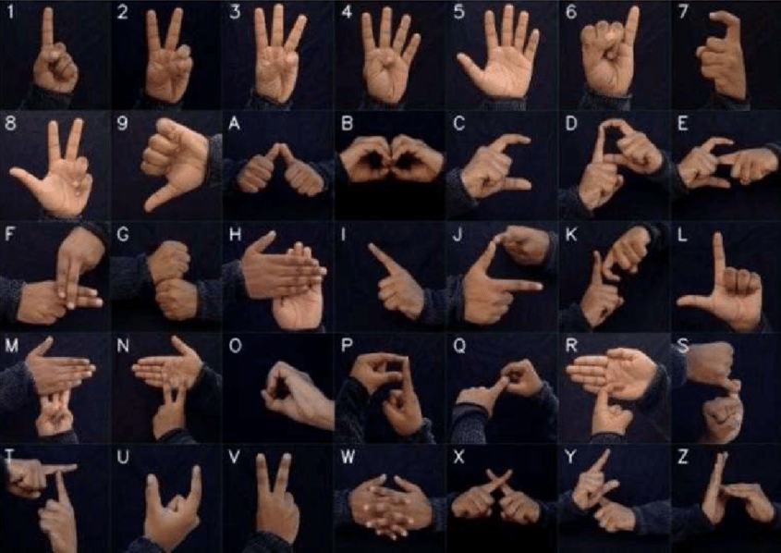
Fig. 1. Image illustrating alphabets and numbers in the Indian Sign Language

Dynamic
Dynamic gestures in Indian Sign Language (ISL) involve movements over time, requiring sequential processing instead of static hand shapes. We have created a custom dataset consisting of 14 gestures that vary across greetings, identity signs, temporal concepts and actions to represent a subset of ISL vocabulary.
These gestures are collected by utilising Python’s OpenCV and Mediapipe libraries. Each recorded gesture is a sequential collection of 30 frames. To reduce noise and jitter in the data collection, we have implemented a moving average filter with a window size of 3 frames, separate filtering for hand and face landmarks and background subtraction to isolate the subject from the environment. OpenCV captures images in ‘BGR’ format so it is converted into ‘RGB’ format. By using Mediapipe’s functions, 21 key-points are extracted for each hand and 468 key-points are extracted for the face, providing x,y and z coordinates. These key-points are then combined and flattened into a 1D array which is then stored as a .npy file.
To ensure quality assurance, we have also implemented a motion detection algorithm based on frame differencing to trigger data collection only when the participant is actively performing a gesture. This is done by calculating absolute differences between consecutive frames and applying thresholding and morphological operations to identify significant movement. These steps help prevent false triggers for signing. At the very end, we balance the dataset to avoid data imbalance and skewness.

  - Preprocessing
The preprocessing stage ensures that both static and dynamic sign gestures are appropriately formatted for accurate recognition by the deep learning models. It involves data normalization, feature extraction, encoding, and standardization to maintain consistency across different hand positions, sizes, and gesture sequences.

Static
For static sign recognition the preprocessing stage configures the MediaPipe Hands detector to efficiently process video-like frames, ensuring robust and accurate hand gesture recognition. The detector is set to require a minimum confidence level of 50% for detection and tracking while allowing the identification of up to two hands per image.
To ensure position and scale invariance, we normalize the x and y coordinates relative to the hand’s bounding box to preserve the hand's relative shape and position in the image. This normalization standardizes the data across different hand positions and sizes, preventing discrepancies in feature extraction due to variations in distance or placement.
We further process the image by converting it into an RGB format to align with the CNN model's input requirements. MediaPipe hand detection is then applied, and potential errors are handled by validating and sorting detected hands based on handedness.
The dataset is preprocessed by encoding categorical labels into numerical indices using label encoding and one-hot encoding labels to ensure compatibility with the model. The processed data is subsequently split into training and testing sets, maintaining a ratio of 80:20.

Dynamic
Certain pre-processing operations were performed on the dynamic dataset prior to training our model. To increase the robustness of our model and counter the weakness of a relatively small training dataset, we used data augmentation techniques specifically tailored for time-series data.
Time warping was used by repeating or skipping random frames within a sequence, mimicking variations in signing speed of various users. We also added random gaussian noise to landmark coordinates that mimicked natural variations in hand and face positioning to make the model more robust to slight variations in gesture performance.
These augmentations were generated dynamically so that each mini batch was presented with distinct augmentations, essentially increasing the training dataset and exposing the model to a greater variety of gesture variations. This aids in enhancing model generalization to real-time usage.
The dataset was then split using a stratified method so that 85% of the dataset was used for training and validation and 15% was used as a hold-out test set.

  - Training Model

Static
We use a combination of Convolutional Neural Networks (CNN) for extracting spatial features and Long Short-Term Memory (LSTM) networks for handling sequential data for training. It starts with a one-dimensional convolutional layer containing 64 filters of size 3, which helps in detecting local patterns within the input sequence. This is followed by a max-pooling layer that reduces dimensionality while retaining critical spatial information.
The extracted features are then passed through an LSTM layer with 128 units, allowing the model to capture temporal relationships in gesture sequences. To prevent overfitting, a dropout layer with a 50% rate is incorporated. Additionally, a fully connected dense layer with 128 neurons and ReLU activation enhances non-linear feature representation.
The final classification is performed using a softmax activation function, which assigns input sequences to their respective gesture classes. The model is optimized using the Adam optimizer for efficient learning, with categorical cross-entropy loss guiding training and accuracy serving as the key performance metric. We train the model for 50 epochs with a batch size of 32 to ensure robust learning.

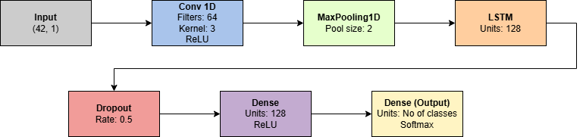
Fig. 2. CNN+LSTM Model Structure

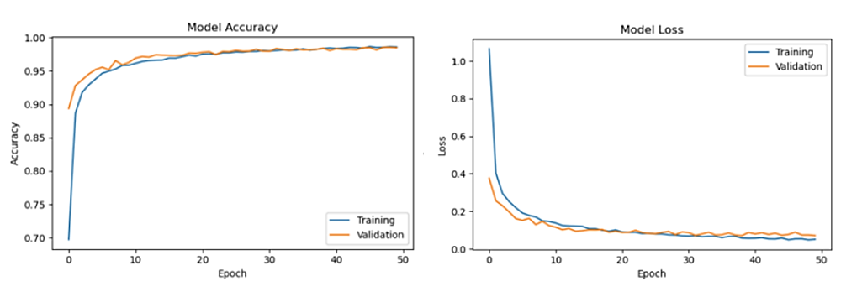 Fig. 3. Training vs Validation Accuracy and Loss of the Static Model

Dynamic
We employed a Bidirectional Long Short-Term Memory (LSTM) architecture which we refer to as the GestureNet model. This is composed of an input layer followed by two bidirectional LSTM stacked layers of 160 and 96 units, respectively, allowing extraction of temporal patterns from the forward and backward movements of a 30-frame sequence for each gesture.
Following this are two fully connected dense layers of 256 and 128 units that employ LeakyReLU activation together with batch normalization.
In between the LSTM and dense layers, dropout layers are inserted, as well as L2 regularization (λ=0.0003) in order to counteract the possibility of overfitting the model.
Finally, a softmax-activated dense layer of 14 output classes matching the gestures is present. We trained the model for 200 epochs, and employed early stopping to track the validation loss using a patience limit of 35 epochs.
To achieve optimal training, we used cosine decay learning rate scheduler that reduced the learning rate step by step according to:

$lr = {lr}_{initial} × \frac{(1 + cos(π × epoch / total_epochs)) }{2} …$(1)

Additionally, the Adam optimizer is also used for gradient-based optimization. More advanced callbacks and model checkpointing have also been included to save the best-performing model.
The model is then tested using a 5-fold stratified cross-validation method, which gives comprehensive testing across various data segments and deals with the limitations of a small dataset size and possible data biases.
After cross-validation, the final model was trained on the full training and validation set (85% of the total data) and tested on the held-out test set (15%).

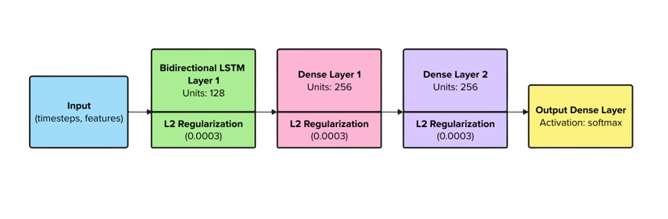
Fig. 4. GestureNet Model Architecture

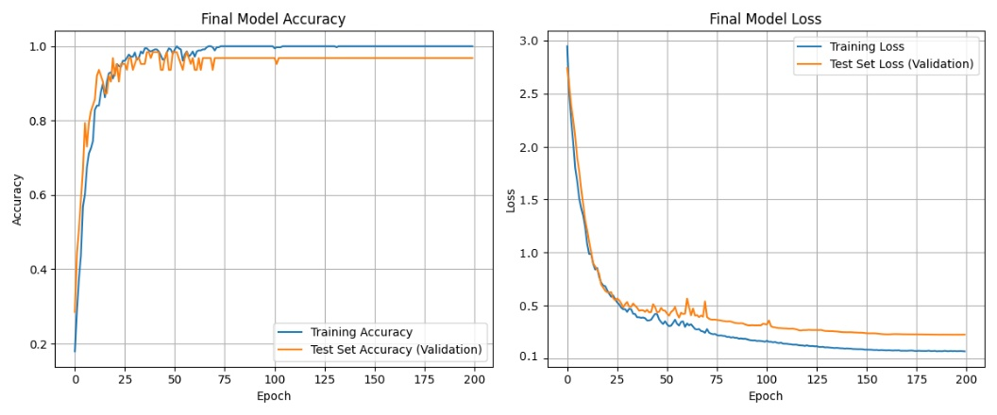
Fig. 5. Training vs Validation Accuracy and Loss of the Dynamic Model

  - Real-Time Detection
For real time static gesture detection, each frame is processed to detect hand landmarks and the pre-trained scaler is loaded for consistent feature normalization. The hand landmark detection parameters are adjusted to detect up to two hands with an 80% confidence threshold which ensures reliable detection. To improve hand detection and visual clarity, we combine background-only blurring and skin color segmentation. Background blurring uses a hand mask from MediaPipe landmarks to keep the hand sharp while blurring only the background. Skin color segmentation further refines this mask by isolating skin-toned regions in the frame. By merging both techniques, we more accurately separate the hand from the background, reducing false blurring and enhancing recognition performance. Our static recognition code includes a flexible 3-second timer, which was added to give users ample time to perform each sign comfortably. This timer can be adjusted or removed entirely, as it was primarily implemented for ease of signing during development and testing. After a user completes a gesture, the system takes about 40ms to analyze the input, recognize the gesture, and display the corresponding text.
Similarly, for dynamic gestures, the confidence thresholds are set high at 0.9 to reduce false positives and ensure accurate detection. Rather than classify each frame individually, the system implements temporal aggregation, that is a collection period for more reliable recognition. When a hand is detected, the system begins extracting keypoints from both hands and face across multiple frames, building a sequence of length 30 frames. A confidence-weighted voting system selects the most frequent prediction as the final gesture, effectively filtering out transient movements and reducing misclassifications. Additionally, previously described measures to combat noise and jitter are also applied in the real time prediction.

  - Semantic Sentence Formation
The recognised dynamic gestures are added in a buffer and then sent as an API request to the Inference client of Meta Llama 3.1, along with a prompt asking it to create a semantically accurate sentence. This LLM then processes the request in the backend and retrieves back a meaningful sentence created by the gloss gestures passed to it while retaining the context of the signer. This is a novel idea that enables you to translate gestures at a sentence level instead of simply recognising and representing them as words. By leveraging Generative AI, we bypass the overhead of natural language processing steps that would have had to be otherwise carried out to create semantically meaningful sentences.

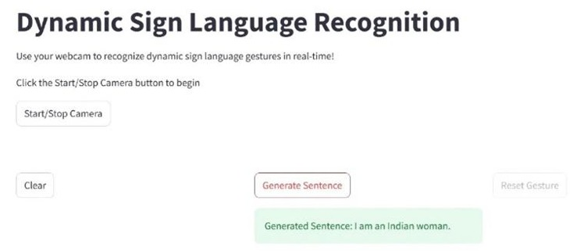
Fig. 6. Sign Language to Text Generation using Llama 3.1

  - Speech to Text
For static gesture recognition, the predicted letter is added to a buffer which forms the word. Similarly for dynamic recognition, the sentence retrieved from the Llama3.1 call is stored. These are passed to the pyttsx library, which converts the word or sentence into speech. The advantage of using pyttsx is its non-reliance on internet connectivity. This enhances accessibility for users.

  - Implementation Details
We have implemented our proposal as a system built with streamlit, a lightweight python-based web-framework as the frontend with our backend using TensorFlow, Keras, OpenCV, NumPy, and MediaPipe libraries. The system runs as a standalone streamlit application.
The training was done on systems having a multicore i5 processor with 16GB RAM and a webcam of minimum 720p resolution.
- Results
  - Performance of CNN-LSTM
The trained CNN-LSTM model achieves high classification accuracy. The training accuracy of the model is 98.59%, while the testing accuracy is 98.47%, indicating minimal overfitting and strong generalization to unseen data. The performance of the model is evaluated using accuracy metrics and training and validation loss curves. The hybrid architecture accurately distinguishes between multiple gesture classes.

  - Performance of GestureNet
The GestureNet model has very good classification accuracy. The final training accuracy for this model is 99.008% and the validation accuracy is 96.83%. The performance of the model is calculated using accuracy metrics and training and validation loss curves.
While the validation loss is still quite high, this is typical of gesture recognition models that have to deal with problems like high variability and noisier data. Since the validation accuracy is very high, the high loss doesn’t deter the classification process.

Table 1. Comparison of Accuracies of Various Models

Model | Static Gesture Accuracy (%) | Dynamic Gesture Accuracy (%)
CNN+LSTM | 94.2 | 87.6
ResNet50 | 96.8 | 78.3
MediaPipe + Random Forest | 95.4 | 82.7
3D-CNN | 91.3 | 89.8
Vision Transformer | 95.9 | 85.2
GCN (Graph Convolutional Network) | 93.7 | 91.2
EfficientNet + GRU | 94.8 | 88.9
GoogleNet + Optical Flow | 90.6 | 86.1
Multimodal Fusion (CNN + RNN + Depth) | 97.3 | 92.6
Custom ISL-Net | 96.2 | 90.7
Proposed | 98.47 | 96.83

  - Sentence Fluency and Semantic Evaluation
To test the sentence fluency and semantic evaluation of our GenAI outputs, we created test cases where we mapped gloss sequences to target sentences and applied surface-level and semantic metrics.
Traditional n-gram overlap measures such as BLEU-4 which is calculated by matching 1-to-4-word sequences between reference and generated text yielded a score of 0.43, which was expected given the flexible mapping between sign language glosses and natural language sentences. This was also reflected by the Word Error Rate (WER) inverse score which was 0.55.
However, despite these metrics being moderate, other semantic metrics yielded better results. The NIST score was calculated as 0.87, indicating that informative word choices were preserved. More importantly, the generated sentences demonstrated excellent fluency, achieving a perfect score of 1.0 on the fluency metric which we derived from text structure analysis including word diversity and length. Semantic similarity, computed via embedding-based methods, reached 0.78, suggesting that the generated sentences capture the intended meaning of the input gestures. We also calculated fuzzy matching scores such as the Fuzzy Token Set Ratio which handles word reordering by comparing word sets rather than exact sequences. This scored 0.93 which further supported the observation that while the word order or specific tokens may vary, the core content is well-aligned with reference sentences.
Overall, we observed that the system generated semantically accurate and fluent sentences which aligns well with the objective of sign language gloss-to-sentence conversion, where semantic equivalence should be prioritized over strict lexical overlap.

- Output
  - Static
The final output of the model is a predicted gesture class corresponding to the input hand gesture which could be a letter or a number. The predicted gesture is displayed in real-time, allowing users to visualize the classification results.

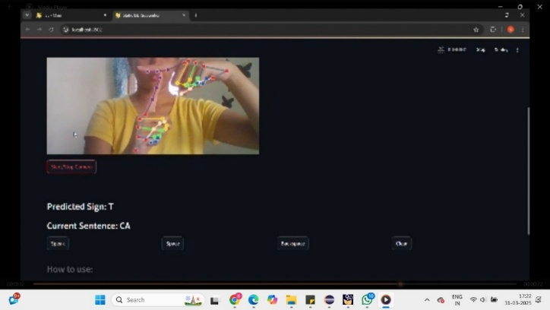 Fig. 7. Static Gesture Recognition of ‘T’

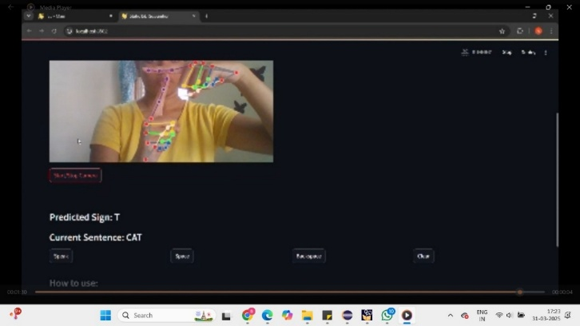
Fig. 8. Static Gesture Recognition – Final output: ‘CAT’

  - Dynamic
The final output of the model is a predicted gesture class corresponding to the input hand gesture which could be a word or a phrase. The predicted gesture is displayed in real-time, allowing users to visualize the classification results.

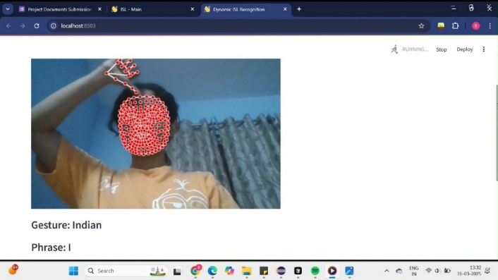
Fig. 9. Dynamic Gesture Recognition of ‘Indian’

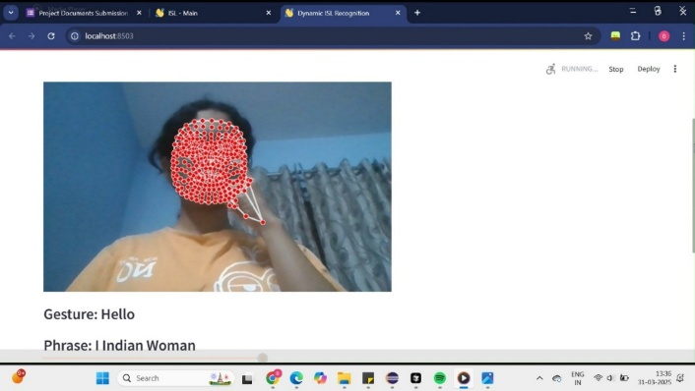
Fig. 10. Dynamic Gesture Recognition of ‘Woman’
- Conclusion
A real-time vision-based system that recognises Indian sign language gestures and converts them to semantically accurate sentences by leveraging Generative AI is an avenue that holds immense potential in modern India. However, several gaps exist in this proposal; first and foremost, the development of a combined model that recognises both static and dynamic signs is necessary to further bridge the gap between research done so far that primarily targets static gestures or dynamic gestures individually. Another important aspect is the size of the dynamic gesture dataset which could be increased so as to include a more comprehensive vocabulary. Further provisions could be made so as to convert the sentences formed into regional, vernacular languages to increase accessibility and enhance user experience. Further research focused on these limitations would enable the creation of a more holistic system and perhaps more innovative models that expand current avenues.
- Acknowledgement
The authors marked with an asterisk (*) contributed equally to this work.
We deeply appreciate the guidance and support provided by our mentor, Prof. Shilpa Pant, from the Computer Science Engineering Department for her essential guidance, unwavering support, and constant encouragement during this research. Her specialized knowledge and observations have been instrumental in shaping this work.
We also extend our heartfelt appreciation to MKSSS’s Cummins College of Engineering for Women, Pune, for providing the required resources and a conducive environment for research. This project would not have been possible without the institution’s support.
Finally, we acknowledge the efforts of all those who contributed directly or indirectly to this research. Their inputs and feedback have helped us refine our work and move closer to our goal of advancing Indian Sign Language recognition technology.

References
[1] Akash Kolkur, Amruta Yattinmalgi, Gangadharayya Korimath, et al., “Deep Learning based Indian Sign Language Recognition for People with Speech and Hearing Impairment,” IEEE International Conference on Contemporary Computing and Communications, 2024

[2] A. Singh, A. Wadhawan, M. Rakhra, U. Mittal, A. A. Ahdal and S. K. Jha, "Indian Sign Language Recognition System for Dynamic Signs," 10th International Conference on Reliability, Infocom Technologies and Optimization (Trends and Future Directions) (ICRITO), 2022

[3] I. Keren Beulah, Kumudha Raimond, G. Litisha Miraclin, “Indian Sign Language Recognition for Static Gestures using DenseNet169 Model,” 8th International Conference on Communication and Electronics Systems (ICCES), 2023

[4] N. Chandarana, S. Manjucha, P. Chogale, N. Chhajed, M. G. Tolani and M. R. M. Edinburgh, "Indian Sign Language Recognition with Conversion to Bilingual Text and Audio," International Conference on Advanced Computing Technologies and Applications (ICACTA), 2023

[5] Rajat Soni, Anshul Vijay, Aakash Khandelwal, Radhika Vijay, Vipin Yadav and Deepa Bhatia, "Real-time recognition framework for Indian Sign Language using fine-tuned convolutional neural networks", In: Prashant Singh Rana, Deepak Bhatia and Himanshu Arora (eds), SCRS Proceedings of International Conference of Undergraduate Students, SCRS, India, 2023

[6] Soumen Das, Saroj Kr Biswas, Biswajit Purkayastha, “Automated Indian Sign Language Recognition System by fusing deep and handcrafted furniture,” Multimedia Tools and Applications, 2022

[7] Subramanian, B., Olimov, B., Naik, S.M. et al., “An Integrated Mediapipe-Optimized GRU Model for Indian Sign Language Recognition,” Sci Rep 12, 11964, 2022

