Ananya Basak
Roll No: UG/02/BTCSEAIML/2023/062
Reg. No: AU/2023/0010194
Sec: E
Unstructured Database Lab 23.03.2026 | studio 3T
Database: college_student
Collection: students
Insertion:
use collegeDB_62
db.createCollection("students")
b.students.insertMany([
{ roll: 1, name: "Anu", age: 22, department: "IT", marks: 85 },
{ roll: 2, name: "Riya", age: 21, department: "CSE", marks: 78 },
{ roll: 3, name: "Aman", age: 23, department: "IT", marks: 92 },
{ roll: 4, name: "Neha", age: 20, department: "ECE", marks: 74 },
{ roll: 5, name: "Raj", age: 24, department: "CSE", marks: 88 },
{ roll: 6, name: "Simran", age: 22, department: "IT", marks: 81 },
{ roll: 7, name: "Karan", age: 21, department: "ECE", marks: 69 },
{ roll: 8, name: "Priya", age: 23, department: "CSE", marks: 95 }
])

Q1. Display all documents
db.students.find()
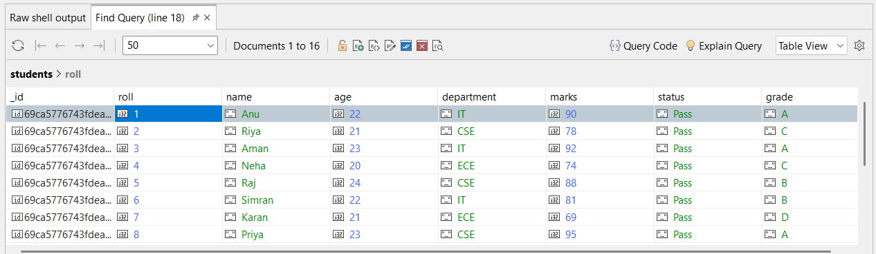
Q2. Find students from IT department
db.students.find({ department: "IT" })
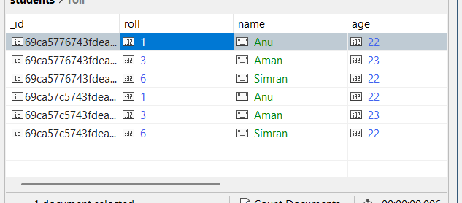

Q3. Find students with marks > 80
db.students.find({ marks: { $gt: 80} })
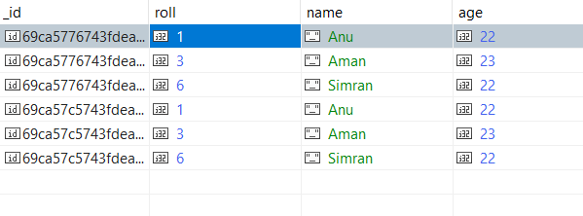
Q4. Insert one new student
db.students.insertOne(
{ roll: 9, name: "Esha", age: 22, department: "CSE", marks: 87 }
)
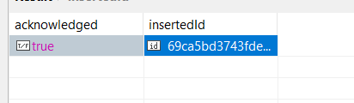

Q5. Update marks of Anu to 90
db.students.updateOne(
{ name: "Anu" },
{ $set: { marks: 90 } }
)
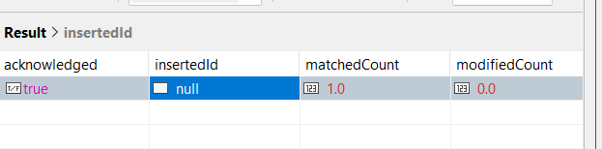

Q6. Add a new field "status: Pass" for all students
db.students.updateMany(
{},
{ $set: { status: "Pass" } }
)
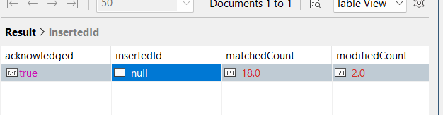

Q7. Delete all students with marks < 70
db.students.deleteMany({ marks: { $lt: 70 } })
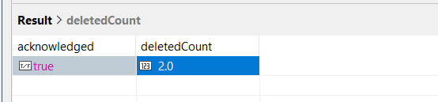
Q8. Count students in CSE department
-db.students.countDocuments({ department: "CSE" })
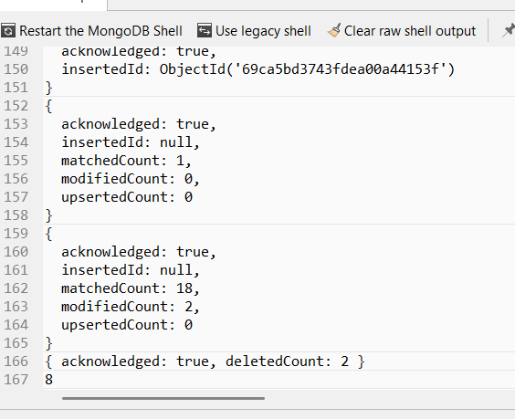

Q9. Find total students in each department
db.students.aggregate([
{ $group: { _id: "$department", total: { $sum: 1 } } }
])

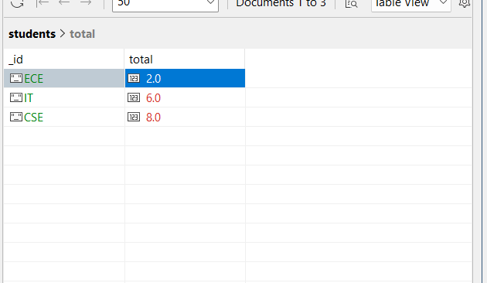
Q10. Find highest marks
db.students.find().sort({ marks: -1 }).limit(1)
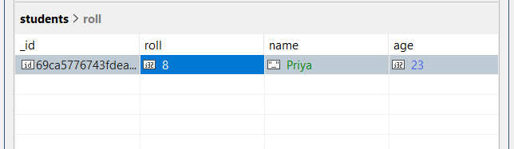

Q11. Find the second highest marks
db.students.find().sort({ marks: -1 }).skip(1).limit(1) 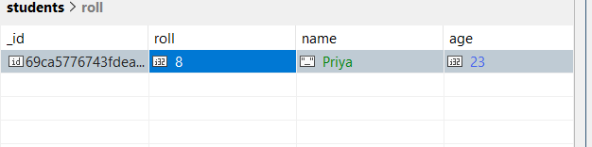
Q12. Find students whose name starts with 'A' and marks > 80
db.students.find({
name: { $regex: "^A" },
marks: { $gt: 80 }
})
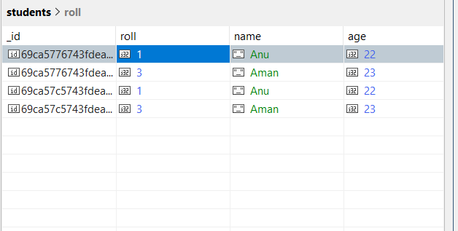

Q13. Display department-wise average marks, only for departments where avg > 80
db.students.aggregate([
{
$group: {
_id: "$department",
avgMarks: { $avg: "$marks" }
}
},
{
$match: { avgMarks: { $gt: 80 } }
}
])
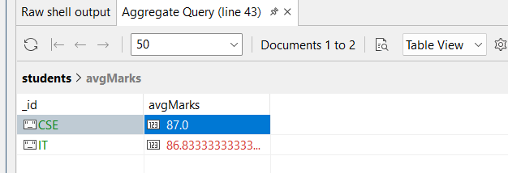

Q14. Find students with marks between 75 and 90, sorted by marks ascending
db.students.find({
marks: { $gte: 75, $lte: 90 }
}).sort({ marks: 1 })
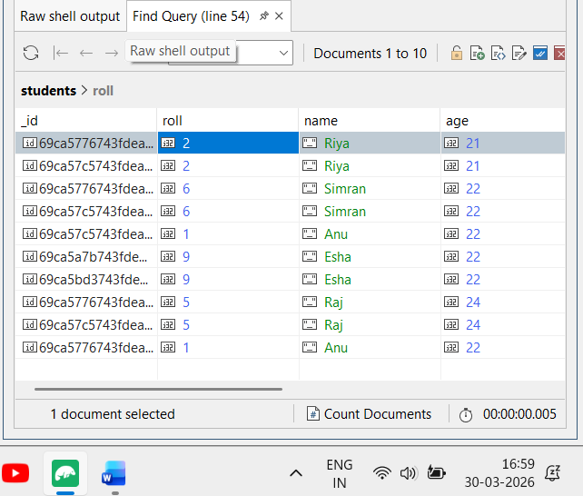

Q15. Add grade field based on marks
db.students.updateMany(
{},
[
{
$set: {
grade: {
$switch: {
branches: [
{ case: { $gte: ["$marks", 90] }, then: "A" },
{ case: { $gte: ["$marks", 80] }, then: "B" },
{ case: { $gte: ["$marks", 70] }, then: "C" }
],
default: "D"
}
}
}
}
]
)
