UNSTRUCTURED DATABASE LAB 6
Name: Ananya Basak
Roll No: UG/02/BTCSEAIML/2023/062
REG NO: AU/2023/0010194
SEC: E
Database: collegeDB
Collection: Employees
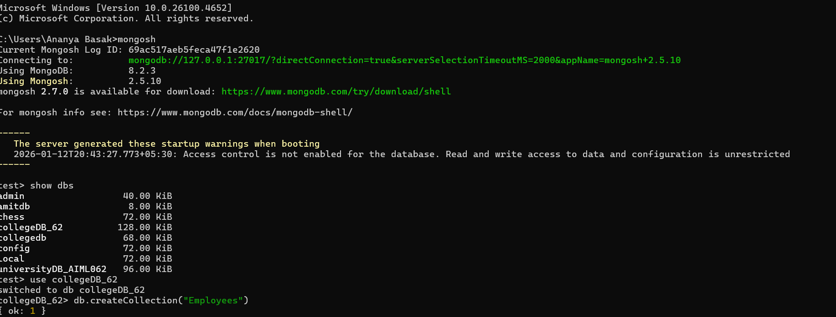
Insertion
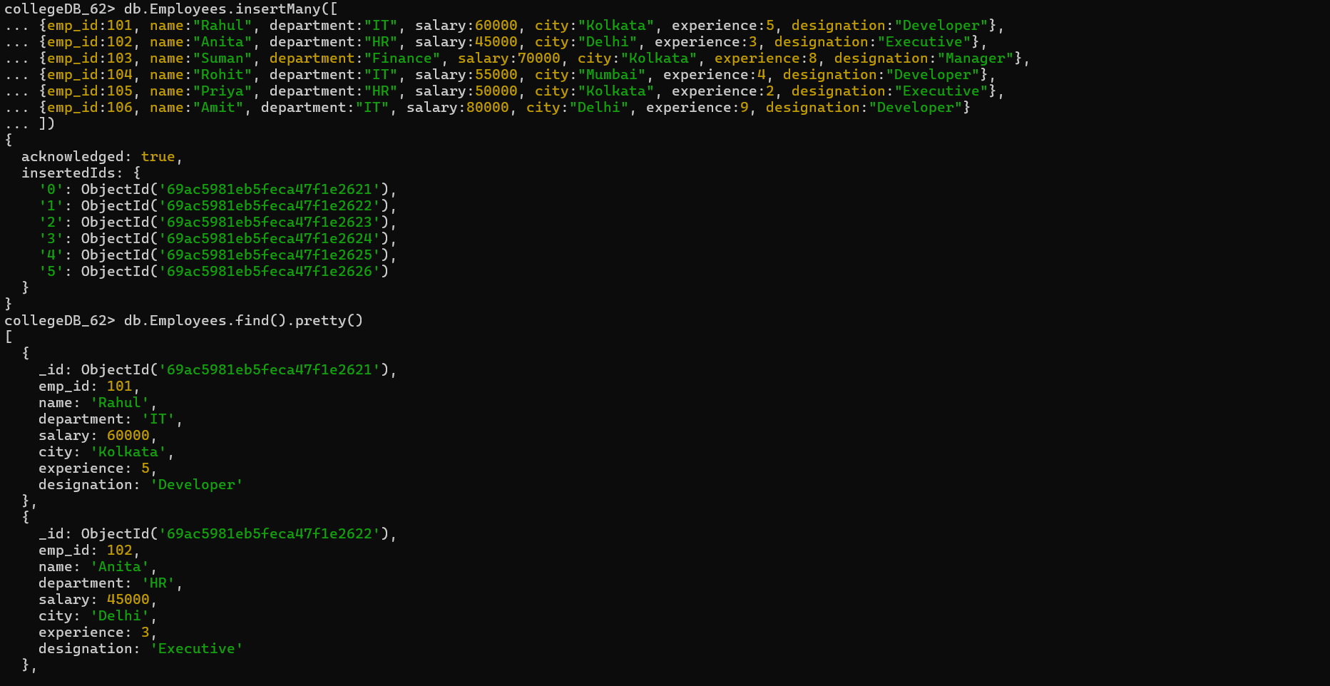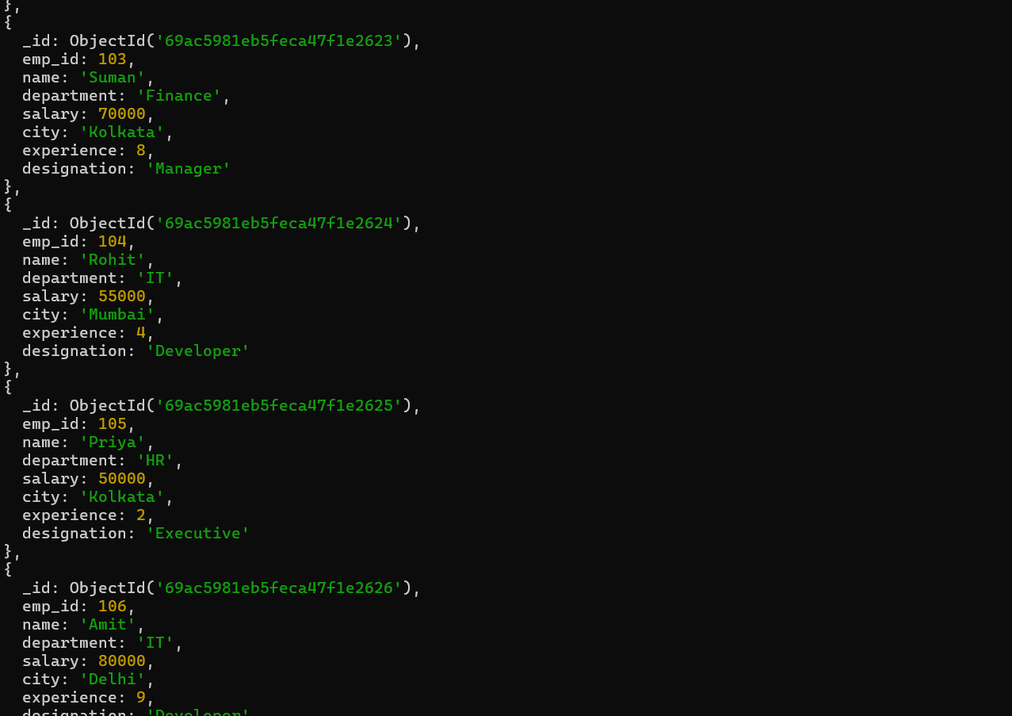

Lab 6
Question description
Q1. Display employee name and salary only.
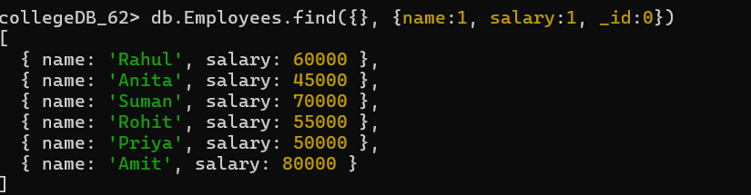
Q2. find employees working in hr department.
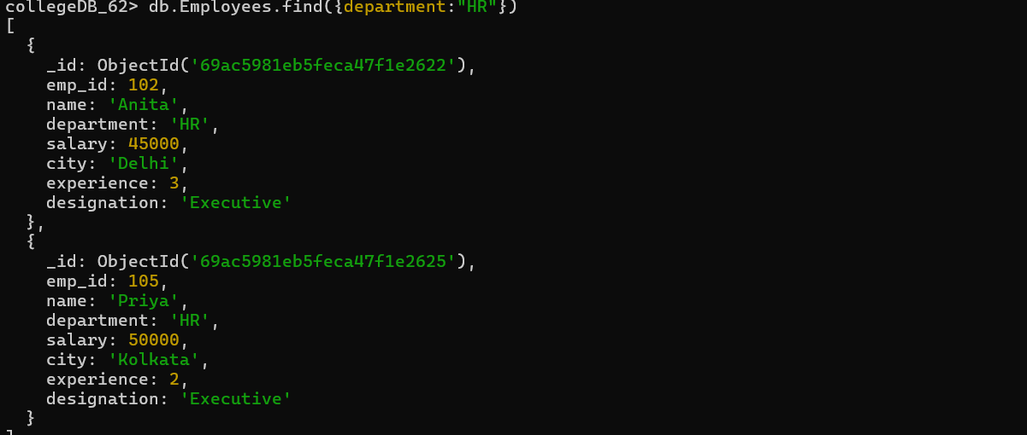

Q3. Find employees whose salary is between 50,000 and 80,000.
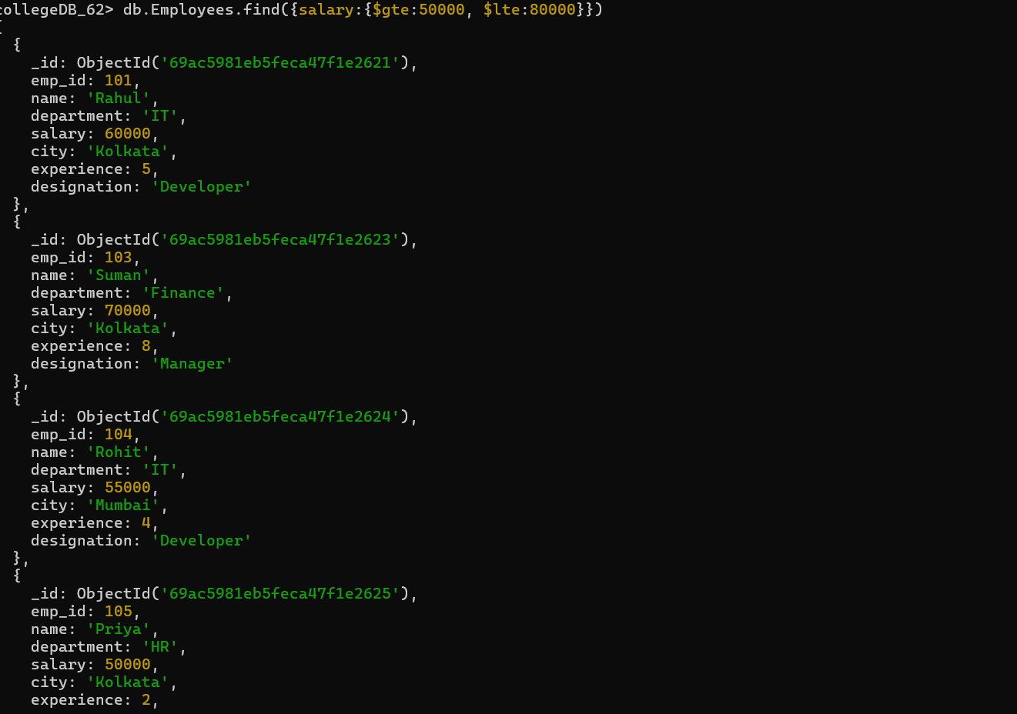
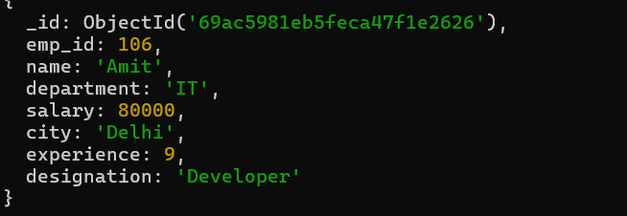
Q4. Display employees from Kolkata city.
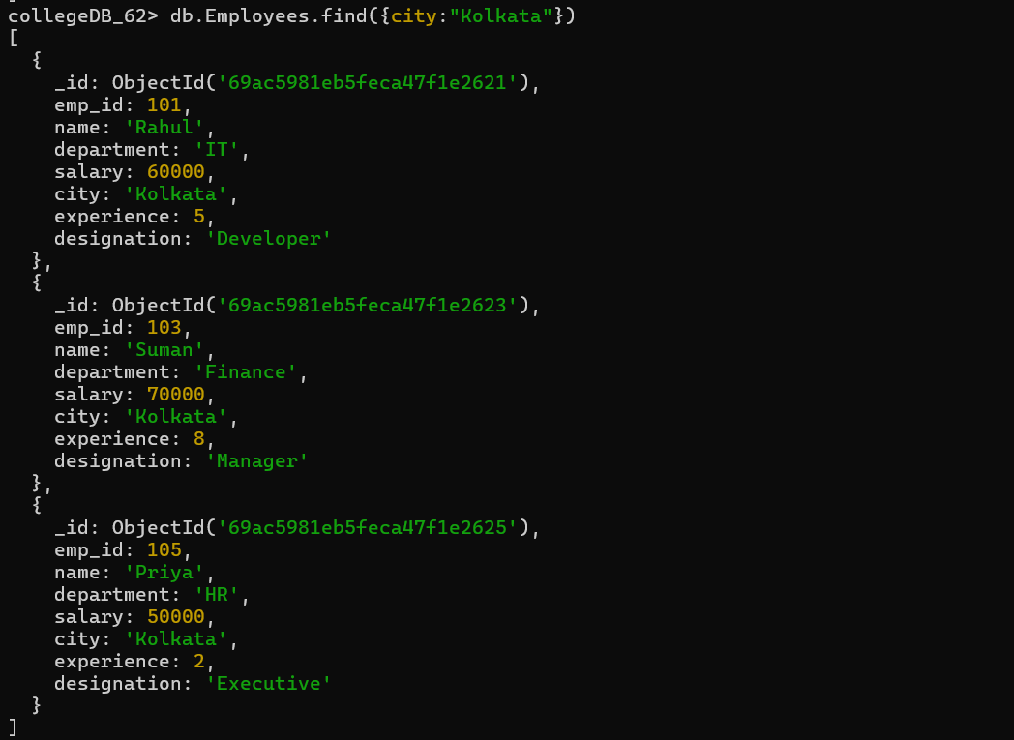

Q5. Sort employees by experience in ascending order.

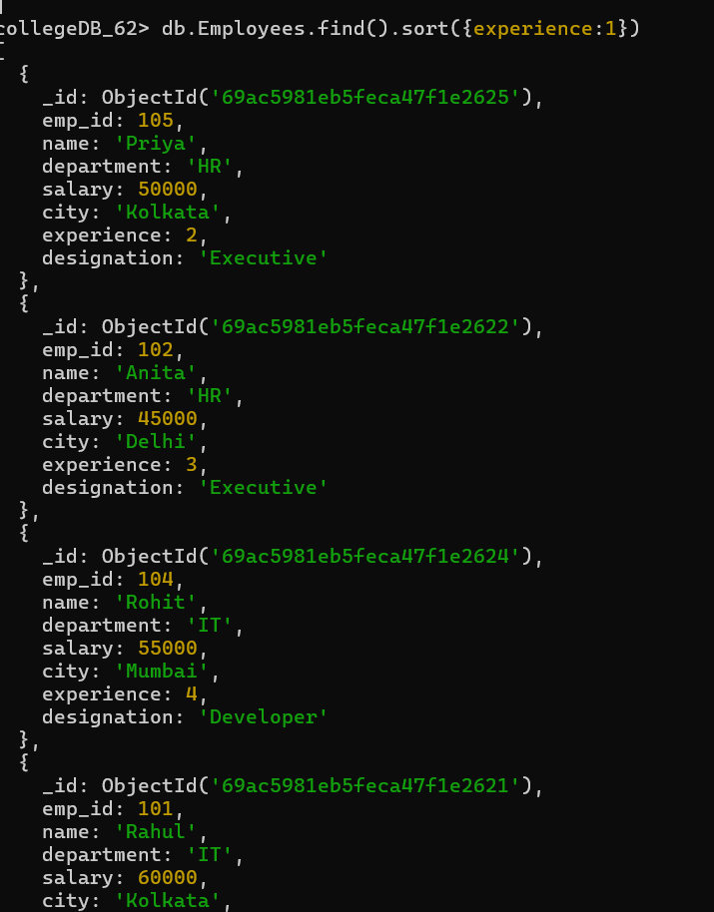
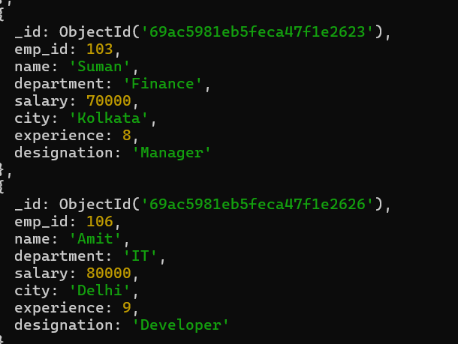

Q6. Display top 5 most experienced employees.

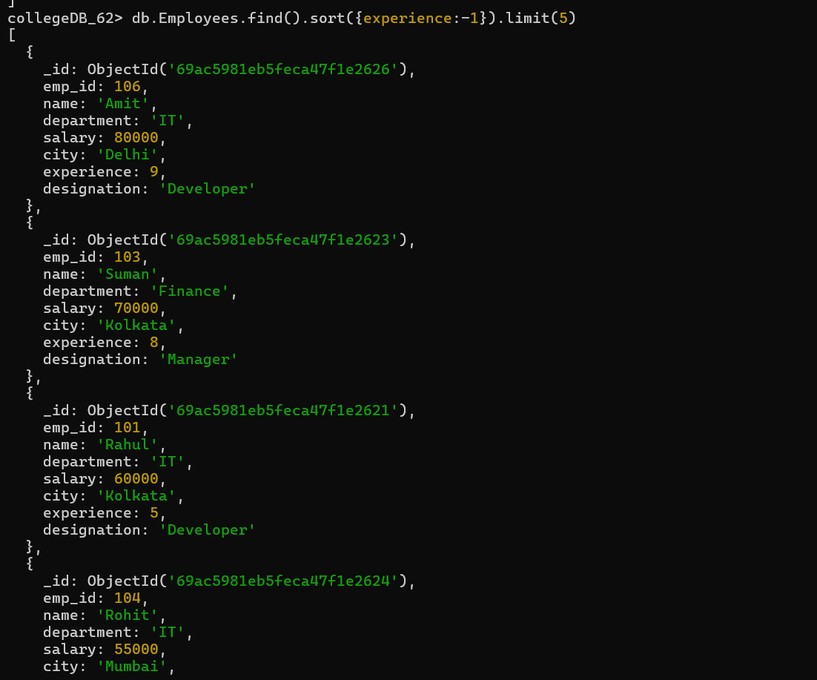
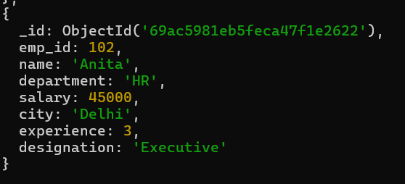

Q7. Update salary of employee with emp_id 102 to 48,000.
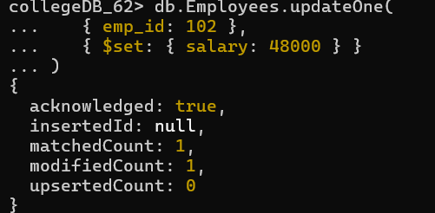
Q8. Increase salary of all it employees by 10,000.
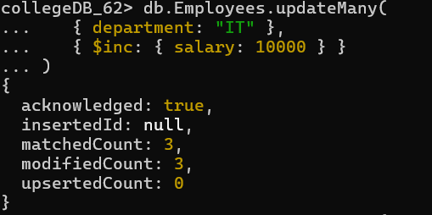
Q9. Update designation to ""senior developer"" for it employees having experience more than 5 years."
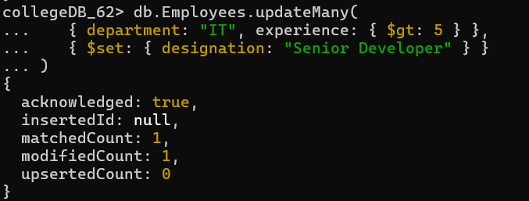
Q10. Delete employees whose experience is less than 2 years.
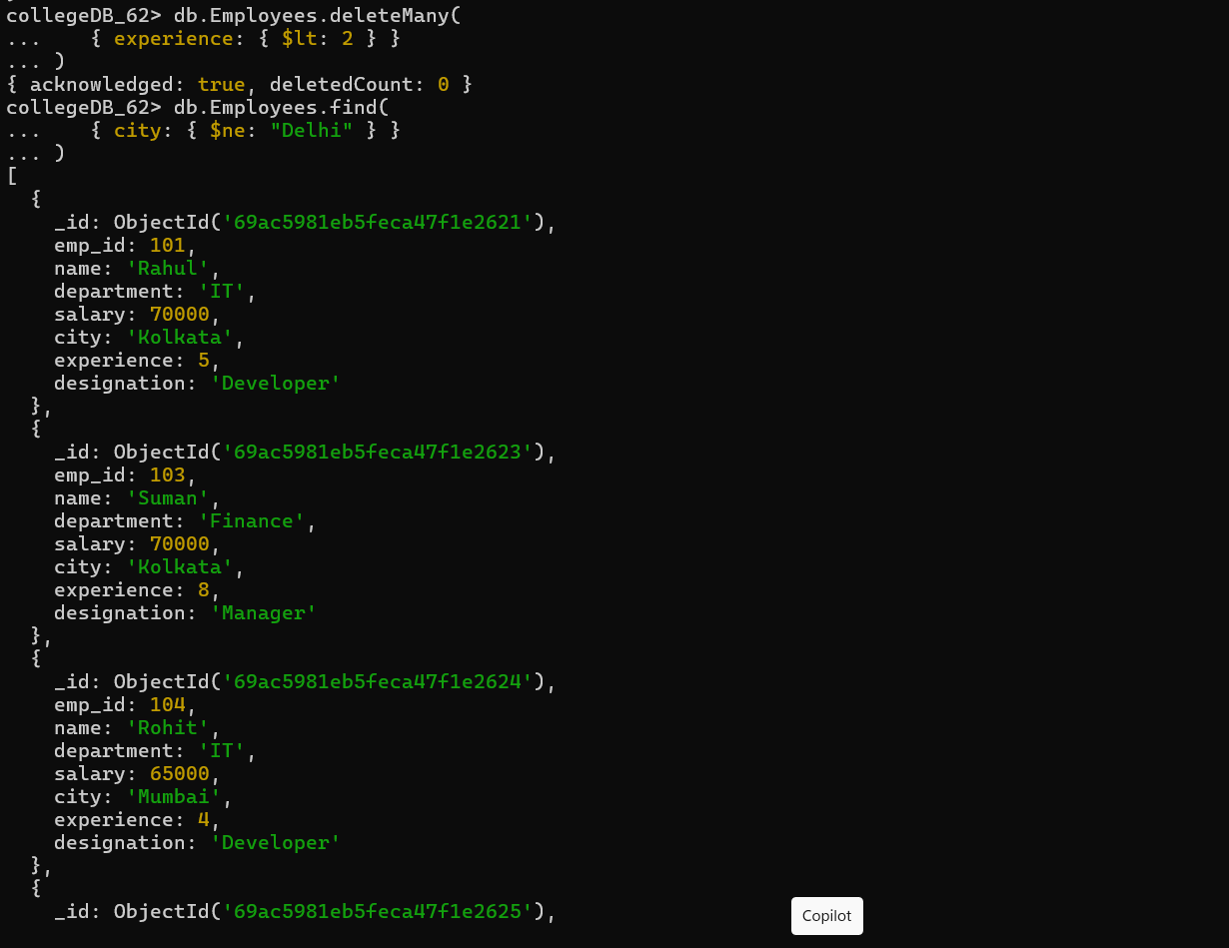
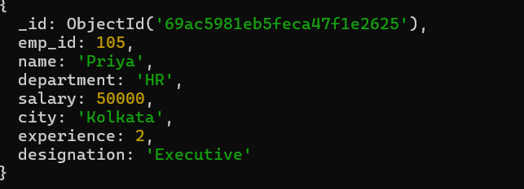

Q11. Display employees who are not from Delhi.
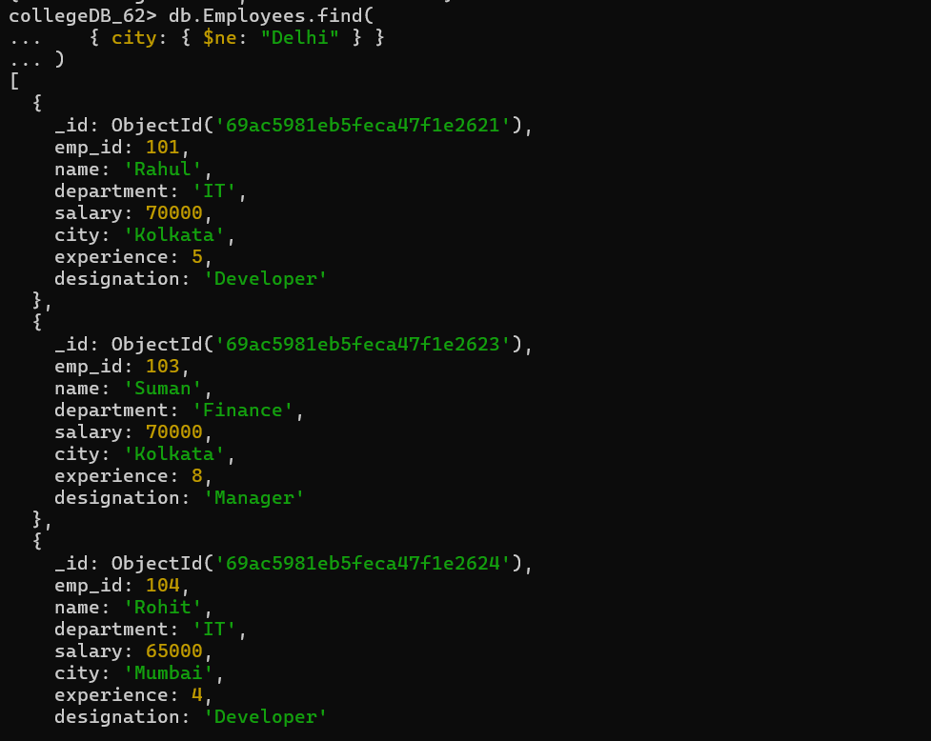
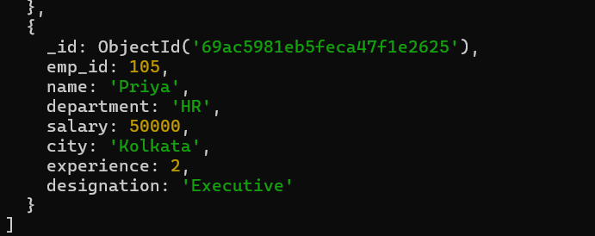
Q12. Find employees whose designation is developer and salary greater than 60,000.

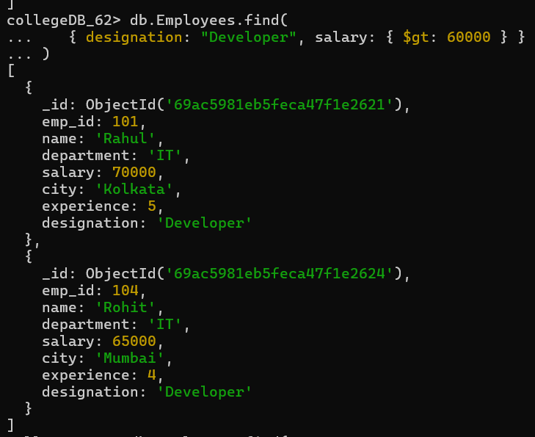

Q13. Display employees working in it or finance department.
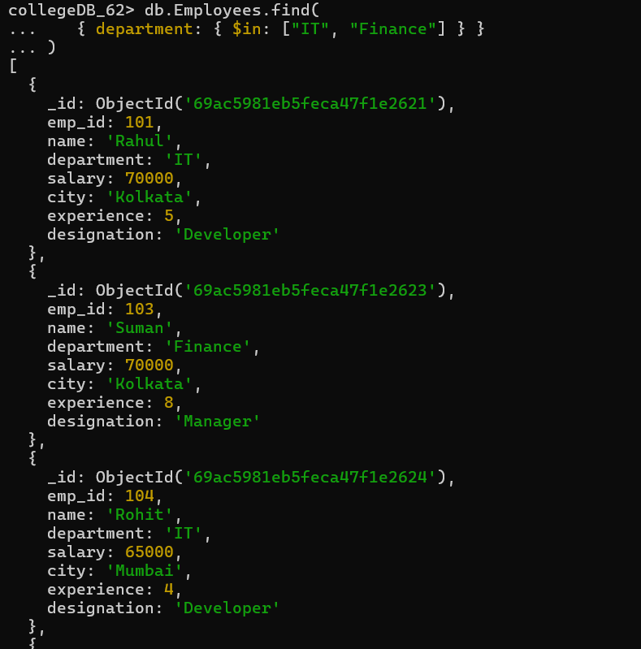

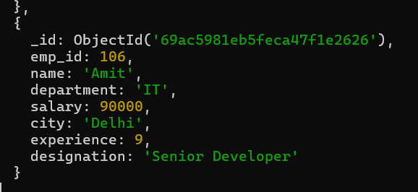

Q14. Display employees sorted by department and then by salary.

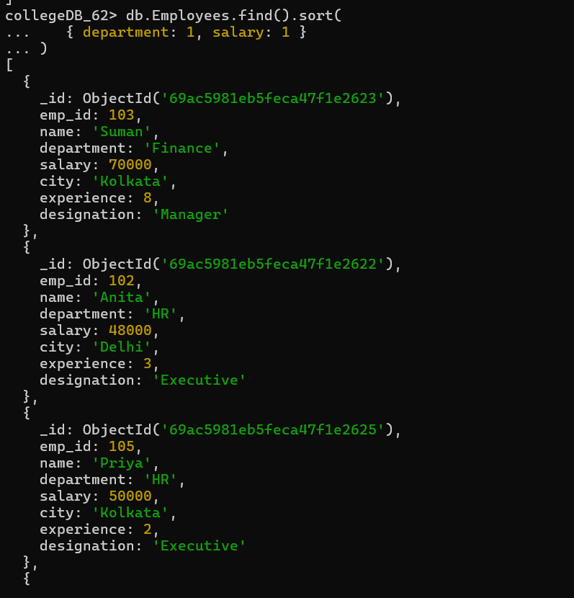
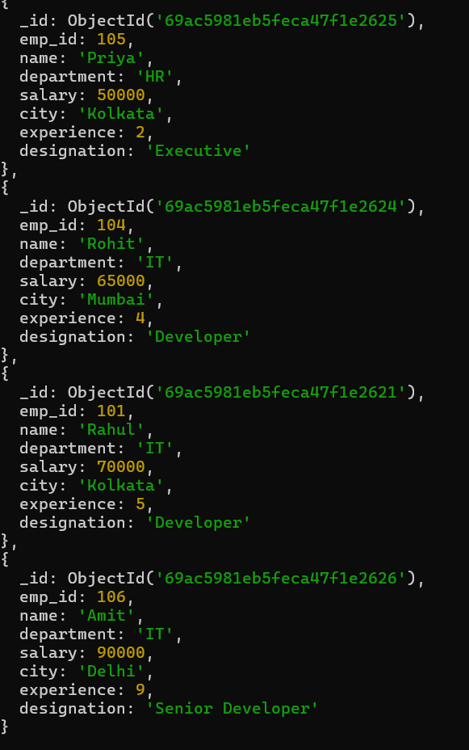

Q15. Count total number of employees in the company.
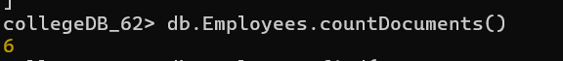
Q16. Display employees whose salary is not equal to 50,000.
