DS_05.R

anany

2024-06-15

#load necessary libraries  
library(dplyr)

## Warning: package 'dplyr' was built under R version 4.3.3

##   
## Attaching package: 'dplyr'

## The following objects are masked from 'package:stats':  
##   
## filter, lag

## The following objects are masked from 'package:base':  
##   
## intersect, setdiff, setequal, union

library(ggplot2)

## Warning: package 'ggplot2' was built under R version 4.3.3

library(lubridate)

## Warning: package 'lubridate' was built under R version 4.3.3

##   
## Attaching package: 'lubridate'

## The following objects are masked from 'package:base':  
##   
## date, intersect, setdiff, union

library(leaflet)

## Warning: package 'leaflet' was built under R version 4.3.3

library(sp)

## Warning: package 'sp' was built under R version 4.3.3

library(readr)

## Warning: package 'readr' was built under R version 4.3.3

#loading the dataset  
Road_accident <- read_csv("~/Road_accident.csv")

## Rows: 12316 Columns: 32

## ── Column specification ────────────────────────────────────────────────────────  
## Delimiter: ","  
## chr (27): Day_of_week, Age_band_of_driver, Sex_of_driver, Educational_level...  
## dbl (4): Driving_experience, Service_year_of_vehicle, Number_of_vehicles_i...  
## time (1): Time  
##   
## ℹ Use `spec()` to retrieve the full column specification for this data.  
## ℹ Specify the column types or set `show_col_types = FALSE` to quiet this message.

print(Road_accident)

## # A tibble: 12,316 × 32  
## Time Day_of_week Age_band_of_driver Sex_of_driver Educational_level   
## <time> <chr> <chr> <chr> <chr>   
## 1 17:02 Monday 18-30 Male Above high school   
## 2 17:02 Monday 31-50 Male Junior high school  
## 3 17:02 Monday 18-30 Male Junior high school  
## 4 01:06 Sunday 18-30 Male Junior high school  
## 5 01:06 Sunday 18-30 Male Junior high school  
## 6 14:15 Friday 31-50 Male Junior high school  
## 7 17:30 Wednesday 18-30 Male Junior high school  
## 8 17:20 Friday 18-30 Male Junior high school  
## 9 17:20 Friday 18-30 Male Junior high school  
## 10 17:20 Friday 18-30 Male Junior high school  
## # ℹ 12,306 more rows  
## # ℹ 27 more variables: Vehicle_driver_relation <chr>, Driving_experience <dbl>,  
## # Type_of_vehicle <chr>, Owner_of_vehicle <chr>,  
## # Service_year_of_vehicle <dbl>, Defect_of_vehicle <chr>,  
## # Area_accident_occured <chr>, Lanes_or_Medians <chr>, Road_allignment <chr>,  
## # Types_of_Junction <chr>, Road_surface_type <chr>,  
## # Road_surface_conditions <chr>, Light_conditions <chr>, …

#checking for missing values   
Road_accident<-na.omit(Road_accident)  
  
#converting time column to appropriate data type  
Road_accident$Time<-hms::as_hms(Road_accident$Time)  
  
#summary statistics for the dataset  
summary(Road_accident)

## Time Day_of_week Age_band_of_driver Sex_of_driver   
## Length:103 Length:103 Length:103 Length:103   
## Class1:hms Class :character Class :character Class :character   
## Class2:difftime Mode :character Mode :character Mode :character   
## Mode :numeric   
##   
##   
## Educational_level Vehicle_driver_relation Driving_experience  
## Length:103 Length:103 Min. : 0.000   
## Class :character Class :character 1st Qu.: 1.000   
## Mode :character Mode :character Median : 4.000   
## Mean : 4.971   
## 3rd Qu.: 8.000   
## Max. :16.000   
## Type_of_vehicle Owner_of_vehicle Service_year_of_vehicle  
## Length:103 Length:103 Min. :1.000   
## Class :character Class :character 1st Qu.:3.000   
## Mode :character Mode :character Median :4.000   
## Mean :4.757   
## 3rd Qu.:6.500   
## Max. :9.000   
## Defect_of_vehicle Area_accident_occured Lanes_or_Medians Road_allignment   
## Length:103 Length:103 Length:103 Length:103   
## Class :character Class :character Class :character Class :character   
## Mode :character Mode :character Mode :character Mode :character   
##   
##   
##   
## Types_of_Junction Road_surface_type Road_surface_conditions  
## Length:103 Length:103 Length:103   
## Class :character Class :character Class :character   
## Mode :character Mode :character Mode :character   
##   
##   
##   
## Light_conditions Weather_conditions Type_of_collision   
## Length:103 Length:103 Length:103   
## Class :character Class :character Class :character   
## Mode :character Mode :character Mode :character   
##   
##   
##   
## Number_of_vehicles_involved Number_of_casualties Vehicle_movement   
## Min. :1.000 Min. :1.000 Length:103   
## 1st Qu.:2.000 1st Qu.:1.000 Class :character   
## Median :2.000 Median :1.000 Mode :character   
## Mean :1.883 Mean :1.534   
## 3rd Qu.:2.000 3rd Qu.:2.000   
## Max. :3.000 Max. :4.000   
## Casualty_class Sex_of_casualty Age_band_of_casualty Casualty_severity   
## Length:103 Length:103 Length:103 Length:103   
## Class :character Class :character Class :character Class :character   
## Mode :character Mode :character Mode :character Mode :character   
##   
##   
##   
## Work_of_casuality Fitness_of_casuality Pedestrian_movement Cause_of_accident   
## Length:103 Length:103 Length:103 Length:103   
## Class :character Class :character Class :character Class :character   
## Mode :character Mode :character Mode :character Mode :character   
##   
##   
##   
## Accident_severity   
## Length:103   
## Class :character   
## Mode :character   
##   
##   
##

#extracting hours from the time column  
Road_accident$Hour<-hour(Road_accident$Time)  
  
#ploting the number of accidents by hour  
ggplot(Road_accident,aes(x=Hour))+geom_histogram(binwidth = 1,fill="skyblue",color="red")+labs(title = "Number of accidents by hour of the day",x="Hour of the Day",y="Number of Accidents")

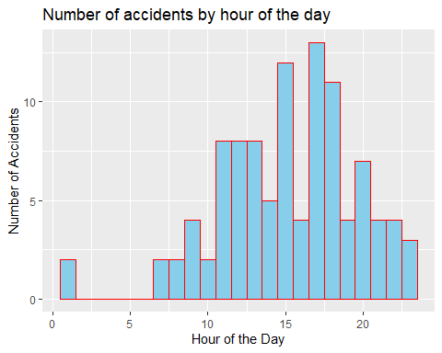

#accidents by weather condition  
ggplot(Road_accident,aes(x=Weather_conditions))+geom_bar(fill="lightgreen",color="black")+labs(title = "Number of Accidents by weather conditions",x="weather condition",y="number of accidents")

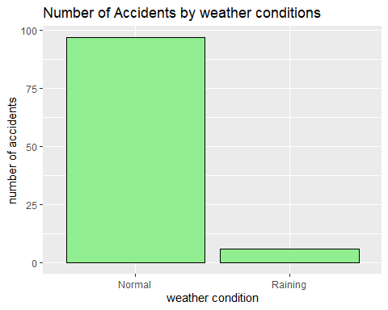

#accidents by road condition  
ggplot(Road_accident,aes(x=Road_surface_type))+geom_bar(fill="lightcoral",color="black")+labs(title = "Number of Accidents by Road Condition",x="Road Condition",y="Number of Accidents")

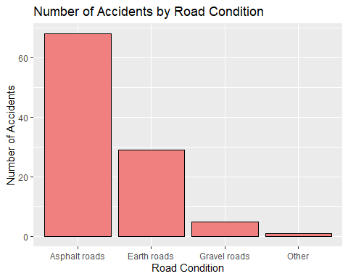

# Example columns: Latitude and Longitude  
if ("Latitude" %in% colnames(Road_accident) & "Longitude" %in% colnames(Road_accident)) {  
 leaflet(data = Road_accident) %>%  
 addTiles() %>%  
 addCircleMarkers(~Longitude, ~Latitude, radius = 3, color = ~Severity,  
 popup = ~paste("Date:", Date, "<br>", "Time:", Time, "<br>", "Severity:", Severity),  
 clusterOptions = markerClusterOptions()) %>%  
 addLegend("bottomright", pal = colorFactor(c("blue", "orange", "red"), domain = Road_accident$Severity),  
 values = ~Severity, title = "Severity")  
} else {  
 print("Latitude and Longitude columns are not available in the dataset.")  
}

## [1] "Latitude and Longitude columns are not available in the dataset."

# Analyze the impact of weather, road condition, and time of day on accident severity  
ggplot(Road_accident, aes(x=Weather_conditions, fill=Casualty_severity)) +  
 geom_bar(position="fill") +  
 labs(title="Accident Severity by Weather Condition", x="Weather Condition", y="Proportion")

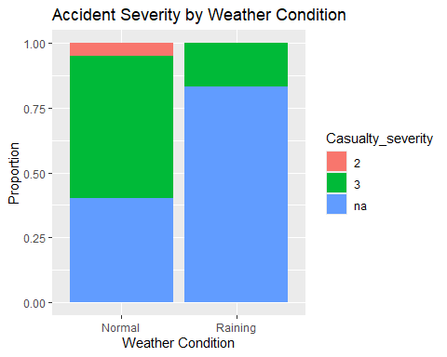

ggplot(Road_accident, aes(x=Road_surface_type, fill=Casualty_severity)) +  
 geom_bar(position="fill") +  
 labs(title="Accident Severity by Road Condition", x="Road Condition", y="Proportion")

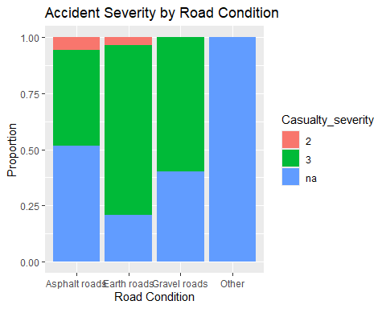

ggplot(Road_accident, aes(x=Hour, fill=Casualty_severity)) +  
 geom_histogram(binwidth=1, position="fill") +  
 labs(title="Accident Severity by Hour of the Day", x="Hour of the Day", y="Proportion")

## Warning: Removed 15 rows containing missing values or values outside the scale range  
## (`geom_bar()`).

