**Create New Chat Bot**

1. Open the **Amazon Lex Console** in **N.Virginia** Region at [https://console.aws.amazon.com/lex/home?region=us-east-1#](https://console.aws.amazon.com/lex/home?region=us-east-1)
2. On the Bots page, choose Create

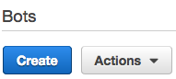

1. Create a ‘Custom bot’.

Name the Bot as **BookAppointment**

Complete other fields as specificed in the picture below and choose **Create**.

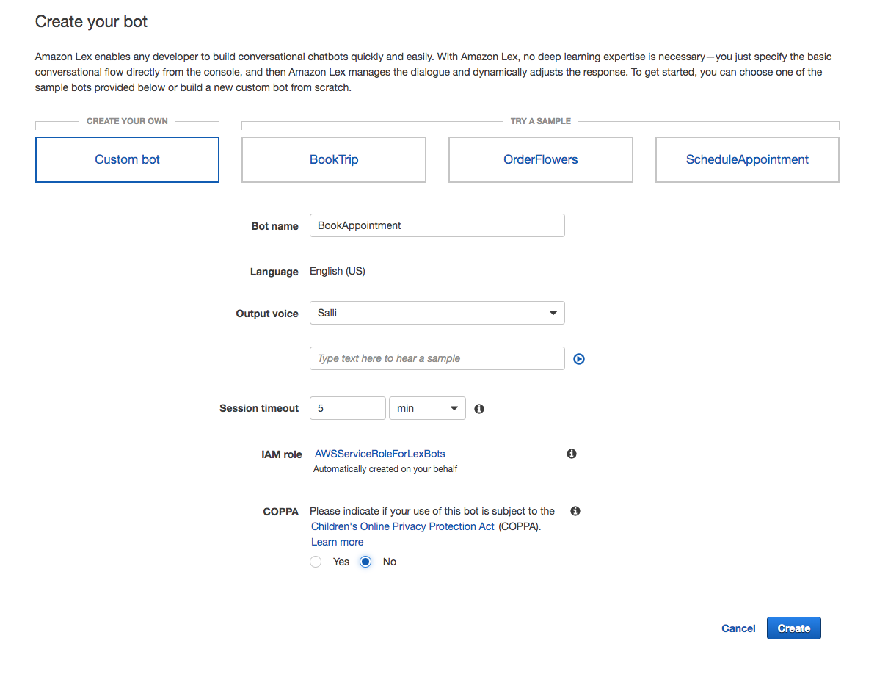

**Create BookAppointment Intent -** Action user wants to perform

1. Choose Create Intent. Name the intent as **BookAppointment**

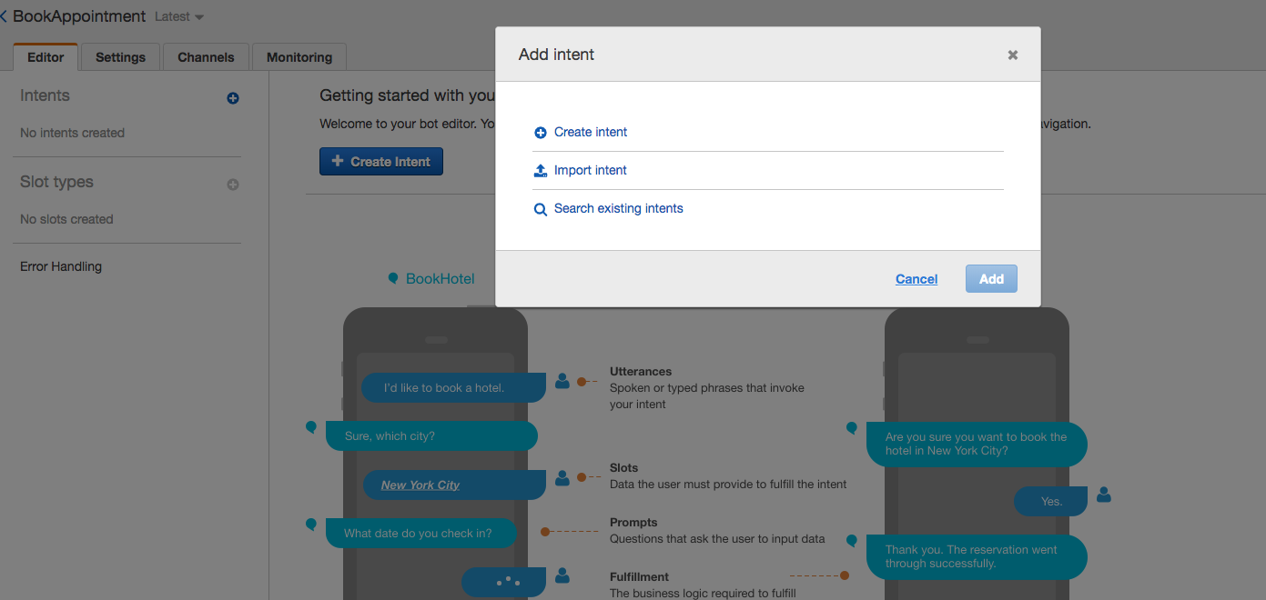

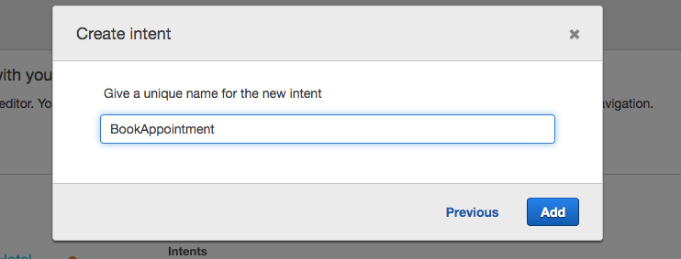

1. Create Utterances - Spoken or typed phrases that will invoke our intent

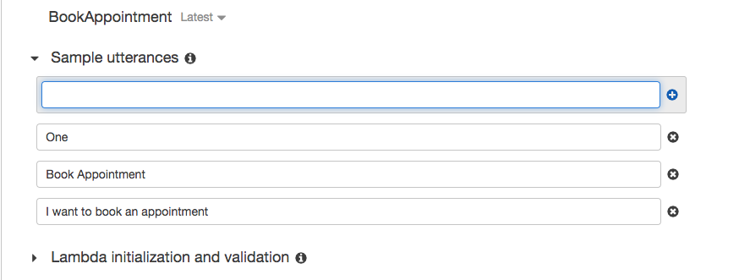

1. Set initialization and validation function

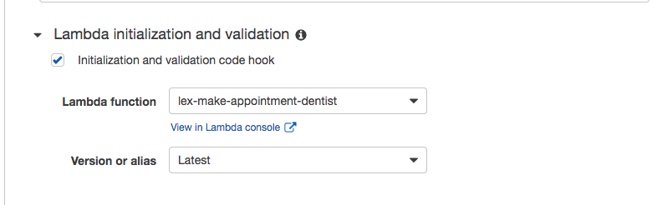

1. Create a Slot type

In the Add slot type dialog box, add the following:

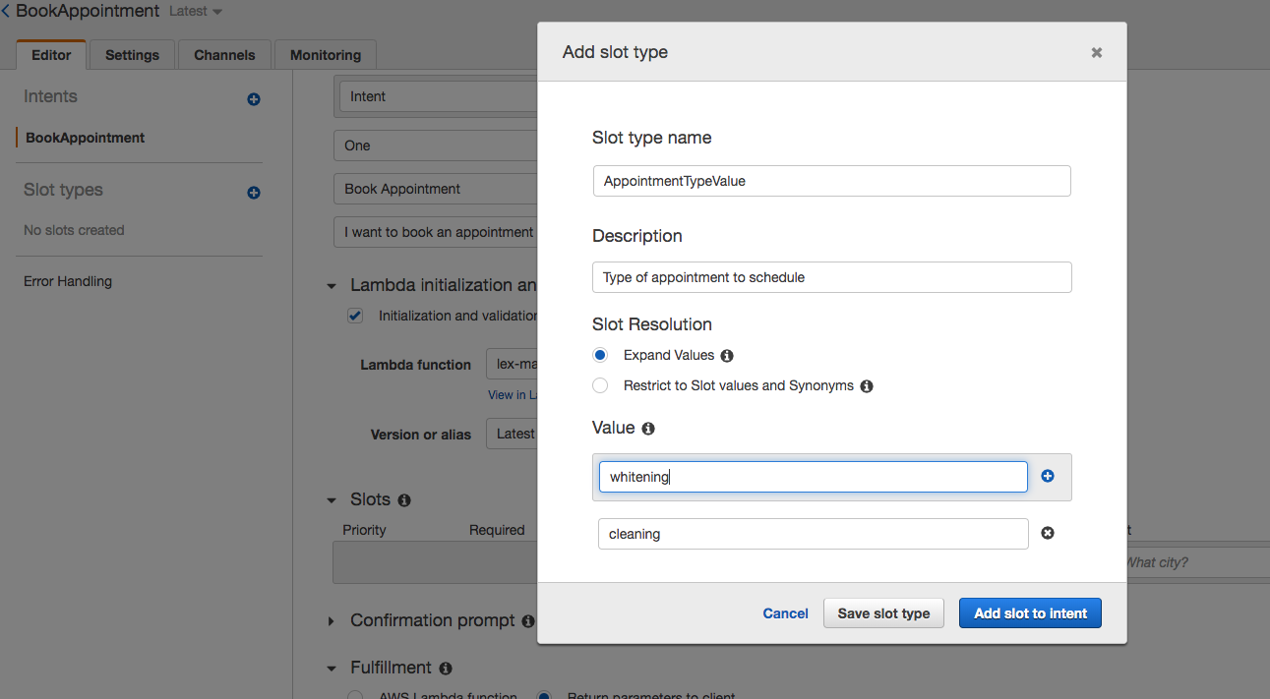

Choose Add slot to intent

1. Adding Slots - Parameters required to fulfil the intent.

Configure the slots as follows:

|  |  |  |  |  |
| --- | --- | --- | --- | --- |
| Priority | Required | Name | Slot type | Prompt |
| 1 | Y | AppointmentType | AppointmentTypeValue | What type of appointment would you like to schedule? |
| 2 | Y | Date | AMAZON.DATE | When should I schedule your appointment? |
| 3 | Y | Time | AMAZON.TIME | When should I schedule your appointment? |

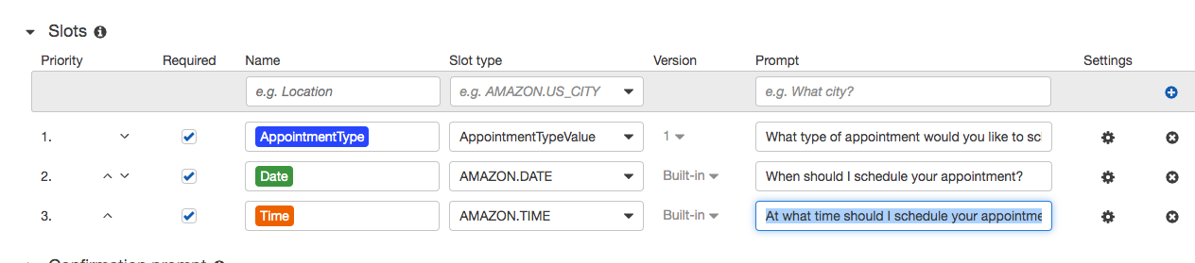

1. Set Fulfillment function

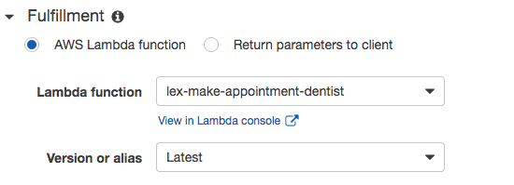

**Create CheckAppointment Intent**

Action user wants to perform

1. Choose to Add Intents. Name intent as **CheckAppointment**



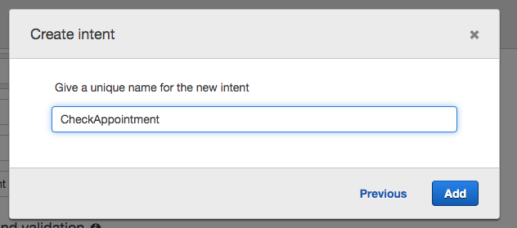

1. Create Utterances - Spoken or typed phrases that will invoke our intent

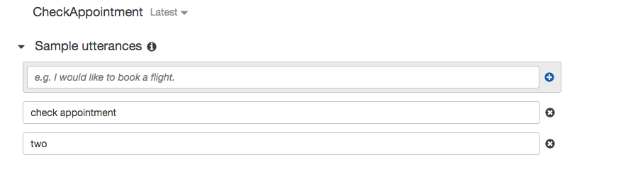

1. Set Fulfillment function



**Build and Publish Bot**

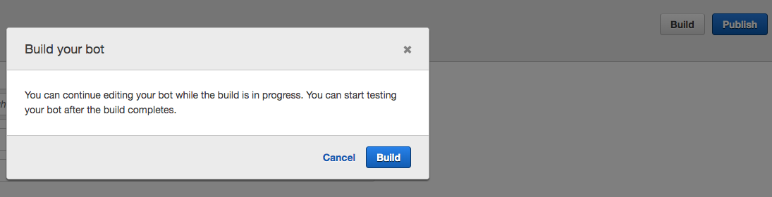

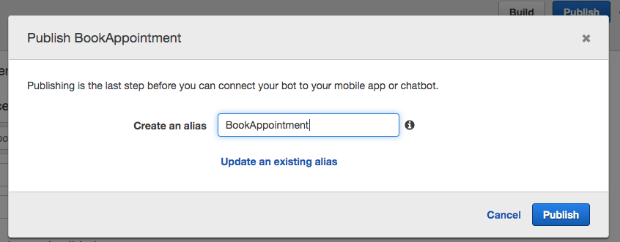

Build and Publish the Bot. Choose Alias as BookAppointment.

**Create Amazon Connect Instance**

1. Open the **Amazon Connect Console** in **Sydney** Region at

<https://ap-southeast-2.console.aws.amazon.com/connect/home?region=ap-southeast-2#>

1. Choose Add an Instance and configure instance as follows:

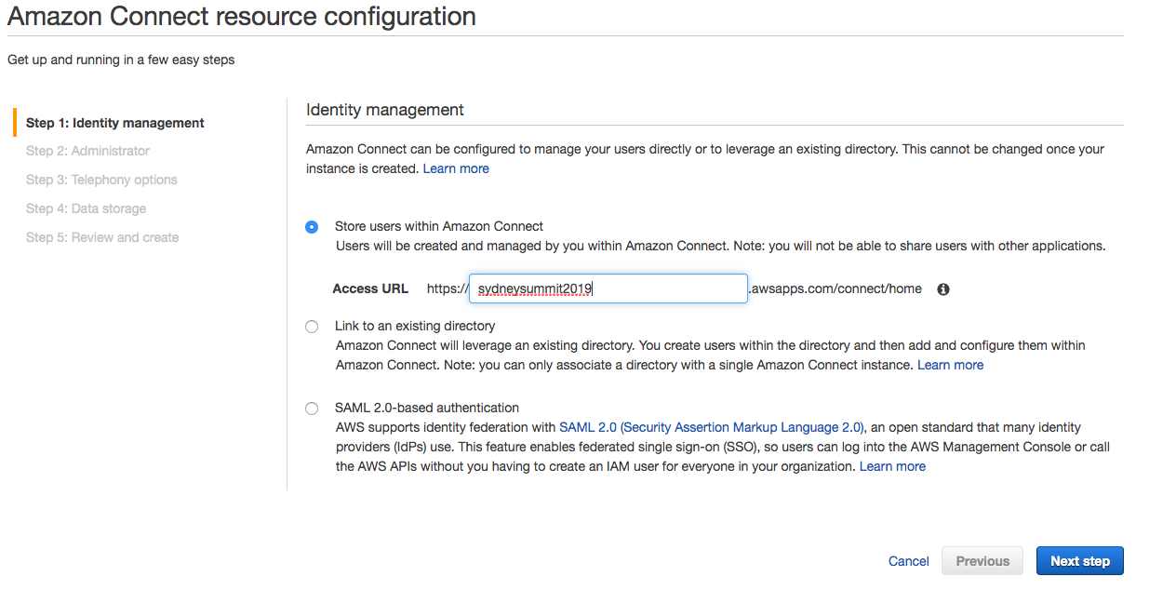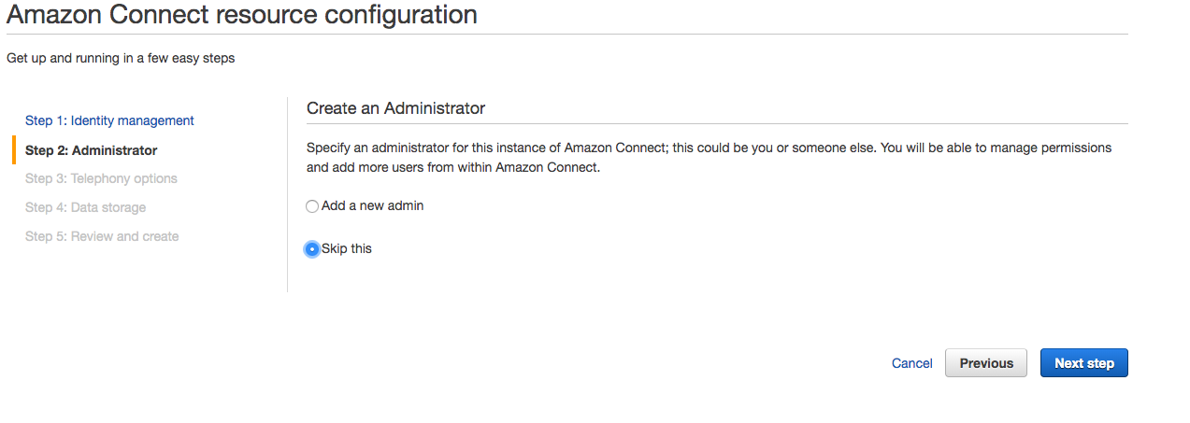

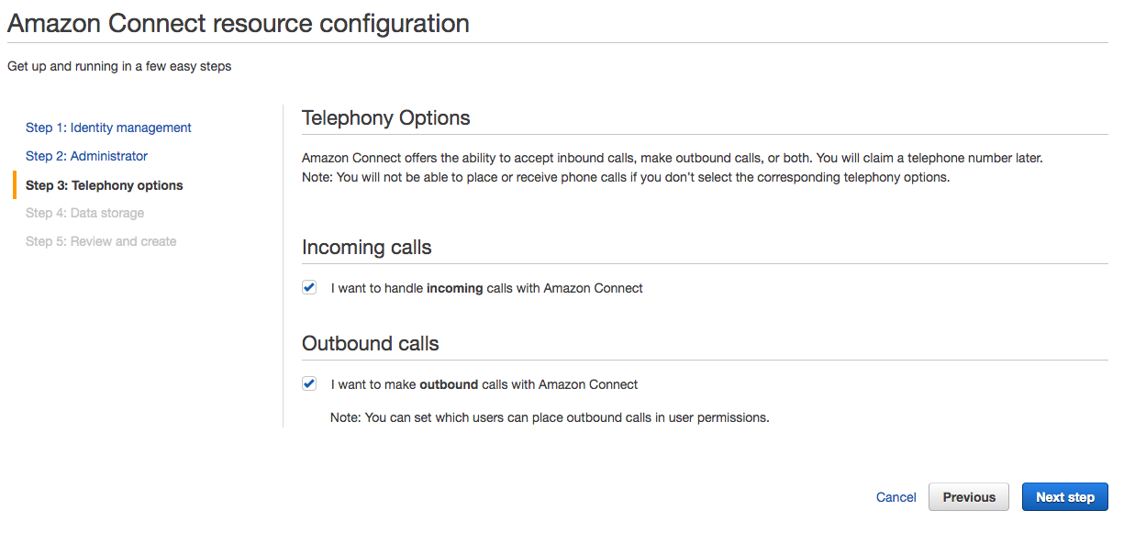

Leave Step 4 and 5 as default and choose Create Instance

**Add the Amazon Lex bot to Amazon Connect Instance**

1. Navigate to [Amazon Connect Console](https://ap-southeast-2.console.aws.amazon.com/connect/home?region=ap-southeast-2)
2. Select the Instance Alias **sydneysummit2019**
3. Choose **Contact Flows**. Under Amazon Lex, choose **+Add Lex Bot**
4. Select the **BookAppointment** bot and choose **Save Lex Bots**.

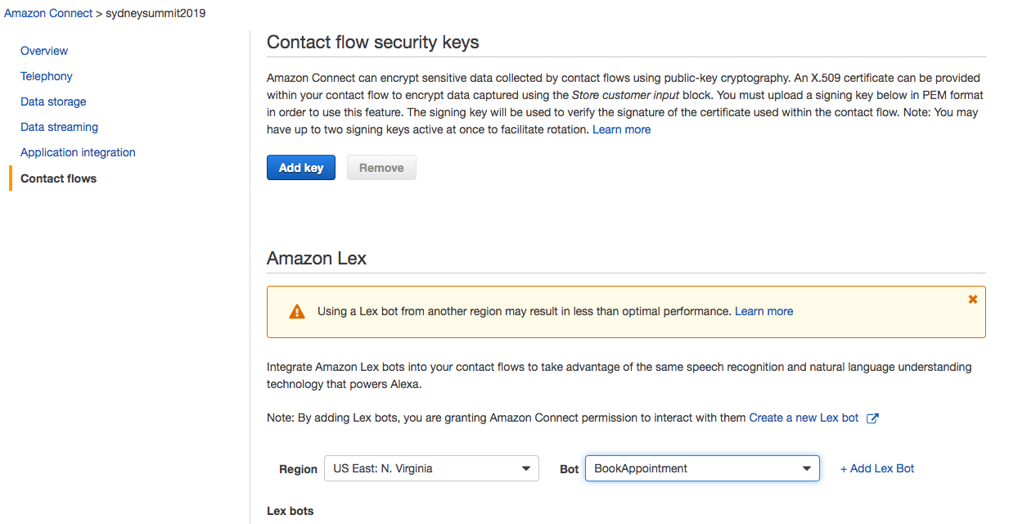

**Create a contact flow and add your Amazon Lex bot**

1. Log in to your Amazon Connect instance

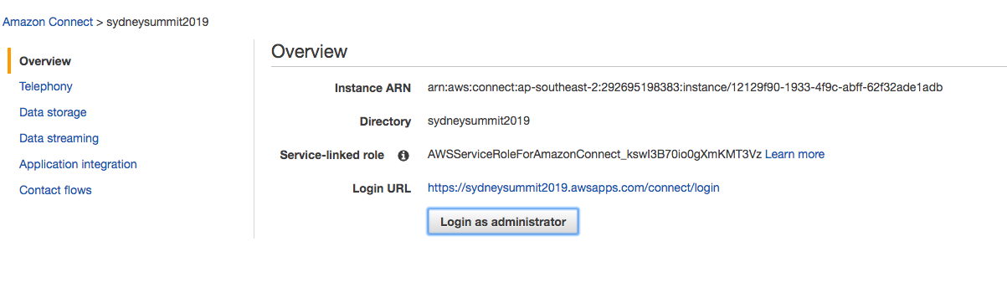

1. Choose **Routing → Contact flows → Create contact flow**, and type a name.

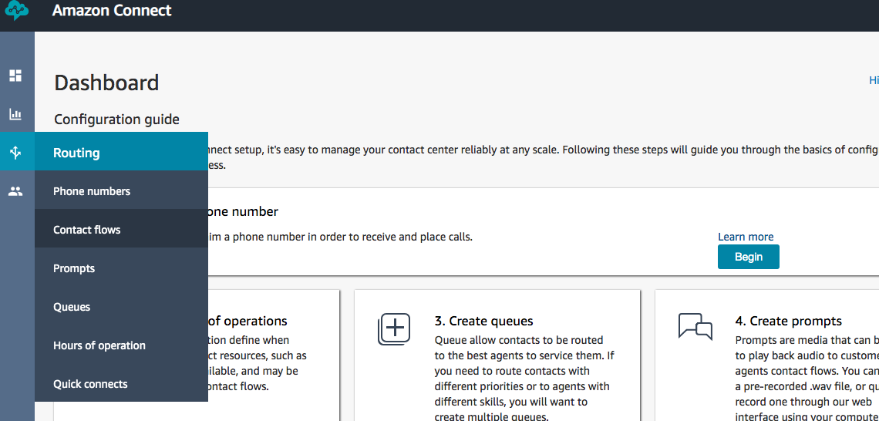

1. Under **Interact**, drag a **Get customer input** block onto the designer, and connect it to the Entry point block.
2. Open the Get customer input block, and choose **Text to speech (Ad hoc)**, Enter text.
3. Type a message that provides callers with information about what they can do. For example, use a message that matches the intents used in the bot, such as “**To make an appointment, press or say 1. To check an appointment, press or say 2**”
4. Select Amazon Lex, for name, use **BookAppointment**. For alias, use **BookAppointment**
5. Choose **Add an attribute → Use attribute**. For type, choose **System**. For Attribute, choose **Customer Number**. For Destination Key, set it as **ContactNumber**. The settings should look like this
6. To specify the intents, choose Add an intent. Add **BookAppointment** and **CheckAppointment**.
7. The settings should look like the followings:

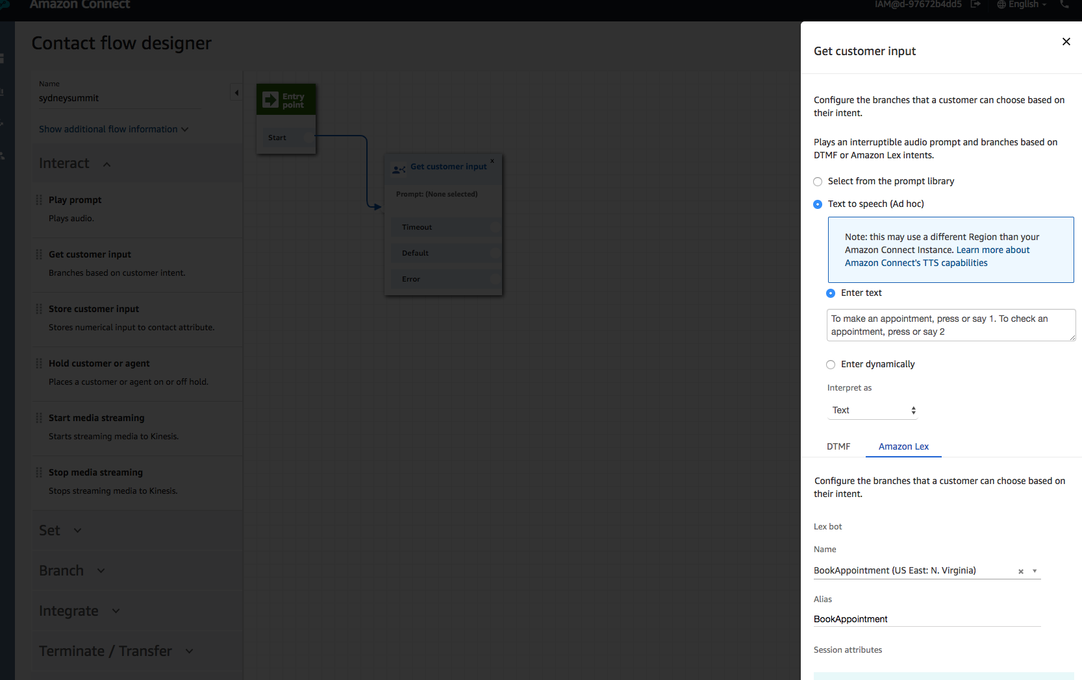

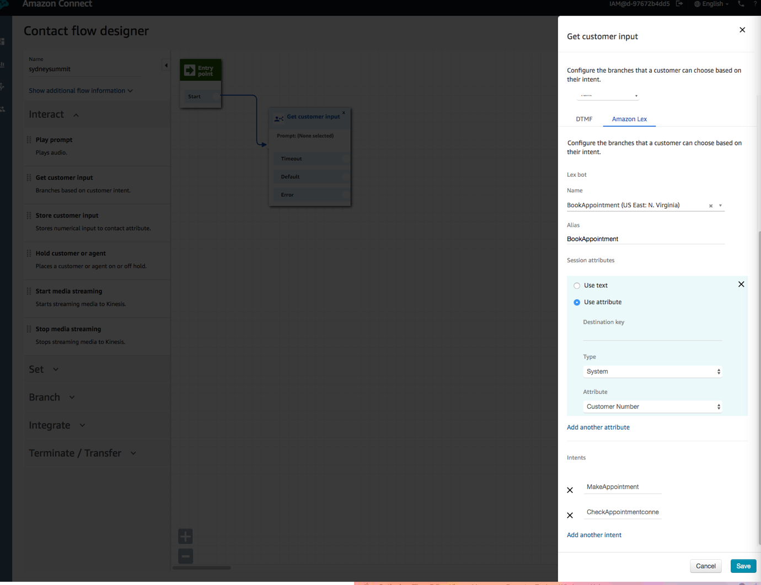

1. Under **Interact**, drag a **Play prompt** block onto the designer, and connect it to the Default and Error from the **Get customer input** block.
2. Open the **Play prompt** block and **Text to speech (Ad hoc)**, Enter text. Type “**All of our agents are busy at the moment. Please call again**”. Save the block.
3. Under **Terminate/Transfer,** drag **Disconnect / hang up,** connect it to the **Play Prompt** block and the **BookAppointment** and **CheckAppointment** intents.

The contact flow should look like the followings:

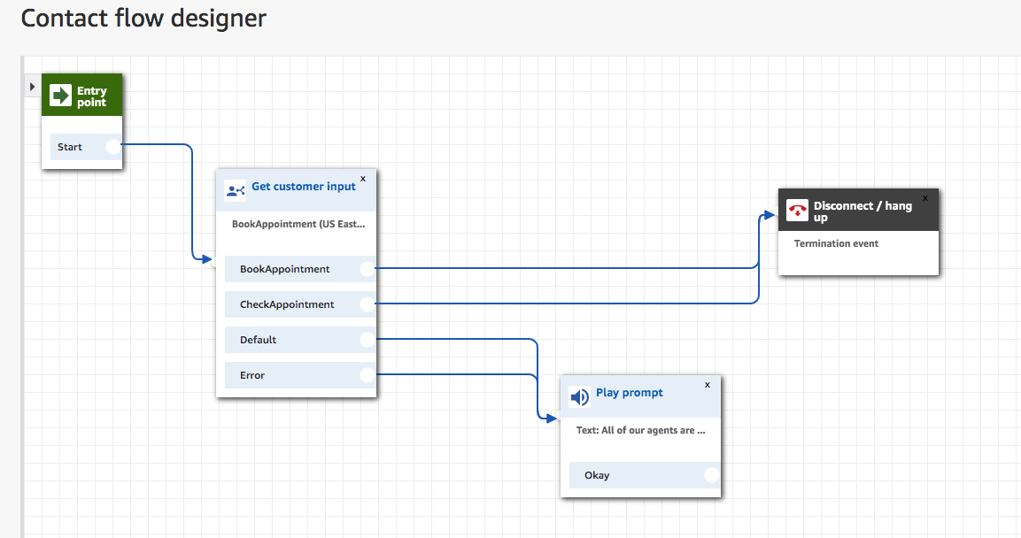

1. **Save and publish** the contact flow.

**Assign the contact flow to a phone number**

1. Open the Amazon Connect Dashboard.
2. Choose **View phone numbers**.

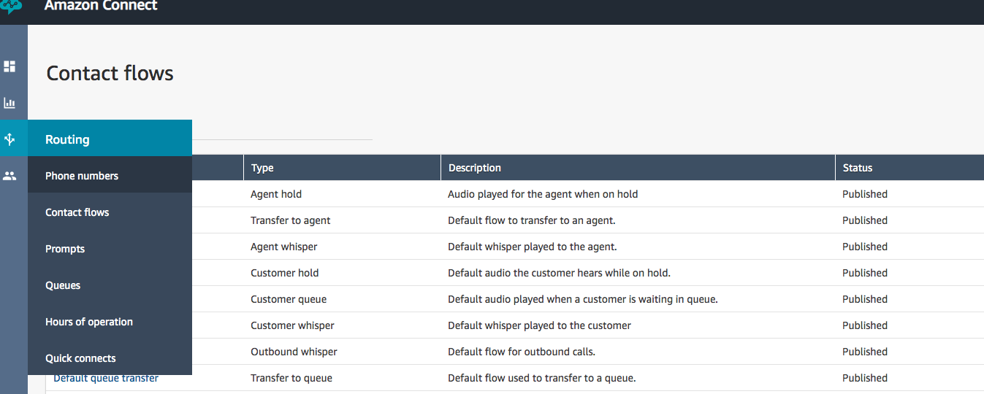

1. **Claim a number,** select **Toll free**. Choose country as **Australia** and any number available
2. In the **Contact flow/IVR** menu, choose the contact flow that you just created.

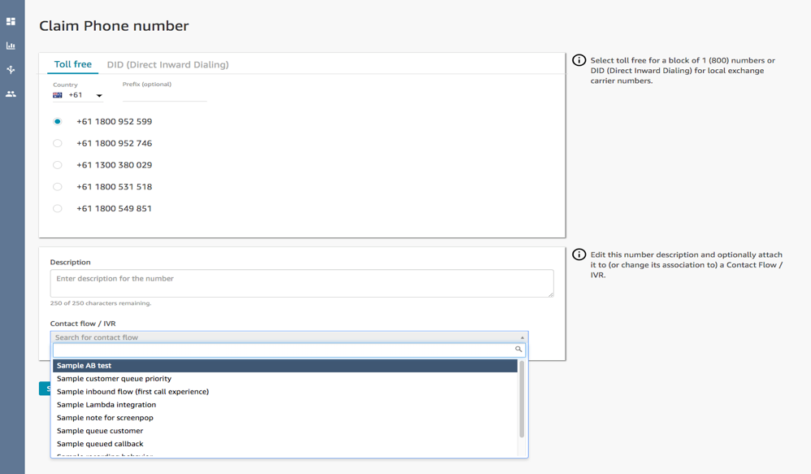

1. Choose **Save**.

**Try it**

Dial the number you claimed above, and follow the prompts.