Original Final

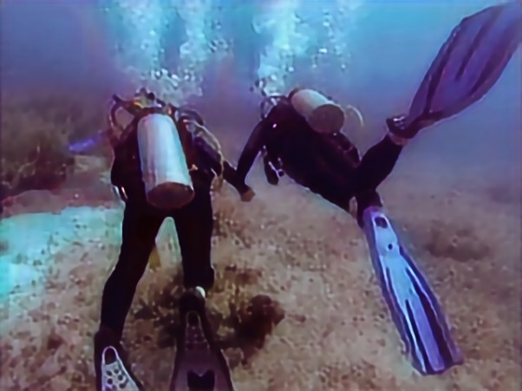 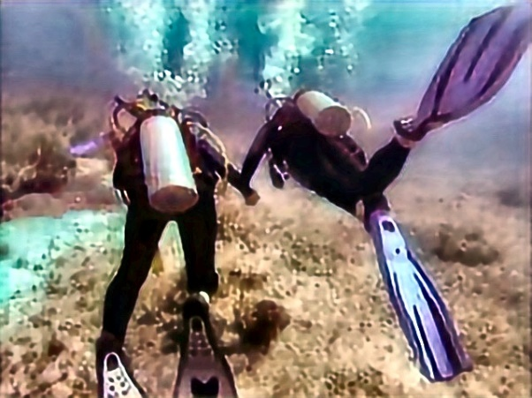

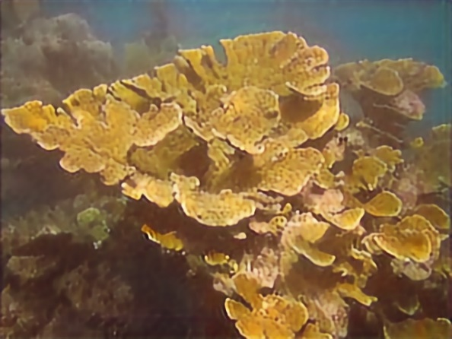 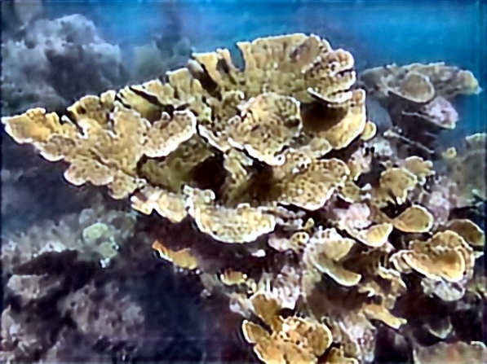

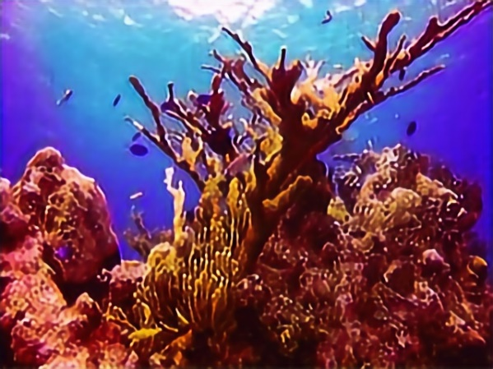 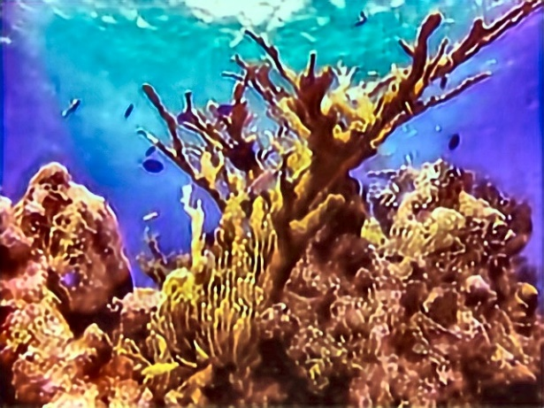

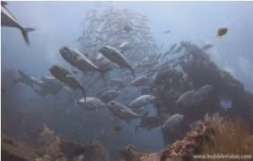 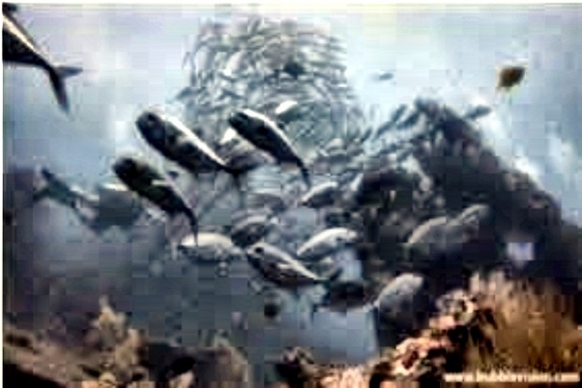

Filters and effects used:

1)Used a custom white balance filter (saw some videos about how it helps to balance the color channels and used some GPT for some tweaks to the deviation value)

2)CLAHE:popular method for increasing contrast in low lighting areas

3)Gamma correction: Again increasing more lighting in low lit area

4) Blue balance: Usually used in underwater enchancing due to blue being a dominant colour(balances the extra blue-ness)