**RESULTS**

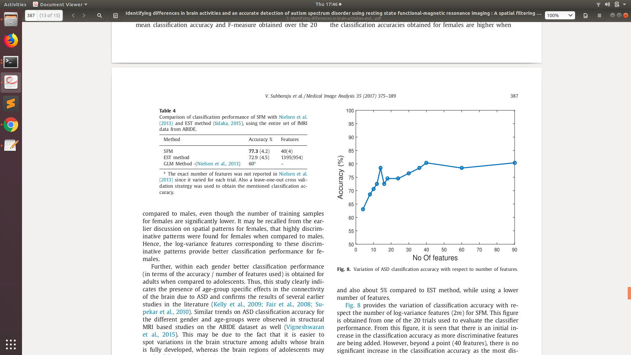

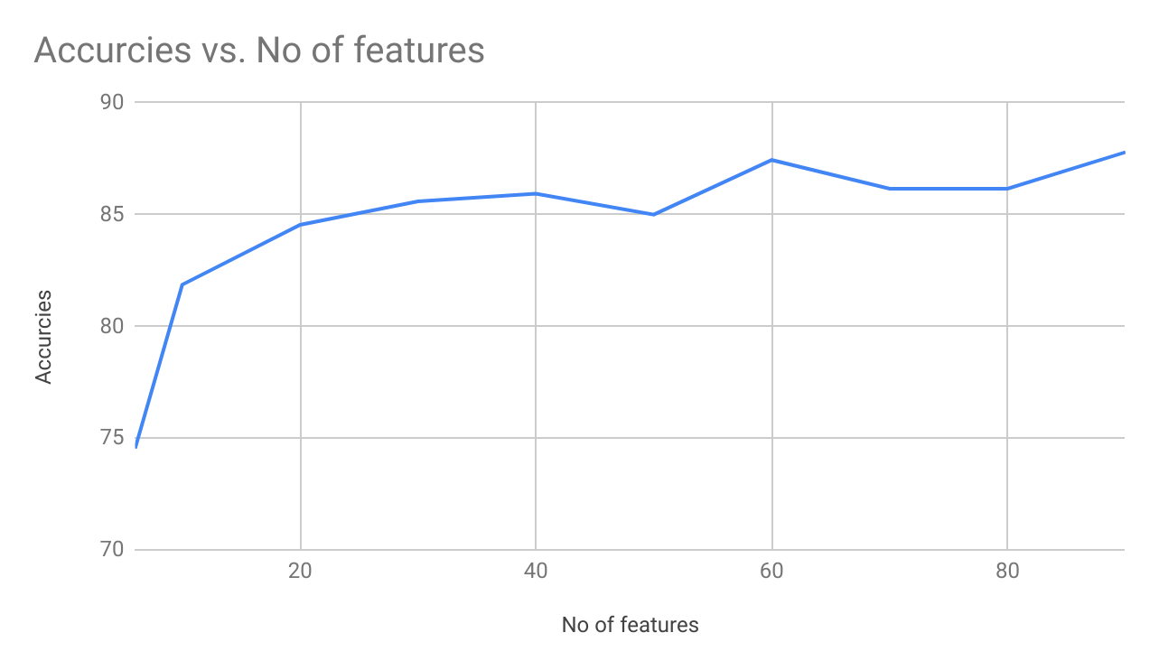

| No of features | Accurcies |
| --- | --- |
| 6 | 74.53 |
| 10 | 81.86 |
| 20 | 84.54 |
| 30 | 85.59 |
| 40 | 85.93 |
| 50 | 85 |
| 60 | 87.44 |
| 70 | 86.16 |
| 80 | 86.16 |
| 90 | 87.79 |