

**UNIVERSITY OF PETROLEUM & ENERGY STUDIES**

**Cloud Project Implementation Report**

**Programme:** B. Tech in Computer Science and Engineering with

Specialization in DevOps

**Course:** Cloud Computing Fundamentals

**Semester:** V

**Session:**  Aug-Dec 2022

**Batch:**  2020-2024

**Faculty:** Mr. Saurabh Shanu

**Submitted By:**

|  |  |  |
| --- | --- | --- |
| **Name** | **SAPID** | **ROLL NO** |
| Ananya Dutta | **500083514** | **R214220145** |



**Cybernetics Cluster**

**School of Computer Science**

**University of Petroleum and Energy Studies**

**Dehradun-248007**

**TOPIC: Deploying “4-In-A-Row” game using AWS Services**

**TOOLS AND LANGUAGES USED:**

* AWS Services: Amazon S3 Bucket
* HTML
* CSS
* JavaScript

**ALGORITHM:**

* **For deployment**
* Write working code for .html, .css and .js files using Visual Studio Code
* Login to your AWS account
* Search and select S3 from the list of Services
* Create a new Amazon S3 bucket, specifying a name and region
* Enable public access and acknowledge the current settings
* In the ‘Properties’ configure ‘Static Website Hosting’, enable it and specify the ‘index document’.
* From your local computer upload all files to your S3 Bucket using drag and drop
* In Properties enable ACLs under ‘Object Ownership’.
* Make all the uploaded files ‘public using ACL’.
* In Properties tab scroll down to look for ‘Static Website Hosting’ find a link -ending with ‘amazonaws.com’.
* Using this link access, the deployed project from anywhere across the region specified.
* **For code**

Note: - Only two players can play this game.

* Create 7 Columns and 6 Rows for input fields
* Take any two colors, eg:-(Red – player1, Yellow – player2)
* If 4 fields in a column is filled with the same color continuously then

Pop out the window with message “Color wins”

* If 4 fields in a row is filled with the same color continuously then

Pop out the window with the message “Color wins”

* If 4 fields in a diagonal is filled with the same color continuously then  
  pop out the window with message “Color Wins”
* Else give alternate chances to give the input till all rows and columns aren’t filled with any color

**CODE:**

HTML File:

<!DOCTYPE html>

<html lang="en">

<head>

    <meta charset="UTF-8">

    <meta http-equiv="X-UA-Compatible" content="IE=edge">

    <meta name="viewport" content="width=device-width, initial-scale=1.0">

    <title>Document</title>

    <link rel="stylesheet" href="connect4.css">

</head>

<body>

    <h1>CONNECT-4</h1>

    <h2 id="whosturn">Red's Turn</h2>

    <div class="board">

        <ul class="column" id="c1">

            <p id="c1r6"></p>

            <p id="c1r5"></p>

            <p id="c1r4"></p>

            <p id="c1r3"></p>

            <p id="c1r2"></p>

            <p id="c1r1"></p>

        </ul>

        <ul class="column" id="c2">

            <p id="c2r6"></p>

            <p id="c2r5"></p>

            <p id="c2r4"></p>

            <p id="c2r3"></p>

            <p id="c2r2"></p>

            <p id="c2r1"></p>

        </ul>

        <ul class="column" id="c3">

            <p id="c3r6"></p>

            <p id="c3r5"></p>

            <p id="c3r4"></p>

            <p id="c3r3"></p>

            <p id="c3r2"></p>

            <p id="c3r1"></p>

        </ul>

        <ul class="column" id="c4">

            <p id="c4r6"></p>

            <p id="c4r5"></p>

            <p id="c4r4"></p>

            <p id="c4r3"></p>

            <p id="c4r2"></p>

            <p id="c4r1"></p>

        </ul>

        <ul class="column" id="c5">

            <p id="c5r6"></p>

            <p id="c5r5"></p>

            <p id="c5r4"></p>

            <p id="c5r3"></p>

            <p id="c5r2"></p>

            <p id="c5r1"></p>

        </ul>

        <ul class="column" id="c6">

            <p id="c6r6"></p>

            <p id="c6r5"></p>

            <p id="c6r4"></p>

            <p id="c6r3"></p>

            <p id="c6r2"></p>

            <p id="c6r1"></p>

        </ul>

        <ul class="column" id="c7">

            <p id="c7r6"></p>

            <p id="c7r5"></p>

            <p id="c7r4"></p>

            <p id="c7r3"></p>

            <p id="c7r2"></p>

            <p id="c7r1"></p>

        </ul>

    </div>

</body>

<script src="./connect4.js"></script>

</html>

CSS File:

*{

    margin: 0;

    padding: 0;

}

body{

    display: grid;

    place-items: center;

}

h1{

    text-align: center;

    margin: 20px 0 20px 0;

}

h2{

    text-align: center;

    margin-bottom: 20px;

}

.board{

    display: grid;

    grid-template-columns: repeat(7,1fr);

    border: 2px solid black;

   width: 630px;

   background-color: rgb(74, 74, 198);

}

ul{

    display: grid;

    place-items: center;

}

ul p{

    margin: 5px;

    width: 75px;

    height: 75px;

    border: 2px solid black;

    border-radius: 100px;

    background-color: white;

}

ul:hover{

    cursor: pointer;

    background-color: rgb(98, 136, 238);

}

@media(max-width:700px){

    .board{

        width: 500px;

    }

    ul p{

        width: 55px;

        height: 55px;

    }

}

@media(max-width:520px){

    .board{

        width: 400px;

    }

    ul p{

        width: 40px;

        height: 40px;

    }

}

@media(max-width:420px){

    .board{

        width: 320px;

    }

    ul p{

        width: 30px;

        height: 30px;

    }

}

JavaScript File:

val_c1 = 1

val_c2 = 1

val_c3 = 1

val_c4 = 1

val_c5 = 1

val_c6 = 1

val_c7 = 1

turn = 1

//checking the winner

function check(player) {

    setTimeout(() => {

        for (i = 1; i <= 7; i++) {

            for (j = 1; j <= 3; j++) {

                if (document.getElementById(`c${i}r${j}`).style.backgroundColor == `${player}` && document.getElementById(`c${i}r${j + 1}`).style.backgroundColor == `${player}` && document.getElementById(`c${i}r${j + 2}`).style.backgroundColor == `${player}` && document.getElementById(`c${i}r${j + 3}`).style.backgroundColor == `${player}`) {

                    alert(`${player} wins`)

                    location.reload()

                }

            }

        }

        for (i = 1; i <= 6; i++) {

            for (j = 1; j <= 4; j++) {

                if (document.getElementById(`c${j}r${i}`).style.backgroundColor == `${player}` && document.getElementById(`c${j + 1}r${i}`).style.backgroundColor == `${player}` && document.getElementById(`c${j + 2}r${i}`).style.backgroundColor == `${player}` && document.getElementById(`c${j + 3}r${i}`).style.backgroundColor == `${player}`) {

                    alert(`${player} wins`)

                    location.reload()

                }

            }

        }

        for (i = 1; i <= 4; i++) {

            for (j = 1; j <= 3; j++) {

                if (document.getElementById(`c${i}r${j}`).style.backgroundColor == `${player}` && document.getElementById(`c${i + 1}r${j + 1}`).style.backgroundColor == `${player}` && document.getElementById(`c${i + 2}r${j + 2}`).style.backgroundColor == `${player}` && document.getElementById(`c${i + 3}r${j + 3}`).style.backgroundColor == `${player}`) {

                    alert(`${player} wins`)

                    location.reload()

                }

            }

        }

        for (i = 1; i <= 4; i++) {

            for (j = 6; j >= 4; j--) {

                if (document.getElementById(`c${i}r${j}`).style.backgroundColor == `${player}` && document.getElementById(`c${i + 1}r${j - 1}`).style.backgroundColor == `${player}` && document.getElementById(`c${i + 2}r${j - 2}`).style.backgroundColor == `${player}` && document.getElementById(`c${i + 3}r${j - 3}`).style.backgroundColor == `${player}`) {

                    alert(`${player} wins`)

                    location.reload()

                }

            }

        }

    }, 200)

}

//playing

document.querySelectorAll(".column").forEach((e) => {

    e.addEventListener("click", () => {

        sum = eval(`val_${e.id}`)

        eval(`val_${e.id}++`)

        if (sum <= 6 && turn % 2 != 0) {

            document.getElementById(`${e.id}r${sum}`).style.backgroundColor = "red"

            turn++

            check('red')

            document.getElementById("whosturn").innerText = "Yellow's Turn"

        }

        else if (sum <= 6 && turn % 2 == 0) {

            document.getElementById(`${e.id}r${sum}`).style.backgroundColor = "yellow"

            turn++

            check('yellow')

            document.getElementById("whosturn").innerText = "Red's Turn"

        }

    })

})

**SCREENSHOTS:**

* **Configuring S3 Bucket:**

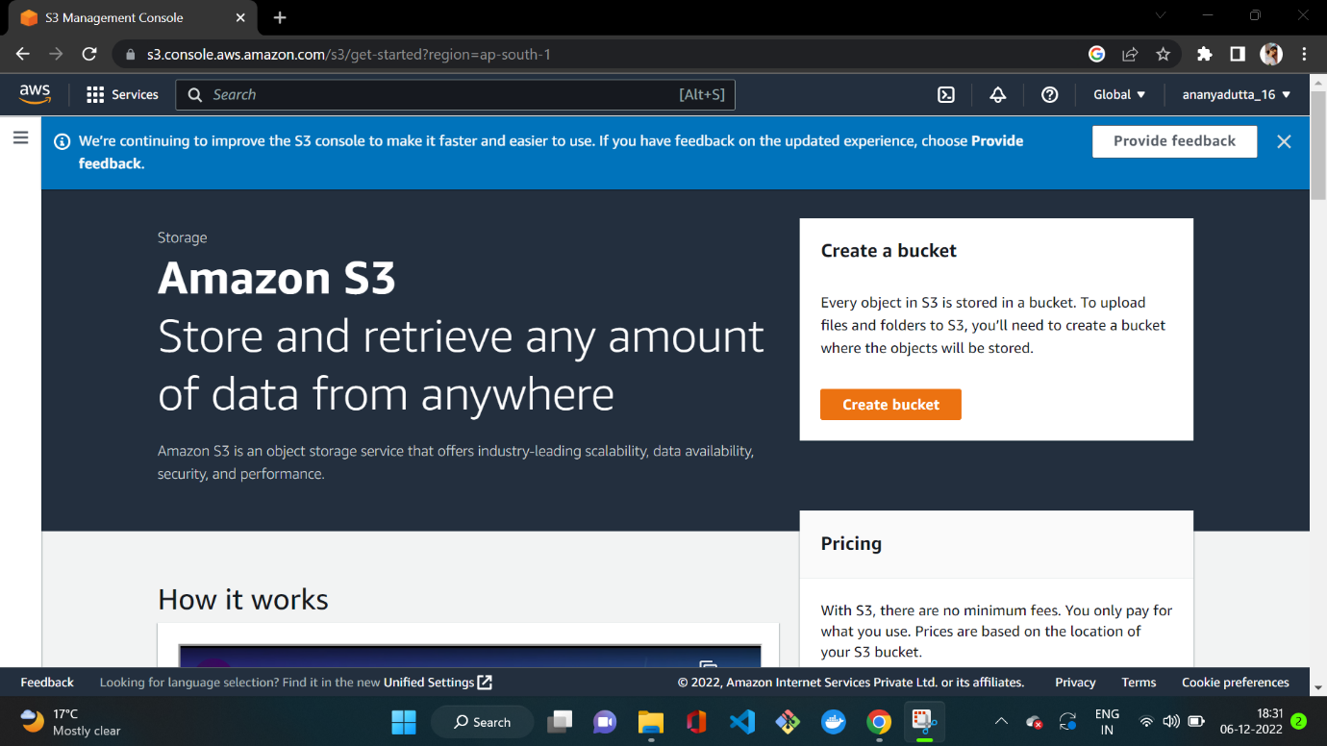

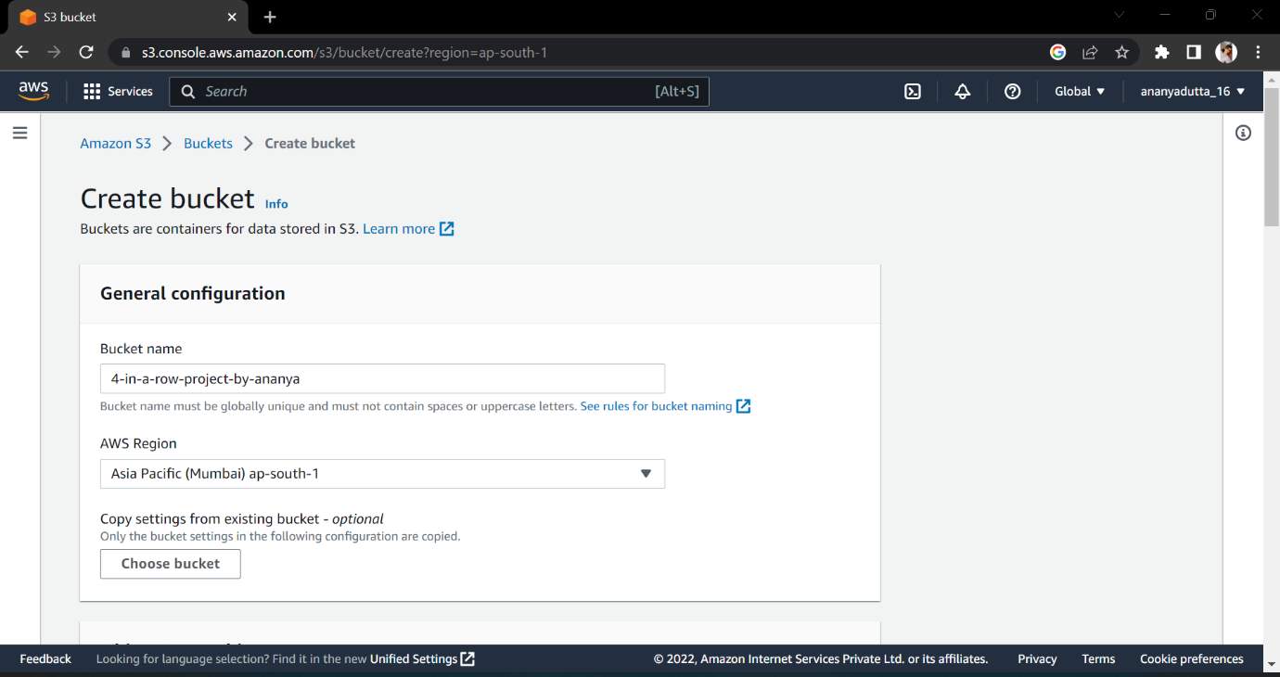

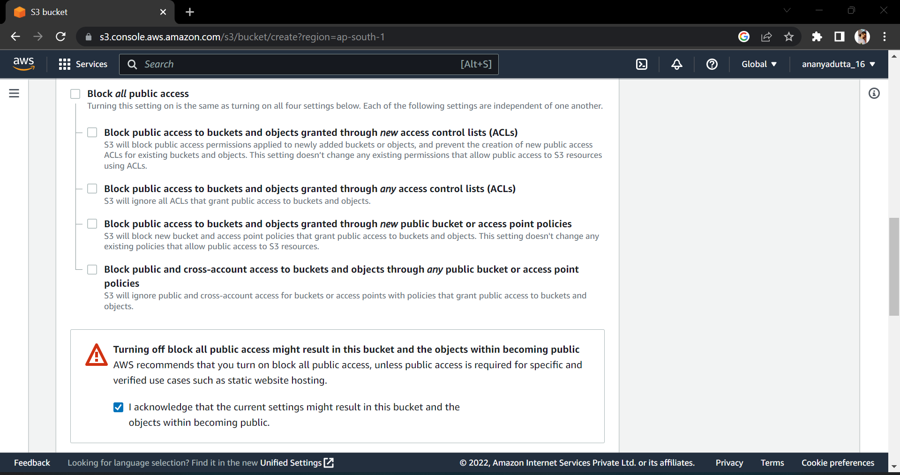

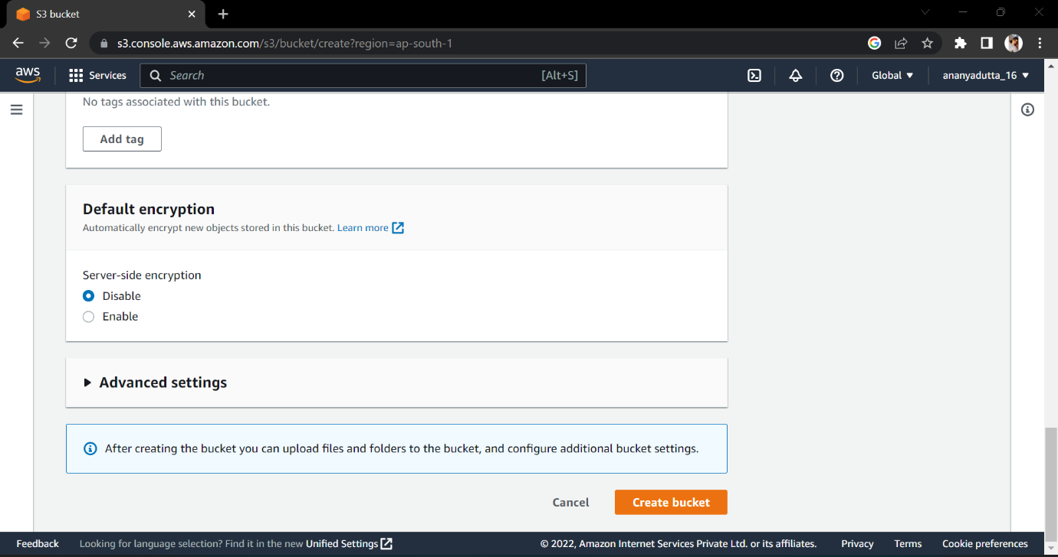

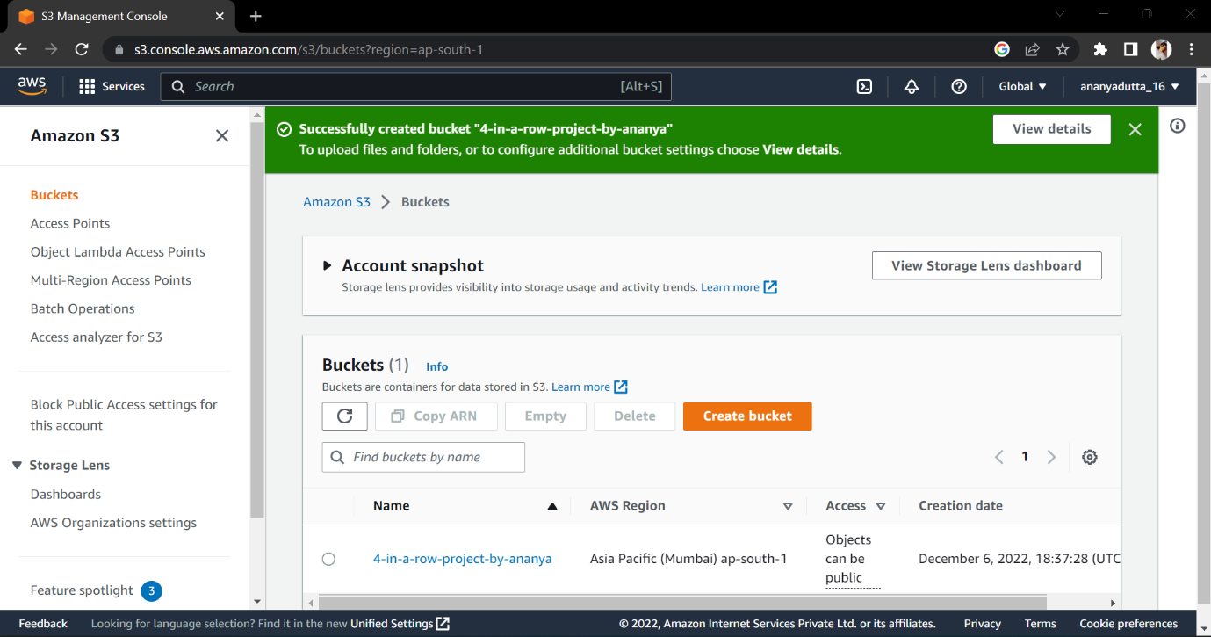

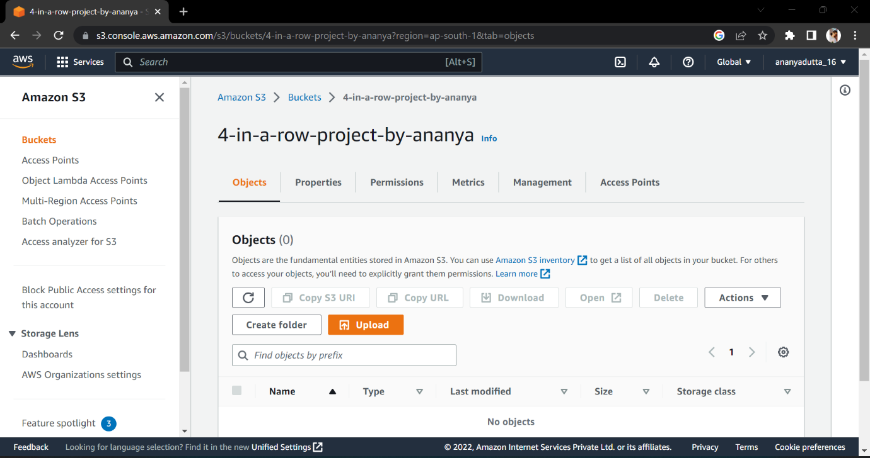

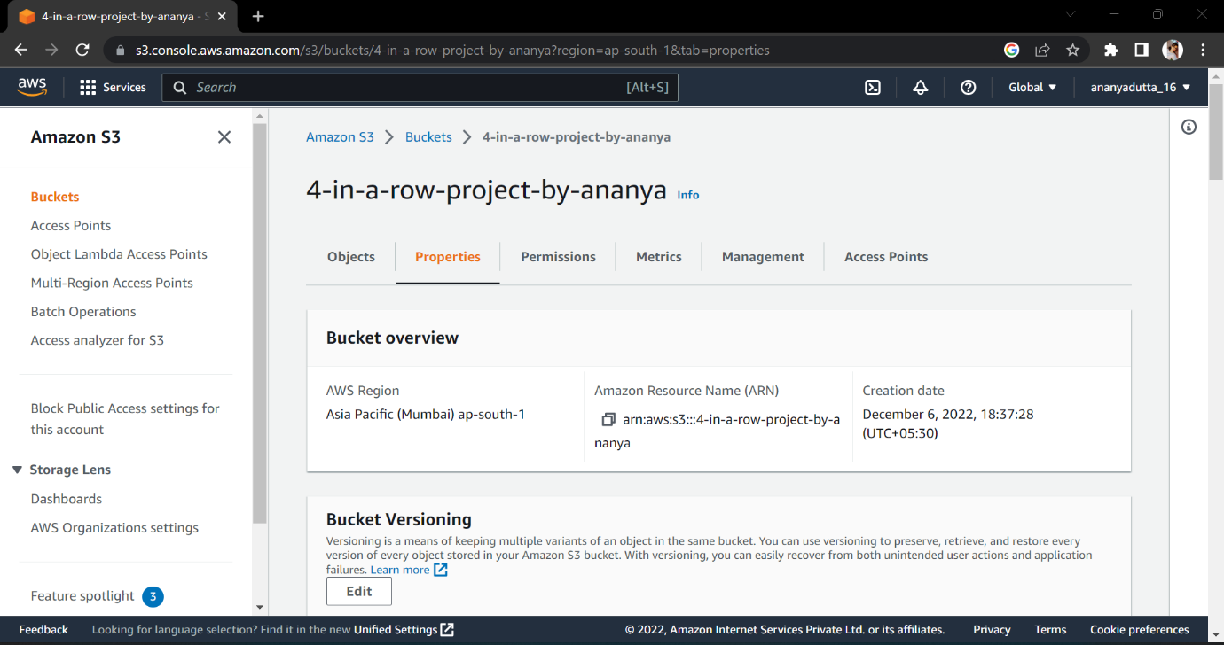

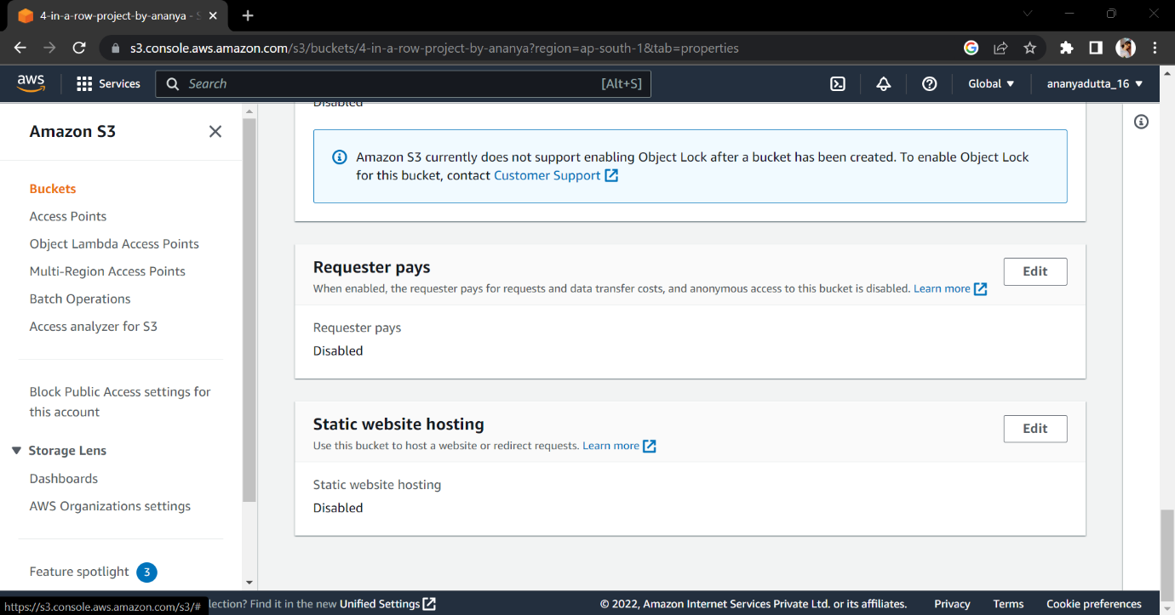

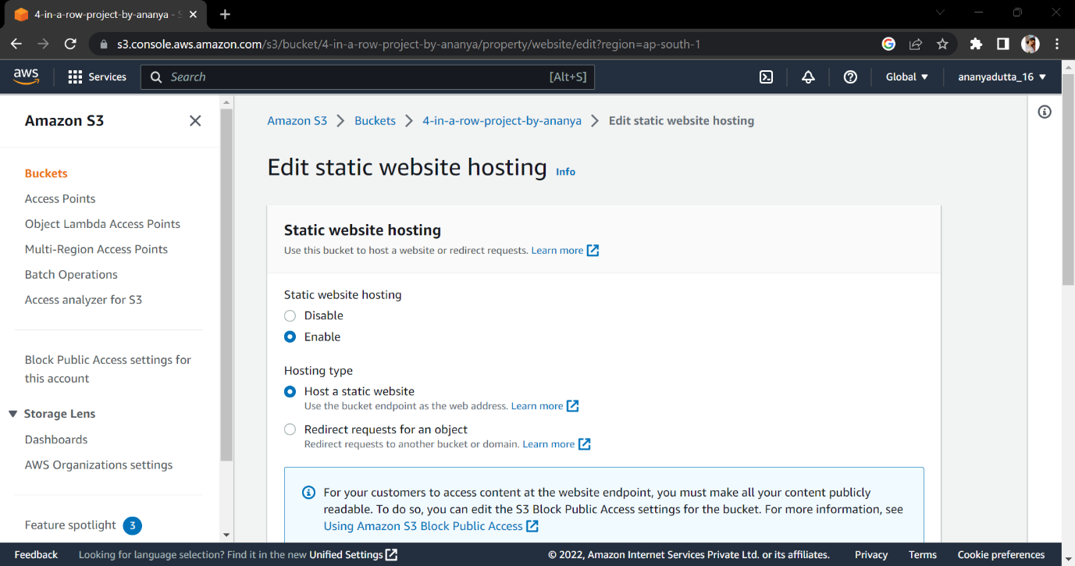

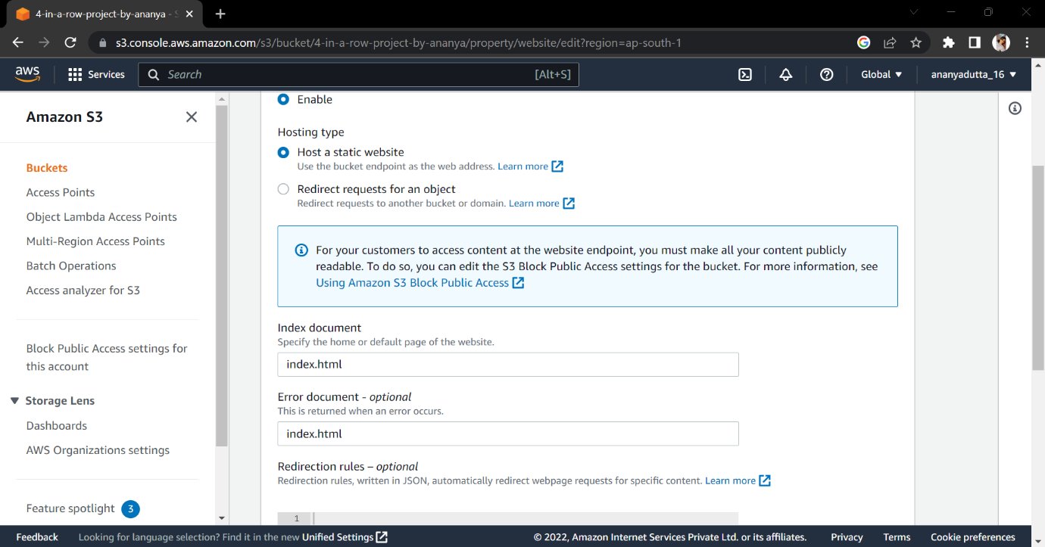

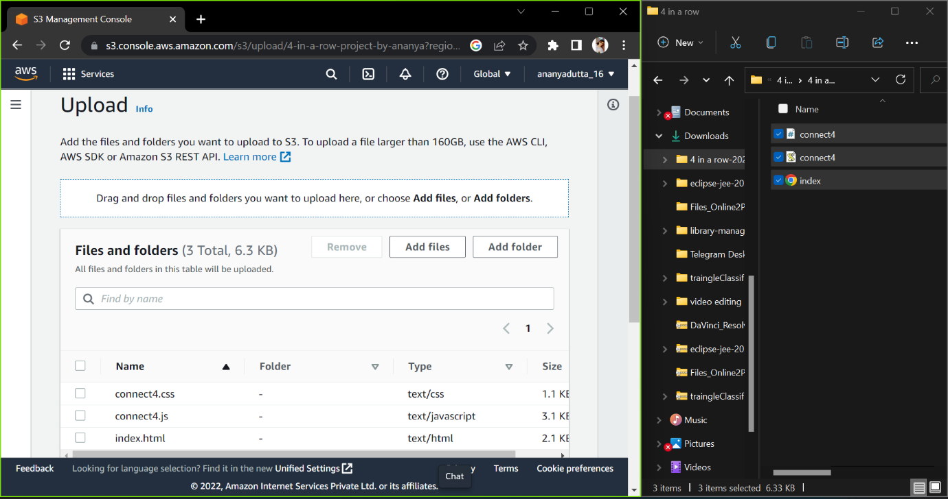

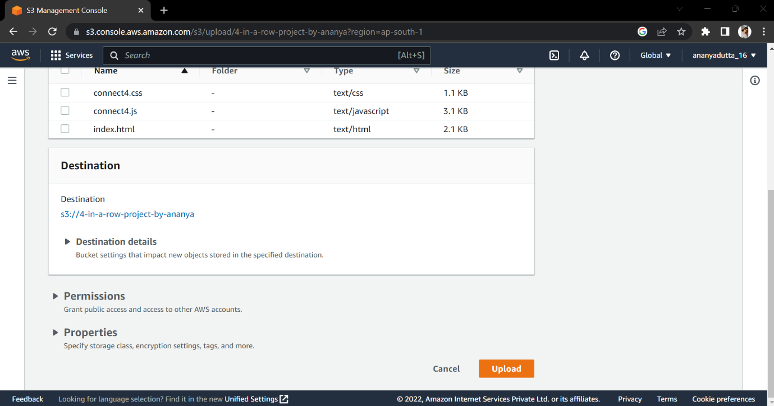

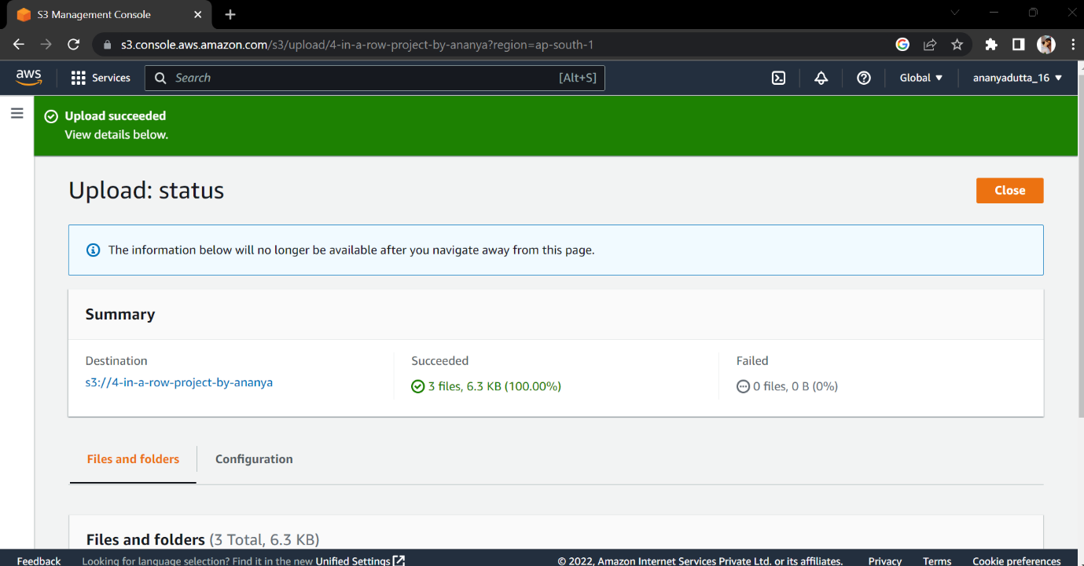

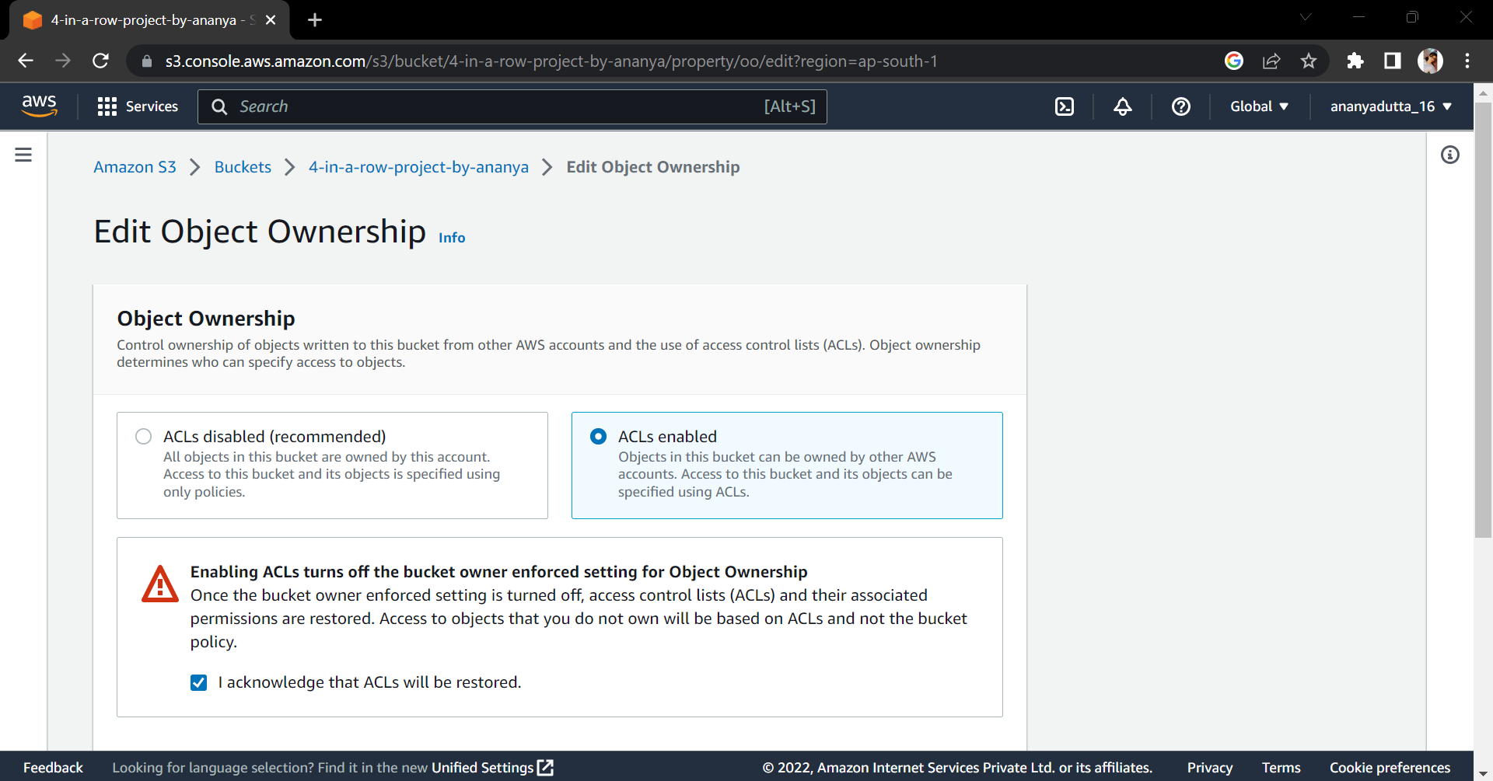

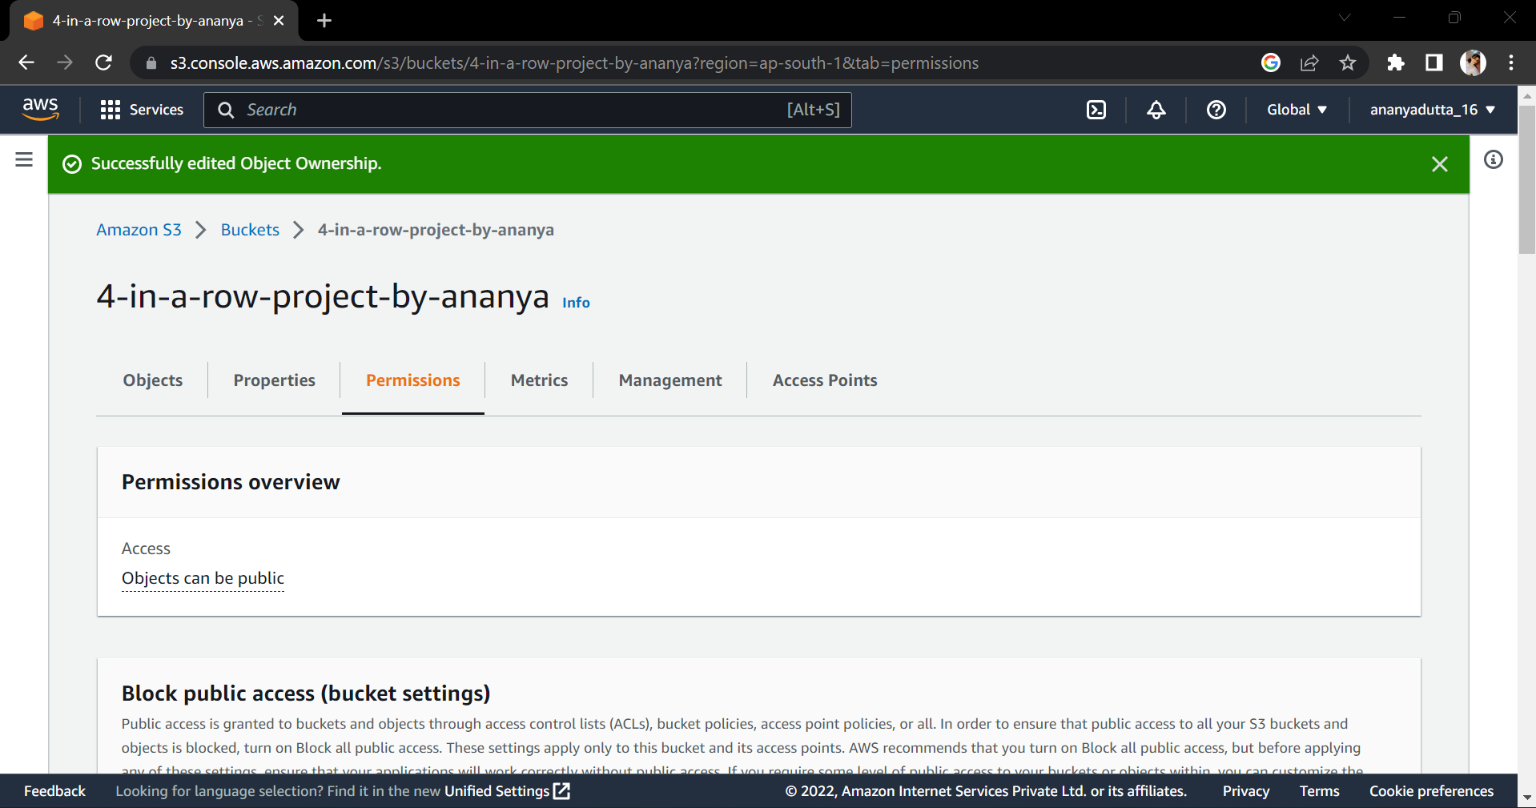

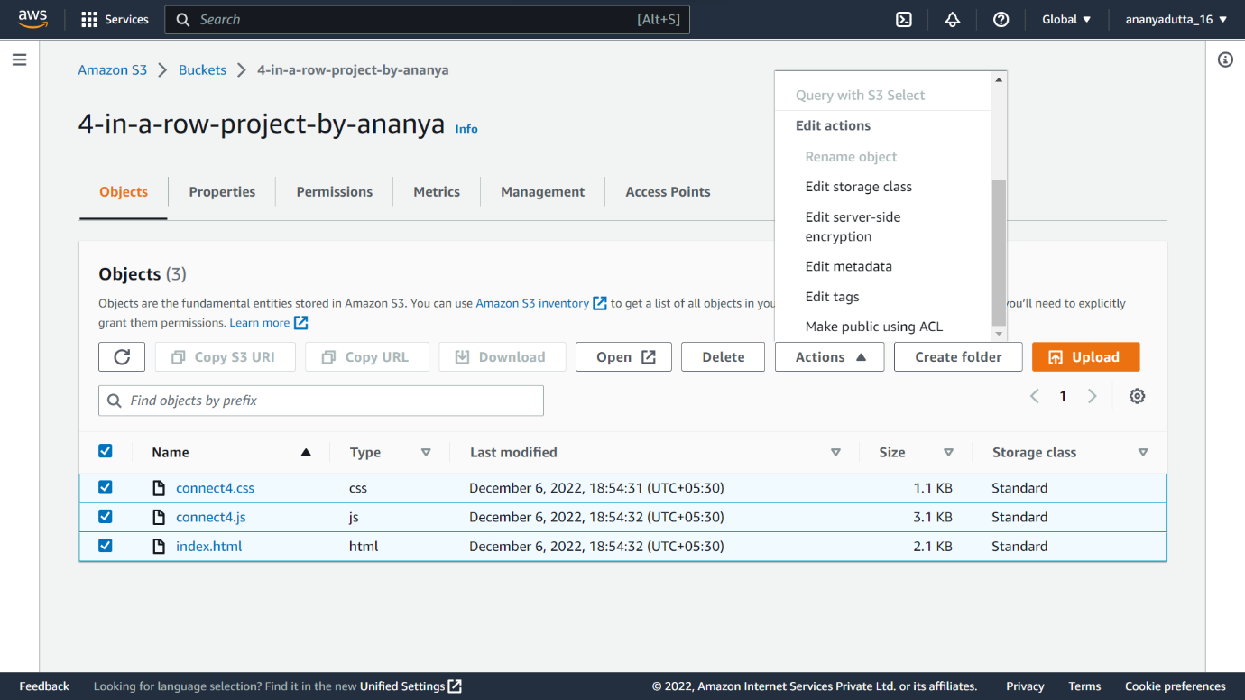

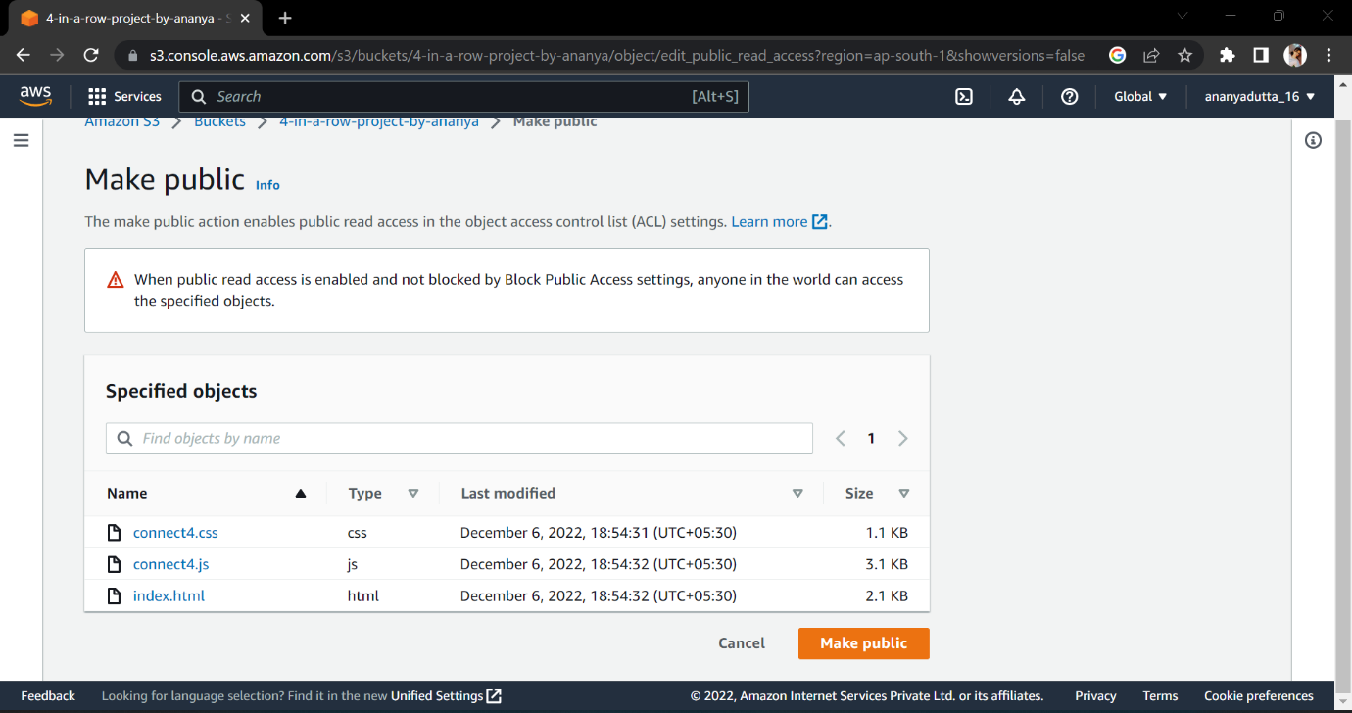

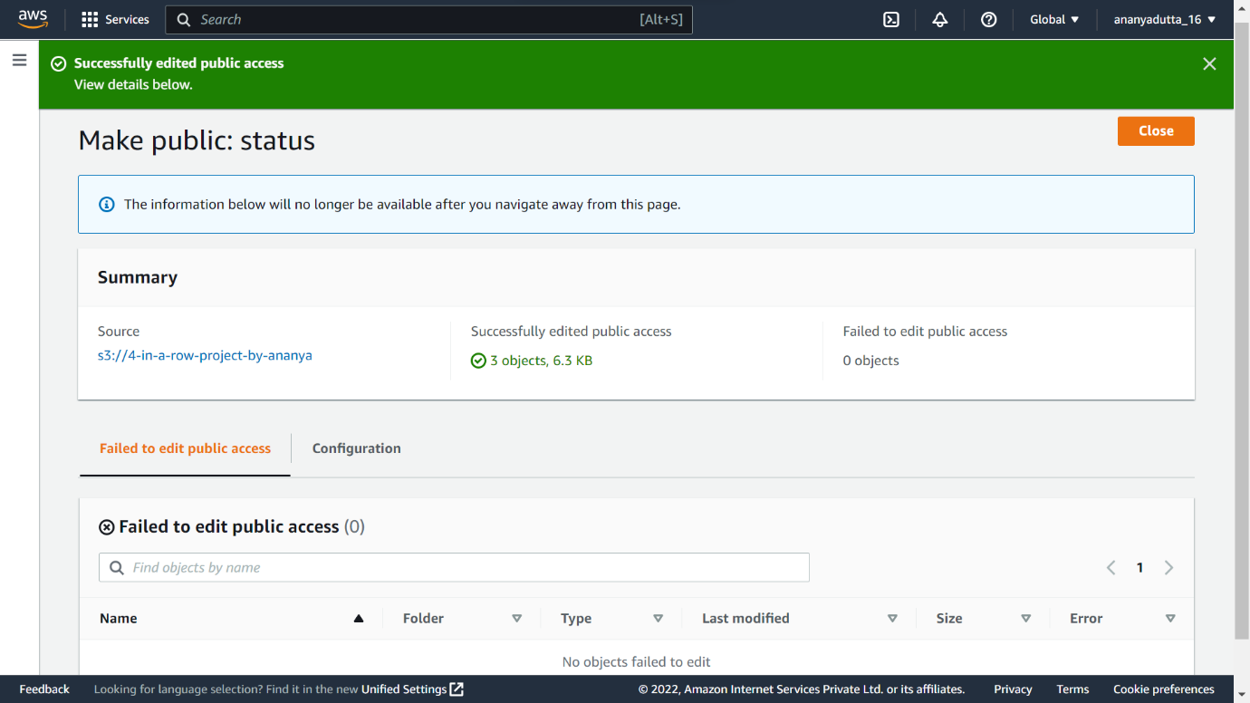

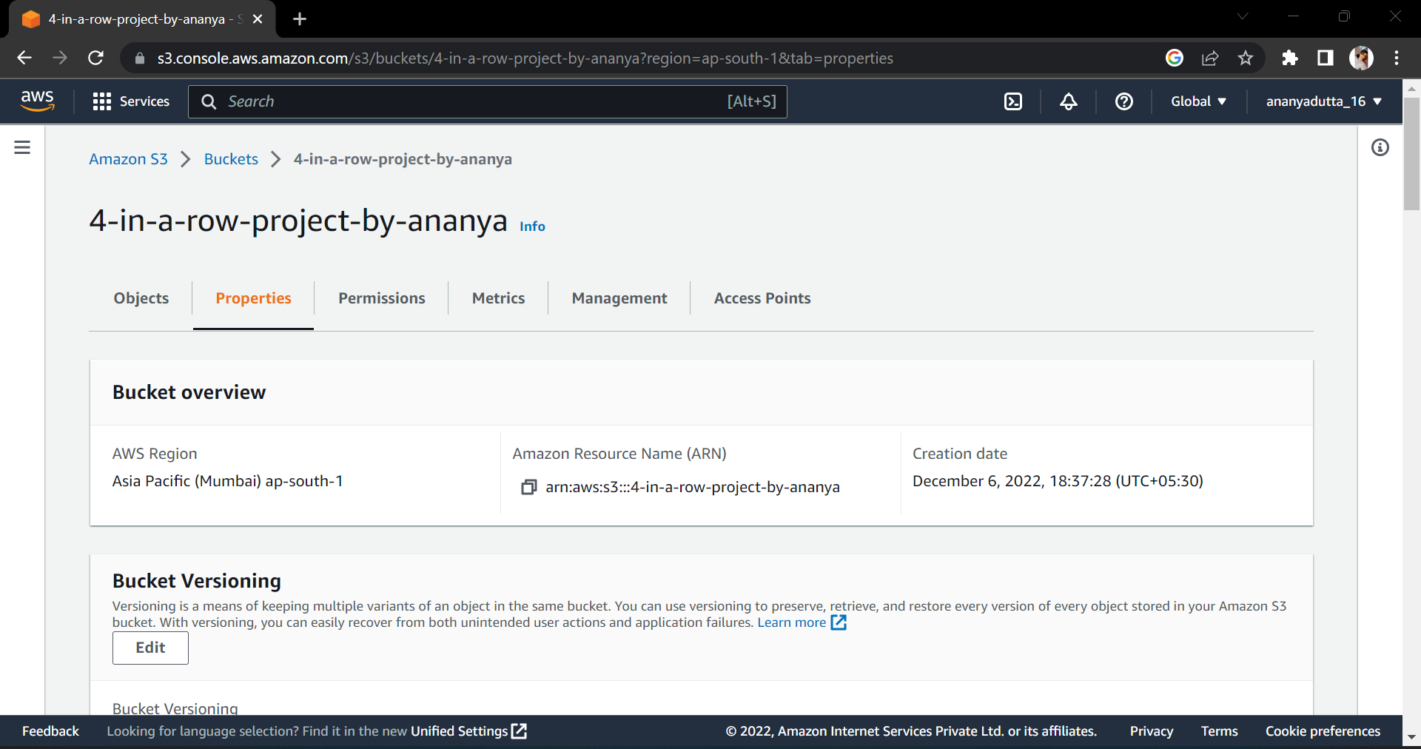

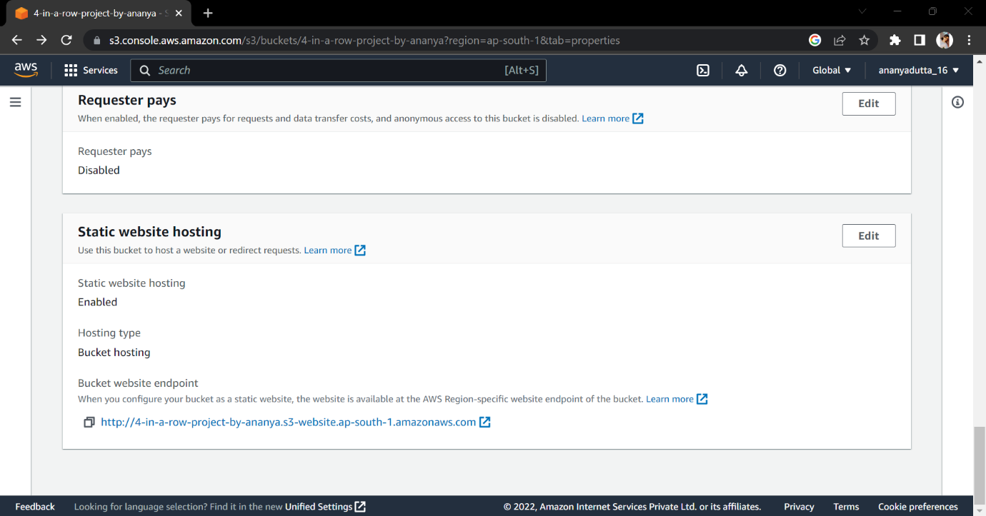

* **WORKING SCREENSHOTS:**

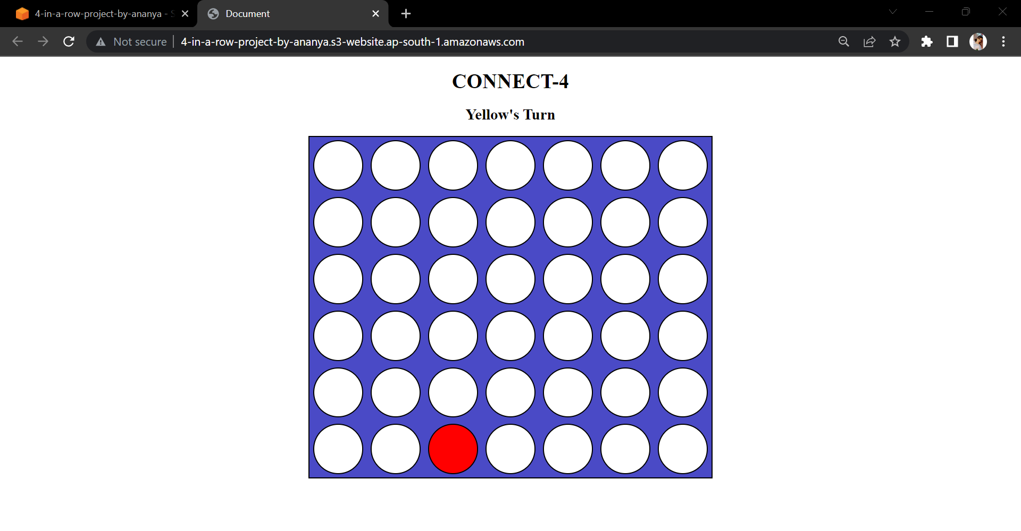

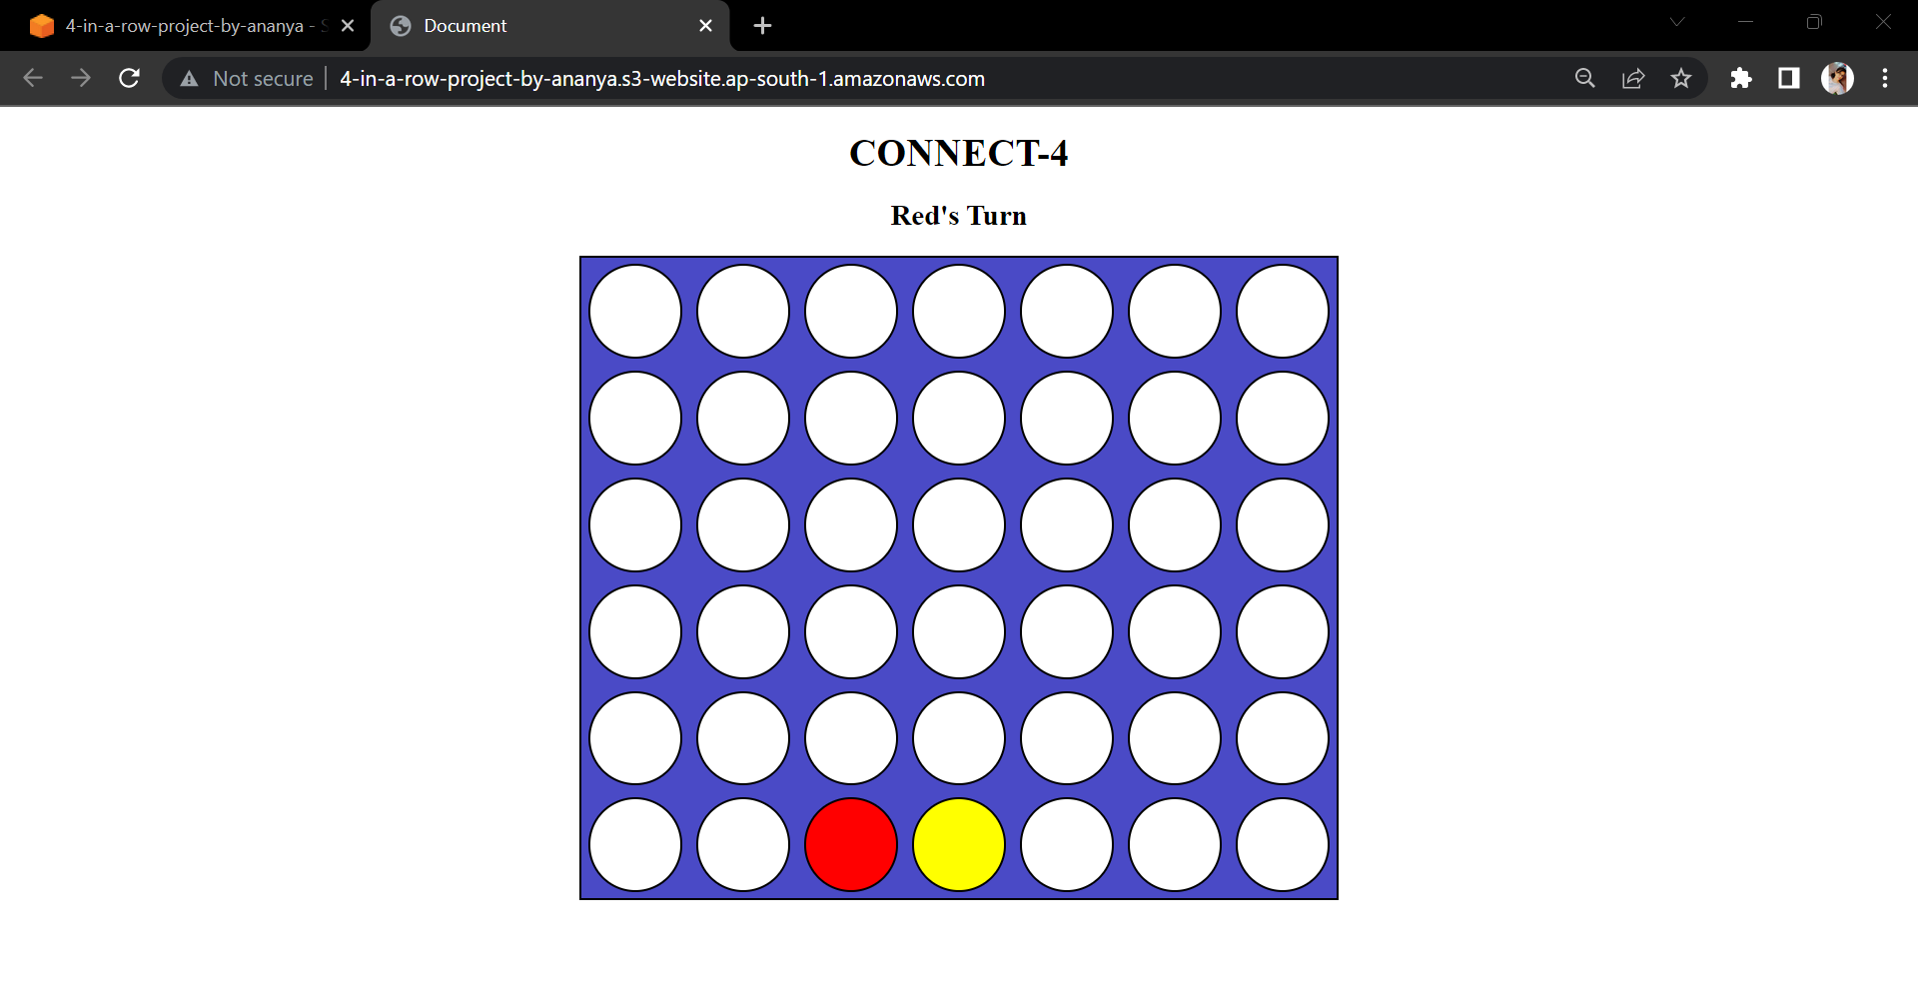

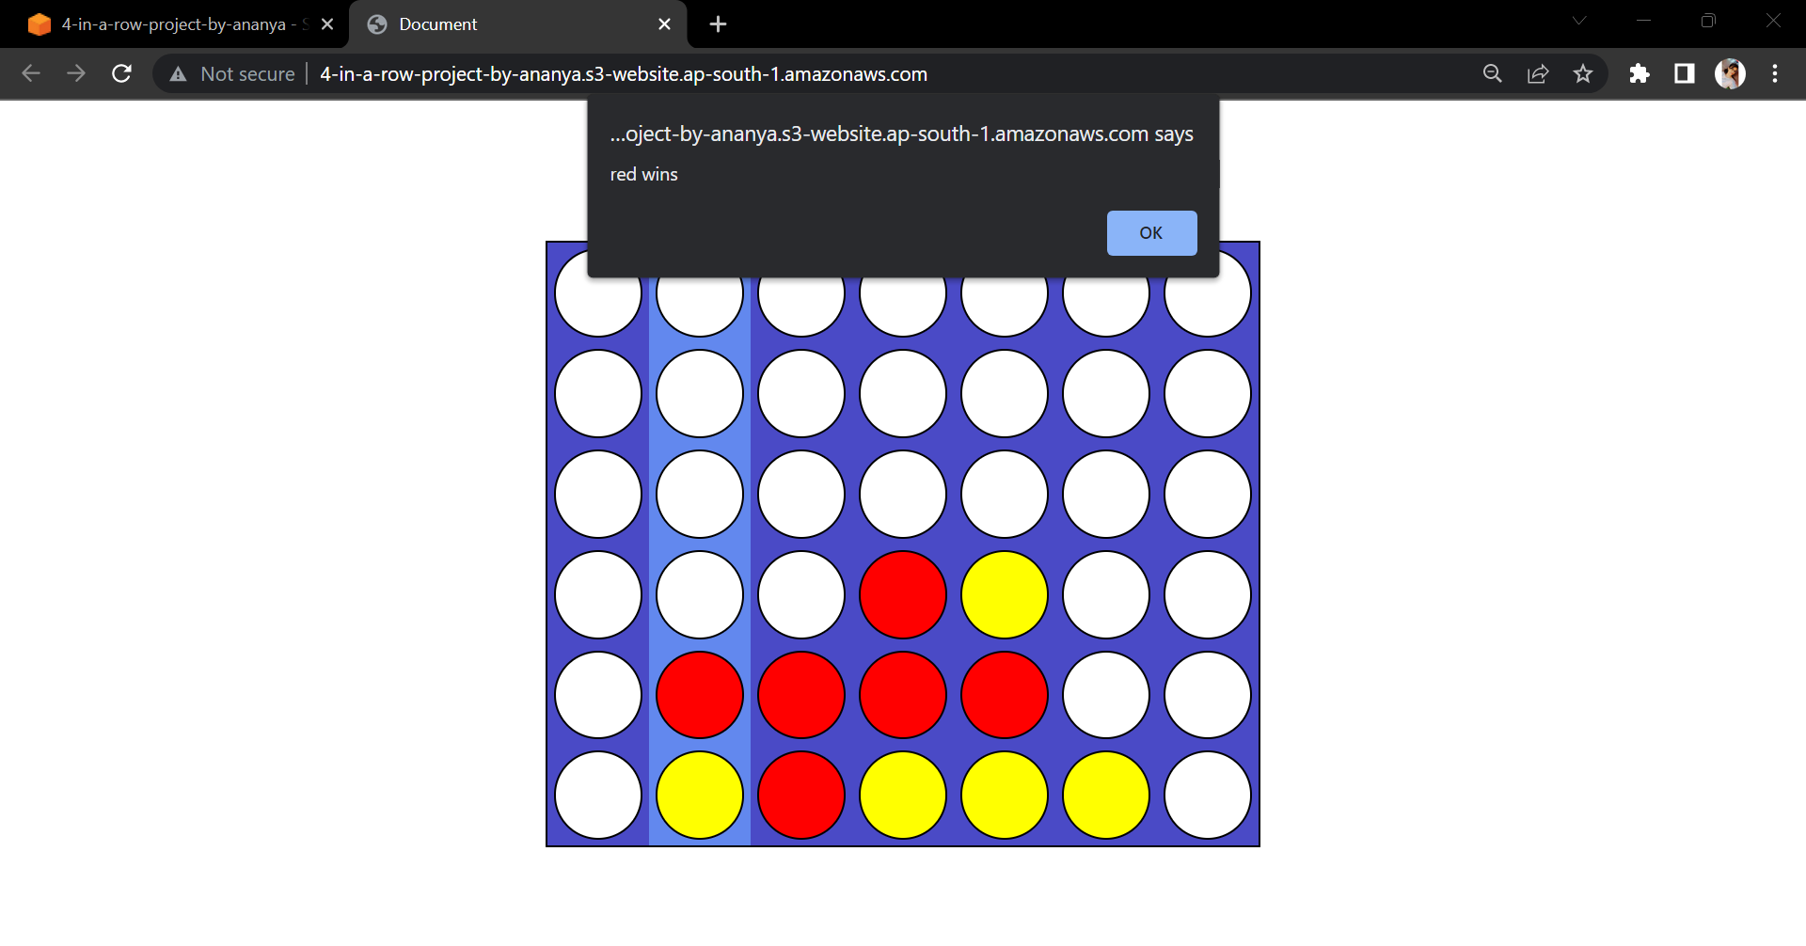

**Implementation link**

[**http://4-in-a-row-project-by-ananya.s3-website.ap-south-1.amazonaws.com/**](http://4-in-a-row-project-by-ananya.s3-website.ap-south-1.amazonaws.com/)