**C.V. RAMAN GLOBAL UNIVERSITY**

**BHUBANESWAR, ODISHA-752054**



**SOFTWARE ENGENEERING**

**CASE STUDY**

**ON**

**ONLINE RAILWAY RESERVATION SYSTEM**

|  |  |
| --- | --- |
| Name | Jesus Kumar Sahoo |
| Roll No | CIT20010 |
| Regd No | 20010239 |
| Branch | CS (IOT & CS) |
| Group | 07 |

**Under The Supervision of**

**Ms. Smita Rani Biswal**

**ASST. PROFESSOR**

**DEPARTMENT OF COMPUTER SCIENCE & ENGINEERING**

**CERTIFICATE OF APPROVAL**

This is to certify that B.Tech. Mini Project Viva-voce of the dissertation entitled “**ONLINE RAILWAY RESERVATION SYSTEM**”, is held on 20/04/2023 (day) in **Software Engineering**, at CGU.I have presented the work in a satisfactory manner to warrant as a pre-requisite for the degree of B.Tech.. It is understood that by this approval the undersigned do not necessarily endorse or approve any statement made, opinion expressed or conclusion drawn therein, but only for the purpose for which it has been submitted.

**BOARD OF EXAMINERS:**

1. **(Examiner/ HOD)**
2. **(Supervisor)**

**ACKNOWLEDGEMENT**

It is a great privilege for us to express our profound gratitude to our respected teacher **Ms. Smita Rani Biswal**, Assistant Professor, Department of Computer Science Engineering, C. V. Raman Global University, for his constant guidance, valuable suggestions, supervision, and inspiration throughout the work without which it would have been difficult to complete the work within the scheduled time,

We are also indebted to the Head of the Department, Computer Science Engineering. C. V. Raman Global University for permitting us to pursue the project. We would like to take this opportunity to thank all the respected teachers of this Department for being a perennial source of inspiration and showing the right path at the time of necessity.

From:-

Jesus Kumar Sahoo  
20010239

CIT20010

CSE (IOT &CS)

**ABTRACT**

The online railway reservation system is a sophisticated and convenient tool for booking train tickets. It enables users to book tickets, check availability of seats, view train schedules, and make cancellations and refunds from anywhere in the world. This system has revolutionized the way people book their train tickets, eliminating the need for long queues and saving valuable time. With the online railway reservation system, users can easily compare prices and routes, select their preferred class of travel, and make secure online payments.

The system also provides users with real-time updates on their booking status and sends them alerts and reminders to ensure a smooth travel experience. Furthermore, the system allows railway authorities to streamline their ticketing process, reduce manual errors, and manage their inventory effectively. Overall, the online railway reservation system is a robust and user-friendly solution that benefits both the customers and the railway authorities.

In our country India, there are number of counters for the reservation of the seats and one can easily make reservations and get tickets. Railway reservation system, has described above, can lead to error free, secure, reliable and fast management system. It can assist the user to concentrate on their other activities rather to concentrate on the record keeping. Thus, it will help organization it better utilization of resources.

**INTRODUCTION**

The online railway reservation system is a sophisticated and innovative solution that has transformed the way people book their train tickets. This system has not only made the booking process more convenient and hassle-free but also provided users with an efficient and reliable way to travel by train.

One of the key benefits of the online railway reservation system is that it enables users to book train tickets from anywhere in the world. The system provides an easy-to-use interface that allows users to search for available trains, check seat availability, view train schedules, and make secure online payments. This eliminates the need for users to physically visit the railway station or travel agency, saving valuable time and effort.

The system also provides real-time updates on booking status and sends alerts and reminders to ensure a smooth travel experience. This means that users can stay informed about their booking status and any changes to their travel plans, making it easier for them to manage their travel schedule.

Furthermore, the online railway reservation system enables railway authorities to manage their inventory more efficiently and reduce the incidence of manual errors. The system allows railway authorities to streamline their ticketing process, making it easier for them to manage their operations and provide better customer service.

**PROBLEM STATEMENT**

The traditional process of railway reservation has been plagued with numerous challenges and drawbacks. One of the primary challenges is the long queues and waiting times at railway stations or travel agencies, which can be time-consuming and inconvenient for users. Additionally, manual processes have led to the incidence of errors in ticket booking, cancellations, and refunds, causing frustration and inconvenience for users.

Another challenge is the limited access to information on train schedules, seat availability, and fares. Users often have to rely on limited information provided at railway stations or travel agencies, which can be inaccurate or incomplete. This can lead to confusion and difficulty in planning travel itineraries.

Furthermore, the traditional process of railway reservation has limited the reach of railway services to a specific geographic location. This has made it difficult for users who live in remote areas or who are unable to physically visit the railway station or travel agency to book their tickets.

Overall, these challenges have made the process of railway reservation cumbersome and inconvenient for users. The problem statement for the online railway reservation system is to address these challenges and provide users with a convenient, efficient, and reliable way to book their train tickets. The online railway reservation system aims to simplify the ticketing process, provide users with accurate and comprehensive information, and enable users to book their tickets from anywhere in the world. The system also aims to streamline the operations of railway authorities, reduce manual errors, and enhance the overall customer experience.

**SOLUTION**

* The solution to the challenges faced by the traditional process of railway reservation is the development and implementation of an online railway reservation system. This system provides a web-based platform that enables users to search for available trains, check seat availability, view train schedules, and make secure online payments from anywhere in the world.
* The online railway reservation system provides users with a convenient and efficient way to book their train tickets, eliminating the need for them to physically visit the railway station or travel agency. This saves valuable time and effort for users, and provides them with the flexibility to plan their travel itinerary at their convenience.
* Moreover, the online railway reservation system provides users with accurate and comprehensive information on train schedules, seat availability, and fares. This helps users to make informed decisions about their travel plans, and eliminates confusion and uncertainty.
* The online railway reservation system also streamlines the operations of railway authorities, enabling them to manage their inventory more efficiently and reduce manual errors. This system provides real-time updates on booking status and sends alerts and reminders to ensure a smooth travel experience.

**System Specification**

The system specification for the online railway reservation system includes the following components:

***Hardware:*** The online railway reservation system requires a reliable and secure server infrastructure that can handle a large number of users simultaneously. The system also requires desktop or mobile devices that are connected to the internet, and that can access the online reservation system through a web browser.

***Software:*** The online railway reservation system requires software that can manage and store user data securely, process online payments, and provide real-time updates on booking status

***Database:*** The online railway reservation system requires a database that can store information on train schedules, seat availability, fares, and user data. The database must be scalable and secure to prevent unauthorized access or data loss.

***Security:*** The online railway reservation system must be secure and protect user data from unauthorized access. The system must use secure protocols for online payments and encrypt user data during transmission and storage.

***User management:*** The online railway reservation system must have a user management system that allows users to create and manage their accounts, view their booking history, and cancel or modify their bookings.

***Integration:*** The online railway reservation system must integrate with other systems such as payment gateways, email notifications, and SMS alerts.

***Performance:*** The online railway reservation system must be able to handle a large number of users simultaneously and provide fast response times. The system must also be able to handle peak loads during holiday seasons or special events.

* **Features of Online Railway Reservation System**

1. ***Train search:*** The system allows users to search for trains based on their preferred travel dates, destination, and origin. Users can also filter search results by train type, fare, and availability.
2. ***Seat availability***: The system displays real-time information on seat availability for each train, enabling users to choose their preferred seat and class.
3. ***Booking and payment:*** The system enables users to book their train tickets and make secure online payments through various payment gateways.
4. ***Cancellation and modification:*** The system allows users to cancel or modify their bookings online, subject to the cancellation policy.
5. ***Train schedule:*** The system provides users with accurate and comprehensive information on train schedules, including arrival and departure times, stoppages, and duration of the journey.
6. ***User profile:*** The system allows users to create and manage their accounts, view their booking history, and update their personal details.
7. ***Refunds:*** The system facilitates refunds for cancelled bookings as per the refund policy.

***Functional Requirements:***

1. **User Registration:** The system should allow users to create and manage their accounts. Users should be able to create an account by providing their personal details and contact information.
2. **Train Search:** The system should allow users to search for trains based on their preferred travel dates, origin, and destination. Users should be able to filter search results by train type, fare, and availability.
3. **Seat Availability:** The system should display real-time information on seat availability for each train, enabling users to choose their preferred seat and class.
4. **Booking and Payment:** The system should enable users to book their train tickets and make secure online payments through various payment gateways.

***Non-functional Requirements:***

1. **Security:** The system must ensure the security of user data, including personal and payment information. The system must use secure protocols for online payments and encrypt user data during transmission and storage.
2. **Performance:** The system should be able to handle a large number of users simultaneously and provide fast response times. The system must also be able to handle peak loads during holiday seasons or special events.
3. **Availability:** The system should be available 24/7, except during scheduled maintenance windows.
4. **Scalability:** The system must be scalable to accommodate increasing numbers of users and data volumes.
5. **Reliability:** The system must be reliable and maintain high levels of uptime. The system must also have a disaster recovery plan to ensure business continuity in case of unforeseen events.

**DFD**

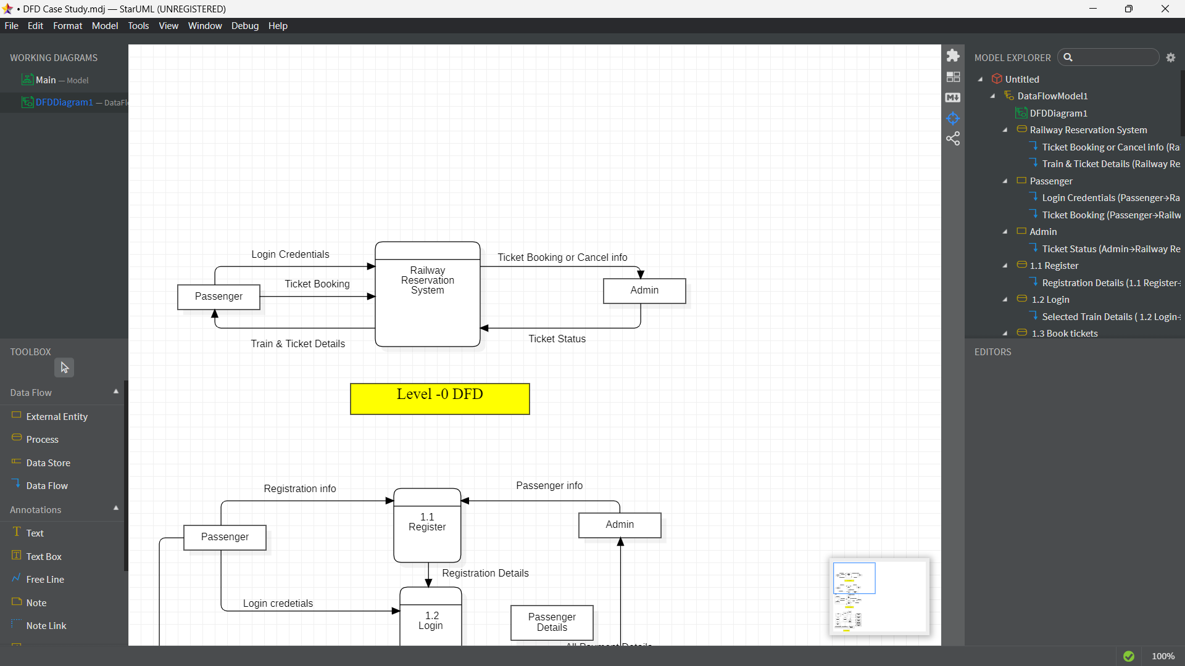

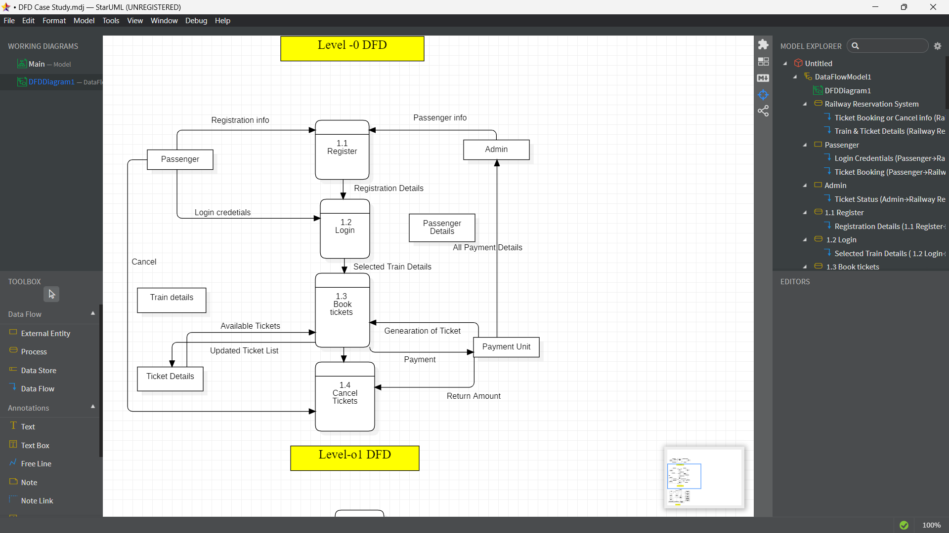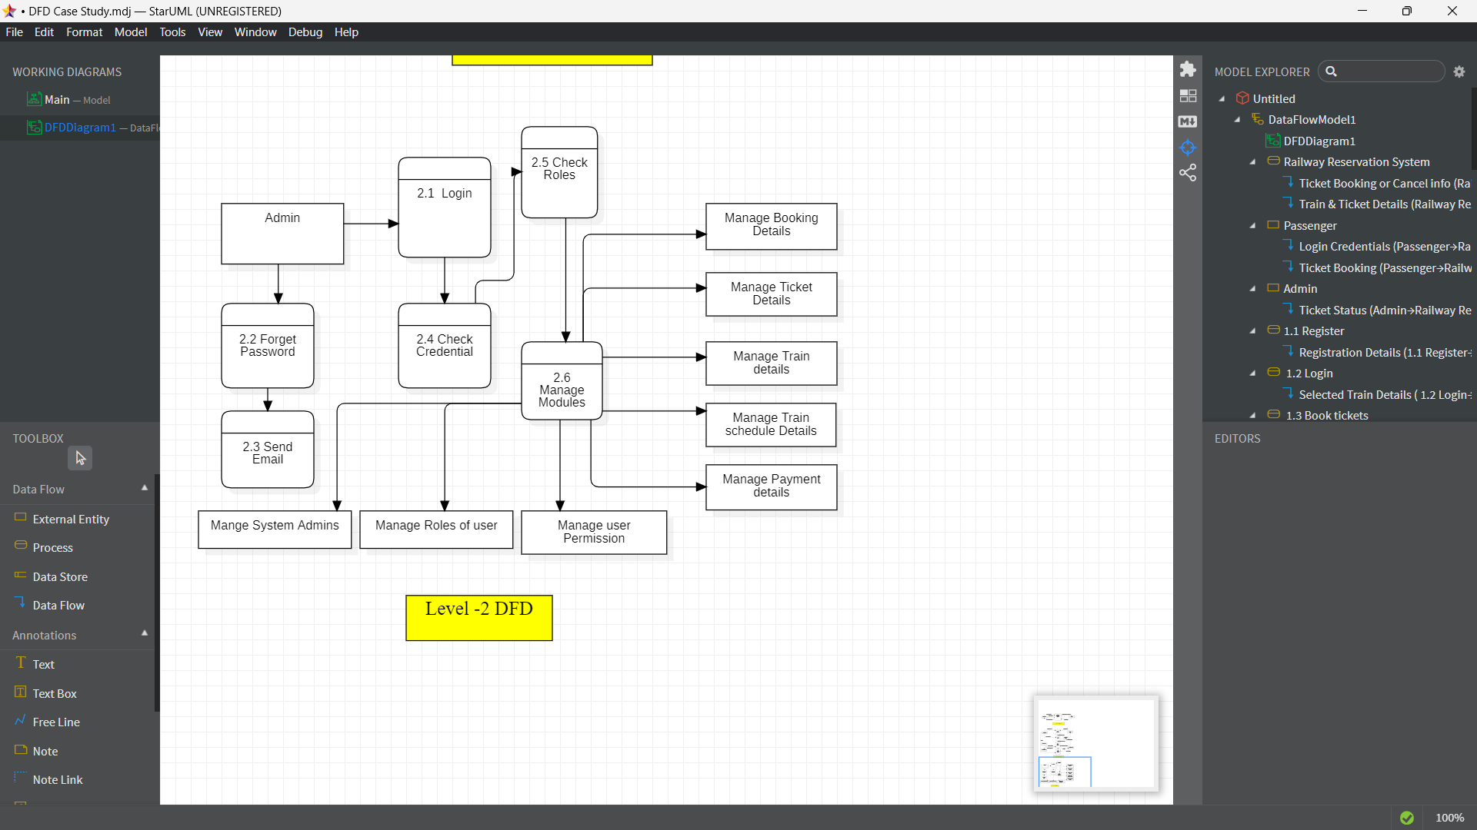

**CLASS DIAGRAM**

* Class diagram is a static diagram. It represents the static view of an application. Class diagram is not only used for visualizing, describing, and documenting different aspects of a system but also for constructing executable code of the software application.
* Class diagram describes the attributes and operations of a class and also the constraints imposed on the system. The class diagrams are widely used in the modelling of object oriented systems because they are the only UML diagrams, which can be mapped directly with object-oriented languages.

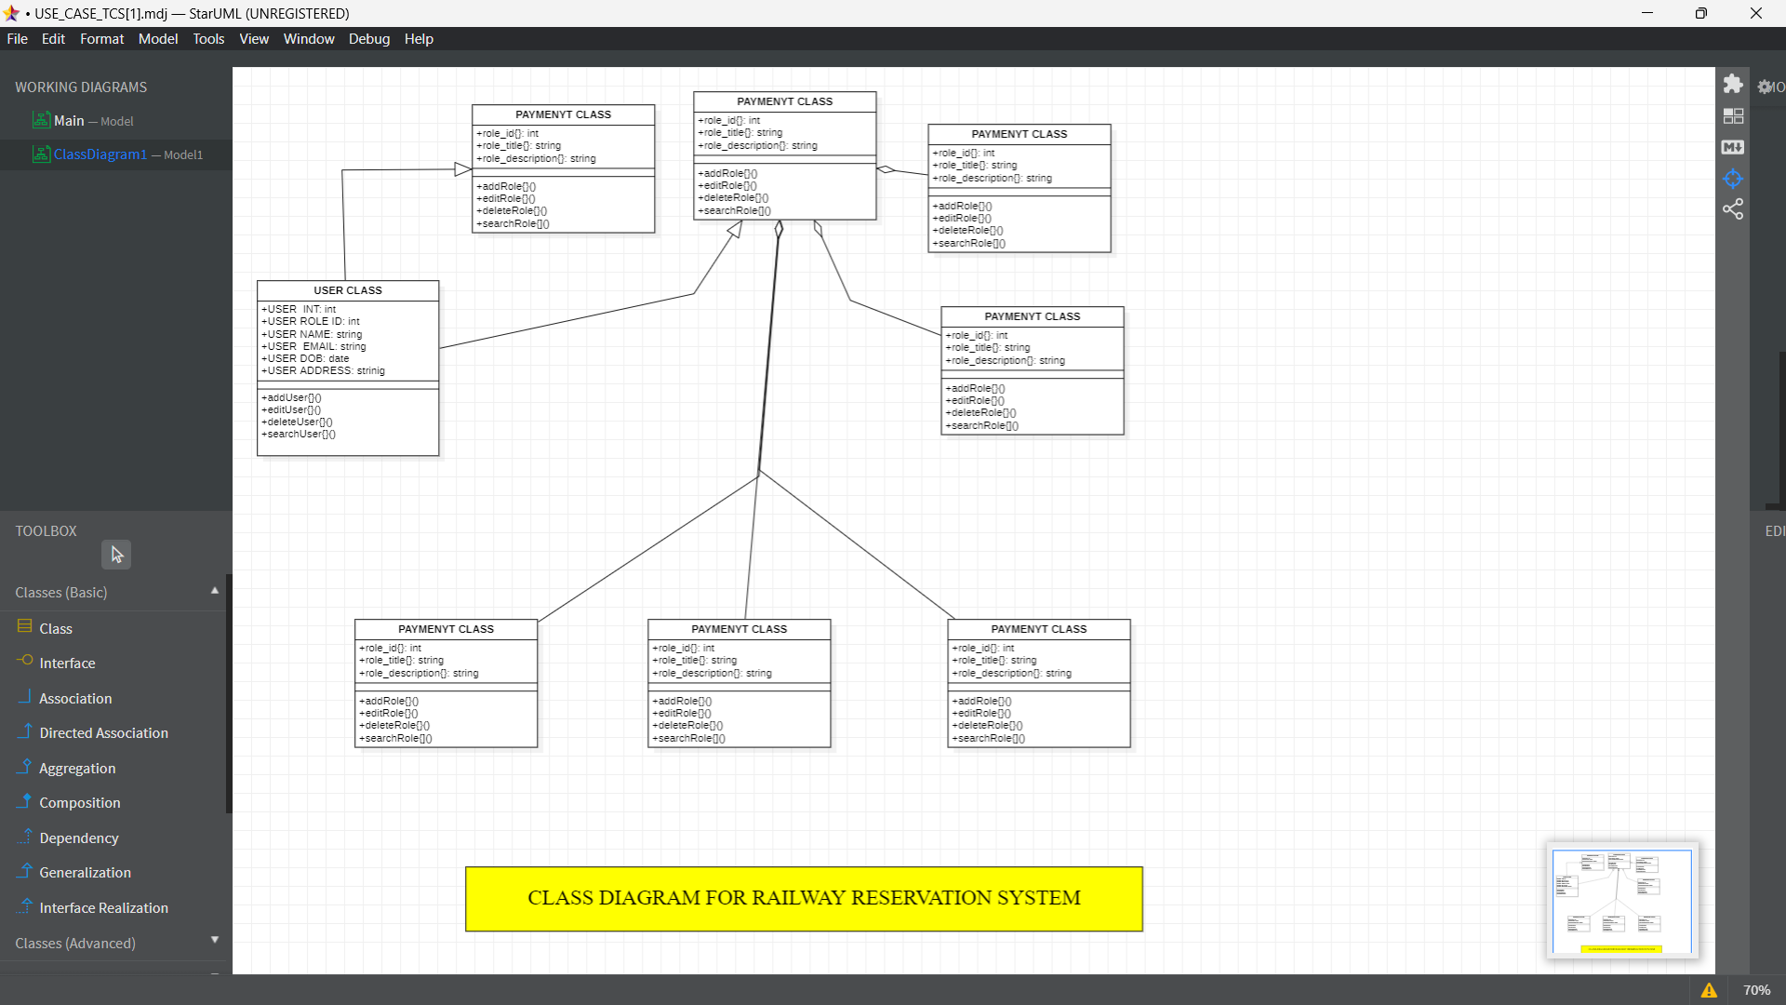

**USE CASE DIAGRAM**

* A use case diagram is used to represent the dynamic behaviour of a system. It encapsulates the system's functionality by incorporating use cases, actors, and their relationships.
* It models the tasks, services, and functions required by a system/subsystem of an application. It depicts the high-level functionality of a system and also tells how the user handles a system.

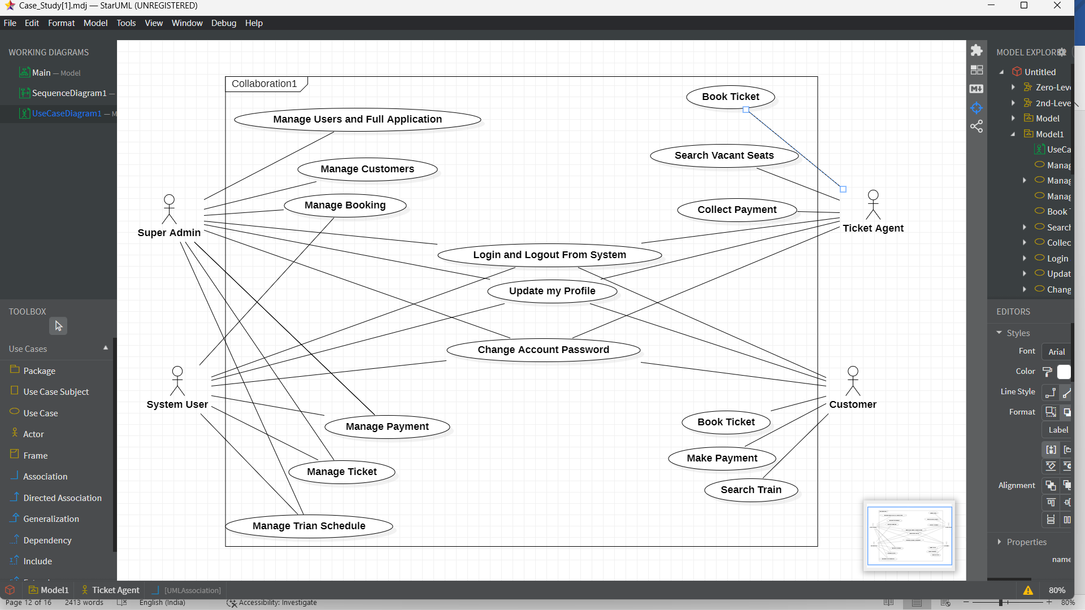

**SEQUENCE DIAGRAM**

* The sequence diagram represents the flow of messages in the system and is also termed as an event diagram. It helps in envisioning several dynamic scenarios.
* 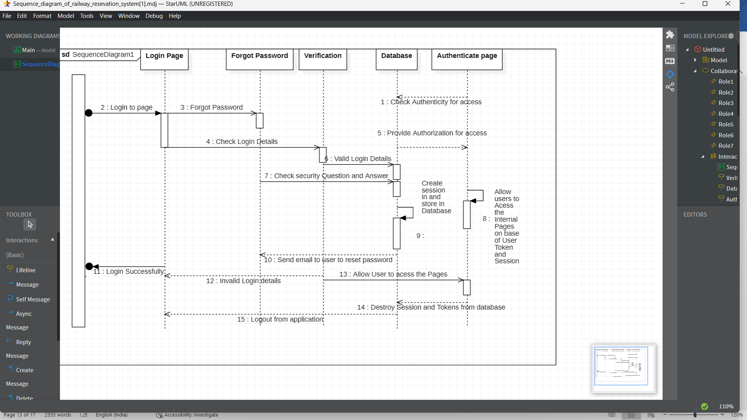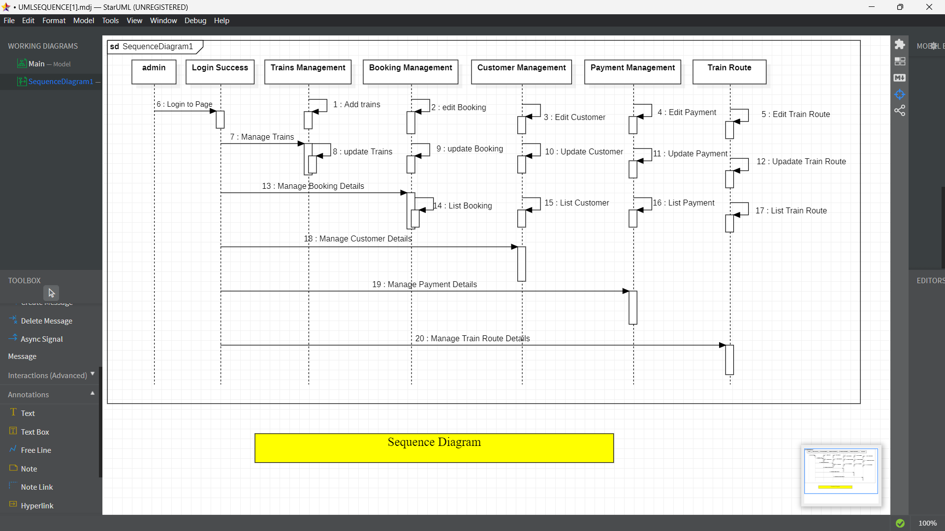It portrays the communication between any two lifelines as a time-ordered sequence of events, such that these lifelines took part at the run time.

**ACTIVITY DIAGRAM**

* Activity diagram is basically a flowchart to represent the flow from one activity to another activity. The activity can be described as an operation of the system.
* The control flow is drawn from one operation to another. This flow can be sequential, branched, or concurrent. Activity diagrams deal with all type of flow control by using different elements such as fork, join, etc

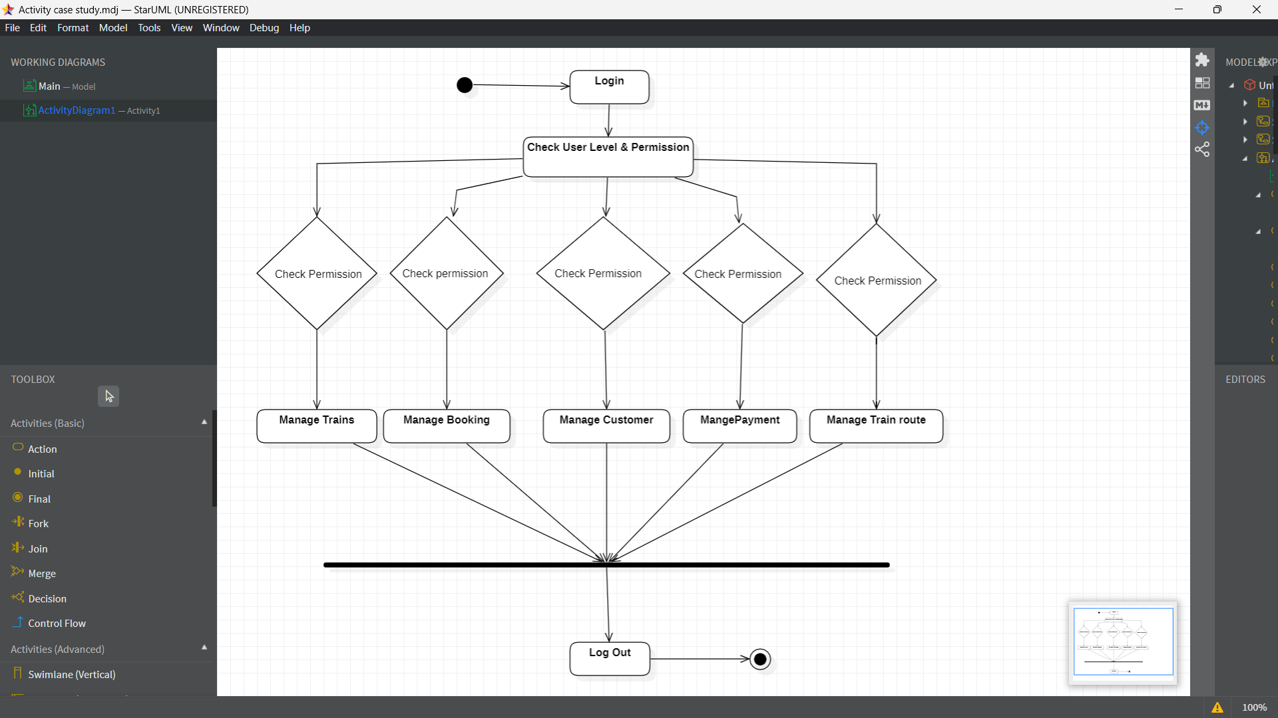

**CONCLUSION**

The online Railway Reservation System is a significant step forward in the railway industry, making it more convenient for passengers to book and manage their travel arrangements. The system has numerous benefits, including time-saving, convenience, and ease of use.

With the online Railway Reservation System, passengers can book their tickets from the comfort of their homes or offices, avoiding long queues at the ticket counters. The system also allows passengers to choose their preferred train, class, and seat, making the booking process more personalized. Additionally, passengers can cancel or modify their bookings online, making it easier to manage changes in their travel plans.

Here is an explanation of some of the components that may be included in all diagram for an online Railway Reservation System:

1. ***DFD Diagram:*** A DFD (Data Flow Diagram) for an online Railway Reservation System would show the flow of data between external entities such as passengers and administrators, processes such as booking and cancelling tickets, data stores such as passenger details and booking information, and the interactions between these components.
2. ***Class Diagram:*** The class diagram represents the classes that are present in the system and their relationships. For example, classes like Passenger, Train, Ticket, Booking, Payment, etc., would be represented in the diagram, along with their attributes and methods.
3. ***Use Case Diagram:*** The use case diagram depicts the interactions between the actors (passengers, administrators, and other stakeholders) and the system. It shows the various use cases (booking a ticket, cancelling a ticket, checking availability, etc.) and how the actors interact with the system to achieve their goals.
4. ***Sequence Diagram:*** The sequence diagram represents the interactions between the various components of the system in a chronological order. It shows the flow of information between the classes, how they communicate with each other, and how the system responds to various events.
5. ***Activity Diagram***: The activity diagram shows the activities or processes that take place in the system, including the flow of events and the order in which they occur. For example, the diagram could include activities like logging in, selecting a train, selecting a seat, making a payment, etc.

* Overall, the online Railway Reservation System has been a game-changer in the railway industry, making the booking process faster, more convenient, and more secure for passengers, while also improving the efficiency of the railway operations.