Visvesvaraya Technological University

Belagavi – 590018

A Python Mini Project Report on

*“Chatbot for RNSIT Website”*

Submitted in partial fulfillment of the requirements for the *I* semester.

Submitted by:

*ANANYA G NAIK*

*RAJNANDANI SINGH*

*NIDHI VIJAY SHINDE*

Under the Guidance of:

*Ms. Likkitha Renukappa*

*Assistant Professor*

*Dept. of Cyber Security*

RNS Institute of Technology

Channasandra, Dr. Vishnuvardhan Road, Bengaluru – 560098

2023-2024

INTRODUCTION

A Chabot is an intelligent piece of software that is capable of communicating and performing actions similar to a human. At the most basic level, a Chabot is a computer program that simulates and processes human conversation (either written or spoken), allowing humans to interact with digital devices as if they were communicating with a real person.

The first-year students will be facing some difficulties in figuring out what is where, and whom to meet, especially on the initial days around the campus. The Chabot aims to help them to tackle these difficulties.

PURPOSE

To help and guide the first-year students and parents around the RNSIT campus.

Scope

Student’s guider:

* Assists students to explore the campus.
* Provides information regarding faculties contact details and their respective departments, where they are available.
* All the above guidance through voice assistance.

Advantages

* Rapid information
* Student friendly
* Easily accessible
* Explore the campus

Disadvantages:

* Sometimes users may need some extra details regarding the college that is not possible in this system

BLOCK DIAGRAM

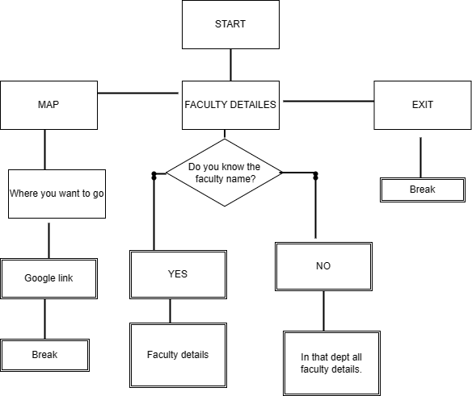

Code

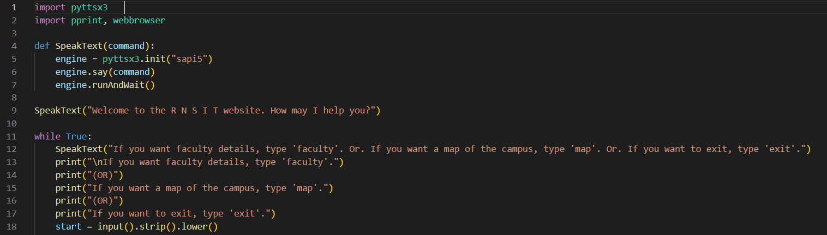

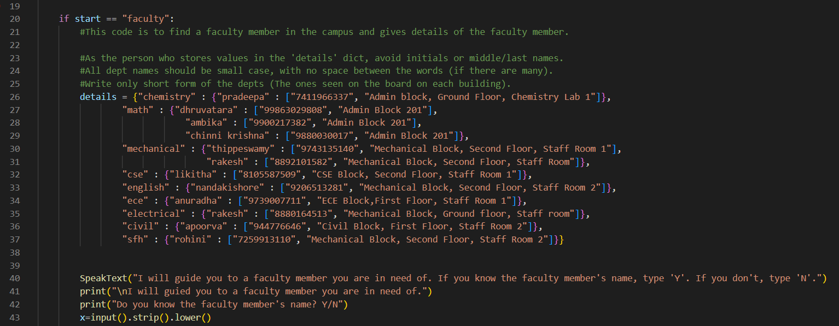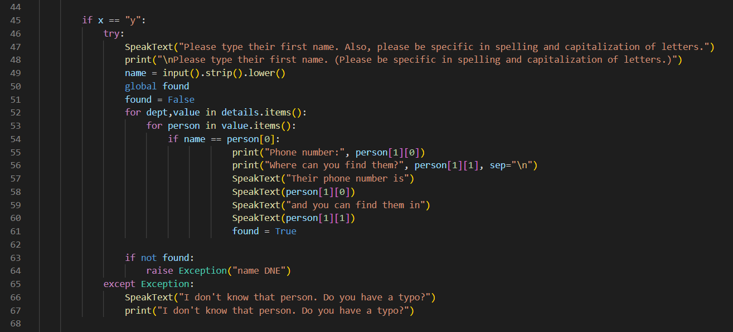

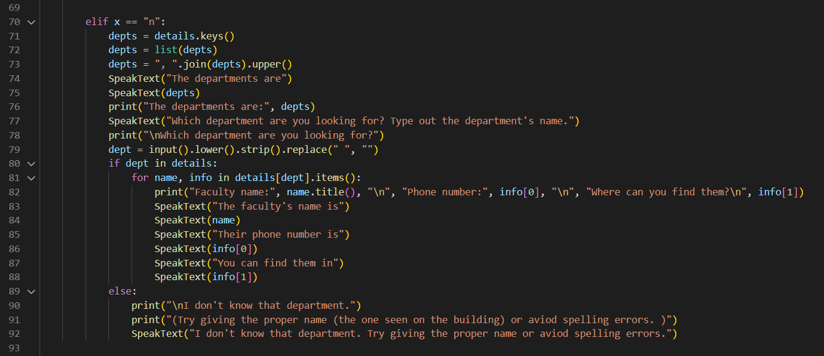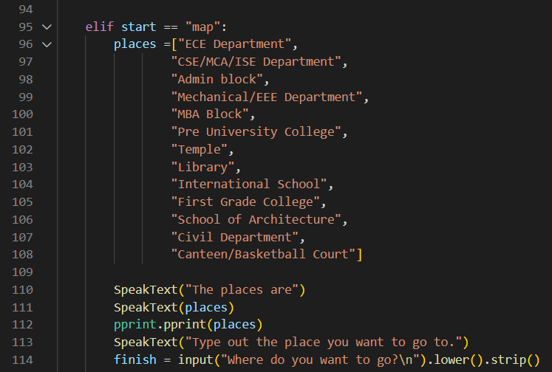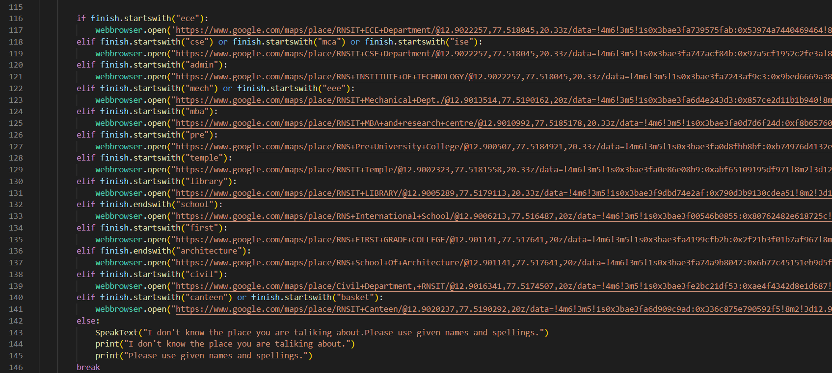

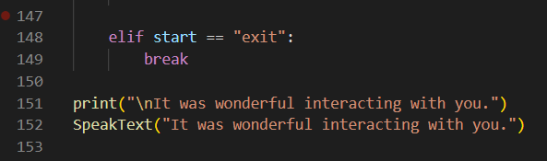

Output

