Invention Disclosure Details

Name and Address of APPLICANT:

Name | Department/Address
MANIPAL UNIVERSITY JAIPUR | Jaipur-Ajmer Express Highway, Dehmi Kalan, Near GVK Toll Plaza, Jaipur, Rajasthan 303007

Name and Address of Inventor:

Name of the Inventor | Nationality | Country of Residence | Address (Please include department name, University Address | Signature (specimen) | Gender(M/F)
Ananya Sharma | Indian | India | B.Tech-CSE/ MANIPAL UNIVERSITY JAIPUR, Bagru, Rajasthan, India- 303007 |  | Female
Ms. Babita Tiwari | Indian | India | Dept Of CSE / MANIPAL UNIVERSITY JAIPUR, Bagru, Rajasthan, India- 303007 |  | Female

DETAILS OF THE PUBLICATION/COMMUNICATION/EXHIBITION IN WHICH THE INVENTION WAS DISCLOSED PRIOR TO PATENT FILING IN PUBLIC DOMAIN.
Response:
TITLE:
Hybrid AI-Based Adaptive Weather-Cluster Forecasting System for Accurate Short-Term Solar Energy Prediction

ABSTRACT
The major issue in this field is that solar forecasting is a challenging task, and it is enhanced with the rapid changes of irradiance caused by the dynamics of the clouds and temporary meteorological turbulence. Modern artificial-intelligence and deep-learning systems are generally based on one forecasting model or require serious computing power, which encumbers real-time flexibility in changing weather patterns [3], [6]. In these regards, this article aims to fill these gaps by proposing a new Architecture-Based Weather-Classification Long-Short-Term Memory (AWC-LM) system that independently classifies weather patterns based on solar irradiance observations including sunny, intermittent cloud, overcast, and others and works out the accurate short-term power forecasts through the specific models of each class [9].
The system is made to identify clusters immediately, switch to the best model in real time and establish a lightweight error-correction loop which keeps the accuracy high even under sudden changes in irradiance. The choice of retraining enables refinement of the results, which is continuously overseen without placing a heavy load of calculations on the computer, thus making the framework for small to medium-scale solar forecasting applications. [5], [7].
An operational model prototype of the AWC-LM model has been achieved which is more accurate as compared to other traditional single model forecasting models. This contribution promotes the objective of intelligent grid integration and improves the stability of the renewable energy systems in harsh operating conditions.
The proposed system is implemented as a software-based forecasting pipeline designed to operate using standard computational resources without reliance on specialized hardware.

What problem was solved by the invention? Provide a brief review of literature and how your invention is different from others.
Predictability of solar energy has received much research interest owing to the fact that solar irradiance is highly variable; this is because of the mobility of clouds, fluctuate in temperature and atmospheric conditions. The real-time forecasting is critical to the successful operation of the grid, energy planning, and the reliable incorporation of renewable energies. The number of artificial intelligence-based methods that have been suggested to enhance prediction accuracy in varying weather conditions has been increasing over the years. The following are some of the major works that exist and are applicable to this project.
Patent US2017031056A1 This patent describes a solar power forecasting system that uses machine learning to estimate the output of individual photovoltaic inverters and combines them to obtain total power generation. However, the system uses fixed prediction models and does not adapt to changing weather patterns through behavior-based clustering or dynamic model selection.

Patent CN120123984A describes a solar radiation forecasting method that combines a data decomposition algorithm with the GraphCast deep learning model to improve prediction accuracy. While the approach is effective in modeling complex weather patterns, it relies on computationally intensive deep learning architectures and does not support behavior-based clustering, real-time model switching, or lightweight adaptive forecasting.
Based on the literature overview, it could be noted that current solutions enhance the level of disaggregated solar energy forecasting with the help of hybrid models and deep learning methods, or IoT systems. Notably, though, the majority of them are computationally expensive, hardware-specific, or utilize fixed forecasting models. The absence of real-time behavior-aware flexibility of existing systems demonstrates the necessity of a lightweight and adaptable forecasting system that has the ability to retain sufficient short-term prediction quality using different solar conditions.

My system is different because:
- It clusters solar behaviour into patterns such as sunny, intermittent-cloud, and overcast-something that most models do not handle explicitly.
- It uses a different lightweight ML model for each behaviour rather than forcing a single model to handle all conditions.
- It adds a light error-correction loop to keep predictions accurate during sudden fluctuations.
- It employs selective retraining; it updates only the weak model instead of retraining the entire system.
- It carries out real-time model switching, selecting the best model immediately in terms of current conditions-a function that no previous research has implemented.
Proposing a new Architecture-Based Weather-Cluster Adaptive Forecasting system (AWC-LM), which can address the above limitations by adding real-time adaptivity, absent in current systems.
This is computationally efficient, unlike the deep-learning architectures that require GPUs and heavy processing. Due to this adaptive, behaviour-aware design, the invention has higher accuracy, better stability, and more practical real-world performance compared to either traditional or deep-learning-only systems.

ADVANTAGES OF THE INVENTION / What are the technical breakthroughs / surprising results/cost advantage achieved through the invention?
The invention provides many worthwhile benefits that enhance the reliability and accuracy of solar forecasting. The system produces short-term forecasts that are notably accurate and stable as the system learns and adapts the current operational behaviour of the weather. The invention considers an adaptive, cluster-based forecasting system that has not been evident in previous studies and offers a unique technical improvement.
Encompassing many advantages, the invention includes:
- The system allows very precise short-term predictions of the sun, especially because most of the currently existing models cannot make predictions with the right level of accuracy in the case of rapidly moving clouds and in unpredictable weather.
- The system will dynamically alternate between behavioural clustering and real time model switching which results in the ability of the system to behave in a different manner under sunny, cloudy and overcast conditions thus providing a better accuracy compared to the previous studies.
- The use of lightweight machine-learning models, enforced by the invention and imposing much lower compute demands than deep-learning methods, is another benefit as it allows the forecasting system to operate in real time, as well as on low-power platforms.
- The saving in costs and usage of other resources is that the invention results in less forecasting errors without the use of costly sensors, imaging, or Internet of Things networks, which would provide a clear cost benefit over systems based on hardware.
- In addition, the dynamic, adaptive error rectification mechanism in the system has increased stability and predictive integrity of forecasts during fast changes and thus is better than the previously benchmarked ML forecasting system.
- Selective retraining regime gives the model different learning behaviours.
- The tuned and retrained models of the different types of clouds as shown in the results section still gave out results as the observational and true solar generation, although as error correction adjustments were made to the results; erratic forecasting tendencies were indicated as initially concluded and provided to give a framework on what actually needs to be done in further enhancement.

SALIENT FEATURES OF THE INVENTION / What in your view is unique about the present invention?

Some of the salient features of the invention are:

• The present invention introduces an adaptive behavior-based forecasting system that reacts differently under sunny, intermittent-cloud, and overcast conditions, instead of relying on one static model for all scenarios.
• It deploys the use of behavior clustering in concert with lightweight ML models, a uniquely hybrid approach that is rarely applied within existing solar forecasting research.
The invention performs real-time model switching, immediately choosing an optimal prediction model in response to the current behavior of the sun with a significant increase in short-term accuracy.
• Unlike deep-learning-heavy systems, the invention maintains strong performance while being computationally efficient and is thus deployable in real time on low-power devices and small solar setups.
It features an adaptive error-correction mechanism that continuously updates the prediction based on the recent deviations, providing the system with high stability even during rapid irradiance variations.
It applies a selective retraining workflow whereby only the low-performance cluster model is updated rather than retraining the complete system to save cost, time, and computation.
• It does not require expensive sensors, cameras, or IoT hardware; hence, it becomes far more affordable and accessible than picture-based and sensor-dependent forecast approaches.
• The framework is designed to enable seamless integration at rooftop, as well as plant-level solar installations with scalable and flexible options for different users.
• The invention is implemented as a modular software pipeline, enabling future extension into a web-based visualization or forecasting interface.
• This concept has already been proven through a functional prototype that does clustering, model selection, forecasting, and error correction in one pipeline. It represents a unique combination of adaptability, lightweight computation, and high accuracy compared to the broader class of existing solar forecasting approaches.

METHODOLOGY ADOPTED and RESULTS
The methodology adopted and the results obtained by the invention are as follows:
- An operational prototype of the AWC-LM solar forecasting system was developed to demonstrate the whole working flow, which includes the data preprocessing, clustering behaviour models, model selection, and the production of predictions. The underlying structure of an adaptive, condition-sensitive forecasting was confirmed by this exercise.
- Python based tools were used to implement the system to preprocess data, live decode, cluster and train models. They used K -Means clustering to categorize solar behaviour into sunny, intermittent-cloud, and overcast regimes and trained lightweight machine-learning models (Linear Regression, Random Forest, and Gradient Boosting) to each cluster.
- A near real-time or streaming data simulation cluster detection system was added to determine the present condition of the sun, in accordance with the incoming data characteristics such that the system can choose the model that is the most relevant to the identified weather.
- Some of the methods involved, include developing an adaptive error-corrective layer which modifies predictions due to new deviations hence providing consistent and sound short-term predictions even within the rapidly evolving situations.
- This resulted in a mechanism of selective retraining that is designed to specifically retro train the poorly functioning cluster-specific model and keep the full system re-trained thus saving computational load thus making the invention practical to deploy in the field.
- It was an end- to-end workflow that was packaged to include data input, followed by clustering, model training, prediction, correction and monitoring.

The results obtained by the invention are as follows:
• The prototype succeeded in demonstrating all aspects of the AWC-LM forecasting pipeline: the system can pre-process data, classify solar behaviour, and make accurate short-term predictions in real time.
• Testing confirmed that behaviour-based clustering is a practical and effective alternative to using a single forecasting model, giving the system higher stability during sudden irradiance changes.
• The adaptive model-switching approach demonstrated scalability and was compatible with standard solar datasets, not requiring any specific hardware, like sky cameras or IoT sensors.
• The invention showed that lightweight ML models, in conjunction with real-time cluster detection and error correction, can achieve forecasting accuracy equal to heavier deep-learning methods but with significantly lower computational cost.
• Clearly, the system greatly improved prediction reliability for intermittent-cloud periods where most models tend to fail, proving its utility to grid operators, managers of solar plants, and researchers requiring accurate short-term forecasts.
The results are based on controlled datasets and simulated real-time conditions, and further improvements can be achieved through extended datasets and deployment-based testing.

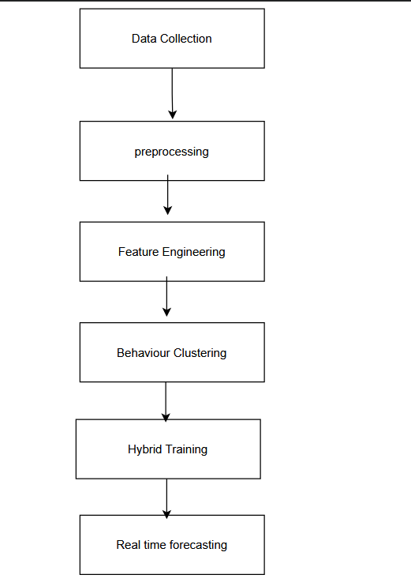

Figure 1: Flowchart representation of the Hybrid AI-Based Adaptive Weather-Cluster Solar Forecasting System.

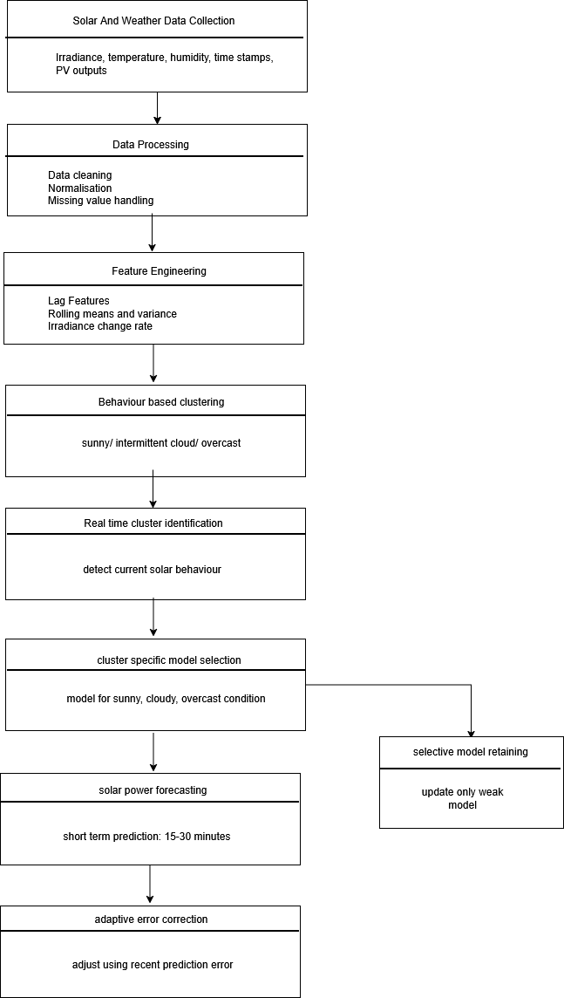

Figure 2: Detailed analysis of flowchart of Hybrid AI-Based Adaptive Weather-Cluster Solar Forecasting System.

References:

[1] Egbuna, I. K., Salihu, F. B., Okara, C. C., & Olayiwola, D. E. (2025). Advances in AI-powered energy management systems for renewable-integrated smart grids. World Journal of Advanced Engineering Technology and Sciences, 15(2), 2300-2325. https://doi.org/10.30574/wjaets.2025.15.2.0685
[2] Sharif, A. A. (2021). AI-Powered Renewable Energy Forecasting: A Hybrid Deep Learning and Physics-Based Model for Solar and Wind Energy Prediction in Smart Grid Applications. International Journal of Emerging Trends in Computer Science and Information Technology, 2(2), 1-7.
https://doi.org/10.63282/3050-9246.IJETCSIT-V2I2P101
[3] Shan, S., Ding, Z., Zhang, K., Wei, H., Li, C., & Zhao, Q. (2023). ACGL-TR: A deep learning model for spatio-temporal short-term irradiance forecast. Energy Conversion and Management, 284, 116970.
https://doi.org/10.1016/j.enconman.2023.116970
[4] Ukoba, K., Olatunji, K. O., Adeoye, E., Jen, T. C., & Madyira, D. M. (2024). Optimizing renewable energy systems through artificial intelligence: Review and prospects. Energy & Environment, 35(7), 3833-3879.
https://doi.org/10.1177/0958305X241256293
[5] Khan, N., Khan, S. U., Ullah, F. U. M., Lee, M. Y., & Baik, S. W. (2023). AI-assisted hybrid approach for energy management in IoT-based smart microgrid. IEEE Internet of Things Journal, 10(21), 18861-18875.
https://doi.org/10.1109/JIOT.2023.3293800

[6] adjal, B., Nadour, M., Bechouat, M., Hadroug, N., Sedraoui, M., Rabehi, A., ... & Agajie, T. F. (2025). Hybrid deep learning CNN-LSTM model for forecasting direct normal irradiance: a study on solar potential in Ghardaia, Algeria. Scientific Reports, 15(1), 15404. https://doi.org/10.1038/s41598-025-94239-z

[7] Zhou, H., Liu, Q., Yan, K., & Du, Y. (2021). Deep learning enhanced solar energy forecasting with AI‐driven IoT. Wireless Communications and Mobile Computing, 2021(1), 9249387.
https://doi.org/10.1155/2021/9249387

[8] Mariappan, Y., Ramasamy, K., & Velusamy, D. (2025). An optimized deep learning-based hybrid model for prediction of daily average global solar irradiance using CNN SLSTM architecture. Scientific Reports, 15(1), 10761.
https://doi.org/10.1038/s41598-025-95118-3

[9] Dissawa, L. H., Godaliyadda, R. I., Ekanayake, P. B., Agalgaonkar, A. P., Robinson, D., Ekanayake, J. B., & Perera, S. (2021). Sky Image‐Based Localized, Short‐Term Solar Irradiance Forecasting for Multiple PV Sites via Cloud Motion Tracking. International Journal of Photoenergy, 2021(1), 9973010.
https://doi.org/10.1155/2021/9973010

Patent US2017031056A1
Inventors: VEGA-AVILA ROLANDO [US]; KRISH-NASWAMI HARIHARAN [US]; NUMMIKOSKI JARO [US]

Patent CN120123984A
Inventors: LU XIANGHUI; YAN ZIHUANG; WU LIFENG

