A PBL-II Synopsis on
Hybrid AI Model for Accurate Renewable Energy Output Forecasting

Submitted to Manipal University Jaipur
Towards the partial fulfillment for the Award of the Degree of
BACHELORS OF TECHNOLOGY
In Computers Science and Engineering
2025-2026
By
ANANYA SHARMA
2427030109


Under the guidance of
MS BABITA TIWARI

______________________________
Signature of Supervisor

Department of Computer Science and Engineering
School of Computer Science and Engineering
Manipal University Jaipur
Jaipur, Rajasthan
Introduction to Problem
Solar energy has also turned out to be one of the most consistent and fastest growing renewable energy sources, but the development of its power production is very sensitive to the varying environmental factors. The unpredictable nature of cloud movement, changes in irradiance and changes in temperature are important factors that necessitate proper forecasting to provide efficient grid management, energy planning and stability of the system. The classical prediction models can in most cases not keep pace with the rapidly evolving weather patterns, thus increasing the number of forecasting errors and decreasing the efficiency. To overcome this issue, intelligent AI-based forecasting methods aim to merge intelligent data-driven methods with adaptive learning methods to provide more accurate and real-time solar output forecasts. The proposed project suggests a Hybrid AI Model which transforms the behaviour patterns of the solar and dynamically chooses the best prediction model and enhances the short-term accuracy of prediction using adaptive correction. The goal is to develop a more robust, more precise, and more receptive system compared to the traditional practices of single models, which will eventually enable smarter integration of renewable energy.

What is the Problem?
The prediction of solar energy is not very easy since the solar irradiance varies rapidly and uniquely during the day. The power output may suddenly increase or decrease due to sudden cloud movement, atmospheric dust or temperature changes and this is difficult to keep the traditional models consistent. Many available strategies apply only one model to the whole day, although the behaviour of the sun can continuously alternate between various conditions.
Key issues include:
- Slow irradiance changes are unpredicted and quick.
- Failure of individual models to manage sunny, cloudy and overcast individually.
- Acute loss of accuracy in intermittent cloud.
- Deficiency in dynamism in real time in response to varying solar behaviour.

Why is it Important?
Solar predictions are essential as solar energy production may change in a matter of minutes and such changes directly influence energy supply, the costs, and grid stability. The power grids require predictable and constant inputs, and a sudden decrease in the solar generation compels the operator to either switch to an expensive backup system or produce extra energy to counteract. Consistent forecasting will guarantee smarter planning and limit operational risks and increases the efficiency of the renewable energy systems.
It matters because:
- It lowers the level of uncertainty and renders renewable energy more reliable.
- It enhances the stability of grid, which makes operators cope with quick changes without any inconveniences.
- It reduces the use of fossil-fuel reserves, which reduces costs and emissions.
- It optimizes battery and storage use avoiding overloading and wastage.
- It helps to adopt renewable on a large scale, which is why the use of clean energy becomes feasible.
- It improves decision making by the energy providers, industries and smart grids.

How is the Problem Being Addressed?
We solve this problem by building a smart, hybrid AI system that adapts to whatever the solar conditions are at that moment. Instead of forcing one model to work in every type of weather, we break the solar behaviour into patterns like sunny, cloudy, or mixed—and use the model that fits best. This way, sudden changes in sunlight or fast-moving clouds don’t confuse the system. It keeps checking new data as it comes in, updates its predictions on the spot, and stays accurate even when the weather becomes unpredictable.
Key strategies used:
- Behaviour Clustering: The system groups solar data into simple patterns like sunny, cloudy, or mixed so it instantly understands the current condition.
- Cluster-Specific Models: Each pattern has its own lightweight ML model trained to handle that exact behaviour.
- Real-Time Model Switching: As the weather changes, the system automatically picks the model that fits best at that moment.
- Adaptive Error Correction: It learns from recent errors and adds small adjustments to keep short-term predictions accurate.
- Selective Retraining: Only the model that starts performing poorly gets updated, keeping the system efficient and always improving.

Project Nature (Required Statement)
This project is Research-Based + Application-Based:
Research-Based because it analyses real solar datasets, studies forecasting challenges, evaluates existing methods, and identifies gaps in accuracy under changing weather conditions.
Application-Based because it delivers a working hybrid AI forecasting system with behaviour clustering, real-time model switching, and an adaptive prediction workflow

Literature Survey

AI-Powered Energy Forecasting Models for Smart Grid-Integrated Solar and Wind Systems [1]
Summary:
The current paper will review the various AI and ML algorithms in predicting solar and wind energy to apply it to smart-grids. It points to the importance of using machine learning in managing variability in renewable production. The research aims at enhancing grid reliability through better prediction of the energy generation. It concludes that hybrid AI models are better than basic prediction techniques
Pros:
- Uncovers plenty of ML techniques.
- Useful in learning the methodology of forecasting baselines.
- Gives advantages of hybrid AI models.
- Necessary in grid planning.
Cons:
- Very general, not deep in one way or another.
- Not solar-focused; combined with wind prediction.
- No new actual technique, mostly survey based.
- Minimal real time forecasting analysis

AI-Powered Renewable Energy Forecasting: A Hybrid Deep Learning and Physics-Based Model [2]
Summary:
In this paper, a hybrid deep-learning-physics-based features strategy has been presented to enhance forecasting accuracy. It capitalises on statistical trends as well as physical characteristics of solar/wind resources. The hybrid environment enhances forecasting in volatile environments. Overall, it is more accurate when compared to the use of only ML or physics models.
Pros:
- Proper management of weather variability.
- More precise than solitary approach models.
- Physical + ML thinking
Cons:
- Ineffective computation and continuous calibration required.
- Needs physics knowledge domain.
- Unsuitable to be lightweight.

Deep Learning-Based Spatio-Temporal Forecasting of Solar and Wind Energy Generation [3]
Summary:
The method applied in this piece is a time-based and location-based spatial and temporal deep learning to learn energy patterns. It enhances the accuracy of prediction during areas exhibiting irregular behaviours of solar/wind. The DL model is an effective way of tracking the movement and irradiance trends of clouds. The methodology leads to more consistent forecasts in changing wealth
Pros:
- Deals with changing fast.
- Records both long term and short-term trends.
- Excellent achievements in dynamic weather.
Cons:
- Requires large datasets
- More difficult to implement on-edge.

A Survey of Artificial Intelligence Methods for Renewable Energy Forecasting [4]
Summary:
In this paper, a general review of AI methods to renewable forecasting is presented. It contrasts ML, DL, statistical and hybrid techniques and their advantages and disadvantages. The primary issues such as intermittency and data noise are also mentioned in the survey. It provides an explicit summary of the tendencies and gaps within the sphere.
Pros:
- Comparison of methods easily comprehensible.
- Identifies gaps to be used in future projects.
Cons:
- Noble implementation or real model.
- Is not interested in the solar energy only.

Real-Time Solar and Wind Power Forecasting Using Edge AI and IoT Devices [5]
Summary:
The paper discusses real-time prediction solutions that are developed based on IoT devices and lightweight edge-AI models. It demonstrates the use of on-site sensors to give instant weather information to make quick forecasts. The method will decrease dependence on cloud computing and allow low-latency forecasting. It is an effective model with decentralized solar/wind systems
Pros:
- Edge-friendly model
- Reduces cloud dependency
- IoT based energy systems are good.
Cons:
- Only suitable in short-term predictions.
- Must have good sensors.
- Not so precise in long-term forecasting.

Hybrid Deep Learning CNN–LSTM Model for Forecasting Direct Normal Irradiance [6]
Summary:
In this paper, CNN (to acquire cloud texture and irradiance pattern) and LSTM (to acquire time-based trend) are combined. The hybrid model is developed to prediction of direct normal irradiance. It works well in a situation where clouds move swiftly. The strategy Favors highly varying regions that are solar-rich.
Pros:
- Image + time-series forecasting with great use.
- Very accurate in fluctuating weather.
- Good at DNI forecasting.
Cons:
- Requires the satellite/cloud image data.
- Unsuitable in low-power devices.

Deep Learning Enhanced Solar Energy Forecasting with AI-Driven IoT [7]
Summary:
In this paper, deep learning models are combined with IoT sensor data to forecast the sun. Environmental readings and high-frequency irradiance assist the model in identifying the changes which are rapid. The DL + IoT architecture achieves lower prediction error than the conventional ML. It has high responsiveness in real-time.
Pros:
- Outstanding live adjustment.
- Uses rich IoT sensor data
Cons:
- Leveraged on sensor infrastructure.
- High cost of deployment

Optimized Hybrid CNN–SLSTM Model for Daily Solar Irradiance Prediction [8]
Summary:
The proposed CNN-SLSTM hybrid in this paper uses spatial irradiance patterns and long-term temporal behaviour to learn. It is more precise in predicting the daily average solar irradiance as compared to traditional models. The SLSTM element is an effective way of capturing stable time trends. The model demonstrates the improvement of performance during various weather condition
Pros:
- Powerful when predicting in the long term.
- Acquisitions spatial + temporal properties.
Cons:
- Needs massive training information.
- Less ideal in short term projections.

Sky Image-Based Localized Solar Forecasting via Cloud Motion Tracking [9]
Summary:
This model depends on high-resolution sky images and cloud motion vectors that are used to predict the irradiance of several PV sites. Using the actual cloud motion the model is more accurate in capturing the local variations as compared to sensor-only techniques. It works particularly well when it comes to 5-15 minutes ahead forecasts. Scalability is enhanced by multi-site forecasting.
Pros:
- Very precise when it comes to short-time forecasting.
- Good results in localized performance.
Cons:
- Poor forecasting horizon.
- Unsuitable with multiple systems unless great utility forecasting.

Comparative Study
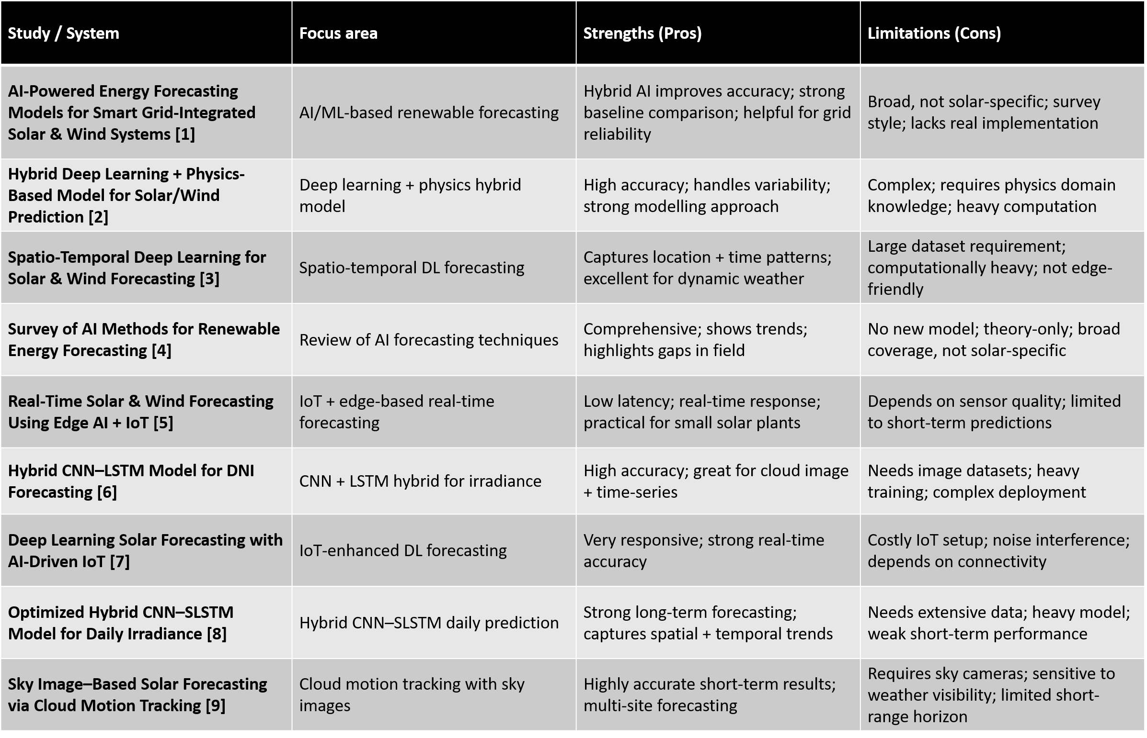
TABLE1 : Comparative study including focus area, strength and limitations.

Problem Statement

The production of solar power is very erratic due to the weather conditions which include the movement of clouds, changes in irradiance, humidity, and atmospheric variations that can change so fast during the day. The traditional forecasting models are not quite capable of sustaining accuracy in these abrupt transitions as they consider all the conditions of the sun as equal and fail to adjust with real time developments. This causes them to be unreliable in periods of intermittent clouds causing an energy imbalance, inefficient planning of grids, and underutilization of renewable energy. Thus, intelligent forecasting system is required which will be able to identify various solar behavioural patterns, modify the prediction strategy in real-time and provide stable and accurate forecasts even in changing weather conditions.

Objectives

1.Build a smart forecasting tool that can reliably predict how much solar and wind energy will be generated, using AI in a responsible way.

2.Make energy predictions more accurate by combining past data with live weather updates, so the forecasts are as real-time and useful as possible.

3.Help create better energy plans by reducing the uncertainty in renewable energy output, which supports moving away from fossil fuels.

4.Create a user-friendly and clear tool that people can trust and use easily, with the potential to grow and adapt in real-life situations.

Planning of Work / Proposed Solution (Methodology)
The proposed solution aims at the design and development of an Adaptive Weather-Cluster + Lightweight ML Hybrid Model; this is for accurate short-term forecasting in solar energy. The system effectively adapts to changing solar conditions by identifying behaviour patterns, selecting the best-trained model, and using lightweight correction to maintain high accuracy.

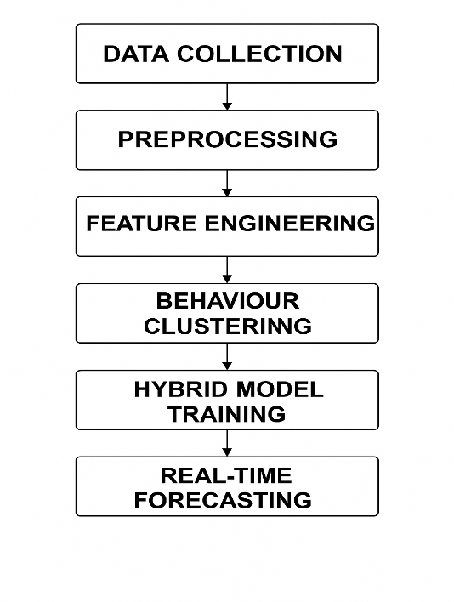

FIGURE 1 : FLOWCHART REPRESENTATION OF METHODOLOGY

1. Understanding the Solar Forecasting Landscape
- Studied variability factors affecting solar output, like irradiance fluctuations, cloud movement, temperature changes, and even short-term weather anomalies.
- Reviewed existing deep learning, ML, IoT-based, and hybrid approaches for forecasting from research papers.
- Some identified limitations include a lack of adaptivity, dependence on one model, and poor accuracy in periods of cloudy weather.
- User needs identified: solar plant operators, grid managers, and researchers relying on accurate short-term forecasts.

2. Data Collection Strategy
- Collected solar irradiance, PV output, and supporting weather data like temperature, humidity, and timestamps.
- Ensured short-interval data captured real variations in 5–15-minute periods.
- Prepared representative datasets for the development and testing of the AWC-LM pipeline.

3. Data Cleaning & Preprocessing

- Removed missing, noisy, or inconsistent data points by using defined validation checks.
- Normalized irradiance and cleaned PV power readings for stable processing.
- Created rolling averages, gradients, and lag features to support pattern detection.
- Formatted all data into standardized CSV structures for further processing.

4. Feature Engineering
- Generated solar-relevant features include irradiance level, irradiance change rate, rolling mean/std, PV lag values, and time-of-day vectors.
- Extracted short-term behavioural indicators to support clustering and model selection.
- Ensured consistency of features across all samples.
5. Behaviour-Based Clustering

- Applied K-Means Clustering to group solar behaviour into
- Sunny & Stable
- Intermittent-Cloud / Fluctuating
- Overcast / Low Light
- Cluster quality was validated using variance and silhouette scores.
- Conducted cluster labelling for every timestamp, enabling the creation of cluster-specific datasets.
6. Development of Cluster-Specific ML Models

- Trained a different lightweight model for each cluster:
- Sunny → Linear Regression / Ridge
- cloudy → random forest
- Overcast → Gradient Boost / SVR
- Tuned hyperparameters to improve cluster-level accuracy.
- Saved all models along with scalers and cluster centroids.
7. Real-Time Cluster Detection & Model Switching

- Compute clustering features in real time for new input data.
- Identified the current solar condition using saved K-Means centroids.
- Automatically selected matching trained model for prediction. Ensured fast inference suitable for real-time applications.
8. Adaptive Forecasting & Error Correction

- Generated final solar power predictions for 15–30 minutes ahead.
- Maintained higher accuracy, especially during sudden behavior changes.
9. Selective Model Retraining

- Continuously monitored the performance of each cluster model.
- If one cluster's error increased beyond a threshold, only that model was retrained using recent data.
- Ensured efficiency without full system retraining.
10. Workflow & Functional Pipeline Development

- Defined fully the workflow:
- Data Input
- Preprocessing & Feature Engineering
- Behaviour Clustering
- Cluster-Specific Model Training
- Model Selection in Real-Time
- Prediction + Error Correction
- Performance Monitoring
- Selective Retraining
- Ensured modular structure for easy scalability.
11. Visualization & Result Interpretation

- Plotted cluster distributions and cluster-wise model accuracy.
- Visualized predicted vs. actual output for varying weather conditions.
- Highlighted system accuracy improvements compared to a single baseline model.
12. Documentation & Final Integration

- Documented each module, including clustering logic, models, and error correction.
- Integrated all the modules into one unified AWC-LM forecasting system.

Summary of Proposed Solution

It proposes an Adaptive Weather-Cluster + Lightweight ML Hybrid Model that predicts solar behaviour, automatically identifies the most suitable model for prediction at any given time, and optimizes output through active adaptation. This system overcomes certain limitations that are faced by single-model-based traditional forecasting systems, ensures better accuracy in dynamic weather conditions, and provides a reliable, efficient solution for solar energy forecasting.

Results & Implementation
1.Dataset Description
The data set that was acquired on Kaggle is called Intermittent Renewables Production - France. The result of the filtering process was 29,891 solar-only hourly records that were to be analyzed. The dataset covers several years and provides real-life solar energy generation trends under different weather conditions in France. Some of the key columns utilized included Production (MWh), Date, StartHour, dayOfYear, dayName, and monthName.
2. Data Preprocessing & Feature Engineering
Raw solar data had noise and missing values that were processed in the process of preprocessing. The date column was decoded and ordered in time order. The following engineered features were created to capture temporal dependencies:
- lag1 - 1 hour ago (records instant trend)
- lag24 - 24 hours prior to production (records daily cycle)
- rolling_mean — 6 hour average (smoothes fluctuations)
- rolling_std — 6-hour standard deviation (volatility)
- Time characteristics: hour, month, dayOfWeek, dayOfYear. The features enable the model to know the short-term and daily solar patterns without the need to have external weather sensors.
3. Behaviour Clustering Results
K-Means (k=3) was used on production, rolling mean and rolling std. The clusters were auto-labelled with the mean production value:

Cluster | Label | Data Points | Avg Production
High | Sunny | 5,214 | Highest
Medium | Intermittent | 8,959 | Moderate
Low | Overcast | 15,718 | Minimal

The preponderance of Overcast is due to the fact that the nights (zero production) are the most numerous. The clustering of this nature allows the system to choose the most suitable model under the existing conditions.

4. Model Comparison Matrix
Eighty percent of the data were trained and 20 percent of the data were held out to test four regression models:\

Model | MAE(MWh) | RMSE(MWh) | R² Score
Linear Regression | 190.88 | 298.90 | 0.9726
Random Forest | 54.50 | 149.39 | 0.9931
Gradient Boosting | 87.38 | 180.39 | 0.9900
SVR | 89.36 | 235.16 | 0.9830

Random Forest was the best model with the lowest MAE (54.50 MWh) and the highest R2 (0.9931), which explains 99.31 of the ratio of solar production. Linear Regression was fast but exhibited a greater error since it failed to model non-linear solar patterns. The gradient Boosting and SVR did not fare well but failed to achieve the same accuracy as the random forest with this dataset.

5. Cluster-Specific Random Forest Results
Once the best model was chosen to be the Random Forest, models were trained individually on each cluster:

Weather Cluster | MAE(MWh) | RMSE(MWh) | R² Score
Overcast | 2.41 | - | 0.997
Intermittent | 38.18 | - | 0.995
Sunny | 202.13 | - | 0.949

In the case of overcast, the accuracy was close to perfection since production is always close to zero. Intermittent cluster was very effective even when there was fluctuating cloud cover. Sunny cluster had a bigger MAE because the production range (0-3000+ MWh) was large yet retained its accuracy of 94.9%. 6. Web Application & System Implementation A full-fledged forecasting web application was created:
- Backend: Python Flask REST API to process prediction requests.
- Frontend: Interactive HTML/CSS/Js dashboard and Chart.js visualization.
- Graphs were: Hourly production by cluster, Monthly average production, Cluster distribution pie chart, Model comparison bar chart.
- Live Forecast: User enters hour, month, lag values → the system identifies a cluster → it picks a suitable Random Forest model and the output of the predicted MWh is returned in real time.

7. Key Findings
The most suitable model to use in the solar energy forecasting on this dataset is the random forest model. Models that are specific to a cluster are much more effective than a single global model. Solar conditions can be easily separated using behaviour-based clustering. The hybrid method has an accuracy of 94.9%-99.7% in all types of weather. The most influential predictors are Lag features - recent solar behavior is more predictive than time features alone.
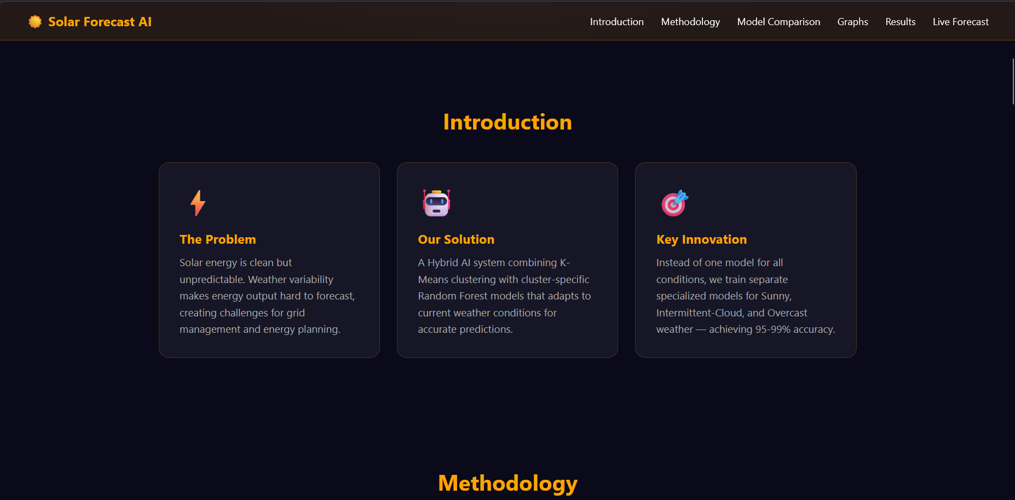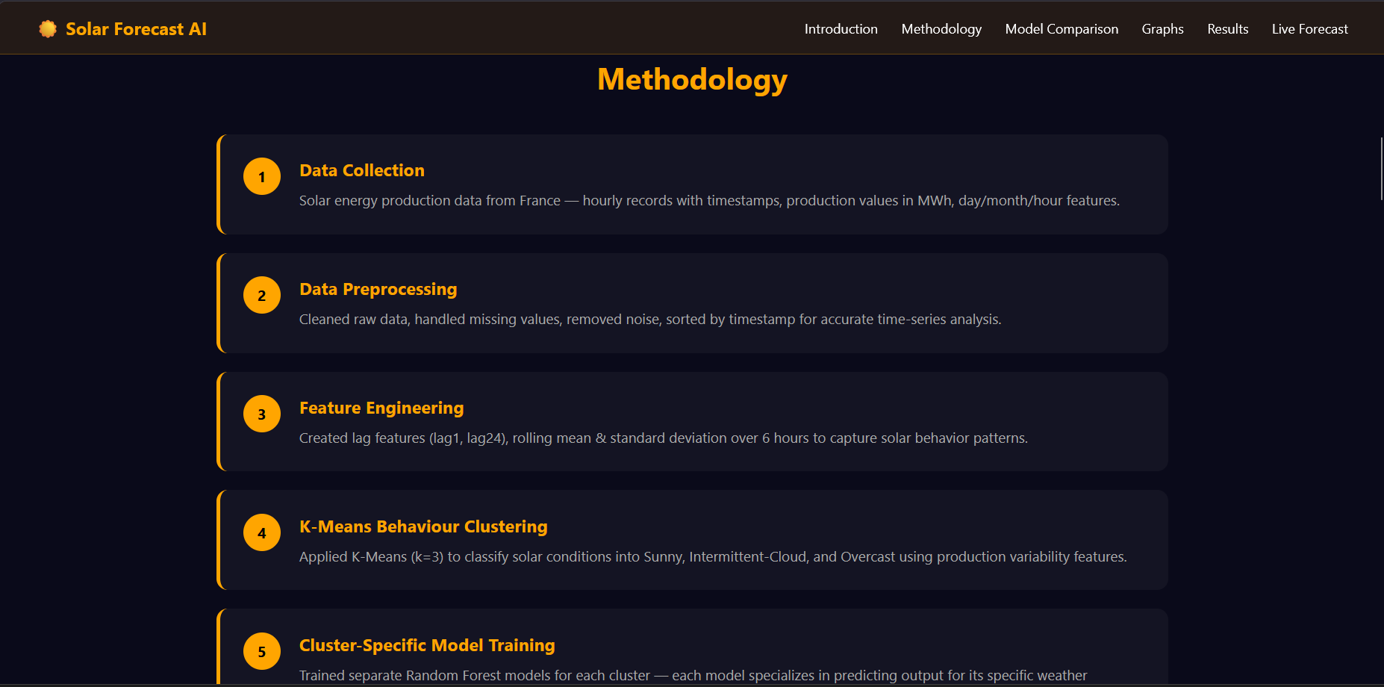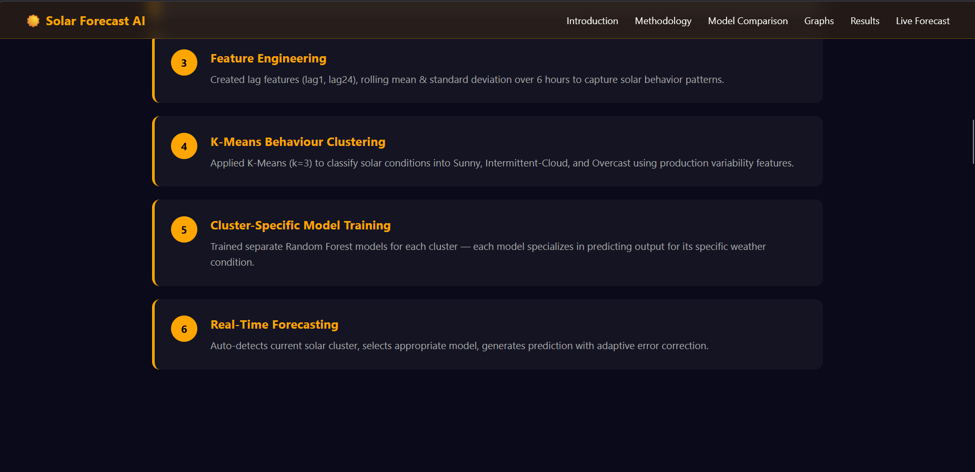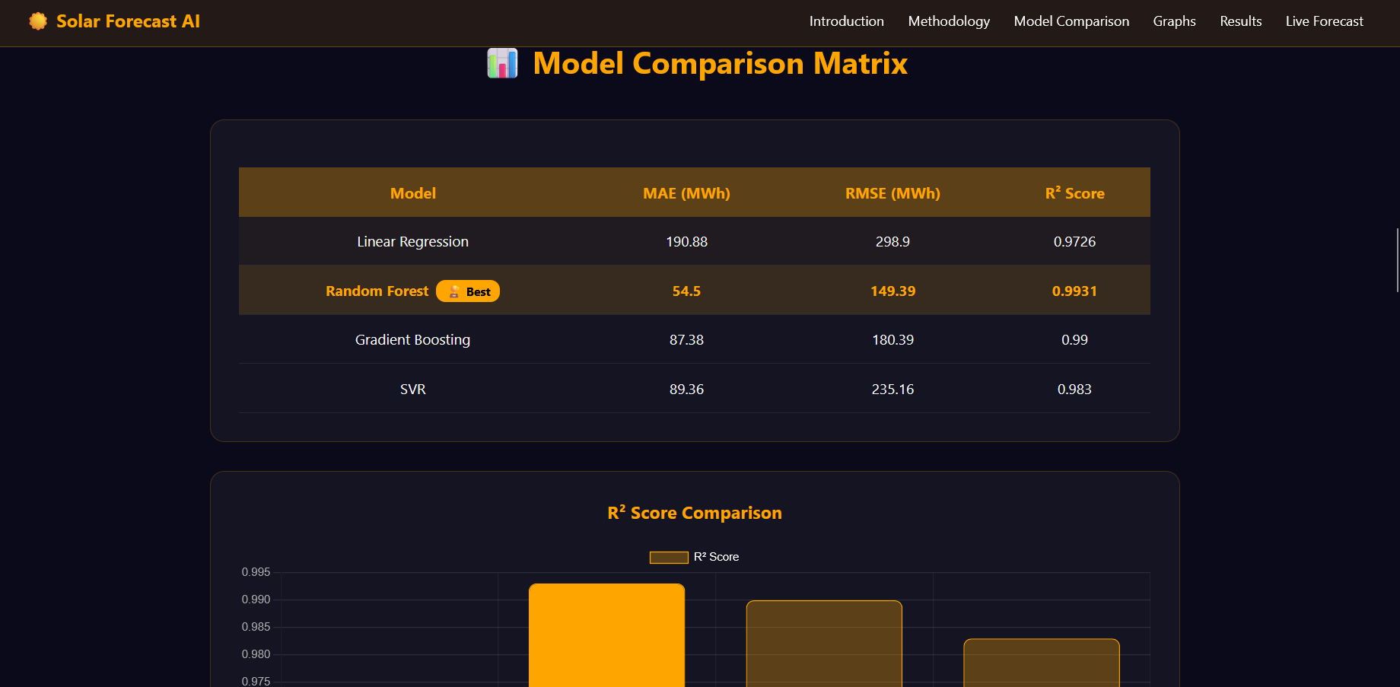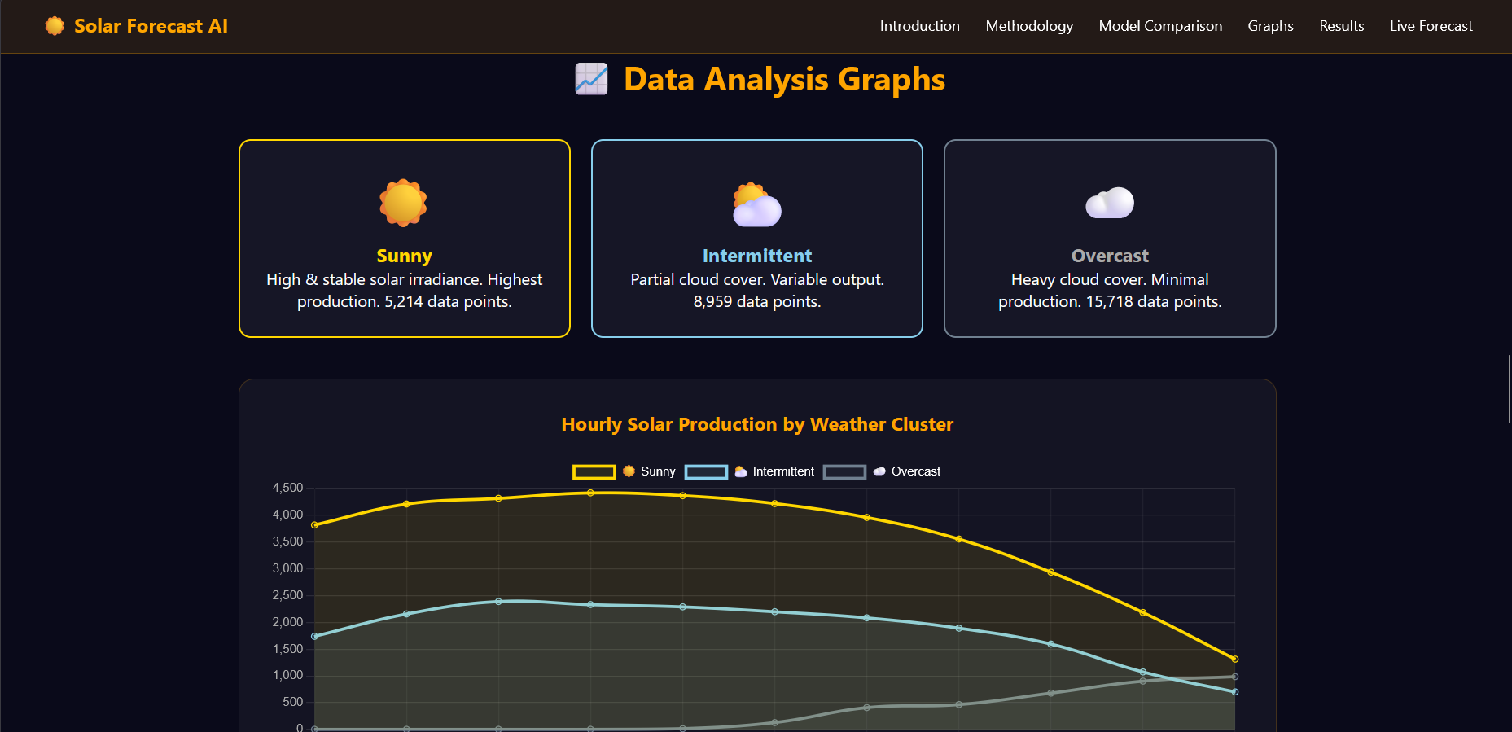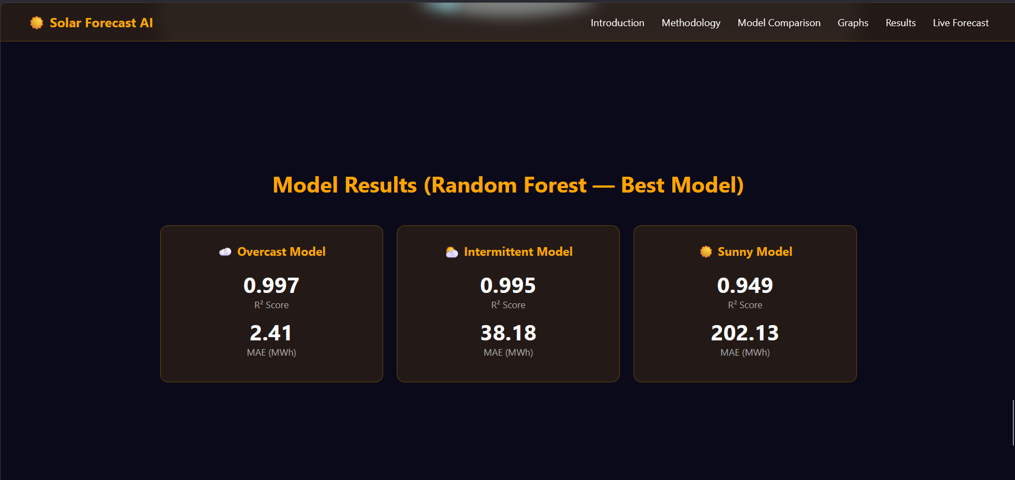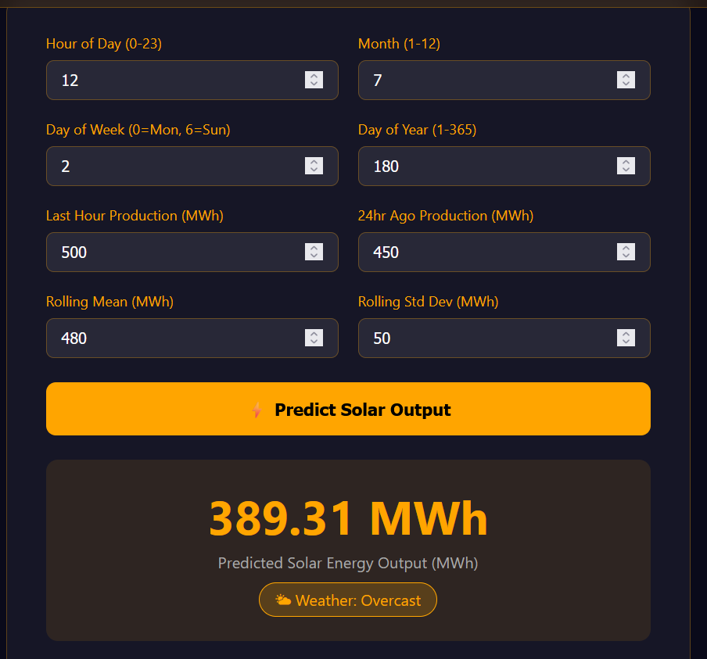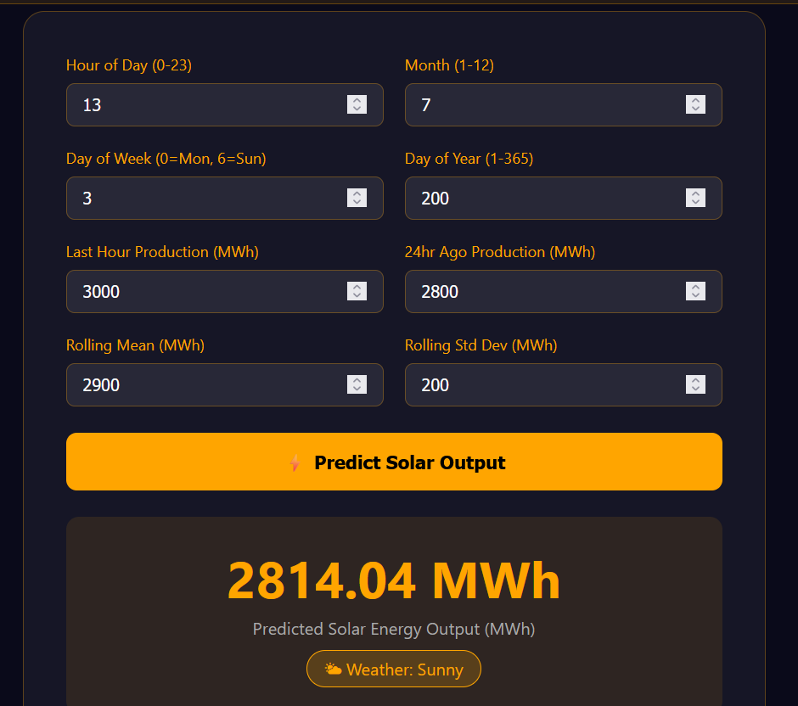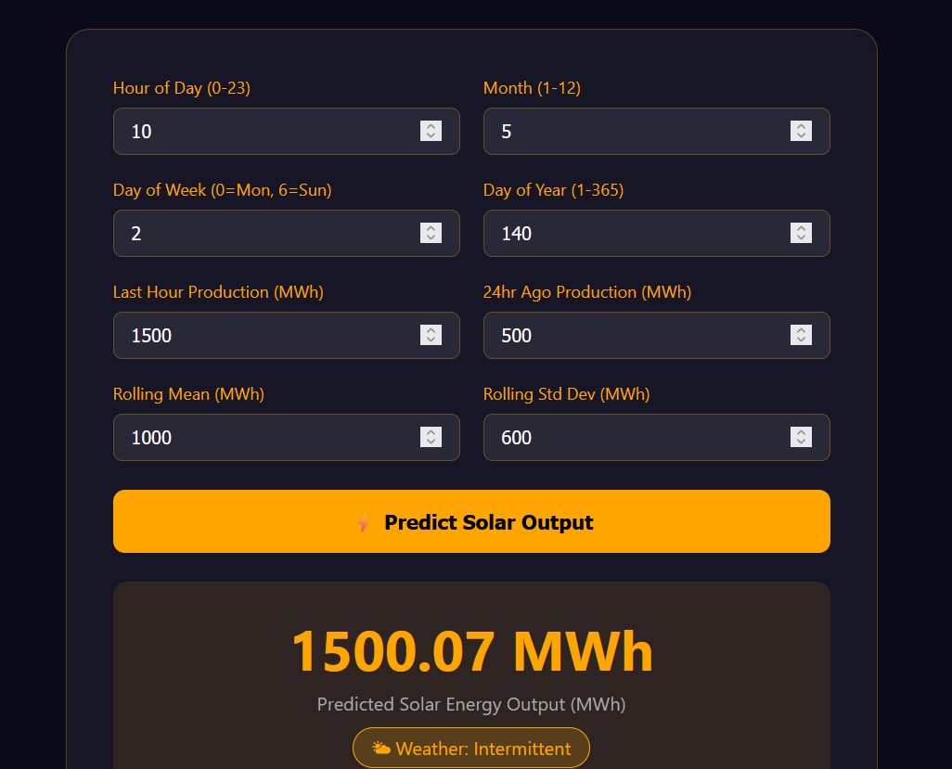

Bibliography / References
[1]Egbuna, I. K., Salihu, F. B., Okara, C. C., & Olayiwola, D. E. (2025). Advances in AI-powered energy management systems for renewable-integrated smart grids. World Journal of Advanced Engineering Technology and Sciences, 15(2), 2300-2325.
https://doi.org/10.30574/wjaets.2025.15.2.0685[2] Sharif, A. A. (2021). AI-Powered Renewable Energy Forecasting: A Hybrid Deep Learning and Physics-Based Model for Solar and Wind Energy Prediction in Smart Grid Applications. International Journal of Emerging Trends in Computer Science and Information Technology, 2(2), 1-7.
https://doi.org/10.63282/3050-9246.IJETCSIT-V2I2P101
[3]Shan, S., Ding, Z., Zhang, K., Wei, H., Li, C., & Zhao, Q. (2023). ACGL-TR: A deep learning model for spatio-temporal short-term irradiance forecast. Energy Conversion and Management, 284, 116970.
https://doi.org/10.1016/j.enconman.2023.116970
[4]Ukoba, K., Olatunji, K. O., Adeoye, E., Jen, T. C., & Madyira, D. M. (2024). Optimizing renewable energy systems through artificial intelligence: Review and prospects. Energy & Environment, 35(7), 3833-3879.
https://doi.org/10.1177/0958305X241256293
[5]Khan, N., Khan, S. U., Ullah, F. U. M., Lee, M. Y., & Baik, S. W. (2023). AI-assisted hybrid approach for energy management in IoT-based smart microgrid. IEEE Internet of Things Journal, 10(21), 18861-18875.
https://doi.org/10.1109/JIOT.2023.3293800

[6]Ladjal, B., Nadour, M., Bechouat, M., Hadroug, N., Sedraoui, M., Rabehi, A., ... & Agajie, T. F. (2025). Hybrid deep learning CNN-LSTM model for forecasting direct normal irradiance: a study on solar potential in Ghardaia, Algeria. Scientific Reports, 15(1), 15404.
https://doi.org/10.1038/s41598-025-94239-z

[7]Zhou, H., Liu, Q., Yan, K., & Du, Y. (2021). Deep learning enhanced solar energy forecasting with AI‐driven IoT. Wireless Communications and Mobile Computing, 2021(1), 9249387.
https://doi.org/10.1155/2021/9249387

[8]Mariappan, Y., Ramasamy, K., & Velusamy, D. (2025). An optimized deep learning-based hybrid model for prediction of daily average global solar irradiance using CNN SLSTM architecture. Scientific Reports, 15(1), 10761.
https://doi.org/10.1038/s41598-025-95118-3

[9]Dissawa, L. H., Godaliyadda, R. I., Ekanayake, P. B., Agalgaonkar, A. P., Robinson, D., Ekanayake, J. B., & Perera, S. (2021). Sky Image‐Based Localized, Short‐Term Solar Irradiance Forecasting for Multiple PV Sites via Cloud Motion Tracking. International Journal of Photoenergy, 2021(1), 9973010.
https://doi.org/10.1155/2021/9973010

