**Movie-Trailer-Website**

A simple movie trailer website project.

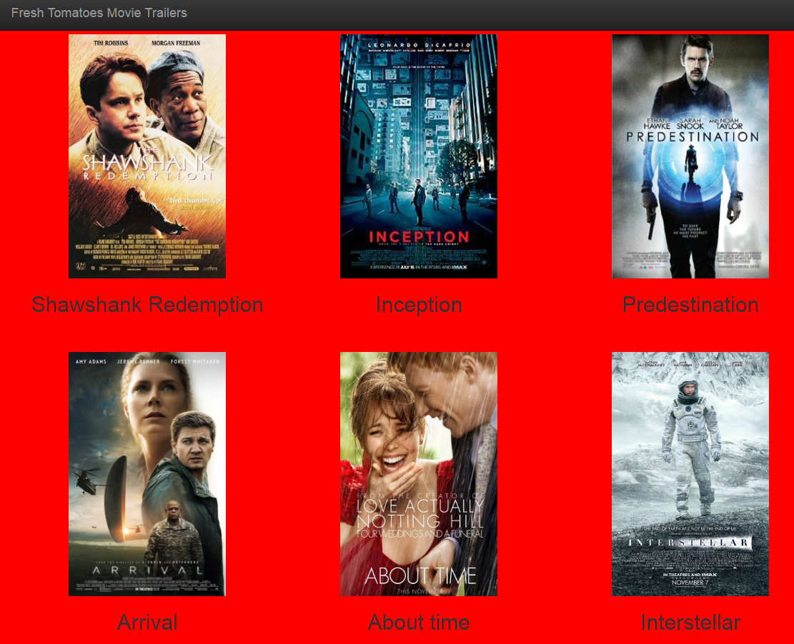

## Table of contents

* [Quick start](https://github.com/edwardbryant/udacity-movie-trailer-project#quick-start)
* [Documentation](https://github.com/edwardbryant/udacity-movie-trailer-project#documentation)
* [Installation](https://github.com/anmolmann/movie-trailer#installation)
* [Usage](https://github.com/anmolmann/movie-trailer#usage)

## Quick Start

After downloading the project files, a movie trailer page can be created by importing [media.py](https://github.com/edwardbryant/udacity-movie-trailer-project/blob/master/media.py) and [fresh_tomatoes.py](https://github.com/edwardbryant/udacity-movie-trailer-project/blob/master/fresh_tomatoes.py) at the start of your Python script. Then create idividual Movie objects by calling media.Movie() and supplying it with four arguments which are movie_title, movie_storyline, poster_image, and trailer_youtube. Lastly, to generate the movie trailers page, call fresh_tomatoes.open_movies_page() and supply it with an array of the movie objects you created.

|  |
| --- |
|  |

## Documentation

This is a server-side code to store a list of your own favourite movies, including box art imagery and a movie trailer URL. This code is then used to generate a static web page allowing visitors to browse their movies and watch the trailers.

## Installation

* Install [Python](https://www.python.org/downloads/) 2.7

## Usage

The project demonstrates the use of a Movie object class in Python to generate a static webpage, which displays a list of favourite movies and links each movie to its trailers video on YouTube. You will understand the role of a simple web server has in receiving a request, executing a block of code and generating a response.