**Project Requirement and Specification**

On

**Home Automation System**

*(CSE core VI Semester Mini Project)*

*2022*



Submitted By :-

Name: Ananya Singh

(CSE-core-G-VI-Sem)

University Roll No. 2014561

Class Roll no. 07

**ACKNOWLEDGEMENT**

I would like to thank Piyush Aggarwal Sir, for providing the resources and believing in me until the completion of this project, and for having faith in me.

Also, I would like to thank my parents for their support and encouragement and for allowing me to reach this far. Last but not the least, my friend Kunal, for helping me with the hardware.

**INTRODUCTION**

The main objective of this project is to develop a home automation system using an Arduino board with Bluetooth remotely controlled by any Android OS smartphone…Modern houses are gradually shifting from conventional switches to a centralized control system, involving remote-controlled switches. Ever thought of a life where you could just command your home appliances to work as you need just by using your voice? Gone are the days when you have to be a billionaire like Tony Stark to have an automated house that is voice-activated. In this short tutorial, I’m going to show you how you can control your electronic appliances like lights using your phone. You can follow this tutorial even if you have no prior knowledge about Programming or Node MCU. So, let’s begin learning Home Automation Using NodeMCU and Google Assistant. Home automation is anything that enables you to use your home’s lighting, heating, and appliances more conveniently and efficiently. It can be as simple as remote or automatic control of a few lights, or it can be a complete system that controls all major parts of your home. Custom set to your own personal preference. It focuses on wireless home automation technologies - these are easy to retrofit into existing homes that now need new wiring and no ripping up the carpets or drilling holes in the walls. Each technology has its own unique features and benefits that make some more suited to particular applications, whilst others can be seen for all general home automation installations.

**ABSTRACT**

The Home Automation System is an extension of current activities performed inside the home. This Home automation System can be developed easily nowadays, because of powerful computational devices and wireless sensor networks (WSN), to IoT-Based Smart Bank to achieve Home automation with gesture detection and control. The main objective of this project is to develop a home automation system using an ESP8266 board remotely controlled by any Android OS smartphone. Modern houses are gradually shifting from conventional switches to centralized control systems, involving remote-controlled switches. Ever thought of a life where you could just command your home appliances to work as you need just by using your voice. Coming days, we are going to use automated houses which are activated. This project will demonstrate controlling lights using the internet.

**REQUIREMENTS OF THE PROJECT:**

**NAME QUANTITY**

1. Breadboard 1
2. Jumper wires (as required)
3. LED 1
4. Node MCU 1
5. Relay 1

**Software REQUIREMENT:**

* Arduino IDE
* Blynk

**HARDWARE DESCRIPTION**

1. **BREAD BOARD:**

A breadboard is used to build and test circuits quickly before finalizing any circuit design. The breadboard has many holes into which circuit components like ICs and resistors can be inserted.

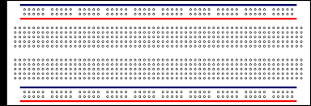

1. **JUMPER WIRES:**

Jumper wires are simply wires that have connector pins at each end, allowing them to be used to connect two points to each other without soldering. Jumper wires are typically used with breadboard and other prototyping tools in order to make it easy to change a circuit as needed.

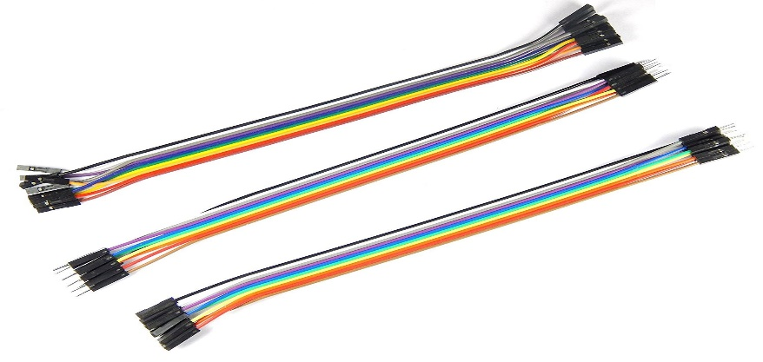

1. **LED (Light Emitting Diode)**

A **light-emitting diode** (**LED**) is a semiconductor that emits light when current flows through it.



1. **NODE MCU (ESP 8266)**

The **NodeMCU ESP8266 development board** comes with the ESP-12E module containing the ESP8266 chip having Tensilica Xtensa 32-bit LX106 RISC microprocessor. This microprocessor supports RTOS and operates at 80MHz to 160 MHz adjustable clock frequency. NodeMCU has 128 KB RAM and 4MB of Flash memory to store data and programs. Its high processing power with in-built Wi-Fi / Bluetooth and Deep Sleep Operating features make it ideal for IoT projects.

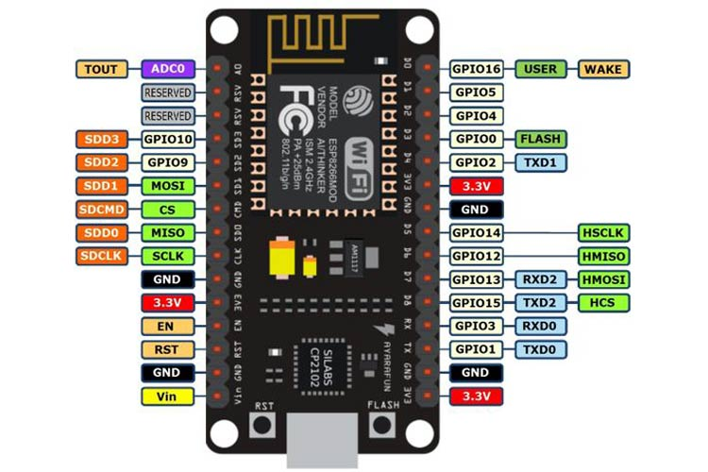

1. **RELAY**

**A relay is an electrically operated switch. It consists of a set of input terminals for a signal or multiple control signals, and a set of operating contact terminals. The switch may have any number of contacts or multiple contact forms, such as make contacts, break contacts, or combinations thereof. Relay is used where it is necessary to control a circuit by an independent low-power signal, or where several circuits must be controlled by one signal. Relays were first used in long-distance telegraph circuits as signal repeaters: they refresh the signal coming in from one circuit by transmitting it to another circuit. Relays were used extensively in telephone exchanges and early computers to perform logical operations.**

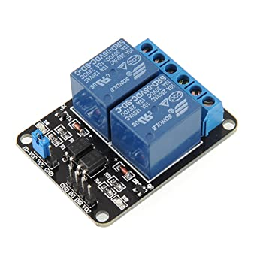

**CIRCUIT DIAGRAM**

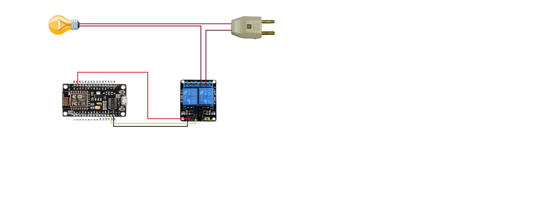

**WORKING OF PROJECT**

* The Home Automation is operating Node MCU esp8266 controller and the command is given by the Blynk android application in a mobile phone using the wi-fi network.
* The Node MCU esp8266 is an inbuilt wi-fi module and the devices are connected with home automation.
* For demonstration in this project a DC appliance and power supply are used, and Node MCU Vin and Ground were given to voltage supply.
* Digital pins D0, and D1 are connected to relay IN1 IN2 respectively and VCC and GND of relays are connected parallel to Vin and Ground.
* For appliances connection will connect to output pins holder of relays.

**APPENDIX**

The code to the project can be found here:

<https://github.com/AnanyaSingh002/HOME-AUTOMATION-SYSTEM.git>

**REFERENCES:**

* [**https://create.arduino.cc/projecthub/prabinrajupreti/iot-based-home-automation-9fac50**](https://create.arduino.cc/projecthub/prabinrajupreti/iot-based-home-automation-9fac50)
* [**https://www.electronicwings.com/nodemcu/control-home-appliances-using-google-assistant**](https://www.electronicwings.com/nodemcu/control-home-appliances-using-google-assistant)
* [**https://www.youtube.com/watch?v=CpUVssHPm_s**](https://www.youtube.com/watch?v=CpUVssHPm_s)