**Project Requirement and Specification**

On

**IoT Based Smart Street Light System**

*(CSE core V Semester Mini Project)*

*2021*



Submitted By:-

Name: Ananya Singh

(CSE-core-G-V-Sem)

University Roll No. 2014561

Class Roll no. 07

**ACKNOWLEDGEMENT**

I would like to thank Piyush Aggarwal Sir, for providing the resources and believing in me until completion of this project and having faith in me.

Also, I would like to thank my parents for their support and encouragement, and allowing me to reach this far. Last but not the least, my friend Kunal, for helping me with the hardware.

**INTRODUCTION**

Smart Street Light spotlights on different restriction and difficulties identified with traditional and old street lights that are confronted now days and the answer for the deal with those issues by embracing the vision of a smart street light. The noteworthiness of this vision is a completely mechanized bidirectional force conveyance of power and information between the road lights and all the directions in the middle". smart street lights are vitality effective as we, as dependable. The primary thought in the present field advances are computerizations, power utilization, and expense adequacy. Automation is implied for the decrease of labour as the human has gotten to be excessively occupied and even incapable' making it impossible to discover time to switch the lights. Presently a day's everybody are mindful of the availability of limited power sources like coal, biomass, and hydro and so on' unnecessary wastage of power in the street rights is one of the noticeable power loss.

**ABSTRACT**

In the present days Automated systems have fewer manual operations, high flexibility, and are accurate.

Especially in the field of electronics automated systems are giving good performance. Our project is to control the switching of Street Lights automatically.

IR Sensors which detects the vehicle with the micro controller are used.

* **T**he main purpose of this project is to switch ON and Off-street lights without manual operation.
* By using this system energy consumption is reduced.
* IR sensors and microcontroller are the main components of this project.
* IR sensor is like our eye which detect the presence of an object.
* LDR acts as a sensor, since a varying voltage drop can be accordance with the varying light.

**REQUIREMENTS OF THE PROJECT:**

**NAME QUANTITY**

1. Bread board 1
2. Jumper wires (as required)
3. LED 1
4. IR sensors 2
5. LDR 1
6. Resistors 2
7. Node MCU 1

**Software REQUIREMENT:**

* Arduino IDE

**HARDWARE DESCRIPTION**

1. **BREAD BOARD:**

A breadboard is used to build and test circuits quickly before finalizing any circuit design. The breadboard has many holes into which circuit components like ICs and resistors can be inserted.

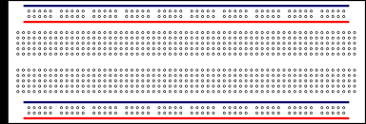

1. **JUMPER WIRES:**

Jumper wires are simply wires that have connector pins at each end, allowing them to be used to connect two points to each other without soldering. Jumper wires are typically used with bread board and other prototyping tools in order to make it easy to change a circuit as needed.

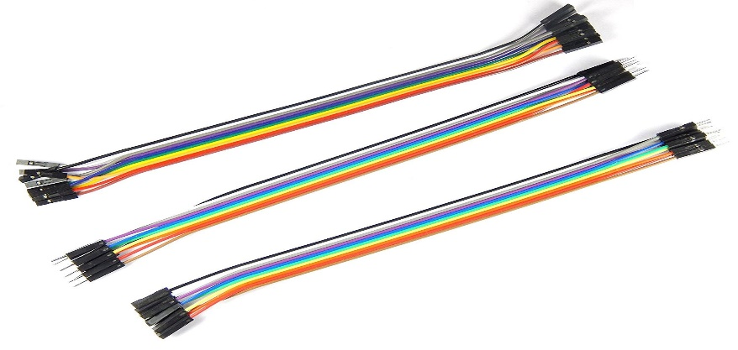

1. **LED (Light Emitting Diode)**

A **light-emitting diode** (**LED**) is a semi-conductor that emits light when current flows through it.



1. **IR SENSORS**

The sensor works by detecting reflected light coming from its own infrared LED. By measuring the amount of reflected infrared light, it can detect light or dark (lines) or even objects directly in front of it. An onboard RED LED is used to indicate the presence of an object or detect line. Sensing range is adjustable with inbuilt variable resistor. The sensor has a 3-pin header which connects to the microcontroller board or Arduino board via female to female or female to male jumper wires. A mounting hole for easily connect one or more sensor to the front or back of your robot chassis.

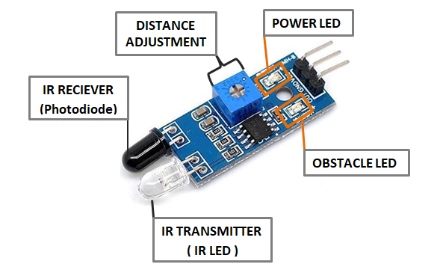

1. **LDR (Light Dependent Resistor)**

Light Dependent Resistor (LDR) is made up of light sensing material called Cadmium Sulphide i.e. CdS. LDR is a Cadmium Sulphide photo resister that changes its resister according to the spectrum of light falls on it. Its resistance is 1MΩ in the absence of sunlight and 5kΩ in the presence of sunlight. So, when there is complete darkness it conducts electricity very poorly due to high resistance and when there is a visible spectrum of light it conducts electricity very well.

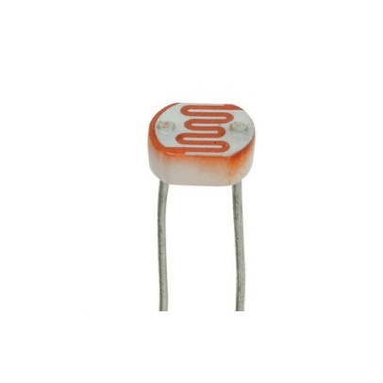

1. **RESISTORS**

The resistor is a passive electrical component that creates resistance in the flow of electric current.



In this project 2 resistors are used one for LDR and other for LED.

1. **NODE MCU (ESP 8266)**

The **NodeMCU ESP8266 development board** comes with the ESP-12E module containing the ESP8266 chip having Tensilica Xtensa 32-bit LX106 RISC microprocessor. This microprocessor supports RTOS and operates at 80MHz to 160 MHz adjustable clock frequency. NodeMCU has 128 KB RAM and 4MB of Flash memory to store data and programs. Its high processing power with in-built Wi-Fi / Bluetooth and Deep Sleep Operating features make it ideal for IoT projects.

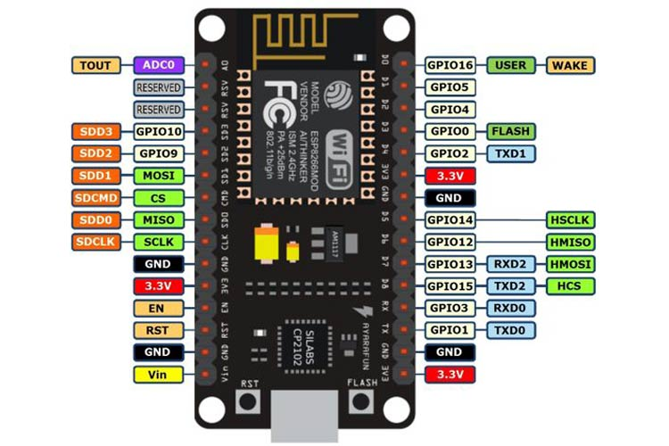

**BLOCK Diagram**

REGULATED POWER SUPPLY

LED

IR

IR

NodeMCU

ESP 8266

**CIRCUIT DIAGRAM**

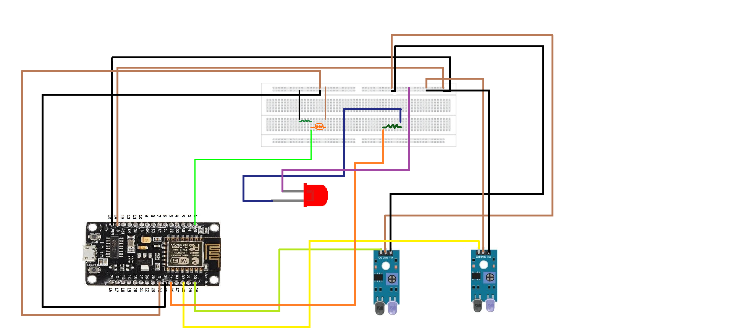

**WORKING OF PROJECT**

* The main aim of the project is to automatic switch on/off the street light by sensing the vehicle.
* In this project, IR sensors are used for sensing the vehicles.
* Initially the street lights are in off state by using the LDR.
* As the IR senses the vehicle the street lights associated with respect that sensor will switch on and off after certain time.

**APPENDIX**

The code to the project can be found here:

[**https://github.com/AnanyaSingh002/SMART_STREET_LIGHT**](https://github.com/AnanyaSingh002/SMART_STREET_LIGHT)

**REFRENCES:**

* [**https://www.slideshare.net/vikramemmidi/ppt-on-automatic-street-light-control-using-ir-sensors**](https://www.slideshare.net/vikramemmidi/ppt-on-automatic-street-light-control-using-ir-sensors)
* [**https://www.geekering.com/categories/embedded-sytems/esp8266/andre-martins/esp8266-nodemcu-blinking-a-led/**](https://www.geekering.com/categories/embedded-sytems/esp8266/andre-martins/esp8266-nodemcu-blinking-a-led/)
* [**https://osoyoo.com/2016/12/02/nodemcu-light-sensor-mqtt/**](https://osoyoo.com/2016/12/02/nodemcu-light-sensor-mqtt/)