EX:2 | EXPLORATORY DATA ANALYSIS (EDA) – DATA IMPORT AND EXPORT
DATE:

AIM:

To import data from various sources such as CSV, Excel, SQL, and Web, perform basic inspection using Pandas, and export the processed data into different file formats.

ALGORITHM:

- Step 1: Import the required Python libraries (Pandas and SQLite3).
- Step 2: Import data from a CSV file using the read_csv() function.
- Step 3: Display the first few records of the CSV data.
- Step 4: Check the structure of the CSV dataset using functions such as info() and describe().
- Step 5: Import data from an Excel file using the read_excel() function.
- Step 6: Display the imported Excel records and verify that the data has been loaded correctly.
- Step 7: Create a SQLite database and establish a connection.
- Step 8: Create a table and insert sample records into the database.
- Step 9: Retrieve records from the SQLite database using an SQL SELECT query and display the results.
- Step 10: Specify the URL containing the dataset.
- Step 11: Import data directly from the URL using the read_csv() function.
- Step 12: Display the imported records obtained from the online source.
- Step 13: Compare and verify the imported data from all sources to ensure successful data loading.
- Step 14: End the program.

PROGRAM:

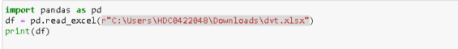

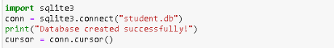

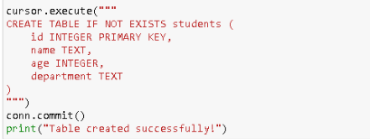

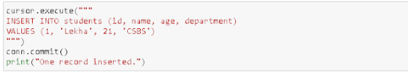

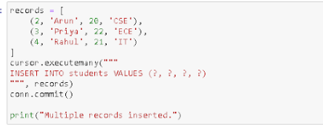

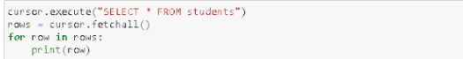

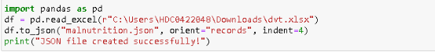

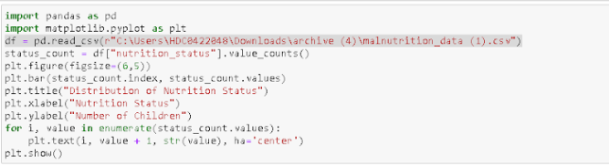

OUTPUT:
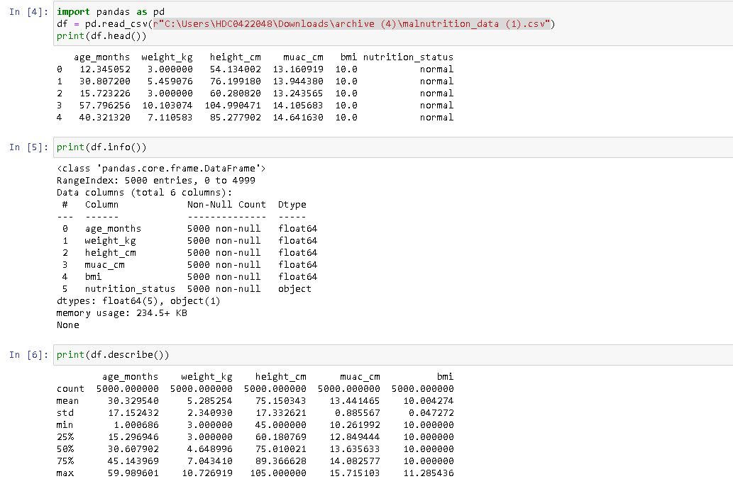
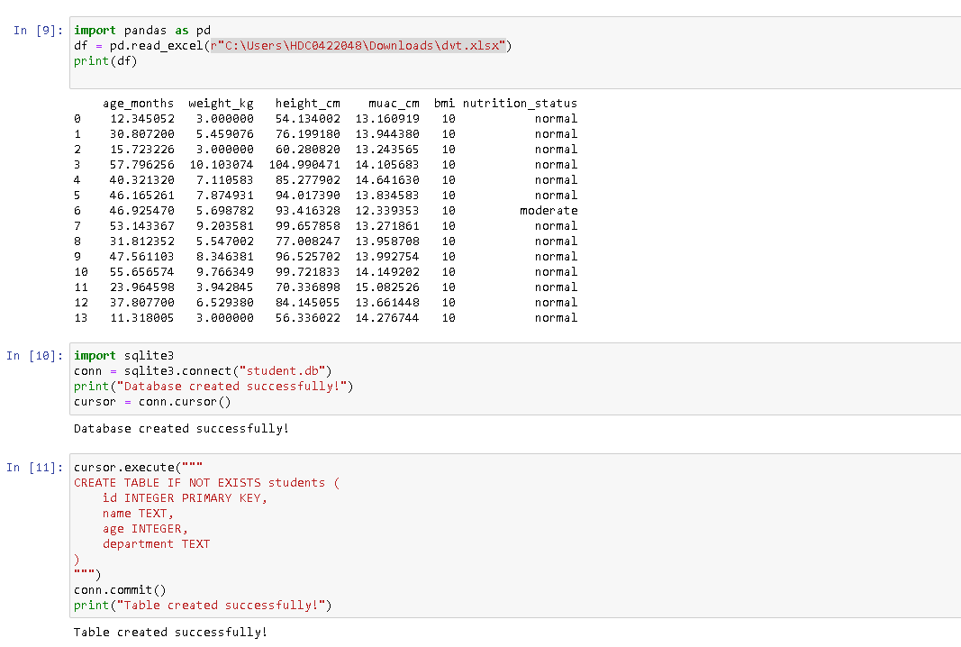

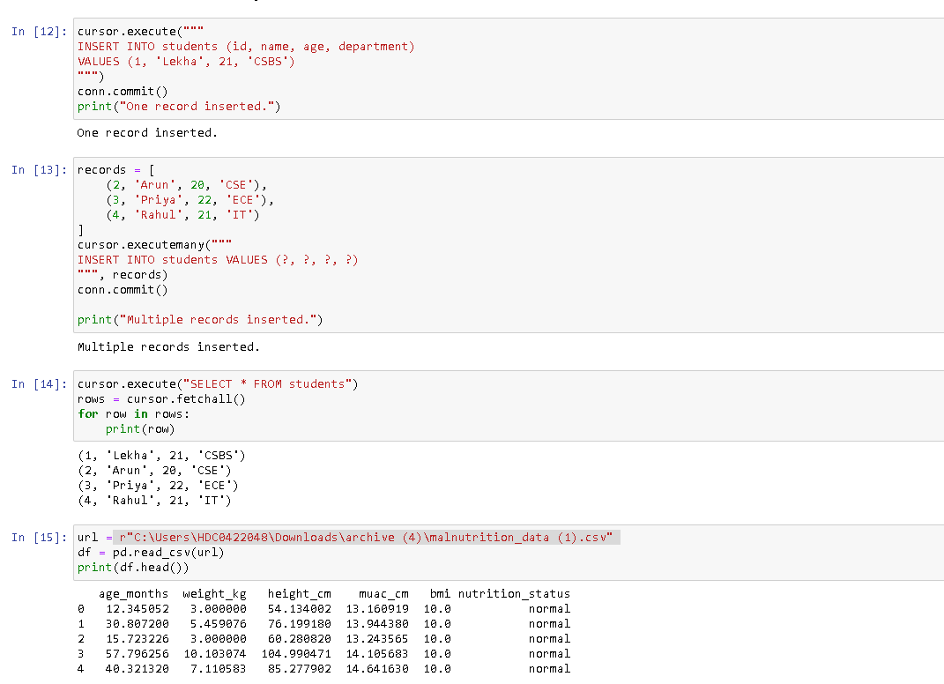
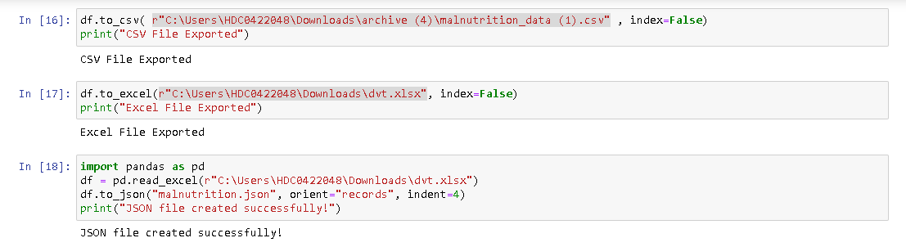
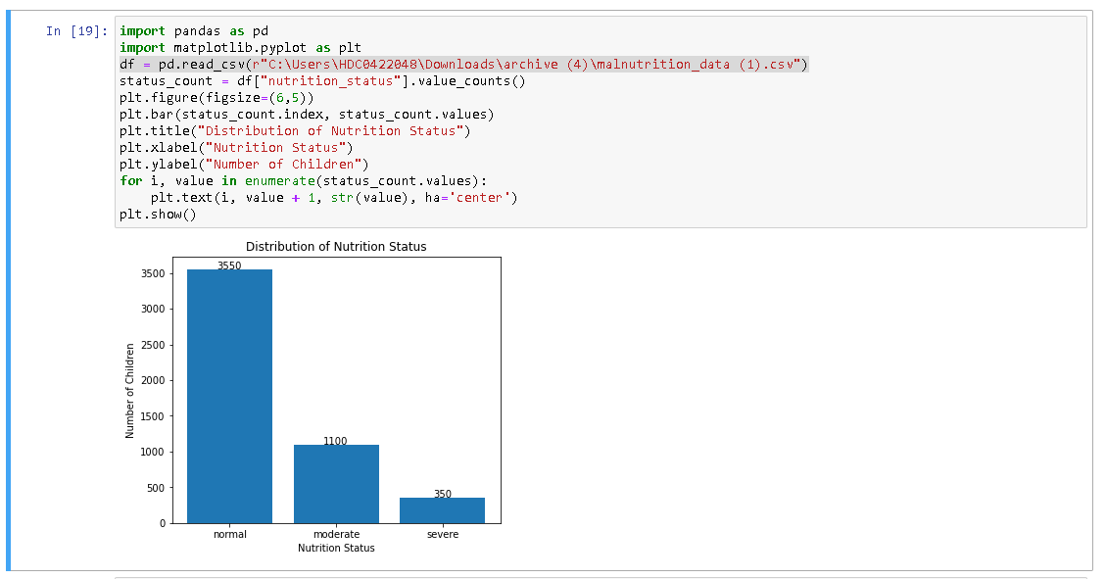

RESULT:

The data was successfully imported from CSV, Excel, SQLite Database, and an online URL using Pandas and SQLite. The imported datasets were displayed and verified for correctness. The database records were retrieved successfully using an SQL query. Thus, data from multiple sources was loaded and analyzed successfully.

