
Department of Computer Science

Lab Manual

of

MACHINE LEARNING

MCA521-4

Class Name: IV MCA

Master of Computer Application

2026

Prepared by: (your name) Verified by:
Dr. Rupali Sunil Wagh
Dr. Helen K Joy
Dr. Shivangi Singh

Department Overview
Department of Computer Science of CHRIST (Deemed to be University) strives to shape outstanding computer professionals with ethical and human values to reshape nation’s destiny. The training imparted aims to prepare young minds for the challenging opportunities in the IT industry with a global awareness rooted in the Indian soil, nourished and supported by experts in the field.

Vision
The Department of Computer Science endeavours to imbibe the vision of the University “Excellence and Service”. The department is committed to this philosophy which pervades every aspect and functioning of the department.

Mission
“To develop IT professionals with ethical and human values”. To accomplish our mission, the department encourages students to apply their acquired knowledge and skills towards professional achievements in their career. The department also moulds the students to be socially responsible and ethically sound.

Introduction to the Programme
Master of Computer Applications (MCA) is a post-graduate programme of CHRIST (Deemed to be University) and approved by the All India Council of Technical Education (AICTE). It is a two-year programme spread over six trimesters to bridge the chasm between computer studies and applications, bringing within reach of enthusiastic youngsters an excellent group of experienced and dedicated staff and experts, and an enviable infrastructure. MCA at CHRIST (Deemed to be University) strives to shape outstanding computer professionals with ethical and human values to reshape the nation’s destiny. The training programme aims to prepare young minds for challenging opportunities in the IT industry with a global awareness rooted in the Indian soil, nourished and supported by experts in the field. The Department is committed to the motto “Excellence and Service,” and this philosophy pervades every aspect of its functioning.

Programme Objective
This programme is conceptualised and designed based on the strong commitment of the
department to provide better quality education to the students. The principal objectives of this
course are to:
● Heighten technological awareness
● Train future industry specialists
● Encourage effective software development
● Provide research training
● Involve students in innovative research
● Produce graduates with a two-year professional education in Computer Science with
technical, professional, and communications skills.

Ethics and Human Values
1. Only proprietary or open-source software would be used for academic teaching and
learning purposes.
2. Copying of programs from the internet, friends or from other sources is strictly
discouraged since it impairs development of programming skills.
3. Unique Practical (Domain based) exercises ensure that the students don’t get involved in
code plagiarism.
4. Projects undertaken by students during the course are done in teams to improve
collaborative work and synergy between team members.
5. Projects involve modularization which initiates students to take individual responsibility
for common goals.
6. Passion for excellence is promoted among the students, be it in software development or
project documentation.
7. Giving due credit to sources during the seminar and research assignment is promoted
among the students
8. The course and its design enforce the practice of good referencing technique to improve
the sense of integrity.
9. Courses involving group discussions and debates on ethical practices and human values
are designed to sensitize the students in dealing with customers and members within the
Organization.

Programme Outcomes:
P01: Foundation Knowledge: Apply knowledge of mathematics, programming logic, and
coding fundamentals for solution architecture and problem-solving.
P02: Problem Analysis: Identify, review, formulate, and analyse problems primarily focussing on customer requirements using critical thinking frameworks.
P03: Development of Solutions: Design, develop and investigate problems with as an
innovative approach for solutions incorporating ESG/SDG goals.
PO4: Modern Tool Usage: Select, adapt, and apply modern computational tools such as the
development of algorithms with an understanding of the limitations including human biases.
P05: Individual and Teamwork: Function and communicate effectively as an individual or a
team leader in diverse and multidisciplinary groups. Use methodologies such as agile.
P06: Project Management and Finance: Use the principles of project management such as
scheduling, and work breakdown structure and be conversant with the principles of Finance for profitable project management.
P07: Ethics: Commit to professional ethics in managing software projects with financial aspects.
Learn to use new technologies for cyber security and insulate customers from malware
P08: Life-long learning: Change management skills and the ability to learn, keep up with
contemporary technologies and ways of working.

Programme Educational Objectives(PEO’s)
PEO1: Develop innovative and effective software solutions through research that addresses
real-world challenges, grounded in a commitment to continuous learning and adaptability.
PEO2: Advance the knowledge and practices in the field of computer applications through
lifelong learning and rigorous research, supporting professional growth and academic excellence.
PEO3: Exhibit ethical leadership, social responsibility to contribute and enhance community
well-being by innovating solutions.
MCA521-4 – MACHINE LEARNING
Course Name: MACHINE LEARNING Code: MCA521-4
Total Hours: 75
L + P + T: 3 + 4 + 0
Max Marks: 100
Credits: 4
Course Type: Core Course
Course Category: Theo&Prac
Course Description
Machine Learning is a key area in computer applications that focuses on building models capable of making predictions or informed decisions based on data. A strong understanding of machine learning enables students to analyze and interpret complex datasets, develop predictive models, and extract meaningful insights. This course covers a wide range of machine learning concepts and techniques, including supervised and unsupervised learning. It provides a solid theoretical foundation while emphasizing practical, hands-on experience with algorithms and real-world data. The course equips students with the knowledge and skills required to apply machine learning techniques across various domains using modern tools and methodologies.
Course Objectives
This course enables students to understand the fundamental concepts of Machine Learning, including its core principles, terminology, and methodologies. Students will learn to differentiate between various types of learning algorithms such as supervised, unsupervised, and reinforcement learning, and recognize their appropriate applications.
Course Outcomes
After successful completion of the course, students will be able to:
● Explain the fundamental principles and scope of Machine Learning
● Implement modelling practices in machine learning for better generalisation
● Interpret predictive modelling results and performance of supervised machine learning techniques
● Assess the outcomes and effects of unsupervised machine learning processes
● Deploy robust machine learning models for interdisciplinary applications

Unit-1: INTRODUCTION TO MACHINE LEARNING Teaching Hours: 15 Hours
Introduction to AI – Knowledge Representation – Data – Representation of Data, Data Processing, Data Storage, Data Processing, Types of Data – Exploratory Data Analysis, Visualisations and Interpretation, Outliers
Machine Learning: Definition, Objectives, Components, Features, Applications – Traditional Programming v/s Machine Learning, Types of Machine Learning – Predictive Models, Statistical Inferences – Applications of Machine Learning
Challenges in ML: Insufficient Quantity of Data, Non-representative and Poor-Quality Data, Irrelevant Features, Estimation Estimation, Reducing Human Biases in Model Building, Ethical Use of Technology
Lab Exercises:
1. Data Preprocessing and visualisation
2. Data exploration and inferences

Unit-2: PROCESSES IN MACHINE LEARNING Teaching Hours: 15 Hours
Data Preparation and Model Selection: Effect of Data Preparation: Encoding, Nominal and Ordinal Representation, Feature Transformation and Feature Engineering, Generalisation, Normalisation, Sampling, Using Saved Weights, Model Selection Strategies: Overfitting, Underfitting, Bias-Variance Trade-off, Testing and Validation: Performance measures - Confusion matrix, Precision-Recall Trade off, F1 Score, ROC Curve, AUC, Error Analysis, Model Parameters, Hyperparameters, Hyperparameter Tuning, Cross Validation, Decision Functions: Introduction to Supervised Machine Learning Methods, Decision Functions, Decision Thresholds, Distance Measures, Hyperplanes, Regression & Classification Problems, Loss and Cost Functions, Linear Regression using OLS, Multi-class vs Multi-label, KNN Classification
Lab Exercises:
3. Saving weights of a generalised model.
4. Regression and Classification Evaluation Metrics: Illustration through Linear Regression and KNN Classification

Unit-3: SUPERVISED LEARNING ALGORITHMS Teaching Hours: 15 Hours
Learning through Optimisation: Gradient Descent, Linear Regression, Logistic Regression Computational Learning: Decision Trees, Naive-bayes classification, Support Vector Machines, Ensemble Learners: Learning, Voting, Bagging, Stacking, Boosting, Random Forests, GridSearchCV
Lab Exercises:

5. Regression through Gradient Descent
6. Comparison of Different Classifiers
7. Illustration of Ensemble Learning Methods

Unit-4: UNSUPERVISED LEARNING AND DIMENSIONALITY REDUCTION Teaching Hours: 15 Hours
Introduction: Types of Unsupervised Learning, Challenges in Unsupervised Learning, Concept of Cost Functions in Unsupervised Learning, Clustering Methods: Distance based, Centroid Based, Elbow method to find Optimal Number of Clusters, Silhouette Method, K-Means Clustering, Hierarchical Clustering: Agglomerative and Bottom Up, Applying Supervised Learning after Clustering, Dimensionality Reduction Methods: Principal Component Analysis (PCA), Linear Discriminant Analysis (LDA)
Lab Exercises:
8. KMeans and Elbow Methods
9. Hierarchical Clustering and Dendrograms
10. Dimensionality Reduction
11. Image Compression using Dimensionality Reduction.

Unit-5 Teaching Hours: 15 Hours
MACHINE LEARNING IN REAL-WORLD
Emerging Techniques: Role of ML in attaining Sustainable Development Goals, Time Series Preprocessing, Blackbox Methods: Neural Networks & Deep Learning, Reinforcement Learning/QLearning, Self Supervised Learning, Quantum Machine Learning, Keras and Tensorflow for designing Multi Layer Perceptron. Case Studies: CNN, RNN, Advances in Deep Learning, Natural Language Processing, Real Time Systems, Computer Vision, Robotics, Expert Systems, Generative Networks, Large Language Models. Model Deployment: Model Deployment: Connecting Models to User Interface, Deployment of ML Models.
Lab Exercises:
12. Training a Multi-layer perceptron
13. Deploying Trained ML-models

Text and Reference Books
[1] Campesato, O. (2020). Artificial Intelligence, Machine Learning and Deep Learning. Mercury Learning and Information.
[2] Andreas C. Müller and Sarah Guido (2017), “Introduction to Machine Learning with Python A Guide For Data Scientists” O’Reilly book
[3] Ethem Alpaydin (2005), “Introduction to Machine Learning”, Prentice Hall of India
[4] Max Kuhn and Kjell Johnson (2018), “Applied Predictive Modelling”, Springer

Essential Reading
[1] Stuart Russell and Peter Norvig(2020), “Artificial Intelligence: A Modern Approach” (4th Edition), Pearson
[2] Aurelien Geron(2019), “Hands on Machine Learning with Scikit-learn, Keras and Tensorflow”, 2nd Edition, O’Reilly Books
[3] Kevin P. Murphy(2012), “Machine Learning: A Probabilistic Perspective”, MIT Press
[4] Hastie, Tibshirani, Friedman(2008), “The Elements of Statistical Learning” (2nd ed), Springer
[5] Ian Goodfellow, Aaron Courville, Yoshua Bengio (2019), “Deep Learning (Adaptive Computation And Machine Learning Series)”, MIT Press
Additional Information (Web Resources):
1. Andrew Ng, Deeplearning.ai, Machine Learning Specialisation, offered through Coursera: https://www.deeplearning.ai/courses/machine-learning-specialization/

Evaluation Pattern: CIA - 50% ESE - 50%

LIST OF PROGRAMS

MSCAIML
Sl.no | Title of lab Experiment | Page number | RBT | CO
1 | India Air Quality & Crop Yield — EDA Lab  Data Preprocessing, Visualisation & Exploration  Combined Lab Sheet |  | L3 | CO1,3
2 | Data exploration and inferences |  | L3 | CO2,3
3 | Student Survey: Simple Linear Regression using Scikit  Learn, OLS, and Parameter Saving |  | L3 | CO3
4 | Regression and Classification Evaluation Metrics |  | L3 | CO3
5 | Linear Regression through Gradient Descent |  | L3 | CO3
6 | Comparison of Logistic Regression and K Nearest Neighbors (KNN) Classifiers |  | L3 | CO3,4
7 | Decision Tree |  | L4 | CO3
8 | Implementation and Performance Evaluation of Categorical Naive Bayes Classifier |  | L3 | CO3
9 |  |  | L3 | CO4
10 |  |  | L5 | CO4

Evaluation Rubrics:
Evaluation Rubrics for each program would be

Submission Guidelines:
- Make a copy of the lab manual template with your <name_reg:no_subject name >,

- Copy the given question and the answer (lab code) with results, followed by the conclusion of that lab. Title the lab as lab number.
- Keep updating your lab manual and show the lab manual of that particular lab for evaluation.
- Create a Git Repository in your profile <ML lab-reg no> . Follow a different branch for each lab <Lab 1, Lab 2…>, and push the code to Git. The link should be provided in Google Classroom along with the PDF of the lab manual.
- Upload the PDF to Google Classroom before the deadline.

Lab 4 : Regression and Classification Evaluation Metrics

Lab Exercise 4:
Part 1: Comprehensive Study of K-Nearest Neighbours (KNN) Classification using Breast Cancer Dataset and Comparison with Regression Evaluation Metrics

Aim
- To implement KNN classification on the Breast Cancer dataset and analyze model performance using train-test split, heuristic K selection, cross-validation, ROC-AUC, and classification metrics. Also, to compare classification metrics with regression metrics studied in Linear Regression (Lab 3).
Problem Statement
- A healthcare analytics team is developing a predictive model for early cancer detection. You are required to build a KNN classifier, optimize its performance using different validation techniques, and compare classification evaluation metrics with regression evaluation metrics from Lab 3.

Evaluation Rubrics

Submission Guidelines
- Make a copy of the lab manual template with your <name_reg:no_subject name>
- Copy the given question and the answer (lab code) with results, followed by the conclusion of that lab. Title the lab as Lab 1.
- Keep updating your lab manual and show the lab manual of that particular lab for evaluation.
- Create a Git repository in your profile <ML lab-reg no>. Follow a different branch for each lab <Lab 1, Lab 2 …> and push the code to Git.
- Provide the Git link in Google Classroom along with the PDF of the lab manual.
- Upload the PDF to Google Classroom before the deadline.

Code with Results
Task 1: Data Preparation
- Load the dataset using sklearn.
- Convert into DataFrame and explore structure.
- Check missing values and duplicates.
- Apply feature scaling using StandardScaler and justify its importance.
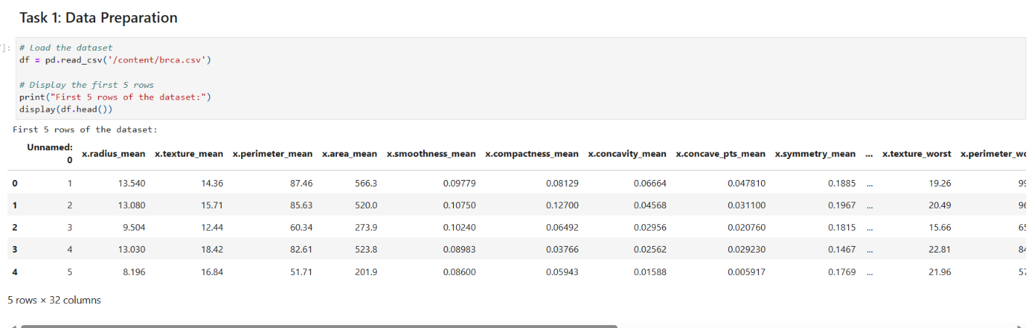

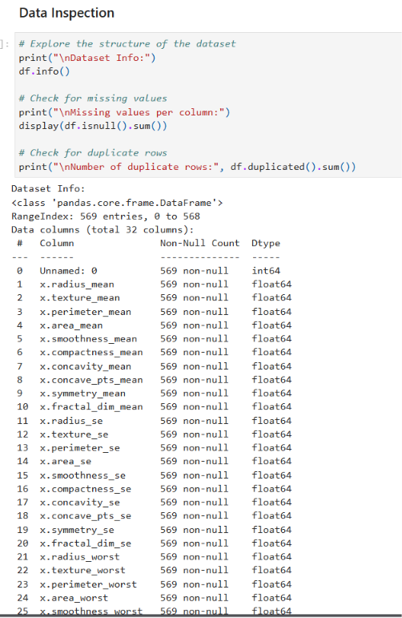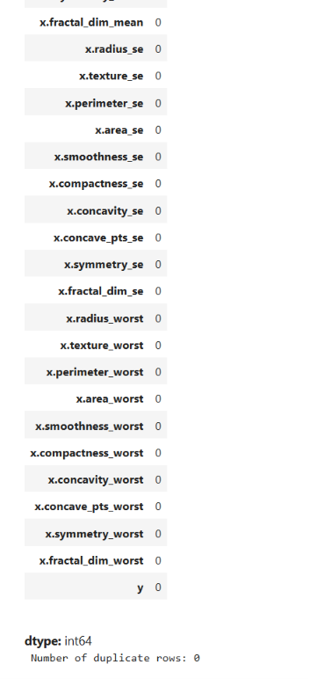
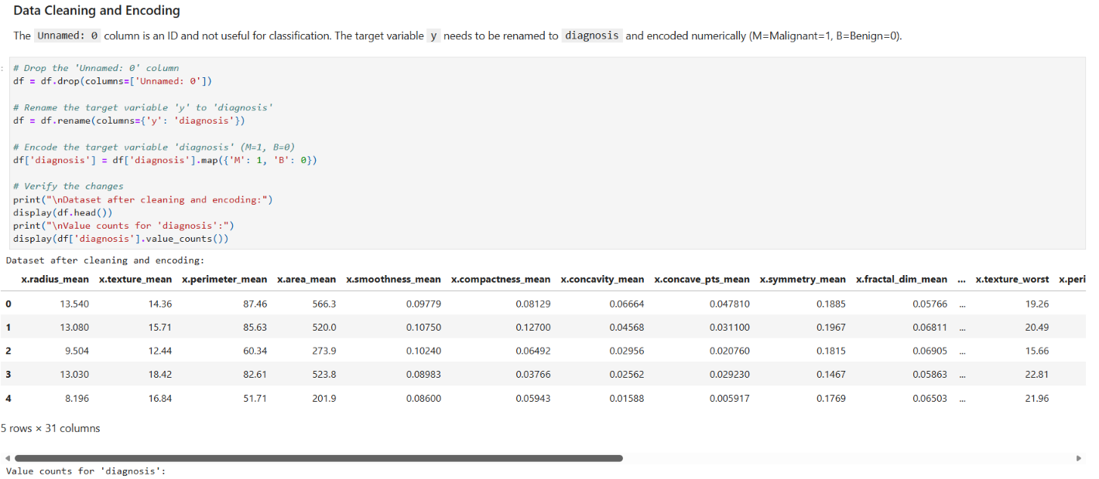
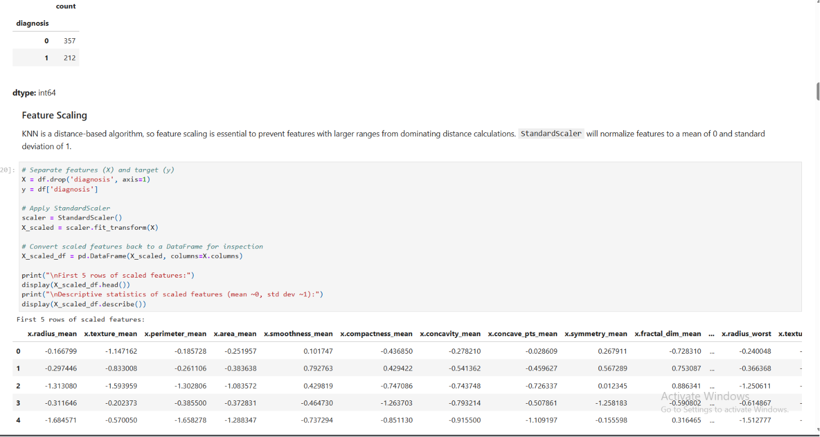
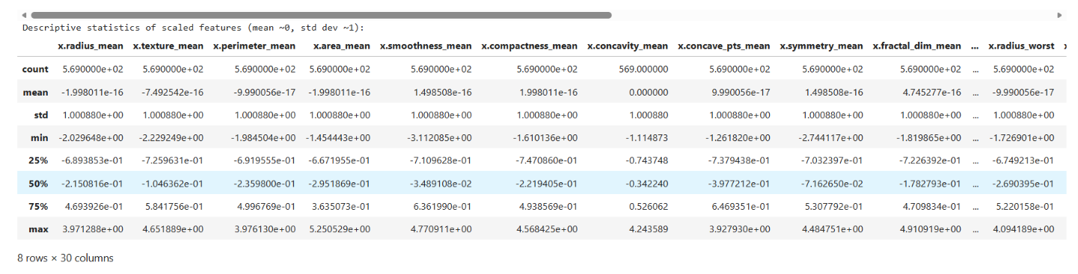
Task 2: Train-Test Split Analysis
- Split dataset into training and testing sets (80:20).
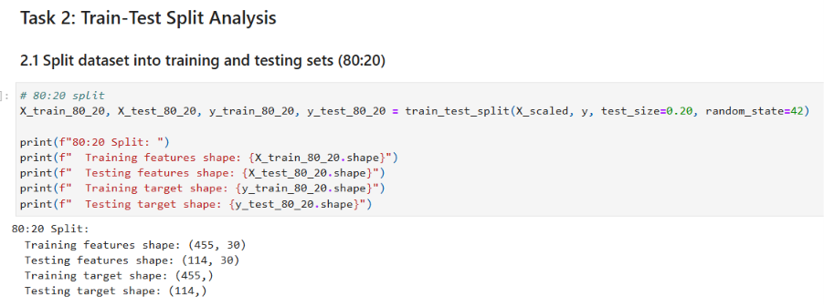
- Repeat with 70:30 and 90:10 splits.
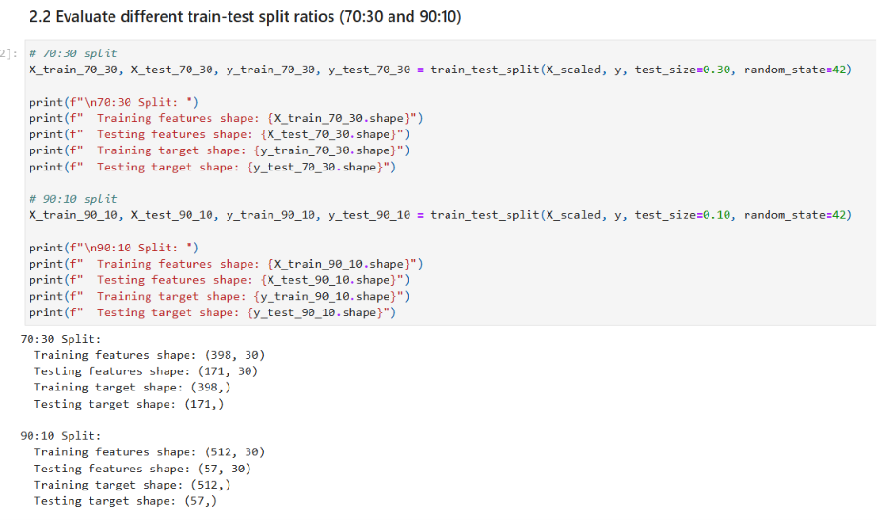
- Compare performance variations across splits.
- Analyze how dataset splitting affects model stability and generalization.
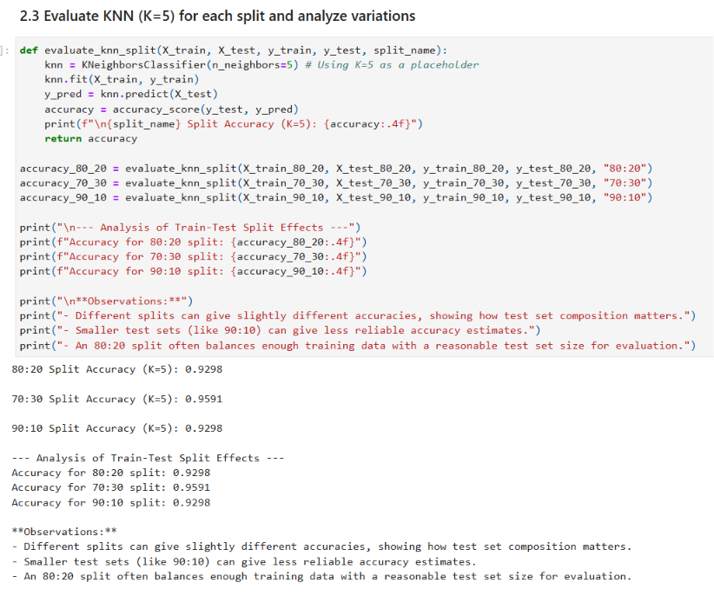
Task 3: KNN Model with Heuristic K Selection
3.1 Heuristic Method for K Selection
- Compute initial K using heuristic rule (K =√n);where n = number of training samples
- Use this value as a baseline K.
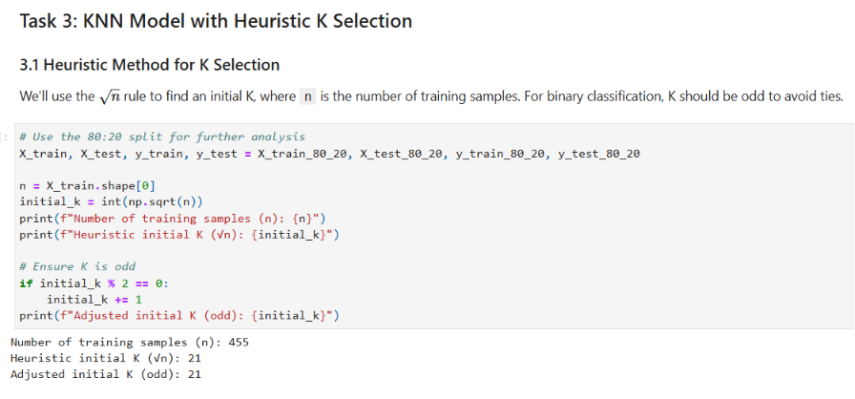
3.2 Model Training
- Train KNN classifier using heuristic K value.
- Experiment with nearby values of K (K ± 5).
- Plot accuracy vs K values.
- Identify optimal K based on performance trend.
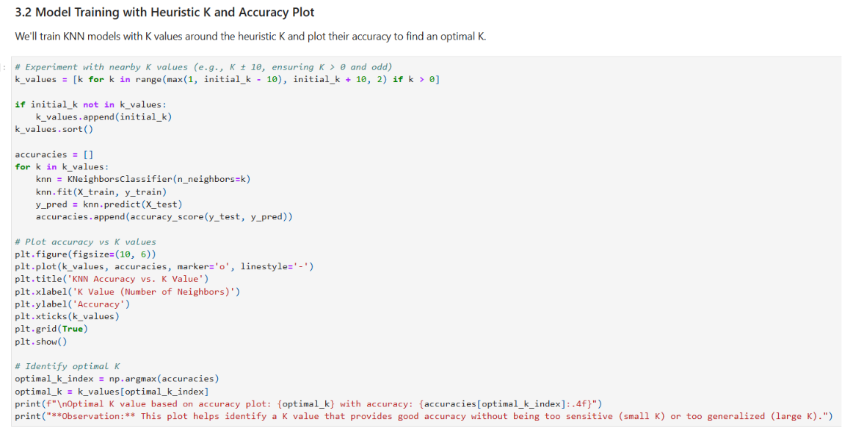
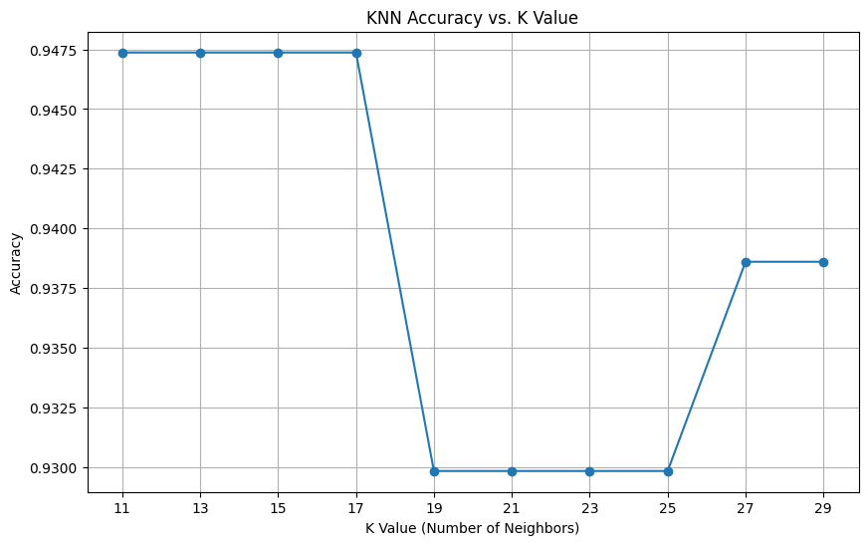
3. 3 Distance Matrix and Decision Boundary Mapping
- Explain any two distance metrics used in KNN: Euclidean Distance and Manhattan Distance. Also mention when each distance metric is suitable.
- Plot the decision boundary of the KNN classifier for different values of K, such as K = 1, K = 5, K = 10, and K = 20. Analyze how the decision boundary changes as K increase
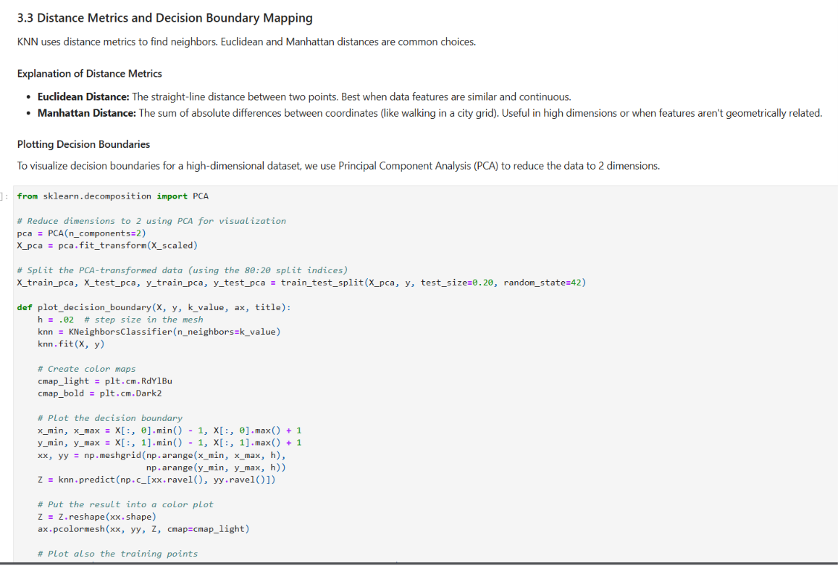
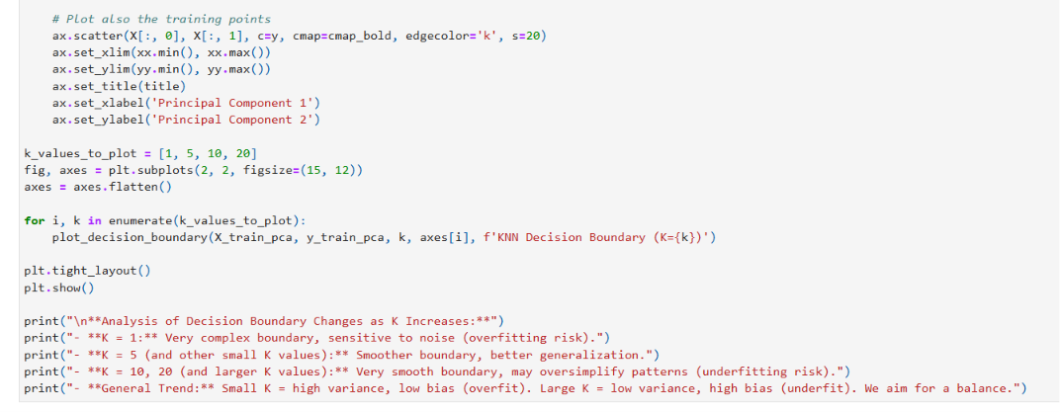
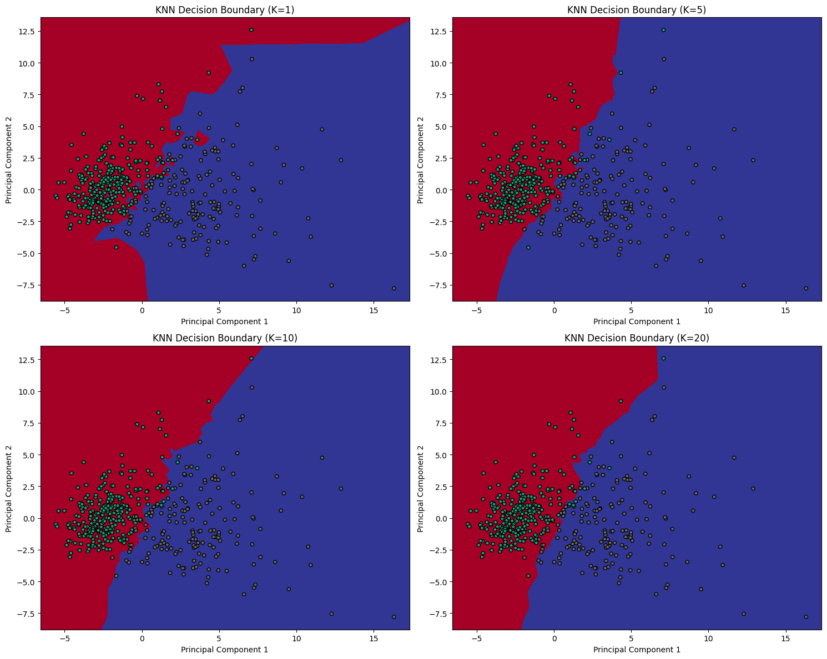
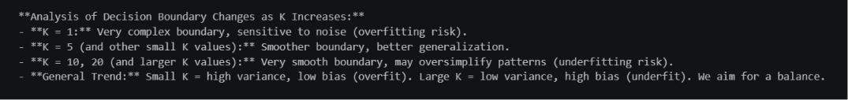
Task 4: Cross Validation
- Apply K-Fold Cross Validation (k = 5 or 10).
- Compute mean accuracy for different K values.
- Compare cross-validation results with train-test split results.
- Select best K based on both heuristic + validation results.
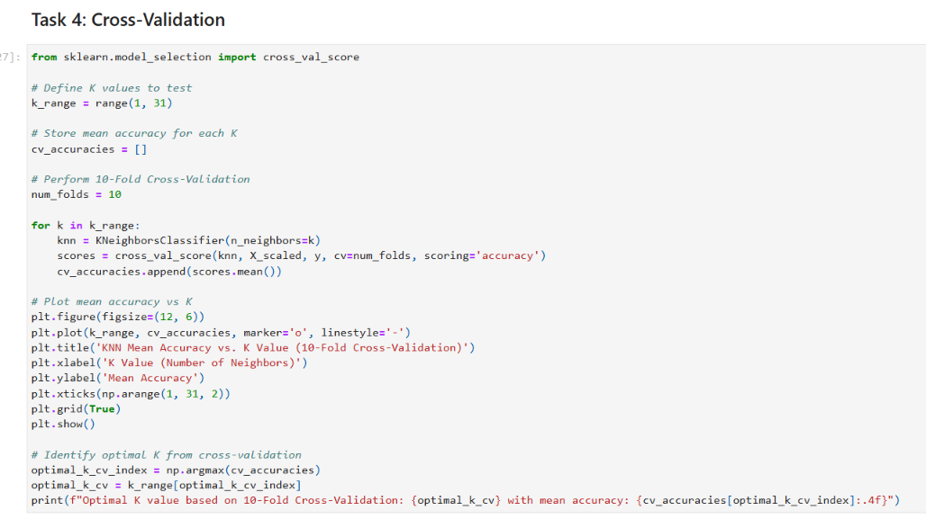
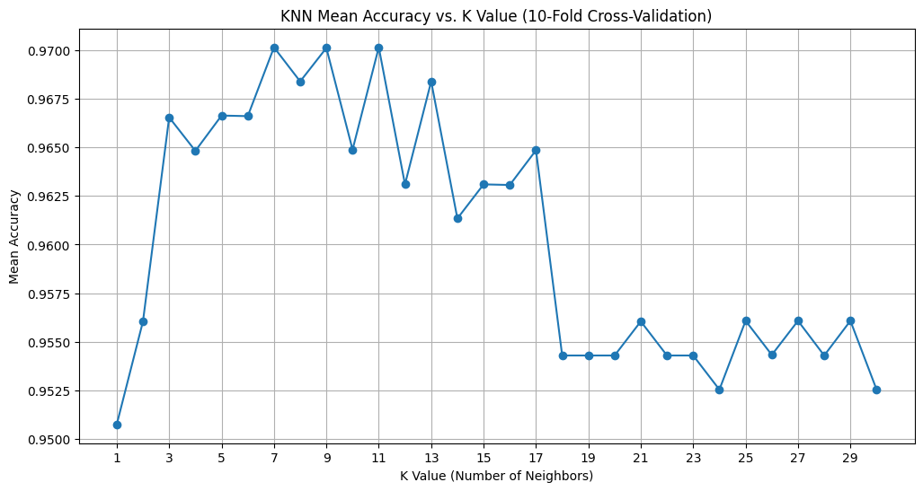
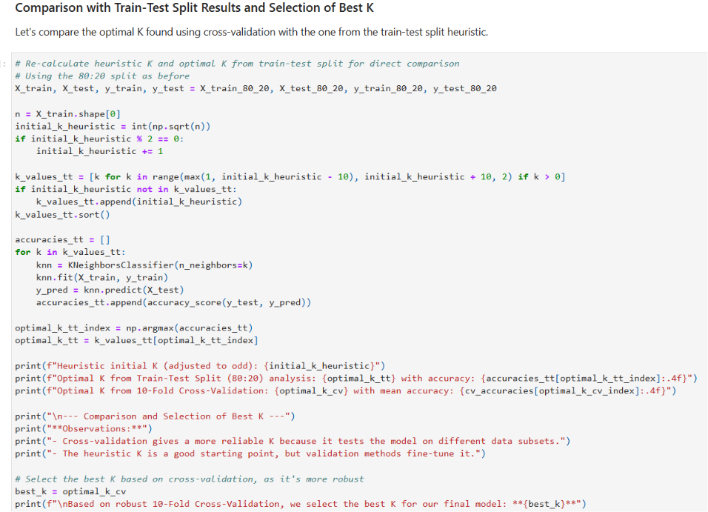
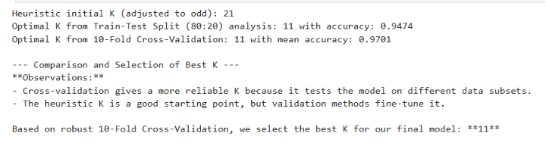
Task 5: Classification Evaluation
Evaluate final model using:
- Accuracy
- Precision
- Recall
- F1 Score
- Confusion Matrix
- ROC Curve and AUC Score
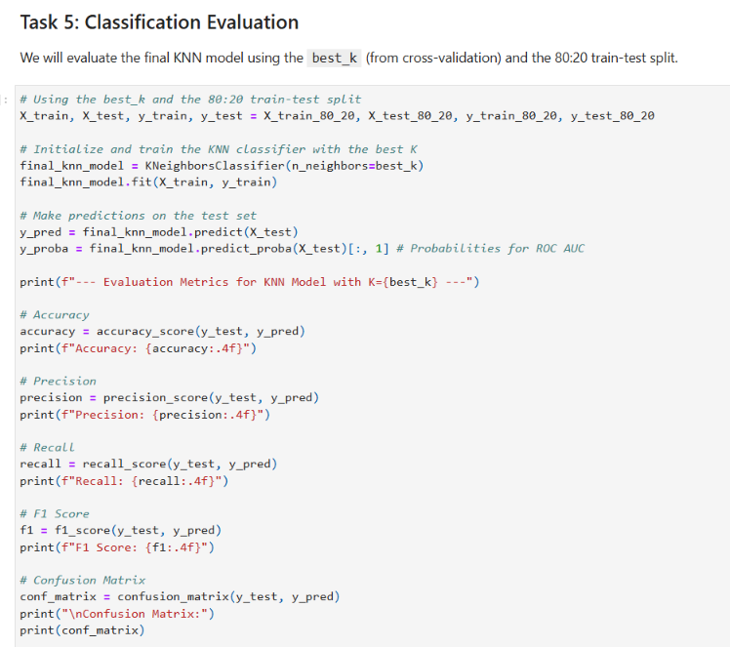
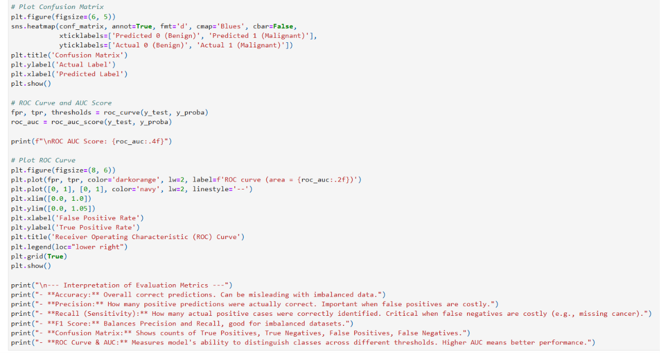
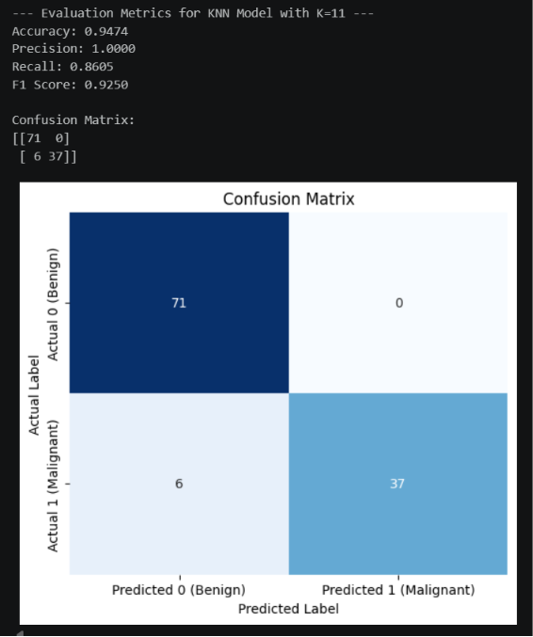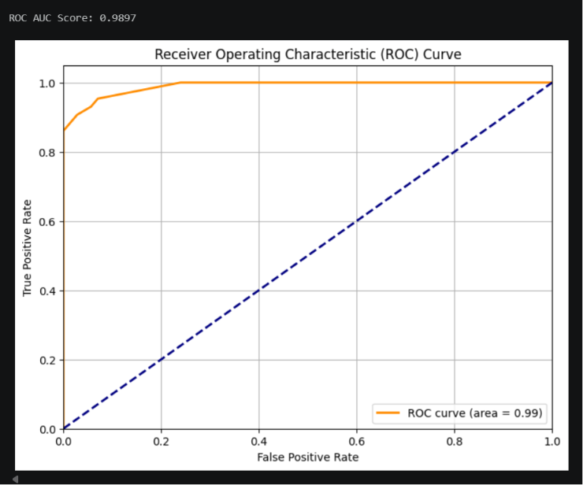
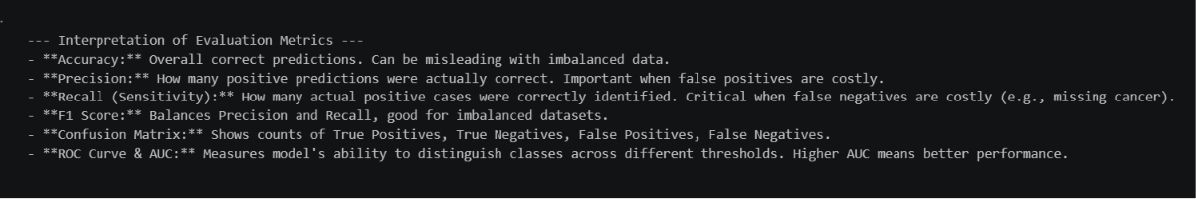

Task 6: Comparative Study with Regression (Lab 3 Integration)
Reference: Recall Lab 3 (Linear Regression) where you evaluated:
- MAE
- MSE
- RMSE
- R² Score
Tasks:
- Compare regression evaluation metrics with classification metrics.
- Explain differences between:
  - Error-based evaluation (Regression)
  - Decision-based evaluation (Classification)
- Compare:
  - R² Score vs Accuracy
  - RMSE vs F1 Score
  - MAE vs Confusion Matrix
- Discuss differences in evaluation logic for:
  - Continuous prediction tasks
  - Classification tasks
Inference Requirement (short and precise -don't generate )
Write a detailed inference covering:
- How regression metrics measure prediction error magnitude
- How classification metrics measure decision correctness
- Why is accuracy insufficient in medical diagnosis
- Why recall and ROC-AUC are more relevant in healthcare
- Overall comparison between regression and classification evaluation frameworks
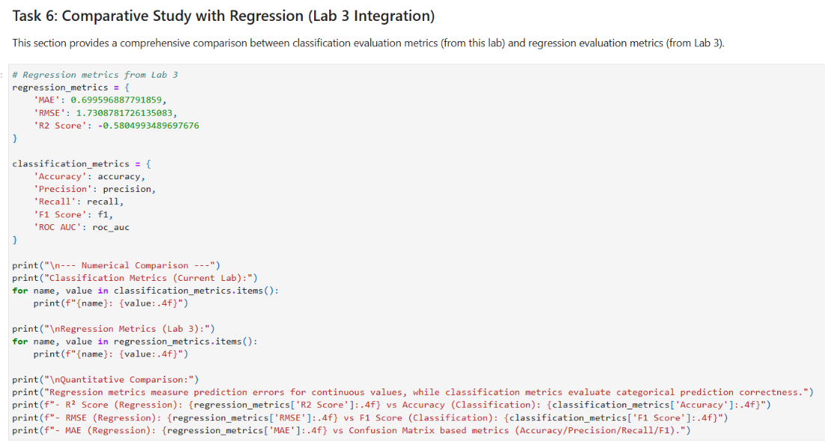
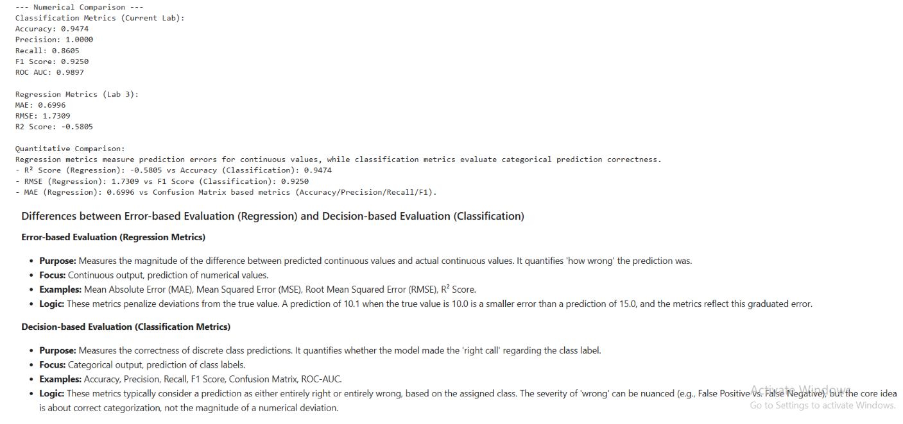
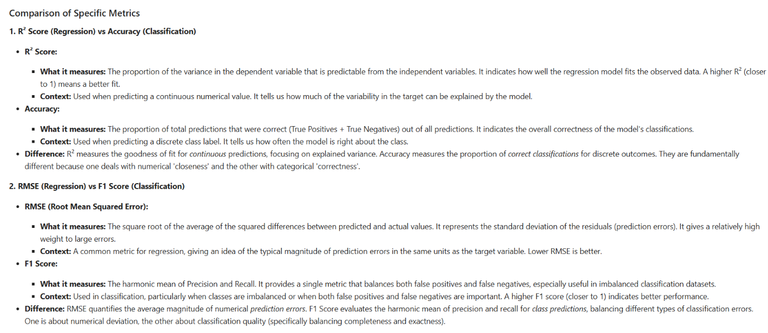
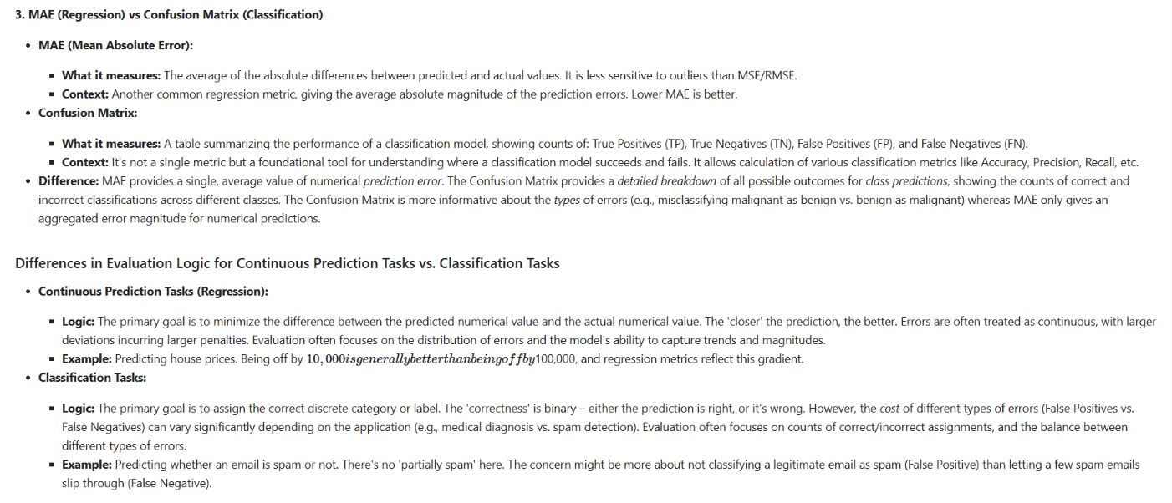
Task 7: Analytical Questions
- Why is KNN called a lazy learning algorithm?
- Why is feature scaling required in KNN?
- Explain heuristic K selection using √n rule.
- Why is cross-validation more reliable than a single train-test split?
- How does K affect bias-variance trade-off?
- Why is recall more important than accuracy in cancer prediction?
- What is the limitation of very large K values?

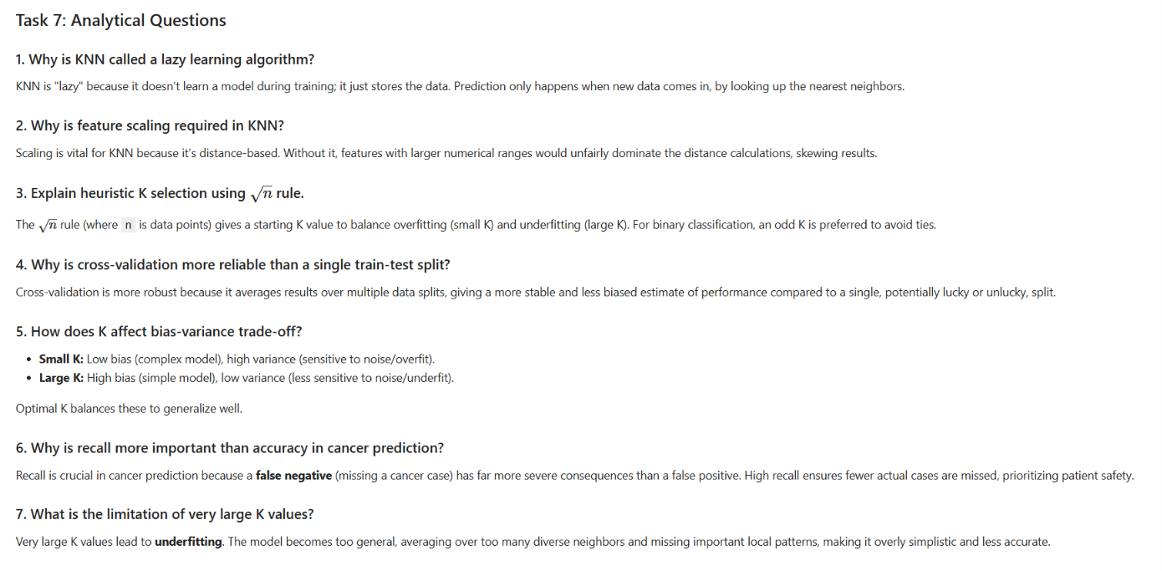
Conclusion /inference
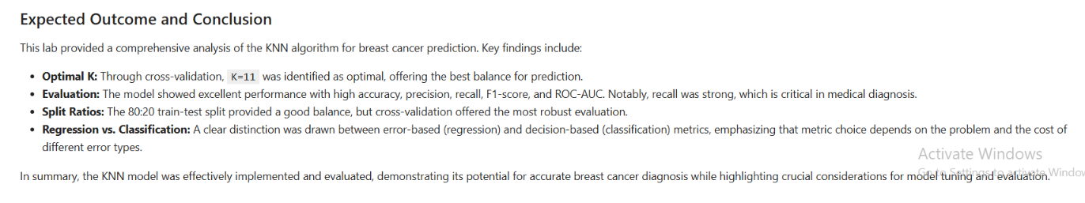

Lab 5 : Linear Regression through Gradient Descent

Lab Exercise 5:

Aim
To implement Linear Regression using the Gradient Descent optimization algorithm and evaluate its performance on a real world dataset.
Objectives
- To understand the concept of Gradient Descent for optimizing a Linear Regression model.
- To preprocess the dataset before model training.
- To implement Linear Regression using Gradient Descent.
- To analyze the convergence of the loss function during training.
- To evaluate the model using standard regression metrics.

Evaluation Rubrics

Submission Guidelines
- Make a copy of the lab manual template with your <name_reg:no_subject name>
- Copy the given question and the answer (lab code) with results, followed by the conclusion of that lab. Title the lab as Lab 1.
- Keep updating your lab manual and show the lab manual of that particular lab for evaluation.
- Create a Git repository in your profile <ML lab-reg no>. Follow a different branch for each lab <Lab 1, Lab 2 …> and push the code to Git.
- Provide the Git link in Google Classroom along with the PDF of the lab manual.
- Upload the PDF to Google Classroom before the deadline.

Code with Results
1. Download and Load the Student Performance Dataset (Math)
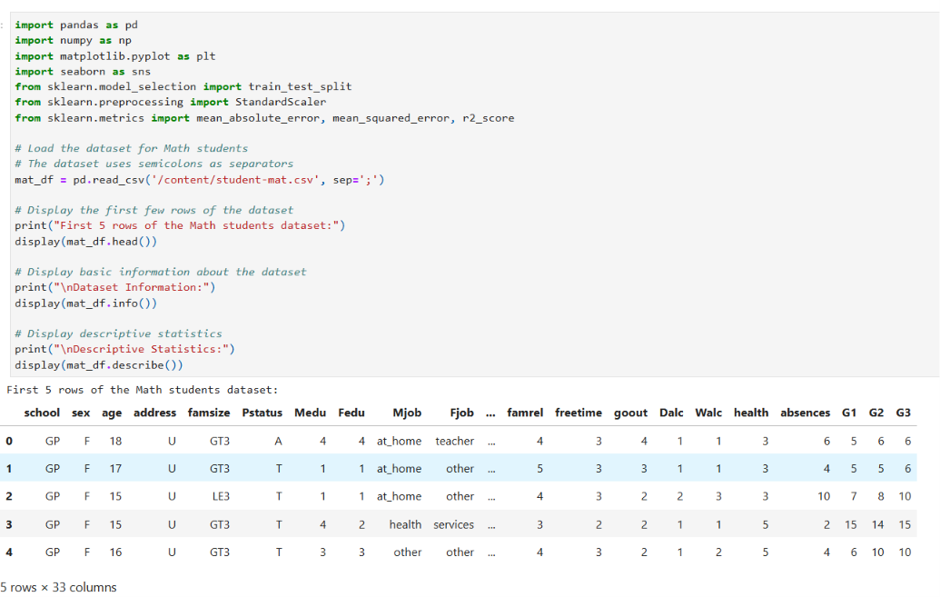
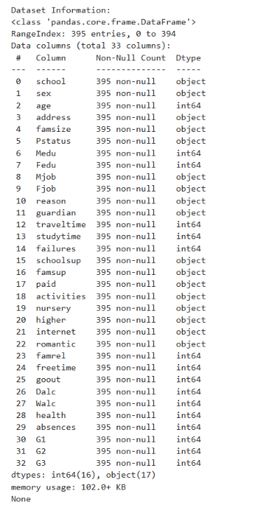
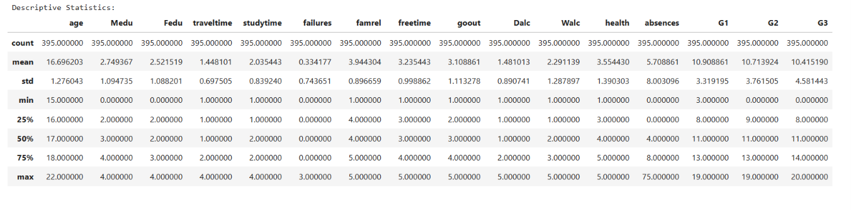
2. Perform Data Preprocessing
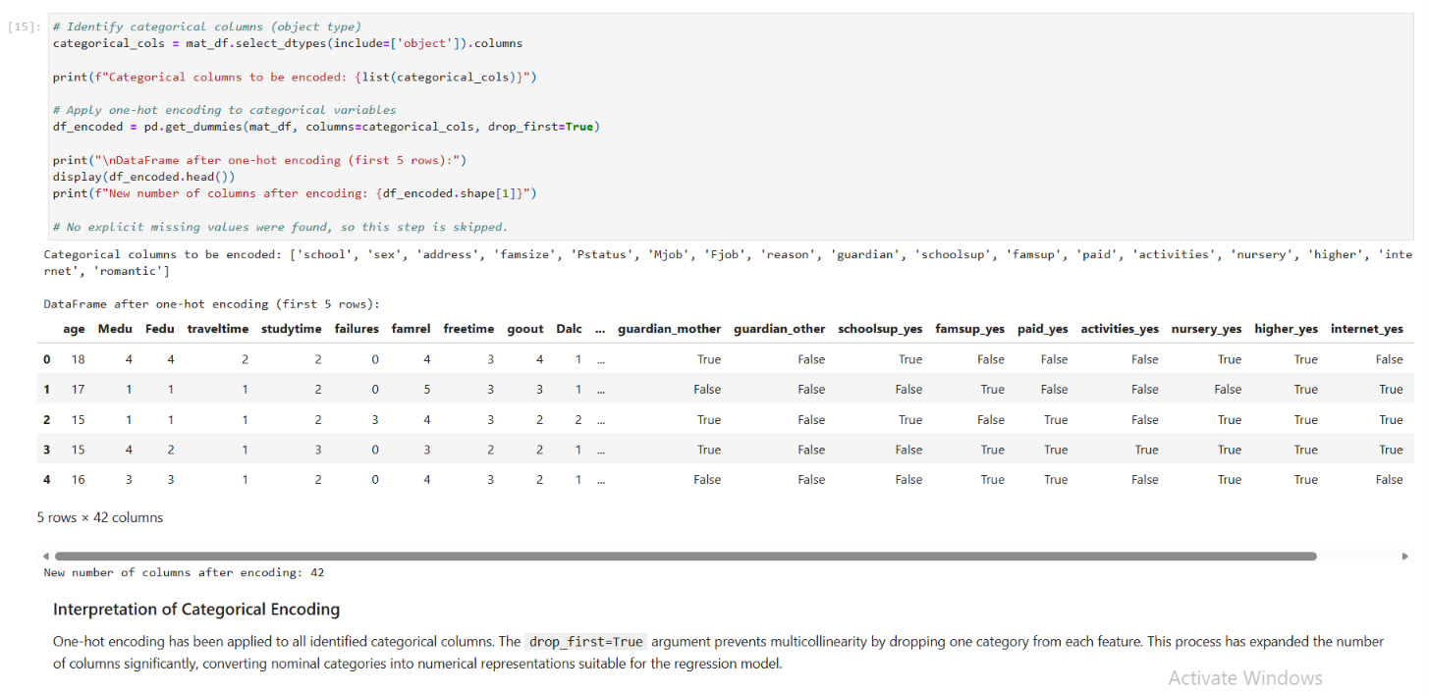
3. Select Appropriate Input Features and the Target Variable
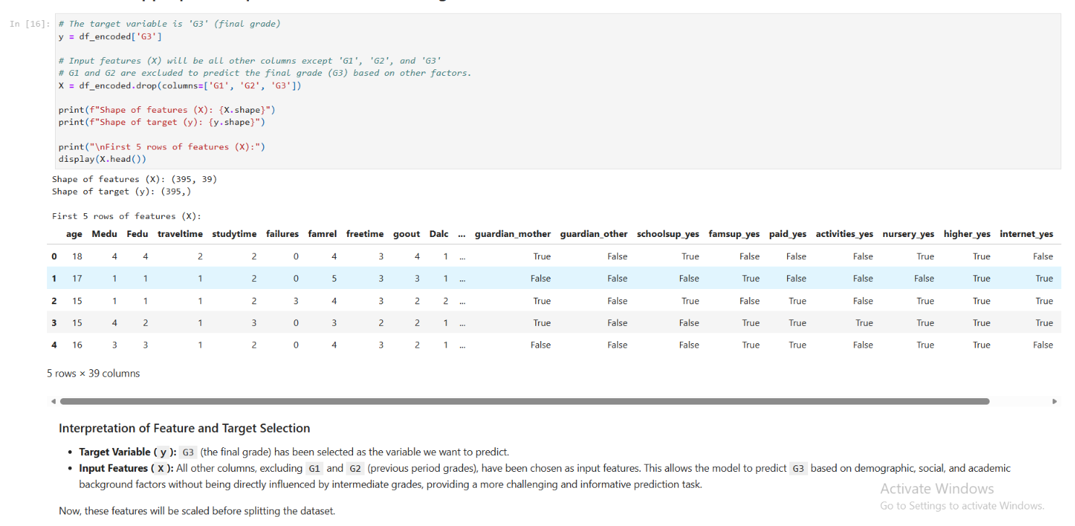
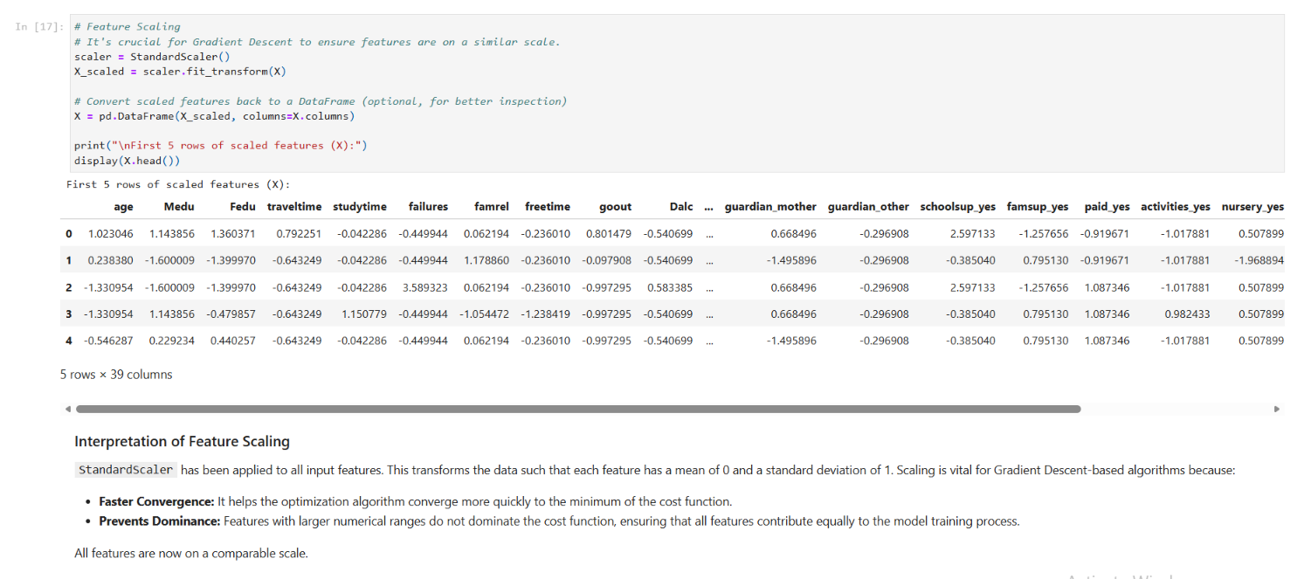
4. Split the Dataset into Training and Testing Sets
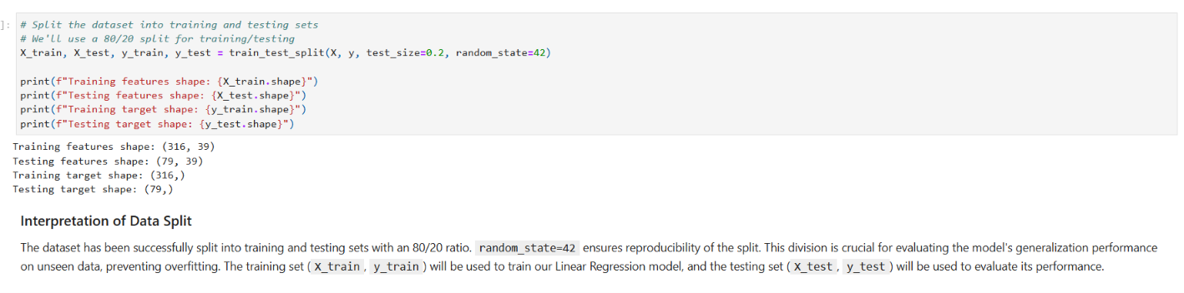
5. Implement Linear Regression using Gradient Descent
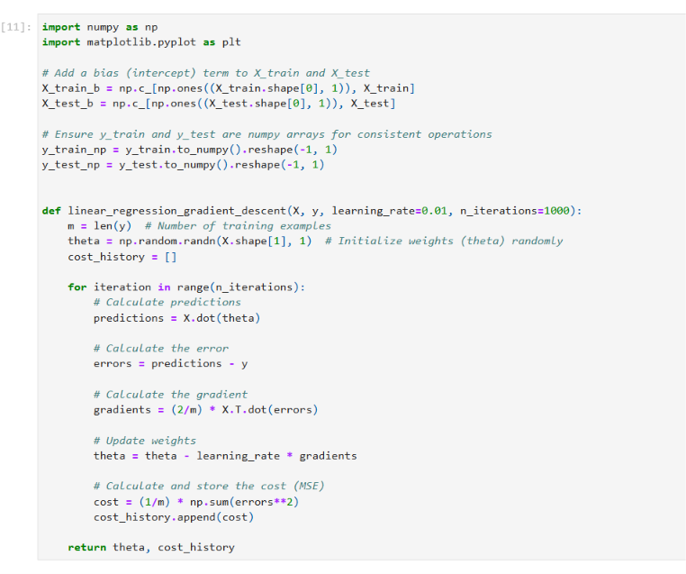
- Experiment with different learning rates
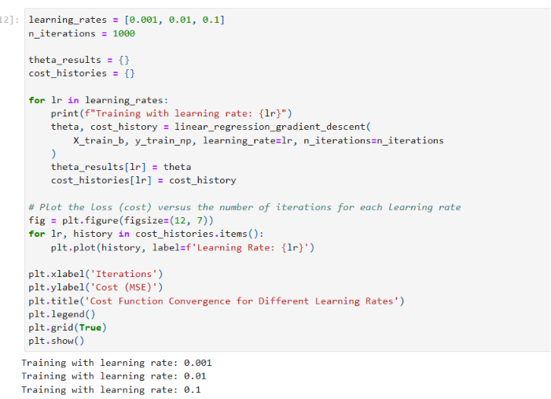
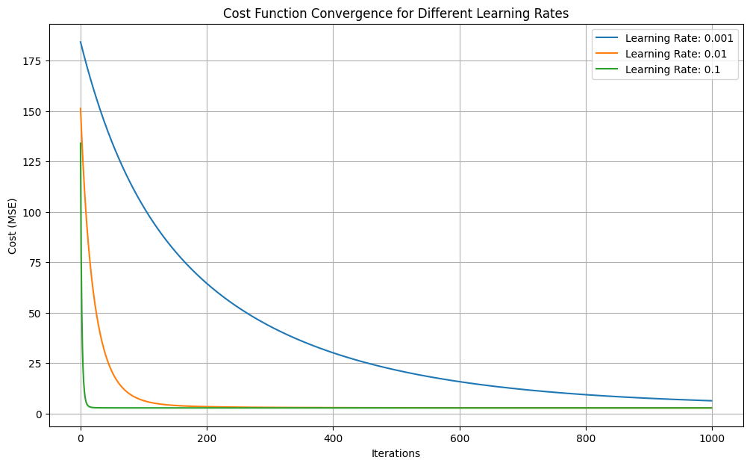
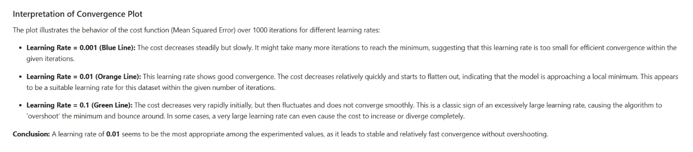
- Evaluate the Trained Model
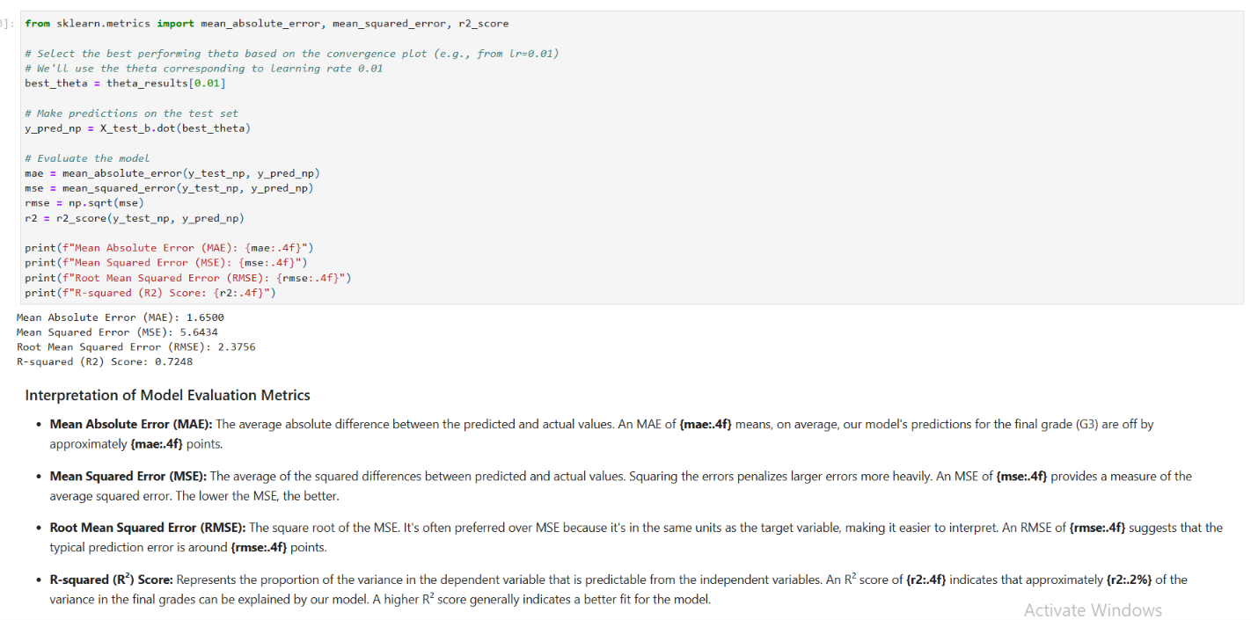
Conclusion /inference
The model demonstrates a reasonable ability to predict student final grades. The MAE and RMSE values provide a practical understanding of the average prediction error, while the R² score indicates how much of the target variable's variability is captured by our features. While the model explains a significant portion of the variance, there's still room for improvement, which could involve feature engineering, using more complex models, or hyperparameter tuning.

Lab 6 : Comparison of Logistic Regression and K Nearest Neighbors (KNN) Classifiers

Lab Exercise 6:

Aim
To implement Logistic Regression and K Nearest Neighbors (KNN) classifiers on the Breast Cancer Wisconsin (Diagnostic) dataset and compare their performance using standard classification evaluation metrics.
Objectives
- To preprocess the dataset for classification.
- To implement Logistic Regression and KNN classifiers using Scikit Learn.
- To evaluate both models using standard performance metrics.
- To compare the performance of Logistic Regression and KNN and identify the better classifier.

Evaluation Rubrics

Submission Guidelines
- Make a copy of the lab manual template with your <name_reg:no_subject name>
- Copy the given question and the answer (lab code) with results, followed by the conclusion of that lab. Title the lab as Lab 1.
- Keep updating your lab manual and show the lab manual of that particular lab for evaluation.
- Create a Git repository in your profile <ML lab-reg no>. Follow a different branch for each lab <Lab 1, Lab 2 …> and push the code to Git.
- Provide the Git link in Google Classroom along with the PDF of the lab manual.
- Upload the PDF to Google Classroom before the deadline.

Code with Results

1. Load the Dataset
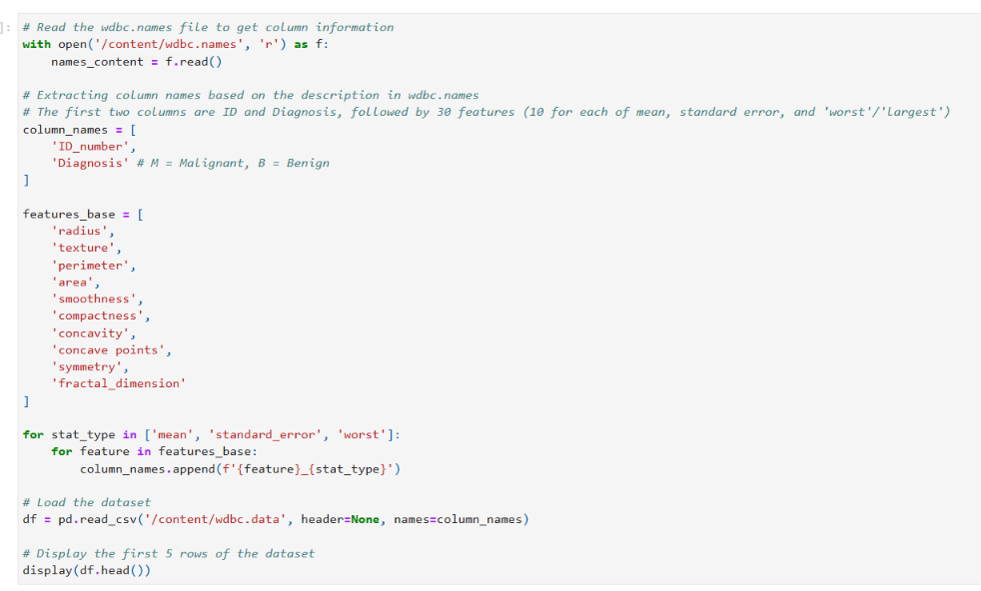
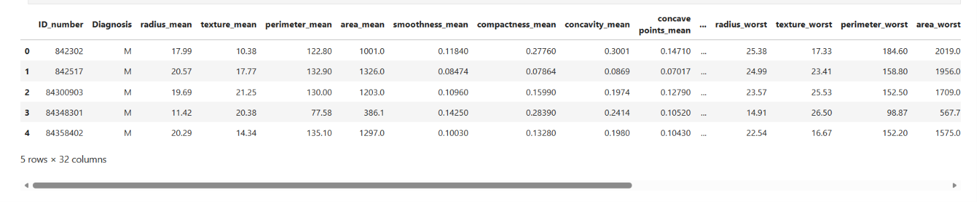
2. Exploratory Data Analysis and Data Preprocessing
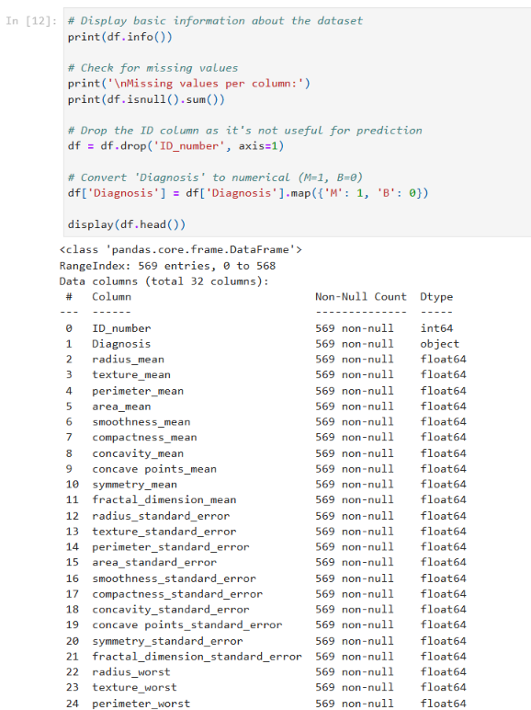
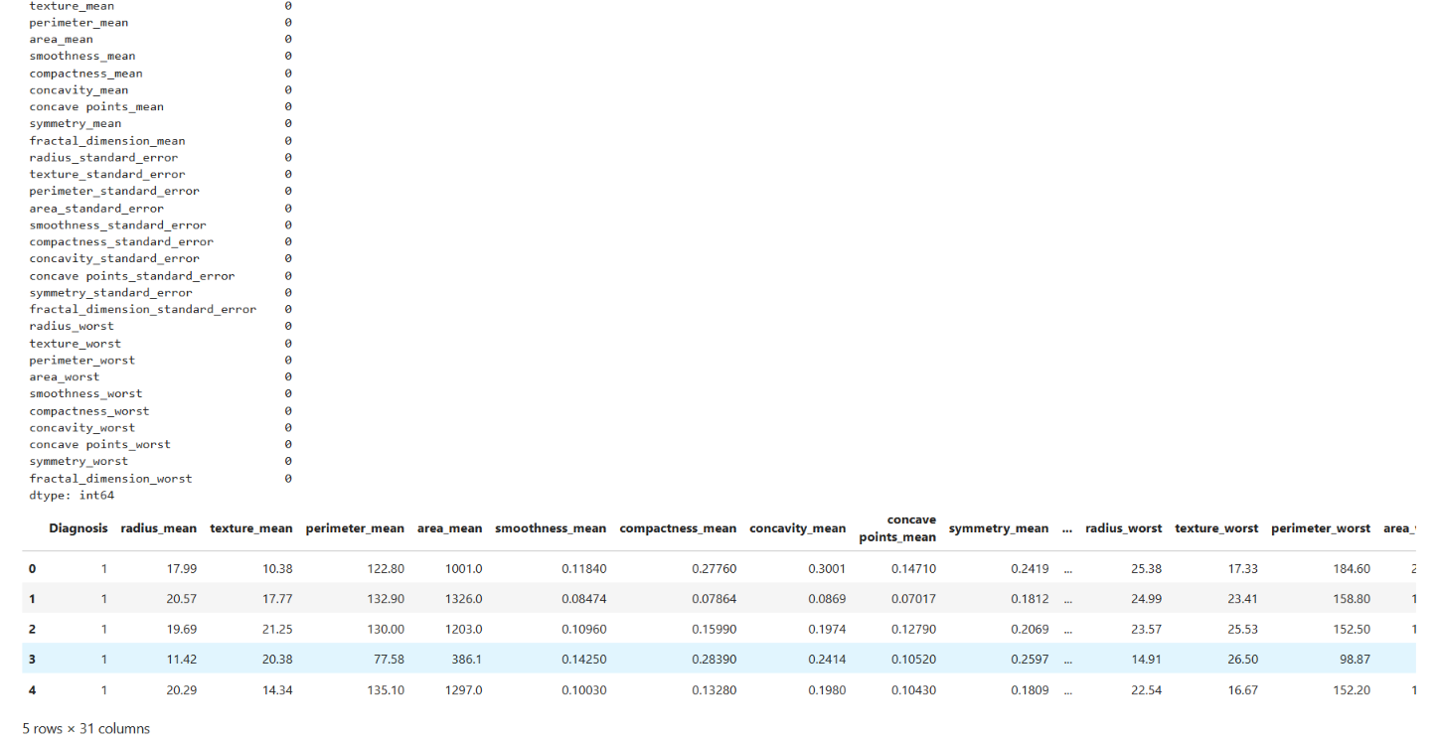
3. Split the Dataset into Training and Testing Sets and Feature Scaling
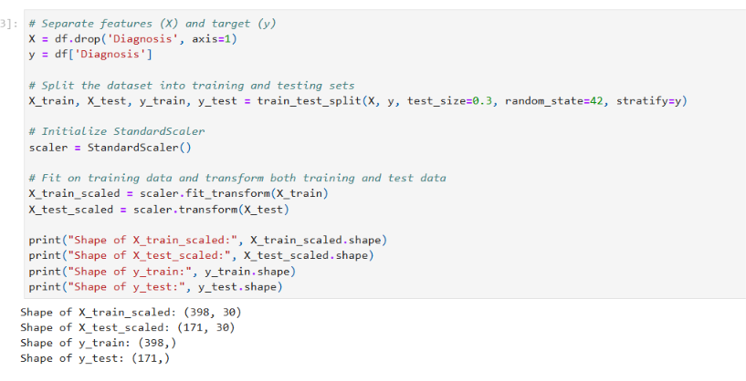
4. Train a Logistic Regression Classifier
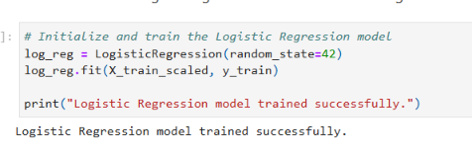
5. Train a K Nearest Neighbors (KNN) Classifier
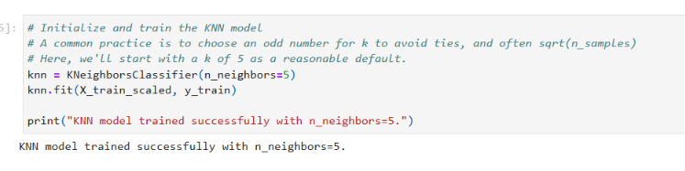
6. Evaluate Classifiers
6.1 Evaluate Logistic Regression
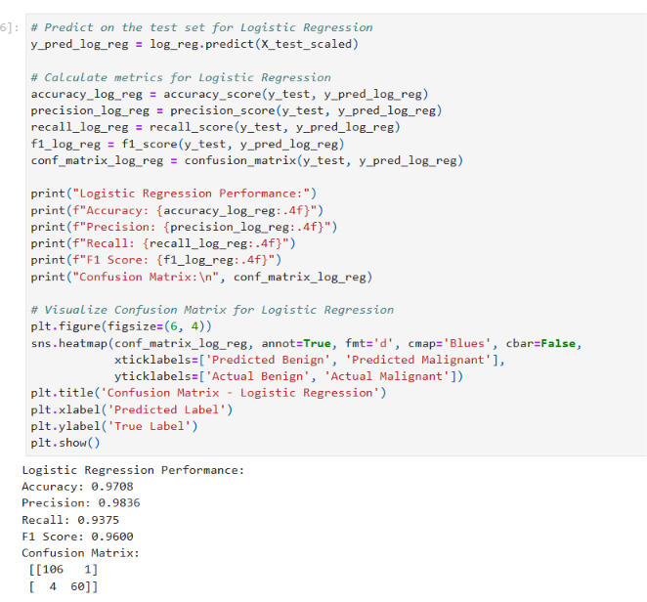
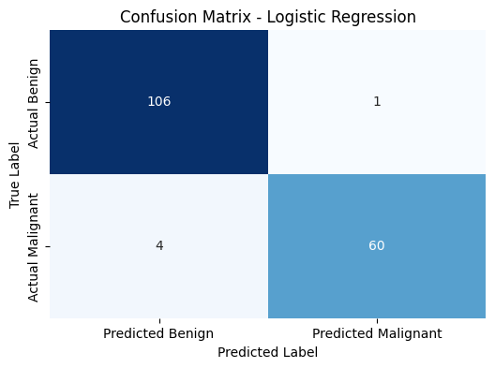
6.2 Evaluate K Nearest Neighbors (KNN)
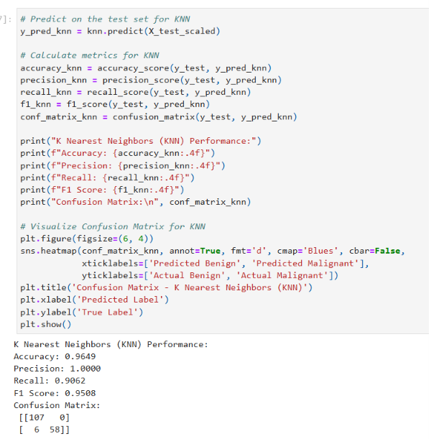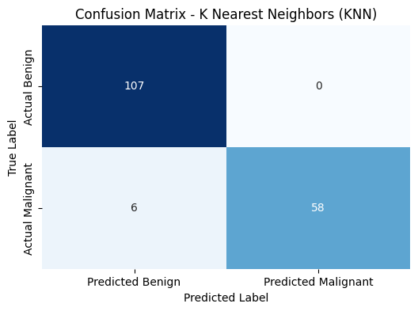
7. Compare the Performance of Logistic Regression and KNN
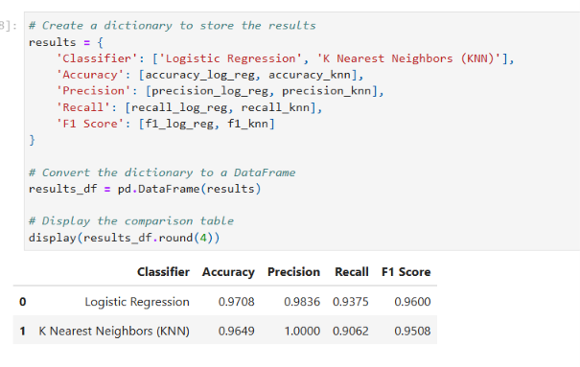
8. Interpret the Results and Comment on the Better Performing Classifier
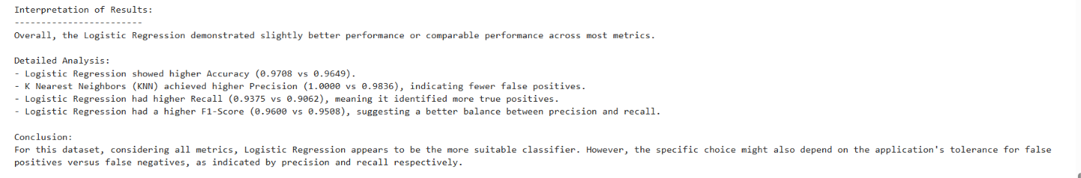
Conclusion /inference
Conclusion: Both Logistic Regression and KNN classifiers performed well on the Breast Cancer Wisconsin dataset. Logistic Regression showed slightly better overall performance with higher Accuracy, Recall, and F1-Score. While KNN achieved perfect Precision, Logistic Regression's higher Recall makes it generally more suitable for a medical diagnostic context where minimizing false negatives is critical.

Lab Activity 7 : Decision Tree

Lab Activity 7 :

Aim
To implement and analyze a Decision Tree classifier on the Iris dataset and evaluate the effect of different hyperparameters on classification performance using Scikit-learn.

Evaluation Rubrics

Submission Guidelines
- Make a copy of the lab manual template with your <name_reg:no_subject name>
- Copy the given question and the answer (lab code) with results, followed by the conclusion of that lab. Title the lab as Lab 1.
- Keep updating your lab manual and show the lab manual of that particular lab for evaluation.
- Create a Git repository in your profile <ML lab-reg no>. Follow a different branch for each lab <Lab 1, Lab 2 …> and push the code to Git.
- Provide the Git link in Google Classroom along with the PDF of the lab manual.
- Upload the PDF to Google Classroom before the deadline.

Code with Results
Task 1: Dataset Exploration
Load the Iris dataset and answer the following:
- How many samples and features are present in the dataset?
- List the feature names and target classes.
- Display the first five records.
- Display the class distribution.
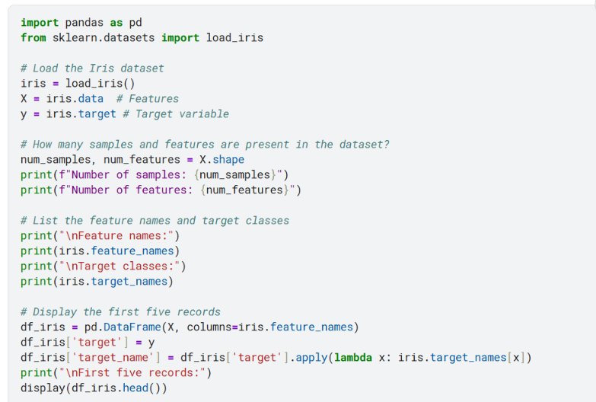
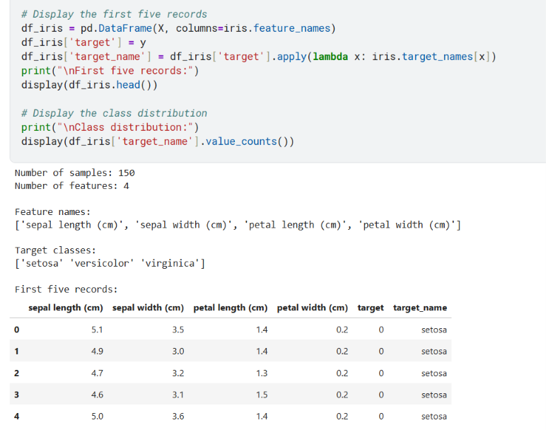
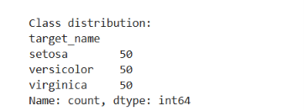
Task 2: Data Preparation
- Split the dataset into training (80%) and testing (20%) sets using random_state=42.
- Briefly explain why the dataset is divided into training and testing sets.
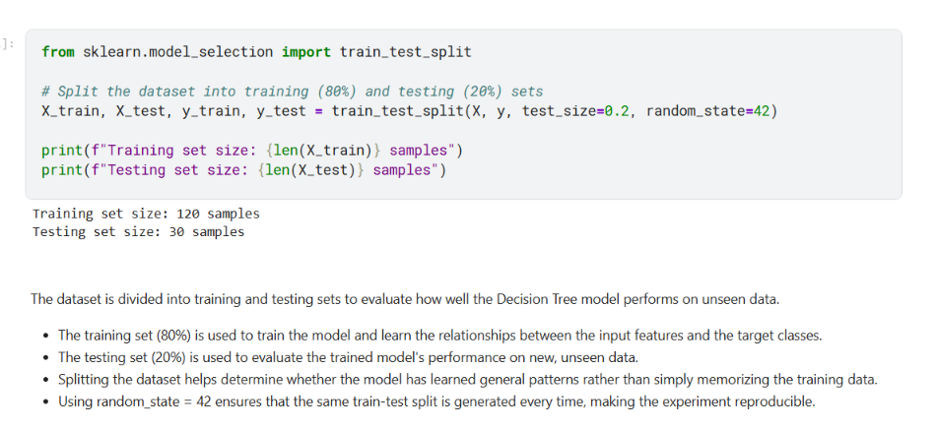
Task 3: Building a Decision Tree Classifier
- Train a Decision Tree classifier using the default parameters.
- Predict the class labels for the test dataset.
- Evaluate the model using:
  - Accuracy Score
  - Confusion Matrix
  - Classification Report
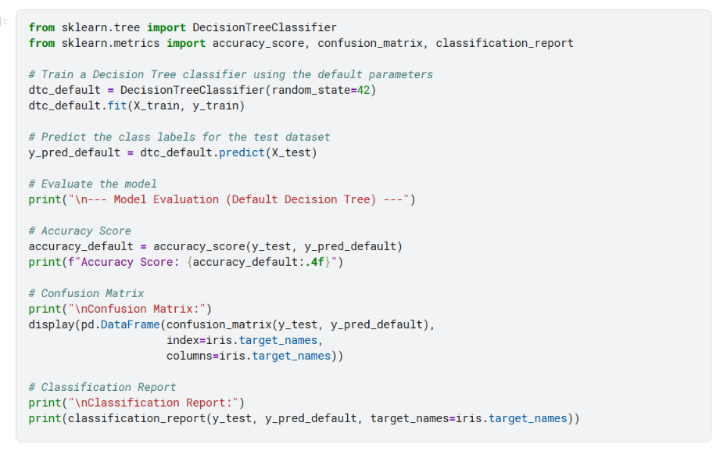
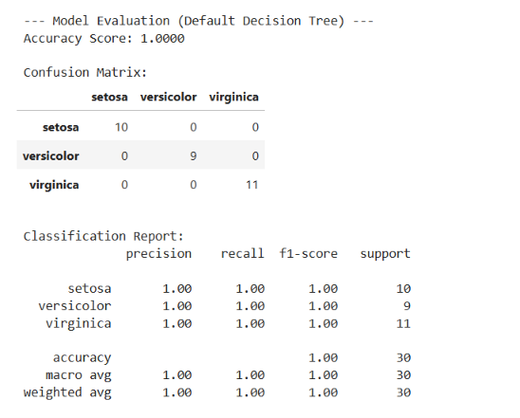
Task 4: Visualizing the Decision Tree
- Visualize the trained Decision Tree using plot_tree().
- From the visualization, identify:
  - Root node
  - Internal nodes
  - Leaf nodes
  - Maximum depth of the tree
- Which feature is selected for the first split? Explain why you think this feature was chosen.
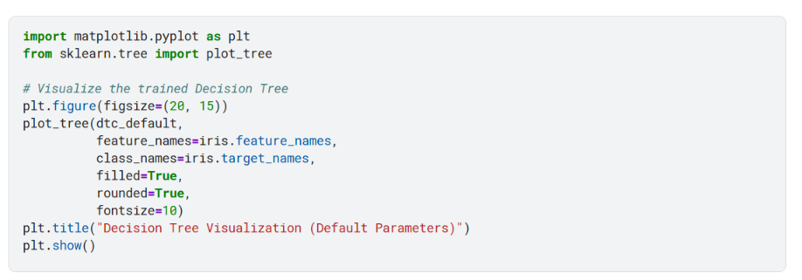
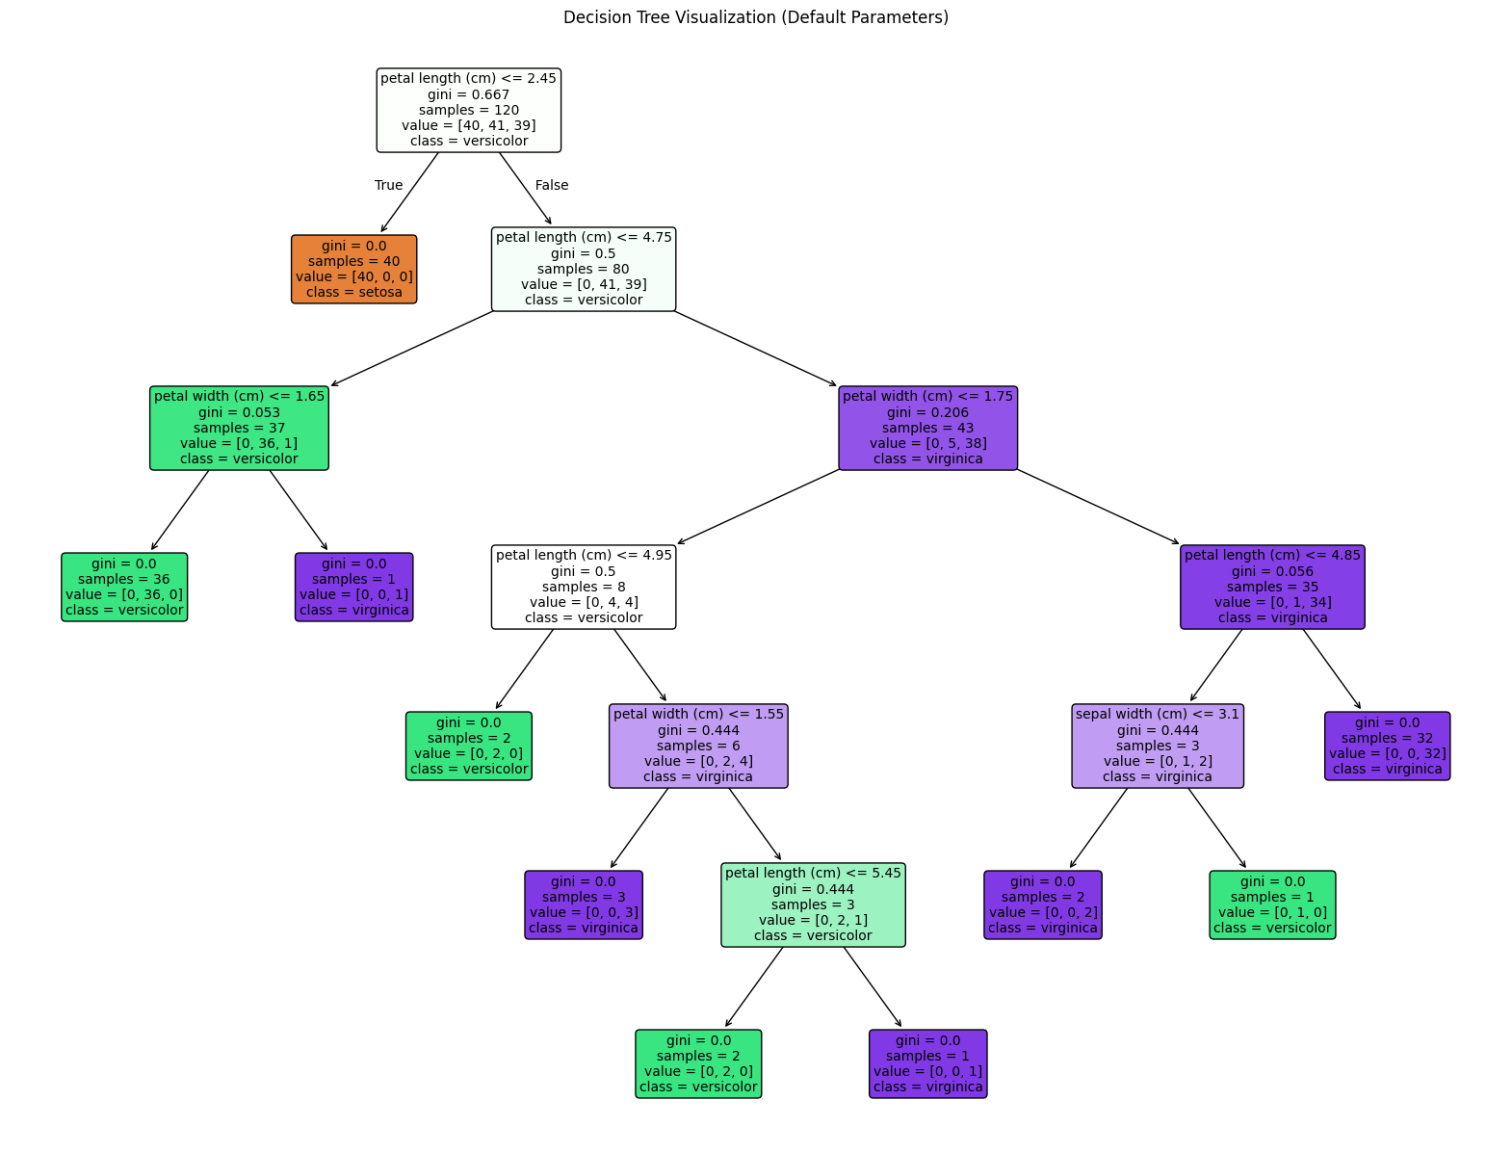
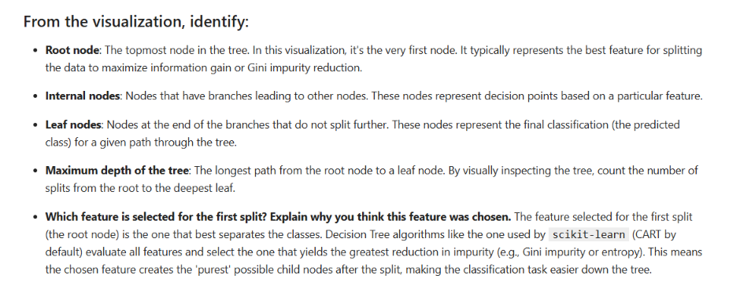
Task 5: Comparing Gini Index and Entropy
Train two Decision Tree models using the following criteria:
- criterion='gini'
- criterion='entropy'
Compare the models based on:
- Accuracy
- Tree depth
- Number of leaf nodes
- Root feature selected
- Which criterion produces a simpler tree?
Summarize your observations in a table.
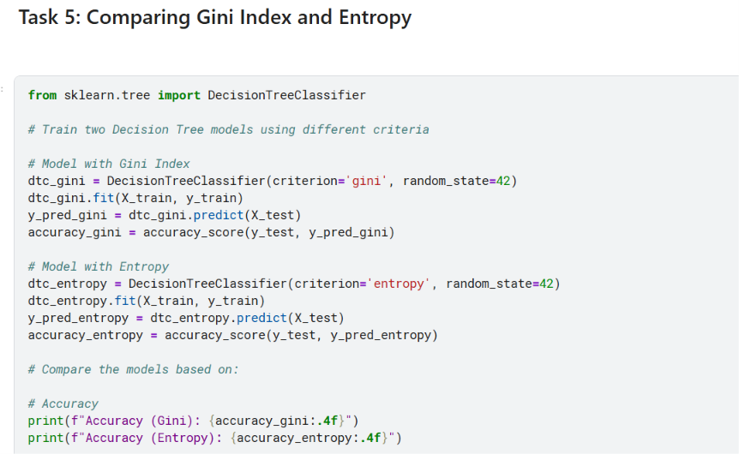
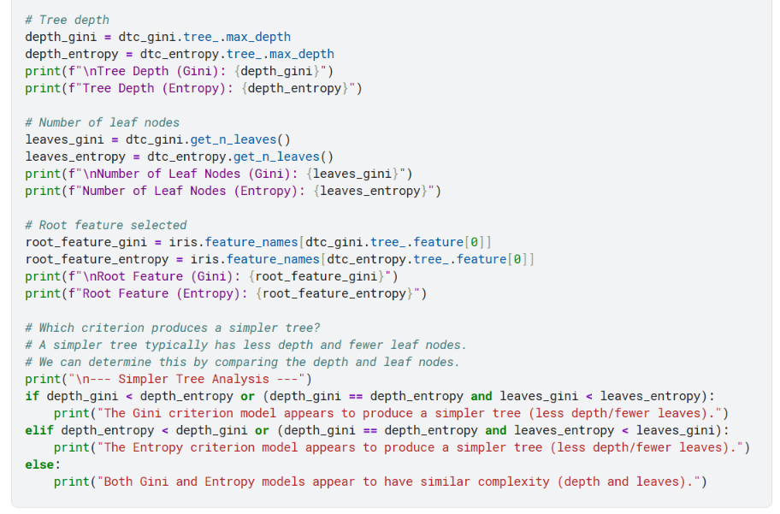
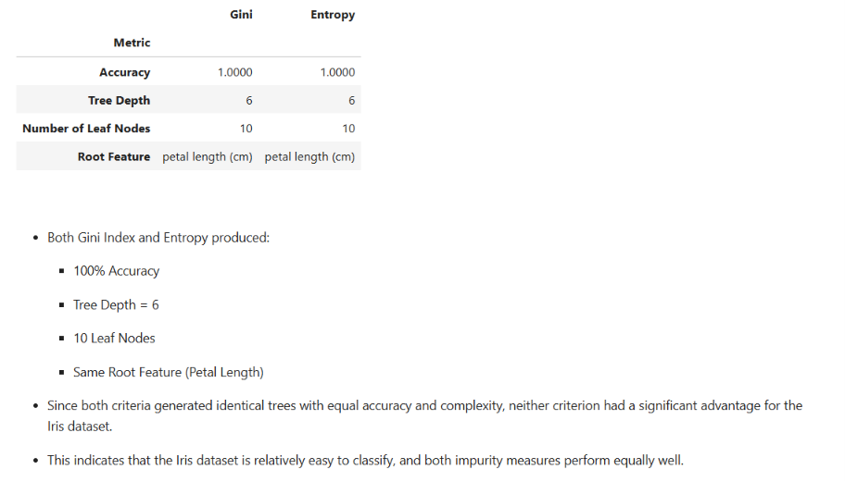
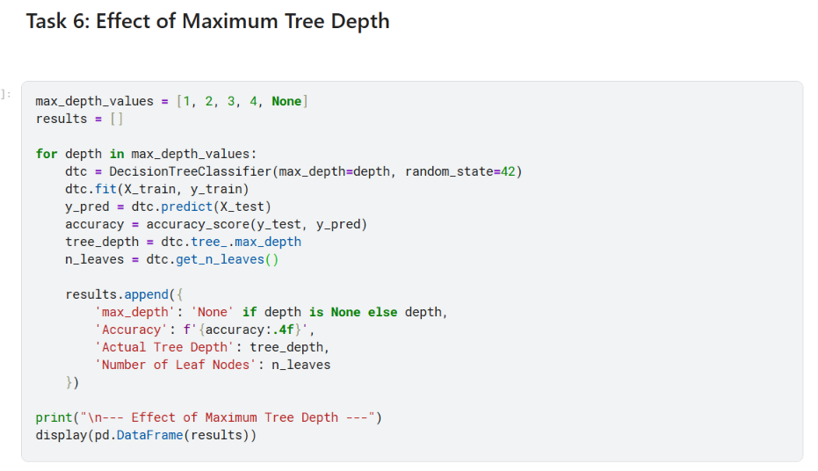
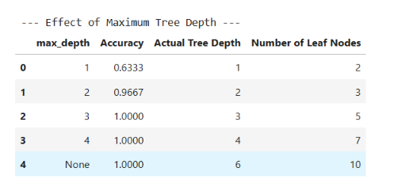
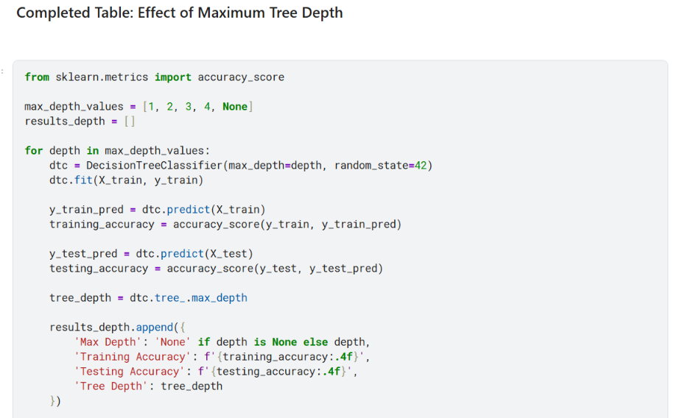
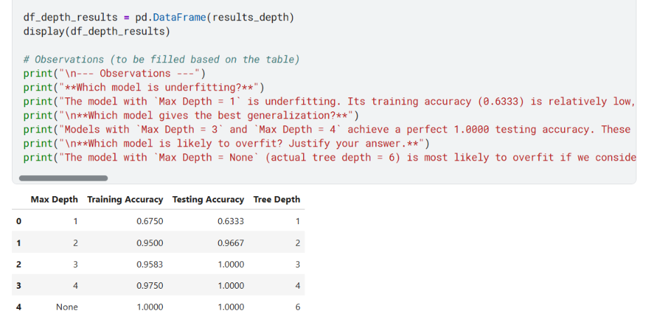
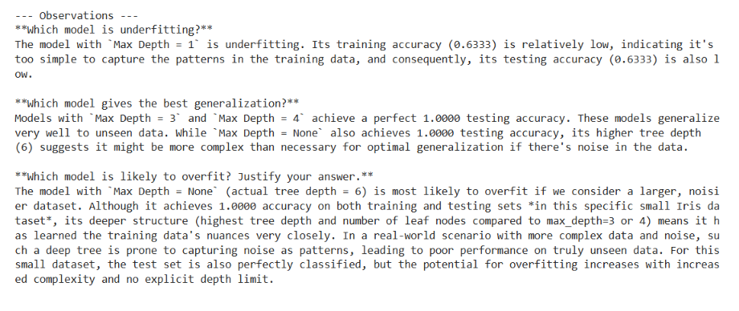
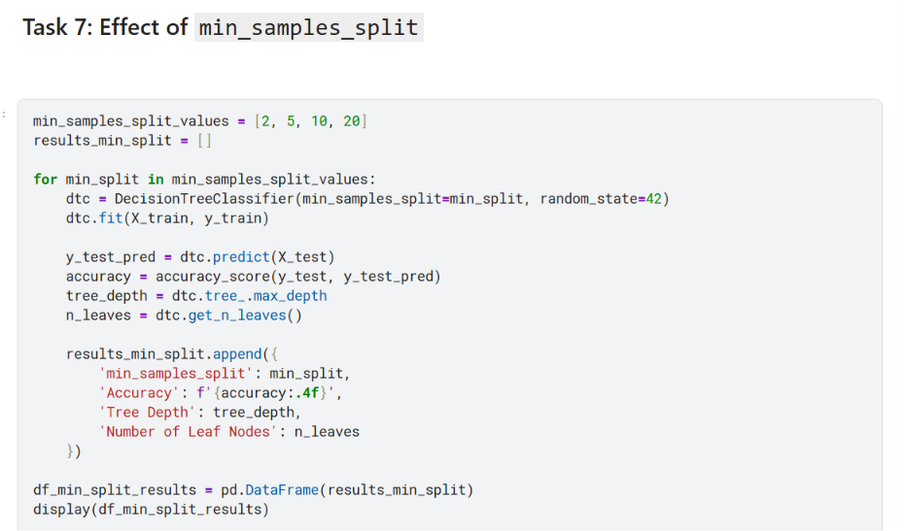
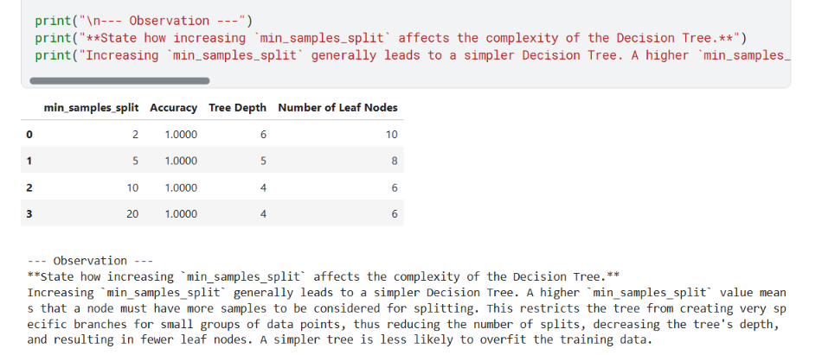
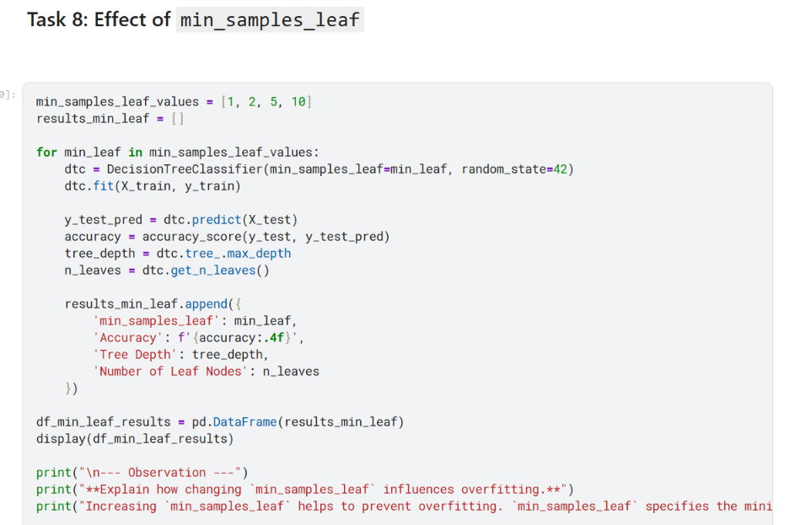
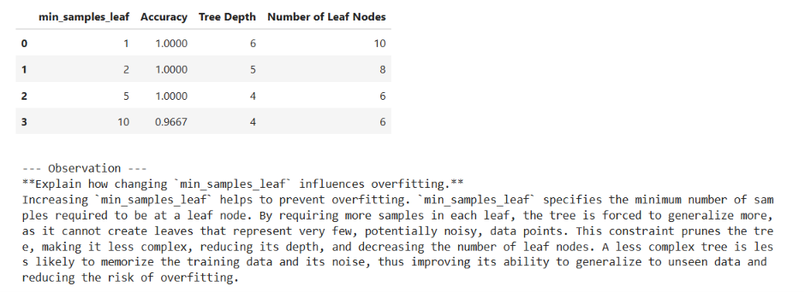
Task 9: Hyperparameter Tuning
Perform hyperparameter tuning using GridSearchCV with the following parameters:
- criterion: gini, entropy
- max_depth: 2, 3, 4, None
- min_samples_split: 2, 5, 10
- min_samples_leaf: 1, 2, 4
Report:
- Best hyperparameter combination.
- Best cross validation score.
- Test accuracy of the optimized model.
- Compare the optimized model with the default Decision Tree model.
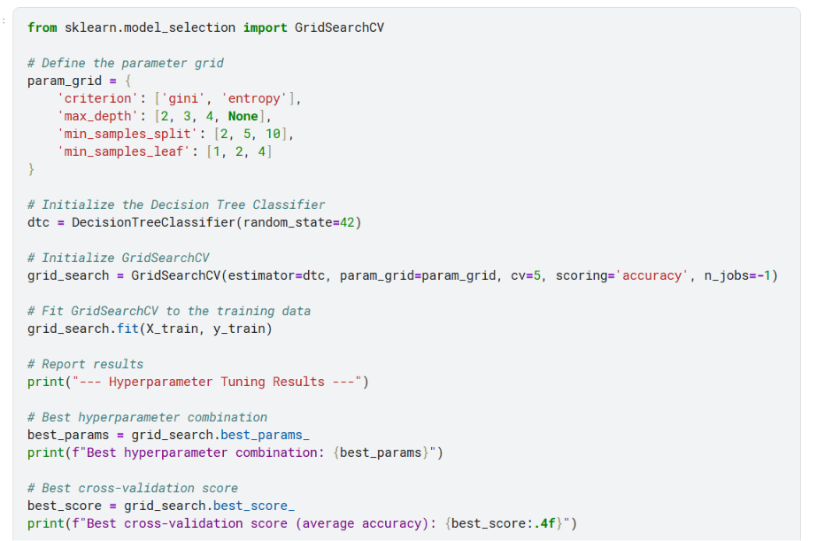
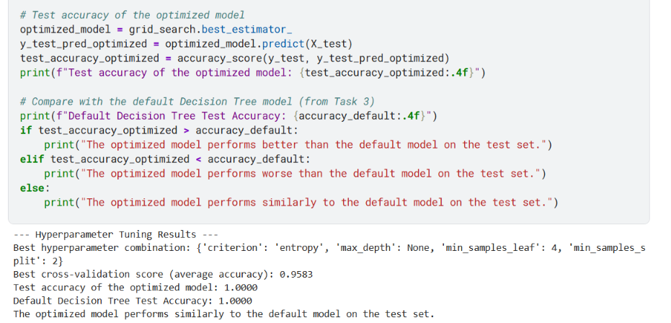
Task 10: Analysis
Answer the following questions.
- What is the role of the criterion parameter in a Decision Tree?
- How does max_depth influence underfitting and overfitting?
- Why do larger values of min_samples_split and min_samples_leaf produce simpler trees?
- Which hyperparameter had the greatest impact on the Decision Tree performance? Support your answer with observations from the experiments.
- Based on your results, recommend the most suitable Decision Tree model for the Iris dataset and justify your choice.
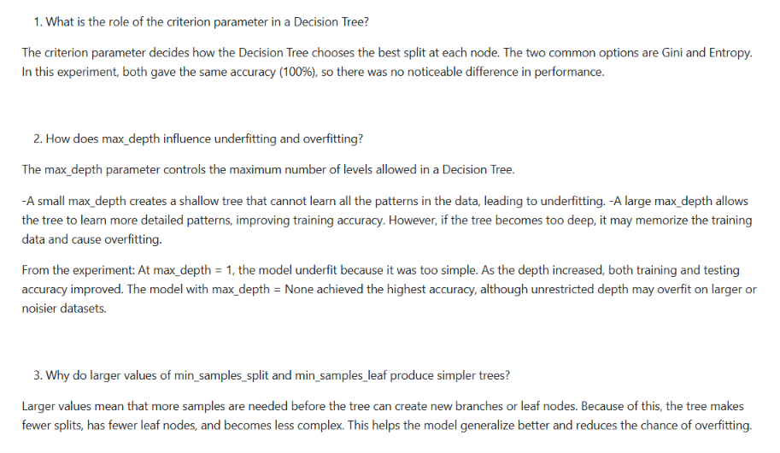
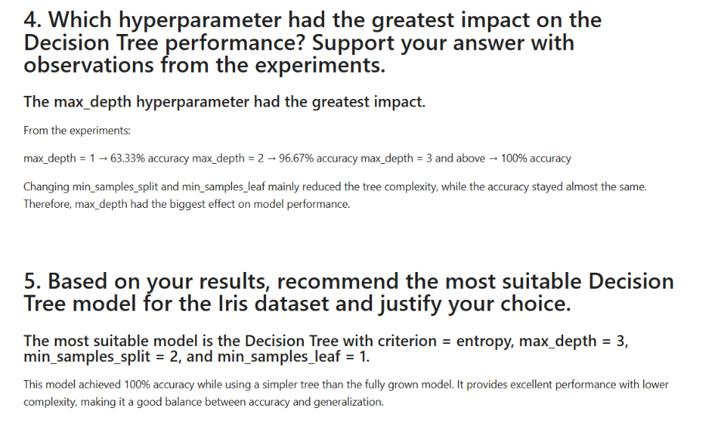
Conclusion /inference
The comparison between the Gini Index and Entropy showed that both criteria performed equally well on the Iris dataset. Both Decision Tree models achieved 100% classification accuracy, had the same tree depth (6), 10 leaf nodes, and selected Petal Length (cm) as the root feature. Therefore, there was no significant difference in terms of accuracy or model complexity. This indicates that the Iris dataset is well-structured and easily separable, allowing both impurity measures to produce equally effective Decision Tree models.

Lab 8 : Implementation and Performance Evaluation of Categorical Naive Bayes Classifier

Lab Exercise 8:

Aim
To implement and evaluate a complete machine learning classification pipeline using the 'Play Tennis' dataset. This involves data preprocessing, dataset partitioning, training and evaluating various classification models (Categorical Naive Bayes, Decision Tree, Logistic Regression, and SVM), performing single-sample inference, and finally, comparing the performance and prediction capabilities of these models.
Objectives
- Load and Preprocess Data: Handle categorical features and target variable.
- Partition Dataset: Split data into training and testing sets.
- Train and Evaluate Naive Bayes: Implement and assess the Categorical Naive Bayes model.
- Perform Single-Sample Inference: Predict for specific new data points with probabilities.
- Compare Multiple Models: Train and evaluate Decision Tree, Logistic Regression, and SVM for comparative analysis.

Evaluation Rubrics

Submission Guidelines
- Make a copy of the lab manual template with your <name_reg:no_subject name>
- Copy the given question and the answer (lab code) with results, followed by the conclusion of that lab. Title the lab as Lab 1.
- Keep updating your lab manual and show the lab manual of that particular lab for evaluation.
- Create a Git repository in your profile <ML lab-reg no>. Follow a different branch for each lab <Lab 1, Lab 2 …> and push the code to Git.
- Provide the Git link in Google Classroom along with the PDF of the lab manual.
- Upload the PDF to Google Classroom before the deadline.

Code with Results

Data Preprocessing:

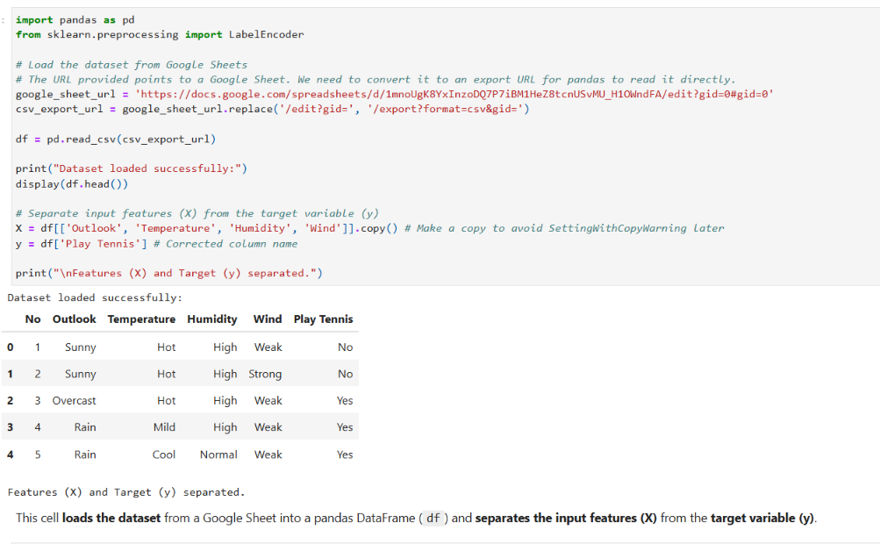

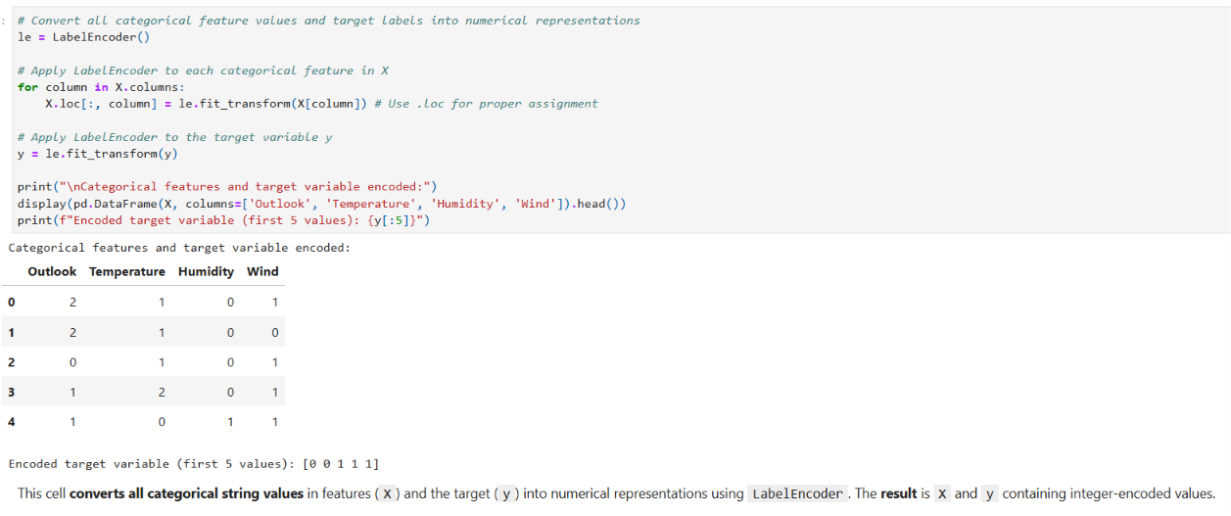

Dataset Partitioning:

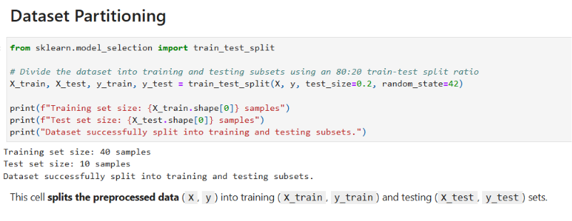

Naive Bayes Model Training & Evaluation:

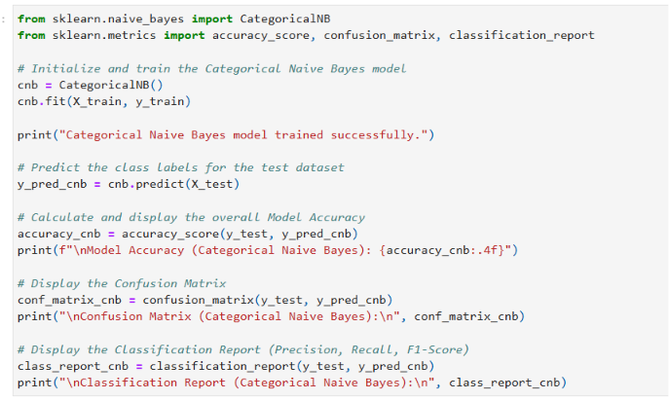
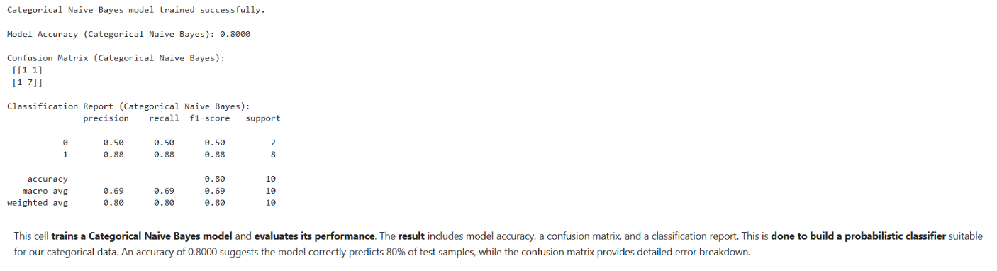

Single-Sample Inference:

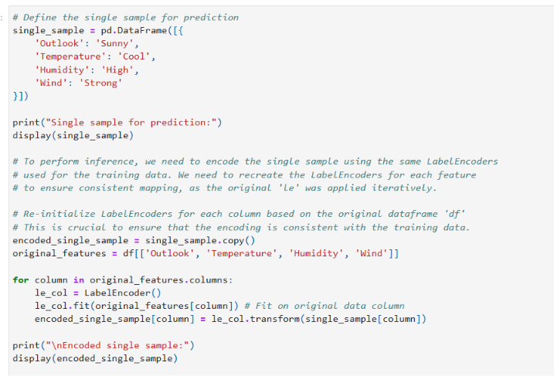
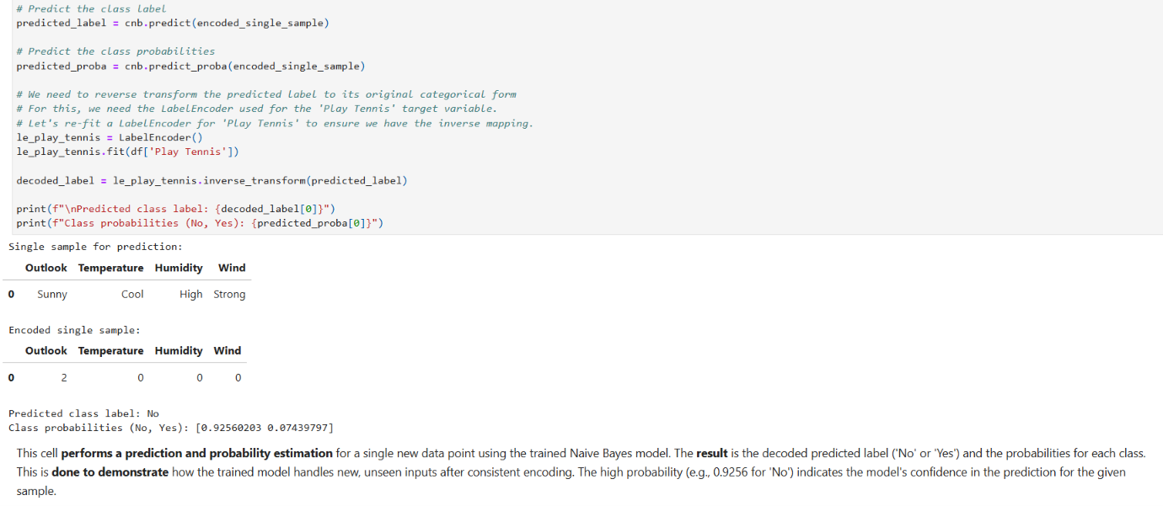

Model Comparison:

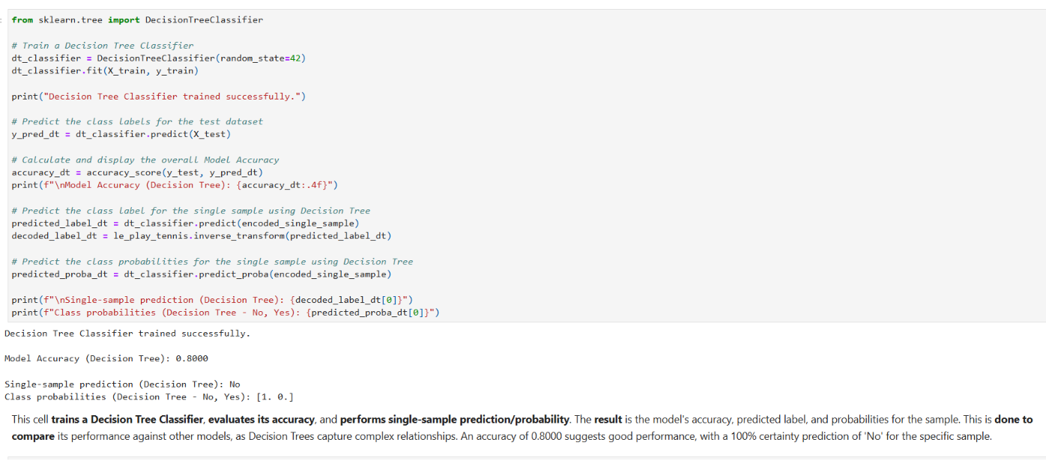

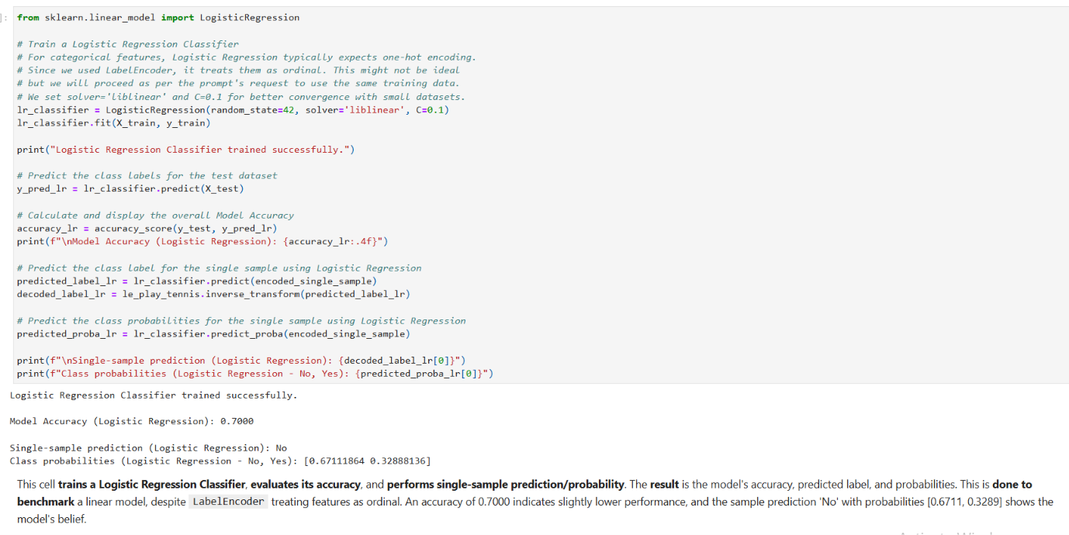
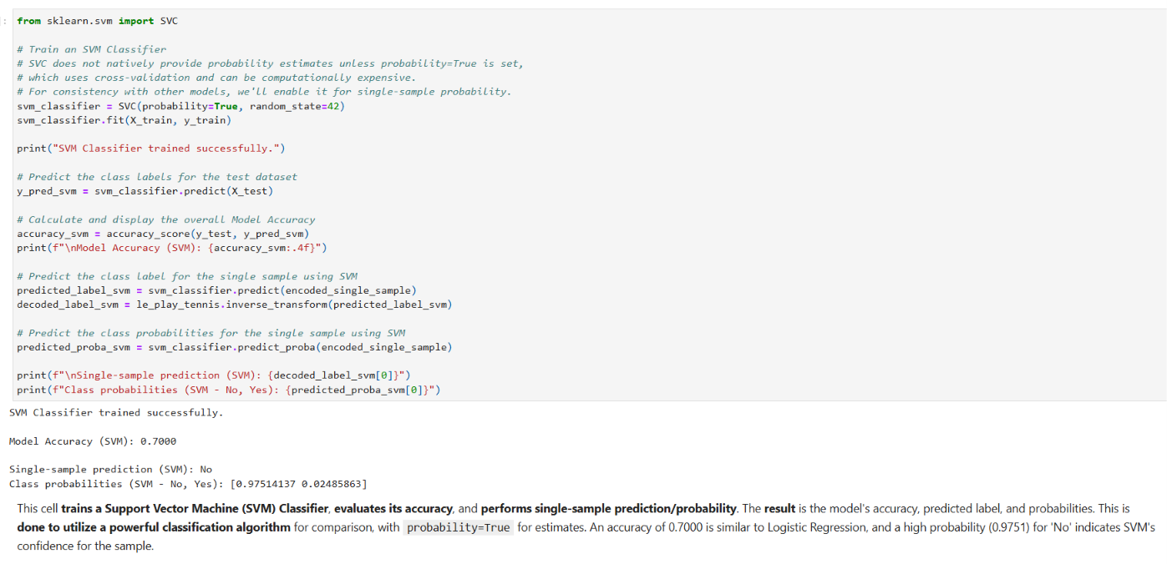
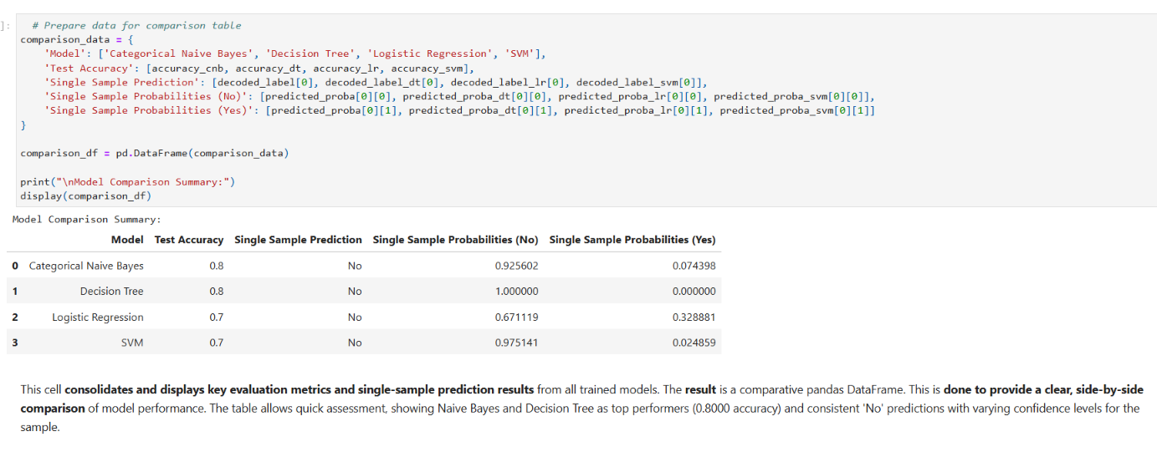

Conclusion /inference
It explores a machine learning pipeline by loading, preprocessing, splitting, training, and evaluating four classification models on a categorical dataset. The result showed varied accuracies (Naive Bayes/Decision Tree: 0.80, Logistic Regression/SVM: 0.70) and consistent 'No' predictions for a single sample with different confidence levels. This was done to compare algorithm suitability and understand prediction behavior across models. The interpretation is that Naive Bayes and Decision Tree were better suited to this specific dataset, and all models strongly agreed on the 'No' prediction for the given sample.

Lab 9 : Support Vector Machine (SVM) and Principal Component Analysis (PCA)

Lab Exercise 9:

Aim
To implement Support Vector Machine (SVM) for classification and Principal Component Analysis (PCA) for dimensionality reduction, and analyse their effectiveness using real world datasets.

Objectives
- To implement and evaluate the performance of the Support Vector Machine (SVM) classifier using different kernel functions.
- To compare the performance of SVM models using standard classification metrics.
- To apply Principal Component Analysis (PCA) for reducing the dimensionality of a high dimensional dataset.
- To analyse the variance retained by the principal components and visualize the transformed feature space.
- To understand the role of supervised learning (SVM) and unsupervised learning (PCA) in machine learning applications.

Evaluation Rubrics

Submission Guidelines
- Make a copy of the lab manual template with your <name_reg:no_subject name>
- Copy the given question and the answer (lab code) with results, followed by the conclusion of that lab. Title the lab as Lab 1.
- Keep updating your lab manual and show the lab manual of that particular lab for evaluation.
- Create a Git repository in your profile <ML lab-reg no>. Follow a different branch for each lab <Lab 1, Lab 2 …> and push the code to Git.
- Provide the Git link in Google Classroom along with the PDF of the lab manual.
- Upload the PDF to Google Classroom before the deadline.

Code with Results

Part A: Support Vector Machine (SVM)

Aim:
To implement the Support Vector Machine (SVM) classifier for a binary classification problem and evaluate its performance.

Load the dataset and perform the necessary preprocessing.

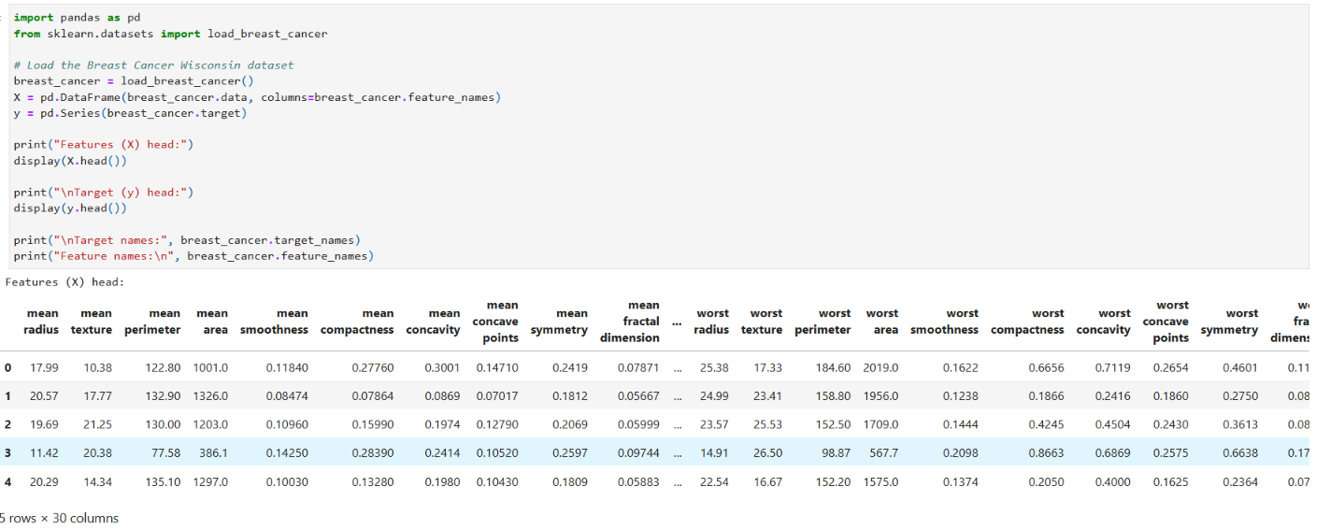

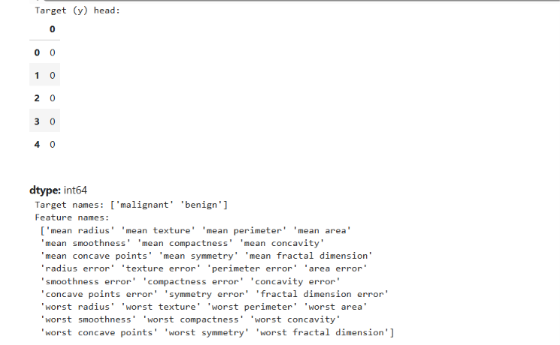

Split the dataset into training and testing sets (80:20).

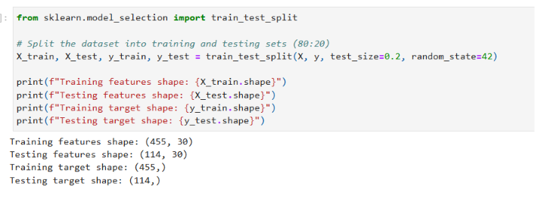

Train an SVM classifier using a Linear Kernel and explore hyper parameter tuning.

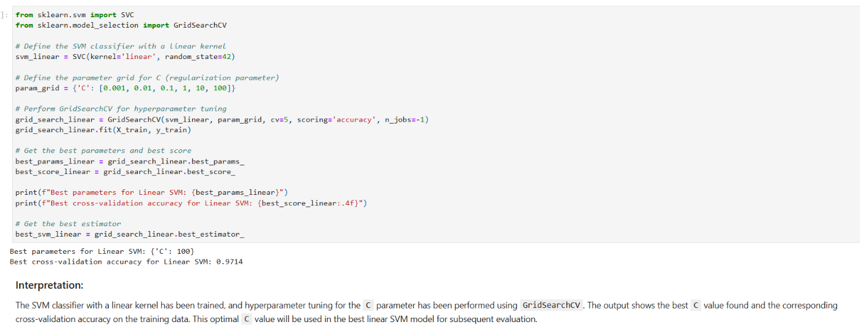

Evaluate the model using:

Accuracy

Precision

Recall

F1 Score

Confusion Matrix

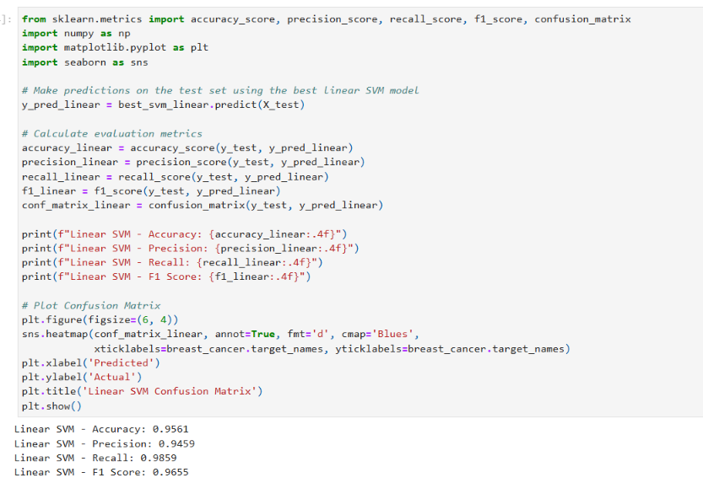
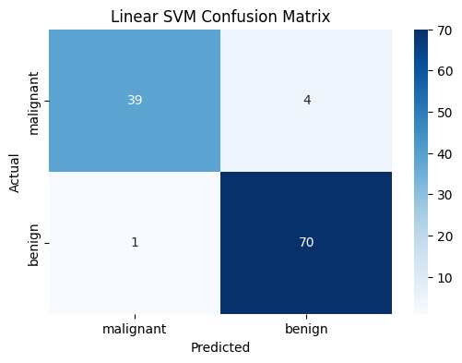

Summarize your observations.

Part B: Principal Component Analysis (PCA)

Aim:
To implement Principal Component Analysis (PCA) for dimensionality reduction and analyse the variance retained by the principal components.

Dataset:
UCI Wine Dataset

Load the dataset and perform feature standardization.
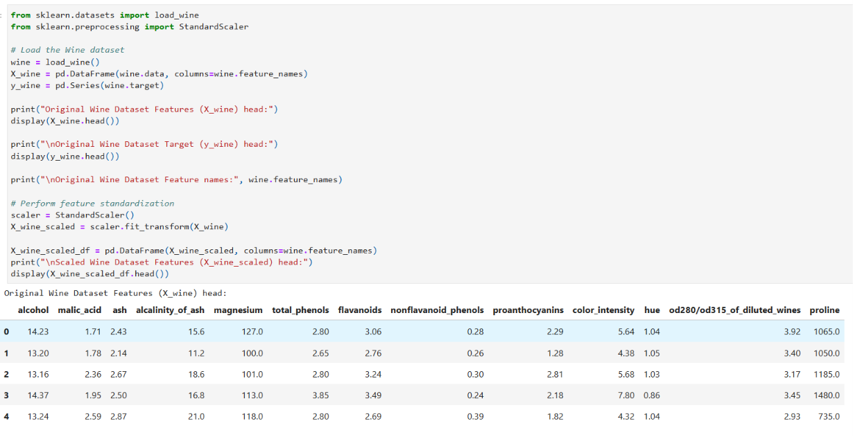
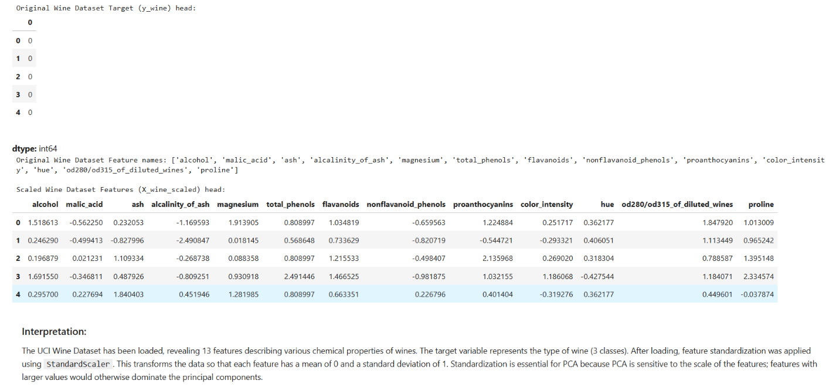

Apply PCA to reduce the dataset from 13 features to 2 principal components and display the explained variance ratio of each principal component.
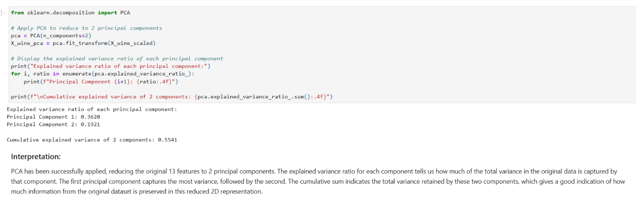

Calculate the cumulative explained variance and determine the minimum number of principal components required to retain at least 95% of the total variance.
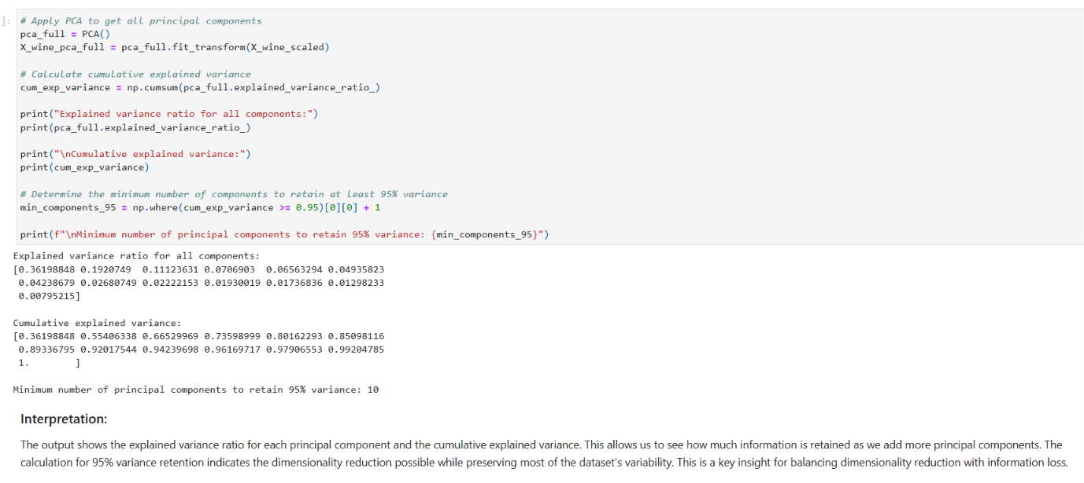

Visualize the transformed dataset using a two dimensional scatter plot.
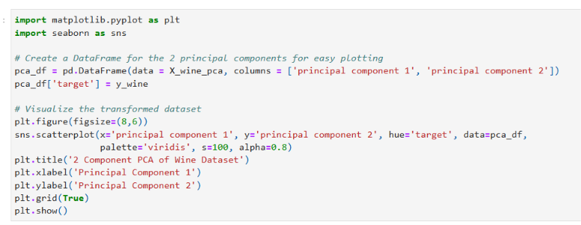
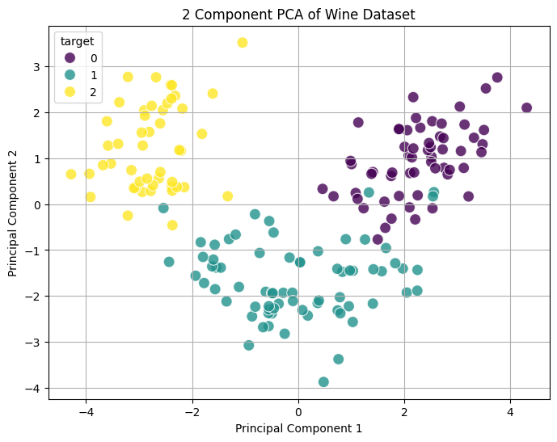

Compare the original and transformed datasets in terms of:

Number of features

Information retained

Computational efficiency
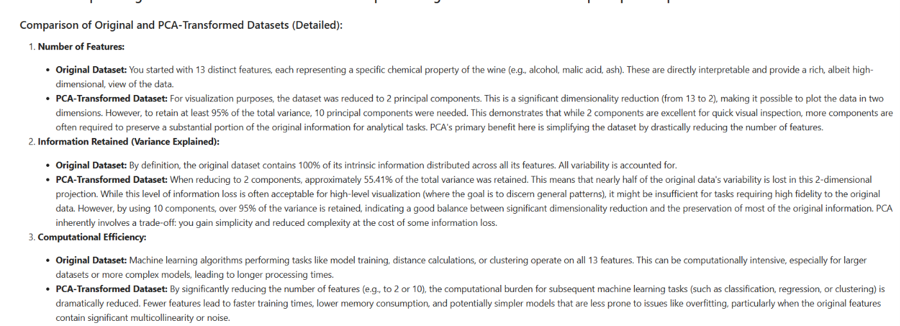

Interpret the significance of the first two principal components.
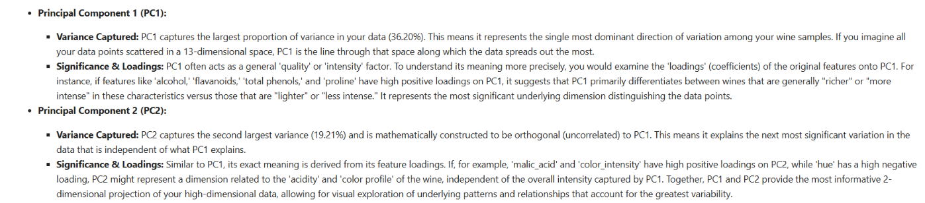

Discuss the advantages, limitations, and applications of PCA in machine learning.
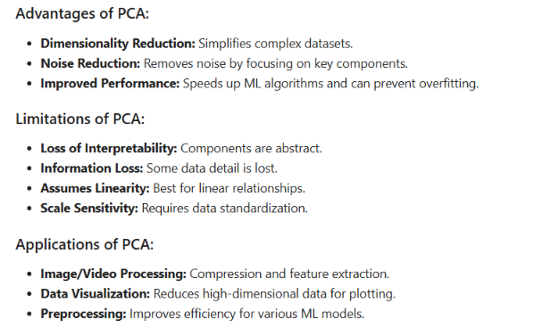

Extra Credits :

- Task 1: Apply Linear Discriminant Analysis (LDA) to the same Wine dataset and reduce it to two linear discriminants.

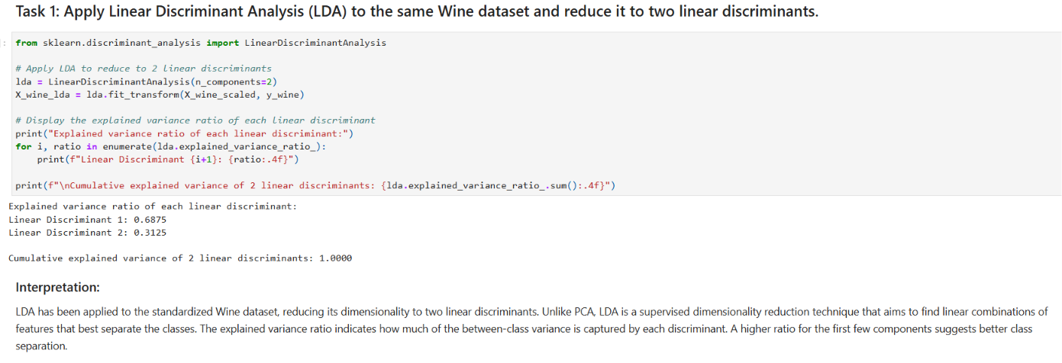

- Task 2: Visualize the LDA transformed data.
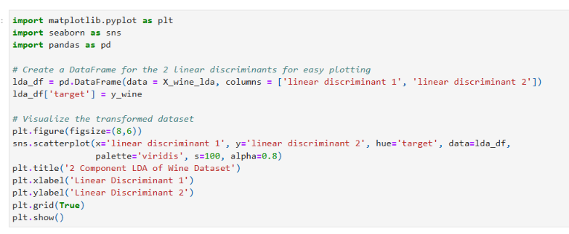
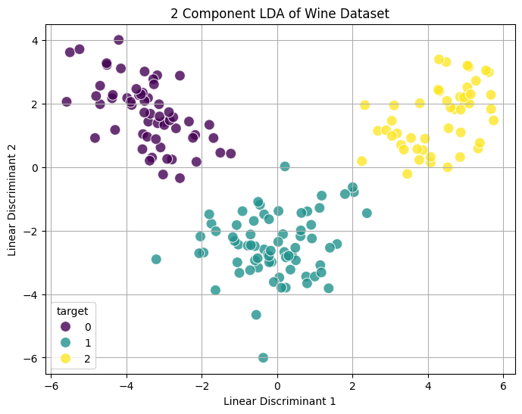
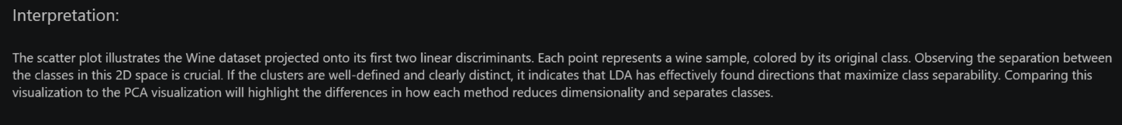

- Comparison of PCA and LDA on the Wine Dataset

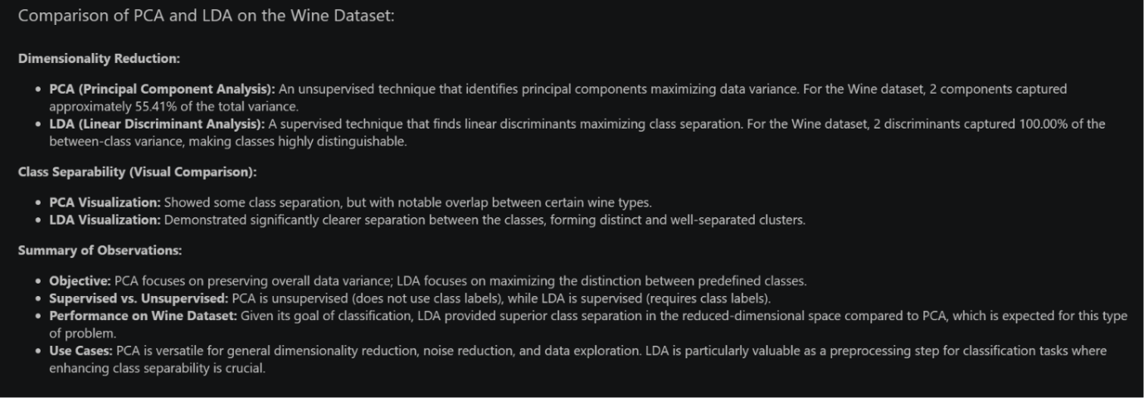

Conclusion /inference

Effectively demonstrated the application of Support Vector Machines (SVM) for classification using the Breast Cancer dataset, highlighting the importance of preprocessing and hyperparameter tuning. It also explored dimensionality reduction techniques, comparing PCA's variance retention on the Wine dataset with LDA's superior class separation for classification. The lab underscored the critical choice between unsupervised (PCA) and supervised (LDA) methods based on specific task objectives.

