
Department of Computer Science

Lab Manual

of

MACHINE LEARNING

MCA521-4

Class Name: IV MCA

Master of Computer Application

2026

Prepared by: Ananya
2547259 Verified by:
Dr. Rupali Sunil Wagh
Dr. Helen K Joy
Dr. Shivangi Singh

Department Overview
Department of Computer Science of CHRIST (Deemed to be University) strives to shape outstanding computer professionals with ethical and human values to reshape nation’s destiny. The training imparted aims to prepare young minds for the challenging opportunities in the IT industry with a global awareness rooted in the Indian soil, nourished and supported by experts in the field.

Vision
The Department of Computer Science endeavours to imbibe the vision of the University “Excellence and Service”. The department is committed to this philosophy which pervades every aspect and functioning of the department.

Mission
“To develop IT professionals with ethical and human values”. To accomplish our mission, the department encourages students to apply their acquired knowledge and skills towards professional achievements in their career. The department also moulds the students to be socially responsible and ethically sound.

Introduction to the Programme
Master of Computer Applications (MCA) is a post-graduate programme of CHRIST (Deemed to be University) and approved by the All India Council of Technical Education (AICTE). It is a two-year programme spread over six trimesters to bridge the chasm between computer studies and applications, bringing within reach of enthusiastic youngsters an excellent group of experienced and dedicated staff and experts, and an enviable infrastructure. MCA at CHRIST (Deemed to be University) strives to shape outstanding computer professionals with ethical and human values to reshape the nation’s destiny. The training programme aims to prepare young minds for challenging opportunities in the IT industry with a global awareness rooted in the Indian soil, nourished and supported by experts in the field. The Department is committed to the motto “Excellence and Service,” and this philosophy pervades every aspect of its functioning.

Programme Objective
This programme is conceptualised and designed based on the strong commitment of the
department to provide better quality education to the students. The principal objectives of this
course are to:
● Heighten technological awareness
● Train future industry specialists
● Encourage effective software development
● Provide research training
● Involve students in innovative research
● Produce graduates with a two-year professional education in Computer Science with
technical, professional, and communications skills.

Ethics and Human Values
1. Only proprietary or open-source software would be used for academic teaching and
learning purposes.
2. Copying of programs from the internet, friends or from other sources is strictly
discouraged since it impairs development of programming skills.
3. Unique Practical (Domain based) exercises ensure that the students don’t get involved in
code plagiarism.
4. Projects undertaken by students during the course are done in teams to improve
collaborative work and synergy between team members.
5. Projects involve modularization which initiates students to take individual responsibility
for common goals.
6. Passion for excellence is promoted among the students, be it in software development or
project documentation.
7. Giving due credit to sources during the seminar and research assignment is promoted
among the students
8. The course and its design enforce the practice of good referencing technique to improve
the sense of integrity.
9. Courses involving group discussions and debates on ethical practices and human values
are designed to sensitize the students in dealing with customers and members within the
Organization.

Programme Outcomes:
P01: Foundation Knowledge: Apply knowledge of mathematics, programming logic, and
coding fundamentals for solution architecture and problem-solving.
P02: Problem Analysis: Identify, review, formulate, and analyse problems primarily focussing on customer requirements using critical thinking frameworks.
P03: Development of Solutions: Design, develop and investigate problems with as an
innovative approach for solutions incorporating ESG/SDG goals.
PO4: Modern Tool Usage: Select, adapt, and apply modern computational tools such as the
development of algorithms with an understanding of the limitations including human biases.
P05: Individual and Teamwork: Function and communicate effectively as an individual or a
team leader in diverse and multidisciplinary groups. Use methodologies such as agile.
P06: Project Management and Finance: Use the principles of project management such as
scheduling, and work breakdown structure and be conversant with the principles of Finance for profitable project management.
P07: Ethics: Commit to professional ethics in managing software projects with financial aspects.
Learn to use new technologies for cyber security and insulate customers from malware
P08: Life-long learning: Change management skills and the ability to learn, keep up with
contemporary technologies and ways of working.

Programme Educational Objectives(PEO’s)
PEO1: Develop innovative and effective software solutions through research that addresses
real-world challenges, grounded in a commitment to continuous learning and adaptability.
PEO2: Advance the knowledge and practices in the field of computer applications through
lifelong learning and rigorous research, supporting professional growth and academic excellence.
PEO3: Exhibit ethical leadership, social responsibility to contribute and enhance community
well-being by innovating solutions.
MCA521-4 – MACHINE LEARNING
Course Name: MACHINE LEARNING Code: MCA521-4
Total Hours: 75
L + P + T: 3 + 4 + 0
Max Marks: 100
Credits: 4
Course Type: Core Course
Course Category: Theo&Prac
Course Description
Machine Learning is a key area in computer applications that focuses on building models capable of making predictions or informed decisions based on data. A strong understanding of machine learning enables students to analyze and interpret complex datasets, develop predictive models, and extract meaningful insights. This course covers a wide range of machine learning concepts and techniques, including supervised and unsupervised learning. It provides a solid theoretical foundation while emphasizing practical, hands-on experience with algorithms and real-world data. The course equips students with the knowledge and skills required to apply machine learning techniques across various domains using modern tools and methodologies.
Course Objectives
This course enables students to understand the fundamental concepts of Machine Learning, including its core principles, terminology, and methodologies. Students will learn to differentiate between various types of learning algorithms such as supervised, unsupervised, and reinforcement learning, and recognize their appropriate applications.
Course Outcomes
After successful completion of the course, students will be able to:
● Explain the fundamental principles and scope of Machine Learning
● Implement modelling practices in machine learning for better generalisation
● Interpret predictive modelling results and performance of supervised machine learning techniques
● Assess the outcomes and effects of unsupervised machine learning processes
● Deploy robust machine learning models for interdisciplinary applications

Unit-1: INTRODUCTION TO MACHINE LEARNING Teaching Hours: 15 Hours
Introduction to AI – Knowledge Representation – Data – Representation of Data, Data Processing, Data Storage, Data Processing, Types of Data – Exploratory Data Analysis, Visualisations and Interpretation, Outliers
Machine Learning: Definition, Objectives, Components, Features, Applications – Traditional Programming v/s Machine Learning, Types of Machine Learning – Predictive Models, Statistical Inferences – Applications of Machine Learning
Challenges in ML: Insufficient Quantity of Data, Non-representative and Poor-Quality Data, Irrelevant Features, Estimation Estimation, Reducing Human Biases in Model Building, Ethical Use of Technology
Lab Exercises:
1. Data Preprocessing and visualisation
2. Data exploration and inferences

Unit-2: PROCESSES IN MACHINE LEARNING Teaching Hours: 15 Hours
Data Preparation and Model Selection: Effect of Data Preparation: Encoding, Nominal and Ordinal Representation, Feature Transformation and Feature Engineering, Generalisation, Normalisation, Sampling, Using Saved Weights, Model Selection Strategies: Overfitting, Underfitting, Bias-Variance Trade-off, Testing and Validation: Performance measures - Confusion matrix, Precision-Recall Trade off, F1 Score, ROC Curve, AUC, Error Analysis, Model Parameters, Hyperparameters, Hyperparameter Tuning, Cross Validation, Decision Functions: Introduction to Supervised Machine Learning Methods, Decision Functions, Decision Thresholds, Distance Measures, Hyperplanes, Regression & Classification Problems, Loss and Cost Functions, Linear Regression using OLS, Multi-class vs Multi-label, KNN Classification
Lab Exercises:
3. Saving weights of a generalised model.
4. Regression and Classification Evaluation Metrics: Illustration through Linear Regression and KNN Classification

Unit-3: SUPERVISED LEARNING ALGORITHMS Teaching Hours: 15 Hours
Learning through Optimisation: Gradient Descent, Linear Regression, Logistic Regression Computational Learning: Decision Trees, Naive-bayes classification, Support Vector Machines, Ensemble Learners: Learning, Voting, Bagging, Stacking, Boosting, Random Forests, GridSearchCV
Lab Exercises:

5. Regression through Gradient Descent
6. Comparison of Different Classifiers
7. Illustration of Ensemble Learning Methods

Unit-4: UNSUPERVISED LEARNING AND DIMENSIONALITY REDUCTION Teaching Hours: 15 Hours
Introduction: Types of Unsupervised Learning, Challenges in Unsupervised Learning, Concept of Cost Functions in Unsupervised Learning, Clustering Methods: Distance based, Centroid Based, Elbow method to find Optimal Number of Clusters, Silhouette Method, K-Means Clustering, Hierarchical Clustering: Agglomerative and Bottom Up, Applying Supervised Learning after Clustering, Dimensionality Reduction Methods: Principal Component Analysis (PCA), Linear Discriminant Analysis (LDA)
Lab Exercises:
8. KMeans and Elbow Methods
9. Hierarchical Clustering and Dendrograms
10. Dimensionality Reduction
11. Image Compression using Dimensionality Reduction.

Unit-5 Teaching Hours: 15 Hours
MACHINE LEARNING IN REAL-WORLD
Emerging Techniques: Role of ML in attaining Sustainable Development Goals, Time Series Preprocessing, Blackbox Methods: Neural Networks & Deep Learning, Reinforcement Learning/QLearning, Self Supervised Learning, Quantum Machine Learning, Keras and Tensorflow for designing Multi Layer Perceptron. Case Studies: CNN, RNN, Advances in Deep Learning, Natural Language Processing, Real Time Systems, Computer Vision, Robotics, Expert Systems, Generative Networks, Large Language Models. Model Deployment: Model Deployment: Connecting Models to User Interface, Deployment of ML Models.
Lab Exercises:
12. Training a Multi-layer perceptron
13. Deploying Trained ML-models

Text and Reference Books
[1] Campesato, O. (2020). Artificial Intelligence, Machine Learning and Deep Learning. Mercury Learning and Information.
[2] Andreas C. Müller and Sarah Guido (2017), “Introduction to Machine Learning with Python A Guide For Data Scientists” O’Reilly book
[3] Ethem Alpaydin (2005), “Introduction to Machine Learning”, Prentice Hall of India
[4] Max Kuhn and Kjell Johnson (2018), “Applied Predictive Modelling”, Springer

Essential Reading
[1] Stuart Russell and Peter Norvig(2020), “Artificial Intelligence: A Modern Approach” (4th Edition), Pearson
[2] Aurelien Geron(2019), “Hands on Machine Learning with Scikit-learn, Keras and Tensorflow”, 2nd Edition, O’Reilly Books
[3] Kevin P. Murphy(2012), “Machine Learning: A Probabilistic Perspective”, MIT Press
[4] Hastie, Tibshirani, Friedman(2008), “The Elements of Statistical Learning” (2nd ed), Springer
[5] Ian Goodfellow, Aaron Courville, Yoshua Bengio (2019), “Deep Learning (Adaptive Computation And Machine Learning Series)”, MIT Press
Additional Information (Web Resources):
1. Andrew Ng, Deeplearning.ai, Machine Learning Specialisation, offered through Coursera: https://www.deeplearning.ai/courses/machine-learning-specialization/

Evaluation Pattern: CIA - 50% ESE - 50%

LIST OF PROGRAMS

MSCAIML
Sl.no | Title of lab Experiment | Page number | RBT | CO
1 |  |  | L3 | CO1,3
2 |  |  | L3 | CO2,3
3 |  |  | L3 | CO3
4 |  |  | L3 | CO3
5 |  |  | L3 | CO3
6 |  |  | L3 | CO3,4
7 |  |  | L4 | CO3
8 |  |  | L3 | CO3
9 |  |  | L3 | CO4
10 |  |  | L5 | CO4

Evaluation Rubrics:
Evaluation Rubrics for each program would be

Submission Guidelines:
- Make a copy of the lab manual template with your <name_reg:no_subject name >,

- Copy the given question and the answer (lab code) with results, followed by the conclusion of that lab. Title the lab as lab number.
- Keep updating your lab manual and show the lab manual of that particular lab for evaluation.
- Create a Git Repository in your profile <ML lab-reg no> . Follow a different branch for each lab <Lab 1, Lab 2…>, and push the code to Git. The link should be provided in Google Classroom along with the PDF of the lab manual.
- Upload the PDF to Google Classroom before the deadline.

Lab 3

Lab Exercise 3: Student Survey: Simple Linear Regression using Scikit Learn, OLS, and Parameter Saving

Aim
- To collect real-world student survey data using Google Forms, preprocess and clean the dataset, perform Simple Linear Regression using Scikit-learn, manually compute the regression equation using Ordinary Least Squares (OLS) formulas, compare both approaches, and save the learned model parameters.

Evaluation Rubrics

Submission Guidelines
- Make a copy of the lab manual template with your <name_reg:no_subject name>
- Copy the given question and the answer (lab code) with results, followed by the conclusion of that lab. Title the lab as Lab 1.
- Keep updating your lab manual and show the lab manual of that particular lab for evaluation.
- Create a Git repository in your profile <ML lab-reg no>. Follow a different branch for each lab <Lab 1, Lab 2 …> and push the code to Git.
- Provide the Git link in Google Classroom along with the PDF of the lab manual.
- Upload the PDF to Google Classroom before the deadline.

Code with Results
Part A: Data Collection and Preprocessing
- Load the dataset using Pandas
- Display the first 5 rows
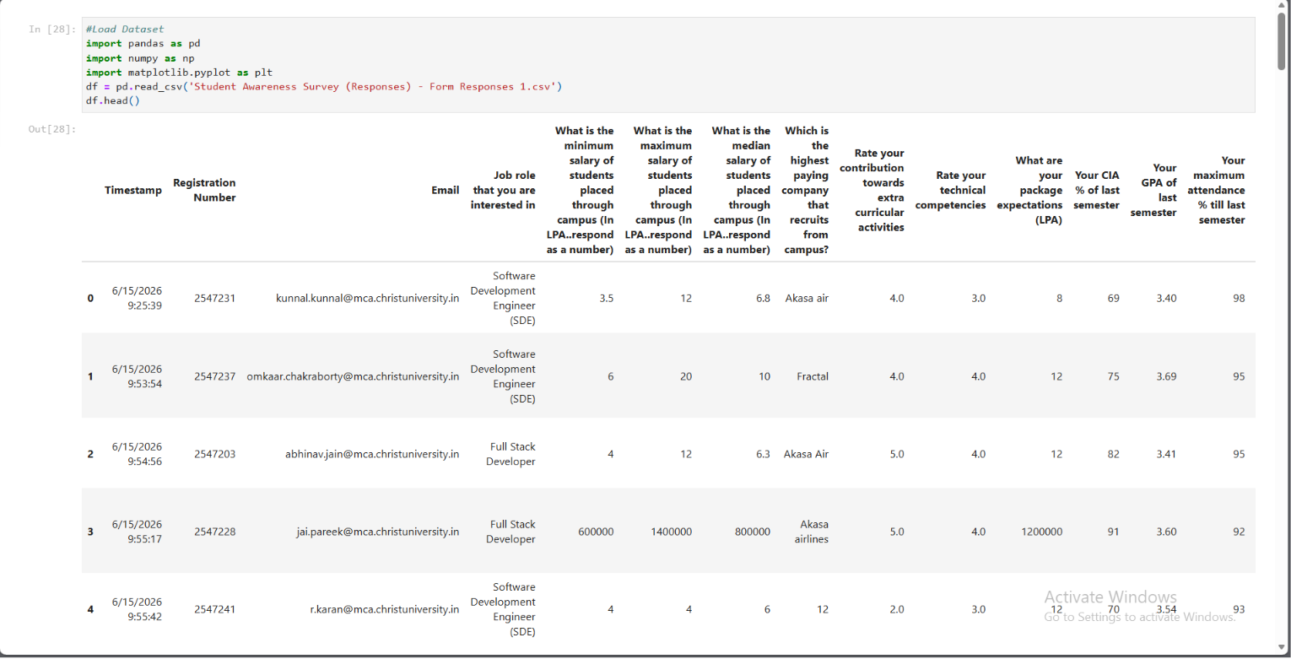
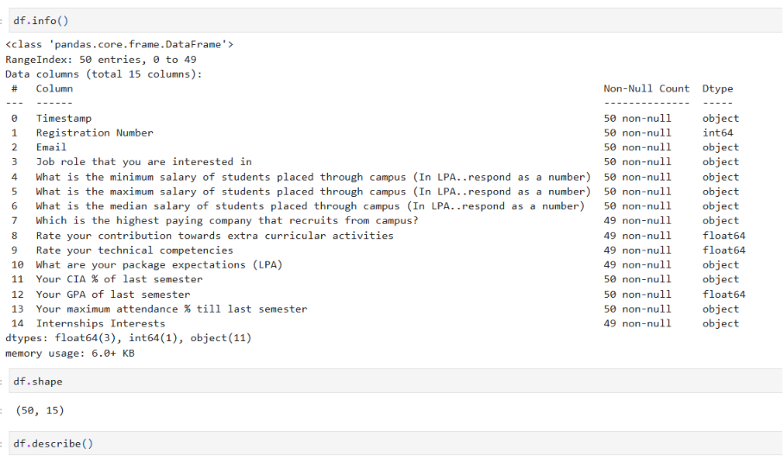
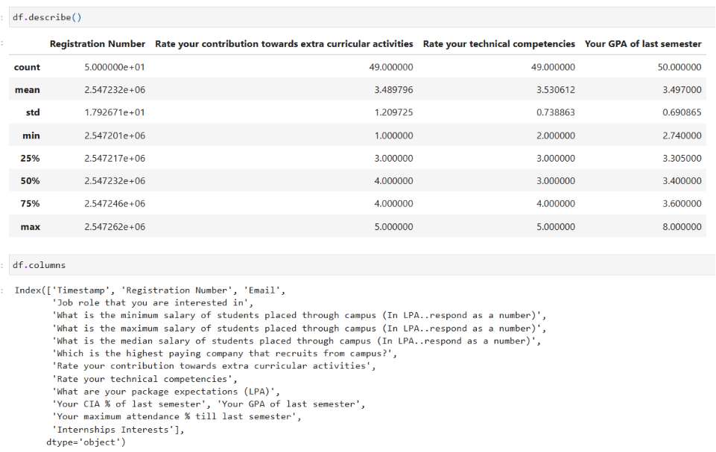
- Identify missing values
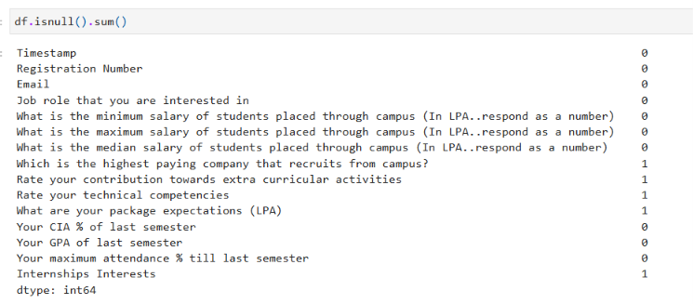
Remove or handle null values
Remove duplicate records if present
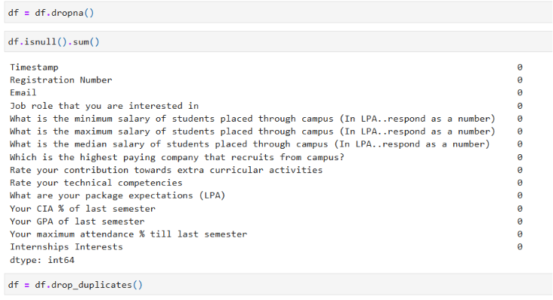
Convert required columns into numerical datatype
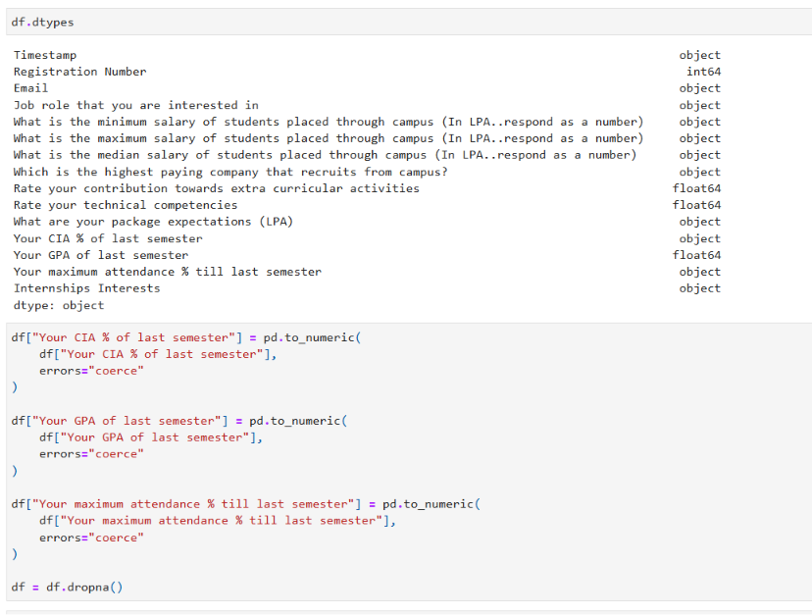
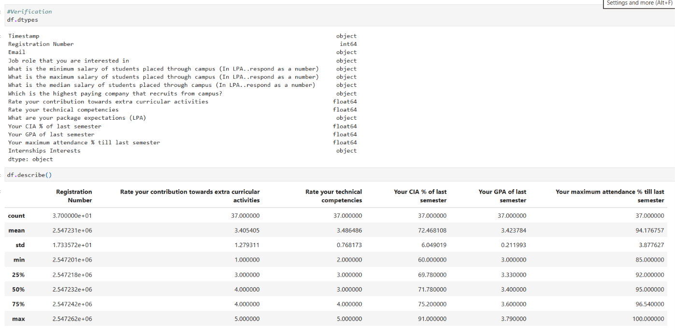
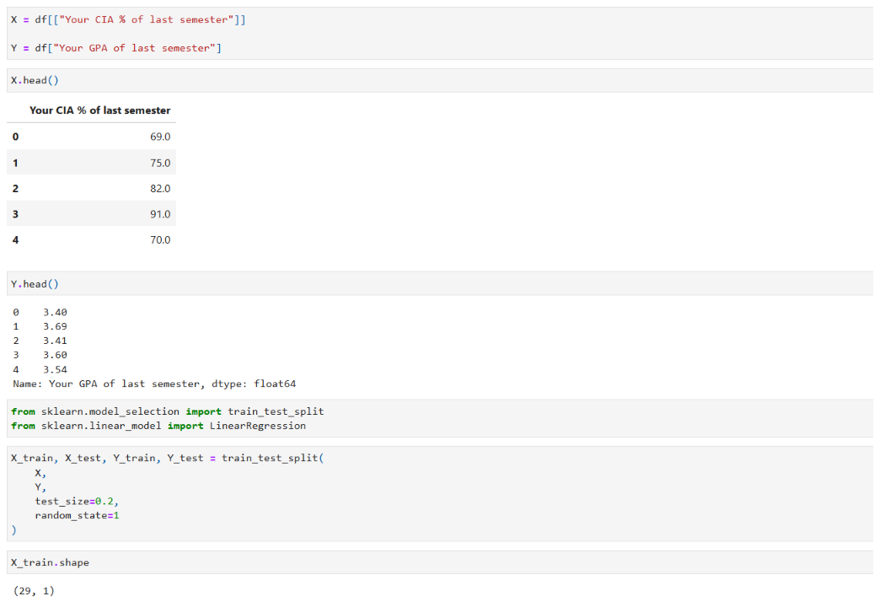
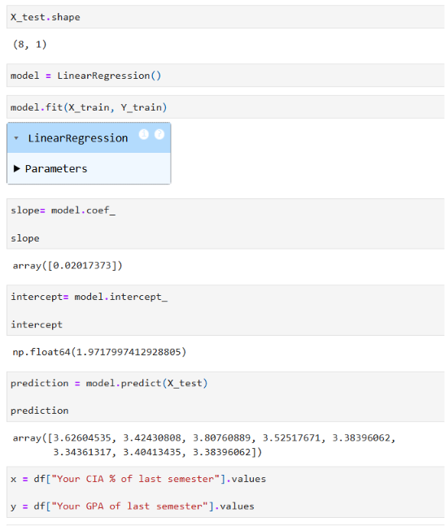
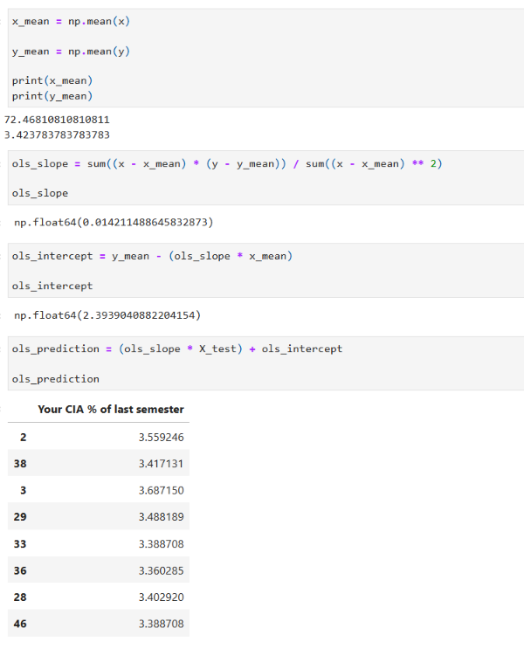
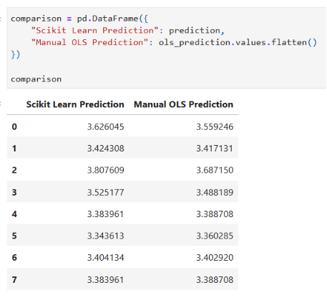
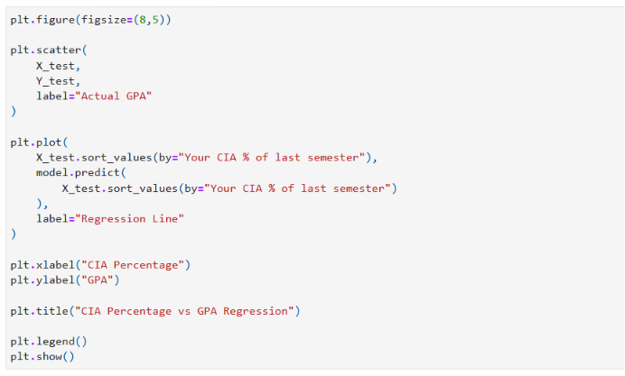
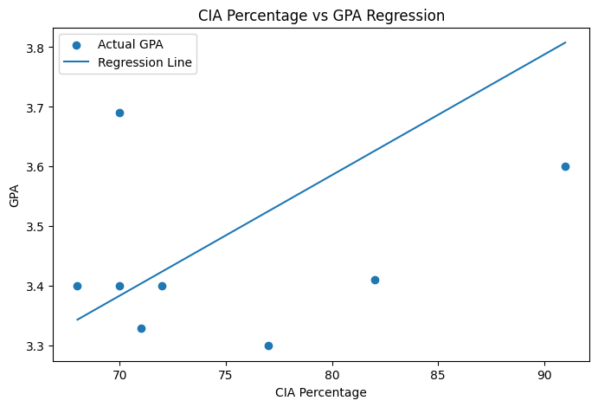
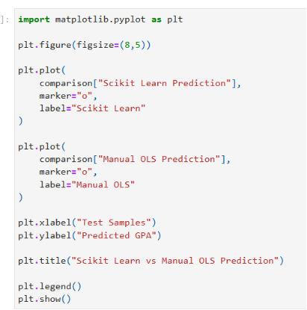
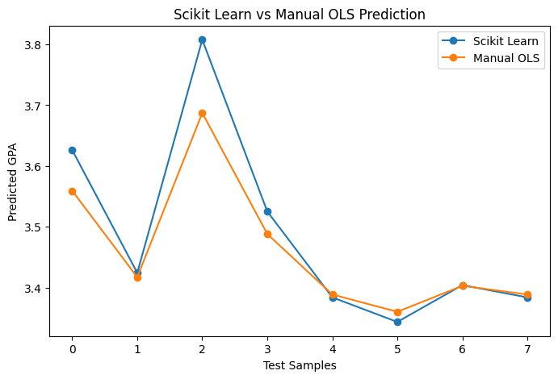

Conclusion /inference
