**SQL LAB-2**

**(Joins, Subquery and View)**

**Please use sakila database tables for below queries.**

1. For each customer who has rented a movie, give customer name, customer_id and rental_id. Write Equi-Join, Natural join and Inner join queries for same.

**Solution:**

Equi-join:

select cust.customer_id,cust.first_name, rent.rental_id from customer cust, rental rent

where cust.customer_id = rent.customer_id;

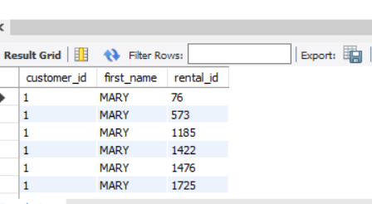

Natural Join:

select cust.customer_id,cust.first_name, rent.rental_id from customer cust natural join rental rent;

Inner Join:

select cust.customer_id,cust.first_name, rent.rental_id from customer cust inner join rental rent on cust.customer_id = rent.customer_id;

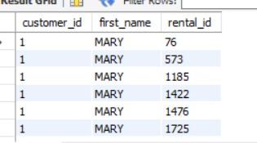

1. List the customer_name, ID and rental_id for all customers. Include those customers also who have not rented any movies.

**Solution:**

select cust.customer_id,cust.first_name, rent.rental_id from customer cust left outer join rental rent on cust.customer_id = rent.customer_id;

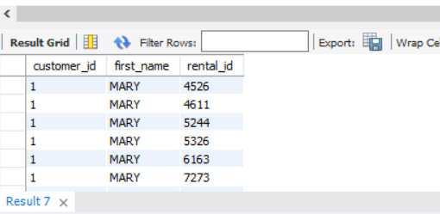

Result set sorted by customer id descending.

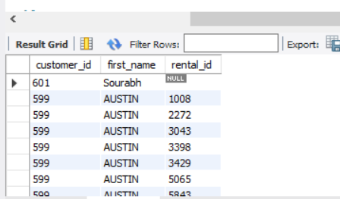

1. List out store_name, store_id, staff_name and staff_id. Include all staff information irrespective store.

**Solution:**

select store.store_id,staff.first_name,staff.staff_id from staff, store

where staff.store_id = store.store_id;

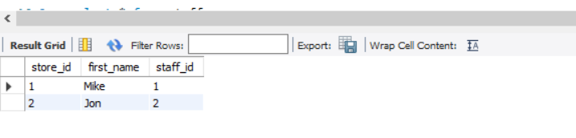

1. List customer_name, customer_id, email, rental_id and rental_date. Result should include all customers and rental information.

**Solution:**

select cust.customer_id,cust.first_name,cust.email, rent.rental_id, rent.rental_date from customer cust left outer join rental rent on cust.customer_id = rent.customer_id

union

select cust.customer_id,cust.first_name,cust.email, rent.rental_id, rent.rental_date from customer cust right outer join rental rent on cust.customer_id = rent.customer_id;

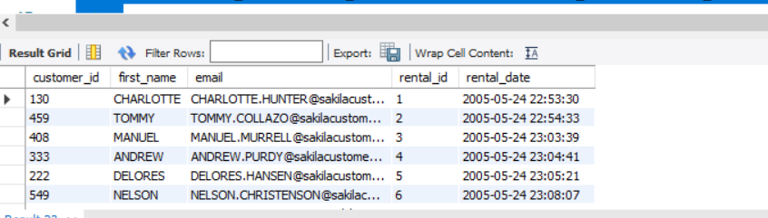

1. List customer_name, customer_id, address, rental_id, rental_date and store_id information.

**Solution:**

select cust.customer_id,cust.first_name,ad.address, rent.rental_id, rent.rental_date, store.store_id from customer cust, rental rent, store ,address ad

where cust.customer_id = rent.customer_id

and cust.store_id = store.store_id

and cust.address_id = ad.address_id;

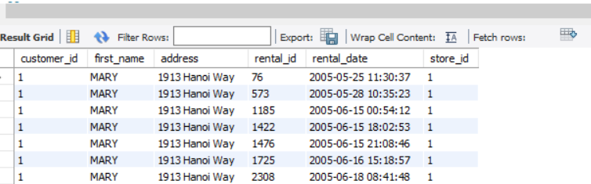

1. Assemble all necessary customer and rental and related store information whose customer_id =374

**Solution:**

select cust.customer_id,cust.first_name,ad.address, rent.rental_id, rent.rental_date, store.store_id from customer cust, rental rent, store ,address ad

where cust.customer_id = rent.customer_id

and cust.store_id = store.store_id

and cust.address_id = ad.address_id

and cust.customer_id =374;

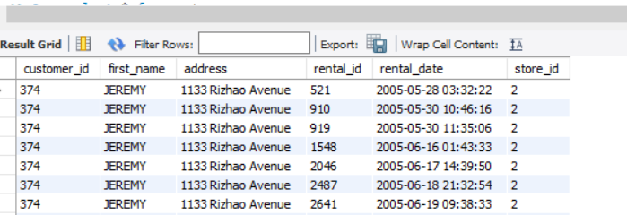

1. List out staff_id and name of each staff and name of their managers.

**Solution:**

select staff.staff_id,staff.first_name,(select staff_i.first_name from staff staff_i where staff_i.staff_id= store.manager_staff_id) Manager_name from staff, store

where staff.store_id = store.store_id;

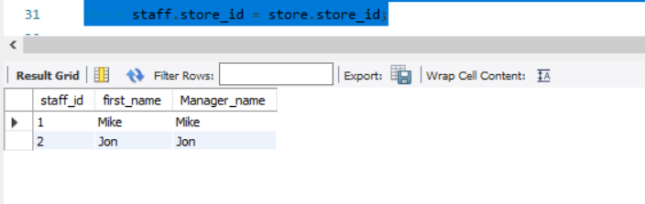

1. List out all customers who have rented the movie.

**Solution:**

select * from customer where customer_id in (select customer_id from rental);

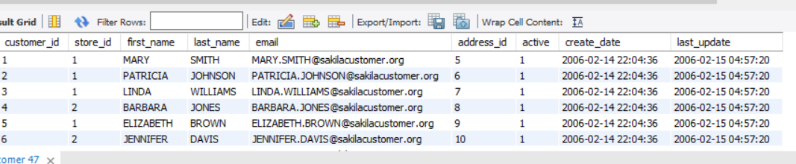

1. Create view called “v_film” and include title, descr, release_year and actor_name where rating = ‘G’

**Solution:**

create view v_film as

select title,description,release_year,actor.first_name from film, actor , film_actor fa

where film.film_id = fa.film_id

and actor.actor_id = fa.actor_id

and film.rating = 'G'

order by title;

select * from v_film;

