**MILESTONE 2**

- What is HTML

- DOM

- HTML and XHTML

- Elements, Tags, Attributes and Layouts

- Semantic and Non-Semantic Elements

- Classes, and Ids

- Formatting, Charsets

**1. What is HTML?**

* HTML – HyperText Markup Language. It is the basic building block for the web page.
* Hypertext – Use of links to connect to web pages within single or multiple site.
* Markup – what HTML tags do to the text inside them. They mark it as specific type of text. It is a way to format or structure the content.

**2. DOM (Document Object Model)**

* DOM represents content of XML or HTML document as tree structure.
* With DOM we can read, access and update the contents of the document.
* Shadow DOM – It allows hidden DOM to be attached to elements in regular DOM tree. This shadow DOM tree starts with shadow root, in which you can attach any element which looks like normal DOM

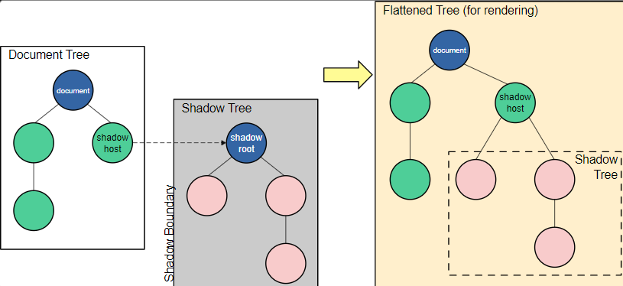

**3. HTML and XHTML**

* XHTML (eXtensible Markup Language) – Made changes in HTML 4.0.
* XHTML is more stricter than HTML.
* XHTML is case sensitive whereas HTML is not case sensitive.

**4. Elements, tags, attributes, layouts:**

* An HTML element is everything from the start tag to the end tag, including the content in between.
* HTML tags and HTML elements.

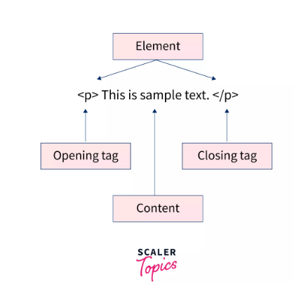

* Tags are the building blocks of HTML. They define how content should be structured and displayed.
* Tags are written within angle brackets, e.g., <p>, <h1>, <div>.
* They can also be self - closing tags.
* Attributes - Attributes provide additional information about an element. They are always included in the opening tag and usually come in name-value pairs. Ex – src, alt, width, type etc.
* Layouts – Arrangement of elements on a web page. HTML and CSS allows to create different layouts. Ex – grid, flexbox etc.,
* Layout tags – <div>, <header>, <footer>, <section>, <article>.

5. **Semantic and Non-Semantic elements:**

* Semantic elements: conveys meaning about content both to browser ad developer. Ex - <header>, <footer>, <section>, <article>.
* Non – Semantic elements: do not provide any information about the content they contain. Ex - <div>, <span>.

6. **Classes and IDs:**

* Class
  + Classes are used to group multiple elements together that share a common style or behaviour. It can be applied to the same class and to multiple elements.
  + Classes are defined with the class attribute and referenced in CSS with a dot (.).
* Id
  + IDs are unique identifiers for a single element on a page. Each ID must be unique within a page, meaning no two elements can have the same ID.
  + IDs are defined with the id attribute and referenced in CSS with a hash (#).

7. **Formatting and charsets:**

* HTML provides tags to format text, making it bold, italic, underlined, etc.
* Common formatting tags:
  + <b> or <strong>: Bold text.
  + <i> or <em>: Italicized text.
  + <u>: Underlined text.
  + <mark>: Highlighted text.
  + <small>: Smaller text.
* Charset (character set) – Standard for encoding characters in text documents. It determines how text is stored and displayed on the web.
* Common charset is UTF-8. It supports wide range of characters and symbols.
* The charset is specified in the <meta> tag within the <head> section of an HTML document.
* <meta> - defines metadata about HTML document. Metdata – information about the data.
* Not displayed in the page. But is used by browsers to display or reload page, search engines.