1. Add even numbers in

const sample = {a:1, b:2, c:{d:4, e:5}, f:6, g:{h:7, i:{j:8,k:9}},l:10}

* 1st solution

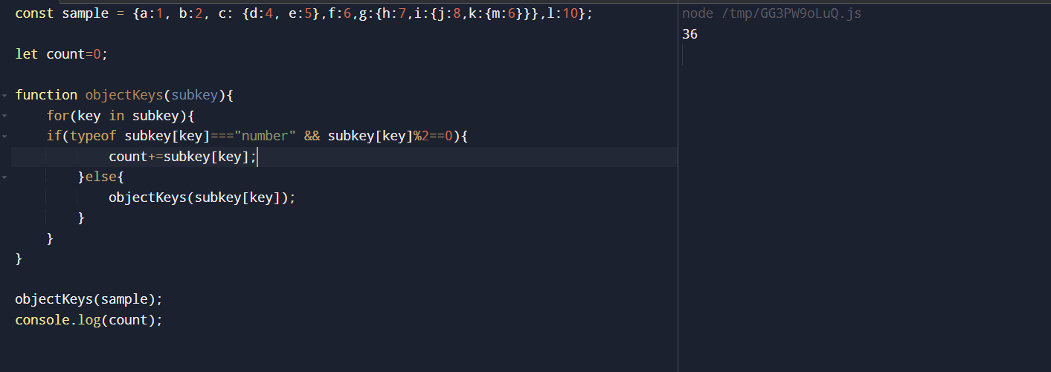

const sample = {a:1, b:2, c: {d:4, e:5},f:6,g:{h:7,i:{j:8,k:{m:6}}},l:10};

let count=0;

function objectKeys(subkey){

for(key in subkey){

if(typeof subkey[key]==="number" && subkey[key]%2==0){

count+=subkey[key];

}else{

objectKeys(subkey[key]);

}

}

}

objectKeys(sample);

console.log(count);

* 2nd solution

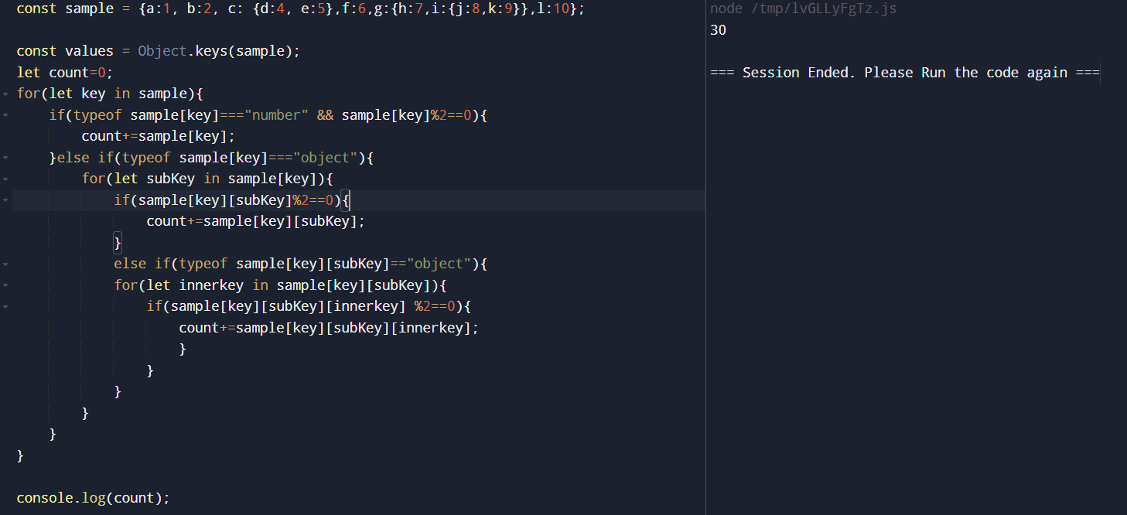

let count=0;

for(let key in sample){

if(typeof sample[key]==="number" && sample[key]%2==0){

count+=sample[key];

}else if(typeof sample[key]==="object"){

for(let subKey in sample[key]){

if(sample[key][subKey]%2==0){

count+=sample[key][subKey];}

else if(typeof sample[key][subKey]=="object"){

for(let innerkey in sample[key][subKey]){

if(sample[key][subKey][innerkey] %2==0){

count+=sample[key][subKey][innerkey];

} } } } } }

console.log(count);