

**A Project report on**

**Automation tessting on TOOLS QA website**

**By**

***Ananya Ujjainwal***

**Batch:ECA(2021-5334)**

**Course: School of Coading-Certified Software Test Engineer**

**Under the Guidence of,**

***Priyanka Desale***

***(Technical trainner)***

***EduBridge***

**Module 4:Widgets**

**TC01: To check the functionality of widgets module .**  
  
w.findElement(By.xpath("//body/div[@id='app']/div[1]/div[1]/div[2]/div[1]/div[1]/div[1]/div[4]/span[1]/div[1]")).click();  
Thread.sleep(5000);

//w.findElement(By.xpath("//body/div[@id='app']/div[1]/div[1]/div[2]/div[1]/div[1]/div[1]/div[4]/span[1]/div[1]")).click();  
//Thread.sleep(5000);

TakesScreenshot t51 =(TakesScreenshot) w;

File srcc51 = t51.getScreenshotAs(OutputType.***FILE***);

Files.*copy*(srcc51, **new** File("F:\\Screenshot\\accordian.png"));

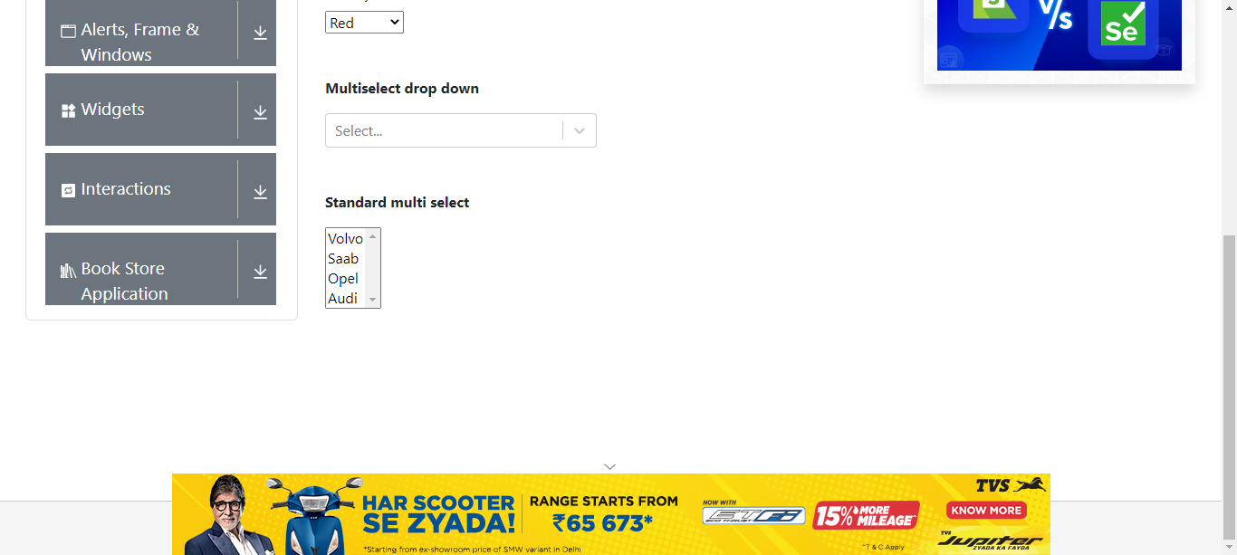

**TC02:To check the functionality of accordance module in widgets module.**  
     
JavascriptExecutor jss1= (JavascriptExecutor) w;  
jss1.executeScript("window.scrollBy(0,2000)");

w.findElement(By.xpath("//body/div[@id='app']/div[1]/div[1]/div[2]/div[1]/div[1]/div[1]/div[4]/div[1]/ul[1]/li[1]")).click();  
Thread.sleep(5000);  
System.out.println("widgets Button");

TC03: To get the title .  
String name1= w.findElement(By.xpath("//div[contains(text(),'Accordian')]")).getText();  
System.out.println(name1);  
     
**TC04:To check the functionality of what is lorem ipsum in accordance module.**  
w.findElement(By.id("section1Heading")).click();

Thread.sleep(5000);  
     
**TC05: To check the functionality of where does it come from in accordance module.**w.findElement(By.xpath("//div[@id='section2Heading']")).click();  
Thread.sleep(5000);

w.findElement(By.id("section2Heading")).click();  
Thread.sleep(5000);  
     
**TC06:To check the functionality of why do we use it in accordance module.**    
w.findElement(By.xpath("//div[@id='section3Heading']")).click();  
Thread.sleep(5000);  
     
w.findElement(By.id("section3Heading")).click();  
Thread.sleep(5000);

TakesScreenshot t52 =(TakesScreenshot) w;

File srcc52 = t52.getScreenshotAs(OutputType.***FILE***);

Files.*copy*(srcc52, **new** File("F:\\Screenshot\\accordian.png"));

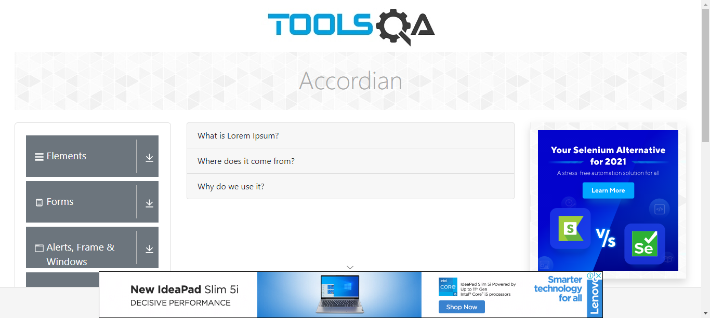

**Defect: Unable to select Color**

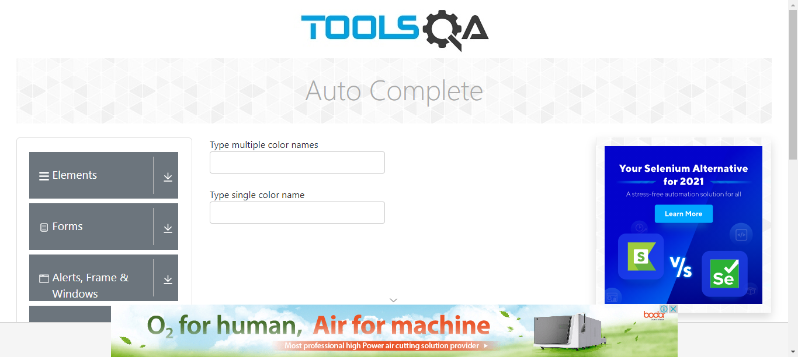

**TC07: To check the functionality of vertical scroll down in accordance module.**

JavascriptExecutor js1= (JavascriptExecutor) w;  
js1.executeScript("window.scrollBy(0,2000)");

**TC08: To check the functionality of Date Picker module in widgets module.**

w.findElement(By.*xpath*("//span[contains(text(),'Date Picker')]")).click();

Thread.*sleep*(5000);

TakesScreenshot t56 =(TakesScreenshot) w;

File srcc56 = t56.getScreenshotAs(OutputType.***FILE***);

Files.*copy*(srcc56, **new** File("F:\\Screenshot\\Date.png"));

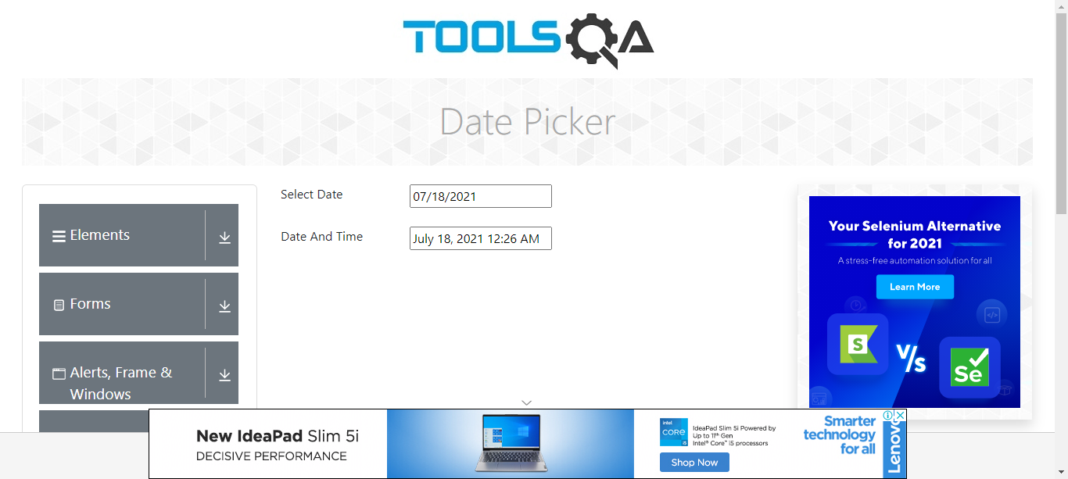

**Defect: Unable to select Date**

**TC09 :To check the functionality of scroll down.**

JavascriptExecutor jss11= (JavascriptExecutor) w;

jss11.executeScript("window.scrollBy(0,2000)");

**TC10:To check the functionality of slider module in widget module.**  
w.findElement(By.xpath("//body/div[@id='app']/div[1]/div[1]/div[2]/div[1]/div[1]/div[1]/div[4]/div[1]/ul[1]/li[4]")).click();  
Thread.sleep(5000);  
     
w.findElement(By.xpath("//body/div[@id='app']/div[1]/div[1]/div[2]/div[2]/form[1]/div[1]/div[1]/span[1]/input[1]")).click();  
Thread.sleep(5000);

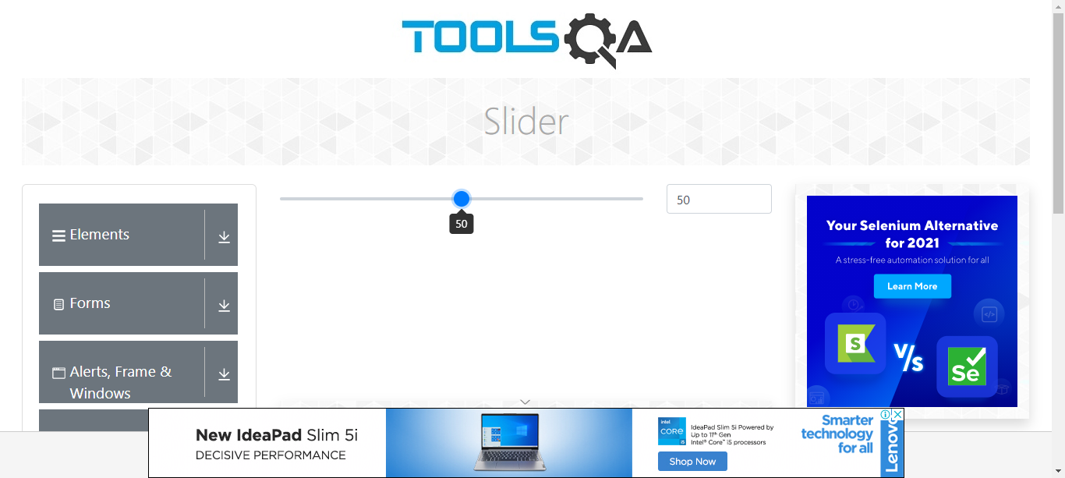

TakesScreenshot t53 =(TakesScreenshot)

File srcc53 = t53.getScreenshotAs(OutputType.***FILE***);

Files.*copy*(srcc53, **new** File("F:\\Screenshot\\slider.png"));

String name2= w.findElement(By.xpath("//div[contains(text(),'Slider')]")).getText();  
System.out.println(name2);  
         
         
**Defect: Unable to select slider on another no**

   

**TC11 :To check the functionality of scroll down.**  
     
JavascriptExecutor js2= (JavascriptExecutor) w;  
js2.executeScript("window.scrollBy(0,2000)");  
  
TC10:To check the functionality of progress bar module in widget module.  
w.findElement(By.xpath("//body/div[@id='app']/div[1]/div[1]/div[2]/div[1]/div[1]/div[1]/div[4]/div[1]/ul[1]/li[5]")).click();

Thread.sleep(5000);

**TC12: To check the functionality of start button in progress bar module.**  
w.findElement(By.id("startStopButton")).click();  
Thread.sleep(5000);  
         
w.findElement(By.xpath("//button[@id='startStopButton']")).click();  
Thread.sleep(5000);  
         
**TC13:To check the functionality of start button(To stop progress bar) in progress module.**

w.findElement(By.xpath("//button[@id='startStopButton']")).click();  
Thread.sleep(5000);

**TC14: To check the functionality of reset button in progress bar module.**  
w.findElement(By.id("resetButton")).click();  
Thread.sleep(5000);

TakesScreenshot t54 =(TakesScreenshot) w;

File srcc54 = t54.getScreenshotAs(OutputType.***FILE***);

Files.*copy*(srcc54, **new** File("F:\\Screenshot\\bar.png"));

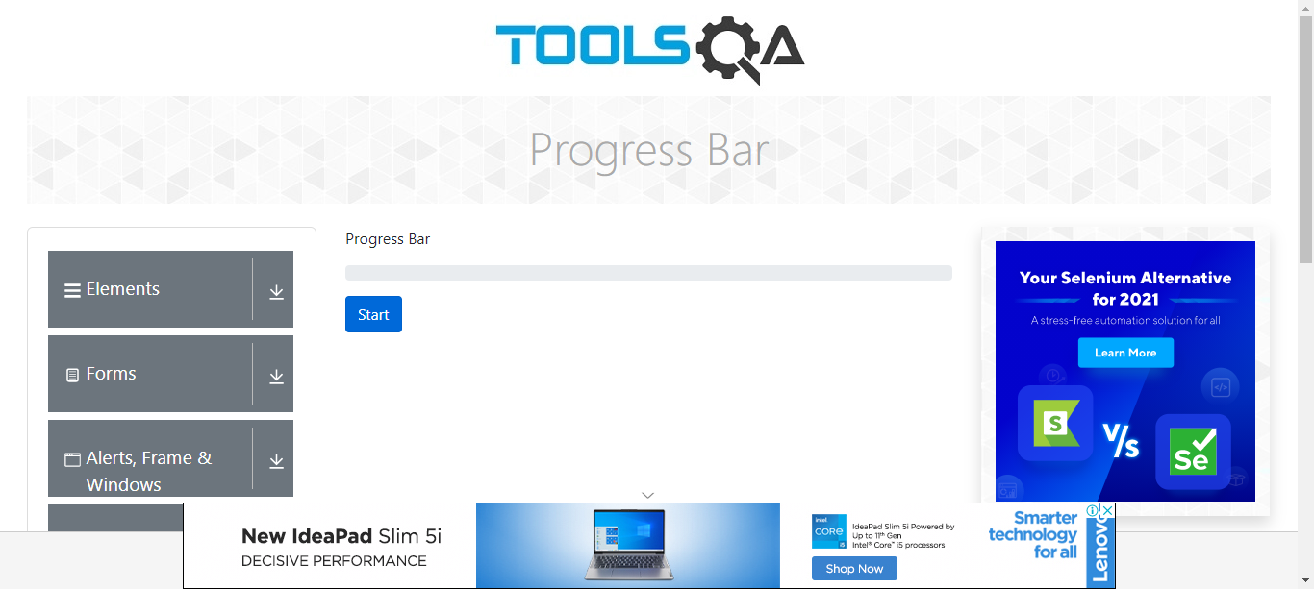

**TC15:To get the title from progress bar.**

String name3= w.findElement(By.xpath("//body/div[@id='app']/div[1]/div[1]/div[1]/div[1]")).getText();  
System.out.println(name3);  
  
**TC16: To check the functionality of scroll down.**JavascriptExecutor js3= (JavascriptExecutor) w;  
js3.executeScript("window.scrollBy(0,2000)");  
  
**TC17:To check the functionality of tabs module in widgets module.**          
w.findElement(By.xpath("//body/div[@id='app']/div[1]/div[1]/div[2]/div[1]/div[1]/div[1]/div[4]/div[1]/ul[1]/li[6]")).click();  
Thread.sleep(5000);

**TC18:** **To check the functionality of origin tab in tabs module.**w.findElement(By.xpath("//a[@id='demo-tab-origin']")).click();  
Thread.sleep(5000);

**TC19:To check the functionality of Use tab in tabs module.**  
w.findElement(By.xpath("//a[@id='demo-tab-use']")).click();

Thread.sleep(5000);

TakesScreenshot t55 =(TakesScreenshot) w;

File srcc55 = t55.getScreenshotAs(OutputType.***FILE***);

Files.*copy*(srcc55, **new** File("F:\\Screenshot\\tabs.png"));

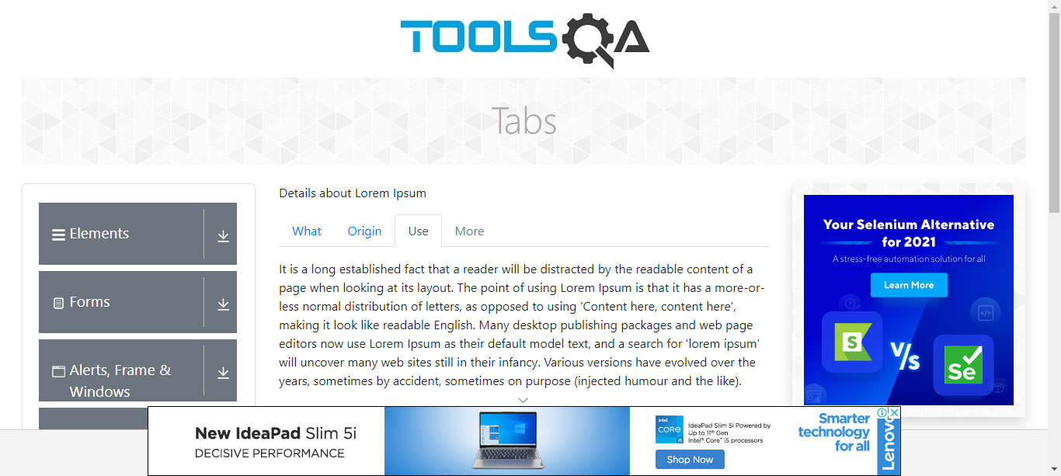

**TC20:To check the functionality of get title.**  
String name4= w.findElement(By.xpath("//div[contains(text(),'Tabs')]")).getText();  
System.out.println(name4);  
     
     
**TC21: To check the functionality of scroll down.**  
  
JavascriptExecutor js4= (JavascriptExecutor) w;  
js4.executeScript("window.scrollBy(0,2000)");

**TC22: To check the functionality of menu module in widget module.**

w.findElement(By.xpath("//body/div[@id='app']/div[1]/div[1]/div[2]/div[1]/div[1]/div[1]/div[4]/div[1]/ul[1]/li[8]")).click();  
Thread.sleep(5000);

**TC23: To check the functionality of main item 2 in menu module.**Actions act=new Actions(w);  
act.moveToElement(w.findElement(By.linkText("Main Item 2"))).perform();  
Thread.sleep(5000);

**TC24:To check the functionality of sub item list in menu item 2 module.**     
Actions act1=new Actions(w);  
act1.moveToElement(w.findElement(By.xpath("//a[contains(text(),'SUB SUB LIST »')]"))).perform();  
Thread.sleep(5000);

**TC25:To check the functionality of sub sub item 1 in menu item 2 module.**Actions act2=new Actions(w);

act2.moveToElement(w.findElement(By.linkText("Sub Sub Item 1"))).perform();

Thread.sleep(5000);

**TC26: To check the functionality of sub sub item 2 in menu item 2 module.**  
Actions act3=new Actions(w);  
act3.moveToElement(w.findElement(By.linkText("Sub Sub Item 2"))).perform();  
Thread.sleep(5000);

TakesScreenshot t91 =(TakesScreenshot) w;

File srcc91 = t91.getScreenshotAs(OutputType.*FILE*);

Files.*copy*(srcc91, new File("F:\\Screenshot\\menu.png"));

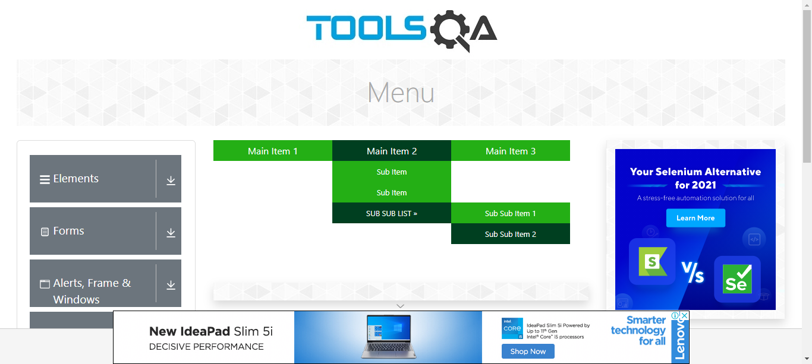   
  
**TC27: To get the title .**String name5= w.findElement(By.xpath("//div[contains(text(),'Menu')]")).getText();  
System.out.println(name5);  
     
     
**TC28: To check the functionality of scroll down.**    
  
JavascriptExecutor js5= (JavascriptExecutor) w;  
js5.executeScript("window.scrollBy(0,2000)");  
  
**TC29:To check the functionality of select menu module in widget module.**  
w.findElement(By.xpath("//body/div[@id='app']/div[1]/div[1]/div[2]/div[1]/div[1]/div[1]/div[4]/div[1]/ul[1]/li[9]")).click();  
Thread.sleep(5000);  
   

String name6= w.findElement(By.xpath("//body/div[@id='app']/div[1]/div[1]/div[1]/div[1]")).getText();  
System.out.println(name6);  
  
**TC30: To check the functionality of select value drop down in select menu module.**

w.findElement(By.xpath("//body/div[@id='app']/div[1]/div[1]/div[2]/div[2]/div[1]/div[2]/div[1]/div[1]/div[1]/div[1]")).click();  
Thread.sleep(5000);  
     
w.findElement(By.xpath("//div[contains(text(),'Group 2, option 1')]")).click();  
Thread.sleep(5000);  
  
**TC31:To check the functionality of select title drop down in select menu module.**

w.findElement(By.xpath("//body/div[@id='app']/div[1]/div[1]/div[2]/div[2]/div[1]/div[4]/div[1]/div[1]/div[1]/div[1]")).click();

Thread.sleep(5000);  
     
w.findElement(By.xpath("//div[contains(text(),'Mrs.')]")).click();  
Thread.sleep(5000);  
     
  
**TC32:To check the functionality of select colour drop down in select menu module.**Select s1 = new Select(w.findElement(By.id("oldSelectMenu")));  
     
s1.selectByVisibleText("Purple");  
Thread.sleep(5000);

**TC33:To check the functionality of scroll down.**    
JavascriptExecutor jss9=(JavascriptExecutor)w;  
jss9.executeScript("window.scrollTo(0,5000)");  
   
     
**TC34 :To check the functionality of multi select drop down in select menu module.**//w.navigate().refresh();

Thread.sleep(5000);  
         
w.findElement(By.xpath("//div[contains(text(),'Select...')]")).click();  
Thread.sleep(5000);

w.findElement(By.xpath("//div[contains(text(),'Blue')]")).click();  
Thread.sleep(5000);  
     
w.findElement(By.xpath("//div[contains(text(),'Red')]")).click();  
Thread.sleep(5000);  
  
w.findElement(By.xpath("//div[contains(text(),'Black')]")).click();  
Thread.sleep(5000);  
w.findElement(By.xpath("//div[contains(text(),'Green')]")).click();  
Thread.sleep(5000);

TakesScreenshot t57 =(TakesScreenshot) w;

File srcc57 = t57.getScreenshotAs(OutputType.*FILE*);

Files.*copy*(srcc57, new File("F:\\Screenshot\\SMenu.png"));

     
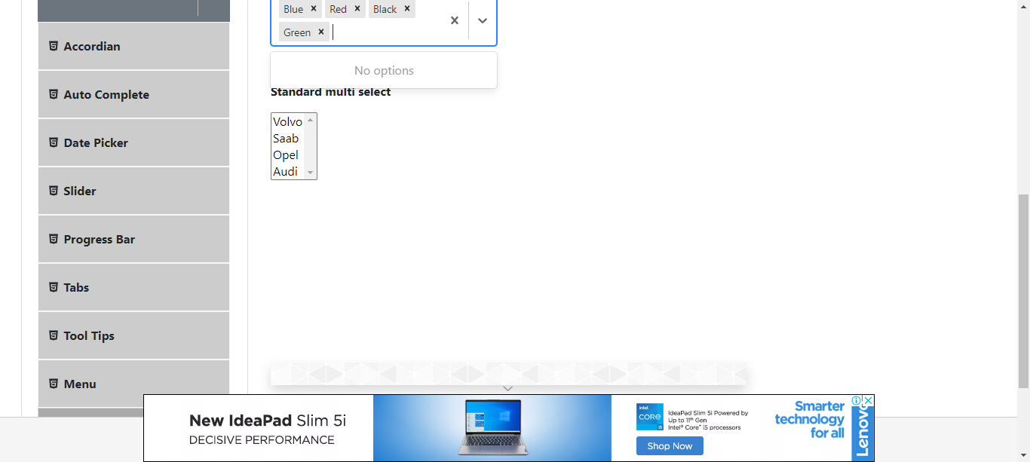  
     
     
   **Defect: Unable to select Last Option**

   