Network phylogenies of Abui
Gereon A. Kaiping
(Universiteit Leiden)
Timor-Alor-Pantar languages, Bayesian inference, Phylogenetic network, Loanword detection, Abui
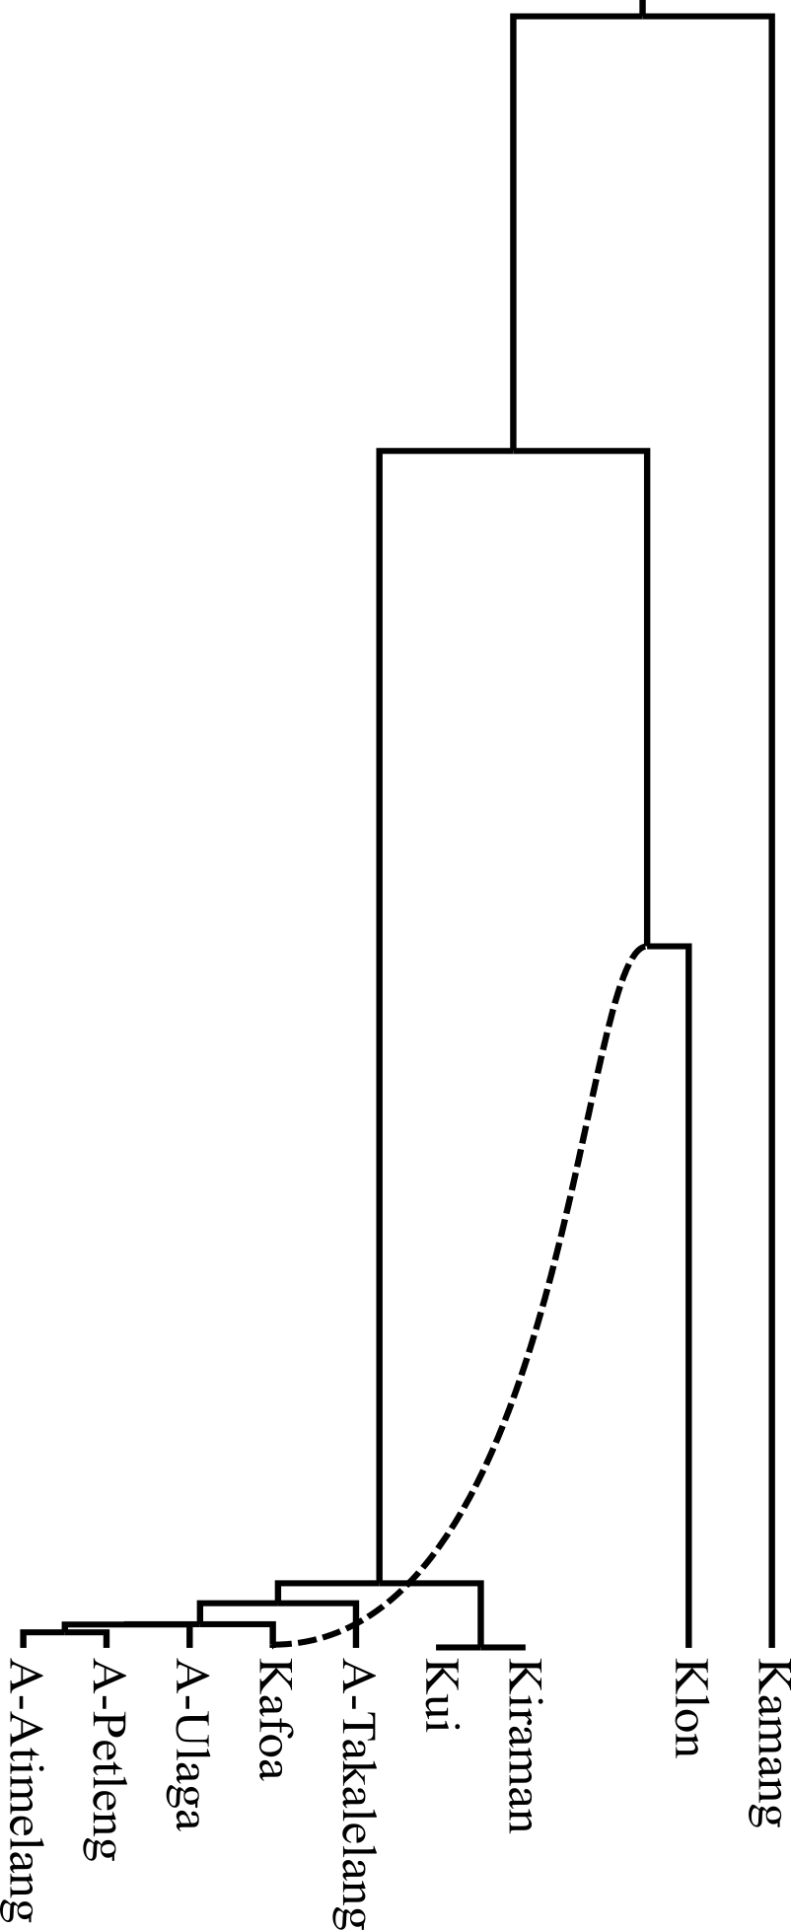
The Alor-Pantar languages are one branch of a small family of non-Austronesian languages spoken on the eponymous islands in Eastern Indonesia. They are supposed to have a long, dense history of internal contact (Klamer 2014). This impedes historical reconstruction, but without established reconstructions and sound correspondences as a base line, a focused study of the borrowing history is nearly impossible. The LexiRumah lexical database (Kaiping & Klamer 2018), together with recent results concerning automatic cognate judgement methods for phylogenetics (Rama et al. 2018), provides a broad, synchronic lexical dataset including items beyond basic vocabulary, which can be used for language comparison with a focus on lexical borrowing. This allows us to study contact based on the signal of lexical change, instead of the (ir-)regularity of sound changes in individual lexical items. Using a pseudo-Dollo model (Bouckaert & Robbeets 2017) in Bayesian phylogenetic network inference methods (Zhang et al. 2018), we study the contact history of Abui [abui1241], an Alor-Pantar language spoken in central Alor, and some of its neighbors. We find a strong signal of proto-Klon [kelo1247] as donor language (γ=50%) for borrowings into Kafoa [kafo1240], which is otherwise very closely related to Abui, possibly even part of the Abui dialect chain. A dated phylogenetic network, created using this methodology, may paint a clearer picture of the language history in the region. But more importantly, this approach gives the inheritance and borrowing history of every lexical form, automatically grouping them into different strata. Grouping the forms by their shared vs. non-shared history will give a clearer picture of systematic sound correspondences and therefore help bottom-up reconstruction.
References
Bouckaert, Remco & Robbeets, Martine. 2017. Pseudo Dollo models for the evolution of binary characters along a tree. bioRxiv. 207571. doi:10.1101/207571.
Kaiping, Gereon A. & Klamer, Marian. 2018. LexiRumah: An online lexical database of the Lesser Sunda Islands. PLOS ONE 13(10). e0205250. doi:10.1371/journal.pone.0205250.
Klamer, Marian. 2014. The Alor-Pantar languages: history and typology. Berlin: Language Science Press.
Rama, Taraka & List, Johann-Mattis & Wahle, Johannes & Jäger, Gerhard. 2018. Are Automatic Methods for Cognate Detection Good Enough for Phylogenetic Reconstruction in Historical Linguistics? arXiv:1804.05416 [cs]. http://arxiv.org/abs/1804.05416 (14 July, 2018).
Zhang, Chi & Ogilvie, Huw A. & Drummond, Alexei J. & Stadler, Tanja. 2018. Bayesian Inference of Species Networks from Multilocus Sequence Data. Molecular Biology and Evolution 35(2). 504–517. doi:10.1093/molbev/msx307.

