ANGEL KIT
Your angel kit has all kinds of crap in it: scissors, rags, tape, needles, damps, gloves, chill coils, wipes, alcohol, injectable tourniquts & bloodslower, instant blood packets (coffee reddener), tubes of meat mesh, bonepins & site injectors, biostabs, chemstabs, narcostabs (chillstabs) in quantity, and a roll of heart jumpshock patches for when it comes to that. It's big enough to fill the trunk of a car. When you use it, spend its stock; you can spend 0–3 of its stock per use. You can resupply it for 1-barter per 2-stock, if your circumstance let you barter for medical supplies.
STOCK
It begins play holding 6-stock.
To use it to stabilize and heal someone at 9:00 or past: roll +stock spent. On a hit, they will stabilize and heal to 6:00, but the MC will choose 1 (on a 10+) or 2 (on a 7–9):
- they need to be physically stabilized before you can move them.
- even narcostabbed, they fight you; you’re acting under fire.
- they’ll be in and out of consciousness for 24 hours.
- stabilizing them eats up your stock; spend 1-stock more.
- they’ll be bedridden, out of action, for at least a week.
- they’ll need constant monitoring and care for 36 hours.
To use it to speed the recovery of someone at 3:00 or 6:00: don’t roll. They choose: spend 4 days (3:00) or 1 week (6:00) blissed out on chillstabs, immobile but happy, or do their time like everyone else.
To use it to revive someone who’s died (at 12:00, not beyond): roll+stock spent. On a 10+, they recover to 10:00. On a 7–9, they recover to 11:00. On a miss, you’ve done everything you can for them, and they’re still dead.

BARTER
If you’re charging someone wealthy for your services, 1-barter is the going rate for: one successful resuscitation (plus material costs); one week’s full around-the-clock care (plus material costs); one month’s employment as angel on call (plus material costs, if any).
1-barter will cover a month’s living expenses, if your tastes aren’t too grand.
As a one-time expenditure, and very subject to availability, 1-barter might count for: two refills for your angel kit; a night in high luxury & company; any weapon, gear or fashion not valuable or hi-tech; repair of a piece of hi-tech gear by a savvyhead; a week’s hire of the protective companionship of a battlebabe or gunlugger; a year’s tribute to a warlord; a month’s maintenance and repairs for a hi-performance vehicle well-used; bribes, fees and gifts sufficient to get you into almost anyone’s presence.
For better stuff, you should expect to make particular arrangements. You can’t just wander around the commons of some hardhold with oddments ajangle and expect to find hi-tech or luxe eternal.

Introducing

THE ANGEL
When you’re lying in the dust of Apocalypse World guts aspilled, for whom do you pray? The gods? They’re long gone. Your beloved comrades? Fuckers all, or you wouldn’t be here to begin with. Your precious old mother? She’s a darling but she can’t put an intestine back inside so it’ll stay. No you pray for some grinning kid or veteran or just someone with a heartshocker and a hand with sutures and a 6-pack of morphine. And when that someone comes, that’s an angel.

a character playbook for
^{Apocalypse} World

additional rules

Harm & Healing
Harm before 6:00 heals automatically with time. Harm after 9:00 gets worse with time, unless stabilized. If the player marks the segment 11:00 to 12:00, it means that the character’s dead but can still be revived. Any harm past that and the character’s dead for reals.

Peripheral Move
When you heal another player’s character’s harm, you get +1Hx with them (on your sheet) for every segment of harm you heal. If this brings you to Hx+4, you reset to Hx+1 as usual, and therefore mark experience. When you heal someone, you see them more clearly.

Infirmary
When you go into your infirmary and dedicate yourself to working on a person, decide what you’re trying for and tell the MC. The MC will tell you “sure, no problem, but...” and then 1 to 4 of the following:
- it’s going to take hours/days/weeks/months of work;
- first you’ll have to get/build/fix/figure out ___;
- you’re going to need ___ to help you with it;
- it’s going to cost you a fuckton of jingle;
- the best you’ll be able to do is a crap version, weak and unreliable;
- it’s going to mean exposing yourself (plus colleagues & patient) to serious danger;
- you’re going to have to add ___ to your infirmary first;
- it’s going to take several/dozens/hundreds of tries;
- you’re going to have to take ___ apart to do it.
The MC might connect them all with “and,” or might throw in a merciful “or.”
Angel
The

creating an angel
Name  Dou, Bon, Abe, Boo, T, Kal, Bai, Char, Jav, Ruth, Wei, Jay, Nee, Kim, veLan, Di, or Dez.  Doc, Core, Wheels, Buzz, Key, Gabe, Biz, Bish, Line, Inch, Grip, or Setter.  stats  Choose one set:  - Cool+1 Hard=0 Hot+1 Sharp+2 Weird-1  - Cool+1 Hard+1 Hot=0 Sharp+2 Weird-1  - Cool-1 Hard+1 Hot=0 Sharp+2 Weird+1  - Cool+2 Hard=0 Hot-1 Sharp+2 Weird-1  MOVES  You get all the basic moves. Choose 2 angel moves.  Hx  Everyone introduces their characters by name, look and outlook. Take your turn. List the other characters’ names. Go around again for Hx. On your turn, choose 1, 2, or all 3:  - One of them put a hand in when it mattered, and helped you save a life. Tell that player Hx+2.  - One of them has been beside you and has seen everything you’ve seen. Tell that player Hx+2.  - One of them, you figure doomed to self-destruction. Tell that player Hx-1.  - Tell everyone else Hx+1. You’re an open book.  On the others’ turns:  - You try not to get too attached. Whatever number they tell you, give it –1 and write it next to their character’s name. | LOOK  Man, woman, ambiguous, transgressing, or concealed.  Utility wear, casual wear plus utility, scrounge wear plus utility.  Kind face, strong face, rugged face, haggard face, pretty face, or lively face.  Quick eyes, hard eyes, caring eyes, bright eyes, laughing eyes, or clear eyes.  Compact body, stout body, spare body, big body, rangy body, or sturdy body.  Gear  You get:  - angel kit  - 1 small practical weapon  - oddments worth 1-barter  - fashion suitable to your look, including at your option a piece worth 1-armor (you detail)  Small practical weapons (choose 1):  - .38 revolver (2-harm close reload loud)  - 9mm (2-harm close loud)  - big knife (2-harm hand)  - sawed-off (3-harm close reload messy)  - stun gun (s-harm hand reload)  Improvement  Whenever you roll a highlighted stat, and whenever you reset your Hx with someone, mark an experience circle. When you mark the 5th , improve and erase.  Each time you improve, choose one of the options. Check it off; you can’t choose it again.

Name
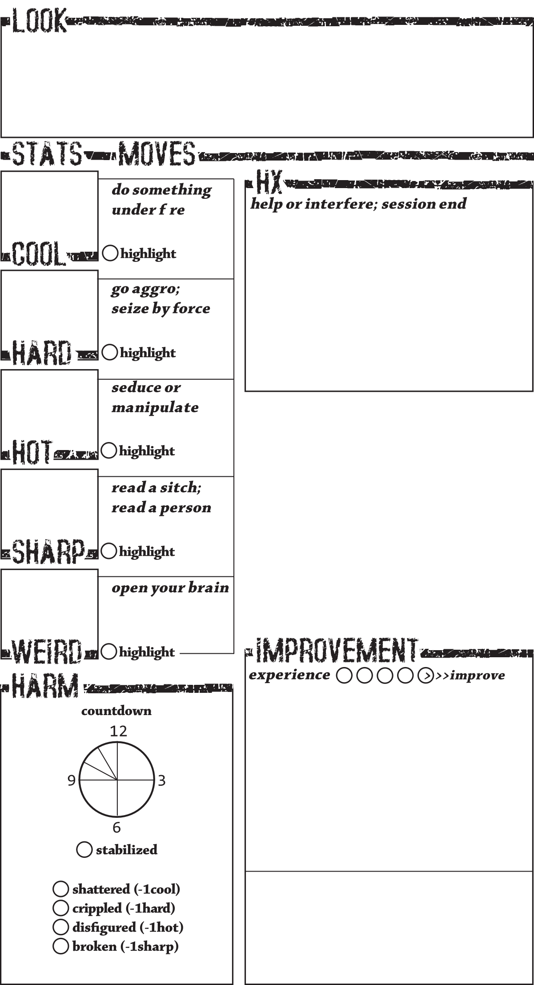
__ get +1sharp (max sharp+3)
__ get +1cool (max cool+2)
__ get +1hard (max hard+2)
__ get +1hard (max hard+2)
__ get +1weird (max weird+2)
__ get a new angel move
__ get a new angel move
__ get 2 gigs (detail) and moonlighting
__ get a move from another playbook
__ get a move from another playbook
If you and another character have sex, your Hx with them on your sheet goes immediately to +3, and they immediately get +1 to their Hx with you on their sheet. If that brings their Hx with you to +4, they reset it to +1 instead, as usual, and so mark experience

ANGEL SPECIAL
__ get +1 to any stat (max stat+3)
__ retire your character (to safety)
__ create a second character to play
__ change your character to a new type
__ choose 3 basic moves to advance.
__ advance the other 4 basic moves.

Angel Moves
Sixth sense: when you open your brain to the world’s psychic maelstrom, roll+sharp instead of roll+weird.
Infirmary: you get an infirmary, a workspace with life support, a drug lab and a crew of 2 (Shigusa & Mox, maybe). Get patients into it and you can work on them like a savvyhead on tech (cf ).
Professional compassion: you can choose to roll+sharp instead of roll+Hx when you help someone who’s rolling.
Battlefield grace: while you are caring for people, not fighting, you get +1armor.
Healing touch: when you put your hands skin-to-skin on a wounded person and open your brain to them, roll+weird. On a 10+, heal 1 segment. On a 7–9, heal 1 segment, but you’re acting under fire from your patient’s brain. On a miss: first, you don’t heal them. Second, you’ve opened both your brain and theirs to the world’s psychic maelstrom, without protection or preparation. For you, and for your patient if your patient’s a fellow player’s character, treat it as though you’ve made that move and missed the roll. For patients belonging to the MC, their experience and fate are up to the MC.
Touched by death: whenever someone in your care dies, you get +1weird (max +3).
OTHER MOVES
GEAR & BARTER
HOLD

