EE314 Digital Circuits Laboratory

Experiment 1 Preliminary
1)
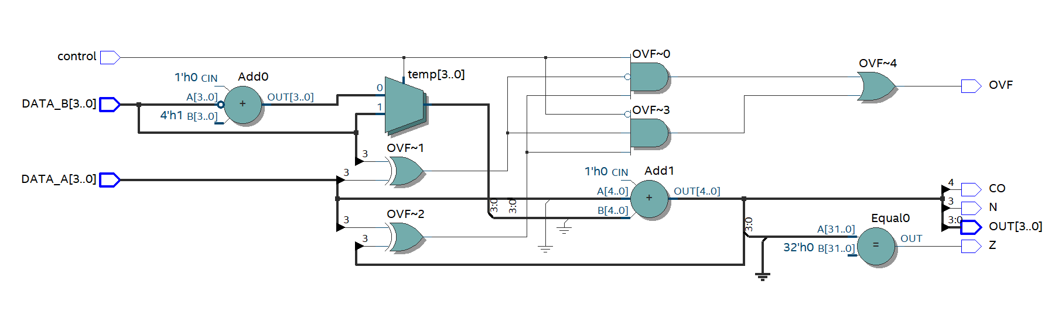
Figure 1: RTL Schematic of Arithmetic Unit
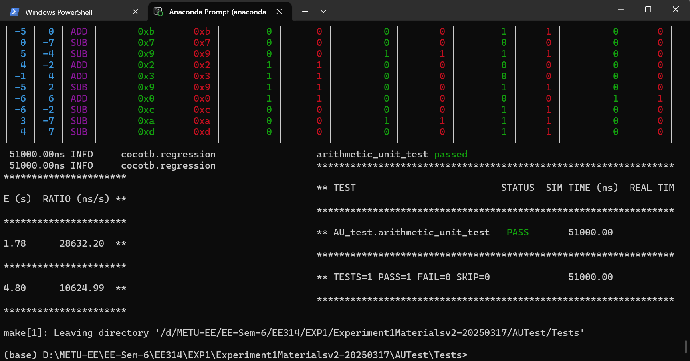
Figure 2: Test Results for Arithmetic Unit

2)
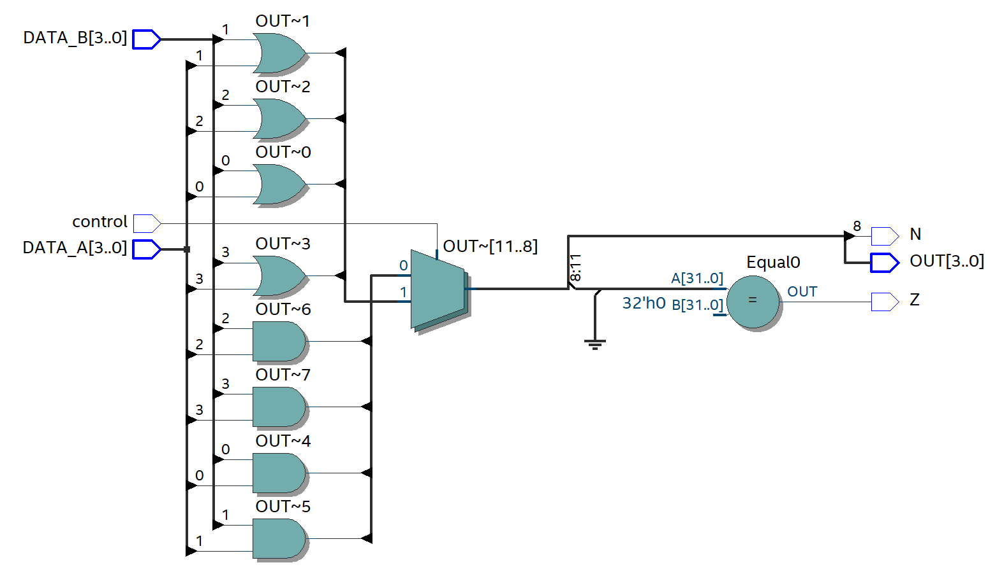
Figure 3: RTL Schematic for Logic Unit

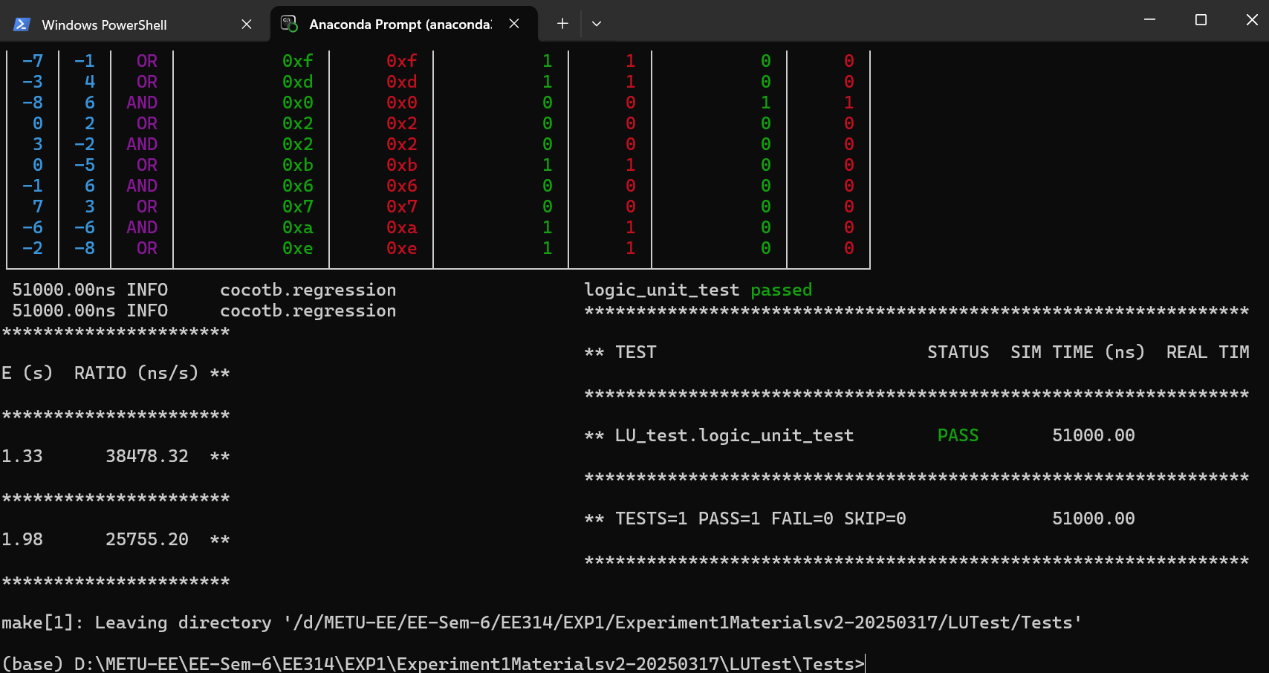
Figure 4: Test Results for Logic Unit

3)
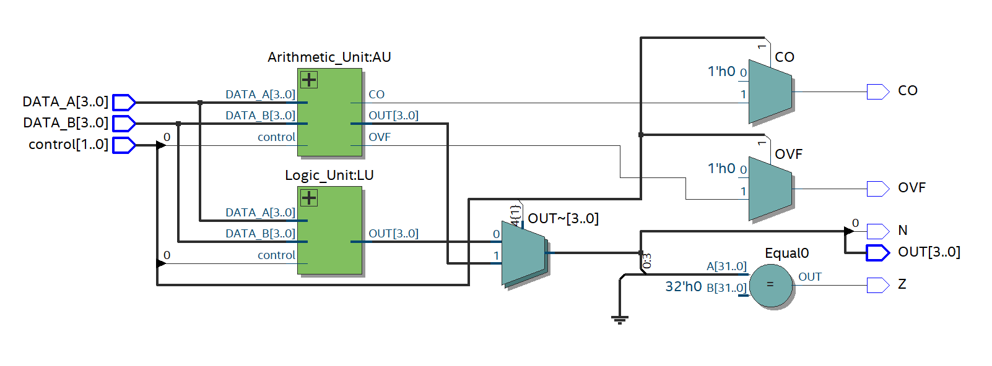
Figure 5: RTL Schematic of ALU
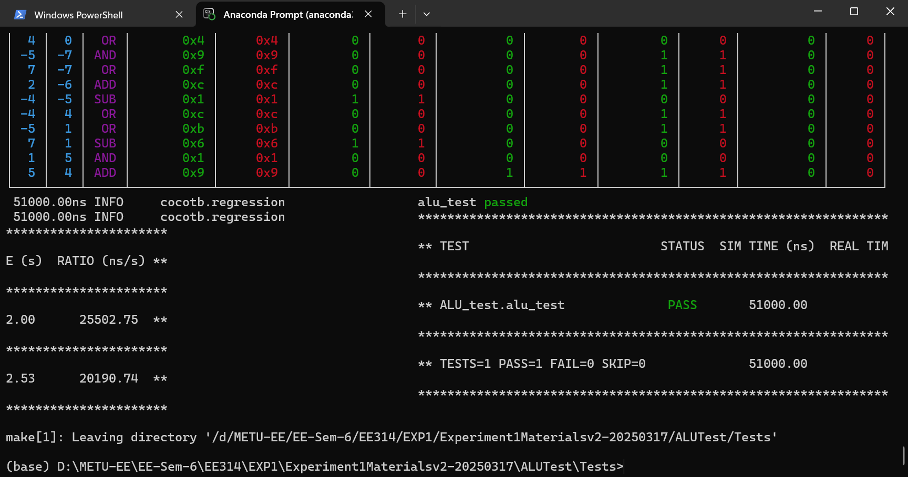
Figure 6: Test Results for ALU

