EE314 Digital Circuits Laboratory

Experiment 2 Preliminary

1)
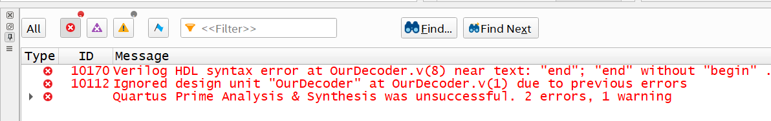
Figure 1: Error Messages for OurDecoder.v
As it can be seen from the error message in Figure 1, “begin-end” structure is used without “begin” statement. In order to solve this problem, we simply add “begin” statement as shown in Figure 2 below.
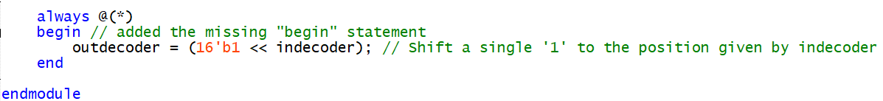
Figure 2: The Correction of Errors in OurDecoder.v

2)
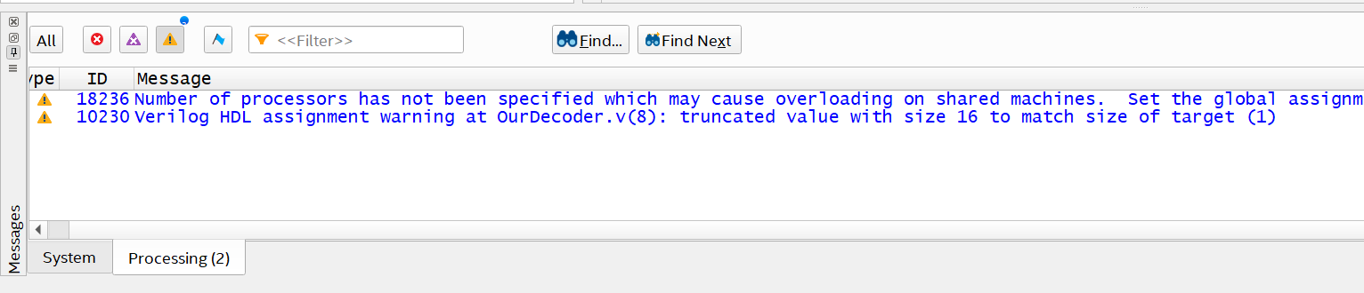
Figure 3: Warning Messages for OurDecoder.v
The second warning message shows that the 16 bit of information is truncated to 1 bit of output register since we have not mentioned the size of the register in the beginning. We will just add the size information ([15:0]) of the output register “outdecoder”:
Figure 4: The Correction of Warnings in OurDecoder.v

3)
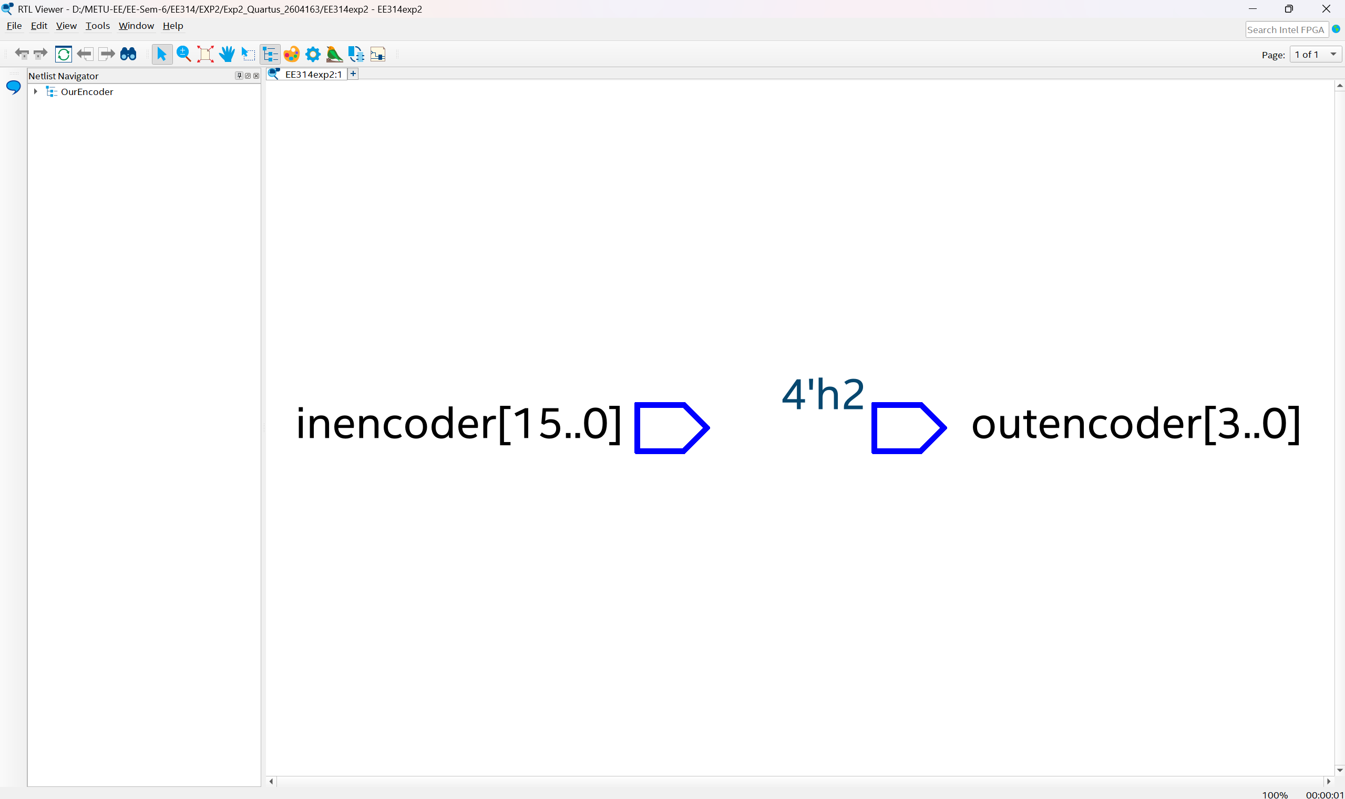
Figure 5:RTL Schematic of OurEncoder.v
In general, it is obvious from Figure 5 that our inputs and outputs are not connected to anything as if they are floating. When we examine the code, we can see that the expression inside case() is given wrong and needs to be changed to “inencoder” since our output is changing depending on the input:
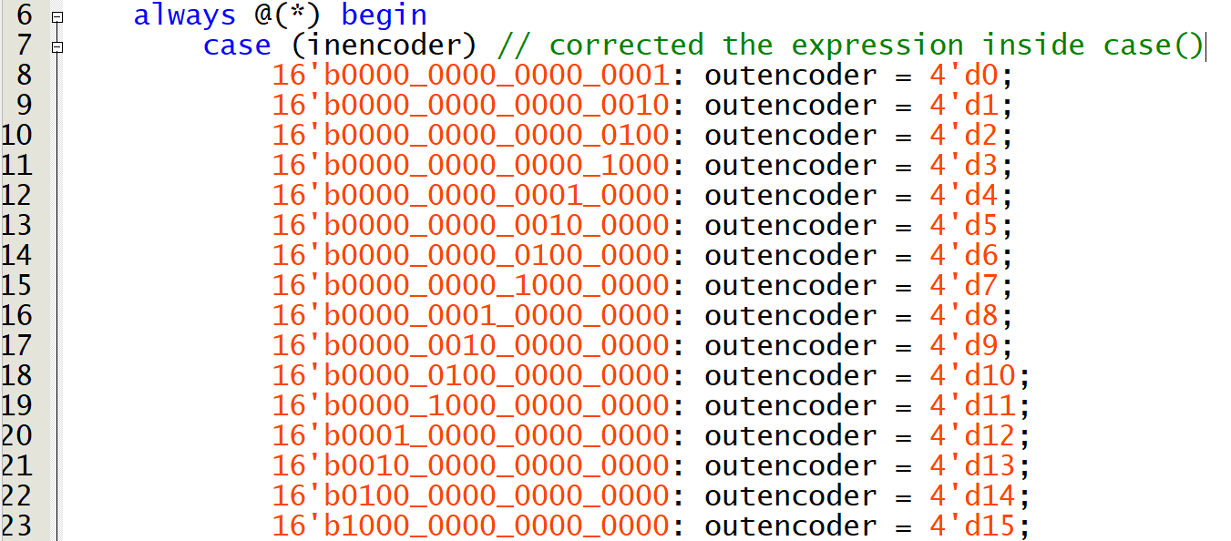
Figure 6: The corrected OurEncoder.v

4)
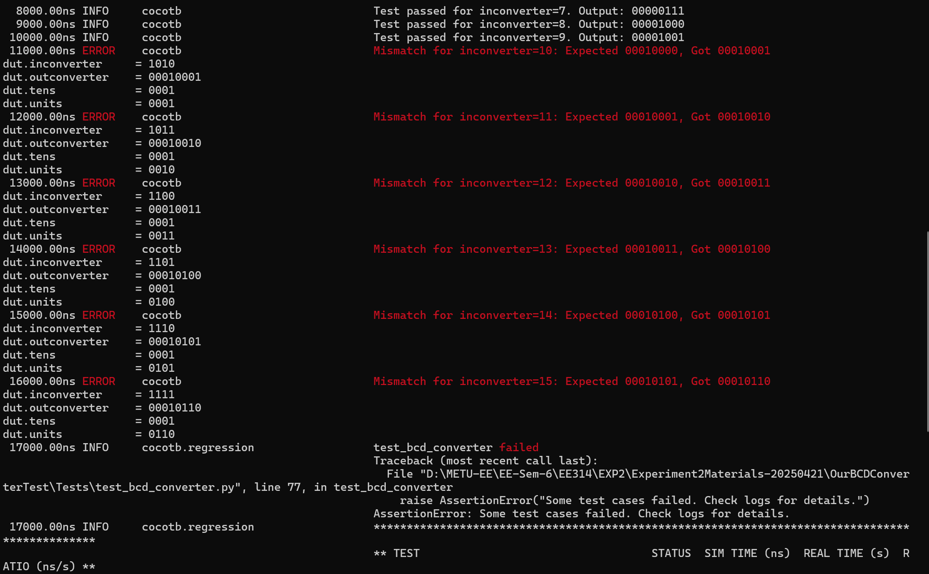
Figure 7: Errors in Testbanch of OurBCDConverter.v
As the errors in testbench explains, we face with errors for cases where input is greater than or equal to 10 so we will check the Verilog code for this case. When we examine the Verilog code, we see that for “units” in if statement instead of “10”, “9” is subtracted from the input:
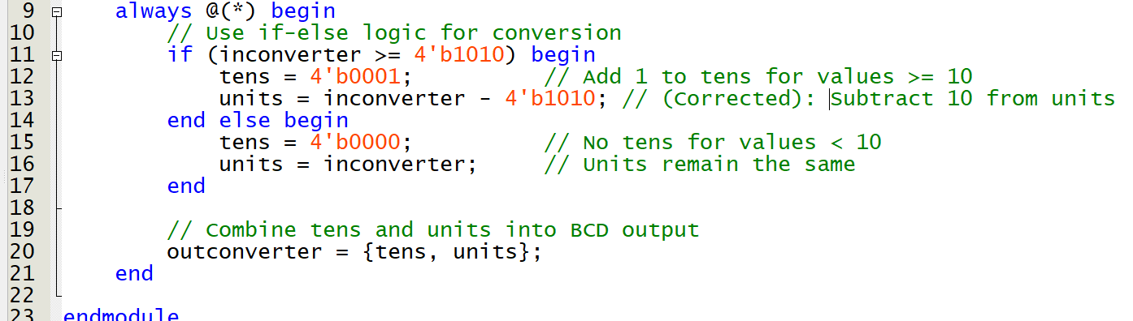
Figure 8: The Corrected OurBCDConverter.v

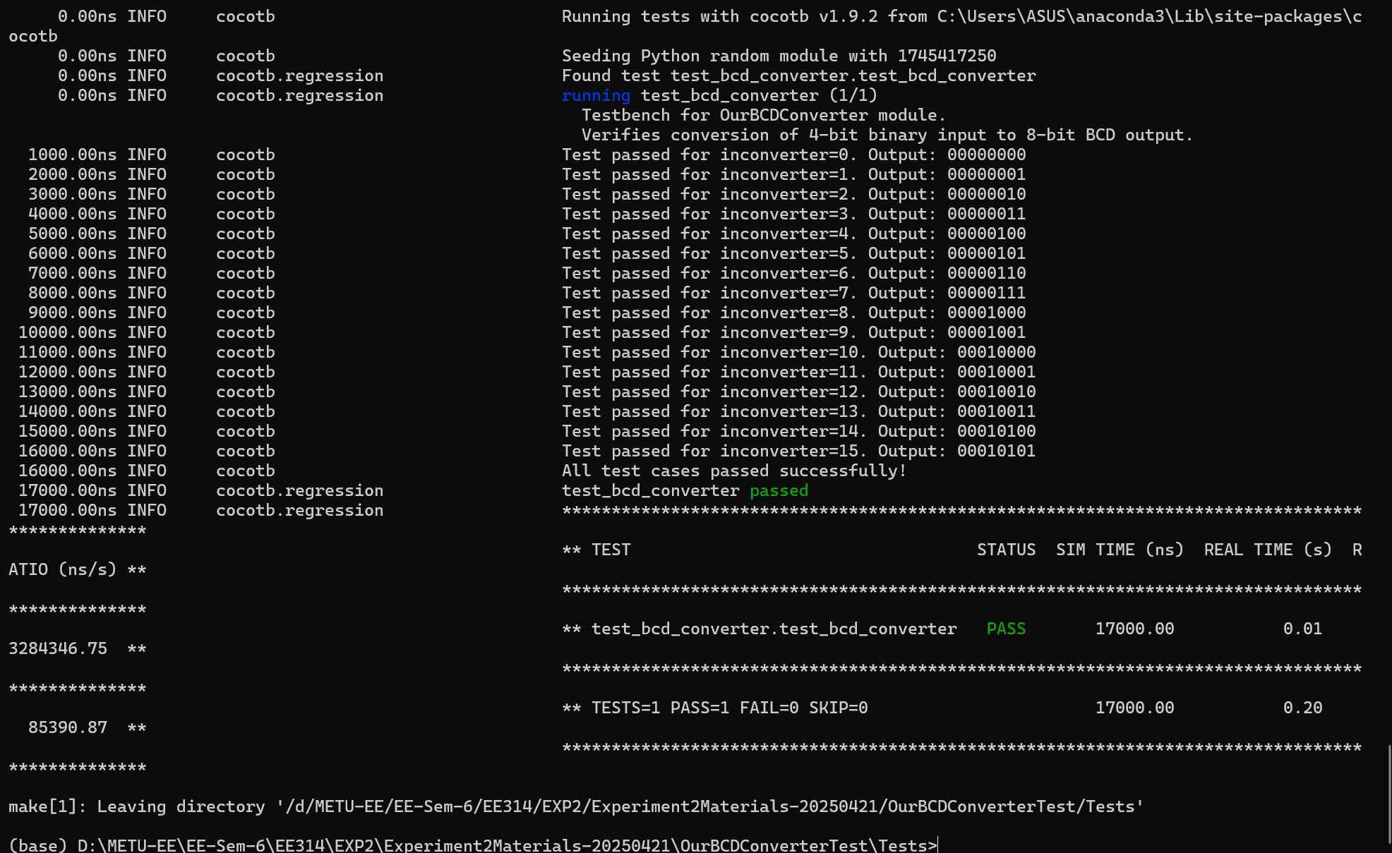
Figure 9: The Result of Test Cases for OurBCDConverter.v

5)
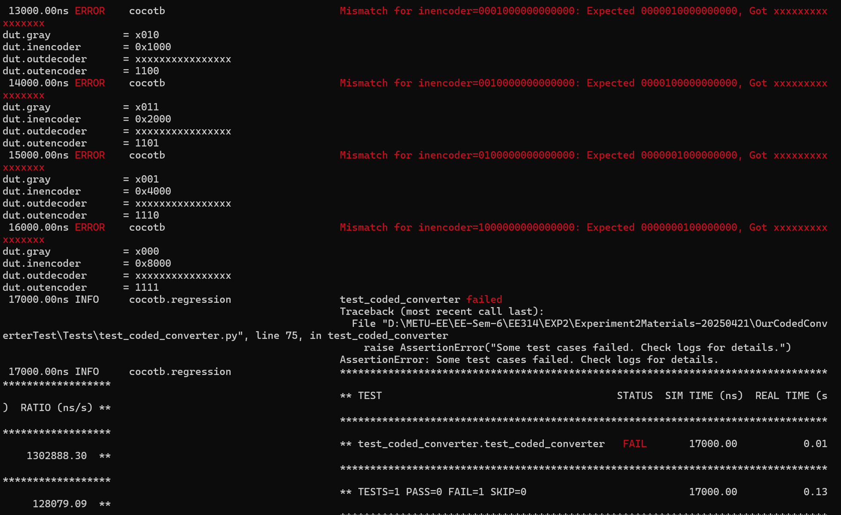
Figure 10: Error for Test of OurCodedConverter.v
In the error messages we see that “outdecoder” is considered as don’t care.
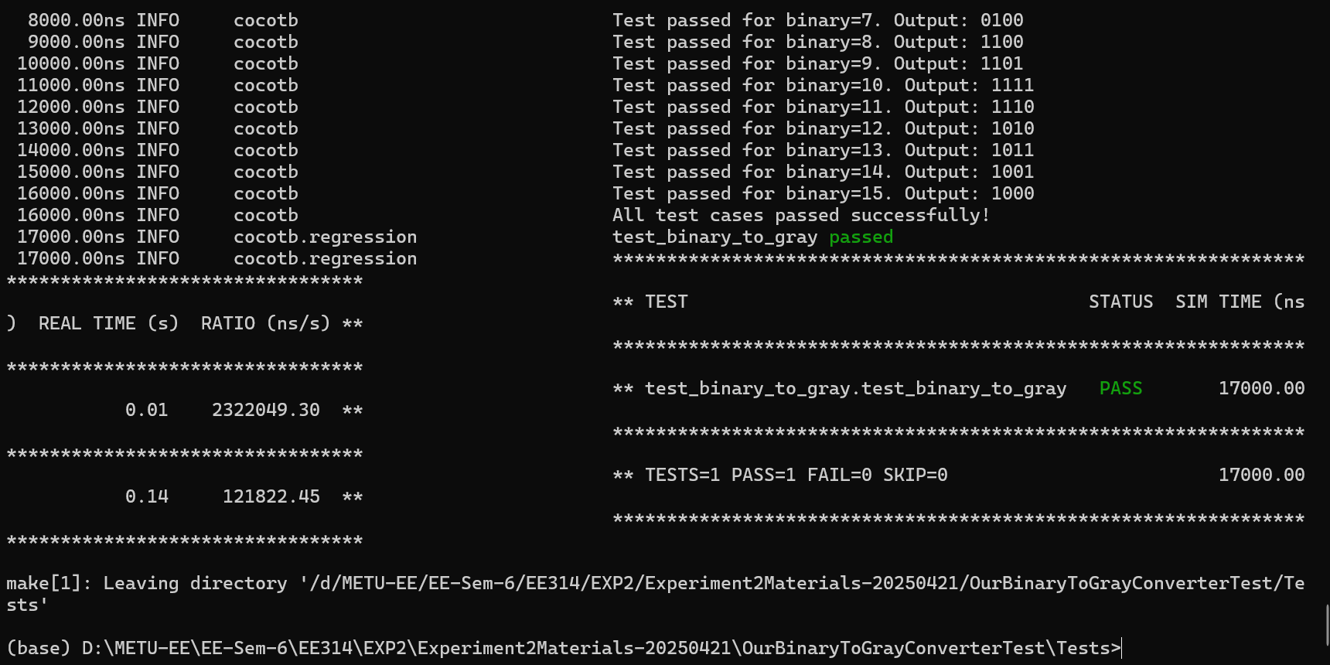
Figure 11: Test Results for OurBinaryToGrayConverter.v
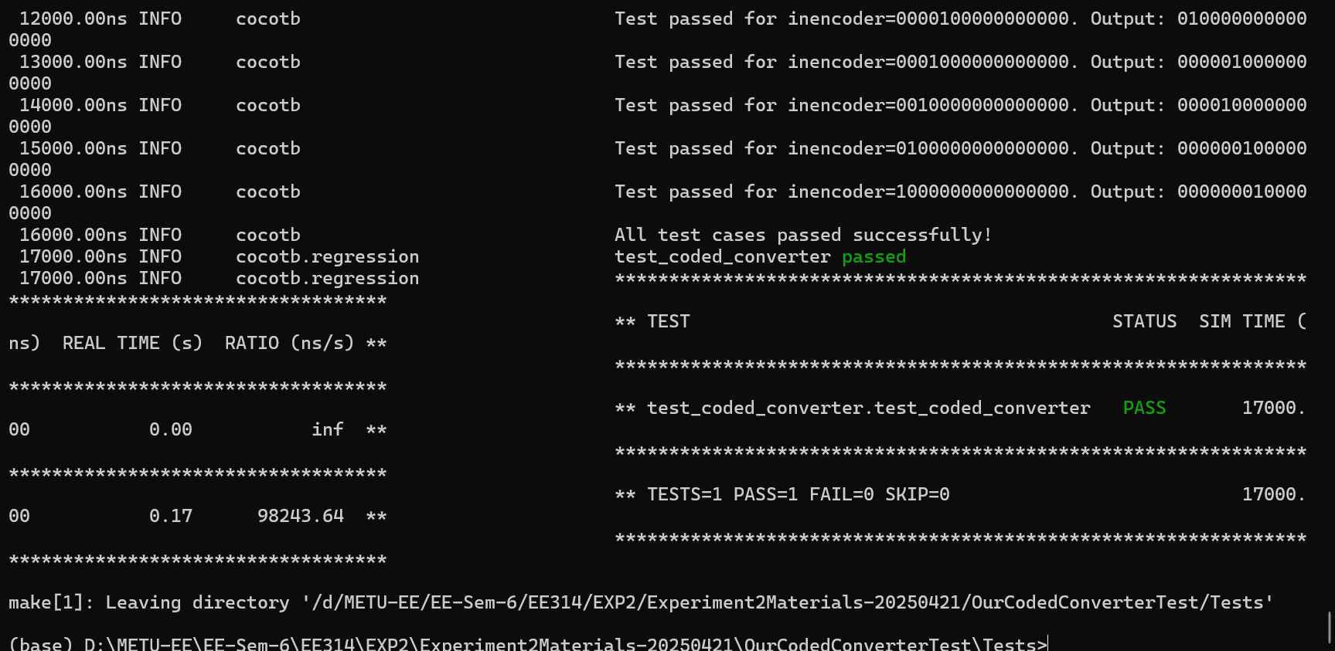
Figure 12: Test Results for OurCodedConverter.v

Appendix

import cocotb
from cocotb.triggers import Timer

def binary_to_gray(binary_val):
binary_to_gray_dict = {
# Binary (4-bit) : Gray Code (4-bit)
'0000': '0000', # 0 → 0
'0001': '0001', # 1 → 1
'0010': '0011', # 2 → 3
'0011': '0010', # 3 → 2
'0100': '0110', # 4 → 6
'0101': '0111', # 5 → 7
'0110': '0101', # 6 → 5
'0111': '0100', # 7 → 4
'1000': '1100', # 8 → 12
'1001': '1101', # 9 → 13
'1010': '1111', # 10 → 15
'1011': '1110', # 11 → 14
'1100': '1010', # 12 → 10
'1101': '1011', # 13 → 11
'1110': '1001', # 14 → 9
'1111': '1000' # 15 → 8
}
binary_str = format(binary_val, '04b')
gray_str = binary_to_gray_dict[binary_str]
return int(gray_str, 2)

@cocotb.test()
async def test_binary_to_gray(dut):
"""
Testbench for OurBinaryToGrayConverter module.
Verifies conversion of 4-bit binary input to 8-bit gray code output.
"""
test_failed = False # Flag to track overall test failure

for binary_val in range(16): # Loop through all possible 4-bit binary values
# Apply the binary input
dut.binary.value = binary_val

# Wait for a short delay to allow combinational logic to propagate
await Timer(1, units='us')

# Calculate expected Gray Code output
expected_gray = binary_to_gray(binary_val)

# Check if the output matches the expected value
if dut.gray.value != expected_gray:
test_failed = True # Mark overall test as failed
cocotb.log.error(
f"Mismatch for binary={binary_val}: Expected {bin(expected_gray)[2:].zfill(4)}, "
f"Got {bin(dut.gray.value)[2:].zfill(4)}"
)
#Log_Design(dut)
else:
cocotb.log.info(f"Test passed for binary={binary_val}. Output: {dut.gray.value}")

# Final assertion for the overall result
if test_failed:
raise AssertionError("Some test cases failed. Check logs for details.")
else:
cocotb.log.info("All test cases passed successfully!")

