EE314 Digital Circuits Laboratory

Experiment 3 Preliminary
1)
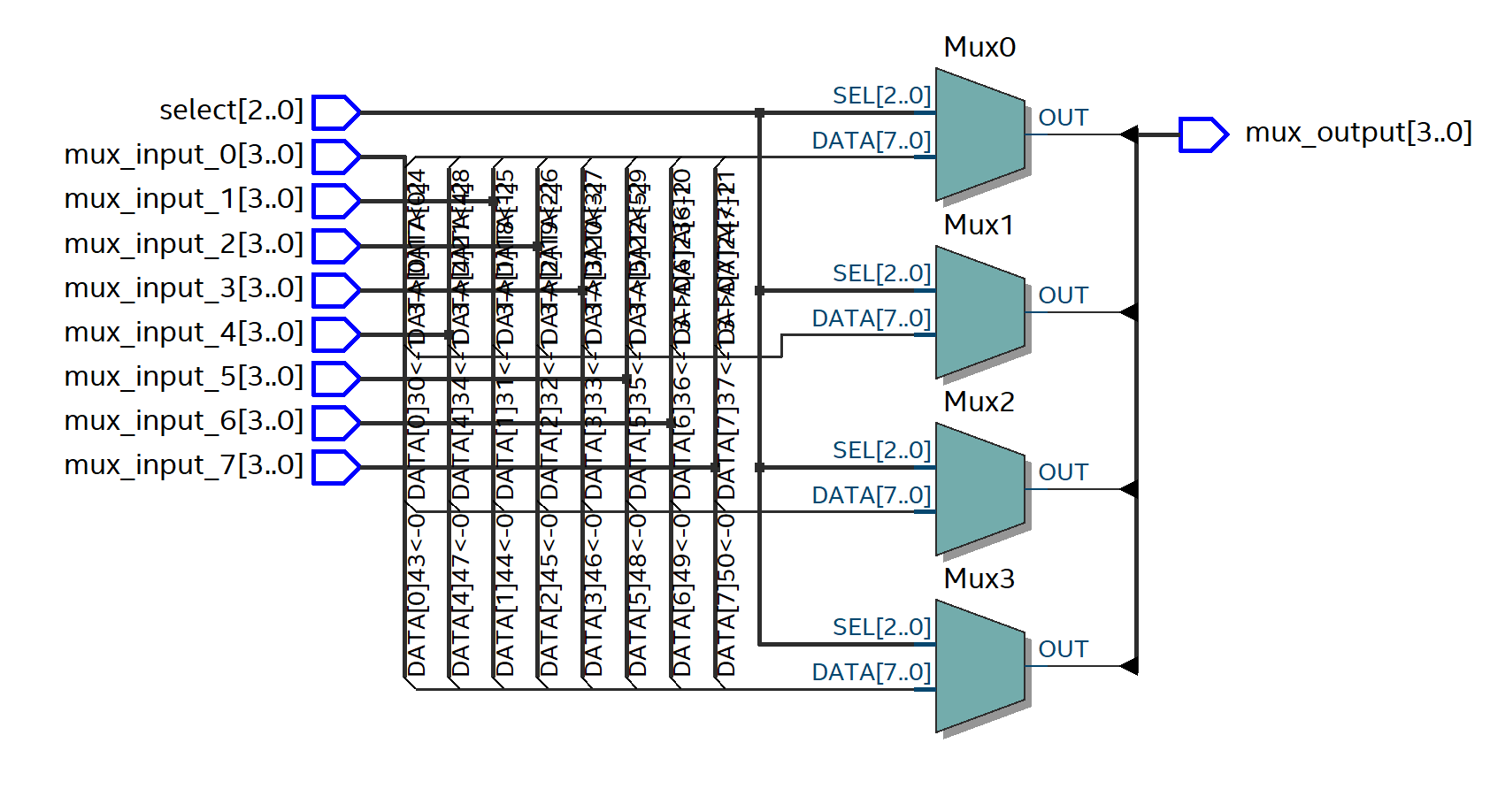
Figure 1: RTL Schematic for MUXx.v

2)
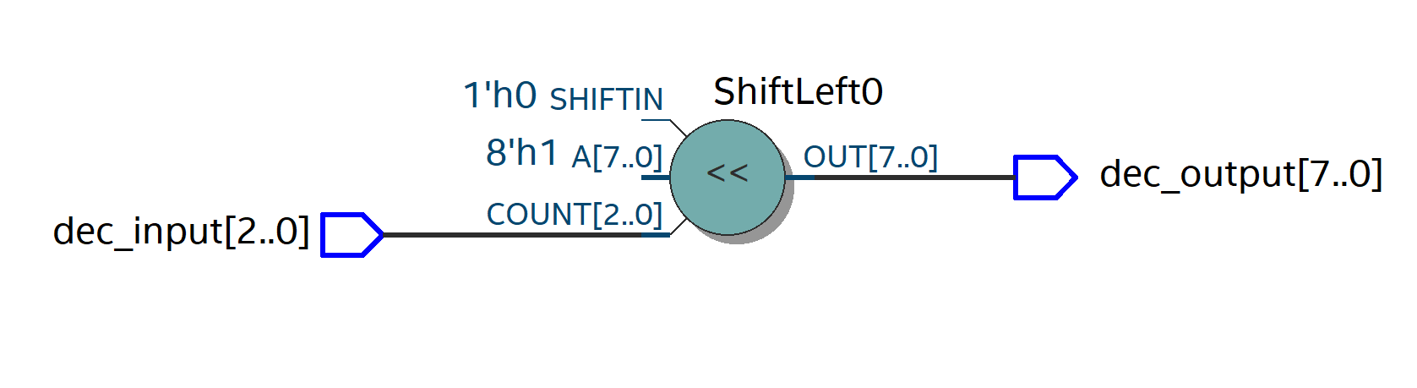
Figure 2: RTL Schematic for Decoder.v

3)
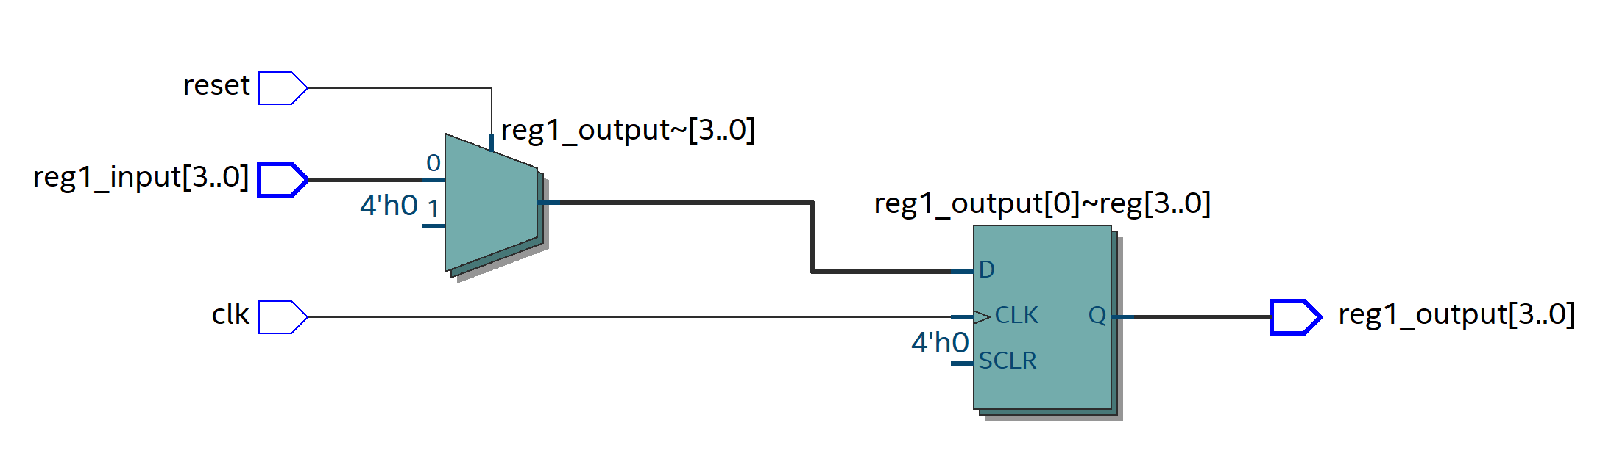
Figure 3: RTL Schematic for Reg1.v

4)
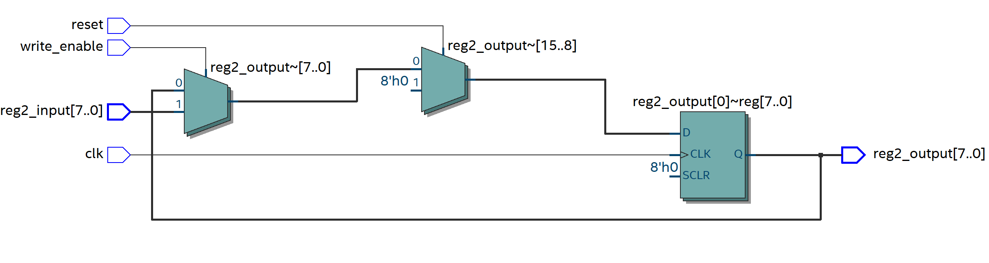
Figure 4: RTL Schematic for Reg2.v

5)
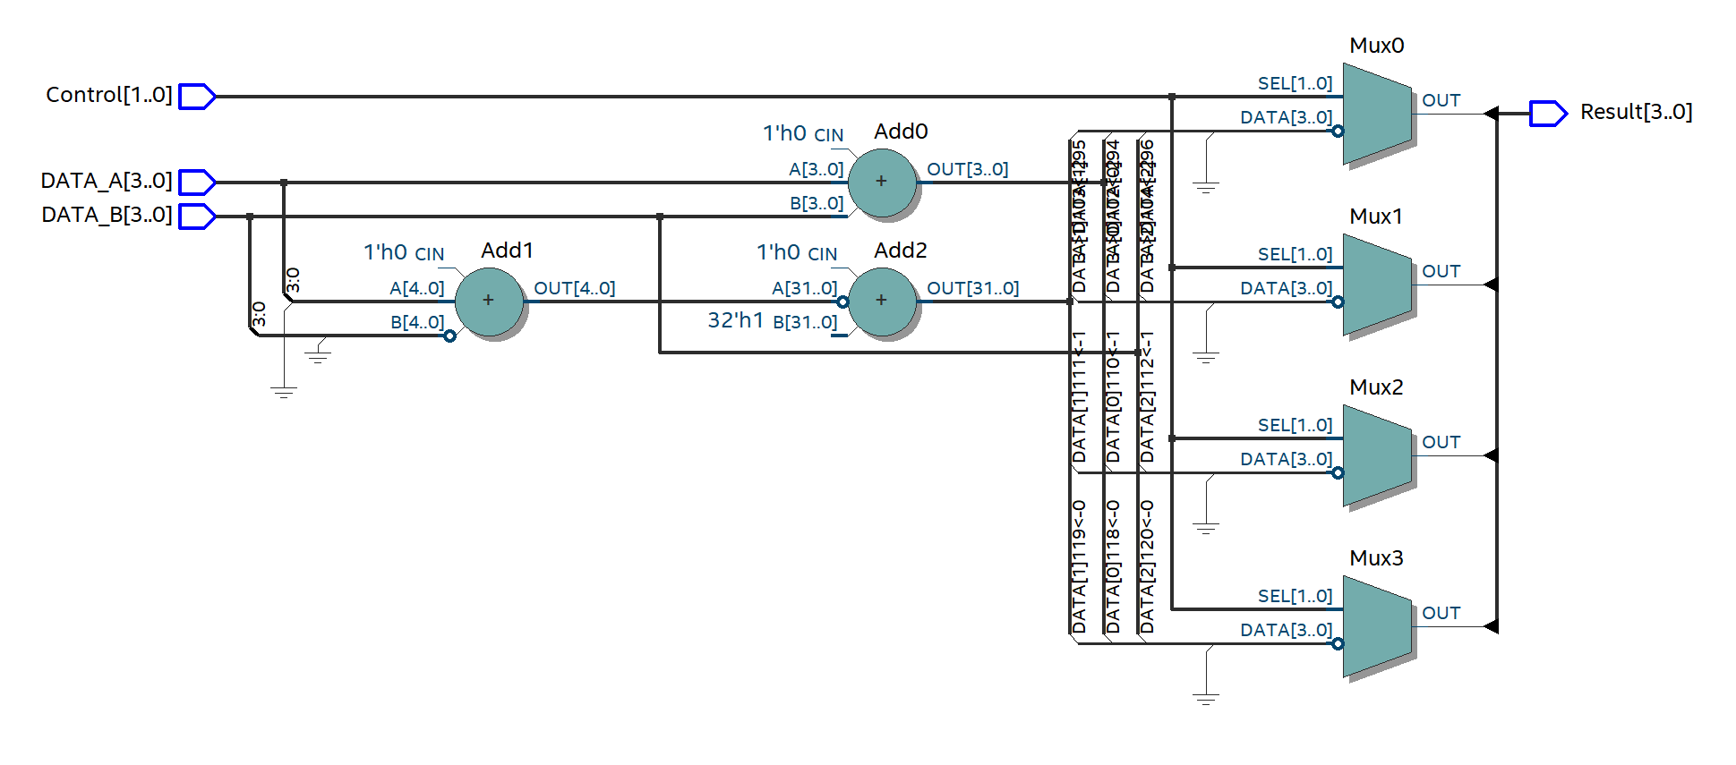
Figure 5: RTL Schematic for ALU.v

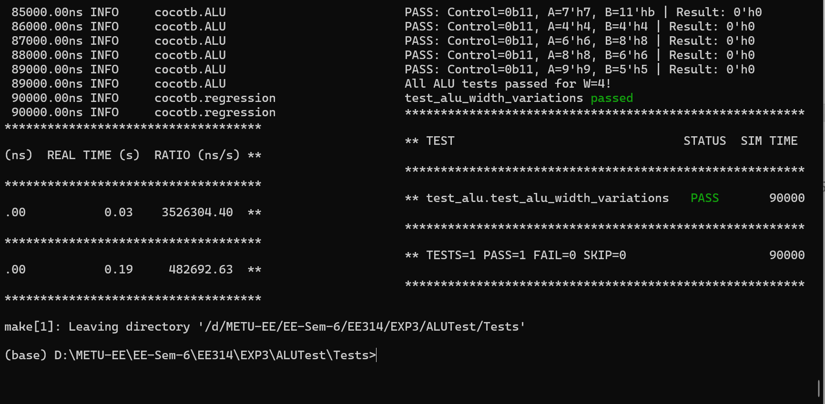
Figure 6: Testbench Results for ALU.v

6)
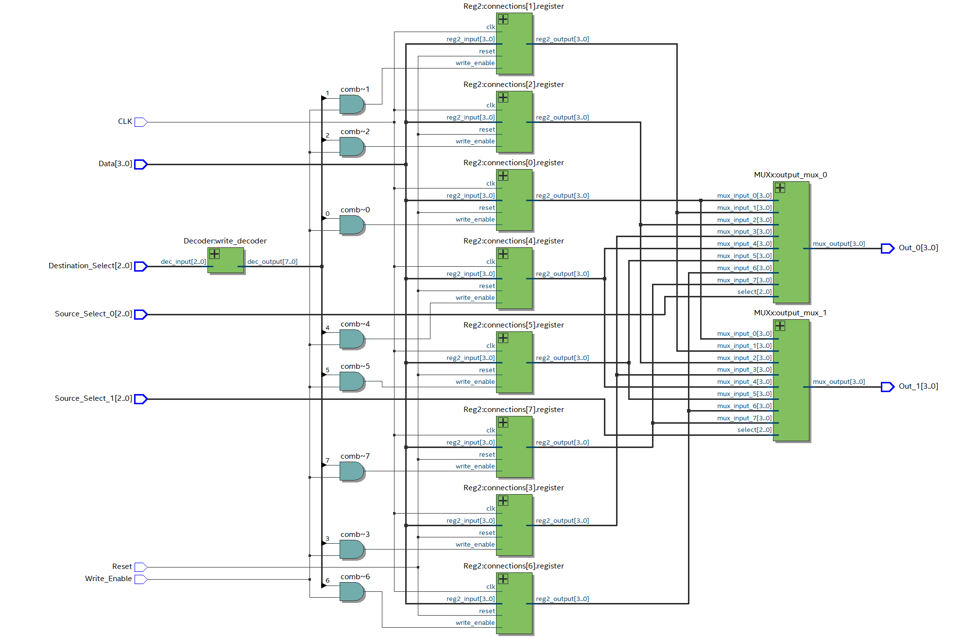
Figure 7: RTL Schematic for Register_File.v

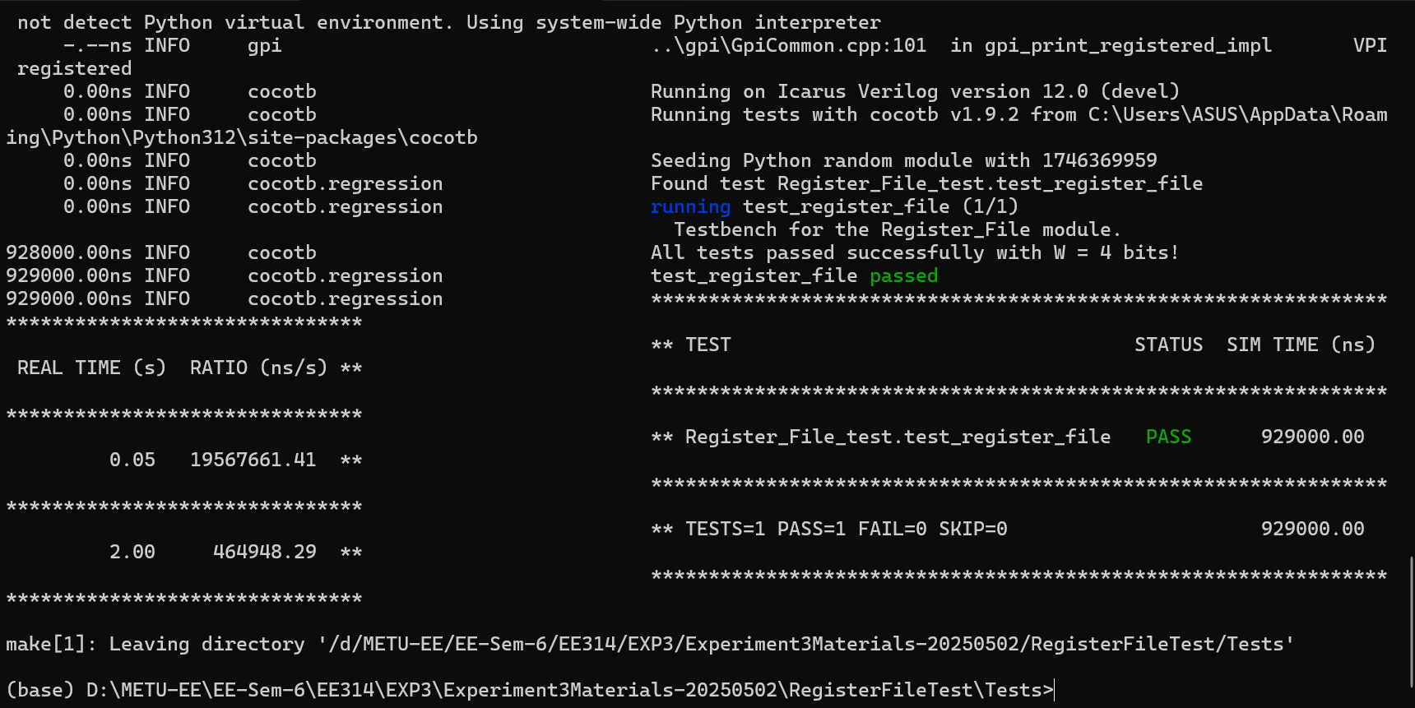
Figure 8: Testbench Results for Register_File.v

