EE314 EXP4 Preliminary

1)
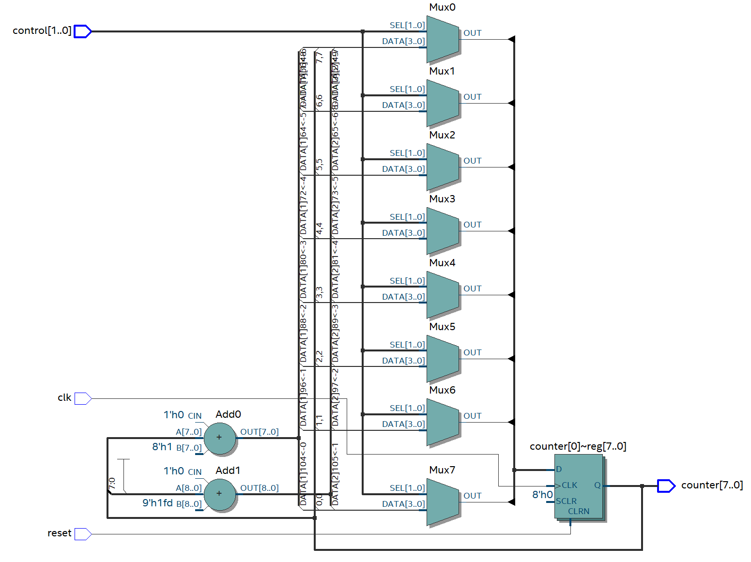
Figure 1: RTL Schematic for Counter.v

2)
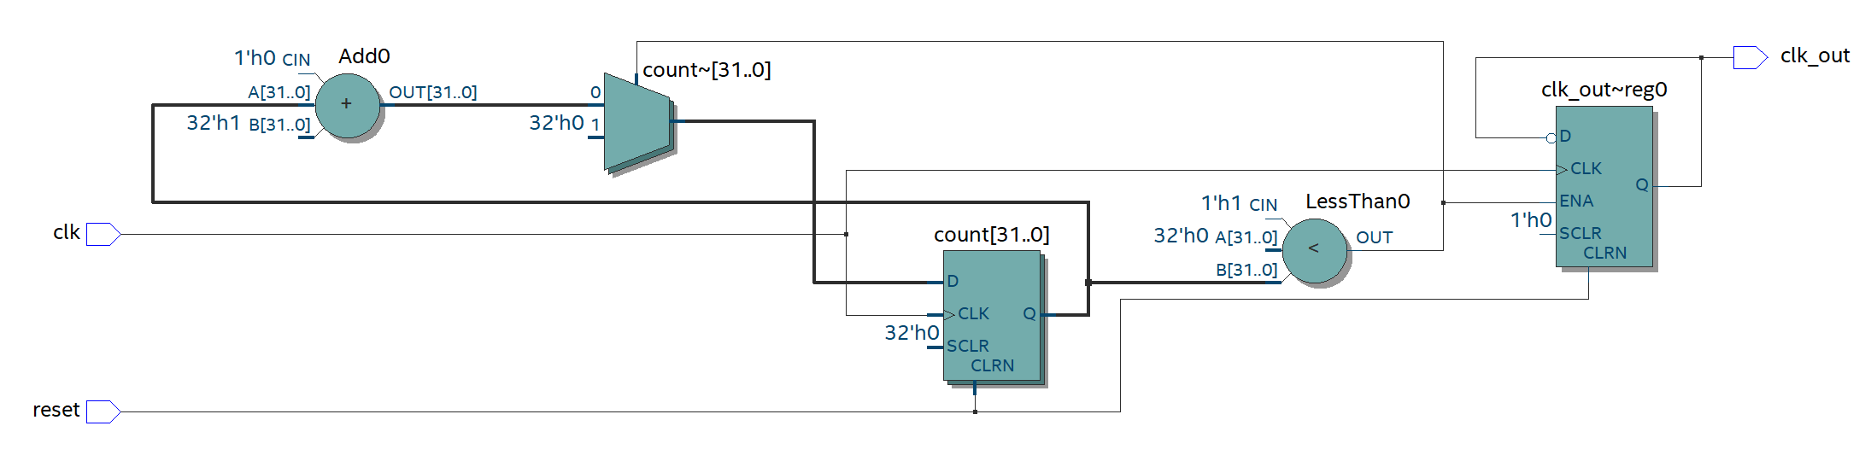
Figure 2: RTL Schematic for Clock_Divider.v

3)
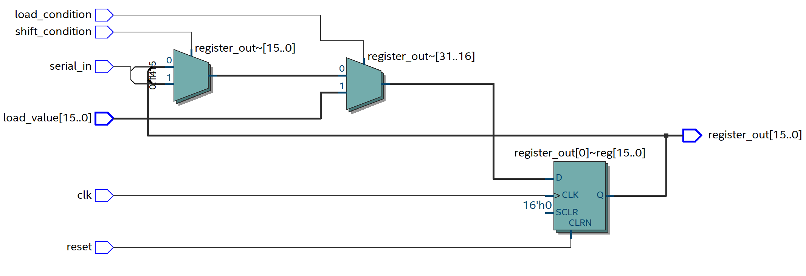
Figure 3: RTL Schematic for Shift_Register.v

4)
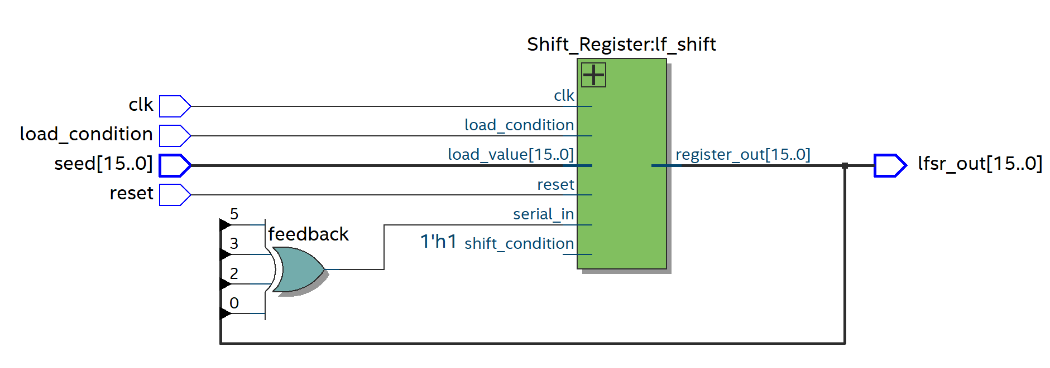
Figure 4: RTL Schematic for LFSR.v

5)
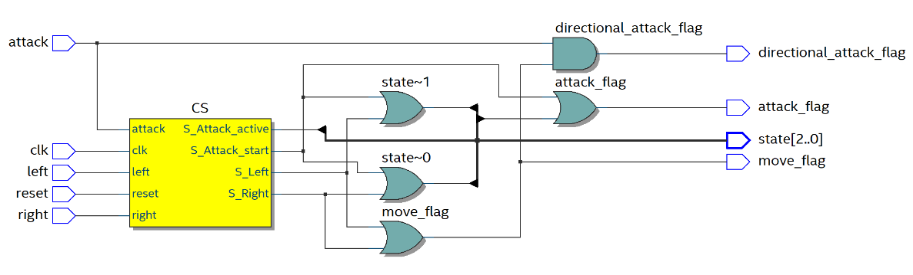
Figure 5: RTL Schematic for Small_Game.v

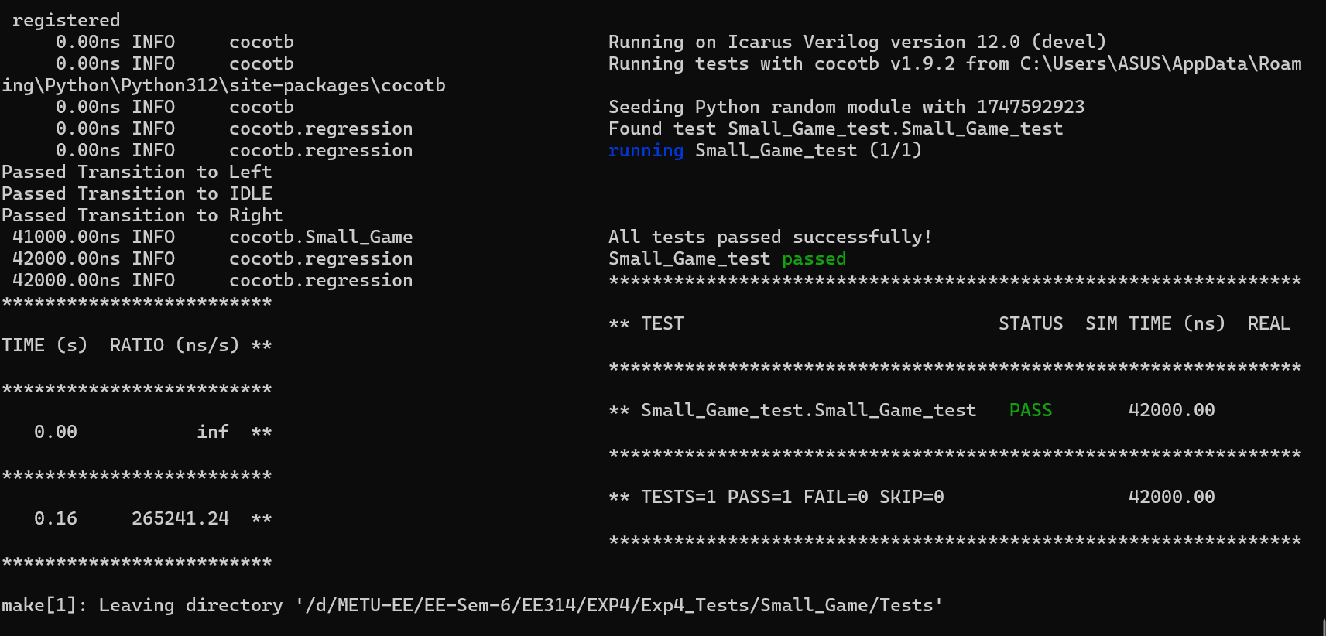
Figure 6: Test Results for Small_Game.v

