Technical Overview (a part of CHEP2007 Paper of GSI)

GSI Darmstadt, 23 September 2007
Version: 0.6
Author: Anar Manafov

Technical Overview

GAW
glite-api-wrapper (GAW) – a C++ library, which wraps some parts of the gLite API, adds automation and helpers in order to simplify access to the needed functionality of gLite (see Figure 1). It is not a general gLite API wrapper; but rather designed and implemented in terms of the needs of the RGLite project. Through the usage of GAW the user gets a general interface to the gLite middleware.

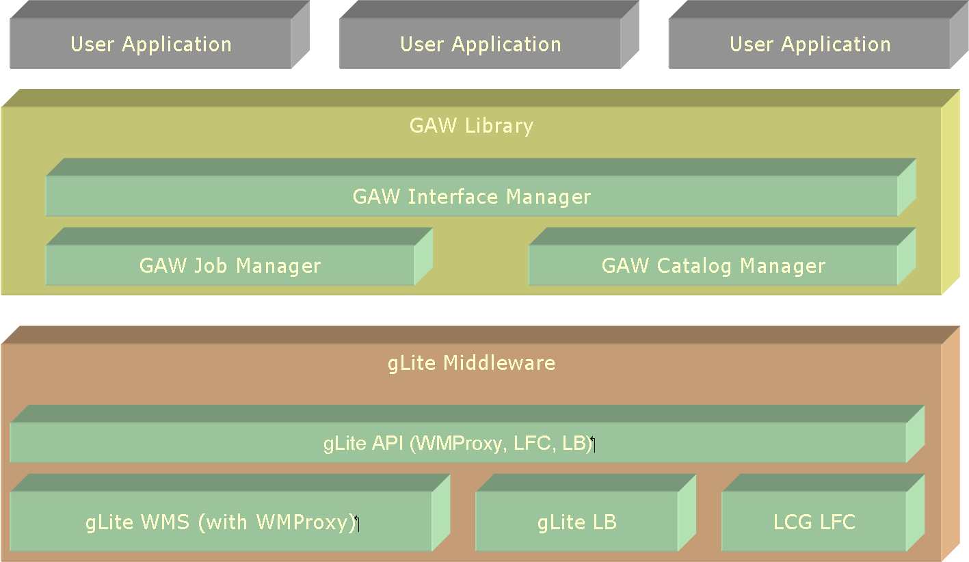
Figure 1

GAW provides the following features:
- Workload Management System operations:
  - job submission – normal, DAG and parametric jobs (WMProxy API),
  - job status querying (LB API),
  - job output retrieving (GridFTP).
- File Catalog operations (LFC API):
  - set/query the current working catalog directory,
  - list files, directories and their stats,
  - add/remove files in a catalog namespace,
  - add/remove directories,
  - add/remove replicas from a given file.
- An executive logging.
- Support of an external xml configuration file.
- Serialization support.

The following, a short usage example of GAW (presented in the Listing 1), shows how convenient with several lines of code users can perform Grid job operations, in compare with several hundred lines of code, which say should have to write if want to use gLite API directly.

…
// GAW Init
CGLiteAPIWrapper::Instance().Init();
// Job submission
CJobManager &mng( CGLiteAPIWrapper::Instance().GetJobManager() );
mng.DelegationCredential();
const string jdl( “test.jdl” );
string jobID;
mng.JobSubmit(jdl, &jobID);
…
// Checking job's status
const glite::lb::JobStatus::Code status = mng.JobStatus(jobID);
…
// Job’s output
mng.JobOutput(jobID, output_dir, &joboutput_path);
…
Listing 1

RGLite
RGLite – a ROOT plug-in, which implements the ROOT Grid interface (see Figure 2) and offers to ROOT users a possibility to use gLite from within their ROOT macros/programs.

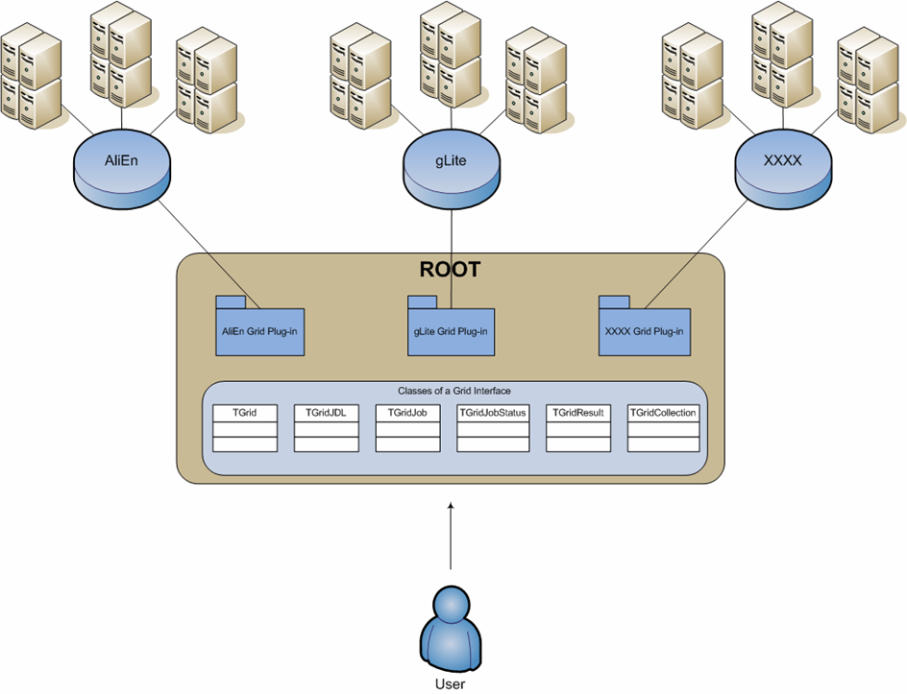
Figure 2

The UML class diagram of RGLite plug-in is presented on the Figure 3.
RGLite provides the whole range of functionality, which is defined by the ROOT Grid interface. Since the standard file operation mechanism in gLite is GFAL -- and the GFAL class-wrapper is a part of the standard ROOT installation, we don’t need to and we didn’t implement this machinery in our plug-in. Users can use the standard ROOT implementation of TGFALFile.
RGLite plug-in doesn’t call gLite API directly, rather it uses GAW library to perform routines on the Grid, such as job submission, job status querying, or file catalog operations.
The fact that RGLite is implemented using GAW calls also means that it supports WMProxy job submission and brings all advantages of this method to the ROOT users.
So far RGLite isn’t a part of the ROOT distribution; we therefore provide a ROOT patch which helps users to easily install RGLite with ROOT source. It is worth to mention that RGLite has been successfully tested with recent versions of ROOT.

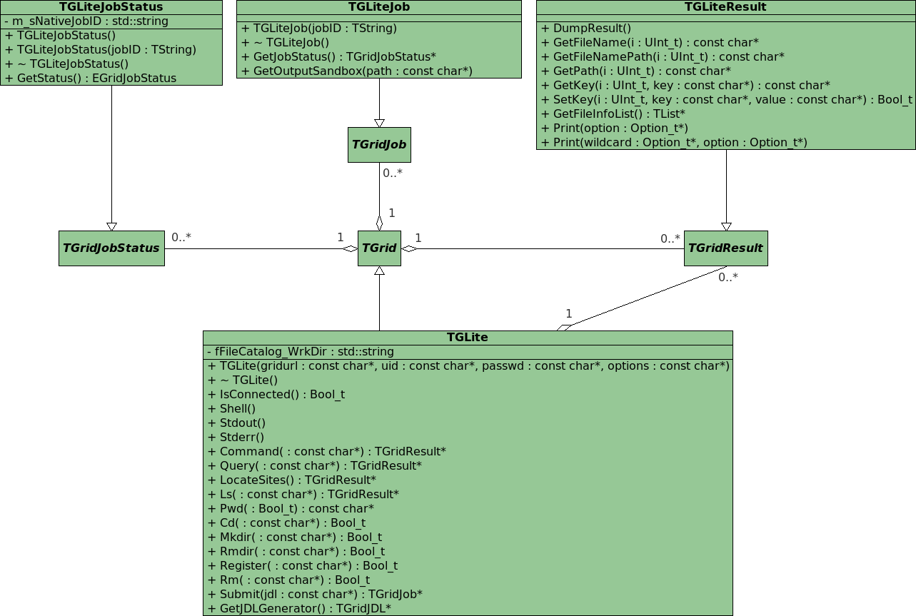
Figure 3

// Initializing RGLite plug-in
TGrid::Connect( “glite” );
// Submitting a job to gLite Grid
TGridJob *job = gGrid->Submit( “test.jdl” );
// querying a status of the job
TGridJobStatus *status = job->GetJobStatus();
status->GetStatus();
// Getting a job's output back to the user
job->GetOutputSandbox( “/home/anar/” );
Listing 2

// Initializing RGLite plug-in
TGrid::Connect( “glite” );
// Changing current File Catalog directory to “dech"
gGrid->Cd( “dech” );
// Querying a list of files of the current FC directory
TGridResult *result = gGrid->Ls();
// Printing the list out, including full file information
result->Print( “all” );
Listing 3

The listings above are showing a simplicity with which users can perform job submission to gLite Grid, query for status of the job and retrieve jobs output to a defined local folder (Listing 2), and perform file catalog operations (Listing 3).

PROOF on the Grid
In order to perform PROOF analysis on the Grid, currently on gLite Grid, the gLitePROOF package has been developed.
gLitePROOF – a gLite PROOF package. It is a number of utilities and configuration files developed at GSI in terms of the D-Grid project and aims to implement a PROOF distributed data analysis on the gLite Grid.
The gLitePROOF package consists of the following components:
- PROOFAgent – a lightweight, standalone C++ application. Acts as a multifunctional proxy client/server and helps to use proof/xrootd on the Grid worker nodes behind a firewall. Also PROOFAgent has a number of additional useful functionalities which help to start, process, and control PROOF interactive analysis. The default configuration file is included.
- PAConsole (see Figure 5) – a standalone C++ application, which provides a GUI and aims to simplify the usage of PROOFAgent and gLitePROOF configuration files. PAConsole uses GAW to perform gLite job submissions. Users can control jobs directly using ROOT and RGLite plug-in instead of using PAConsole.
- xpd.cfg – a generic XROOTD configuration file (configures redirector and remote Grid workers).
- Server_gLitePROOF.sh – a server side script. Helps to start/stop services of gLitePROOF. Could be used via command line or PAConsole GUI.
- gLitePROOF.jdl – a JDL file, describes a generic, parametric Grid job, which is submitted to gLite and aims to execute gLitePROOF workers on Grid worker nodes.

Main use case of gLitePROOF: “Set up PROOF on the Grid”

- Using PAConsole a user configures and starts PROOFAgent server and XROOTD redirector.
  - PROOFAgent connects to XROOTD's proof port and waits for PROOFAgent clients.
- Using PAConsole the user submits gLitePROOF parametric job to the Grid.
  - When the job arrives to a remote worker node it configures the environment and starts all needed services including XROOTD worker and PROOFAgent client.
  - Then PROOFAgent client communicates with PROOFAgent server, exchanges environment data and initiates a network tunnel.
  - When PROOFAgent server accepts a client connection, the client is ready to be a PROOF worker node.
  - When PROOFAgent server detects good connections with its clients, this information is immediately reflected by PAConsole.
- When all workers are connected or when the user is satisfied with the number of connected workers, the PROOF analysis can be processed like on a local batch farm.
  - PROOFAgent can manage disconnects, the user can restart the ROOT session without resubmitting gLitePROOF Grid jobs.
The schematic picture of the main use case of gLitePROOF can be seen on the Figure 4.

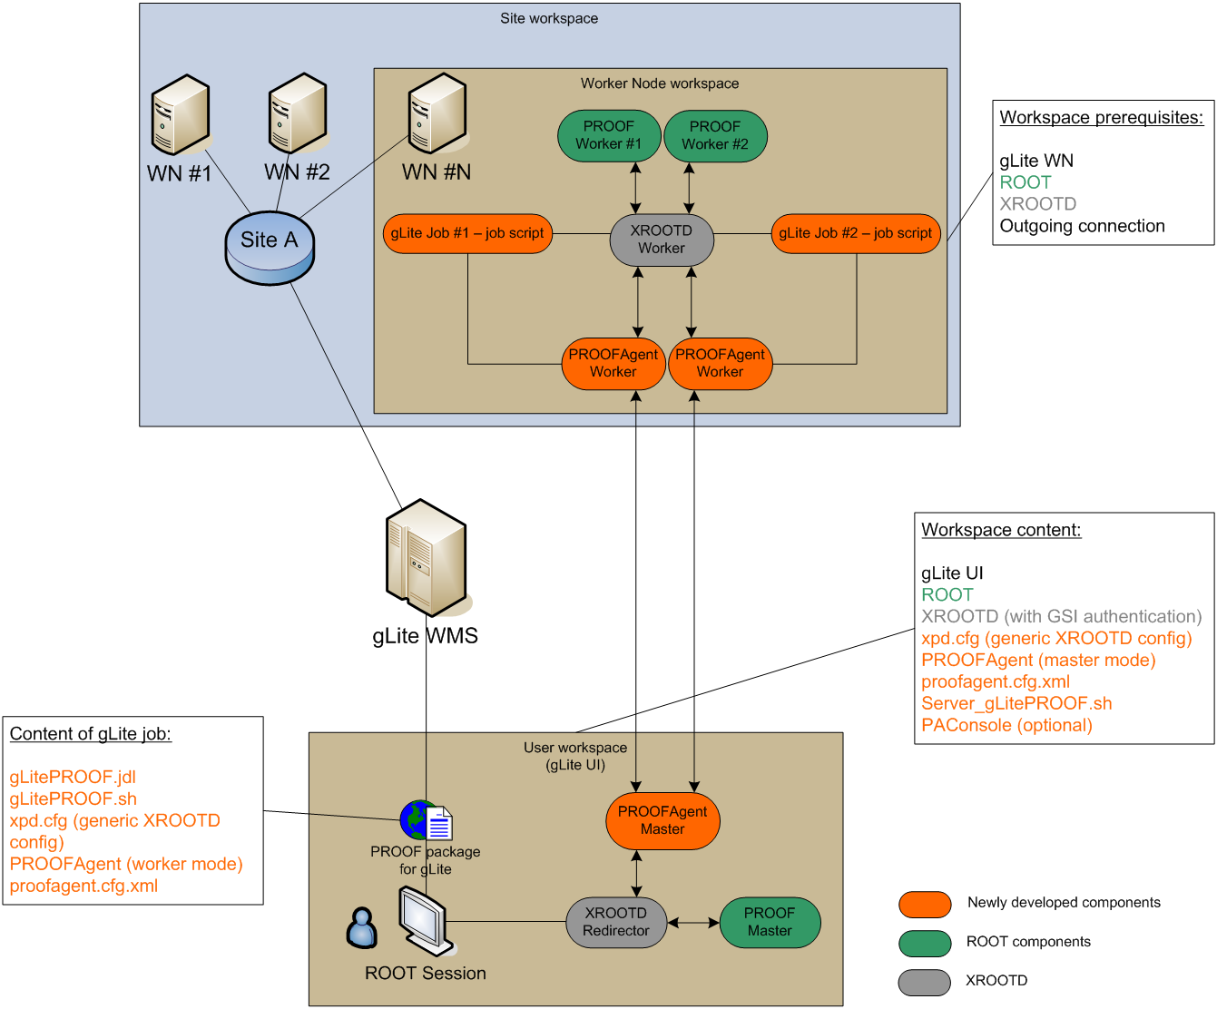
Figure 4

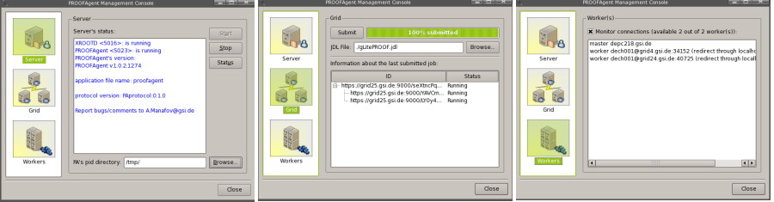
Figure 5

