
Lab 11

Lab title: GH CLI Codespaces + AWS + Terraform: Variables, Collections, Sensitivity & EC2 Provisioning
Submitted to: Engr. Mohammad Shoaib
Submitted by: Anara Hayat
Reg#No: 2023-BSE-008

Task 0 Lab Setup (Codespace & GH CLI)
All actions below should be executed inside the Codespace shell.
Create Codespace & connect:
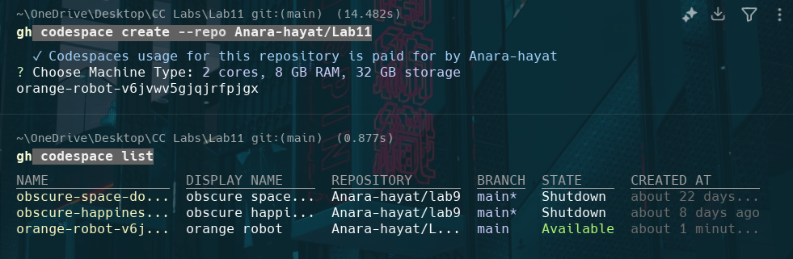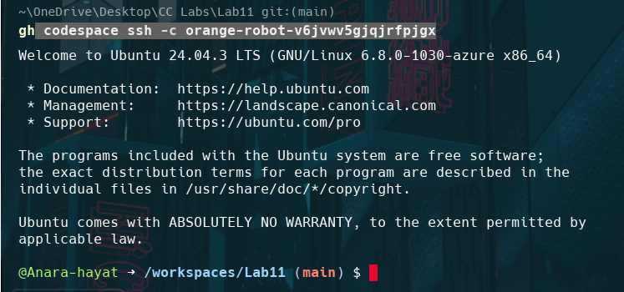
Task 1 — Provider & Basic variable (variable precedence)
- In Codespace create main.tf:
- Edit main.tf and add provider:
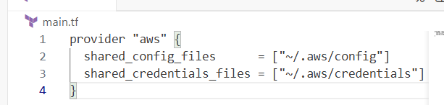
- Initialize:
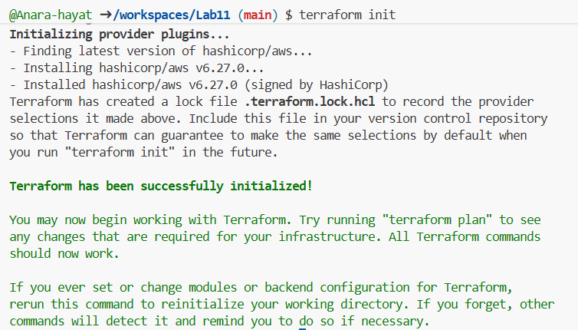
- Define a variable and output:
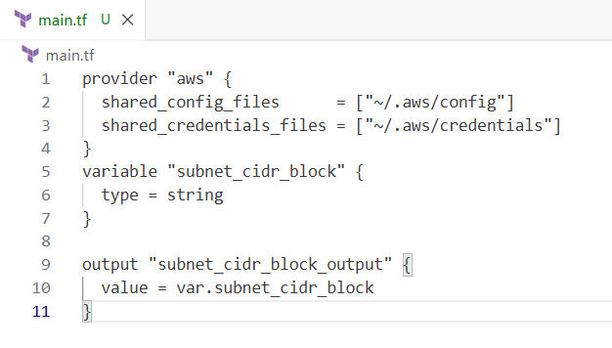
- Run apply (first time without defaults):
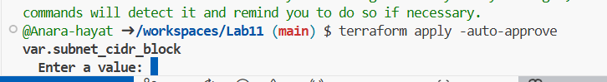
- Add a default to the variable:
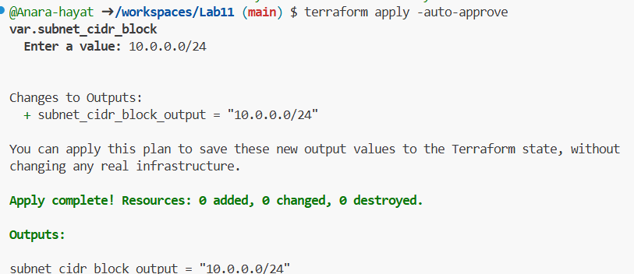
- Export environment variable in Codespace shell:
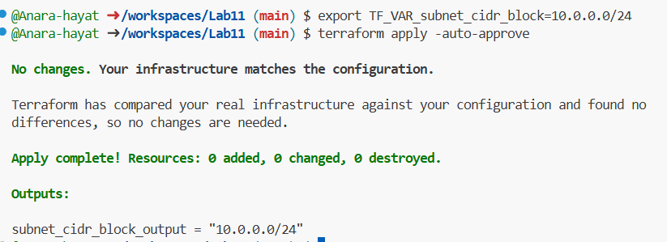
- Create terraform.tfvars overriding values:
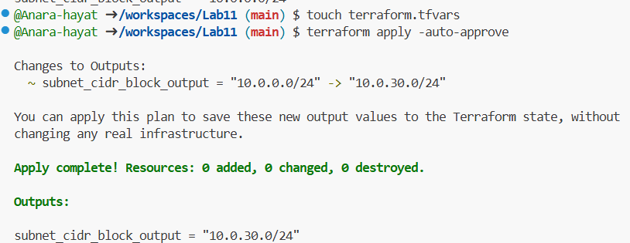
- Override with -var:
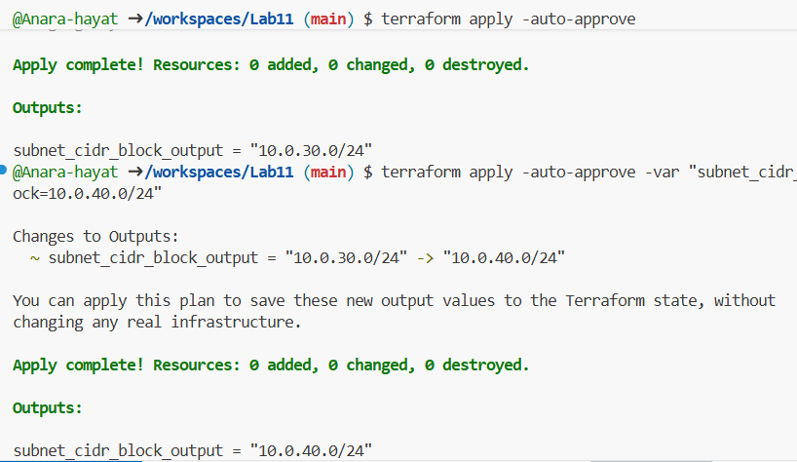
- Show and unset env var:
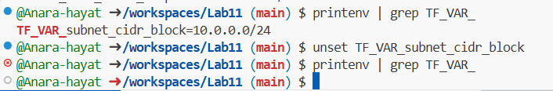
Task 2 — Variable validation & sensitive / ephemeral variables
- Replace subnet_cidr_block variable with this (validation included):
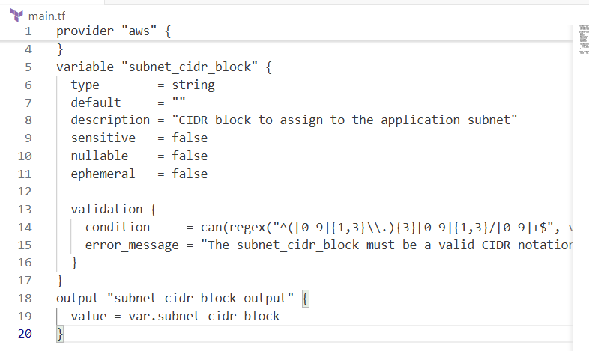
- Test validation failure:
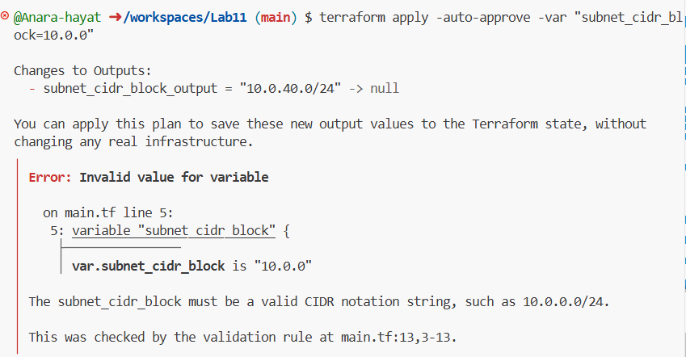
- Create a sensitive variable api_session_token and output (sensitive):
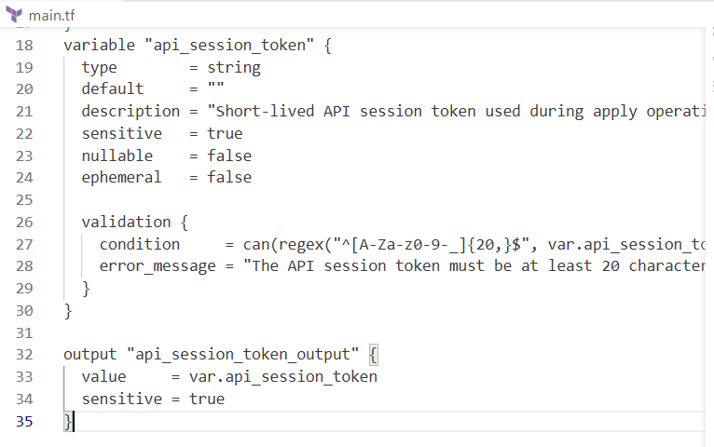
- Run with -var to observe sensitive output behavior:
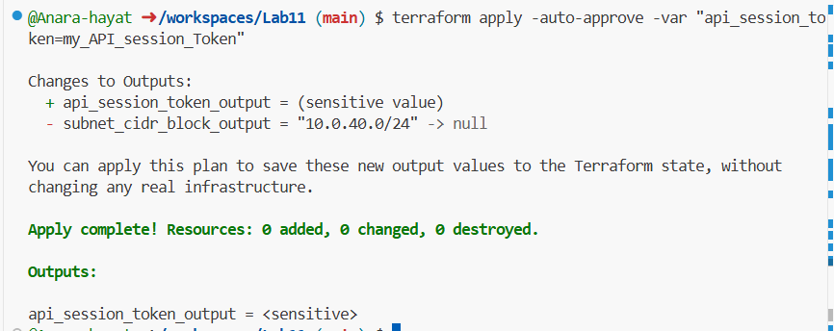
- Check terraform.state for the sensitive output:
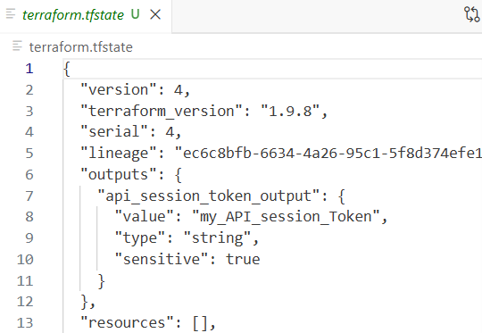
- Make variable ephemeral to hide from state:
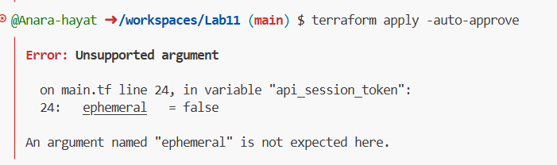
- Set default to test local default:
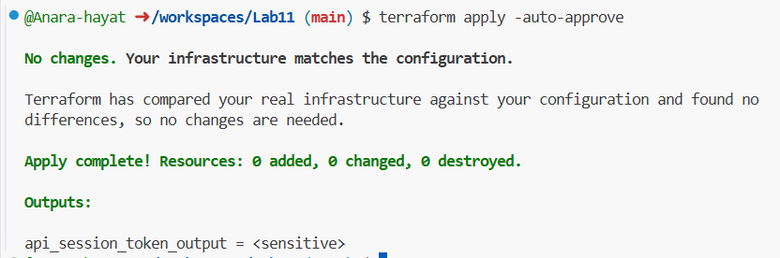
Task 3 — Project-level variables, locals, and outputs
- Add variables to main.tf:
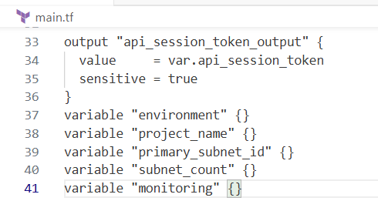
- Populate terraform.tfvars after discovering actual subnet id for availability zone me-central-1a:
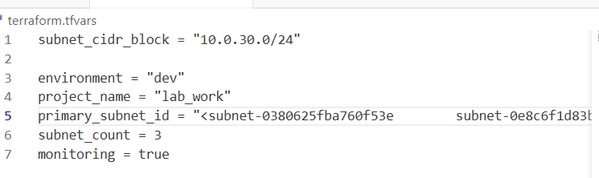
- Create locals.tf with:
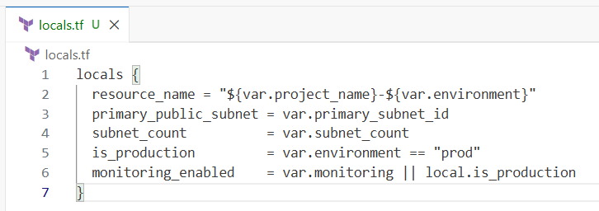
- Add outputs to main.tf:
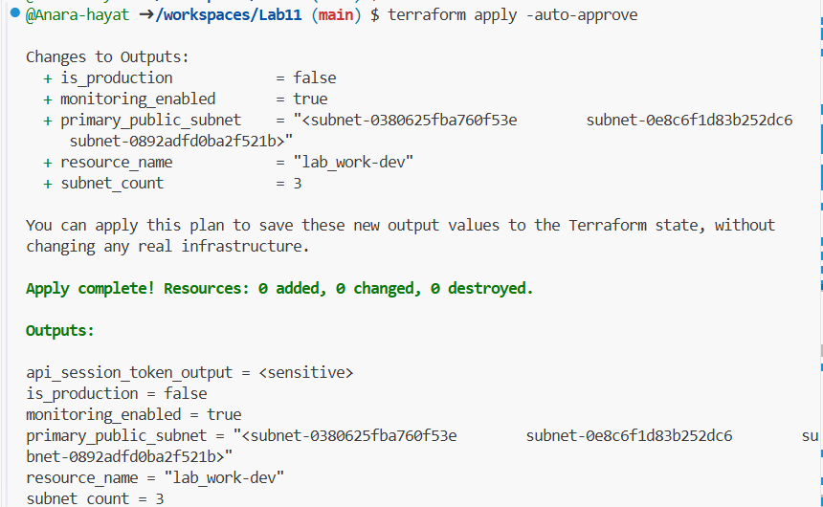
Task 4 — Maps and Objects
- Map variable in main.tf:
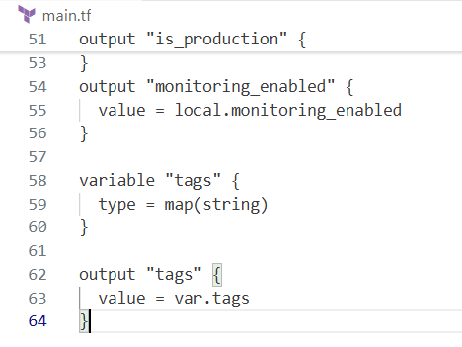
- In terraform.tfvars:
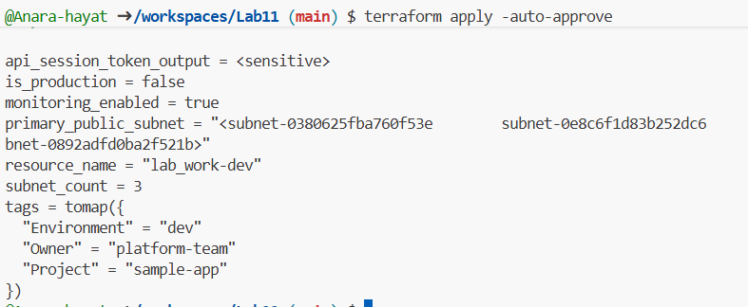
- Define object variable:
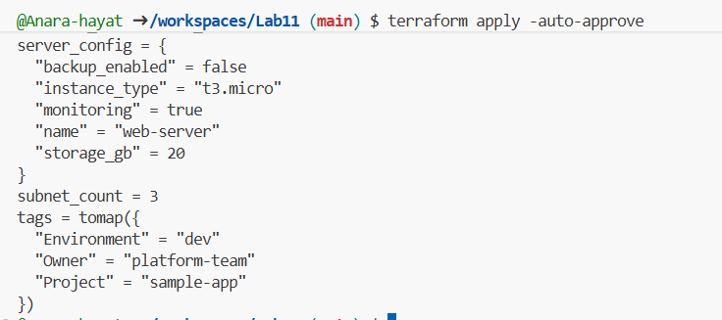
Task 5 — Collections: list, tuple, set & mutation via locals
In this task you will define collection variables (list, tuple, set), observe their behavior, then perform mutations via locals and compare results.
- In main.tf define:
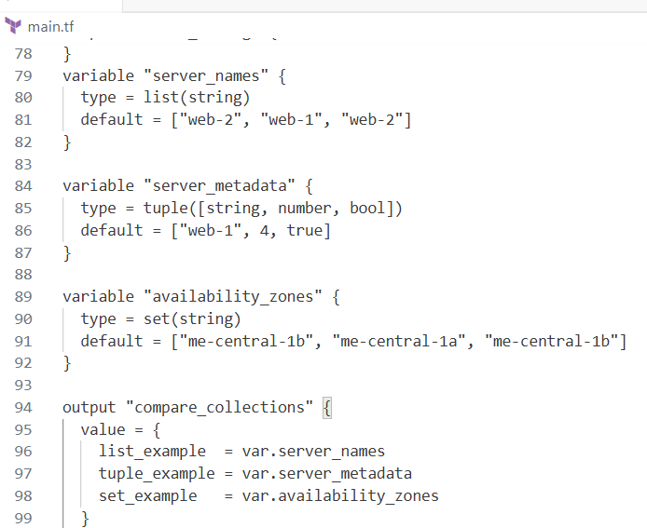
- Run:
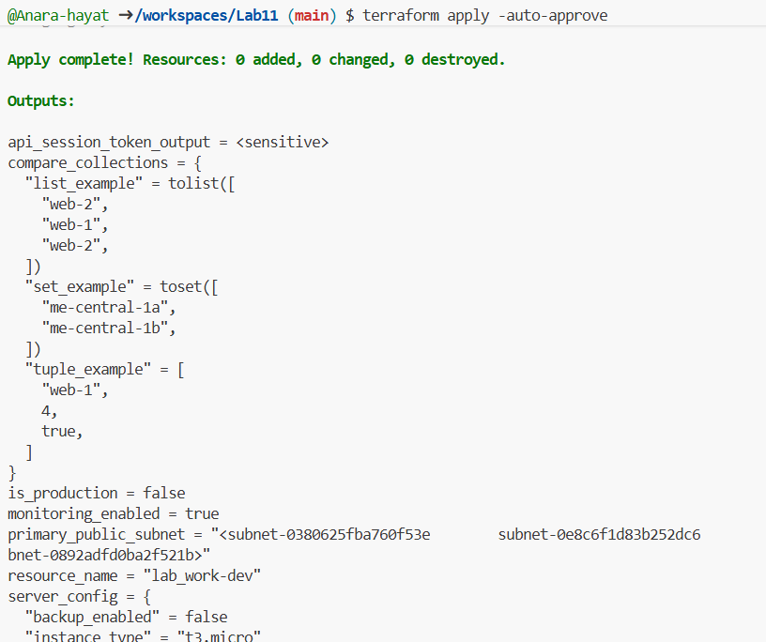
- In locals.tf add mutations: Create or edit locals.tf and add the following locals to demonstrate mutation behavior. Note: tuples are immutable in Terraform's type system, but many operations convert them to lists for evaluation.
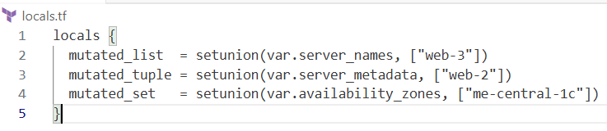
- Add comparison output in main.tf:
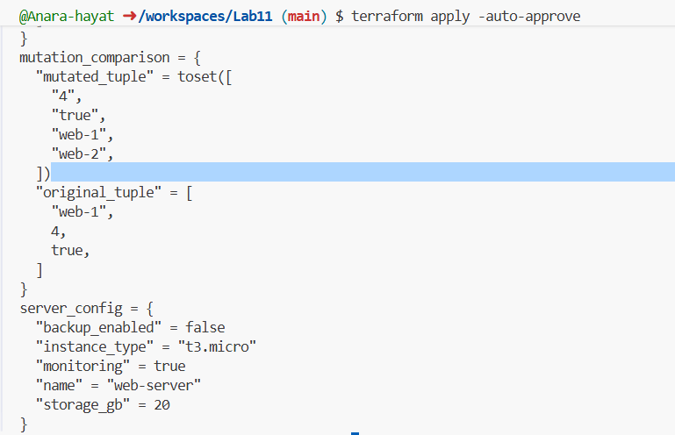
Task 6 — Null, any type & dynamic values
- Null variable:
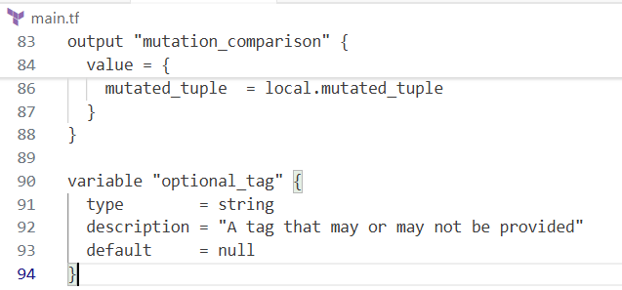
- Merge tags in locals.tf:
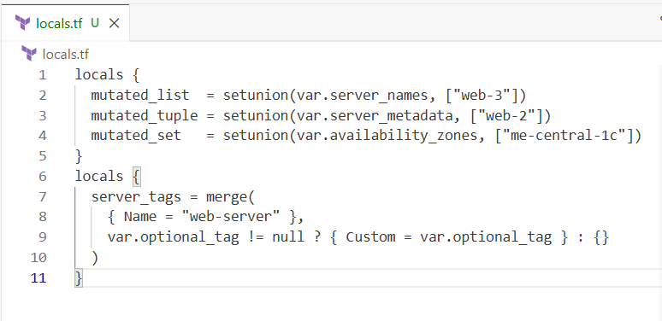
- Output:
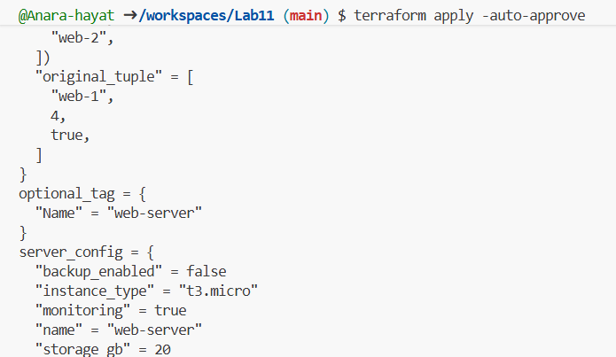
- Add in terraform.tfvars:
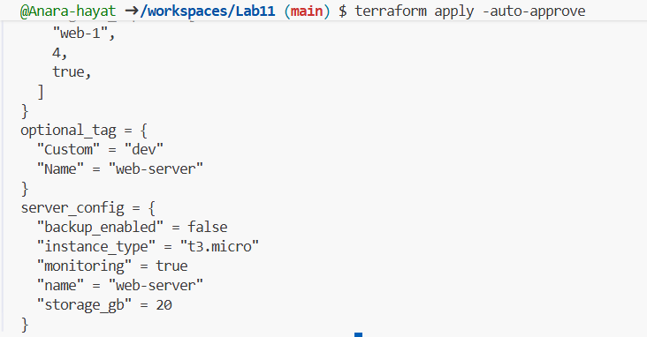
- Any type variable:
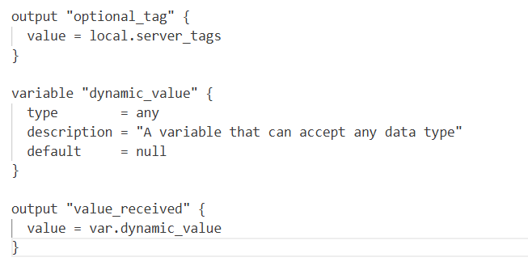
- Now test the dynamic (any) variable with different types. For each change, update terraform.tfvars with the specified value and run terraform apply -auto-approve, then capture the output.
a.String
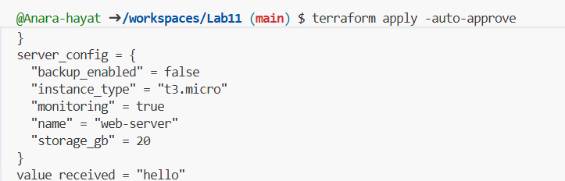
b. Number
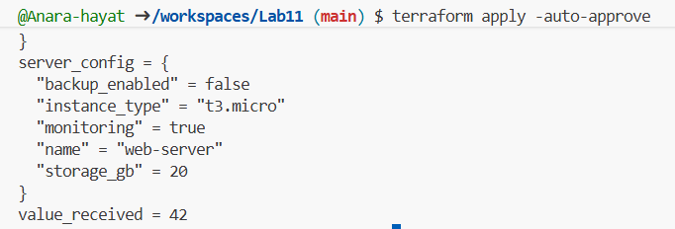
c. list
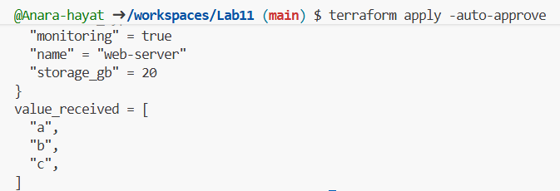
d) Map / Object
- Change terraform.tfvars:
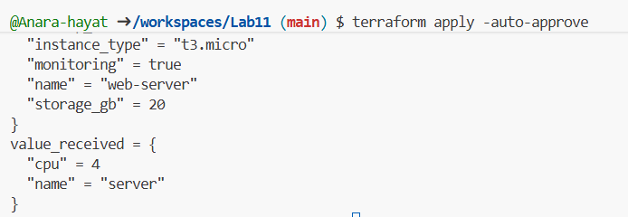
e) Null
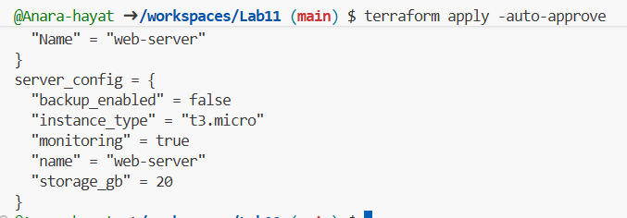
Task 7 — Git ignore
Create .gitignore:
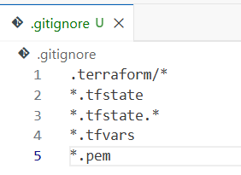
Task 8 — Clean-up then build real infra (VPC, Subnet, IGW, routing, default route table)
In this task you will clean previous example values and build a simple VPC + Subnet, attach an Internet Gateway, and configure routing (first with a custom route table and association, then switch to the default route table).
Perform all commands inside your Codespace shell.
- Clean previous files
- Clean previous files
- Remove all variable assignments from terraform.tfvars (empty the file or delete it).
- Remove all content from locals.tf (delete or empty the file).
- Replace main.tf contents with only the provider block below (start fresh).
Provider block to put in main.tf:
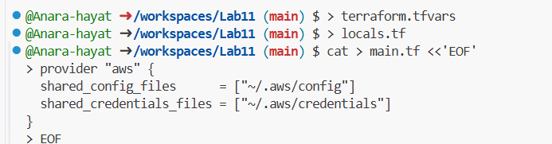
- Define variables in main.tf Add these variable declarations to main.tf (below the provider block):
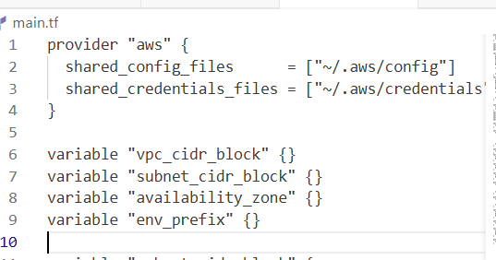
- Create VPC in main.tf Add the VPC resource to main.tf:
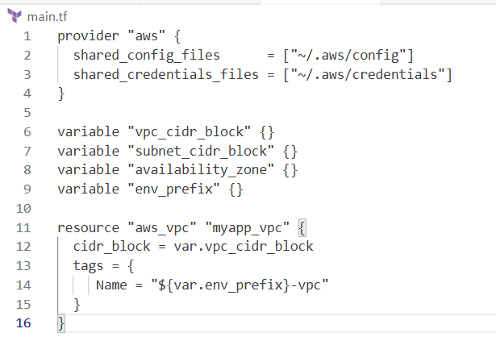
- Create Subnet in the VPC Add the subnet resource to main.tf:
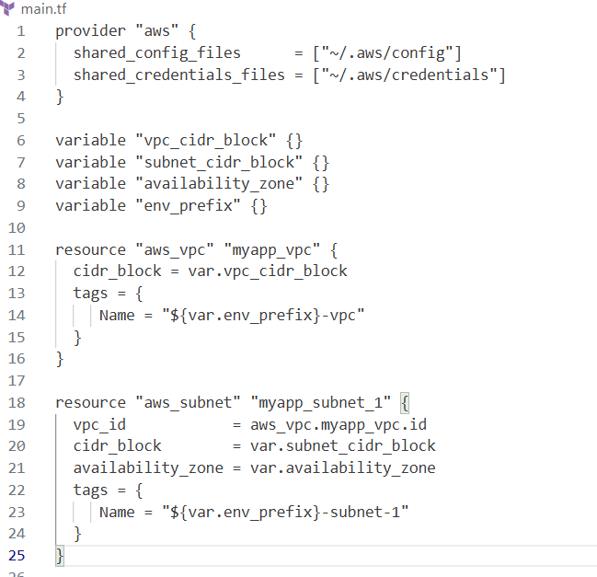
- Populate terraform.tfvars In terraform.tfvars add:
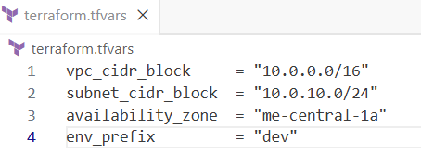
- Apply to create VPC and Subnet Initialize (if needed) and apply:
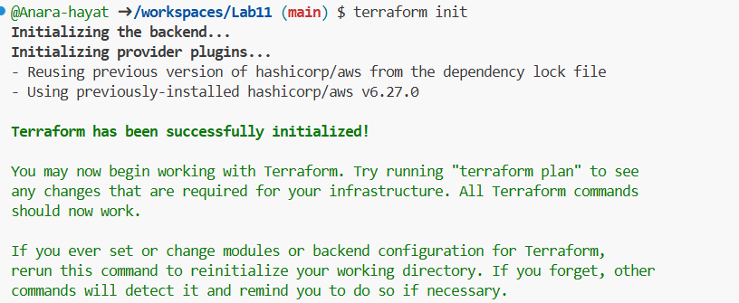
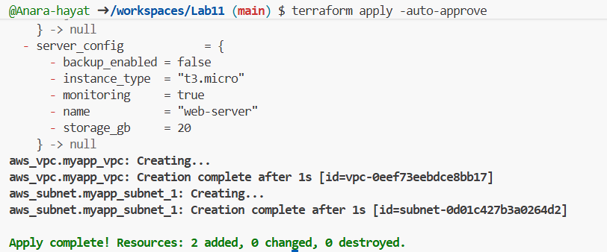
- Create Internet Gateway and Route Table (custom) Add the Internet Gateway and a custom Route Table to main.tf:
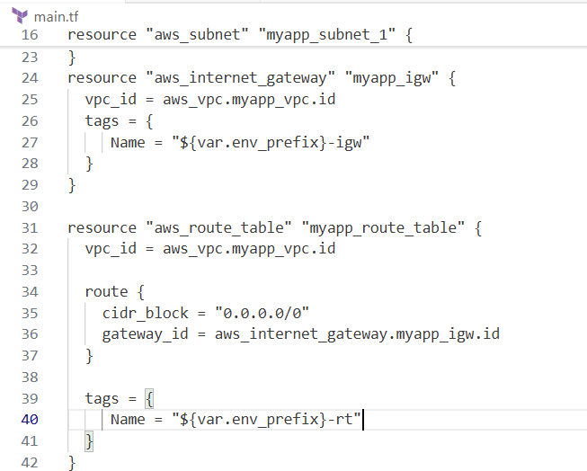
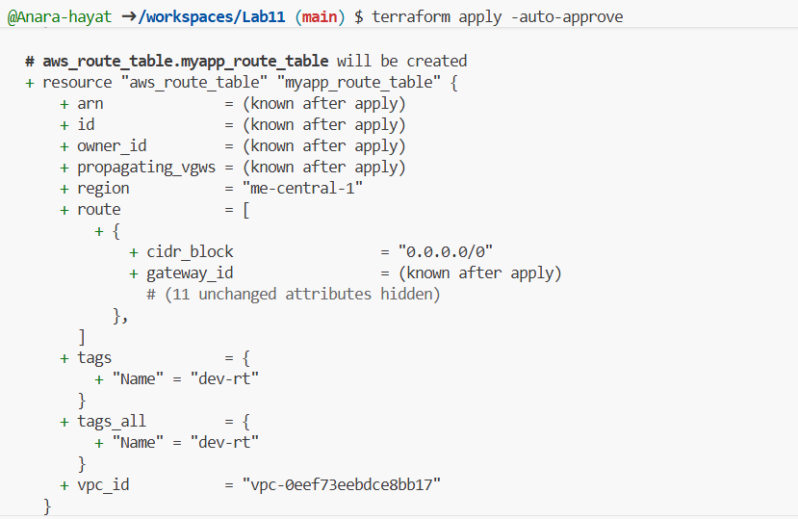
- Associate the Route Table with the Subnet Add the association resource to main.tf:
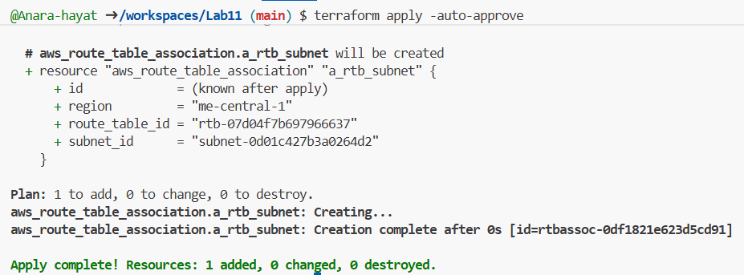
- Switch to default route table (use VPC default route table) Now remove (or comment out) the custom route table and association resources from main.tf:
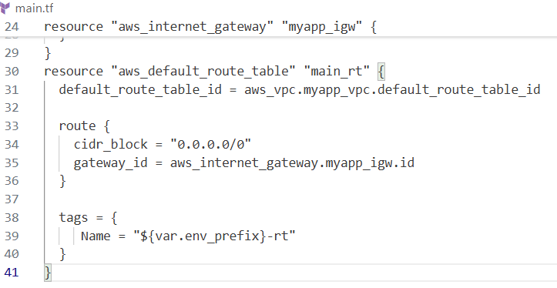
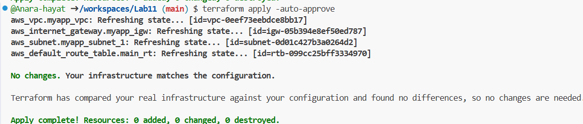
Task 9 — Security Group, Key Pair, EC2 Instance, user_data & nginx
This task walks you through creating a security group, creating an EC2 key pair, launching an EC2 instance, verifying SSH access, and installing nginx via user_data (inline and from a script). Perform all commands from your Codespace shell.
- Add variables to main.tf Add these variables to your main.tf:
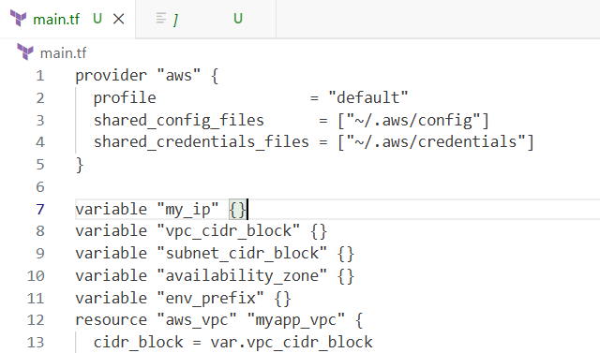
- Get your public IP and set terraform.tfvars From the Codespace shell:
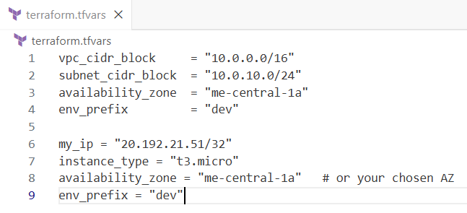
- Create the Security Group (main.tf) Add this resource to main.tf:
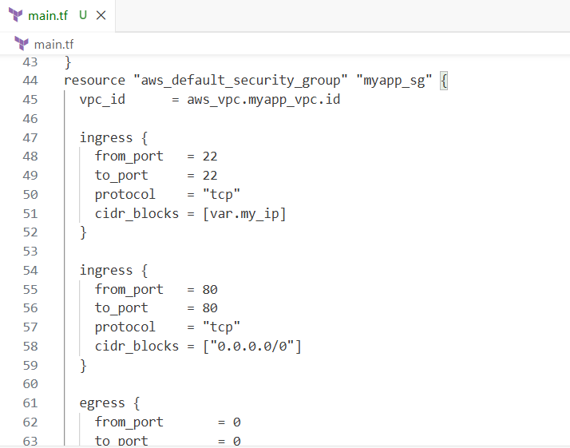
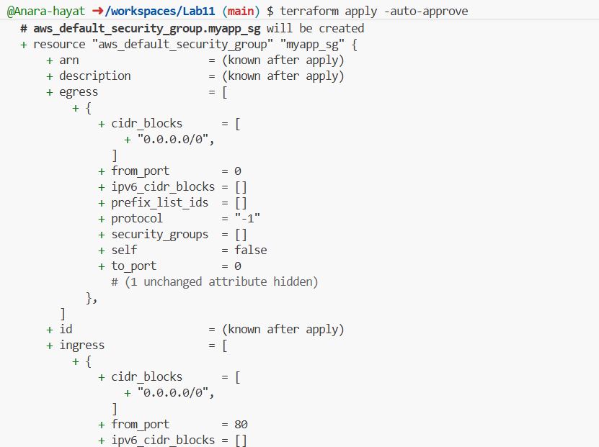
- Create an AWS key pair and save locally. Create a key pair and store the private key in your Codespace. Do NOT commit the .pem file.
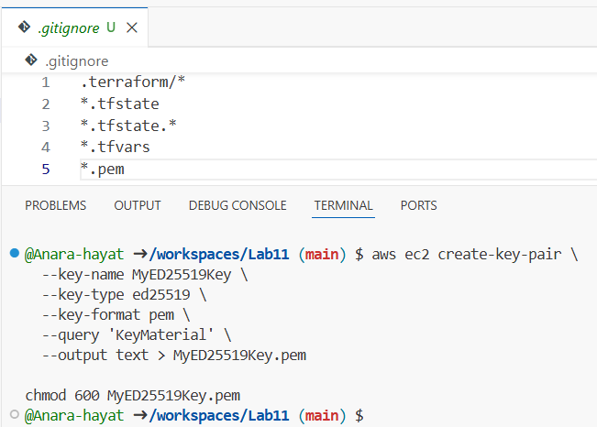
- Add EC2 instance resource (initial) Add the instance resource to main.tf (initially using the created key name):
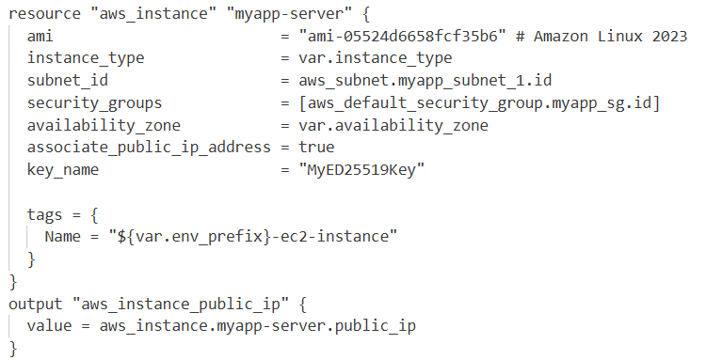
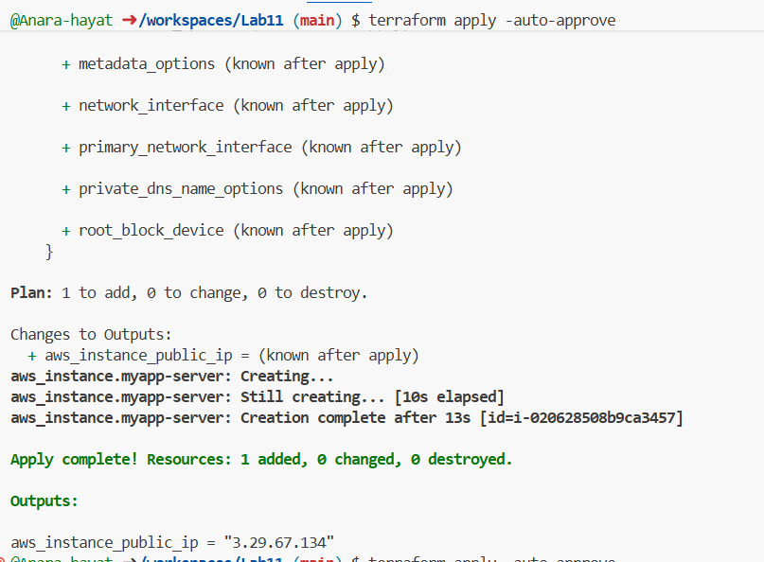
- SSH into the instance (using MyED25519Key) From the Codespace:
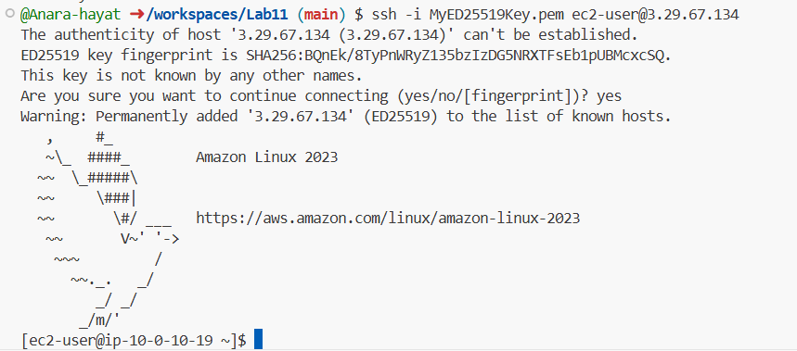
- Generate a local SSH keypair and register it in AWS via Terraform On your Codespace, generate an SSH key pair (accept defaults or specify path):
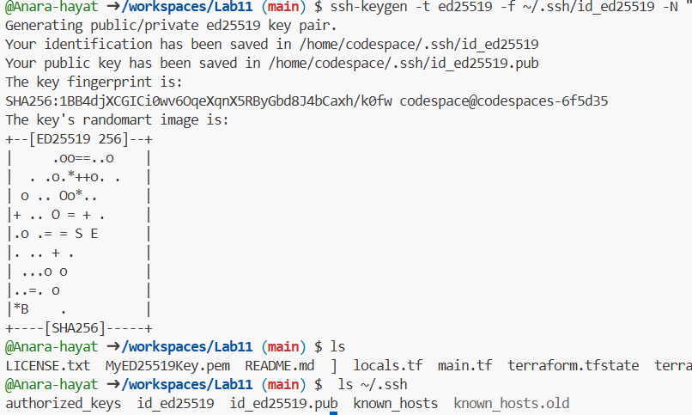
Add a Terraform resource in main.tf to register the public key:
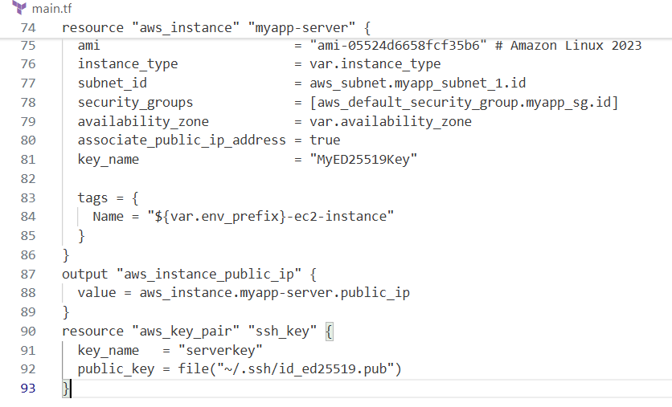
Update the EC2 resource to use the Terraform-managed key:
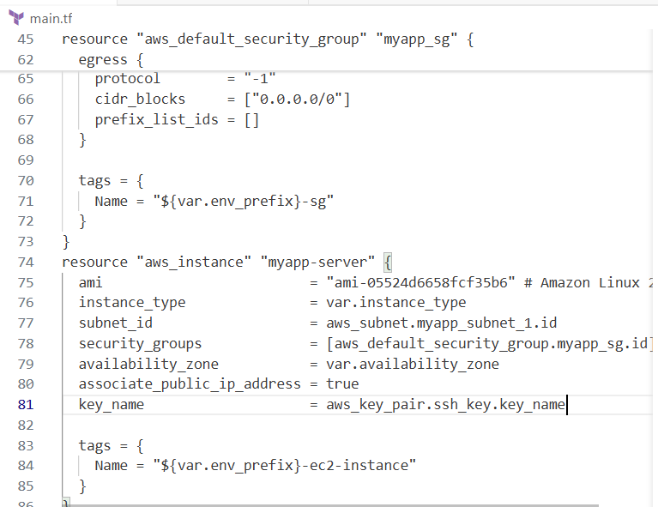
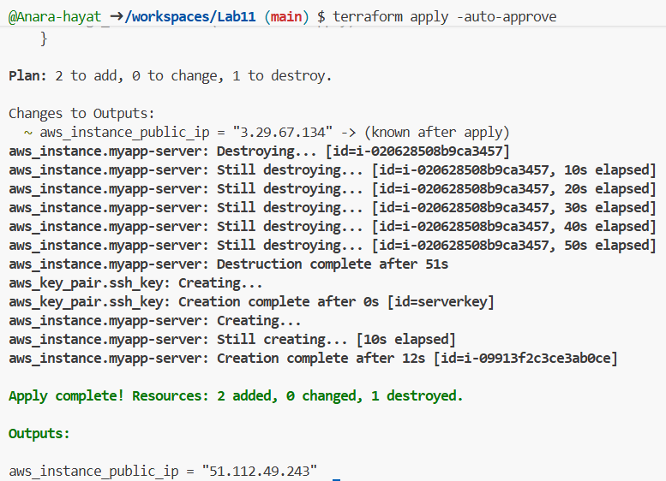
- SSH using the newly registered key Now SSH with your generated private key (the default ssh client will pick up ~/.ssh/id_ed25519):
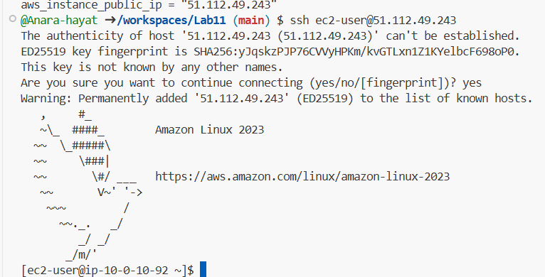
- Install nginx via inline user_data Modify the aws_instance resource to include inline user_data:
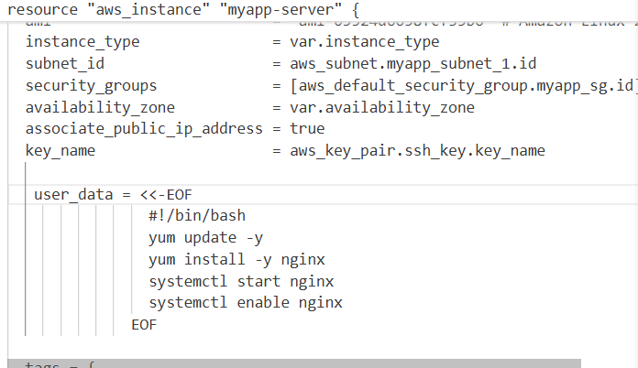
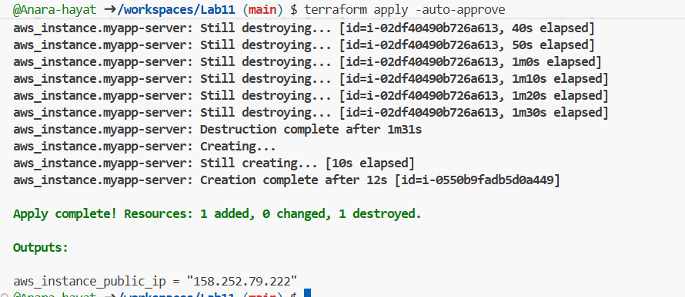
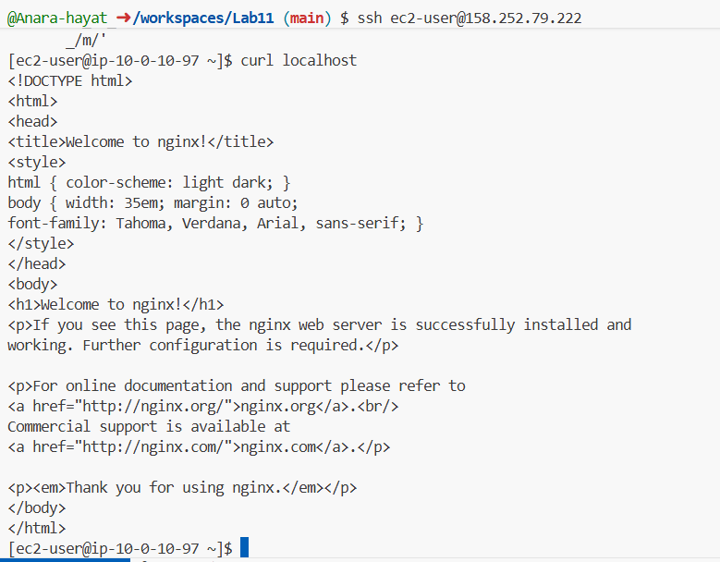
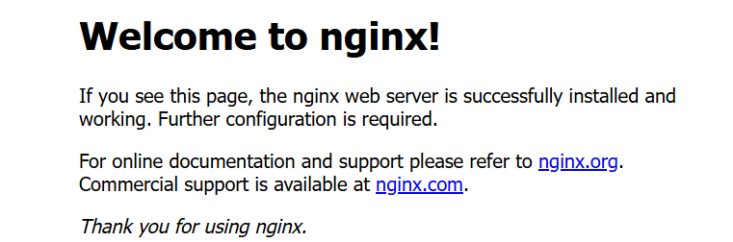
- Use an external script for user_data Create a script file in the Codespace:
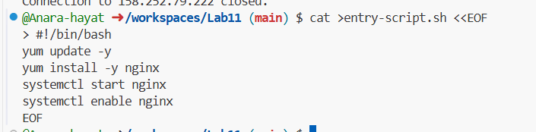
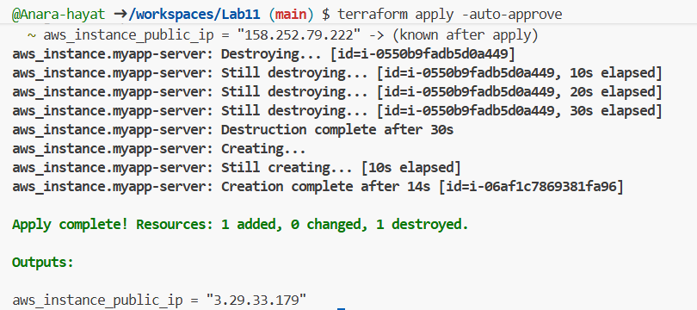
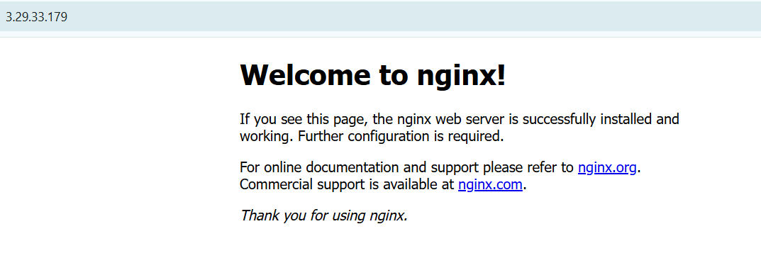
Cleanup
- Destroy all resources:
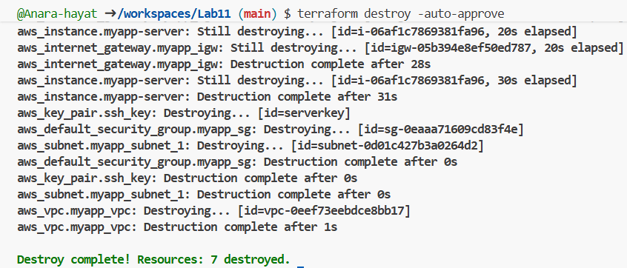
- Verify state files:
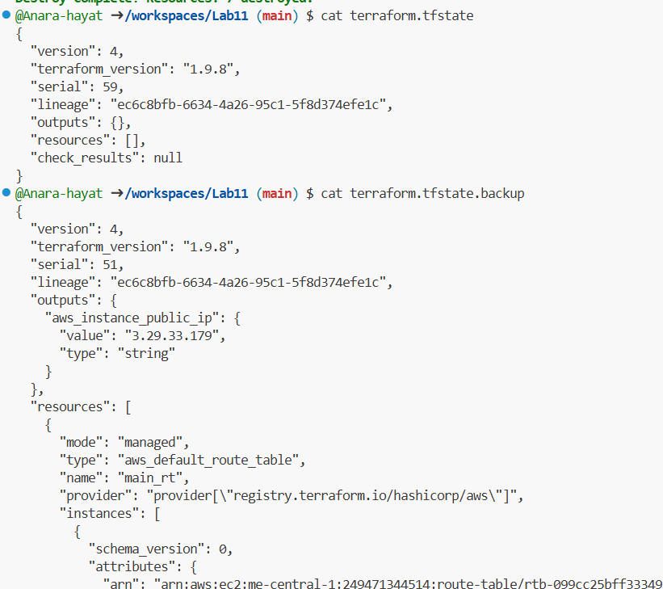
- Ensure no sensitive files are committed. If any private keys or credentials were accidentally committed — rotate them immediately.
