Manaloto, Kent Ian P.  
2 – ECE – A

PROBLEM 1:

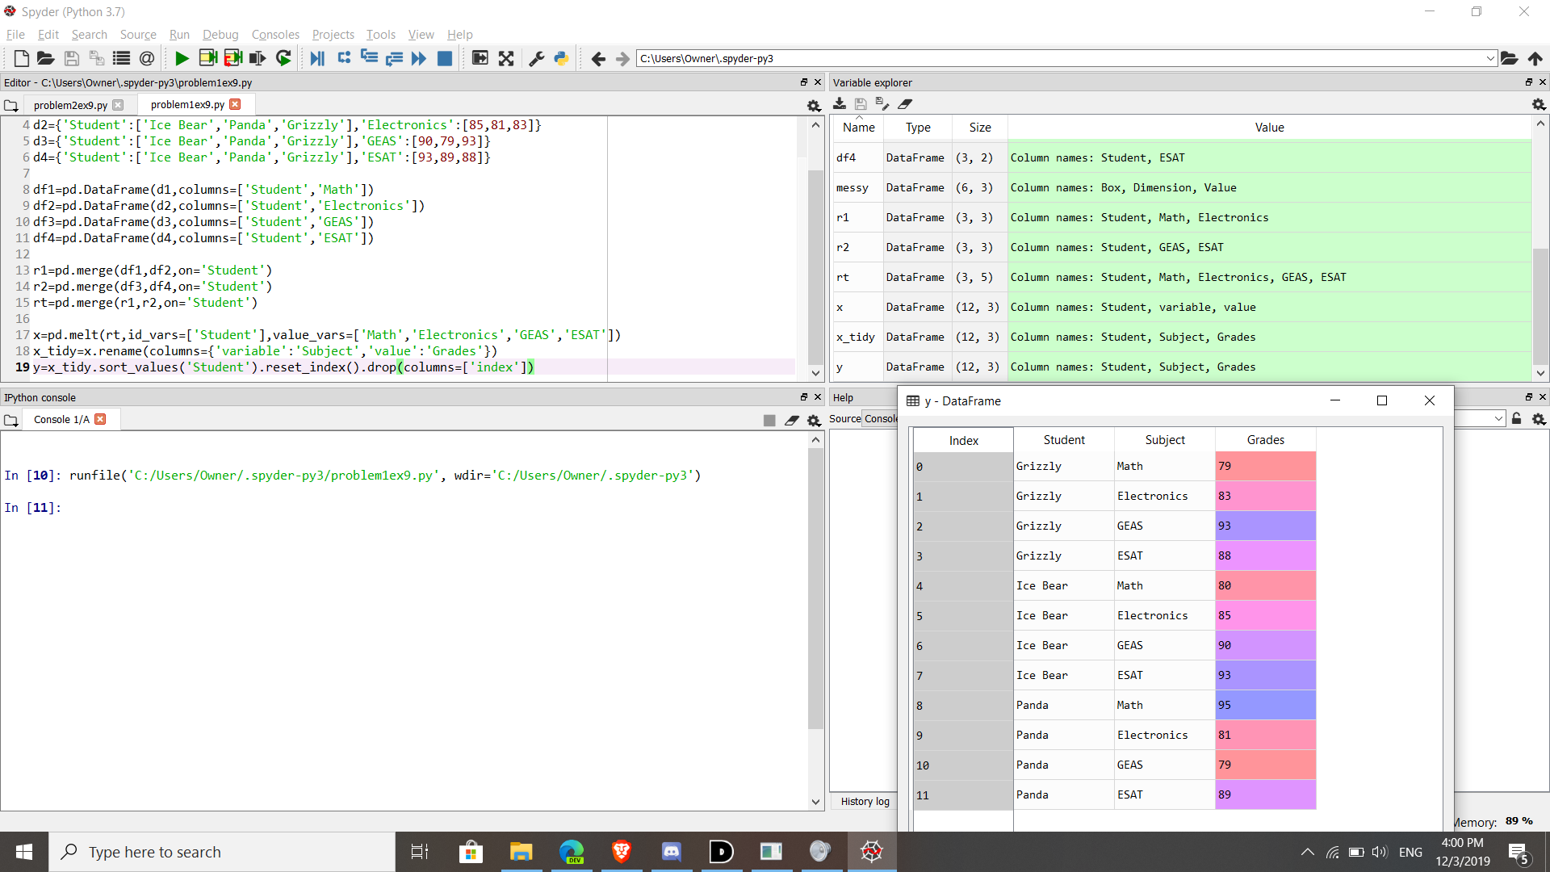

PROBLEM 2:

