**PROOF OF TESTING**

**MATLAB Problem 1**

Attempt 1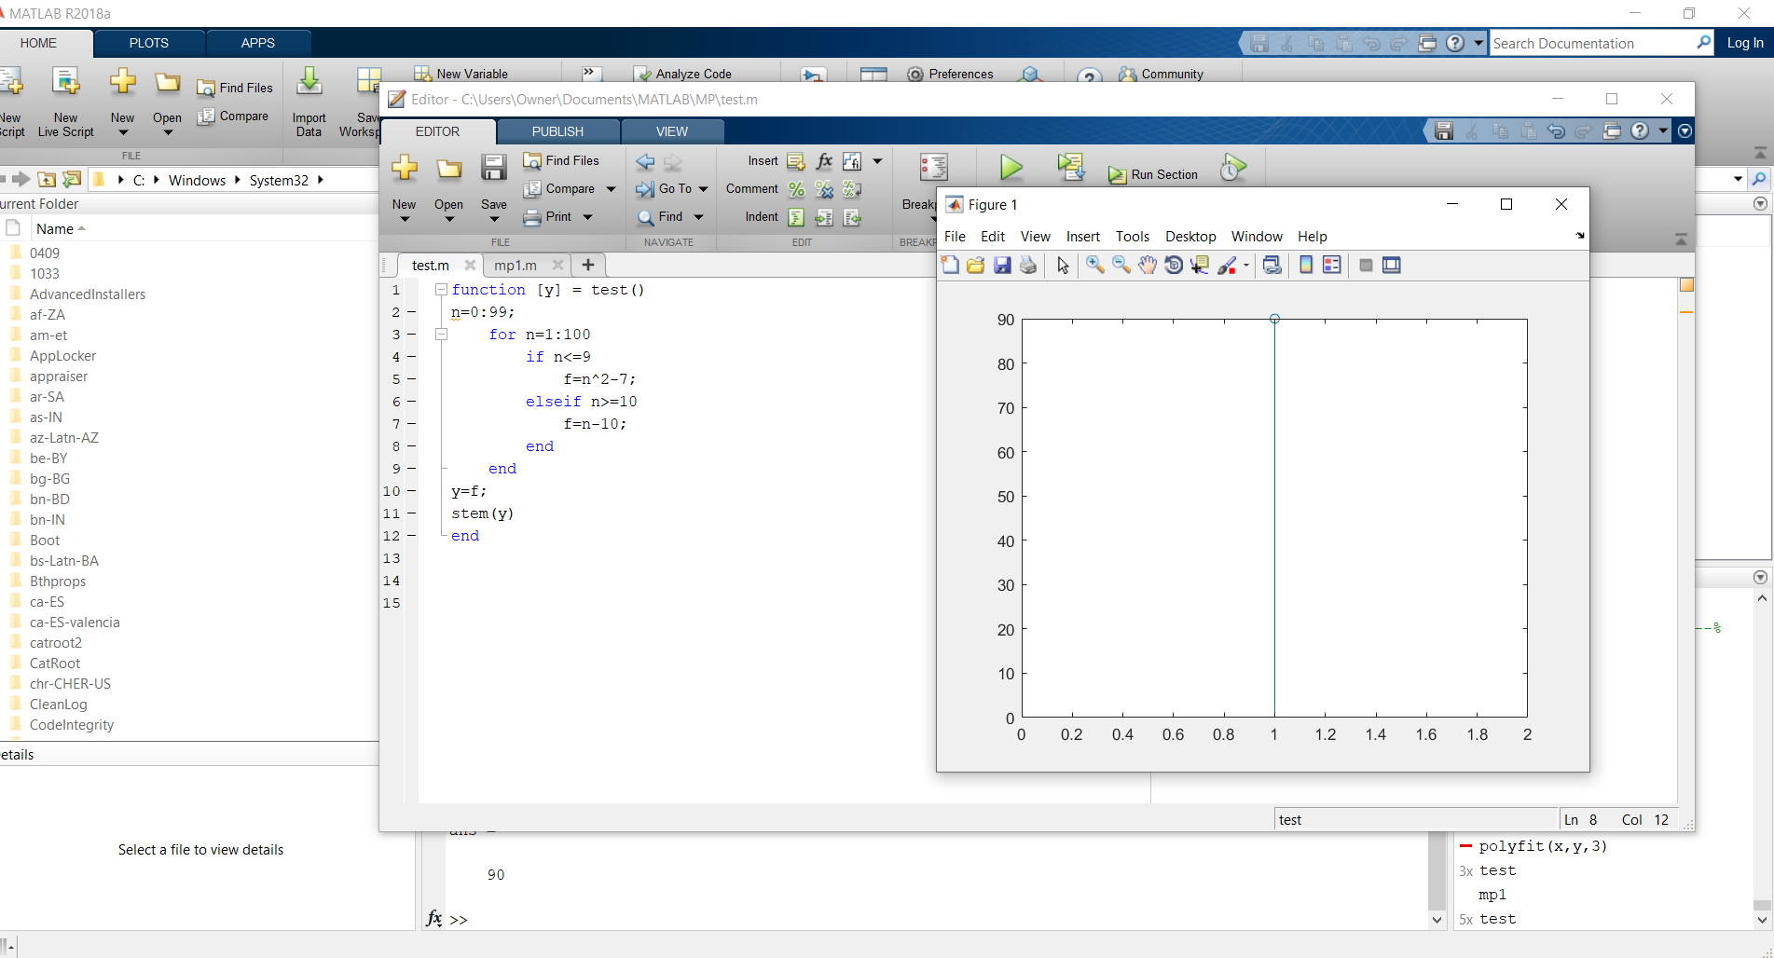

Attempt 2: Try to use another way

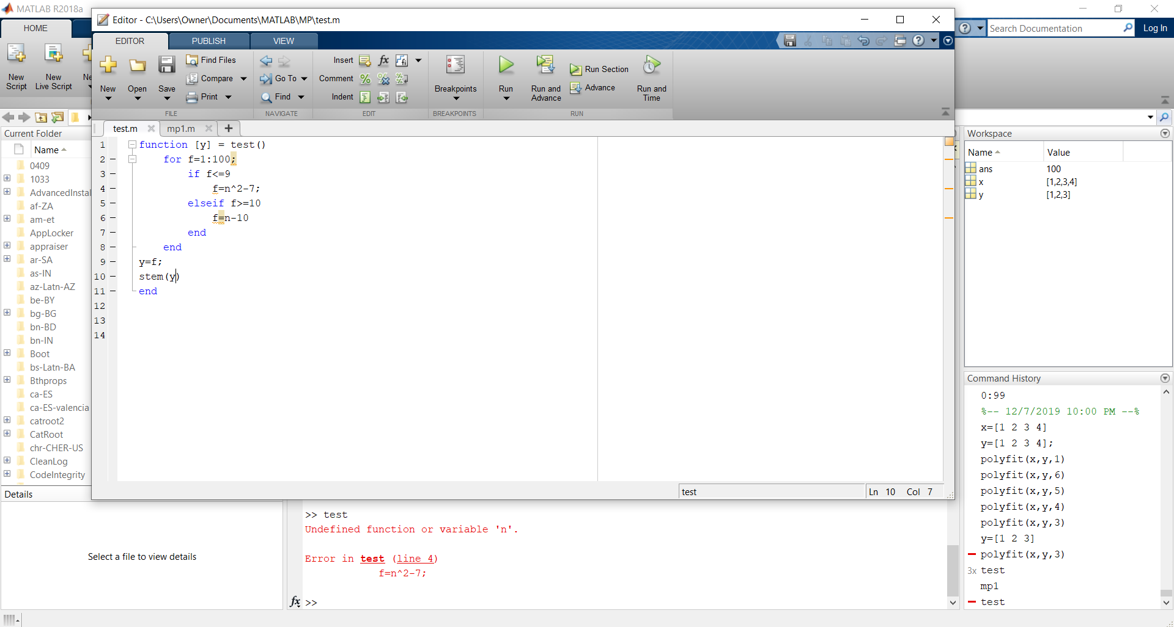

Attempt 3: Try to use f(n) instead

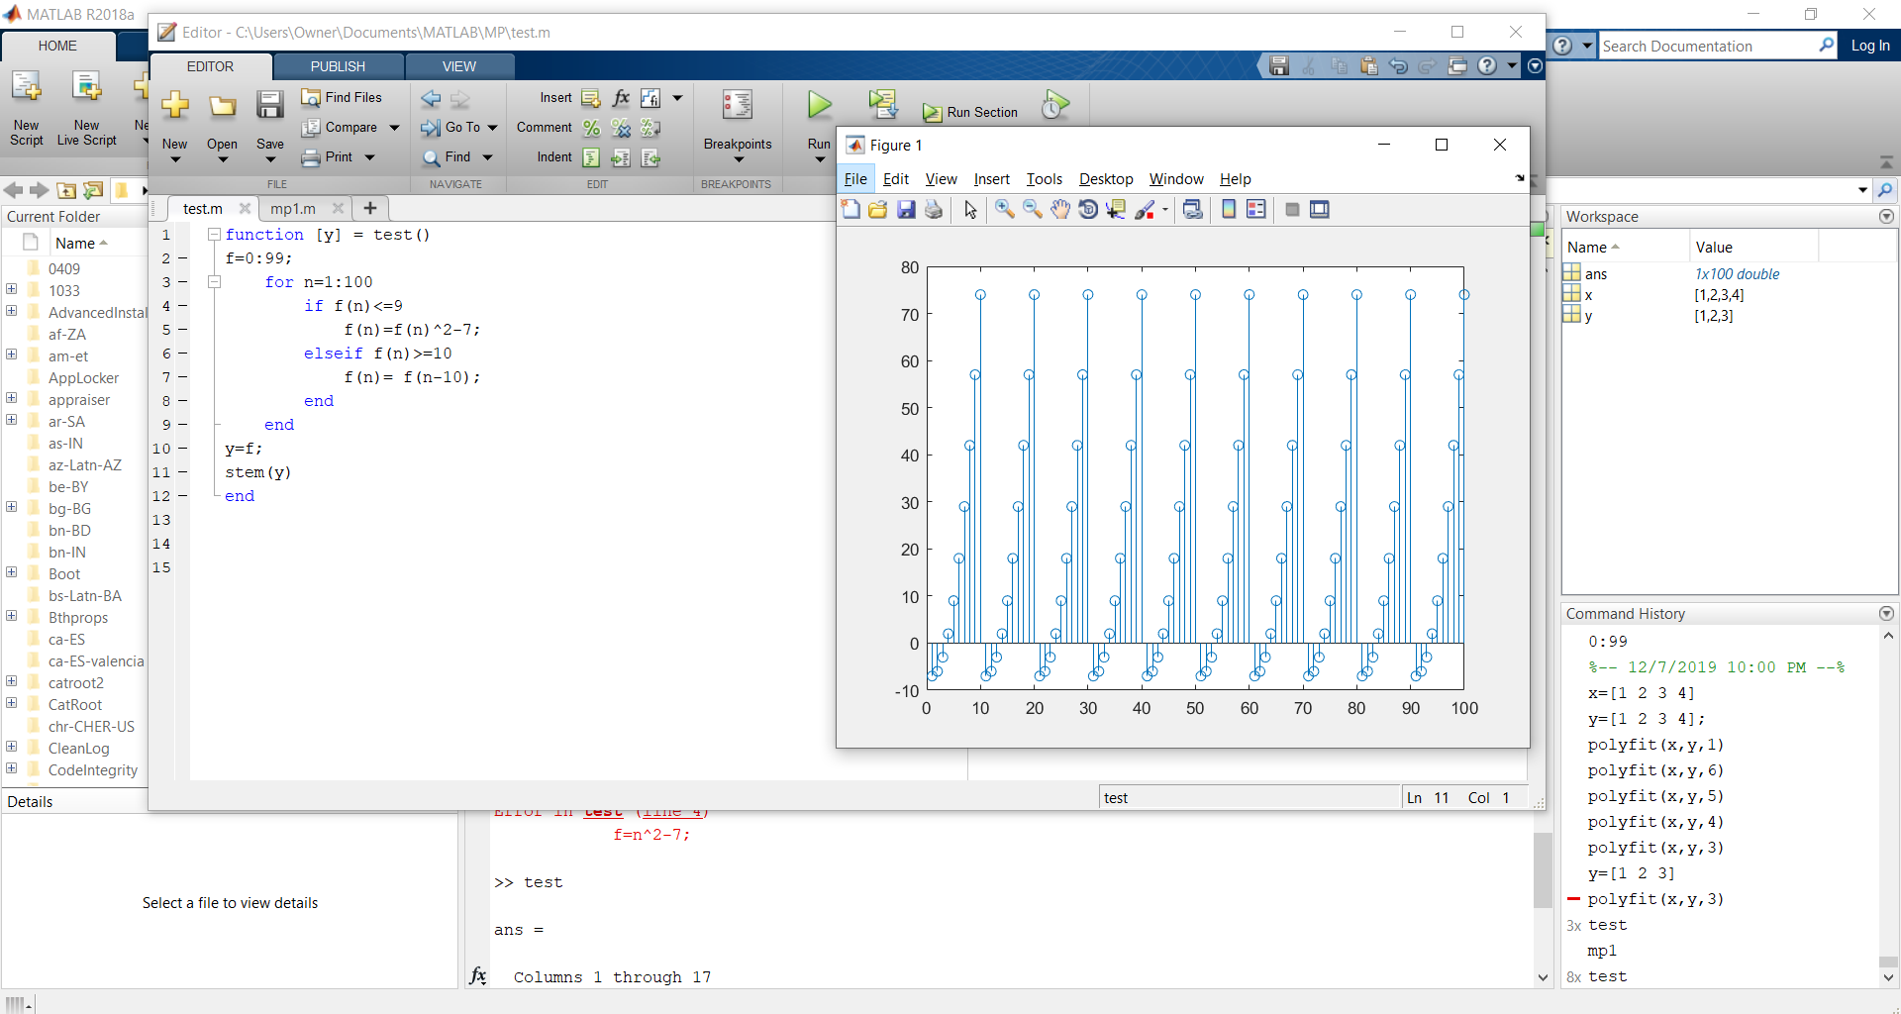



The graph has a repeating pattern. From n=0, the graph rises until it reaches n=9. Afterwards, when n=10, 10 is subtracted from n which makes n=0 again and return to n2 – 7. The graph then follows the same pattern as the first 10 iterations. This continues until the graph reaches the 100th iteration. The function f(n) represents the value of the function at n. When n>=10, then f(n)=f(n-10). This means that when f is at an iteration where n>=10, the function resets the value of n to 0 by subtracting 10 from n and returns to evaluate n2-7 which is the reason why the graph has a repeating pattern.