**PROOF OF TESTING**

**MATLAB Problem 1**

Attempt 1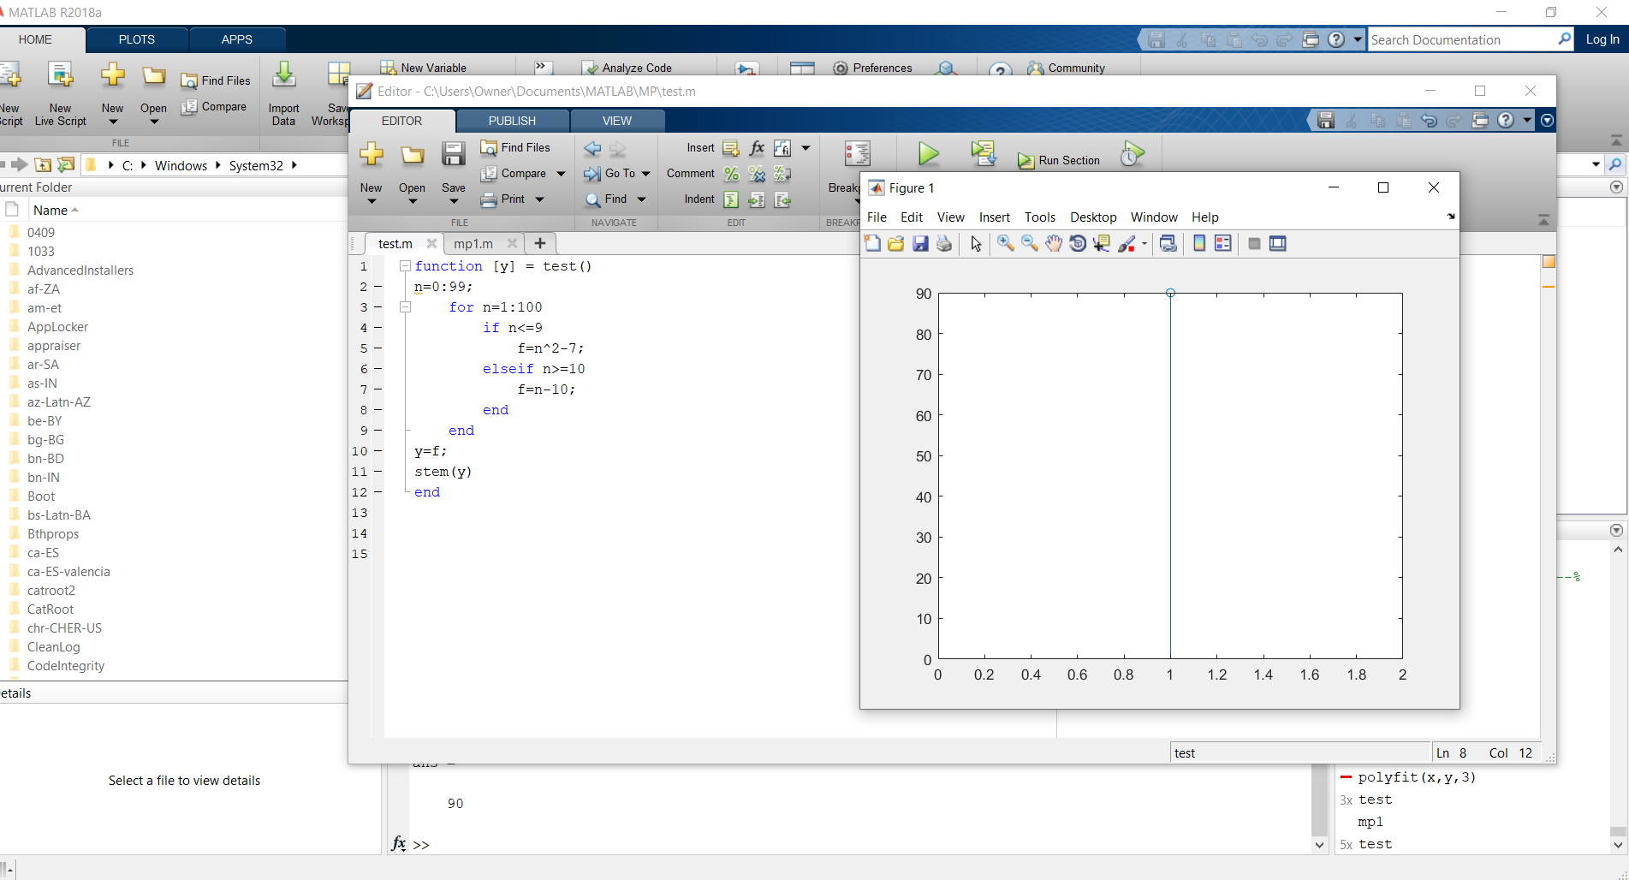

Attempt 2: Try to use another way

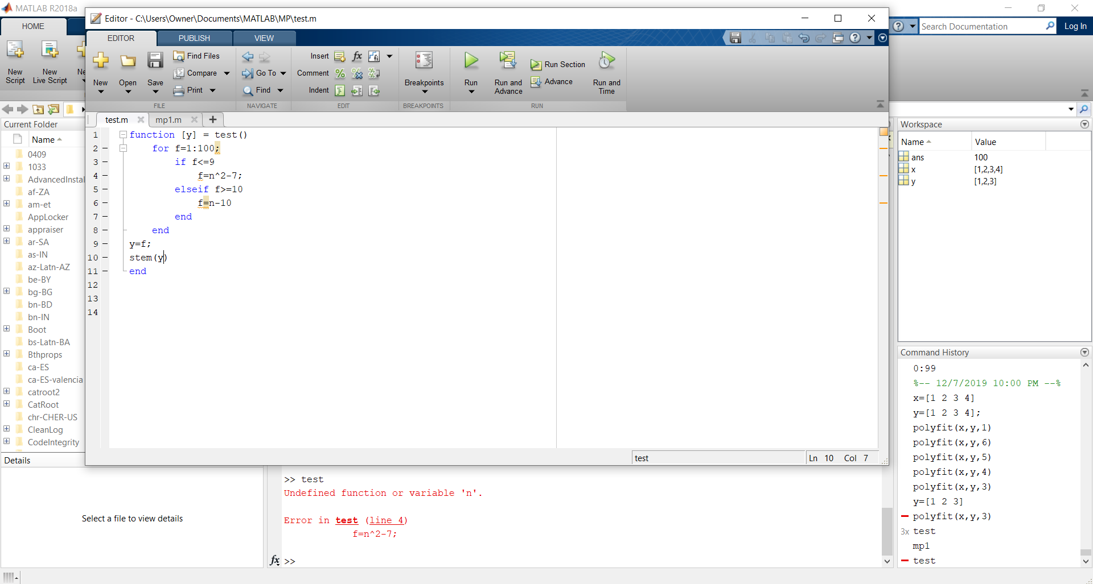

Attempt 3: Try to use f(n) instead

