Another Merco's syndrom near Maison blanche ?

Cars driving on Ancien moulin (make wheels rotate, add a TV van ?)

Draw : multiple houses
Put some cars parked near Nolok Experience Center
Make resident's cars klaxon on approach

Chemin aux boeufs entrance : put some movable barriers to hide the shortcut
“Village“ after Chemin aux boeufs/Bugatti raccord

Add tools in pits

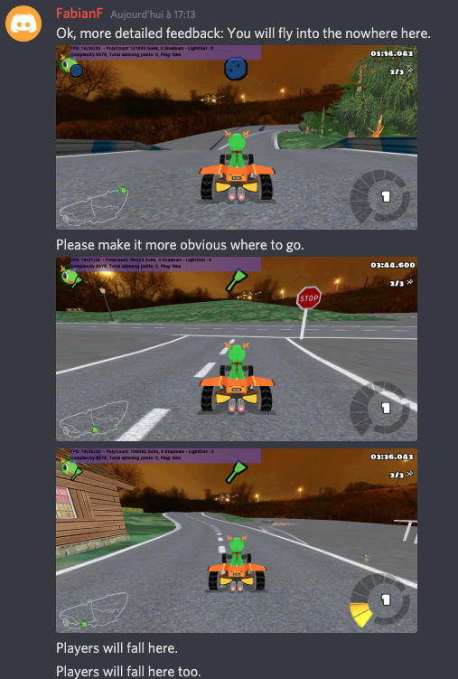
Set mobile end cameras
Add adherence on track to avoid impossible to reach bridge if stopped before

Making tracks :
https://www.youtube.com/watch?v=1VtUDBvL4vQ&start=13s
