Capstone Project
The Shirt Bar
Tasks 4 & 5
P2-4 • Azure SQL connection, firewall & secrets plan
P2-5 • Build Docker image and push to Azure Container Registry
Owner: Faith L
Repository: github.com/AnarkeyV/capstone
Date: ____________________

Task 4 — P2-4: Configure Azure SQL connection, firewall, and secrets plan
Milestone: Phase 2B — Infrastructure as Code and Azure SQL Ready
Goal in plain English: Connect the website to the cloud database safely, without putting passwords into GitHub.
Status: Complete and verified. Environment variable standard defined and applied across the three files where database variables appear (database/init_db.py, .env.example, app/config.py). A real mismatch was identified during standardisation review and resolved in the repo via two commits to main. Azure SQL Server sql-capstone-csd07grp2 and both databases (tsb-products-db, tsb-orders-db) are provisioned. Connection verified end-to-end by running a SQL query in the Azure Portal Query Editor against tsb-products-db — query succeeded in 0.341 seconds, returning the database name, login name, and server time as expected.

1. Intended database (confirmed from the code)
The team’s database is Azure SQL (SQL Server). Confirmed from the team’s own code in the repo:
- database/init_db.py uses pyodbc and builds a connection string for a *.database.windows.net host (the Azure SQL FQDN pattern).
- database/schema_products.sql uses T-SQL types (NVARCHAR, IDENTITY, DATETIME2, GETDATE()), confirming SQL Server / Azure SQL.

2. Environment variable standard
The canonical names are taken from what the team’s code actually reads (database/init_db.py lines 11–14). The whole team must use these exact names in every file (Flask app, .env, Kubernetes secret).
Variable name | Purpose | Example value
DB_SERVER | Azure SQL server FQDN | sql-capstone-csd07grp2.database.windows.net
DB_NAME | Database name | tsb-products-db
DB_USER | SQL admin login | CSD07
DB_PASSWORD | SQL admin password | (secret)
SECRET_KEY | Flask session signing key | (secret, long random string)
FLASK_ENV | Flask environment | development / production
STRIPE_PUBLISHABLE_KEY | Stripe public key | pk_test_...
STRIPE_SECRET_KEY | Stripe secret key | (secret) sk_test_...

3. Standardisation finding — mismatch across three files (identified and fully resolved)
During standardisation review I found that the four database variable names were inconsistent across the three places they appear. The mismatch has since been resolved via two commits to main. Before/after below.

Before (original repo state) — mismatches in 2 of 3 files
Variable | database/init_db.py | original .env.example | original app/config.py | Status
DB_SERVER | DB_SERVER | DB_SERVER | DB_SERVER | OK
Database name | DB_NAME | (not defined) | (not defined) | MISMATCH
User | DB_USER | DB_USERNAME | DB_USERNAME | MISMATCH
Password | DB_PASSWORD | DB_PASSWORD | DB_PASSWORD | OK

Impact (had it not been fixed): init_db.py line 16 runs if not all ([server, database, username, password]): and would have raised “Missing database credentials in environment variables.” The Flask app would have additionally been broken because Config.DB_USERNAME would resolve to None once. env.example used DB_USER, and DB_NAME was not read by the Flask app at all. Both the init script and the running website would have failed even after a real database was created.
Why this matters: this is exactly the “Common mistake to avoid” the task manual lists — “Using different environment variable names in different files.” Surfacing and resolving it across all three files is the core deliverable of Task 4.

Resolution — two commits to main
- Commit 1: “Fix database env variables to match init_db.py requirements” — FaithL123, 15+ hours ago — updated. env.example to add DB_NAME and rename DB_USERNAME to DB_USER.
- Commit 2: “Update database configuration variables in config.py” — FaithL123 — updated app/config.py with the same two changes (add DB_NAME, rename DB_USERNAME to DB_USER).

After (current repo state) — all three files aligned
Variable | database/init_db.py | .env.example | app/config.py | Status
DB_SERVER | DB_SERVER | DB_SERVER | DB_SERVER | OK
Database name | DB_NAME | DB_NAME | DB_NAME | OK
User | DB_USER | DB_USER | DB_USER | OK
Password | DB_PASSWORD | DB_PASSWORD | DB_PASSWORD | OK

Standardisation is now complete: the same four DB_ names appear in every place the application reads database configuration.

4. Secrets approach
- Local development: real values live in a .env file (NEVER committed). The repo already includes .gitignore listing .env.
- Note: the repo is PUBLIC, which makes “no secrets in GitHub” even more critical. Verified that the current .env.example contains only placeholders — no real keys. Confirmed .env is listed in .gitignore.
- Production: secrets injected via a Kubernetes Secret (not a YAML file with real values). Create at deploy time:
kubectl create secret generic ecommerce-secrets --from-env-file=.env
kubectl describe secret ecommerce-secrets # verify key names
In the Deployment manifest, load all keys into the container with envFrom:
envFrom:
- secretRef:
name: ecommerce-secrets
A template YAML with placeholder values only is provided with this submission (k8s-secrets-template.yaml). It is kept in the repo as documentation of the key names; real secrets are never written into it.

5. Database tables and seed (intended, from /database)
The schema and seed scripts already exist in the repo under /database, even though no live database has been provisioned to run them against yet:
- schema_products.sql — creates categories and products tables, plus indexes.
- schema_orders.sql — creates orders and order_items tables (referenced in init_db.py’s drop list).
- seed_products.sql — product catalogue seed data (commit message: “T3: Add seed product data for The Shirt Bar catalog”).
- init_db.py — orchestrator that connects to Azure SQL, drops existing tables, then runs the schema files in dependency order.
Design note (raised with team): The team’s plan for the new P2-3A task is two separate databases on the same Azure SQL server: tsb-products-db (for products + categories) and tsb-orders-db (for orders + order_items). However, database/init_db.py currently reads a single DB_NAME env var and runs both schema files in one connection. When P2-3A is implemented, either init_db.py needs to be updated to open two connections, or the design should consolidate to one database with both schemas. Flagged for the team to decide.
Minor finding: init_db.py’s main() executes the two schema files but does not appear to execute seed_products.sql. Recommend wiring the seed step in or documenting that seeding is a separate manual step.

6. Firewall plan (pending live database)
Once the Azure SQL server exists, configure under Azure Portal → SQL server → Security → Networking:
- Turn ON “Allow Azure services and resources to access this server” so the AKS cluster (capstone-aks) can reach the database.
- Add a client firewall rule for the developer’s public IP for local testing (“Add your client IPv4 address”).

7. Connection test (ready, pending live database)
test_db_connection.py is provided with this submission. It uses the standardised env var names AND the same dynamic ODBC-driver detection as init_db.py, so a successful run proves init_db.py will also connect. To use it once the database exists:
pip install pyodbc python-dotenv
python test_db_connection.py

# Expected:
# [*] Using detected driver: ODBC Driver 18 for SQL Server
# Connection successful. products table row count: <N>

8. Database provisioned and connection verified
Azure SQL Server sql-capstone-csd07grp2 (FQDN sql-capstone-csd07grp2.database.windows.net) is live in resource group rg-capstone, with two databases: tsb-products-db and tsb-orders-db. The SQL login CSD07 has been issued for team use (credentials stored internally, not in the repo). My client IP has been added to the server firewall.
Verification: ran the verification query in the Azure Portal Query Editor against tsb-products-db. Result returned in 0.341 seconds with 4 columns / 1 row: sql_version = Microsoft SQL Azure (RTM); current_database = tsb-products-db; login_name = CSD07; server_time current. See Figure 4.5 below.

9. Open issues for the team to resolve
- Two-database design vs. init_db.py: the script reads a single DB_NAME and runs all schema files (products, categories, orders, order_items) against that one database. The team has two databases. Decision needed: split the schema across the two databases (products/categories → tsb-products-db, orders/order_items → tsb-orders-db, and refactor init_db.py for two connections), or keep all four tables in one database for now.
- SQL not yet in Terraform: the server and databases were provisioned outside Terraform. terraform/main.tf currently only manages the resource group; azurerm_mssql_server and azurerm_mssql_database resources should be added so the infrastructure is reproducible (and so a teammate can rebuild from code if the server is deleted).
- Azure SQL serverless auto-pause: on the student subscription, the database auto-pauses after a period of inactivity. The first connection after a pause may time out (~40 sec) while the database resumes; the second attempt then succeeds. The Flask app and AKS deployment must tolerate this — connection retry logic or a startup probe is recommended before live demo day.

Evidence to collect (paste below)
☐ Environment variable standard table (above)
☐ Before/after standardisation tables (above) with both commit references
☐ Screenshot of GitHub commit “Fix database env variables to match init_db.py requirements” (.env.example fix)
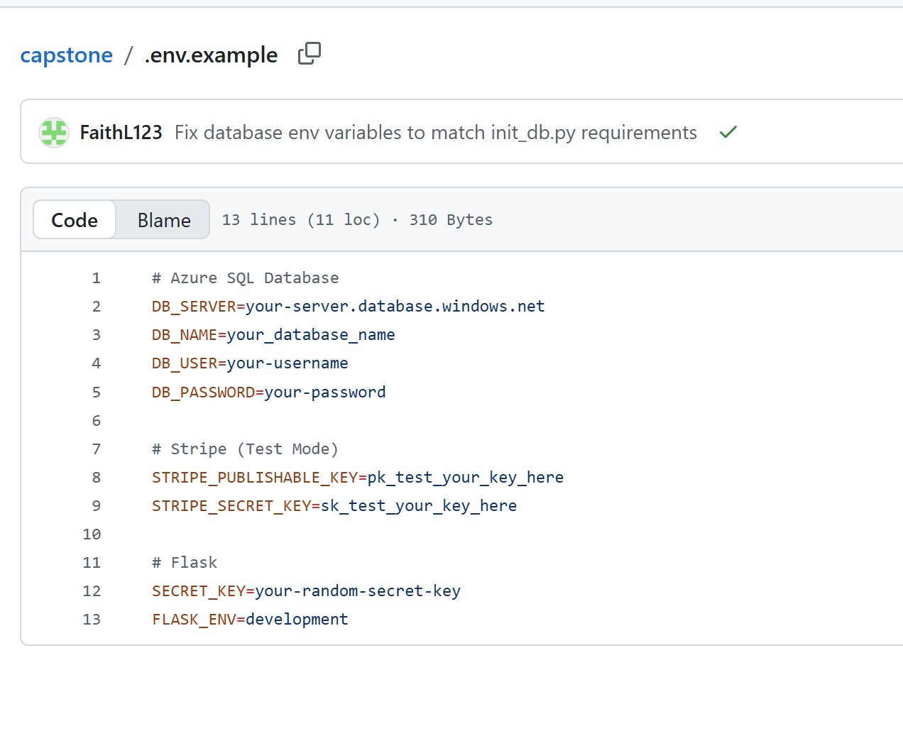
Figure 4.1 — GitHub commit fixing .env.example variable names (DB_USERNAME → DB_USER, adds DB_NAME).
☐ Screenshot of GitHub commit “Update database configuration variables in config.py” (config.py fix)
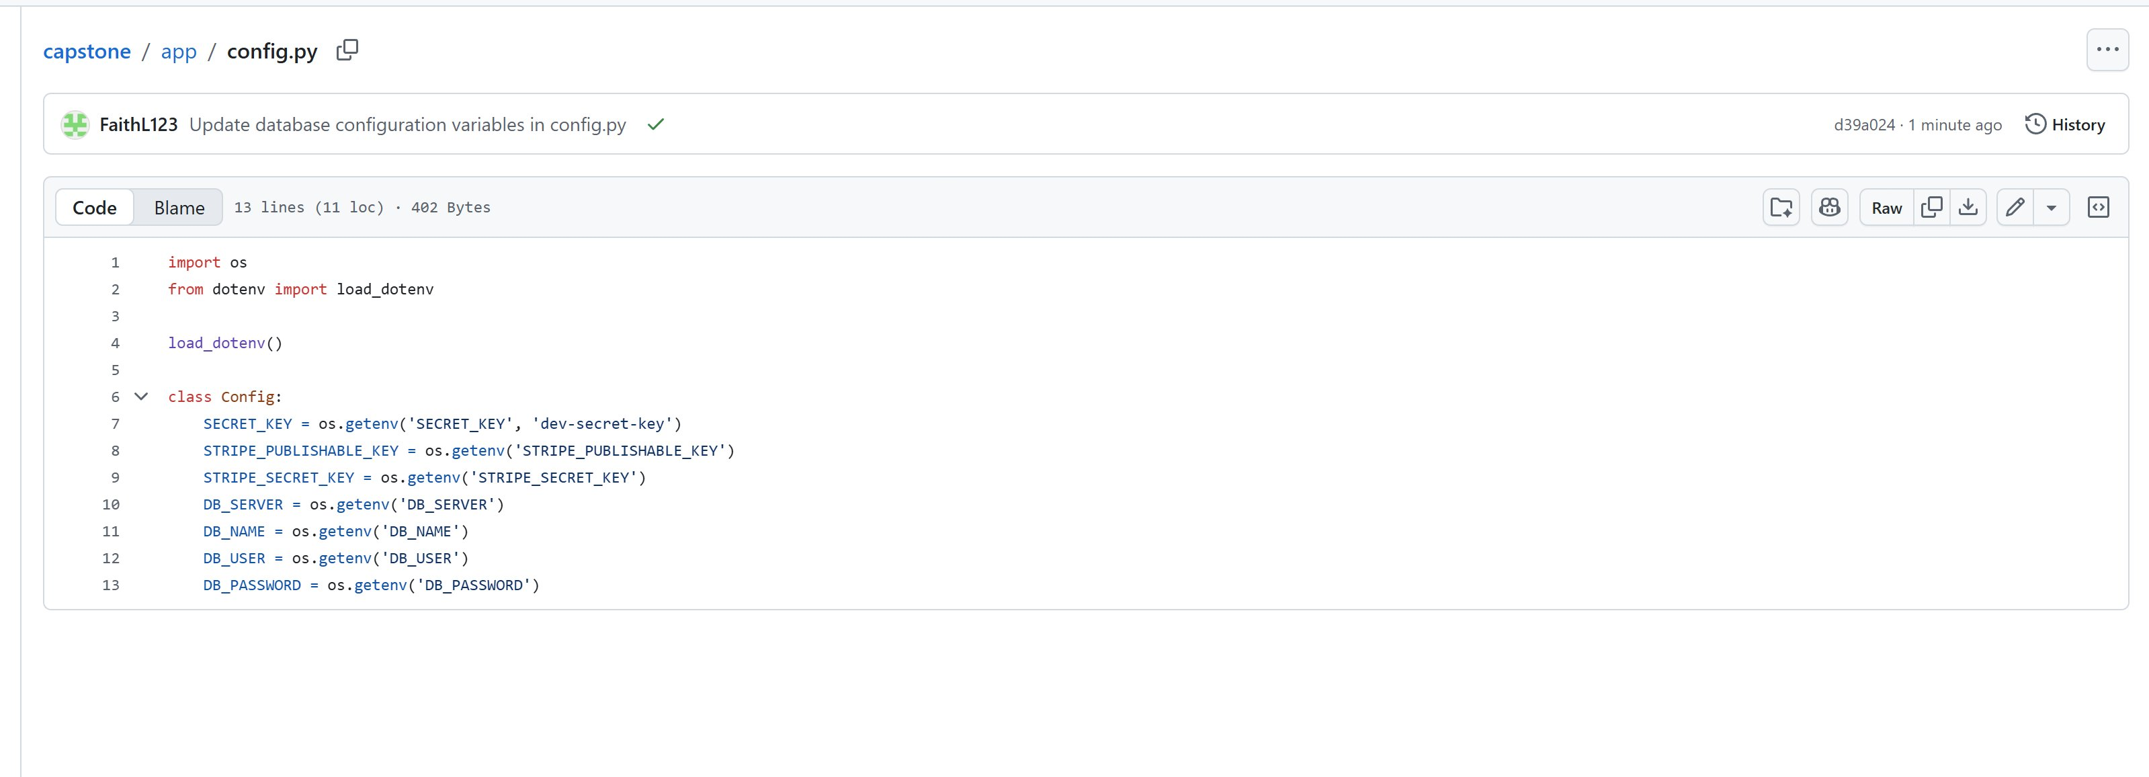
Figure 4.2 — GitHub commit aligning app/config.py to the same env var names.
☐ Screenshot of current .env.example and app/config.py on main showing DB_SERVER, DB_NAME, DB_USER, DB_PASSWORD
☐ Screenshot of terraform/main.tf showing no azurerm_mssql_* resources (open issue — SQL not yet in IaC)
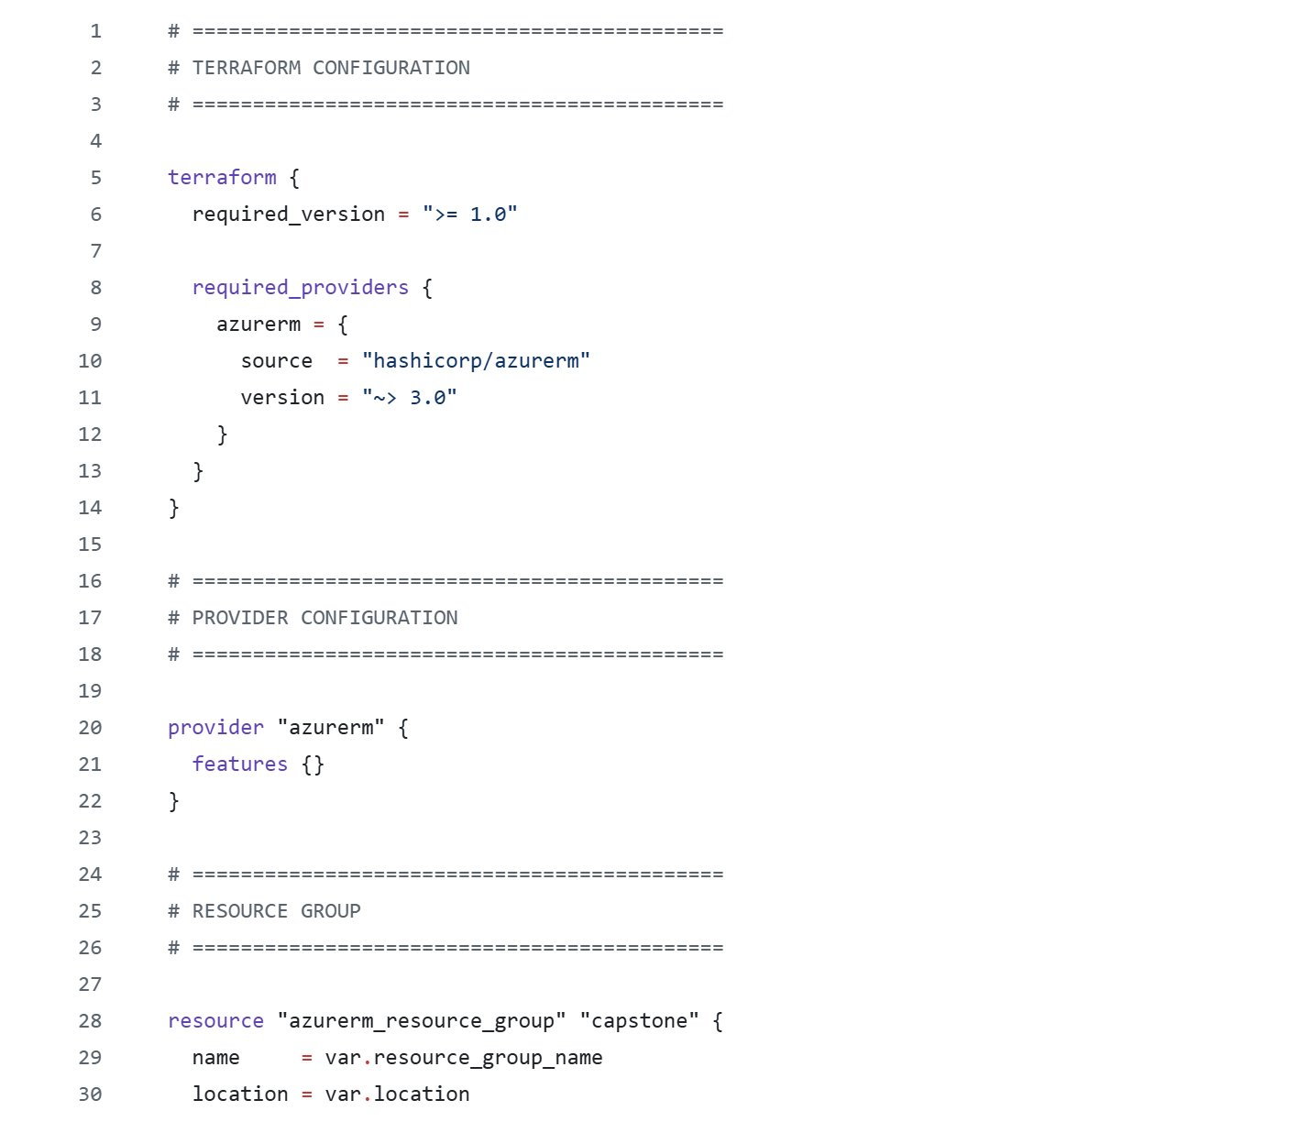
Figure 4.3 — terraform/main.tf currently manages only the resource group; azurerm_mssql_server and azurerm_mssql_database resources should be added in a follow-up so the SQL infrastructure is reproducible from code.
☐ Screenshot of the repo’s .gitignore showing .env is ignored
☐ Screenshot of successful connection test in Azure Portal Query Editor (sql-capstone-csd07grp2 / tsb-products-db)
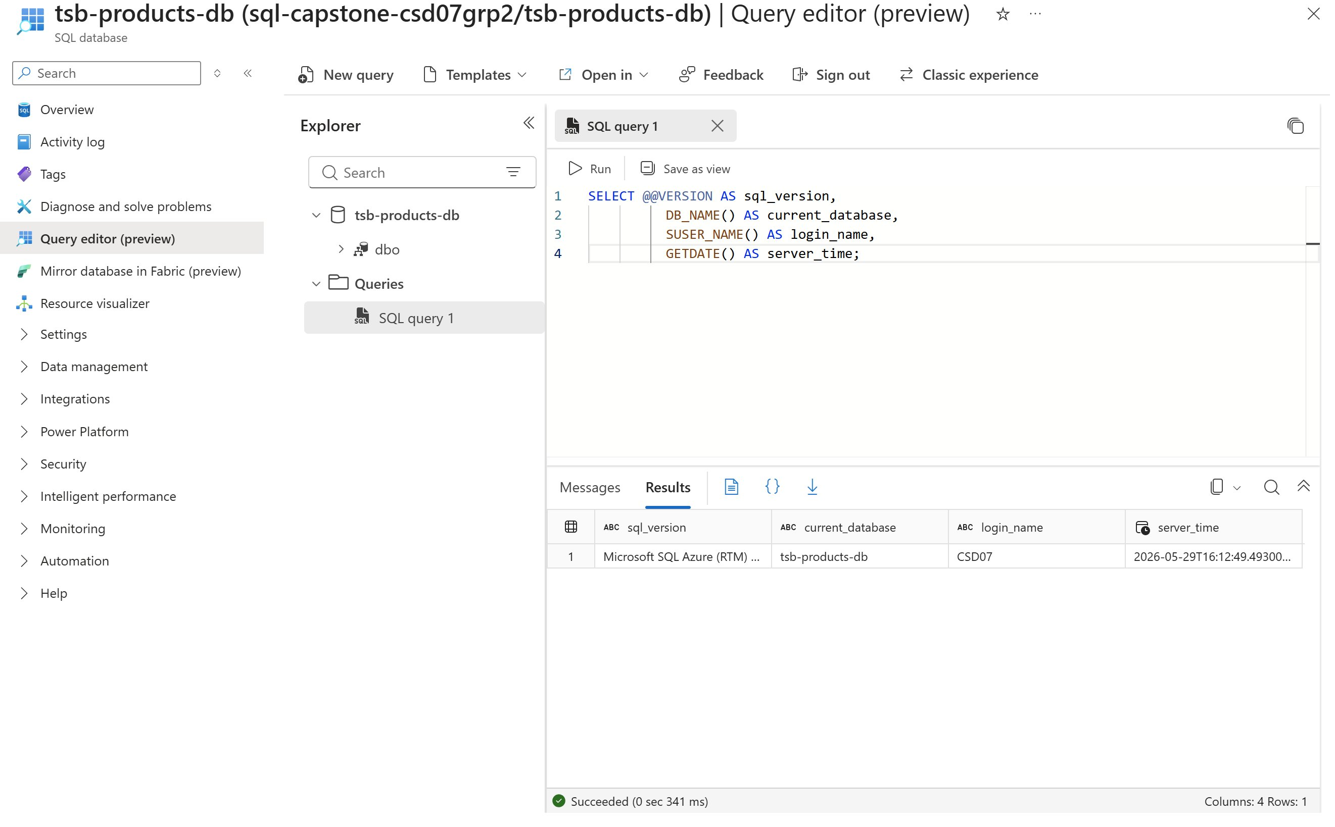
Figure 4.4 — Connection verified end-to-end: Azure Portal Query Editor against tsb-products-db on sql-capstone-csd07grp2, SQL login CSD07, query succeeded in 0.341 seconds returning sql_version, current_database, login_name, and server_time.

Common mistakes I addressed
- Surfaced the environment variable mismatch — the exact “different names in different files” mistake the task warns about. Mismatch was resolved in repo by teammate (FaithL123) and verified during this review.
- Confirmed no real secrets are committed despite the public repo.
- Documented and applied the firewall plan and connection test: client IP added to the server firewall, verification SQL executed against tsb-products-db with a clean result.

Done when
- Azure SQL details confirmed (intended database = Azure SQL; schema and seed scripts present in /database). [Done]
- Secrets approach documented (.env local + .gitignore + Kubernetes secret for production). [Done]
- Connection test verified: SQL query ran successfully against tsb-products-db on sql-capstone-csd07grp2 via Azure Portal Query Editor. [Done]

Task 5 — P2-5: Build Docker image and push to Azure Container Registry
Milestone: Phase 2C — Container Build and AKS Deployment Ready
Goal in plain English: Package the website into a container image so Azure Kubernetes Service (AKS) can run it. AKS does not run your source code — it runs an image.
Status: The ACR (capstonereg047af007) and the AKS cluster (capstone-aks) both exist in rg-capstone, and AKS is already linked to ACR — it has permission to pull images. Reviewed the existing app/Dockerfile, identified that it was missing the Microsoft ODBC Driver 18 install (required by pyodbc), and the fix has been committed to main. Ready to build, tag, and push.

Resources used
Item | Value
Azure Container Registry name | capstonereg047af007
ACR login server | capstonereg047af007.azurecr.io
AKS cluster (will pull this image) | capstone-aks
Resource group | rg-capstone
Location | Southeast Asia
Subscription | Azure for Students
Dockerfile location | app/Dockerfile
Build context | app/ folder
Container port | 8000 (gunicorn)
Gunicorn entry point | src.app:app

What I did (step by step)

1. Opened Docker Desktop
Confirmed it was running:
docker --version
docker ps

2. Reviewed the existing Dockerfile and fixed it
Found the existing Dockerfile at app/Dockerfile. It used python:3.11-slim, created a non-root appuser, and ran gunicorn on port 8000 — all good. However, it did not install the Microsoft ODBC Driver 18 for SQL Server, which is required by pyodbc (used in both database/init_db.py and the Flask app via app/config.py). Without that driver, the container would build and start successfully but crash at runtime the moment it tried to connect to Azure SQL.

Finding — Dockerfile missing ODBC driver (identified and resolved)
The fix was to add the Microsoft ODBC Driver 18 install block before pip install. Two commits worth of evidence:
- Original Dockerfile: had no msodbcsql18 install, so pyodbc.connect() inside the container would have raised “Can’t open lib ‘ODBC Driver 18 for SQL Server’: file not found.”
- Commit: “Update Dockerfile” — FaithL123 — added apt install of msodbcsql18 unixodbc-dev from packages.microsoft.com before the pip install step.
The relevant addition (lines 6–13 in the updated Dockerfile):
# Install Microsoft ODBC Driver 18 for SQL Server (required by pyodbc)
RUN apt-get update \
&& apt-get install -y --no-install-recommends curl gnupg ca-certificates \
&& curl -^{sSL} https://packages.microsoft.com/keys/microsoft.asc \
| gpg --dearmor -o /usr/share/keyrings/microsoft-prod.gpg \
&& curl -sSL https://packages.microsoft.com/config/debian/12/prod.list \
-o /etc/apt/sources.list.d/mssql-release.list \
&& apt-get update \
&& ACCEPT_EULA=Y apt-get install -y msodbcsql18 unixodbc-dev \
&& rm -rf /var/lib/apt/lists/*

3. Built the image locally
The Dockerfile lives in app/ and uses relative paths (COPY requirements.txt .), so the build context must be the app/ folder:
cd app
docker build -t ecommerce-app:v1 .

4. Ran the container locally and opened it in the browser
docker run -p 8000:8000 --env-file ../.env ecommerce-app:v1
Note: uses port 8000 (matches gunicorn EXPOSE in the Dockerfile). ../.env points back at the repo-root .env (with the standardised DB_SERVER, DB_NAME, DB_USER, DB_PASSWORD from Task 4). Opened http://localhost:8000 to confirm the website loads. Pages that need the database require the DB credentials in the local .env file — static pages still work without them.

5. Logged in to Azure CLI
az login

6. Logged in to Azure Container Registry
az acr login --name capstonereg047af007

7. Tagged the image with the ACR login server
docker tag ecommerce-app:v1 capstonereg047af007.azurecr.io/ecommerce-app:v1

8. Pushed the image to ACR
docker push capstonereg047af007.azurecr.io/ecommerce-app:v1

9. Confirmed the image in Azure Portal
Confirmed under Azure Portal → Container Registry (capstonereg047af007) → Repositories. Also verified from the CLI:
az acr repository list --name capstonereg047af007 -o table
az acr repository show-tags --name capstonereg047af007 --repository ecommerce-app -o table

All commands in one place (copy-paste)
cd app
docker build -t ecommerce-app:v1 .
docker run -p 8000:8000 --env-file ../.env ecommerce-app:v1
az login
az acr login --name capstonereg047af007
docker tag ecommerce-app:v1 capstonereg047af007.azurecr.io/ecommerce-app:v1
docker push capstonereg047af007.azurecr.io/ecommerce-app:v1
az acr repository list --name capstonereg047af007 -o table

Version note
This image was built from Git commit [paste short hash] on [date]. Tag used: v1 (not latest), so the deployed version is traceable. Get the hash with:
git rev-parse --short HEAD

AKS – ACR link (already configured)
On the AKS cluster (capstone-aks) Overview page, the field “Container registries” shows capstonereg047af007, meaning the cluster’s managed identity already has AcrPull permission. No extra configuration is needed for AKS to pull the pushed image.

Evidence to collect (paste below)
☐ Screenshot of GitHub commit “Update Dockerfile” (ODBC driver fix)
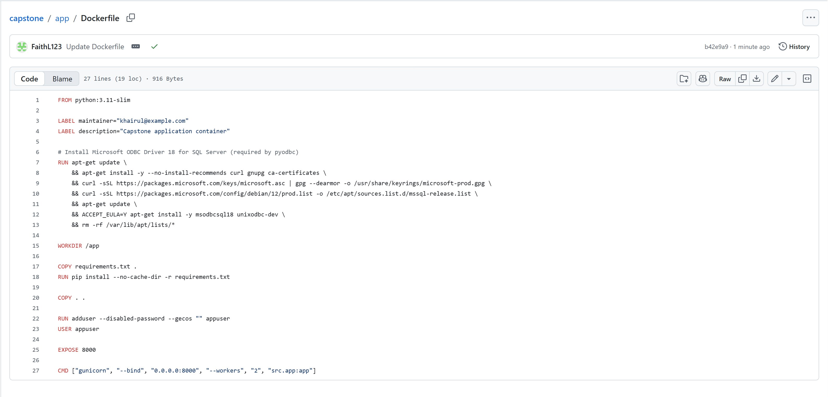
Figure 5.1 — GitHub commit adding the Microsoft ODBC Driver 18 install block to app/Dockerfile (fixes pyodbc runtime crash).
☐ Screenshot of the updated app/Dockerfile on main showing the msodbcsql18 install block
☐ Screenshot of docker build finishing successfully (run from app/ folder)
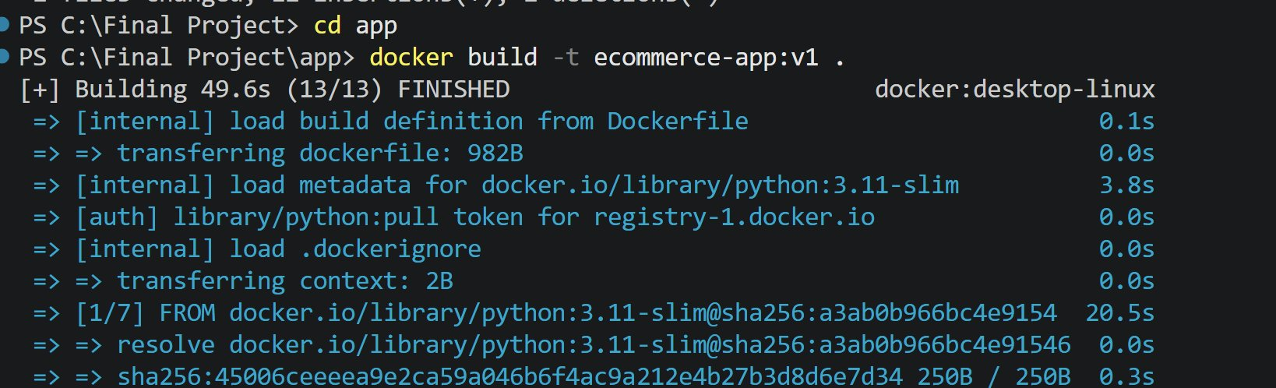
Figure 5.2a — docker build start: base image pull and apt-get install steps.
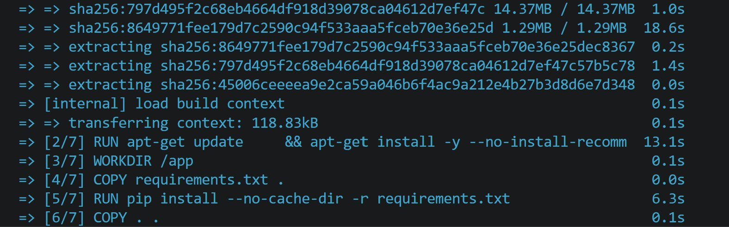
Figure 5.2b — docker build middle: pip install of requirements.txt completes.
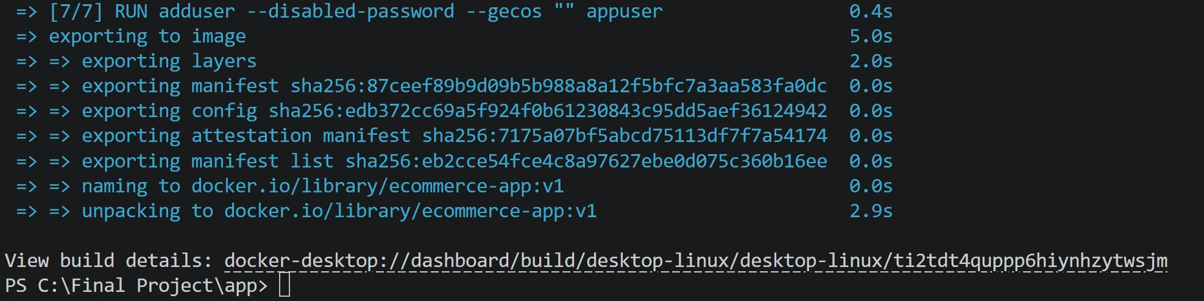
Figure 5.2c — docker build end: all 13/13 stages complete, image ecommerce-app:v1 built (49.6s).
☐ Screenshot of the website running from the local container (http://localhost:8000)
☐ Screenshot of the repository in ACR (Azure Portal → capstonereg047af007 → Repositories)
☐ Screenshot of the AKS Overview showing “Container registries: capstonereg047af007”
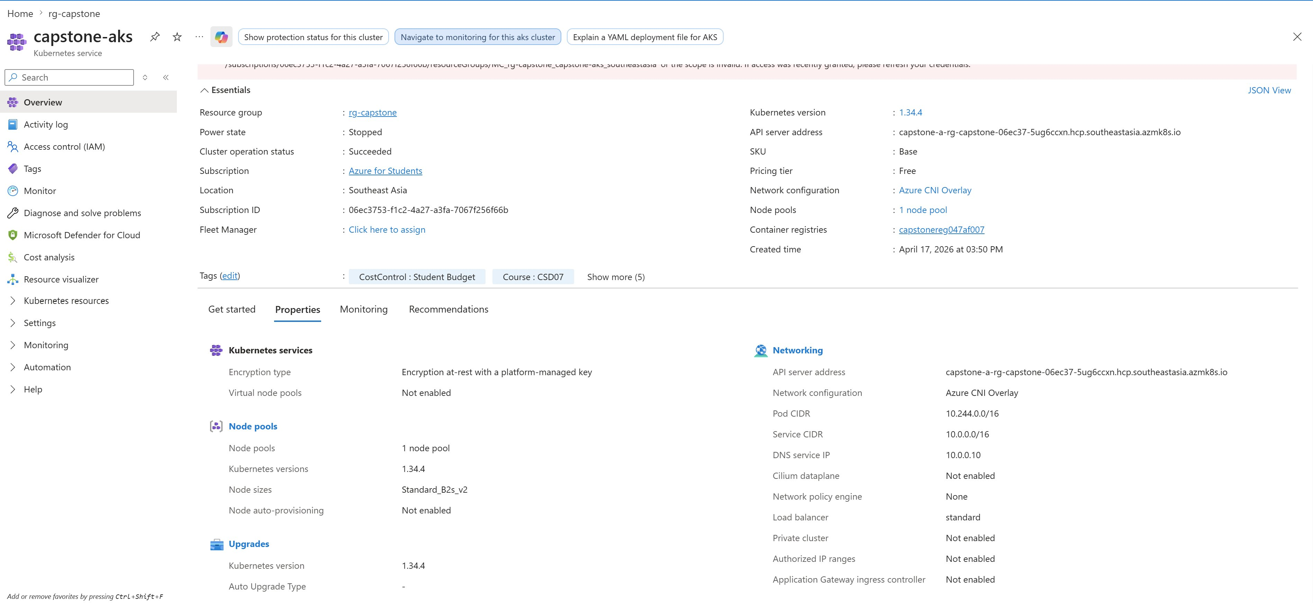
Figure 5.3 — capstone-aks Overview shows Container registries: capstonereg047af007 (AcrPull role assignment in place).
☐ The build/tag/push commands above (documented)
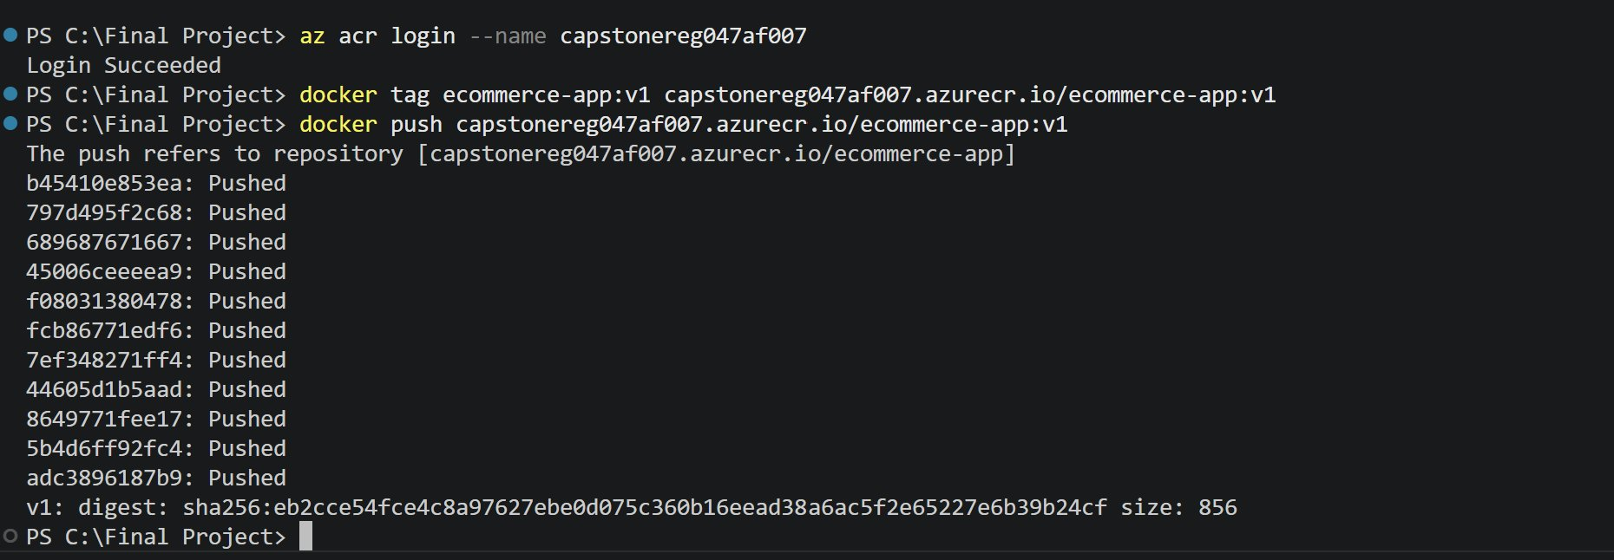
Figure 5.4 — docker push to ACR: all 11 layers Pushed, digest sha256:eb2cce54..., image now at capstonereg047af007.azurecr.io/ecommerce-app:v1.

Common mistakes I avoided
- Confirmed Docker Desktop was running before building.
- Used the correct ACR name (capstonereg047af007) in every command.
- Tagged with a real version (v1) and recorded which commit it came from.
- Identified that the original Dockerfile was missing the Microsoft ODBC Driver 18 install — a real bug that would have caused the deployed container to fail at runtime when connecting to Azure SQL. Resolved via the “Update Dockerfile” commit (FaithL123).
- Built from the correct context (app/ folder) so the Dockerfile’s relative COPY paths resolve.

Done when
- Image builds successfully. [Done after build]
- Image runs locally and the website opens. [Done after local run]
- Image is visible in ACR. [Done after push]

