**Superstore Sales Dataset**

**Teams Members :**

* Anas Alaa
* Mahmoud Hossam
* Omar Mohamed
* Menna Tallah Mahmoud
* Mohamed Haytham
* Abdelrahman Ibrahim

**Source :**

From DEPI (“ <https://drive.google.com/file/d/1QE_uoS8Aywd7ZFhmMvDmVf7jf0XN6mhw/view?usp=sharing> ”)

**Project Objective:**

* Q1: What is the total sales revenue generated by the store?
* Q2: How many orders were placed?
* Q3: How many unique customers made purchases?
* Q4: What is the average sales per order?
* Q5: What is the average monthly sales?
* Q6: Which categories and sub-categories generated the highest sales?
* Q7: Who are the top customers in terms of sales?
* Q8: Which regions and states contributed most to the sales?
* Q9: How were sales distributed across different shipping modes?
* Q10: How did sales perform across customer segments?

**Clean :**

1. Remove Null Values
2. Remove Duplicates
3. Remove Column Country “one Country”
4. Change type columns “order date” and “ship date” to date type
5. Change type column id to integer

**Codes :**

* **Make Calendar Table** :

CalendarTable = ADDCOLUMNS ( CALENDAR ( MINX (Sales, Sales[OrderDate]), MAXX (Sales, Sales[OrderDate]) ),"Year", YEAR([Date]),"Month", FORMAT([Date], "MMMM"), "Month Number", MONTH([Date]),"Quarter", "Q" & FORMAT([Date], "Q"), "Weekday", FORMAT([Date], "dddd"), "Weekday Number", WEEKDAY([Date]))

* **Make Some Calculated Measuers :**

1. Avg Sales per Order = [Total Sales] / DISTINCTCOUNT('Superstore Sales Dataset'[Order ID])
2. Monthly Sales = TOTALMTD([Total Sales], 'Superstore Sales Dataset'[Order Date])
3. Sales Year Growth = VAR CurrentYearSales = [Total Sales]

VAR PreviousYearSales = CALCULATE([Total Sales], SAMEPERIODLASTYEAR('Superstore Sales Dataset'[Order Date]))RETURN IF(NOT ISBLANK(PreviousYearSales), (CurrentYearSales - PreviousYearSales) / PreviousYearSales, BLANK())

1. Total orders = COUNT('Superstore Sales Dataset'[Order ID])
2. Total Sales = SUM('Superstore Sales Dataset'[Sales])
3. Unique Customers = DISTINCTCOUNT('Superstore Sales Dataset'[Customer ID])

**Insights :**

total sales revenue = 2.26M

orders were placed = 9800

unique customers = 793

average sales per order = 459.48

average monthly sales = 83 K

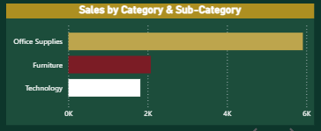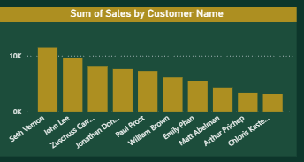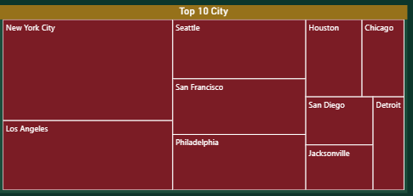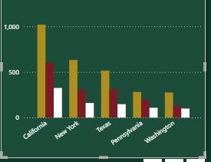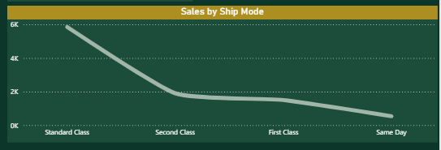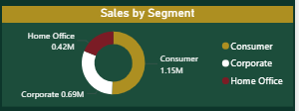

**Recommendation :**

1. **Optimize High-Performing Categories**  
   Focus on "Furniture" and "Office Supplies" categories that drive 65% of revenue.
2. **Target Top Customers**  
   Create loyalty programs for the top 10 customers contributing $420K+ in sales.
3. **Improve Underperforming Regions**  
   Investigate low sales in the Central region and run targeted promotions.
4. **Enhance Shipping Experience**  
   Reduce reliance on "Standard Class" shipping (avg. 5-day delay) and promote "First Class".
5. **Boost Consumer Segment Growth**  
   Offer discounts to the "Consumer" segment to close the gap with "Corporate".