Documentation





***NOTE APP***

Done by:

**Osama Assaf**

**AbedAlaziz Al khdour**

**Saleh Ghammaz**

**Anas AlKhabbas**

**Presented to LTUC – Flutter Development Course**

**October, 2022**

**Repository link**:

<https://github.com/Note-App-Org/Flutter-Note-App.git>

# **ACKNOWLEDGMENTS**

***First and foremost, we would like to thank our Teacher (AbedAlraheem Alsaqqa) who guided us in doing*** ***these project. He provided us with invaluable advice and helped us in difficult periods. His motivation and help contributed tremendously to the successful completion of the project.***

Contents

**ACKNOWLEDGMENTS** 3

**INTRODUCTION** 5

**Main work** 6

**Application Design & Implementation:** 7

Implementation: 7

Add Firebase: 7

Add Firebase Authentication: 8

Add FireStore: 9

Application Design: 11

1-Sign up: 11

2-Log in: 12

3- Home Screen: 13

4- Add Note Screen: 14

**Coding** 15

Authentication 15

1- login_view.dart 15

2- register_view.dart 15

CRUD Operation 16

1- Get notes 16

2- Delete Note 16

3- Add Note 17

4- Update Note 18

# **INTRODUCTION**

We have created a new app "Note App" to help you stay organized and manage your day.

*What does the application provide?*

* ***Each user has their own notes.***
* ***Add new note.***
* ***Edit a note.***
* ***Delete a note.***
* ***Setting the color of note.***
* ***Sign up and sign in screens.***
* ***Dark & light Theme.***
* ***State Management: Provider.***
* ***Design Pattern: MVVM (Model View ViewModel).***

# **Main work**

***We can divide our application main work into main parts:***

1. **Part** **one: Sign up screen.**
2. **Part** **Two: Log in screen.**
3. **Part** **Three: Note List Screen.**
4. **Part Four: Add Note Screen.**
5. **Part Five: Edit Note & change background color note.**
6. **Part six: Delete Note.**

# **Application Design & Implementation:**

## Implementation:

### Add Firebase:

**1- First, at the root of Flutter project directory, run this command: flutterfire configure:**

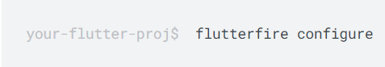

**2- Add this** **package: flutter pub add firebase core:**

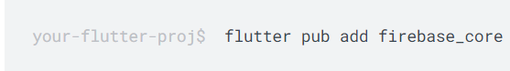

**3- Import the packages and write those lines into void main:**

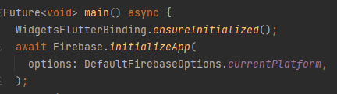

**4- From your Flutter project directory, run the following command to ensure that your Flutter app's Firebase configuration is up-to-date and select the project you will work on it:**

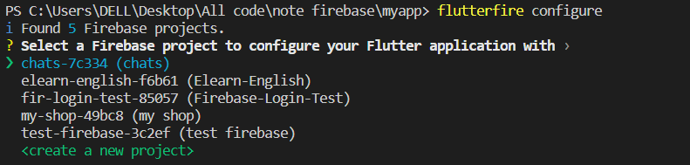

**5-Select the platform should your configuration support.**

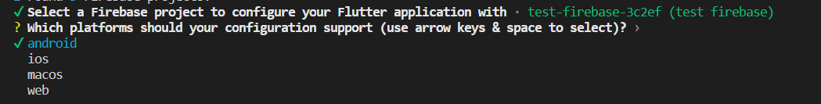

### Add Firebase Authentication:

**1-From the root of your Flutter project, run the following command to install the plugin:**



**2- Import the plugin in your Dart code:**



**3- Go to firebase and select Authentication:**



**4- Select Email and password as first sign-in method:**

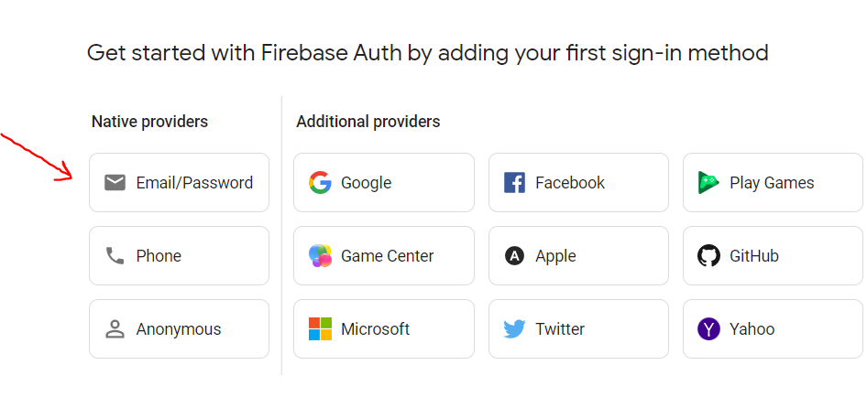

### Add FireStore:

**1 - Navigate to the Cloud Fire store section of the Firebase console. You'll be prompted to select an existing Firebase project. Follow the database creation workflow:**



**2- Select a starting mode for your Cloud Firestore Security Rules**

**(Test mode Or Production mode):**

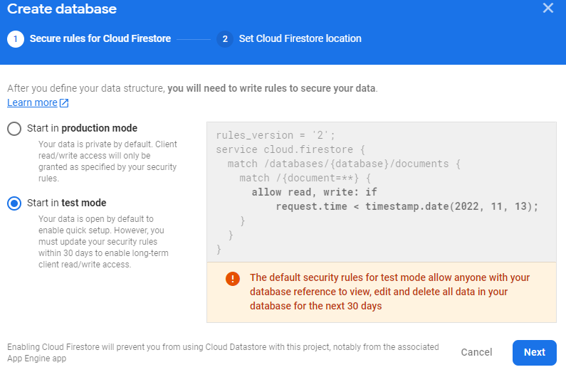

**3- Select a location for your database:**

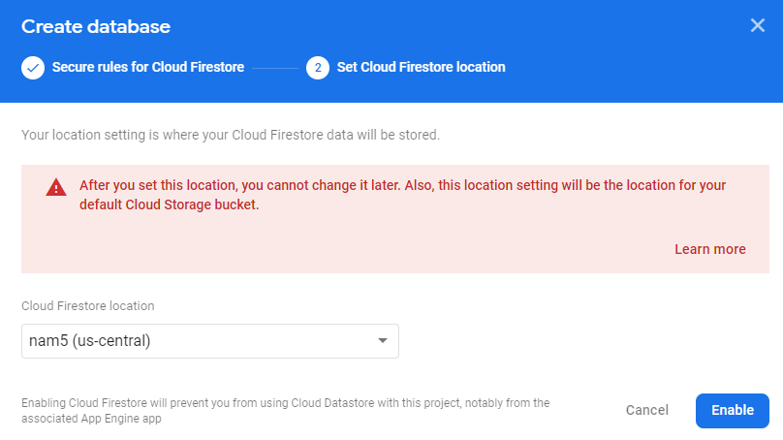

You can check Documentation [here](https://firebase.google.com/docs/flutter/setup?platform=android) for more information

## Application Design:

### 1-Sign up:

1. Add Image like circle avatar.
2. Add Text field for username.
3. Add Text field for email.
4. Add Text field for password.
5. Add Elevated button for sign up.
6. Add text button navigate to login page.

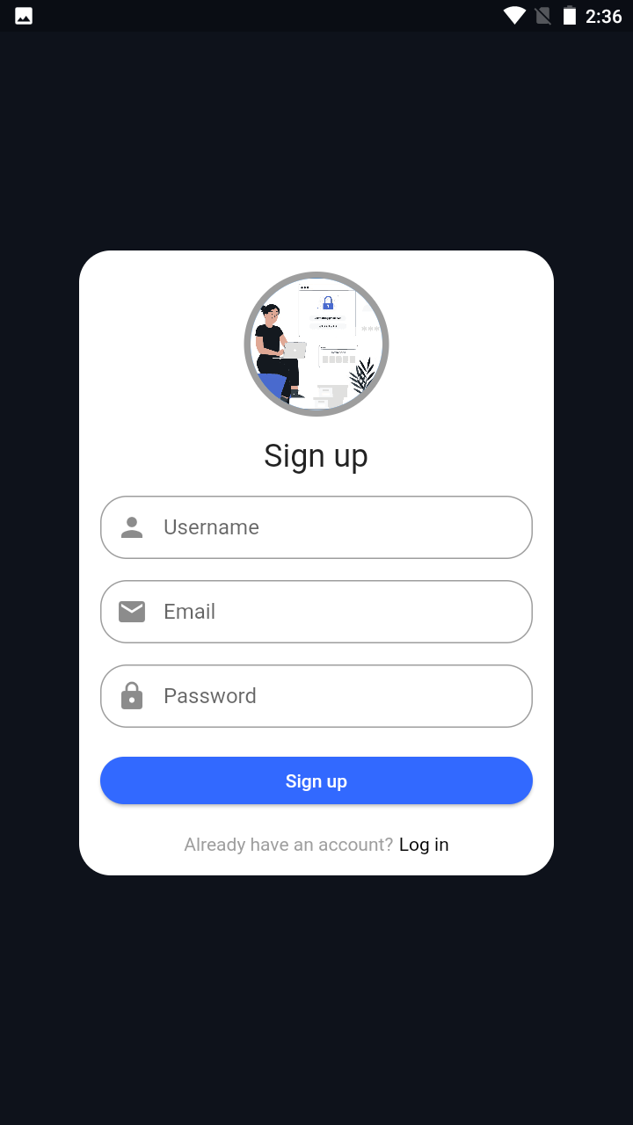

### 2-Log in:

1. Add Image like circle avatar
2. Add Text field for email
3. Add Text field for password
4. Add Elevated button for log in
5. Add text button navigate to sign up

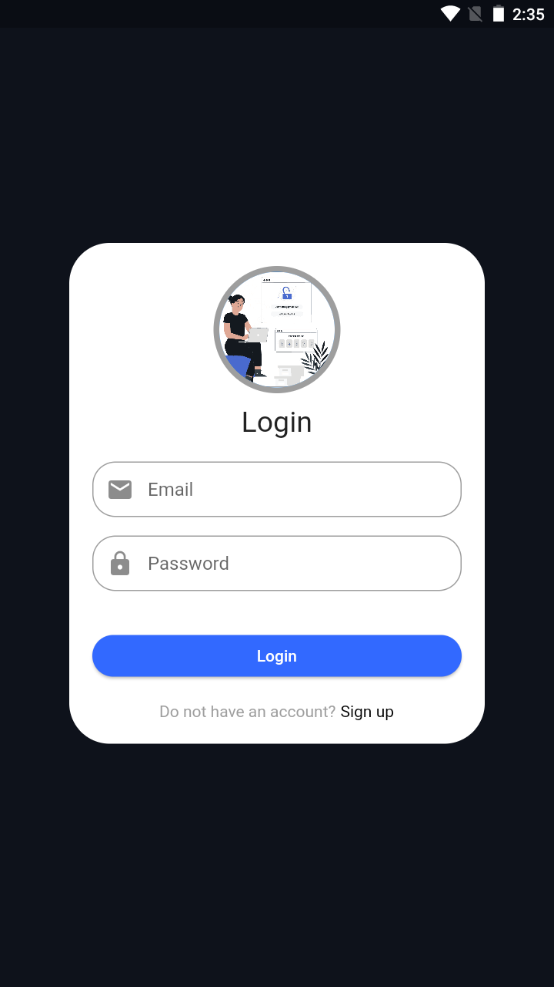

### 3- Home Screen:

1. Add Switch for dark and light mode
2. Preview for note
3. Edit any note
4. Edit background colors
5. Delete Note
6. Add log out Icon Button
7. Add Floating Action Button to add new note

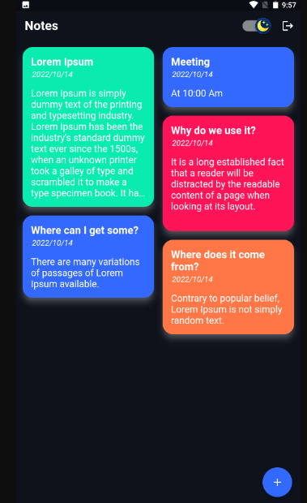

### 4- Add Note Screen:

1. Select background color
2. add title and content
3. Elevated button to save note
4. Arrow for back to home screen

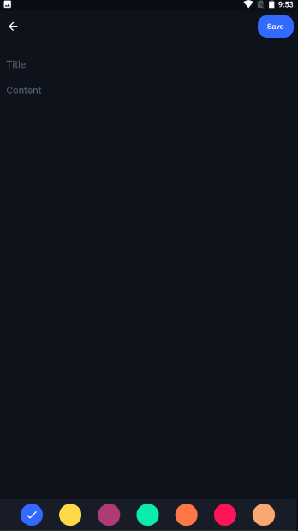

# **Coding**

## Authentication

### login_view.dart

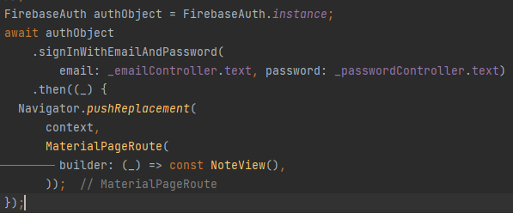

### register_view.dart

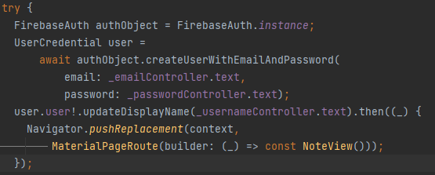

## CRUD Operation

### Get notes

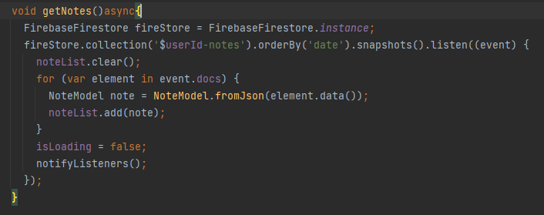

### Delete Note

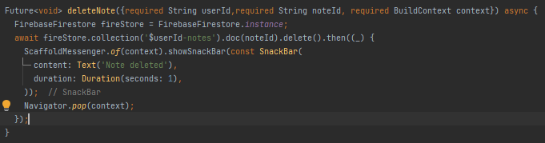

### Add Note

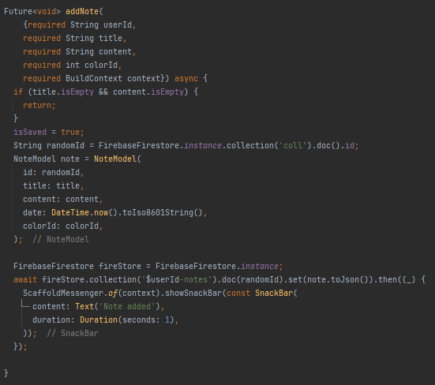

### Update Note

