

Documentation



**School App**

TABLE OF CONTENT

ACKNOWLEDGMENTS 5

**INTRODUCTION** 6

**Main work** 7

Implementation 8

Add firebase: 8

Add Firebase Authentication: 9

Add Fire Store: 12

Coding: 15

Authentication: 15

Signup: 15

Login: 16

Login with google: 17

Logout: 17

Forgot password: 18

News 18

Add news: 18

Update News: 18

Read News: 19

Delete News: 19

User List: 20

Subjects: 21

Read subject: 21

Add subject: 22

Get Books From API: 23

About Us: 23

Our Location: 23

Our Website: 23

Application Design: 24

Authentication: 24

Home Screen: 25

User List: 26

Library Screen: 27

Subject Screen: 28

News Screens: 29

Use Case Diagram: 30

**School App**

Done by:

**Osama Assaf**

**Malak Dawod**

**Anas AlKhabbas**

**Samar Shehab**

**AbedAlaziz Al khdour**

**Presented to LTUC – Flutter Development Course**

**October, 2022**

**Repository link**:

<https://github.com/Best-Team-Org/school-management.git>

# ACKNOWLEDGMENTS

*First and foremost, we would like to thank our Teacher (AbedAlraheem Alsaqqa) who guided us in doing* *these project. He provided us with invaluable advice and helped us in difficult periods. His motivation and help contributed tremendously to the successful completion of the project.*

# **INTRODUCTION**

We have created a new app "School App":

This application deals with various modules like student module in which we can get the details about the students. Second module is the teacher in which we can get details about teachers and last is admin module in which we can manage the students and teacher details.

*What does the application provide?*

* ***Each user has their own account and role.***
* ***Show user list.***
* ***Books library.***
* ***Add subject.***
* ***Show subjects.***
* ***Sign up and sign in screens.***
* ***Add, delete, and update news.***
* ***Show all news on home screen.***
* ***State management: Provider.***
* ***Design pattern: MVVM (Model View ViewModel).***

# **Main work**

***We can divide our application main work into main parts:***

**Part** **one: Signup.**

**Part** **two: Login.**

**Part three: Login with google.**

**Part four: Logout.**

**Part five: Reset password.**

**Part six: Read news.**

**Part seven: Add, update and delete news.**

**Part eight: Read news.**

**Part nine: Add subject.**

**Part ten: Subjects list.**

**Part eleven: Get books from API.**

# Implementation

## Add firebase:

1. **First, at the root of Flutter project directory, run this command: “flutterfire configure”:**

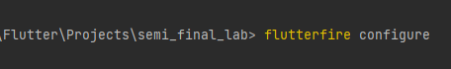

1. **From your Flutter project directory, run the following command to ensure that your Flutter app's Firebase configuration is up-to-date and select the project you will work on it:**

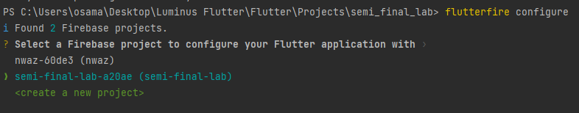

1. **Select the platform should your configuration support.**

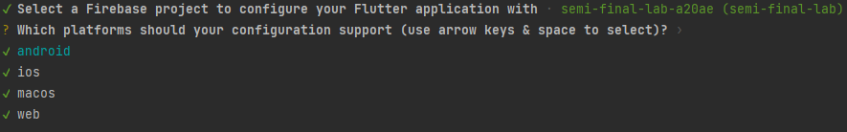

1. **Initialize Firebase: Before any Firebase services can be used, you must first install the “firebase_core” plugin, which is responsible for connecting your application to Firebase. Install the plugin by running the following command from the project root:**

**C:\Users\osama\Desktop\3.PNG**

1. **Import the packages and write those lines into void main:**

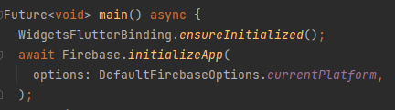

## Add Firebase Authentication:

1. **From the root of your Flutter project, run the following command to install the plugin:**

**C:\Users\osama\Desktop\5.PNG**

1. **Import the plugin in your Dart code:**

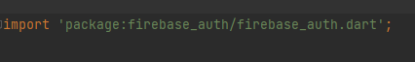

1. **Go to firebase and select Authentication:**

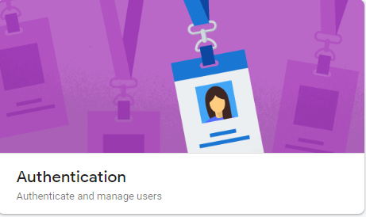

1. **Select Email and password as first sign-in method:**

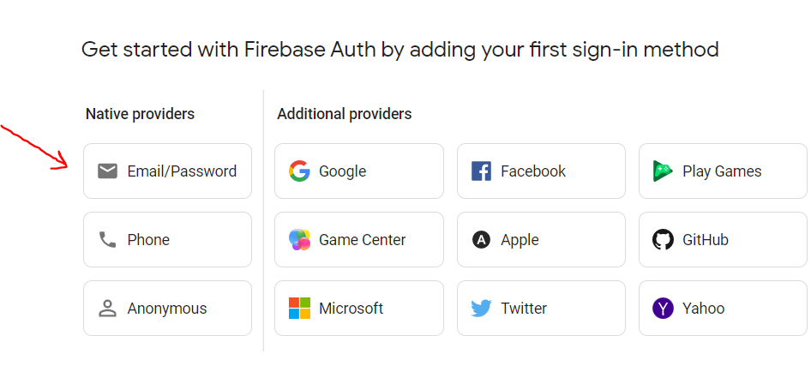

1. **Enable that authentication method and click Save:**

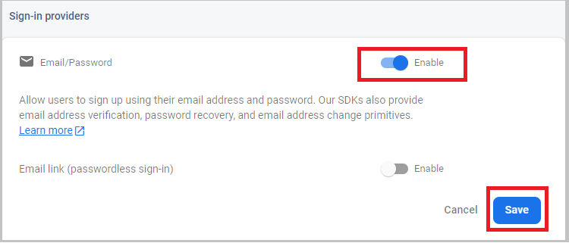

1. **Select Email and password as first sign-in method:**

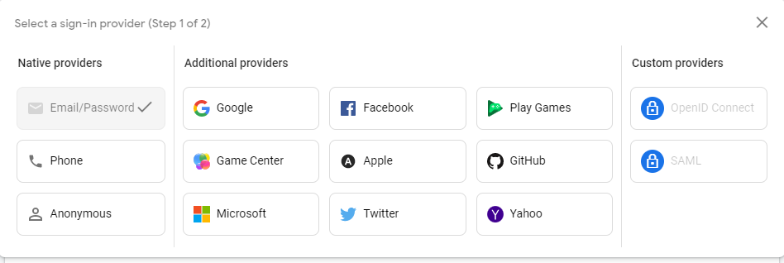

1. **Enable that authentication method and click Save:**

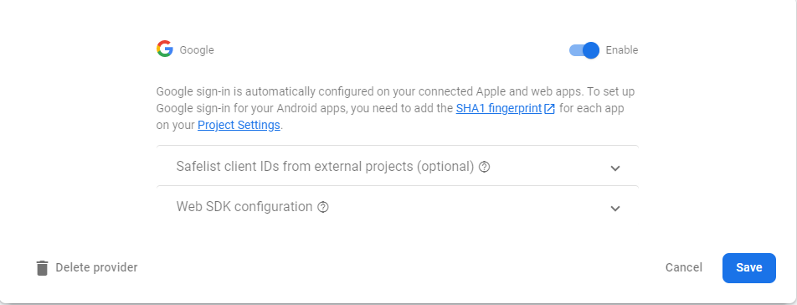

## Add Fire Store:

1. **Navigate to the Cloud Fire store section of the Firebase console. You'll be prompted to select an existing Firebase project. Follow the database creation workflow:**

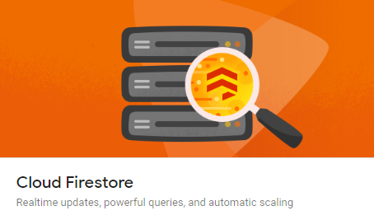

1. **Select a starting mode for your Cloud Fire store Security Rules**

**(Test mode Or Production mode):**

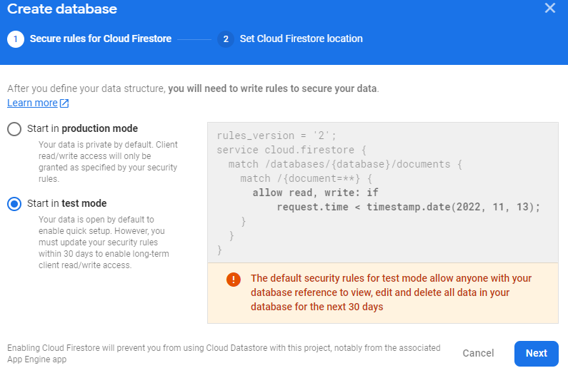

1. **Select a location for your database:**

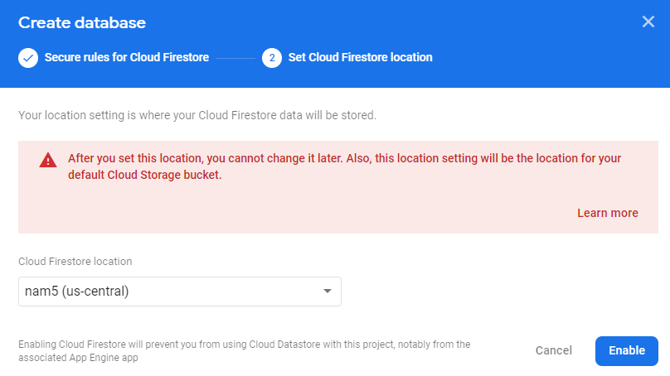

1. **From the root of your Flutter project, run the following command to install the plugin:**

**https://cdn.discordapp.com/attachments/1031969812164915222/1033341056483344434/9.PNG**

1. **From the root of your Flutter project, run the following command to install the plugin:**

https://cdn.discordapp.com/attachments/1031969812164915222/1033341056927928361/10.PNG

**\*\*\*Go to (android/app/build.gradle) and make these changes:**

1. **Edit this line to make sure don’t have error:**



1. **Change minSdkVersion to 19 & Add multi index and give it true :**

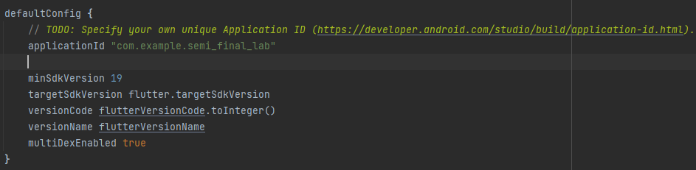

1. **Add this line in dependency:**

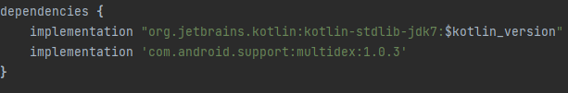

# Coding:

## Authentication:

### Signup:

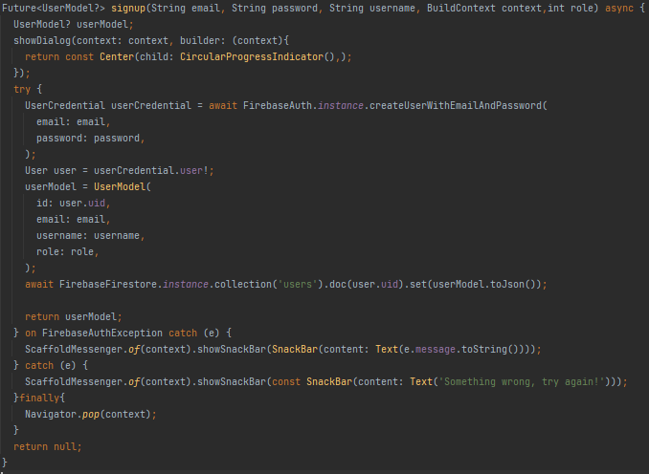

### Login:

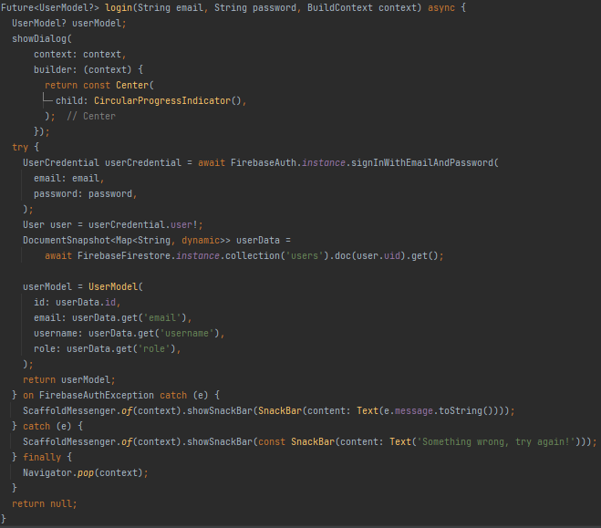

### Login with google:

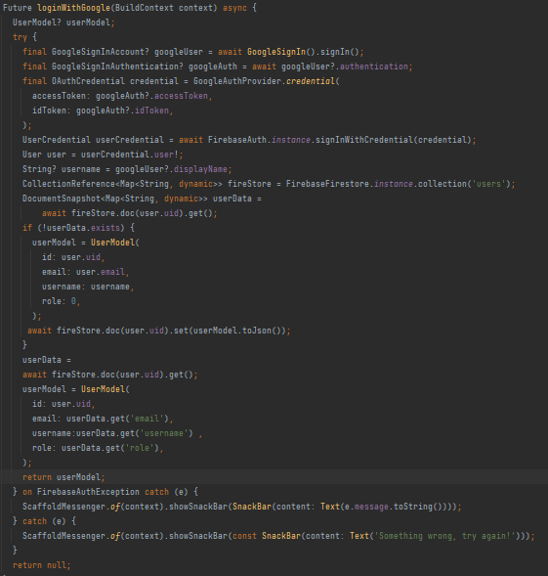

### Logout:

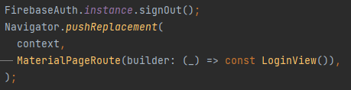

### Forgot password:

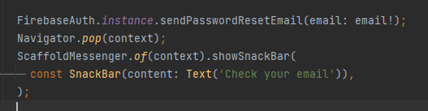

## News

### Add news:

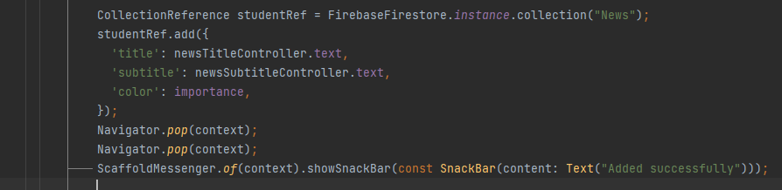

### Update News:

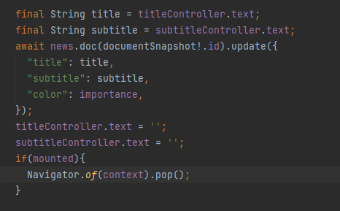

### Read News:

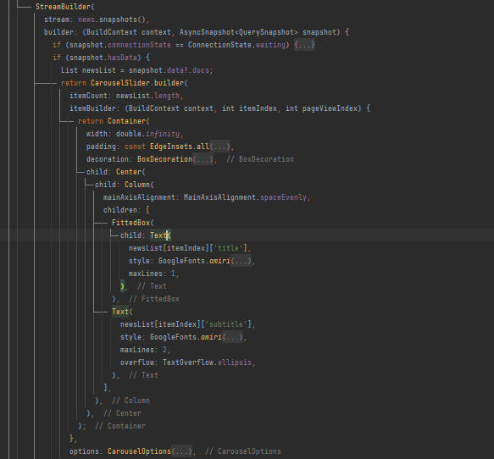

### Delete News:

https://cdn.discordapp.com/attachments/1031969812164915222/1033349413256581130/4.PNG

## User List:

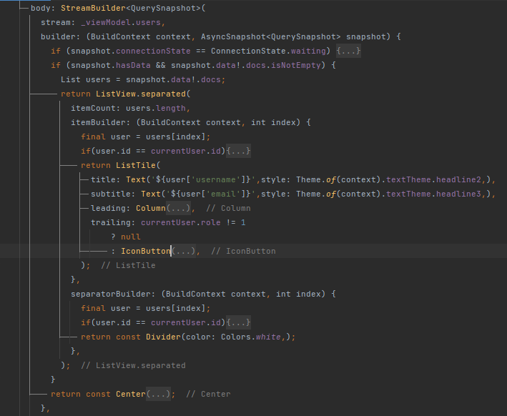

## Subjects:

### Read subject:

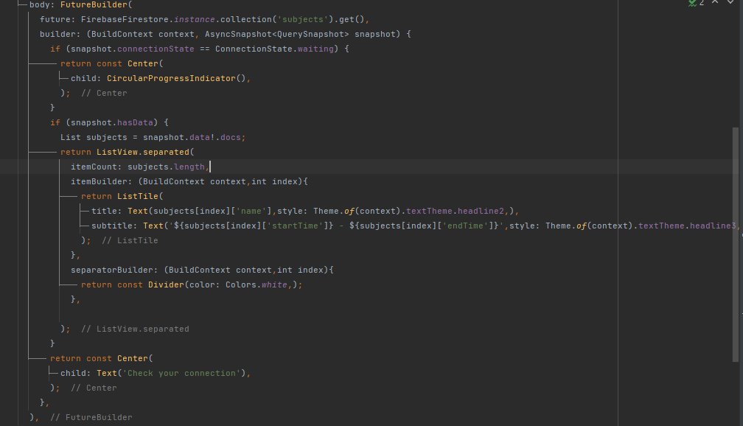

### Add subject:

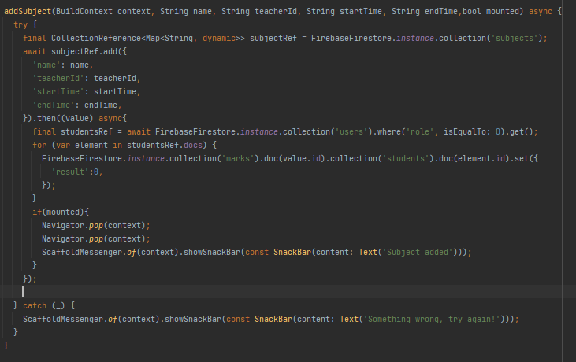

## Get Books From API:

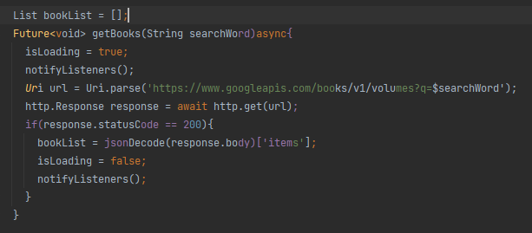

## About Us:

### Our Location:

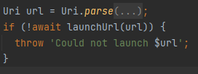

### Our Website:

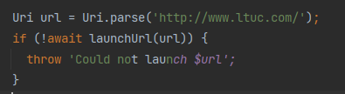

# Application Design:

## Authentication:

**Login with Google or Email & password** Signup Forget password

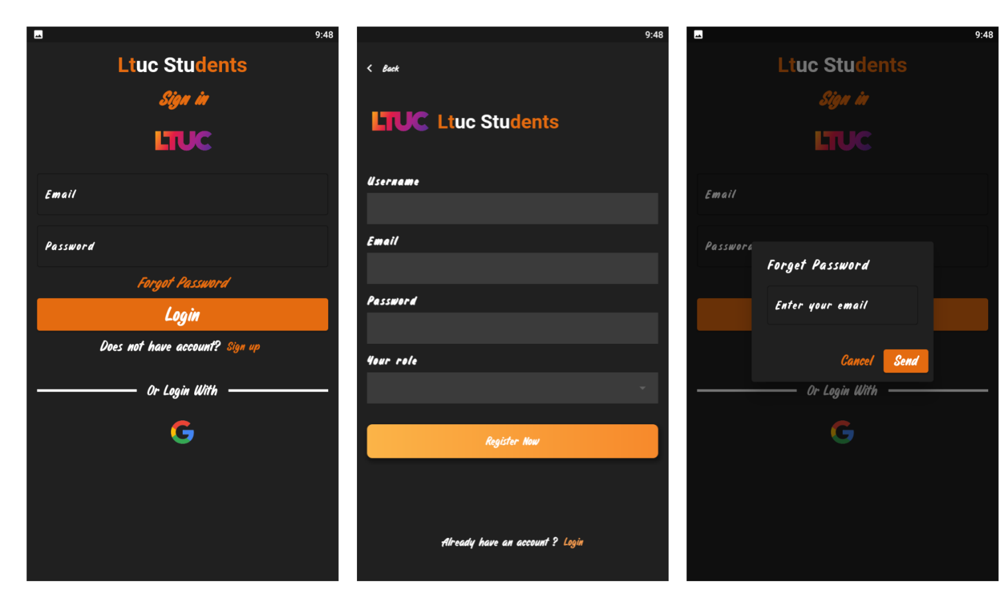

## Home Screen:

**Show News**

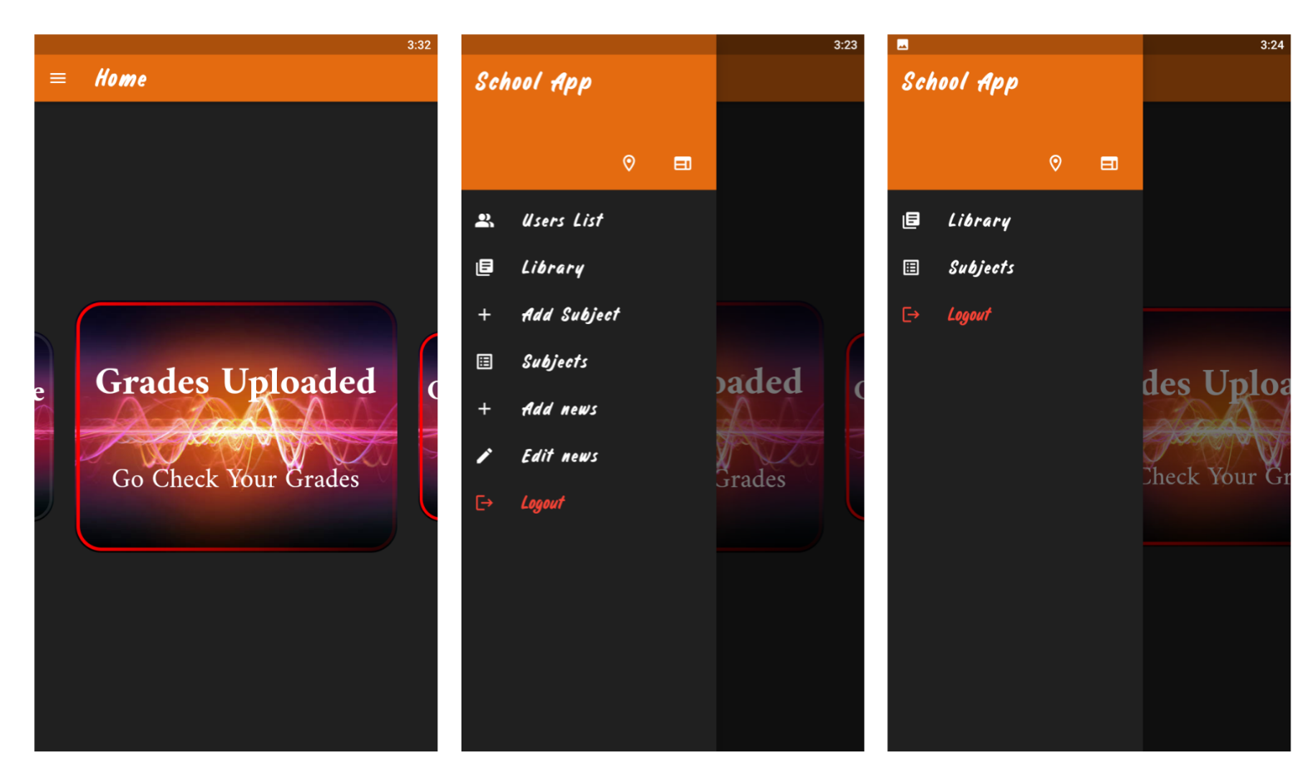

## User List:

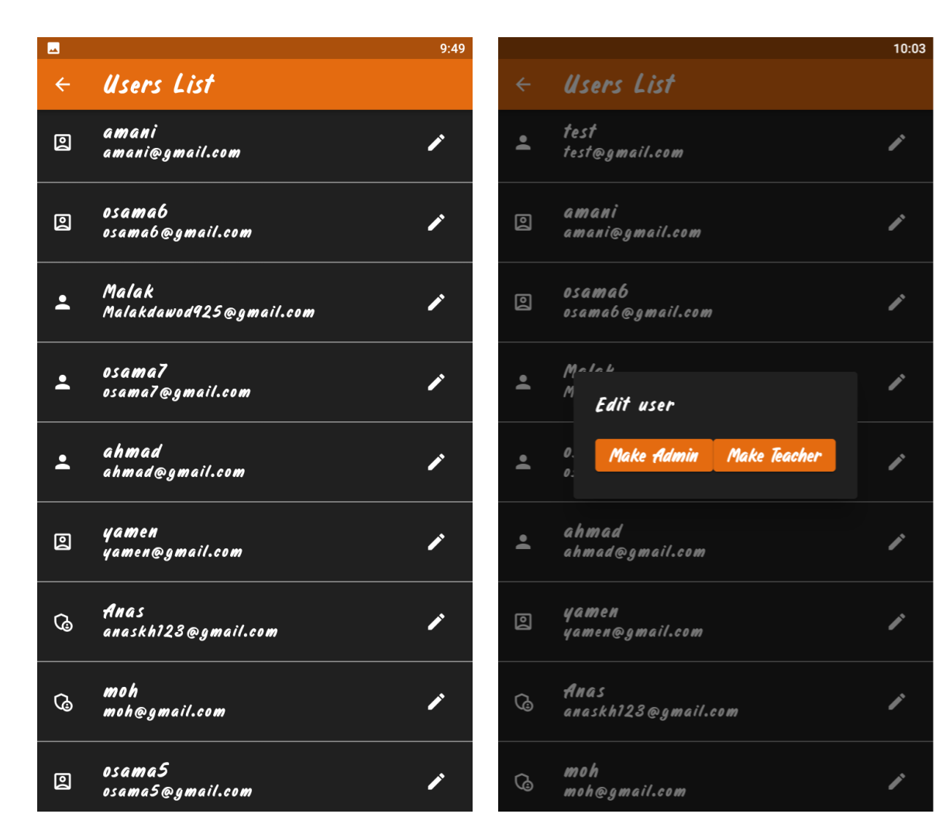

## Library Screen:

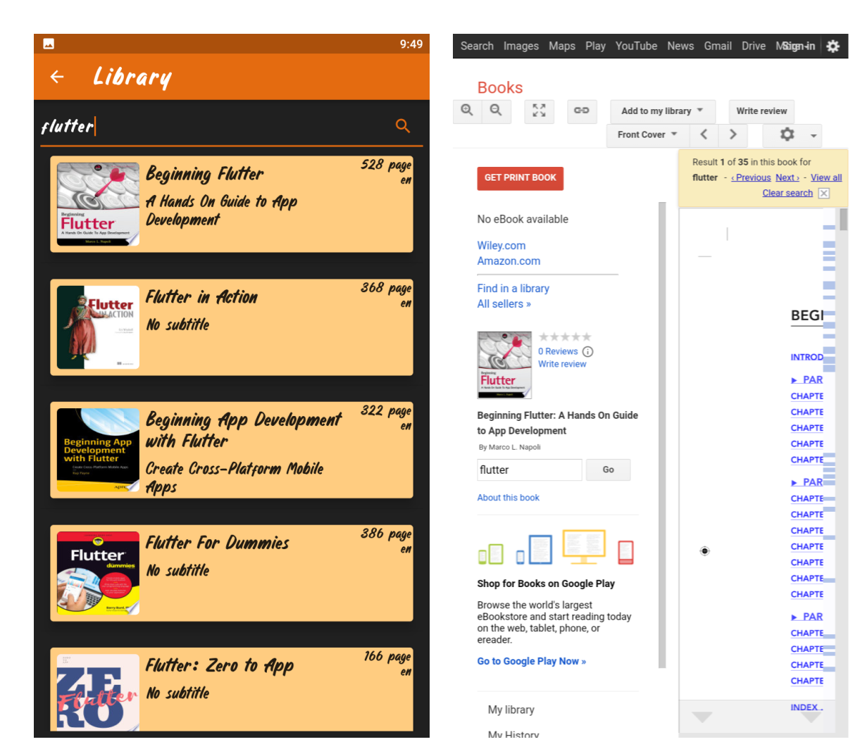

## Subject Screen:

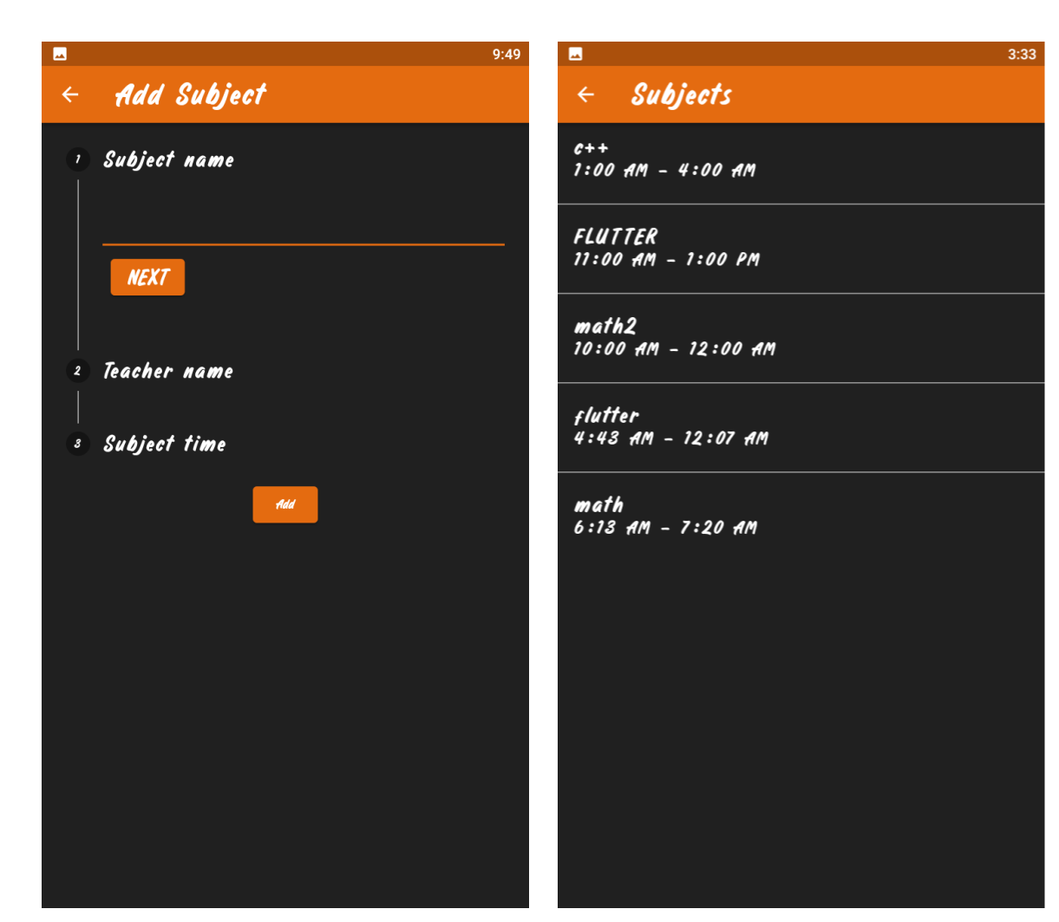

## News Screens:

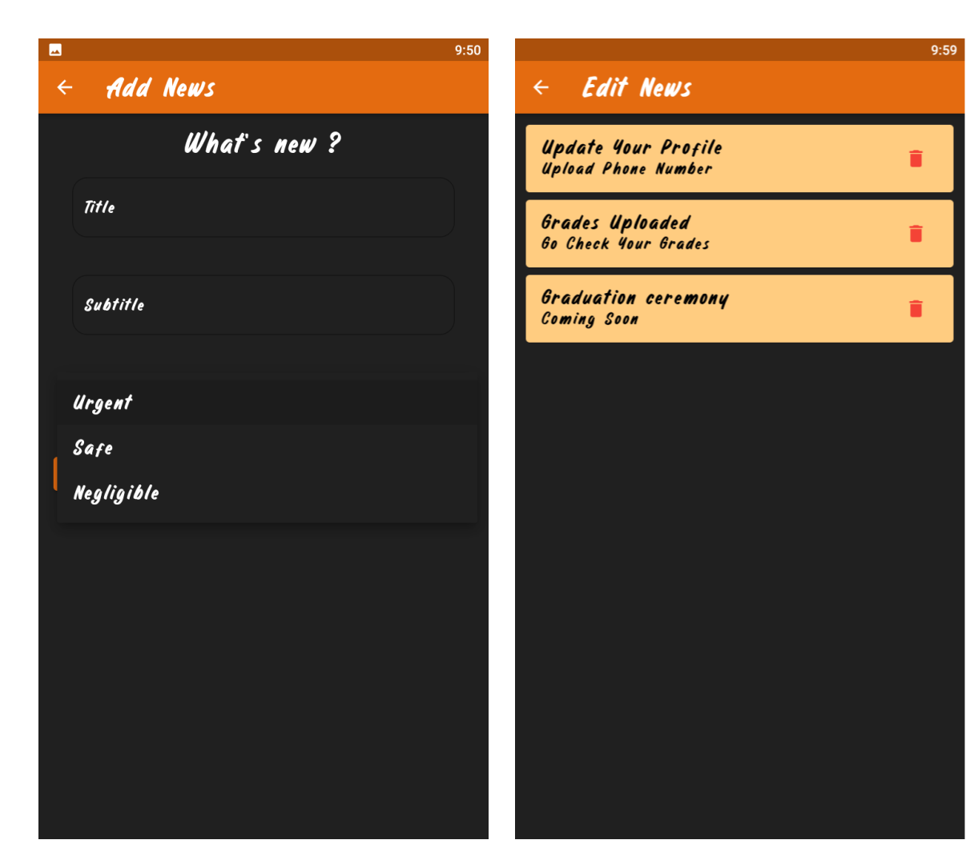

# Use Case Diagram:

