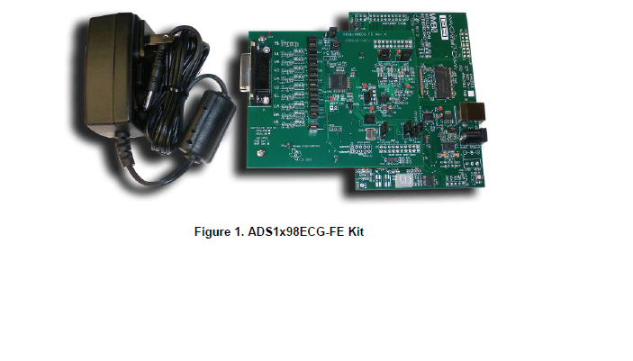w uesd this kit to take the signal from throat of human firstly w try to take ECG signal (Heartbeat) and w success to do that 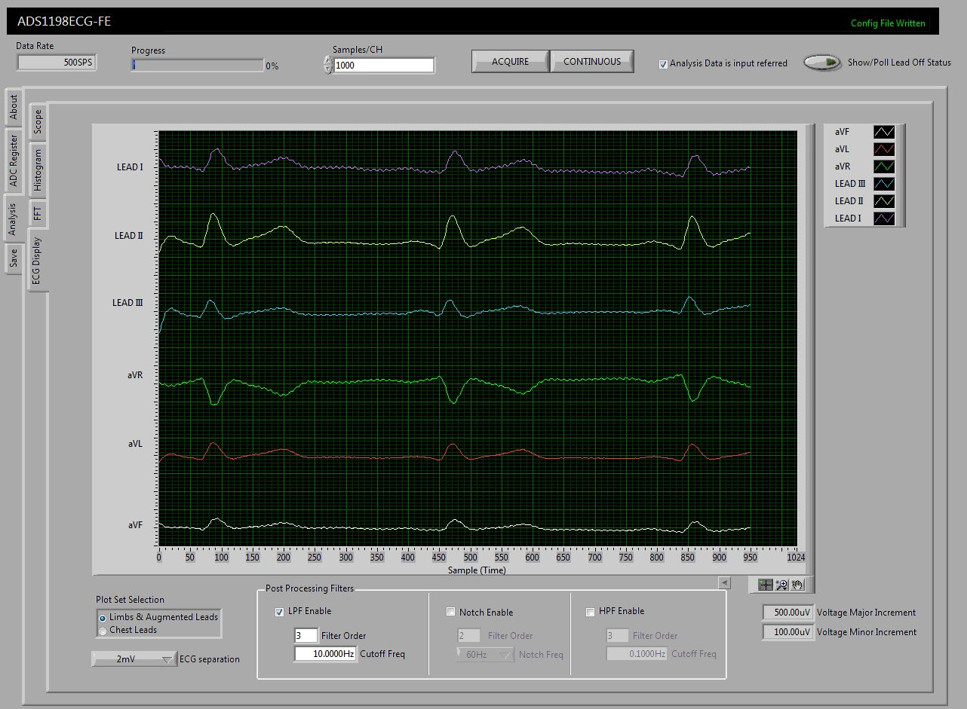

Then w try to take signal from throat by that cable

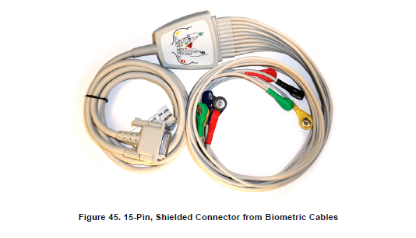

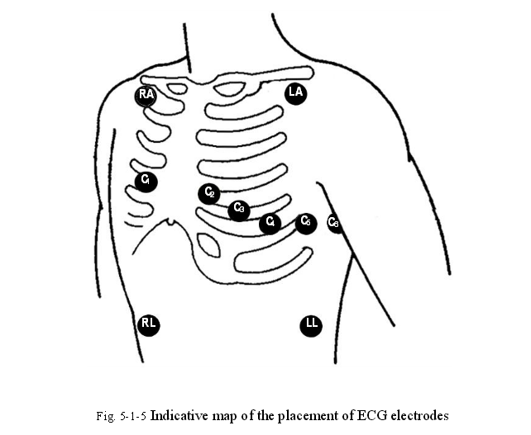

but we can't do by that kit

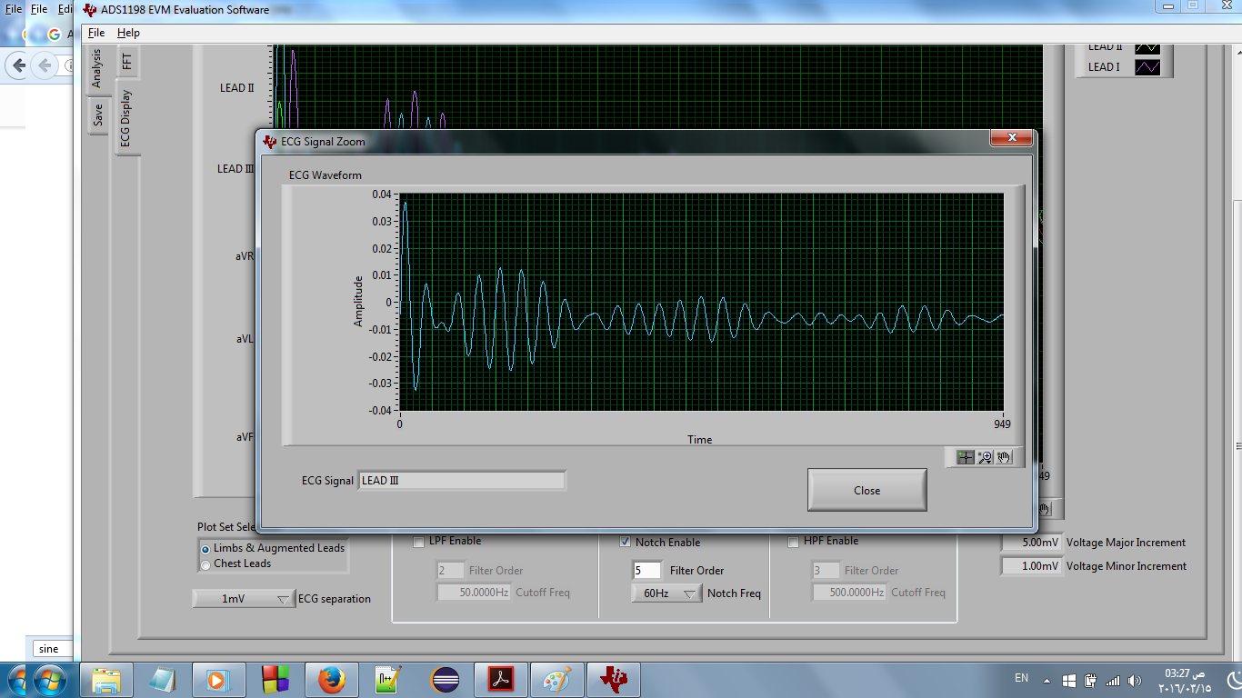

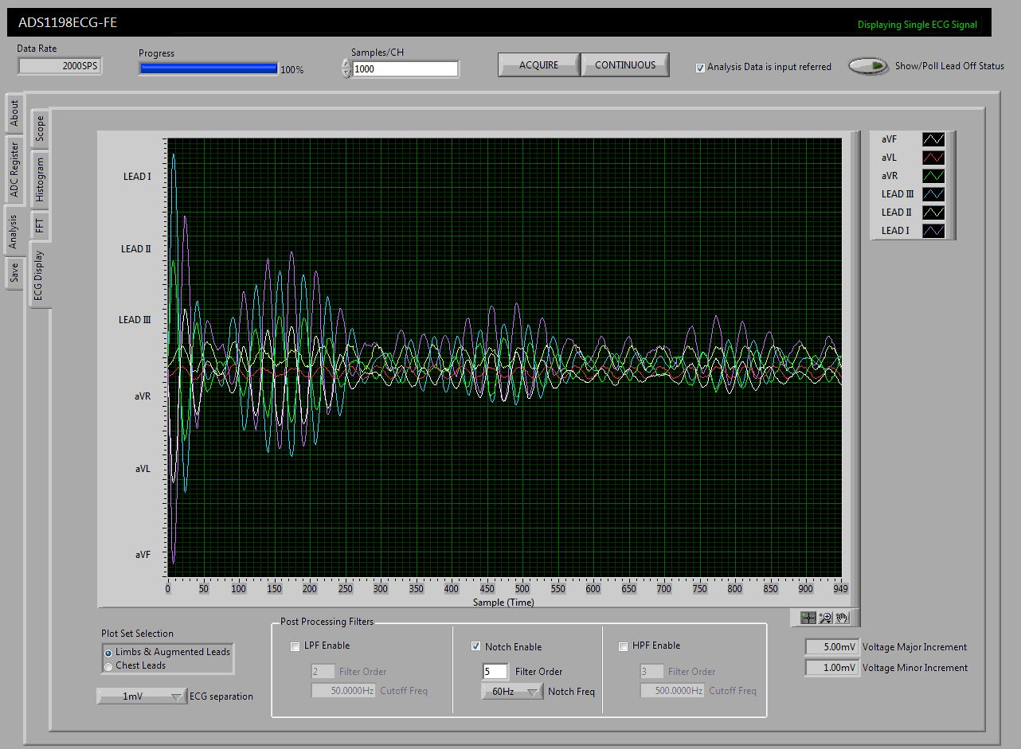

Because kit was for ECG only not to EMG that we want so w excluding this kit after we discussed that with Texas site and they said that this kit can't read vocal signal