***15-122 Project Description***

*Description:*

-My project will consist of a game that will use the interaction of the user as the controls instead of using the keyboard or mouse. I will be using the camera feed and overlay it with a transparent GUI which will be the game graphics. This will create the effect that the user is directly apart of the game. I will be tracking the movements of the user’s hands, and the movement will dictate different actions in the game.

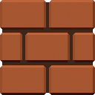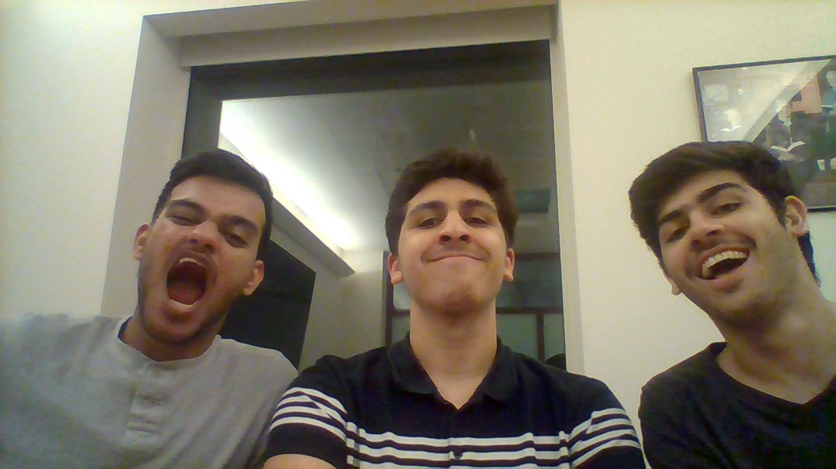-example of what it would look like:

This is not an example of how my game will actually look like, this is just to show an idea of what I mean when I say overlay the graphics on top of the camera feed( however, the graphics will be transparent so a view of the user will not be lost, I just couldn’t do that on word.)

-For now, my game program will consist of the user trying to move a ball across different obstacles, to try and reach the level flag.

*Libraries:*

-pygame

-opencv

*Features:*

-Main menu which includes a login, signup, leaderboard, play game buttons.

-There will be multiple levels for the story mode. In addition to that, I’ll add an infinite mode where obstacles will be generated randomly based off other levels.

-The user will be able to see their score, points are given based on how fast a level is passed.

-Program will hopefully be able to track hands, however, this can be hard to achieve with 100% accuracy if the camera feed is busy with objects, so I’ll make the program be able to track different colors or objects and use that to interact with the game.

-Game will have a pause or resume button, and those will work if the user hovers over the buttons on the screen with their hand/controller.

*User-interface:*

* Login screen with main menu to start game and select different options, starting the game can be done by hovering controller over start button.
* Game will be controlled by moving the hand across the air, and the game will react based on the hand.
* -There will be a pause and resume button that can be hovered over to pause the game while playing.

*First check point:*

-The tracking controls would be finished completely and some of the first few levels would be done. The start screen will also be finished.

*Second Checkpoint:*

-Rest of the levels will be complete, and also the infinite mode.