Pharmacy Management System
Database Management System Lab Project

Submitted by
Name | Student ID | Role
[Member 1 Full Name] | [Student ID] | [Role]
[Member 2 Full Name] | [Student ID] | [Role]
[Member 3 Full Name] | [Student ID] | [Role]

Course: [Course Code - Course Title]
Submitted to: [Instructor / Teacher Name]
Department / Section: [Your Department and Section]
Date of submission: [Date]

1. Project Description
The Pharmacy Management System is a desktop database application that helps a pharmacy manage its day to day operations. It keeps records of medicines and their stock levels, the categories medicines belong to, the suppliers who provide them, the customers who buy them, and the employees who serve those customers. It also records every sale and the individual medicines sold on each sale.
The application is built with Python (Tkinter) for the graphical user interface and SQLite as the relational database. Through the GUI the user can add, update, delete and search records in every table, and can view a set of reports such as current stock, low stock alerts, medicines that are about to expire, sales per customer, revenue per category and full sales invoices.
The database consists of seven related tables and is normalized up to the third normal form (3NF). Primary keys uniquely identify each record and foreign keys maintain the relationships and referential integrity between the tables.

Objectives
- Design a normalized relational database (up to 3NF) for a pharmacy.
- Use appropriate primary keys, foreign keys, data types and constraints.
- Provide a GUI to Add, Update, Delete, Search and View records.
- Provide reports built from JOIN and aggregate (GROUP BY) queries.
- Demonstrate DDL (table creation) and DML (insert, update, delete, select).

Tools and Technologies
Item | Technology used
Programming language | Python 3
GUI library | Tkinter (ttk) - part of the Python standard library
Database | SQLite (file based relational database, standard SQL)
Diagram | Entity Relationship Diagram rendered with Matplotlib

2. Entity Relationship Diagram (ERD)
The ERD below shows the seven entities, their attributes, the primary key (PK) and foreign key (FK) of each entity, and the one-to-many (1:N) relationships between them.
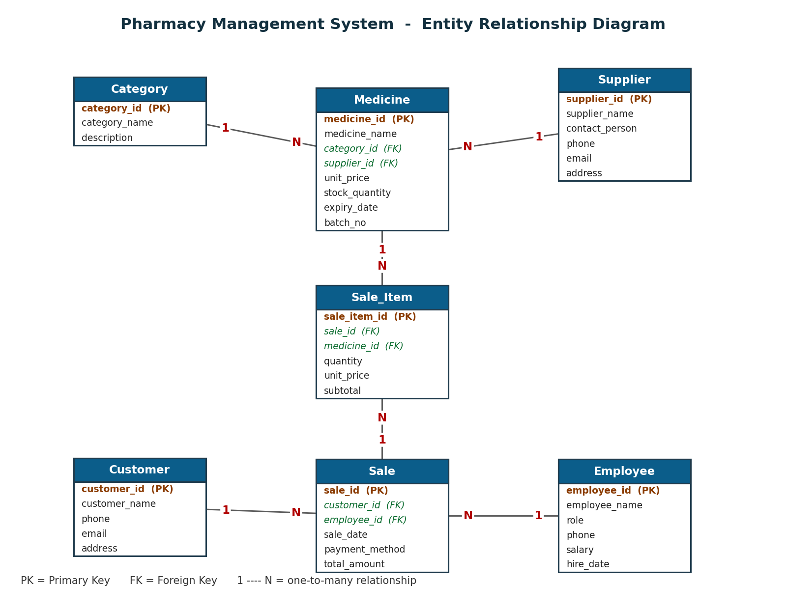
Figure 1: ER Diagram of the Pharmacy Management System

Relationships
- One Category has many Medicines. (Category 1 : N Medicine)
- One Supplier supplies many Medicines. (Supplier 1 : N Medicine)
- One Customer can make many Sales. (Customer 1 : N Sale)
- One Employee can handle many Sales. (Employee 1 : N Sale)
- One Sale contains many Sale_Items. (Sale 1 : N Sale_Item)
- One Medicine can appear in many Sale_Items. (Medicine 1 : N Sale_Item)
- Because of the Sale_Item table, Sale and Medicine have a many-to-many (M : N) relationship: a sale can include many medicines and a medicine can be sold on many sales. Sale_Item resolves this M:N relationship.

3. Normalization (up to 3NF)

Unnormalized data (the problem)
If we stored a whole sale in a single row, for example one Sale row that lists all the medicines bought as a comma separated value, and repeated the customer name, phone and address on every sale, the data would contain repeating groups and a lot of duplication. This causes insertion, update and deletion anomalies. Normalization removes these problems by splitting the data into well defined tables.

First Normal Form (1NF) - atomic values, no repeating groups
Every column holds a single (atomic) value and every table has a primary key. A sale that contains several medicines is not stored as a list inside the Sale table. Instead, each medicine on a sale is stored as a separate row in the Sale_Item table. So no cell contains multiple values and there are no repeating groups.

Second Normal Form (2NF) - no partial dependency
The database is in 1NF and every non-key column depends on the whole primary key. Each table uses a single-column primary key (for example medicine_id, sale_id, sale_item_id), so no column can depend on only part of the key. For instance, in Sale_Item the quantity and unit_price depend on the full key sale_item_id, which identifies one specific line of one specific sale.

Third Normal Form (3NF) - no transitive dependency
The database is in 2NF and no non-key column depends on another non-key column. For example, the Medicine table stores only category_id and supplier_id (foreign keys); it does not store category_name or supplier_name. Those descriptive attributes live once in the Category and Supplier tables. This removes the transitive dependency medicine_id -> category_id -> category_name. Likewise, the Sale table stores customer_id rather than the customer's name, phone and address, which are kept once in the Customer table.

Result
Each fact is stored in exactly one place, update and deletion anomalies are avoided, and referential integrity is enforced through foreign keys.

4. Table Structure
The database has seven tables. Each table is listed below with its columns, data types, keys and constraints.

Category
Groups of medicines (for example Antibiotics).
Column | Data Type | Key / Constraint | Description
category_id | INTEGER | PRIMARY KEY, AUTOINCREMENT | Unique id of the category
category_name | TEXT | NOT NULL, UNIQUE | Name of the category
description | TEXT | (nullable) | Short description

Supplier
Companies that supply medicines to the pharmacy.
Column | Data Type | Key / Constraint | Description
supplier_id | INTEGER | PRIMARY KEY, AUTOINCREMENT | Unique id of the supplier
supplier_name | TEXT | NOT NULL | Company name
contact_person | TEXT | (nullable) | Person to contact
phone | TEXT | (nullable) | Phone number
email | TEXT | (nullable) | Email address
address | TEXT | (nullable) | Address

Medicine
Products in stock; each has one category and one supplier.
Column | Data Type | Key / Constraint | Description
medicine_id | INTEGER | PRIMARY KEY, AUTOINCREMENT | Unique id of the medicine
medicine_name | TEXT | NOT NULL | Name of the medicine
category_id | INTEGER | NOT NULL, FOREIGN KEY -> Category | Category it belongs to
supplier_id | INTEGER | NOT NULL, FOREIGN KEY -> Supplier | Supplier that provides it
unit_price | REAL | NOT NULL, CHECK >= 0 | Selling price per unit
stock_quantity | INTEGER | NOT NULL, DEFAULT 0, CHECK >= 0 | Units currently in stock
expiry_date | TEXT | (nullable) | Expiry date (YYYY-MM-DD)
batch_no | TEXT | (nullable) | Manufacturer batch number

Customer
People who buy medicines.
Column | Data Type | Key / Constraint | Description
customer_id | INTEGER | PRIMARY KEY, AUTOINCREMENT | Unique id of the customer
customer_name | TEXT | NOT NULL | Customer name
phone | TEXT | (nullable) | Phone number
email | TEXT | (nullable) | Email address
address | TEXT | (nullable) | Address

Employee
Pharmacy staff who handle the sales.
Column | Data Type | Key / Constraint | Description
employee_id | INTEGER | PRIMARY KEY, AUTOINCREMENT | Unique id of the employee
employee_name | TEXT | NOT NULL | Employee name
role | TEXT | (nullable) | Job role (Pharmacist, Cashier, ...)
phone | TEXT | (nullable) | Phone number
salary | REAL | CHECK >= 0 | Monthly salary
hire_date | TEXT | (nullable) | Date of joining

Sale
One sales transaction (the invoice header).
Column | Data Type | Key / Constraint | Description
sale_id | INTEGER | PRIMARY KEY, AUTOINCREMENT | Unique id of the sale
customer_id | INTEGER | NOT NULL, FOREIGN KEY -> Customer | Customer who bought
employee_id | INTEGER | NOT NULL, FOREIGN KEY -> Employee | Employee who served
sale_date | TEXT | NOT NULL | Date of the sale
payment_method | TEXT | (nullable) | Cash / Card / Mobile Banking
total_amount | REAL | DEFAULT 0 | Total value (sum of its line items)

Sale_Item
Line items of a sale (the invoice detail). Resolves the M:N relationship between Sale and Medicine.
Column | Data Type | Key / Constraint | Description
sale_item_id | INTEGER | PRIMARY KEY, AUTOINCREMENT | Unique id of the line item
sale_id | INTEGER | NOT NULL, FOREIGN KEY -> Sale (ON DELETE CASCADE) | Sale it belongs to
medicine_id | INTEGER | NOT NULL, FOREIGN KEY -> Medicine | Medicine that was sold
quantity | INTEGER | NOT NULL, CHECK > 0 | Number of units sold
unit_price | REAL | NOT NULL, CHECK >= 0 | Price per unit at time of sale
subtotal | REAL | (computed) | quantity x unit_price

5. DDL - Data Definition Language
The following SQL statements create the database tables with their primary keys, foreign keys, data types and constraints. (Full file: schema.sql)
-- =====================================================================
-- schema.sql - Data Definition Language (DDL)
-- Pharmacy Management System (SQLite)
--
-- Creates 7 related tables, normalized up to 3NF, with primary keys,
-- foreign keys, data types and integrity constraints.
-- =====================================================================

PRAGMA foreign_keys = ON;

-- Drop in reverse dependency order so the script can be re-run safely.
DROP TABLE IF EXISTS Sale_Item;
DROP TABLE IF EXISTS Sale;
DROP TABLE IF EXISTS Medicine;
DROP TABLE IF EXISTS Employee;
DROP TABLE IF EXISTS Customer;
DROP TABLE IF EXISTS Supplier;
DROP TABLE IF EXISTS Category;

-- ---------------------------------------------------------------------
-- 1. Category : the group a medicine belongs to (Antibiotics, etc.)
-- ---------------------------------------------------------------------
CREATE TABLE Category (
category_id INTEGER PRIMARY KEY AUTOINCREMENT,
category_name TEXT NOT NULL UNIQUE,
description TEXT
);

-- ---------------------------------------------------------------------
-- 2. Supplier : companies that supply medicines to the pharmacy
-- ---------------------------------------------------------------------
CREATE TABLE Supplier (
supplier_id INTEGER PRIMARY KEY AUTOINCREMENT,
supplier_name TEXT NOT NULL,
contact_person TEXT,
phone TEXT,
email TEXT,
address TEXT
);

-- ---------------------------------------------------------------------
-- 3. Medicine : products in stock. Each medicine belongs to one
-- Category and is provided by one Supplier (two foreign keys).
-- ---------------------------------------------------------------------
CREATE TABLE Medicine (
medicine_id INTEGER PRIMARY KEY AUTOINCREMENT,
medicine_name TEXT NOT NULL,
category_id INTEGER NOT NULL,
supplier_id INTEGER NOT NULL,
unit_price REAL NOT NULL CHECK (unit_price >= 0),
stock_quantity INTEGER NOT NULL DEFAULT 0 CHECK (stock_quantity >= 0),
expiry_date TEXT,
batch_no TEXT,
FOREIGN KEY (category_id) REFERENCES Category(category_id),
FOREIGN KEY (supplier_id) REFERENCES Supplier(supplier_id)
);

-- ---------------------------------------------------------------------
-- 4. Customer : people who buy medicines
-- ---------------------------------------------------------------------
CREATE TABLE Customer (
customer_id INTEGER PRIMARY KEY AUTOINCREMENT,
customer_name TEXT NOT NULL,
phone TEXT,
email TEXT,
address TEXT
);

-- ---------------------------------------------------------------------
-- 5. Employee : pharmacy staff who handle the sales
-- ---------------------------------------------------------------------
CREATE TABLE Employee (
employee_id INTEGER PRIMARY KEY AUTOINCREMENT,
employee_name TEXT NOT NULL,
role TEXT,
phone TEXT,
salary REAL CHECK (salary >= 0),
hire_date TEXT
);

-- ---------------------------------------------------------------------
-- 6. Sale : one sales transaction (an invoice header).
-- Linked to the Customer who bought and the Employee who served.
-- ---------------------------------------------------------------------
CREATE TABLE Sale (
sale_id INTEGER PRIMARY KEY AUTOINCREMENT,
customer_id INTEGER NOT NULL,
employee_id INTEGER NOT NULL,
sale_date TEXT NOT NULL,
payment_method TEXT,
total_amount REAL DEFAULT 0,
FOREIGN KEY (customer_id) REFERENCES Customer(customer_id),
FOREIGN KEY (employee_id) REFERENCES Employee(employee_id)
);

-- ---------------------------------------------------------------------
-- 7. Sale_Item : the line items of a sale (an invoice detail row).
-- Resolves the many-to-many relationship between Sale and Medicine:
-- one sale can contain many medicines, and one medicine can appear
-- on many sales.
-- ---------------------------------------------------------------------
CREATE TABLE Sale_Item (
sale_item_id INTEGER PRIMARY KEY AUTOINCREMENT,
sale_id INTEGER NOT NULL,
medicine_id INTEGER NOT NULL,
quantity INTEGER NOT NULL CHECK (quantity > 0),
unit_price REAL NOT NULL CHECK (unit_price >= 0),
subtotal REAL,
FOREIGN KEY (sale_id) REFERENCES Sale(sale_id) ON DELETE CASCADE,
FOREIGN KEY (medicine_id) REFERENCES Medicine(medicine_id)
);

6. DML - Data Manipulation Language
At least 20 records are inserted into every table (see seed.sql). A complete set of 20 demonstration queries is provided in queries.sql. Representative examples are shown below.

Insert a new medicine (DML - INSERT)
INSERT INTO Medicine (medicine_name, category_id, supplier_id,
unit_price, stock_quantity, expiry_date, batch_no)
VALUES ('Azithromycin 250mg', 1, 3, 9.50, 120, '2027-10-31', 'BATCH-AZI-21');

Update the stock of a medicine (DML - UPDATE)
UPDATE Medicine
SET stock_quantity = stock_quantity + 100
WHERE medicine_name = 'Paracetamol 500mg';

Delete a record (DML - DELETE)
DELETE FROM Customer
WHERE customer_id = 20;

Search a medicine by partial name (SELECT + LIKE)
SELECT * FROM Medicine
WHERE medicine_name LIKE '%cin%';

Join medicines with their category and supplier (INNER JOIN)
SELECT m.medicine_name, c.category_name, s.supplier_name, m.unit_price
FROM Medicine m
JOIN Category c ON m.category_id = c.category_id
JOIN Supplier s ON m.supplier_id = s.supplier_id;

Total amount spent by each customer (GROUP BY + aggregate)
SELECT cu.customer_name, COUNT(sl.sale_id) AS orders,
SUM(sl.total_amount) AS total_spent
FROM Customer cu
JOIN Sale sl ON cu.customer_id = sl.customer_id
GROUP BY cu.customer_id
ORDER BY total_spent DESC;

Medicines priced above the average (subquery)
SELECT medicine_name, unit_price
FROM Medicine
WHERE unit_price > (SELECT AVG(unit_price) FROM Medicine);

7. GUI Screenshots
The screenshots below show the running application performing each of the required operations: viewing, adding, updating, deleting, searching, and viewing reports.
Screenshot 1: Main window: the Medicine tab showing all records (the View function).
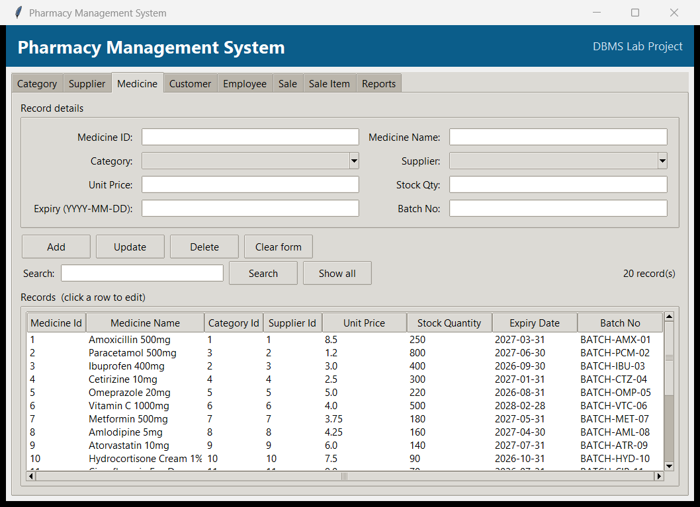

Screenshot 2: Add: the Category form filled in, ready to click Add.
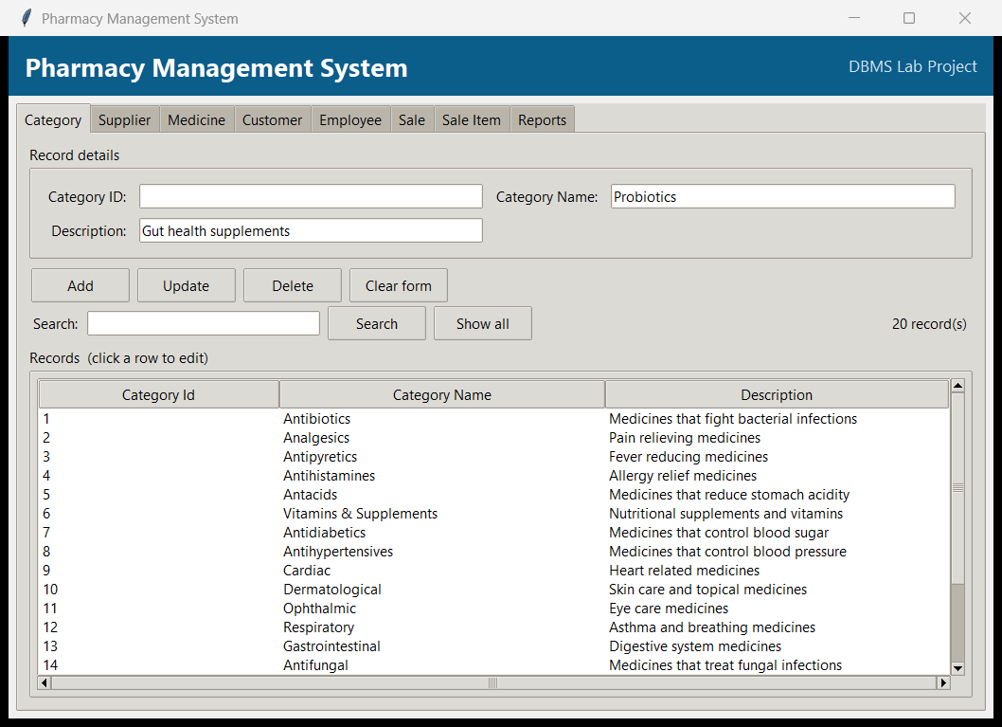

Screenshot 3: Update: a record selected from the list with a field edited, ready to click Update.
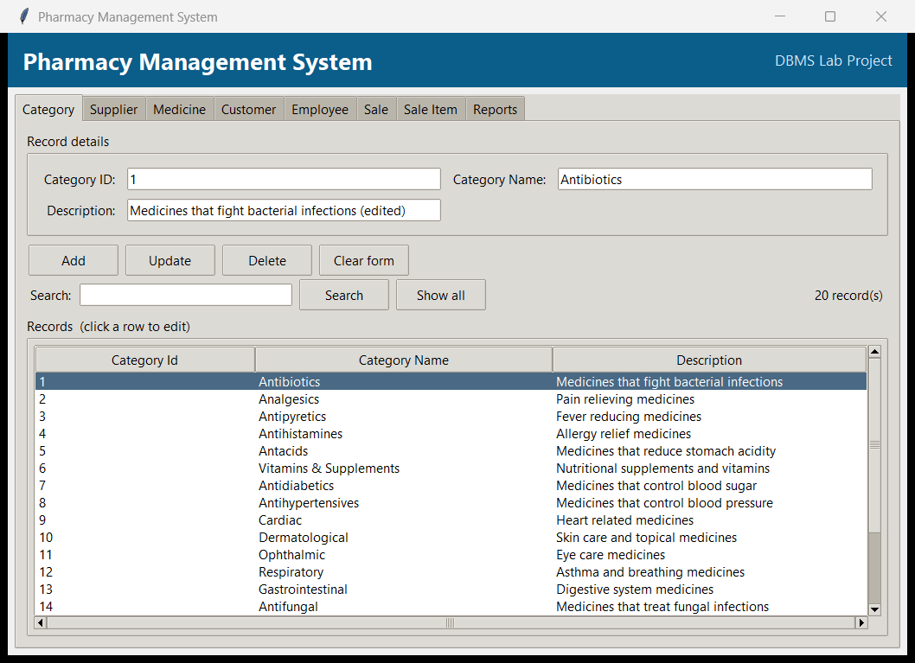

Screenshot 4: Delete: the confirmation dialog shown before a record is removed.
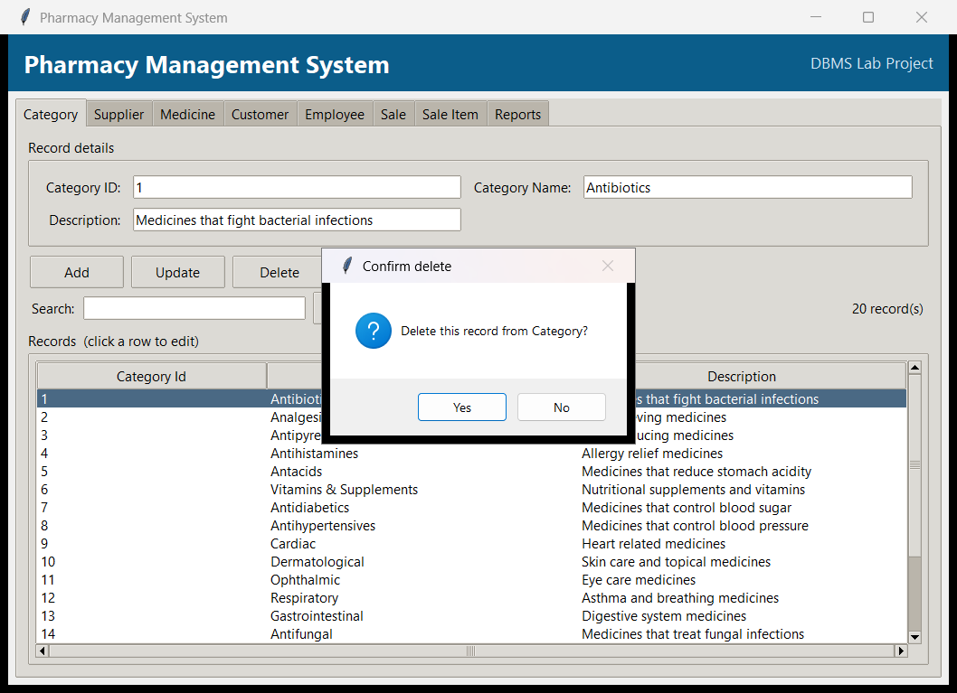

Screenshot 5: Search: medicines filtered by the search term 'Amox'.
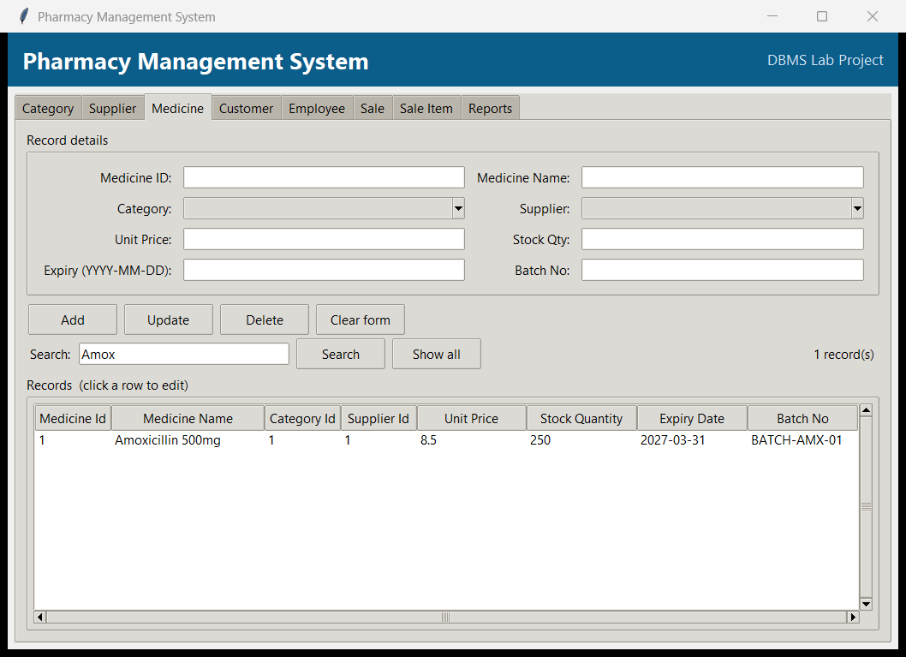

Screenshot 6: Reports: the Invoice details report, built from a multi-table join.
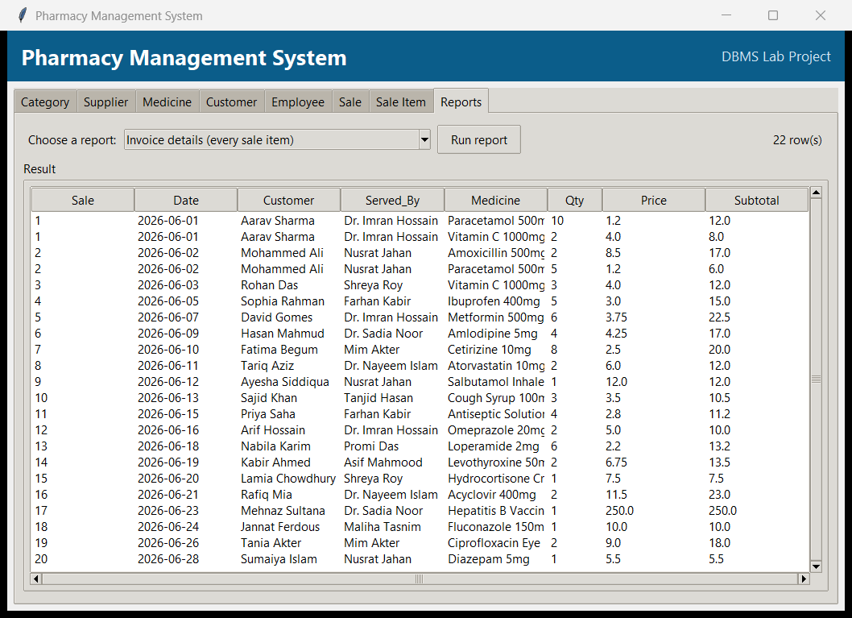

8. How to Run the Project
- Make sure Python 3 is installed (the GUI uses tkinter and sqlite3, which come with Python, so nothing extra is needed to run the app).
- Open a terminal in the project folder.
- Build the database (creates pharmacy.db with all the sample data): python init_db.py
- Start the application: python app.py (the database is also built automatically the first time if it is missing).
- Use the tabs to Add, Update, Delete and Search records, and open the Reports tab to view the reports.

