# Report: Analysis and Resolution of Website Instability

## 1. Executive Summary

This report details my analysis of server logs, which confirms a high-volume bot attack as the root cause of recent website downtime. I have identified the responsible IP addresses and propose an immediate, no-cost solution using an industry-standard service that will resolve the issue and improve overall site performance.

## 2. Problem Analysis & Evidence

A systematic analysis of the provided log file was conducted to identify traffic patterns. The data clearly points to a coordinated, non-human source. This is visualised in the chart below. The top two IP addresses show identical, high-volume activity, which is a definitive sign of an automated script.

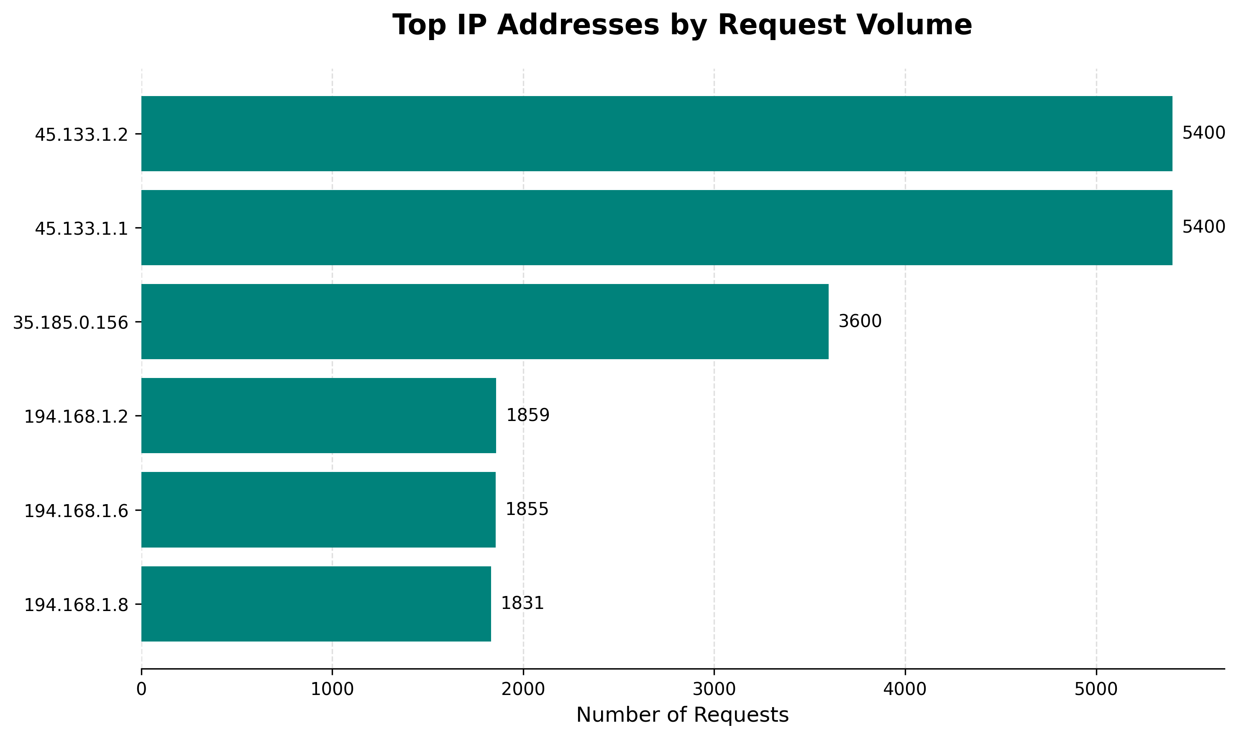

*Figure 1: Request counts from top IP addresses showing clear bot-like symmetry.*

## 3. Recommendations: A Cost-Effective, Layered Defence

Given our startup environment with limited resources, my recommendations prioritise solutions that are free, effective, and require minimal implementation time.  
  
Primary Recommendation: Implement Cloudflare's Free Tier. Cloudflare is a market-leading Web Application Firewall (WAF) and Content Delivery Network (CDN) [1]. By routing our traffic through their service, we can automatically block malicious traffic before it reaches our server and simultaneously boost site performance for legitimate users [2].  
  
Secondary Recommendation: Configure Server-Side Rate Limiting. As a best practice, we should also configure our existing web server (e.g., Nginx) to temporarily block IPs that make an excessive number of requests. This is a standard module used for mitigating DDoS attacks and brute-force attempts [3].

## 4. Conclusion & Business Impact

By implementing these measures, we will immediately stabilise the platform. This will eliminate productivity loss from fighting server issues and allow our engineering team to refocus on building value-adding features for our subscribers.

## 5. References

**[1]** Cloudflare, Inc. (2024). *What is a WAF? | Web Application Firewall*. [Online]. Available at: https://www.cloudflare.com/learning/ddos/glossary/web-application-firewall-waf/

**[2]** Cloudflare, Inc. (2024). *Cloudflare Free Plan*. [Online]. Available at: https://www.cloudflare.com/plans/free/

**[3]** Nginx, Inc. (2024). *Module ngx_http_limit_req_module*. [Online]. Available at: http://nginx.org/en/docs/http/ngx_http_limit_req_module.html