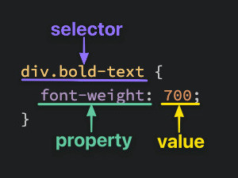

* is the universal selector

.my-class {} : class selector
#my-id {} : ID selector
.first-class, .second-class {} : Grouping selector, when two groups of elements share some style declarations
.first-class.second-class {} : Chaining selectors

.first-class .second-class {} : Descendant combinator

Common properties

color
background-color
font-family : always have fall back fonts in case the one you use is not supported
font-size
font-weight : usually between 100-900 (700 being bold)
text-align
height / width : can use auto on one and give a value to the other

margin : increases the space between a box and any others that sit next to it
padding : increases the space between the edge of a box and the content inside of it
Borders : increases the space between the margin and the padding

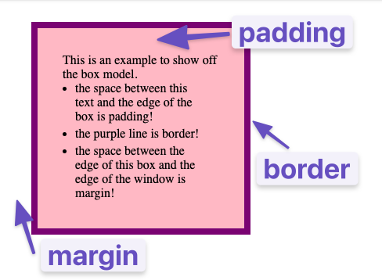

box-sizing: border-box; : makes it so that the padding and border size is subtracted from the specified width/height

CSS rules of cascade

Specificity : inline > ID > Class > Type
Inheritance
Rule Order : the last rule wins in a tie-break

Additional Resources:
CSS Foundations by Odin Project
https://www.theodinproject.com/lessons/foundations-css-foundations

The CSS cascade
https://wattenberger.com/blog/css-cascade

CSS Specificity
https://www.w3schools.com/css/css_specificity.asp

Tips and tricks on font family
https://www.bitdegree.org/learn/font-family-css#how-to-use-a-downloaded-font

Mozilla CSS reference
https://developer.mozilla.org/en-US/docs/Web/CSS/Reference#index

Get started with viewing and changing the DOM
https://developer.chrome.com/docs/devtools/dom/#scroll2
Outer display: Inline vs block boxes
Block
- The box will break onto a new line.
- The width and height properties are respected.
- Padding, margin and border will cause other elements to be pushed away from the box.
- The box will extend in the inline direction to fill the space available in its container. In most cases, the box will become as wide as its container, filling up 100% of the space available.
Inline
- The box will not break onto a new line.
- The width and height properties will not apply.
- Vertical padding, margins, and borders will apply but will not cause other inline boxes to move away from the box.
- Horizontal padding, margins, and borders will apply and will cause other inline boxes to move away from the box.

Standard vs alternate box model
the alternate box model does not take into account the padding and border size to display the box
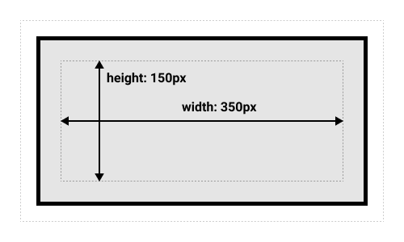
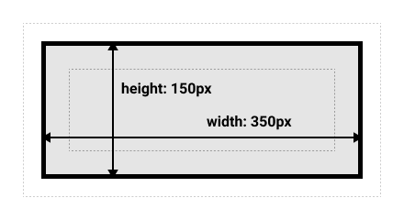
Margin collapsing
Depending on whether two elements whose margins touch have positive or negative margins, the results will be different:

- Two positive margins will combine to become one margin. Its size will be equal to the largest individual margin.
- Two negative margins will collapse and the smallest (furthest from zero) value will be used.
- If one margin is negative, its value will be subtracted from the total.

Div vs span
Div is a block-level element by default. It is commonly used as a container element to group other elements. Divs allow us to divide the page into different blocks and apply styling to those blocks.

Span is an inline-level element by default. It can be used to group text content and inline HTML elements for styling and should only be used when no other semantic HTML element is appropriate.

Flex
flex is a shorthand for 3 properties: flex-grow, flex-shrink and flex-basis

Flex-Grow
flex-grow expects a single number as its value, and that number is used as the flex-item’s “growth factor”. When we applied flex: 1 to every div inside our container, we were telling every div to grow the same amount. The result of this is that every div ends up the exact same size. If we instead add flex: 2 to just one of the divs, then that div would grow to 2x the size of the others.

justify-content : define the horizontal alignment of items

align-items : specifies the default alignment for items inside the flexible container

align-content : similar to align-items, but instead of aligning flex items, it aligns flex lines

align-self : behaves like align-items, but for the flex-item only

flex-direction : choose whether the flexbox behaves as a row or a column

gap : adds space between flex-items

order : choose the order of your flex items (all items have a default order value of 0)

flex-flow : combines flex-direction and flex-wrap (for example you can give it the value of flex-flow: column wrap)

flex-wrap : allows flex-items to wrap when they run out of space (you can also wrap-reverse)

flex: 1 : all your columns are the same width by changing the flex-basis to 0 (1 1 0)

