**Tasks:**

1. Create a new table named product_inventory with columns for product_id, product_name, stock, and price. Insert three different product records with initial stock values. Without committing the transaction, reduce the stock of one of the products and create a savepoint named stock_update.

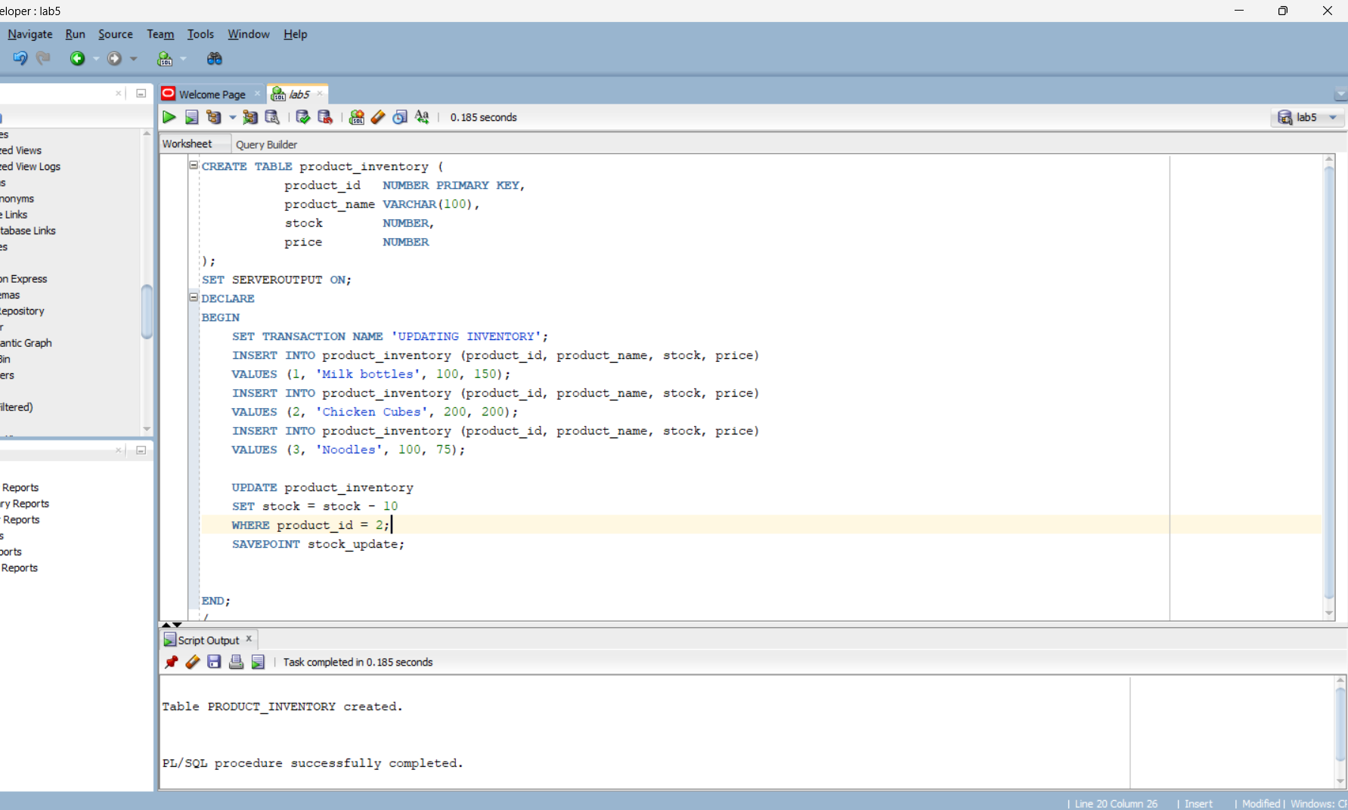

1. In the employee table, add a new employee with a salary. Then, increase their salary by 10%, set a savepoint named salary_increase, and then further increase it by another 5%. Rollback to the salary_increase savepoint.

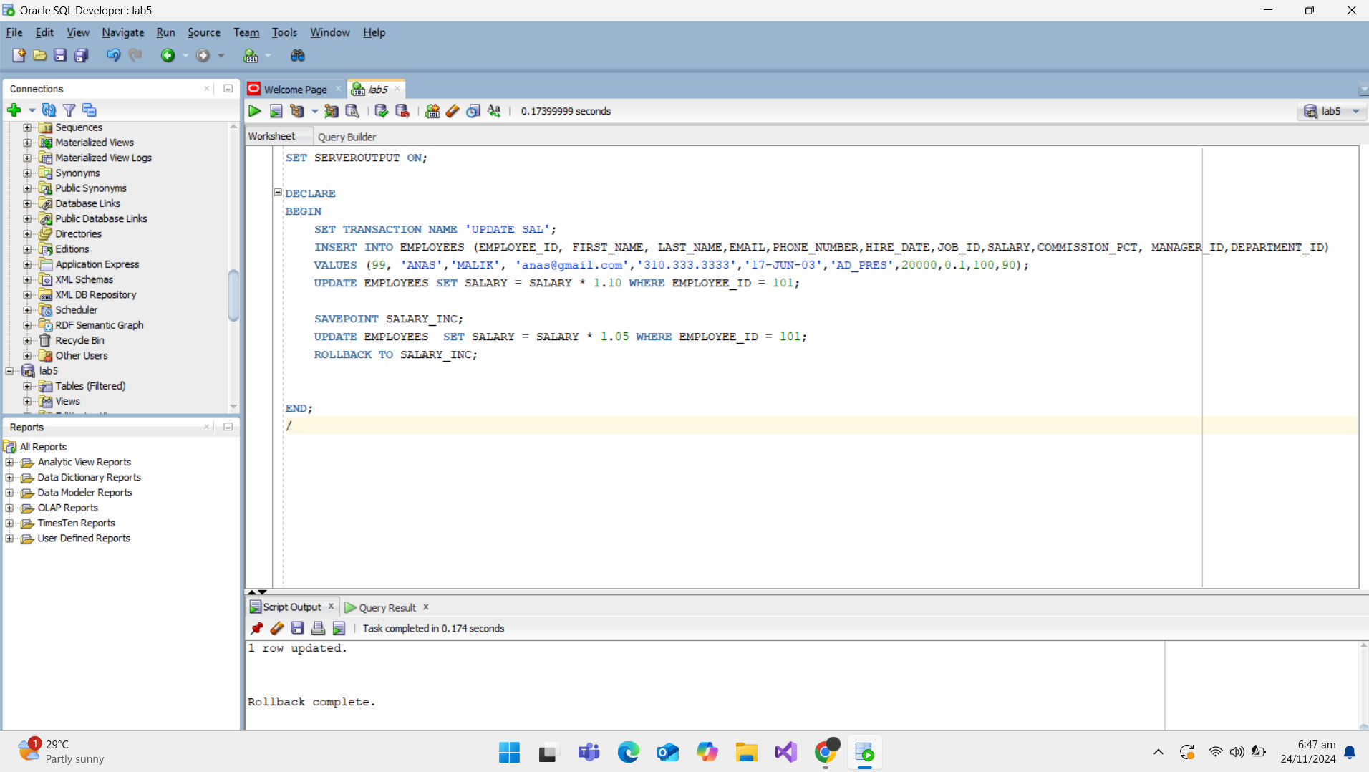

1. Use the customer and orders tables. Insert a new customer into the customer table. Then, insert an order for this customer in the orders table. Use a transaction control to ensure that both the customer and order are inserted only if both statements are successful; otherwise, roll back the changes.

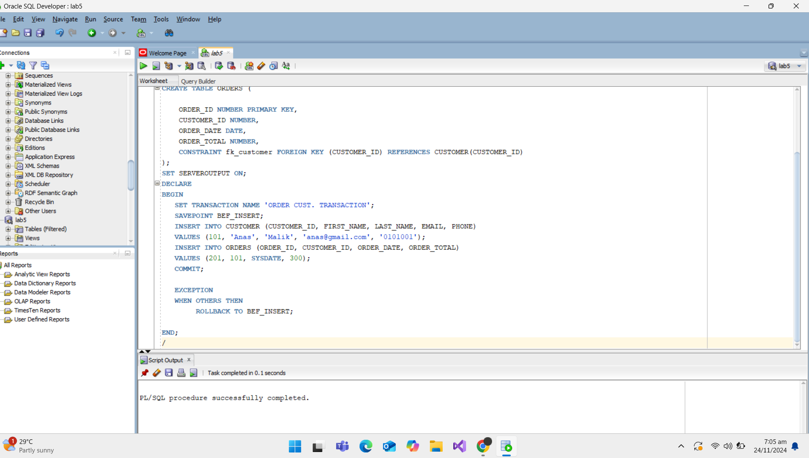

1. Enable AUTOCOMMIT mode in your SQL environment. Insert a row in the sales table with sales_id, customer_id, and amount. After the insertion, check if the row has been committed automatically. Disable AUTOCOMMIT afterward.

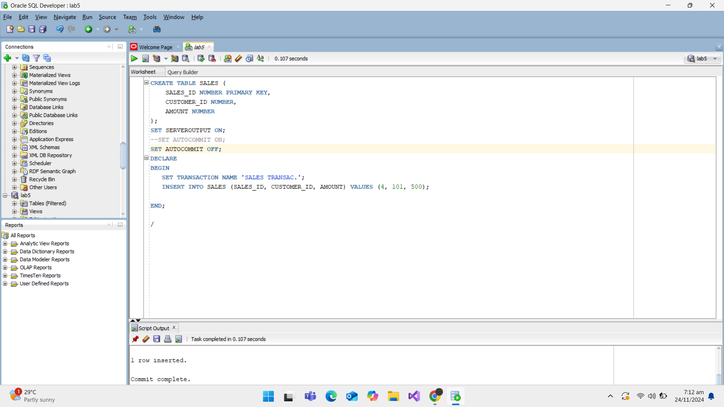

1. Using the transactions table, simulate a transaction where multiple debits and credits are made on an account. Set multiple savepoints after each debit or credit operation, and then rollback to a specific savepoint to undo one of the operations.

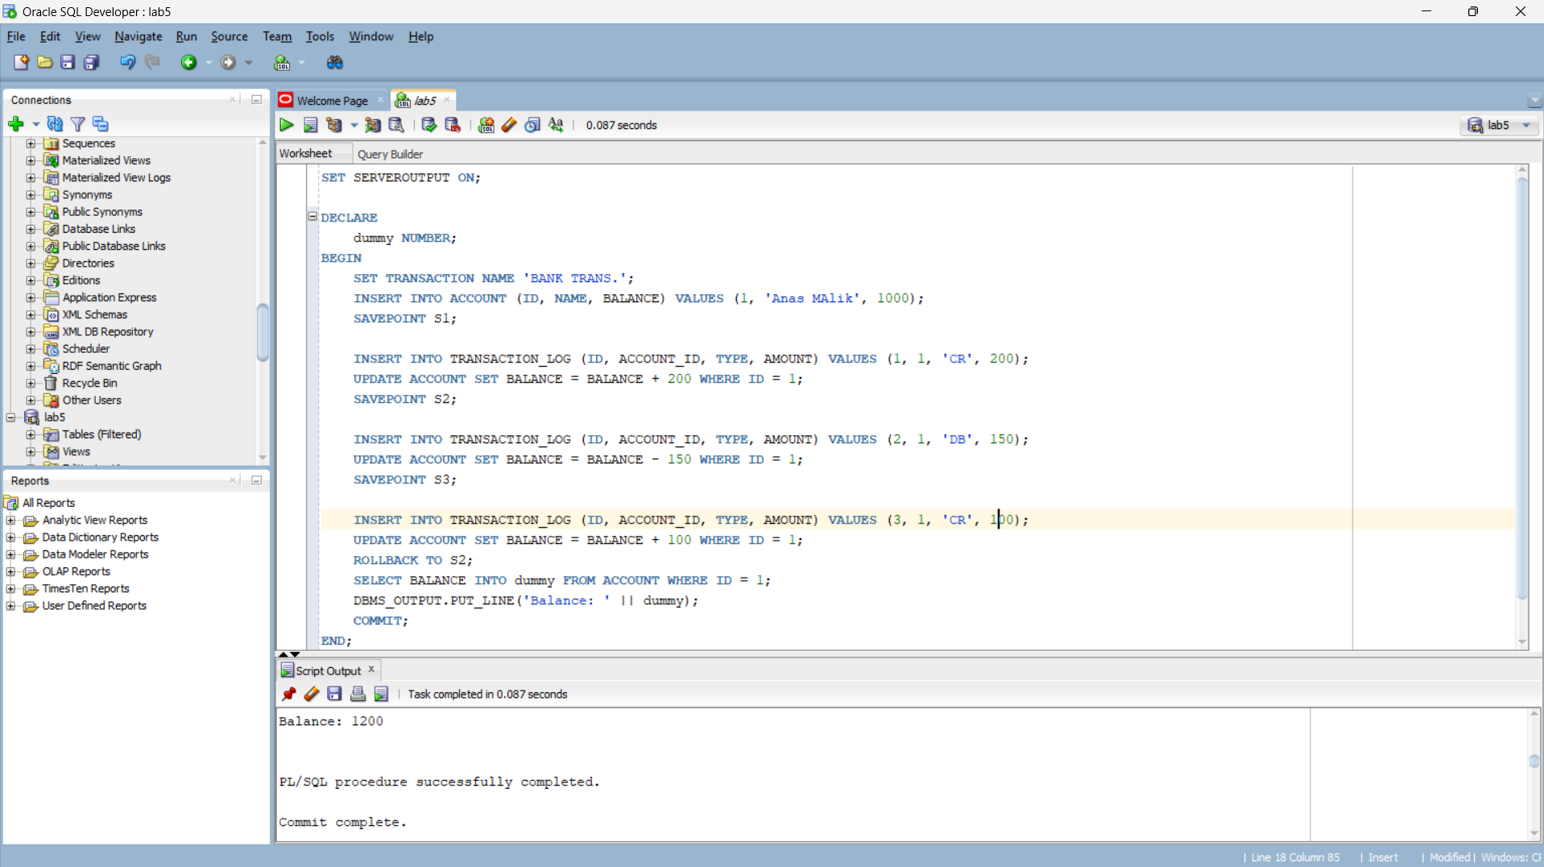

**The End**