PROJECT TECHNICAL REPORT

Design, Deployment and Validation of an Open-Source Security Operations Center (SOC) Laboratory
A WAN / LAN / SOC architecture built with pfSense, Wazuh, MISP, TheHive and Cortex
Prepared by
Anas Dhaha
Date
October 2026

Table of Contents
1. Executive Summary 1
2. Project Overview 1
2.1 Context and Motivation 1
2.2 Objectives 1
2.3 Scope 1
2.4 Technology Selection 1
2.5 Methodology 1
3. Architecture and Environment 1
3.1 Logical Architecture 1
3.2 Network Zones and Addressing 1
3.3 Hardware Environment 1
3.4 Software Environment 1
3.5 Role of Each Component 1
4. Implementation: WAN and LAN Zones 1
4.1 pfSense Gateway Deployment 1
4.2 WAN Zone 1
4.3 LAN Zone 1
4.4 SOC Interface and Zone Isolation 1
5. Implementation: SOC Zone 1
5.1 Wazuh 1
5.2 MISP 1
5.3 TheHive 1
5.4 Cortex 1
6. Configuration and Integration 1
6.1 Custom Detection Rule for pfSense Events 1
6.2 File Integrity Monitoring 1
6.3 Wazuh–MISP Integration 1
6.4 Wazuh Active Response with VirusTotal 1
6.5 Wazuh–TheHive Integration 1
6.6 TheHive Links to Cortex and MISP 1
7. Testing and Results 1
7.1 Test Strategy 1
7.2 T1 – Zone Isolation and pfSense Log Ingestion 1
7.3 T2 – File Integrity Monitoring 1
7.4 T3 – MISP Enrichment 1
7.5 T4 – VirusTotal Detection and Active Response 1
7.6 T5 – TheHive and Cortex Analysis 1
7.7 T6 – End-to-End Alert-to-Case Workflow 1
7.8 Summary of Results 1
8. Challenges and Lessons Learned 1
9. Conclusion and Perspectives 1
9.1 Conclusion 1
9.2 Perspectives 1
References 1
Appendix: List of Acronyms 1

List of Figures
Figure 3.1 Logical architecture of the SOC laboratory: WAN, LAN and SOC zones interconnected by the pfSense gateway
Figure 4.1 Netgate download page – selection of the AMD64 architecture for the pfSense installation image
Figure 4.2 Extraction of the compressed pfSense image with 7-Zip
Figure 4.3 pfSense console menu showing the interface assignment: WAN (em0), LAN (em1) and SOC (OPT1, em2)
Figure 4.4 pfSense web dashboard (Status / Dashboard) accessed from the LAN
Figure 4.5 WAN interface status (em0): address obtained by DHCP from the VMware NAT network
Figure 4.6 LAN interface status (em1): 192.168.10.1/24
Figure 4.7 pfSense LAN rule set including the “Block LAN to SOC (isolation)” rule
Figure 4.8 Isolation rule editor: source LAN subnets, destination SOC subnets, packet logging enabled
Figure 5.1 Wazuh all-in-one installation on the Ubuntu server: system-requirement warnings and installer re-run
Figure 5.2 manage_agents utility on the Wazuh server (v4.14.5): no agent registered yet
Figure 5.3 pfSense remote logging: log server 192.168.20.10:514 with System and Firewall events selected
Figure 5.4 Wazuh ossec.conf: secure agent listener (1514/TCP) and additional syslog listener (514/UDP) restricted to the pfSense address
Figure 5.5 Wazuh manager service status after restart, with the syslog listener bound to port 514
Figure 5.6 “Deploy new agent” wizard of the Wazuh dashboard (Linux, DEB amd64, server address 192.168.20.10)
Figure 5.7 Agent package download and installation on the LAN Kali endpoint, with manager address and agent name set
Figure 5.8 Enabling and starting the wazuh-agent systemd service
Figure 5.9 Endpoints view of the Wazuh dashboard: agent LAN_kali (192.168.10.50) in Active state
Figure 5.10 Agent detail page for LAN_kali: system inventory, MITRE ATT&CK tactics and compliance summary
Figure 5.11 MISP authentication keys: initial key, key used by the Wazuh integration (last seen from 192.168.20.10) and TheHive integration key
Figure 5.12 MISP event “Test EICAR – Wazuh integration” holding the EICAR file hashes
Figure 5.13 TheHive deployment with Docker Compose (Cassandra 4.0 and TheHive 5.2 containers)
Figure 5.14 TheHive login page served on port 9000
Figure 5.15 TheHive administration: creation of a standard user account for analysts
Figure 5.16 TheHive administration: creation of a service account dedicated to the Wazuh integration
Figure 5.17 TheHive case list immediately after deployment (no cases)
Figure 5.18 Cortex deployment with Docker Compose (Cortex 3.1.1 and Elasticsearch 7.17.9)
Figure 5.19 Cortex organisation list after first start: default “cortex” organisation only
Figure 5.20 Cortex organisations after creation of the dedicated “SOC” organisation
Figure 5.21 Cortex users: superadmin “admin” and the “thehive” service account (SOC organisation, read and analyze roles)
Figure 5.22 Cortex: configuration form of the VirusTotal analyzer in the SOC organisation
Figure 6.1 Local rule 100100 in local_rules.xml, raising alerts on pfSense firewall block events
Figure 6.2 syscheck configuration enabling real-time monitoring of /home/kali/RH
Figure 6.3 Integration block of the custom MISP script in ossec.conf
Figure 6.4 ossec.conf excerpt: remove-threat command, active-response definition bound to rule 87105 and custom-thehive integration (API key redacted)
Figure 6.5 TheHive platform management: server definition for Cortex
Figure 6.6 TheHive platform management: new MISP server definition (API key redacted)
Figure 6.7 Confirmation that the MISP server configuration was saved in TheHive
Figure 7.1 Ping from the LAN endpoint to the Wazuh server (192.168.20.10): 100% packet loss
Figure 7.2 Wazuh archives.log: pfSense configuration-change events and filterlog “block” records for the blocked ICMP requests
Figure 7.3 wazuh-logtest session used to inspect the decoding of a sampled log line
Figure 7.4 Test file created in the monitored directory /home/kali/RH
Figure 7.5 FIM events view for agent LAN_kali
Figure 7.6 FIM event list for /home/kali/RH: file added and file deleted events
Figure 7.7 Wazuh integrations.log: MISP lookup of the EICAR MD5, SHA-1 and SHA-256 hashes and the API response
Figure 7.8 Wazuh Discover: alerts of rule group “misp” generated for the EICAR file
Figure 7.9 Malware Detection module: VirusTotal alerts (rule 87105) for the EICAR sample
Figure 7.10 EICAR sample download on the endpoint and troubleshooting of the remove-threat.sh active-response script
Figure 7.11 FIM events showing the sample being added and then deleted
Figure 7.12 Discover view filtered on the EICAR file, showing VirusTotal and active-response fields
Figure 7.13 Expanded alert document for the same file
Figure 7.14 TheHive: creation of the test case for automatic analysis with Cortex
Figure 7.15 Test case in TheHive before any observable is added
Figure 7.16 Adding an observable to the test case
Figure 7.17 Test case observables: IP address 8.8.8.8 tagged TLP:AMBER and PAP:AMBER
Figure 7.18 Cortex Jobs History: VirusTotal_GetReport_3_1 job submitted by the “thehive” service account
Figure 7.19 Cortex analysis report for 8.8.8.8 returned to TheHive: summary and scanner results
Figure 7.20 VirusTotal page of the analysed IP address (cross-check of the report)
Figure 7.21 TheHive alert list: Wazuh alerts “File added to /home/kali/RH/ directory” and “File deleted”
Figure 7.22 Case creation from an alert: empty case or case template
Figure 7.23 Case creation form pre-filled from the alert (title, severity, TLP/PAP and alert details)
Figure 7.24 Adding the agent IP address 192.168.10.50 as an observable
Figure 7.25 Case observables: agent IP address and EICAR MD5 hash
Figure 7.26 Task list of the case
Figure 7.27 Task preview: file verification and host isolation, assigned to the analyst, status In Progress
Figure 7.28 Case task list after the task update
Figure 7.29 Analyzer selection for the hash observable (VirusTotal GetReport)
Figure 7.30 Observables after analysis: report available for the hash observable
Figure 7.31 Analysis report: observables extracted from the report (YARA and Snort rule matches) and VirusTotal summary
Figure 7.32 Analysis report details: SHA-256 of the sample, VirusTotal link, crowdsourced YARA and IDS results
Figure 7.33 Case closure dialog: status, impact and closing summary

1. Executive Summary
This report documents the design, deployment and validation of a virtualised Security Operations Center (SOC) laboratory built exclusively from open-source components. The infrastructure is divided into three network zones – WAN, LAN and SOC – interconnected by a pfSense firewall that enforces segmentation and acts as the single point of traffic control. The SOC zone hosts four platforms that together cover the detect–enrich–investigate–respond cycle: Wazuh (SIEM and XDR), MISP (threat intelligence), TheHive (incident response and case management) and Cortex (automated observable analysis).
The project was carried out incrementally. The pfSense gateway and its three interfaces were deployed first, followed by the Wazuh server, the forwarding of pfSense logs to Wazuh over syslog, and the enrolment of a LAN endpoint as a Wazuh agent. File Integrity Monitoring (FIM) was then enabled and extended through a custom integration with MISP, a VirusTotal-driven active response, and finally the deployment of TheHive and Cortex, with Wazuh alerts forwarded automatically to TheHive. Each step was validated with a controlled, harmless test artefact – the industry-standard EICAR test file – so that every integration could be exercised end to end without risk.
Key outcomes
- Segmentation validated. ICMP traffic from the LAN to the SOC zone is blocked by a dedicated pfSense rule, and each blocked packet is logged (Figure 7.1, Figure 7.2).
- Network telemetry in the SIEM. pfSense system and firewall logs reach Wazuh over syslog (UDP/514) and are converted into alerts by a local rule (ID 100100).
- Endpoint visibility. A LAN endpoint (LAN_kali, 192.168.10.50) is enrolled as a Wazuh agent with real-time FIM on a monitored directory.
- Threat-intelligence enrichment. A custom Wazuh integration queries MISP for the hashes of any file reported by FIM and pushes sightings back to MISP.
- Automated containment. FIM, the VirusTotal integration and a Wazuh Active Response script cooperate to delete a file that VirusTotal flags as malicious (rule 87105).
- Incident handling workflow. Wazuh alerts of level 7 and above are forwarded to TheHive, where analysts open cases, attach observables, launch Cortex analyzers (VirusTotal), execute tasks and close the case with a documented summary.
Beyond demonstrating that the tools interoperate, the laboratory provides a reusable reference platform for SOC experimentation, detection engineering and analyst training. A comparable open-source SOC pipeline – validated against brute-force, network-scan and SQL-injection scenarios in a banking context – is described in reference [1]; this report draws on it to ground design choices and to outline the next steps in Chapter 9.
Report structure. Chapter 2 presents the project overview and technology choices. Chapter 3 describes the architecture and the working environment. Chapters 4 and 5 detail the implementation of the WAN/LAN zones and of the SOC zone respectively. Chapter 6 documents the configuration of the integrations, Chapter 7 the tests and results, Chapter 8 the challenges encountered, and Chapter 9 concludes with perspectives.

2. Project Overview

2.1 Context and Motivation
A Security Operations Center is a centralised function in which a team of security specialists continuously monitors, detects, analyses and responds to security incidents affecting an organisation’s servers, endpoints, network and applications [1, p. 11]. Its effectiveness rests on three complementary pillars – people, processes and technology [1, p. 12]. On the technology side, the Security Information and Event Management (SIEM) platform plays the central role: it collects and correlates event logs from heterogeneous sources, raises alerts when predefined rules or thresholds are met, and produces the reports required for investigation and compliance [1, pp. 13–14].
Commercial SOC tooling is often out of reach for students, small organisations and research groups. This project therefore explores how far a complete SOC pipeline can be built with open-source software alone, in a laboratory that can run on a single workstation yet reproduces the architectural principles of a production environment: network segmentation, centralised logging, threat-intelligence enrichment, case management and automated analysis.

2.2 Objectives
- Deploy a three-zone network (WAN, LAN, SOC) with pfSense as the gateway and enforcement point.
- Install the Wazuh platform and enrol a LAN endpoint as a monitored agent.
- Centralise pfSense logs in Wazuh and turn firewall events into actionable alerts.
- Detect file-system changes with File Integrity Monitoring and enrich them with MISP and VirusTotal intelligence.
- Automate a first containment action through Wazuh Active Response.
- Deploy TheHive and Cortex, connect them to Wazuh and MISP, and validate a complete alert-to-case workflow.

2.3 Scope
The scope covers the three network zones, the five platforms listed above (pfSense, Wazuh, MISP, TheHive, Cortex) and the integrations between them. The laboratory uses plain HTTP between some components, a single Wazuh agent and a single-node deployment of each service. High availability, production-grade TLS, multi-agent scaling and hardening of the guest operating systems are deliberately out of scope and are listed as future work in Chapter 9.

2.4 Technology Selection
The selection of Wazuh as the SIEM follows the comparative analysis of open-source solutions reported in [1, pp. 16–18], summarised in Table 2.1. Wazuh combines SIEM and XDR capabilities in a single platform, covering log analysis, intrusion and malware detection, file integrity monitoring, configuration assessment, vulnerability detection and regulatory compliance [1, pp. 18–19, 23], and it exposes an Integrator module that makes it straightforward to connect external services.
Table 2.1 – Comparison of open-source SIEM candidates (adapted from reference [1], Table 2.4)
Criterion | Wazuh | Graylog | Security Onion
Licence | Free, open source | Open-source edition plus paid options | Free, open source
Deployment effort | Easy installation, good documentation and active community | Simple deployment, intuitive interface | More complex; requires technical expertise
Host-based detection | Yes – host intrusion detection and event analysis | Yes – log analysis and alerts | Yes – advanced network analysis (IDS/NDR)
Network monitoring | Possible through integration | Limited | Very advanced
Hardware needs | Medium | Low to medium | High
Best suited to | SMEs, enterprises, academic projects, advanced SOC | Log centralisation, IT, SMEs | Advanced SOC, threat hunting

The remaining platforms were chosen for their complementary roles. MISP collects, stores and shares indicators of compromise such as malicious IP addresses, domains, file hashes and attack signatures, allowing an organisation to anticipate threats using community-shared intelligence [1, p. 27]. TheHive provides alert management and incident-response case handling; the reference project uses a comparable open-source platform (DFIR-IRIS) for the same purpose [1, p. 27]. Cortex, developed by the TheHive team, removes the manual effort of checking observables by running automated analyzers and responders on demand. Together, Wazuh acts as the “eyes” of the SOC, TheHive as its “operational brain” and Cortex as its automated analysis laboratory.

2.5 Methodology
The deployment followed an incremental, validate-as-you-go approach. Each component was installed and verified in isolation before it was connected to the next, and every integration was exercised with a benign stimulus. The EICAR anti-malware test file [4] was used throughout because its hashes are universally recognised by antivirus engines and threat-intelligence feeds, which makes detections predictable and repeatable while posing no risk to the laboratory.

3. Architecture and Environment

3.1 Logical Architecture
The laboratory architecture, shown in Figure 3.1, separates the infrastructure into three zones connected through a single pfSense instance. The WAN zone represents the Internet and hosts the attacker workstation. The LAN zone represents the protected user network and contains the endpoints and the web server to be defended. The SOC zone is an isolated management network that hosts the monitoring, intelligence and response platforms. Because pfSense is the only path between the zones, every inter-zone flow can be filtered, logged and, if necessary, blocked.
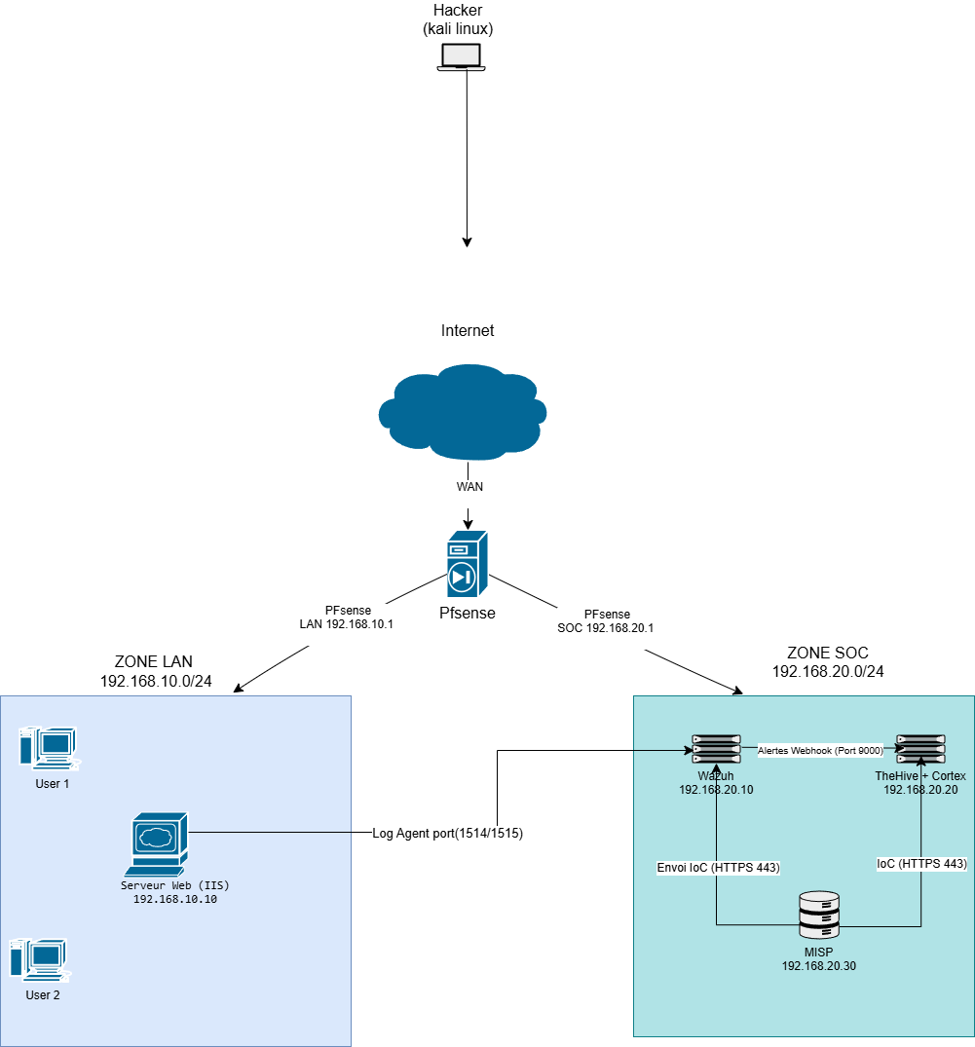
Figure 3.1 – Logical architecture of the SOC laboratory: WAN, LAN and SOC zones interconnected by the pfSense gateway
The diagram highlights the main data flows of the architecture:
- Agent channel – Wazuh agents in the LAN report to the Wazuh server in the SOC zone on ports 1514/1515.
- Network logs – pfSense forwards its system and firewall logs to the Wazuh server using syslog over UDP/514.
- Threat intelligence – the Wazuh server sends indicators (file hashes) to MISP over HTTPS (443) for lookup.
- Incident response – alerts generated by Wazuh are pushed to TheHive, which delegates observable analysis to Cortex and exchanges indicators with MISP.

3.2 Network Zones and Addressing
Each zone is a dedicated /24 network with pfSense holding the .1 address, as detailed in Table 3.2 and Table 3.3. The pfSense virtual machine owns three network adapters – one per zone – while every other virtual machine has a single adapter attached to the VMware virtual network of its zone.
Table 3.2 – Virtual machine inventory and zone placement
Virtual machine | Zone | Operating system | IP address | Role
pfSense | Gateway between the zones | pfSense CE | WAN: NAT (DHCP) · LAN: 192.168.10.1 · SOC: 192.168.20.1 | Firewall / router
Web server | LAN | Ubuntu Server | 192.168.10.10 | Asset to protect (Wazuh agent target)
Wazuh | SOC | Ubuntu Server | 192.168.20.10 | SIEM (indexer + server + dashboard)
TheHive + Cortex | SOC | Ubuntu Server | 192.168.20.20 | Incident response + analysis engine
MISP | SOC | Ubuntu Server | 192.168.20.30 | Threat intelligence

Table 3.3 – VMware network adapter mapping
Virtual machine | Adapters | Connected to
pfSense | 3 | NAT (VMnet8) = WAN · VMnet2 = LAN · VMnet3 = SOC
Web server | 1 | VMnet2 (LAN)
Wazuh | 1 | VMnet3 (SOC)
TheHive + Cortex | 1 | VMnet3 (SOC)
MISP | 1 | VMnet3 (SOC)

Address plan summary: LAN 192.168.10.0/24 (gateway 192.168.10.1) and SOC 192.168.20.0/24 (gateway 192.168.20.1). The WAN interface receives its address from the VMware NAT network.
Note on service endpoints
During the validation phase, the web interfaces of MISP, TheHive (port 9000) and Cortex (port 9001) were all reached at 192.168.20.30, as shown in the screenshots of Chapters 5 to 7. Table 3.2 reflects the initial address plan; the integration URLs used in this report follow the addresses actually observed in the laboratory.

3.3 Hardware Environment
The whole laboratory runs on a single workstation under VMware, as specified in Table 3.1. The 32 GB of RAM and the multi-core processor are sufficient to run the five virtual machines simultaneously.
Table 3.1 – Host hardware used for the laboratory
Characteristic | Value
Computer | Asus TUF A15
Operating system | Windows 11
Processor | AMD Ryzen 5 7000 series
Memory (RAM) | 32 GB
Storage (SSD) | 512 GB
Graphics card | NVIDIA GeForce RTX 2050

For reference, the project described in [1, p. 26] allocated 8 GB of RAM, 2 processor cores and 80 GB of disk to its Wazuh server, and 2.5 GB of RAM, 2 cores and 40 GB to its MISP server, running on Ubuntu 24.04. These figures are a useful baseline when sizing a comparable laboratory.

3.4 Software Environment
Table 3.4 lists the software used. The Wazuh installation assistant deployed the platform in its all-in-one form, in which the indexer, server and dashboard share one host. This layout suits small deployments; for production use, the Wazuh documentation recommends hosting the server and the indexer on separate machines and clustering the indexer for high availability [1, p. 24].
Table 3.4 – Software stack
 | Component | Version / image | Purpose
 | VMware | Workstation hypervisor | Virtualisation of all laboratory machines
 | pfSense CE | 2.8.1-RELEASE (amd64) | Gateway, firewall, syslog source
 | Wazuh | 4.14.x (manager and agent 4.14.5) | SIEM / XDR platform: indexer, server, dashboard, agents
 | MISP | Web application on Ubuntu Server | Threat-intelligence sharing platform
 | TheHive | strangebee/thehive:5.2 with cassandra:4.0 | Alert and case management
 | Cortex | thehiveproject/cortex:3.1.1 with elasticsearch:7.17.9 | Automated analyzers and responders
 | Docker Compose | – | Container orchestration for TheHive and Cortex
 | Kali Linux | 2023.3 (agent endpoint) | LAN endpoint and test workstation

3.5 Role of Each Component
Table 3.5 summarises the contribution of each tool to the SOC and the main data it exchanges with the others.
Table 3.5 – Role of each component in the SOC architecture
Component | Function in the SOC | Main interactions
pfSense | Segmentation, routing and filtering between zones; source of network telemetry | Sends system and firewall logs to Wazuh (syslog UDP/514)
Wazuh | Collects and analyses logs; detects intrusions, file changes and malware; triggers active response | Receives agent and syslog data; queries MISP and VirusTotal; forwards alerts to TheHive
MISP | Stores and shares indicators of compromise | Answers hash lookups from Wazuh; shares indicators with TheHive
TheHive | Alert triage, case management, tasks and collaboration | Receives Wazuh alerts; submits observables to Cortex; connects to MISP
Cortex | Runs analyzers (for example VirusTotal) on observables and returns reports | Receives jobs from TheHive; queries external services

4. Implementation: WAN and LAN Zones
This chapter covers the zones that sit outside the SOC: the WAN, which simulates Internet connectivity, and the LAN, which holds the protected assets. Both are created and controlled through the pfSense gateway, whose deployment is described first.

4.1 pfSense Gateway Deployment
Objective. Provide routing, segmentation and filtering between the WAN, LAN and SOC zones, and act as a source of network telemetry for the SIEM.
Implementation approach. The pfSense CE installation image for the AMD64 architecture was downloaded from the Netgate website (Figure 4.1) and extracted with 7-Zip (Figure 4.2). A virtual machine with three network adapters was created and the system installed; the adapters were then assigned to the WAN, LAN and SOC roles from the console menu.
Configuration details. The console (Figure 4.3) confirms the assignment of em0 to the WAN, em1 to the LAN and em2 to the SOC (OPT1) interface. The resulting configuration is summarised in Table 4.1. The web dashboard (Figure 4.4) is used for all further administration.
Outcome. The gateway is operational with three active interfaces, the system reports version 2.8.1-RELEASE, and the dashboard is reachable from the LAN.
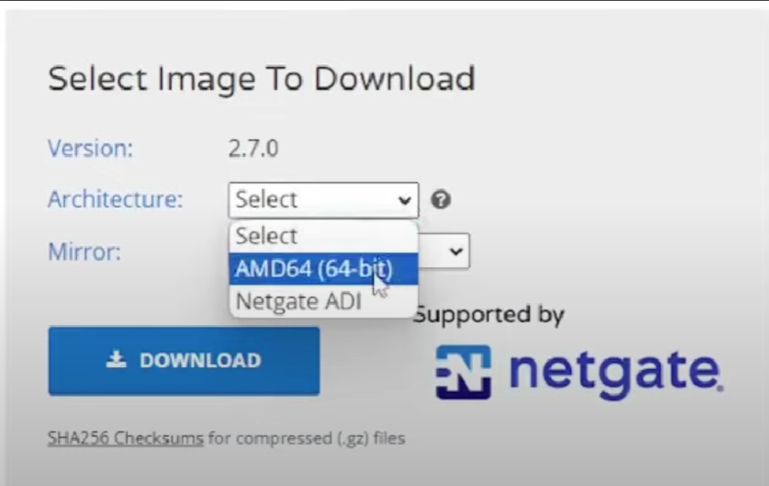
Figure 4.1 – Netgate download page – selection of the AMD64 architecture for the pfSense installation image
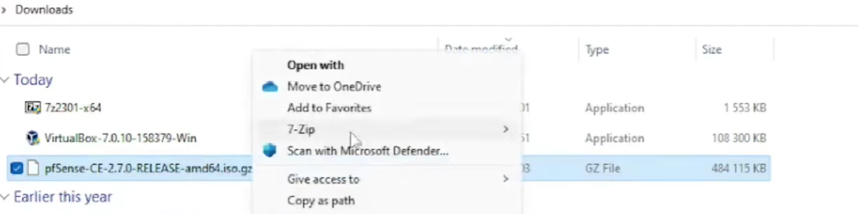
Figure 4.2 – Extraction of the compressed pfSense image with 7-Zip
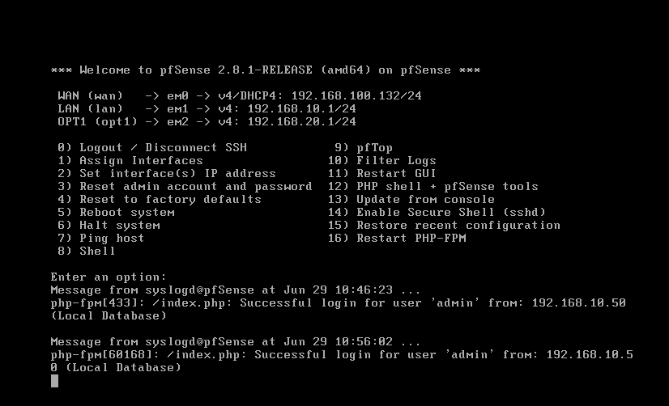
Figure 4.3 – pfSense console menu showing the interface assignment: WAN (em0), LAN (em1) and SOC (OPT1, em2)
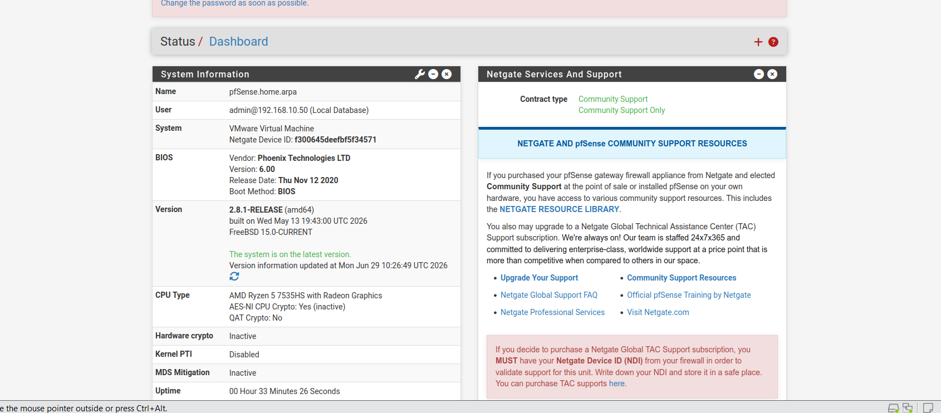
Figure 4.4 – pfSense web dashboard (Status / Dashboard) accessed from the LAN
Table 4.1 – pfSense interface configuration
Zone | Interface | Network adapter | IPv4 configuration
WAN | em0 | VMnet8 (NAT) | DHCP – 192.168.100.132/24, gateway and DNS 192.168.100.2
LAN | em1 | VMnet2 | Static – 192.168.10.1/24
SOC (OPT1) | em2 | VMnet3 | Static – 192.168.20.1/24

4.2 WAN Zone
Objective. Simulate Internet connectivity and provide the origin of external, untrusted traffic.
Implementation approach. The WAN interface is attached to the VMware NAT network (VMnet8) and obtains its configuration by DHCP.
Configuration details. Figure 4.5 shows interface em0 in the “up” state with address 192.168.100.132/24, gateway 192.168.100.2 and the same address as DNS server. The architecture (Figure 3.1) places the attacker workstation in this zone, so that any traffic it generates must traverse pfSense before reaching the LAN or SOC.
Outcome. The gateway has outbound connectivity, which is also required to download packages for the other virtual machines.
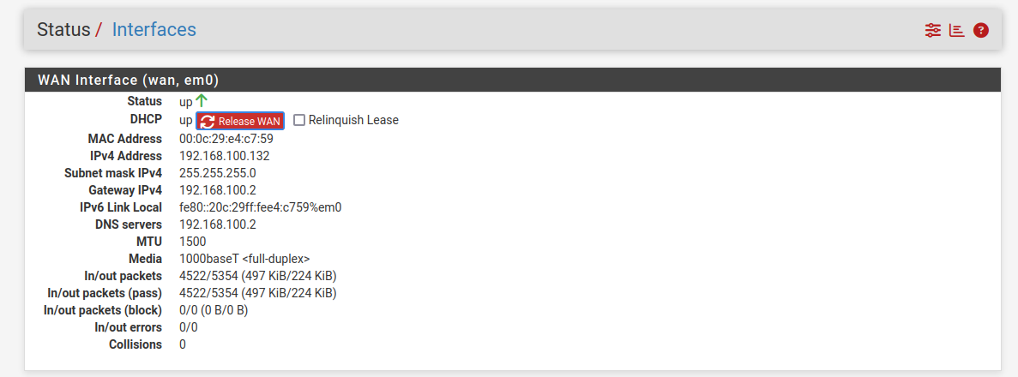
Figure 4.5 – WAN interface status (em0): address obtained by DHCP from the VMware NAT network

4.3 LAN Zone
Objective. Host the protected assets – user workstations, the web server and the monitored endpoint – in a network separated from the SOC.
Implementation approach. The LAN interface em1 is attached to VMnet2 and serves as the default gateway (192.168.10.1) of the 192.168.10.0/24 network.
Configuration details. Figure 4.6 confirms the interface status and address. The LAN contains the web server (192.168.10.10), the asset to be protected, and a Linux endpoint (192.168.10.50) that is later enrolled as the Wazuh agent LAN_kali (Section 5.1.4) and from which the pfSense dashboard is administered (Figure 4.4).
Outcome. The LAN is operational and its traffic is routed and filtered by pfSense.
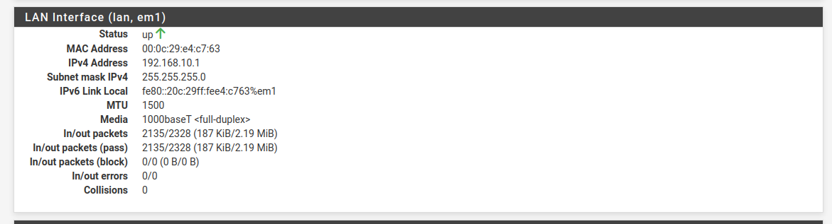
Figure 4.6 – LAN interface status (em1): 192.168.10.1/24

4.4 SOC Interface and Zone Isolation
Objective. Prevent unrestricted access from the user network to the security tooling, so that a compromised LAN host cannot tamper with the SOC platforms.
Implementation approach. The SOC interface (em2, 192.168.20.1/24) was added as OPT1 and a blocking rule was created on the LAN interface.
Configuration details. The rule, visible in Figure 4.7 and detailed in Figure 4.8, matches IPv4 traffic with the LAN subnets as source and the SOC subnets as destination, uses the action Block, and has the option “Log packets that are handled by this rule” enabled. Logging is essential: it is the firewall log entries generated by this rule that are later forwarded to Wazuh (Section 5.1.3). Only the Wazuh agent channel (ports 1514/1515, see Figure 3.1) is intended to cross from the LAN to the SOC zone.
Outcome. Pings from the LAN endpoint to the Wazuh server fail with 100% packet loss, proving that isolation is effective (Chapter 7, Figure 7.1).
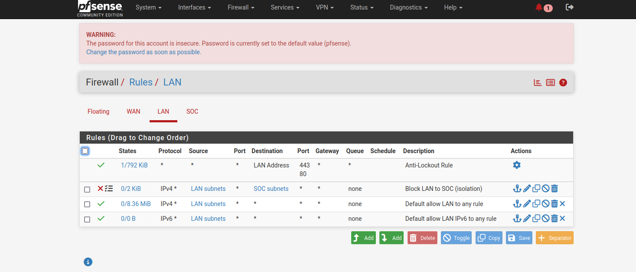
Figure 4.7 – pfSense LAN rule set including the “Block LAN to SOC (isolation)” rule
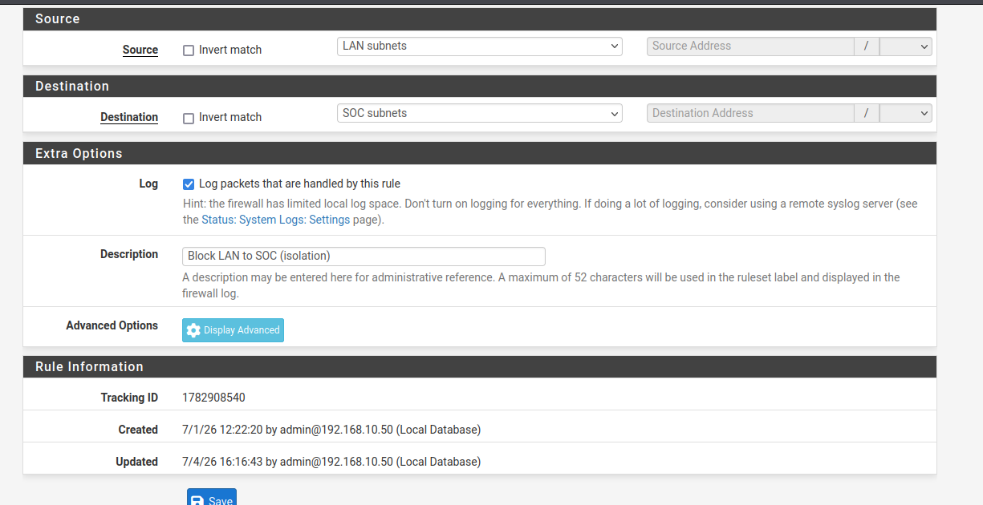
Figure 4.8 – Isolation rule editor: source LAN subnets, destination SOC subnets, packet logging enabled
Security note
The dashboard banner visible in Figure 4.7 warns that the administrator account still uses the default password. In any environment beyond an isolated laboratory, the password must be changed immediately after installation.

5. Implementation: SOC Zone
The SOC zone (192.168.20.0/24) hosts the four platforms that perform monitoring, intelligence, investigation and analysis. Table 5.1 lists the services and ports used by the laboratory; the following sections describe the deployment of each platform in the order in which it was built.
Table 5.1 – Service endpoints and ports used in the laboratory
Service | Address / port | Protocol | Used by
Wazuh dashboard | 192.168.20.10 : 443 | HTTPS | Analysts
Wazuh agent communication | 192.168.20.10 : 1514 / 1515 | TCP | Wazuh agents (LAN)
Wazuh syslog receiver | 192.168.20.10 : 514 | UDP | pfSense
MISP web interface and API | 192.168.20.30 : 80/443 | HTTP(S) | Wazuh integration, TheHive, analysts
TheHive | 192.168.20.30 : 9000 | HTTP | Wazuh integration, analysts
Cortex | 192.168.20.30 : 9001 | HTTP | TheHive, analysts

5.1 Wazuh

5.1.1 Role and components
Wazuh is an open-source platform that merges XDR and SIEM capabilities. Its architecture has four main parts [1, pp. 23–24]: the Wazuh agent, a lightweight program installed on each monitored endpoint that collects logs, process activity and file changes; the Wazuh server, which decodes the received data, applies detection rules and generates alerts; the Wazuh indexer, a search engine that stores and indexes alerts and events as JSON documents; and the Wazuh dashboard, the web console used to explore alerts and manage the platform. Devices on which no agent can be installed – firewalls, switches, routers – can still send their logs to the server through standard protocols such as syslog [1, p. 24]; this is precisely how pfSense is integrated in this project.

5.1.2 Installation
Objective. Deploy a complete Wazuh stack (indexer, server and dashboard) on the SOC virtual machine at 192.168.20.10.
Implementation approach. After updating the package index (sudo apt update), the installation assistant for the 4.14 branch was downloaded and run in all-in-one mode: curl -sO https://packages.wazuh.com/4.14/wazuh-install.sh followed by sudo bash wazuh-install.sh -a.
Configuration details. The installer checked the host before proceeding. As shown in Figure 5.1, it issued a warning that the operating system is not part of its list of recommended systems and then stopped with an error because the virtual machine did not meet its recommended minimum hardware requirements; the message indicates the -i option to ignore these checks. The installation was therefore re-run with sudo bash wazuh-install.sh -a -i, which completed the installation of the components and announced that the web interface would be available on port 443.
Outcome. The Wazuh manager runs (wazuh-manager.service active, Figure 5.5), the manage_agents utility reports version 4.14.5 and an empty agent list (Figure 5.2), and the dashboard is reachable over HTTPS at 192.168.20.10.
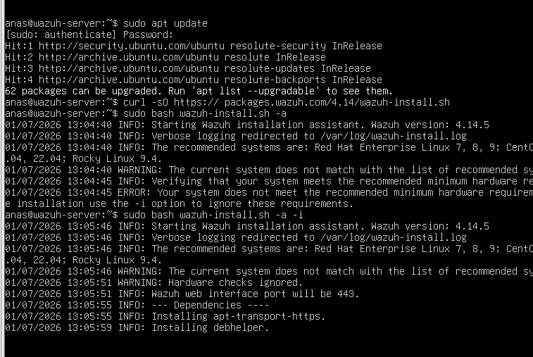
Figure 5.1 – Wazuh all-in-one installation on the Ubuntu server: system-requirement warnings and installer re-run
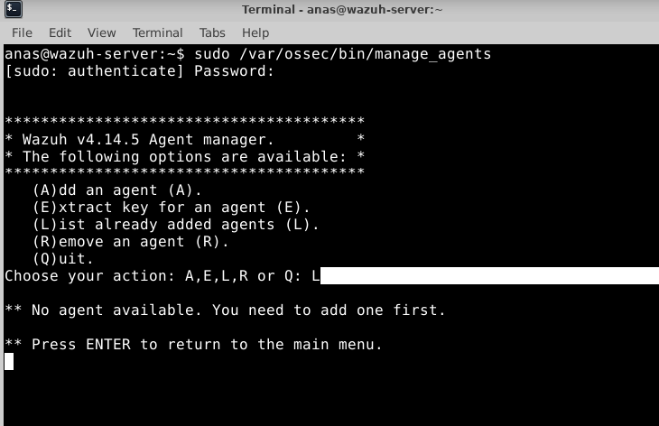
Figure 5.2 – manage_agents utility on the Wazuh server (v4.14.5): no agent registered yet

5.1.3 Reception of pfSense logs
Objective. Give the SIEM visibility on the gateway’s activity – configuration changes, DHCP events and, above all, firewall decisions – without installing an agent on pfSense.
Implementation approach. pfSense is configured as a syslog client and Wazuh as a syslog server, with the listener restricted to the pfSense address.
Configuration details. In pfSense (Status › System Logs › Settings), the remote log server is set to 192.168.20.10:514 and the “System Events” and “Firewall Events” categories are selected (Figure 5.3). On the Wazuh server, a second <remote> block is added to /var/ossec/etc/ossec.conf next to the default secure listener (Figure 5.4):
<remote>
<connection>syslog</connection>
<port>514</port>
<protocol>udp</protocol>
<allowed-ips>192.168.20.1</allowed-ips>
</remote>

After restarting wazuh-manager, the service status and the open sockets confirm that the manager listens on port 514 (Figure 5.5). The allowed-ips directive ensures that only the pfSense SOC interface can inject syslog messages, which limits the risk of log forgery from other hosts.
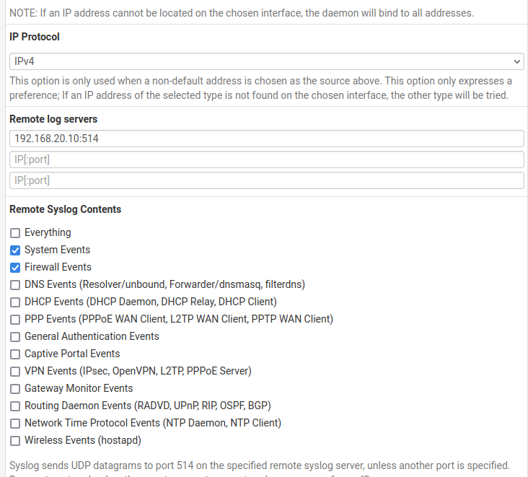
Figure 5.3 – pfSense remote logging: log server 192.168.20.10:514 with System and Firewall events selected
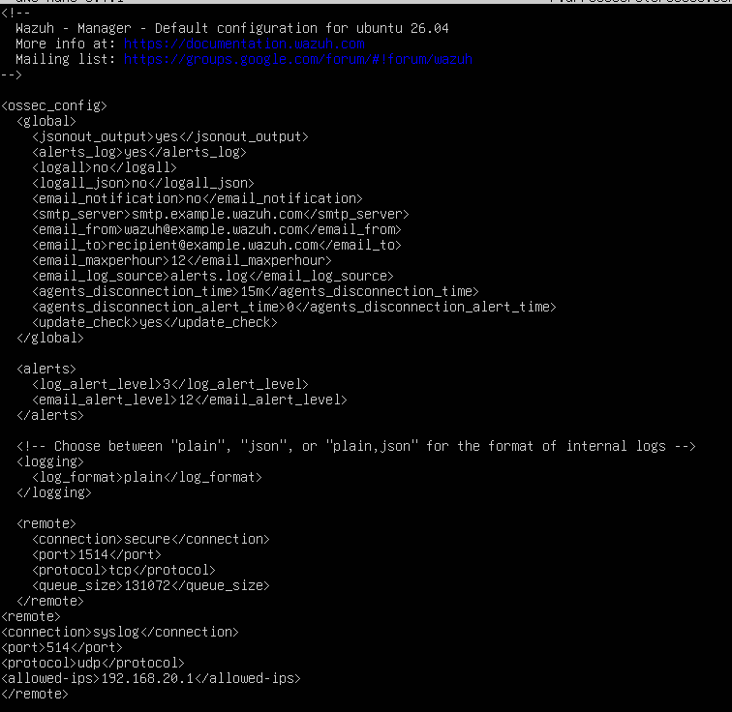
Figure 5.4 – Wazuh ossec.conf: secure agent listener (1514/TCP) and additional syslog listener (514/UDP) restricted to the pfSense address
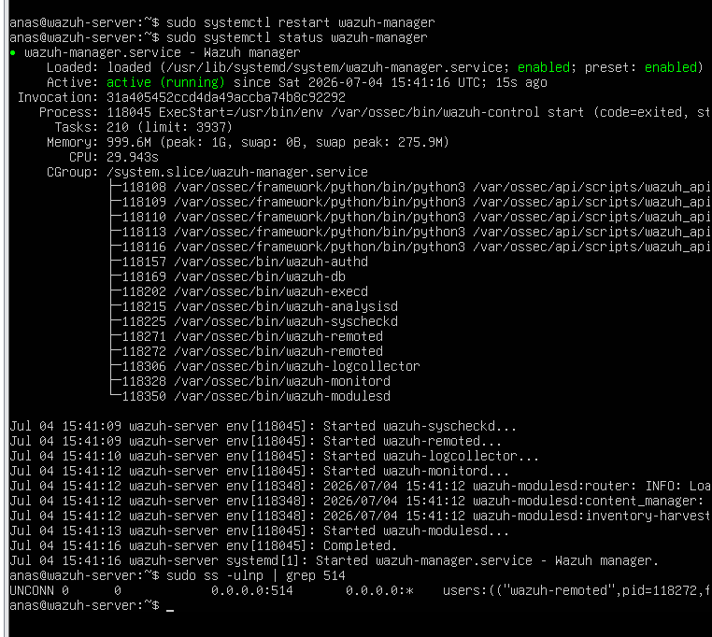
Figure 5.5 – Wazuh manager service status after restart, with the syslog listener bound to port 514

5.1.4 Agent deployment on the LAN endpoint
Objective. Collect host-level telemetry (logs and file-integrity data) from a LAN endpoint.
Implementation approach. The “Deploy new agent” wizard of the Wazuh dashboard (Figure 5.6) generates the installation command for the chosen platform (Linux, DEB amd64) and server address (192.168.20.10). On the LAN Kali endpoint, the agent package was downloaded and installed with the manager address and the agent name passed as environment variables (Figure 5.7), then enabled and started as a systemd service (Figure 5.8).
Configuration details. The commands executed on the endpoint were:
wget https://packages.wazuh.com/4.x/apt/pool/main/w/wazuh-agent/wazuh-agent_4.14.5-1_amd64.deb
sudo WAZUH_MANAGER='192.168.20.10' WAZUH_AGENT_NAME='LAN_kali' dpkg -i ./wazuh-agent_4.14.5-1_amd64.deb
sudo systemctl daemon-reload
sudo systemctl enable wazuh-agent
sudo systemctl start wazuh-agent

Outcome. The Endpoints view (Figure 5.9) shows one agent in Active state – ID 001, name LAN_kali, address 192.168.10.50, Kali GNU/Linux 2023.3, version 4.14.5 – and the agent page (Figure 5.10) exposes its system inventory, the MITRE ATT&CK tactics observed and its compliance status. This also confirms that the agent channel can cross the LAN-to-SOC boundary.
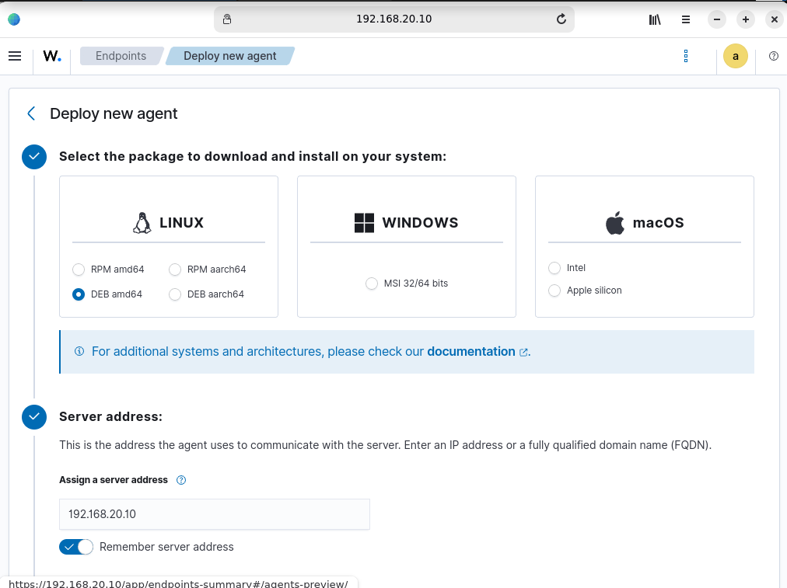
Figure 5.6 – “Deploy new agent” wizard of the Wazuh dashboard (Linux, DEB amd64, server address 192.168.20.10)
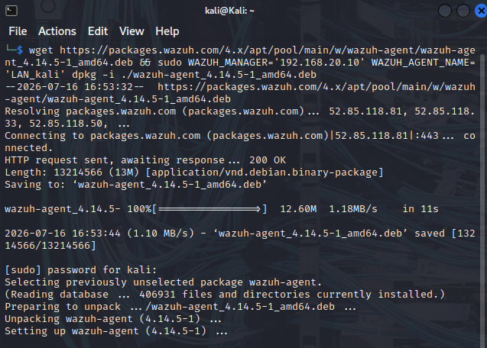
Figure 5.7 – Agent package download and installation on the LAN Kali endpoint, with manager address and agent name set
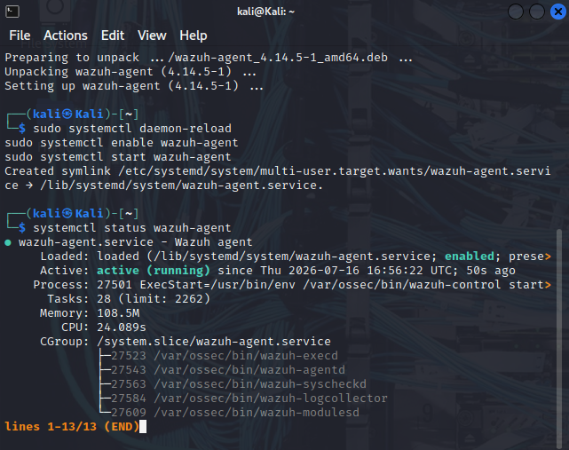
Figure 5.8 – Enabling and starting the wazuh-agent systemd service
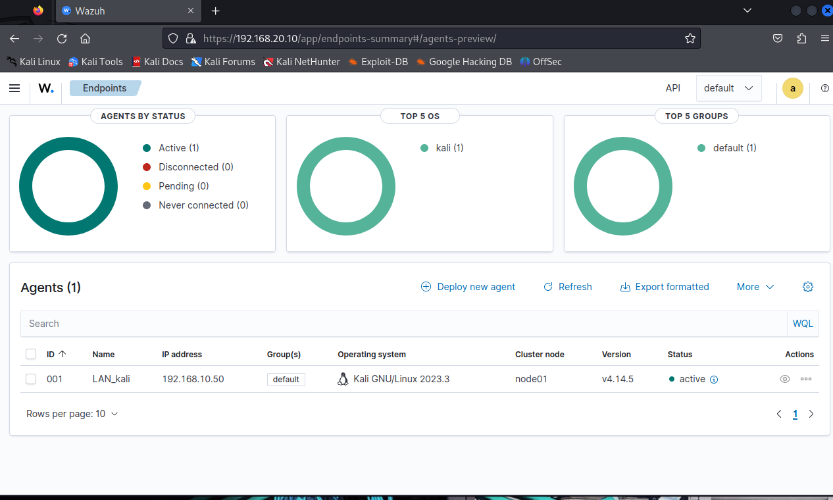
Figure 5.9 – Endpoints view of the Wazuh dashboard: agent LAN_kali (192.168.10.50) in Active state
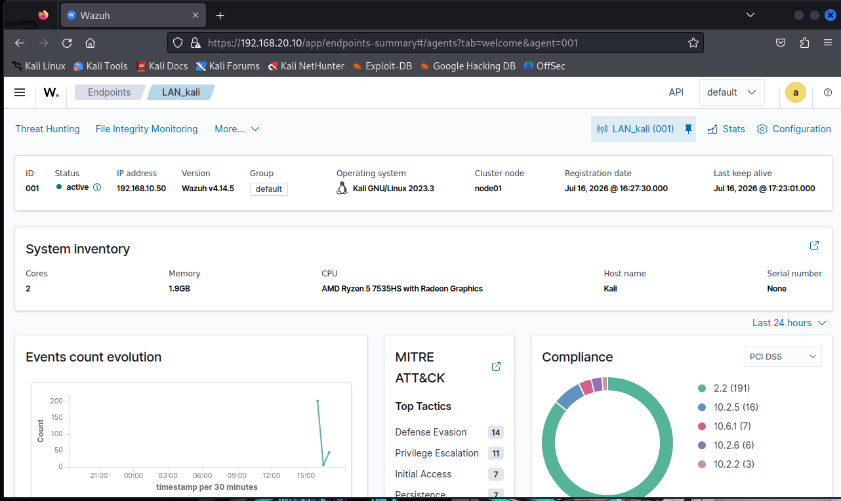
Figure 5.10 – Agent detail page for LAN_kali: system inventory, MITRE ATT&CK tactics and compliance summary

5.2 MISP

5.2.1 Role
MISP (Malware Information Sharing Platform) is the threat-intelligence component of the SOC. It stores indicators of compromise – malicious IP addresses, suspicious domains, hazardous file hashes and attack signatures – and allows their collection, correlation and sharing [1, p. 27]. In this laboratory it answers the hash lookups issued by Wazuh and exchanges indicators with TheHive.

5.2.2 Preparation for the integrations
Objective. Make MISP ready to be queried by Wazuh and TheHive.
Implementation approach. MISP runs on its own Ubuntu Server virtual machine in the SOC zone (192.168.20.30) and is administered through its web interface. Two API credentials were prepared: one for the Wazuh integration and one for TheHive.
Configuration details. The authentication-keys page (Figure 5.11) lists the initial auto-generated key and the keys created for the integrations; the key used by Wazuh is recorded as last seen from 192.168.20.10, the Wazuh server, which evidences that the integration reached MISP. To obtain a deterministic positive match, an event named “Test EICAR – Wazuh integration” was created and populated with the MD5, SHA-1 and SHA-256 hashes of the EICAR test file (Figure 5.12):
MD5 : 44d88612fea8a8f36de82e1278abb02f
SHA-1 : 3395856ce81f2b7382dee72602f798b642f14140
SHA-256: 275a021bbfb6489e54d471899f7db9d1663fc695ec2fe2a2c4538aabf651fd0f

Outcome. MISP holds a known-malicious reference set against which Wazuh can be tested, and dedicated API keys allow each client to be identified and revoked independently.
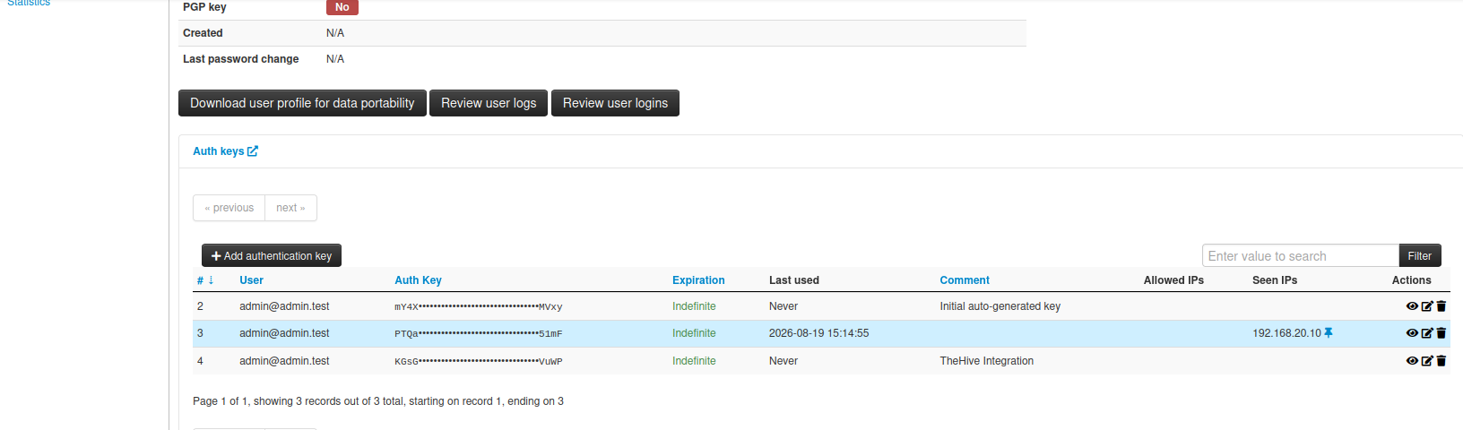
Figure 5.11 – MISP authentication keys: initial key, key used by the Wazuh integration (last seen from 192.168.20.10) and TheHive integration key
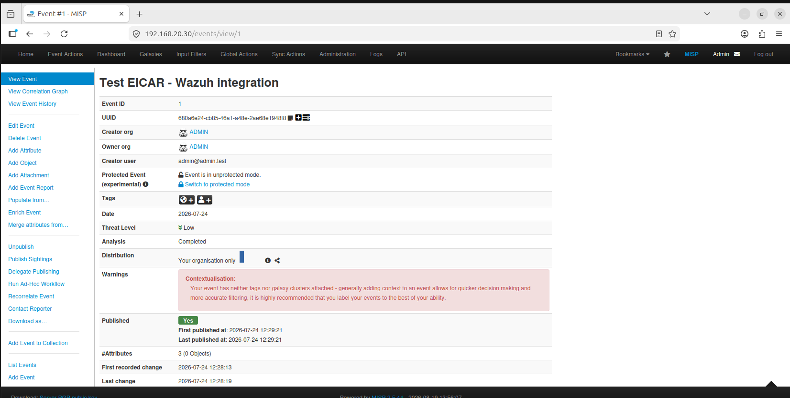
Figure 5.12 – MISP event “Test EICAR – Wazuh integration” holding the EICAR file hashes

5.3 TheHive

5.3.1 Role
TheHive is an open-source platform for security incident response and alert management, a core building block of a SOAR-style architecture. Wazuh detects anomalies and raises alerts; TheHive is where the analyst triages them, investigates, collaborates and resolves the incident through cases, observables and tasks.

5.3.2 Deployment
Objective. Provide a case-management console for the SOC and receive alerts from Wazuh.
Implementation approach. TheHive was deployed with Docker Compose in a dedicated directory: mkdir -p ~/thehive && cd ~/thehive, creation of docker-compose.yml, then sudo docker compose up -d.
Configuration details. The deployment pulled the cassandra:4.0 and strangebee/thehive:5.2 images, created the network and the two data volumes, and started the thehive_cassandra and thehive containers (Figure 5.13). The web application is served on port 9000 (Figure 5.14). Two accounts were then created in the administration area: a standard user for the analyst (Figure 5.15) and a service account dedicated to the Wazuh integration (Figure 5.16). Using a service account for machine-to-machine access keeps automated activity separate from human activity in the audit trail.
Outcome. TheHive starts with an empty case list (Figure 5.17), ready to receive alerts.
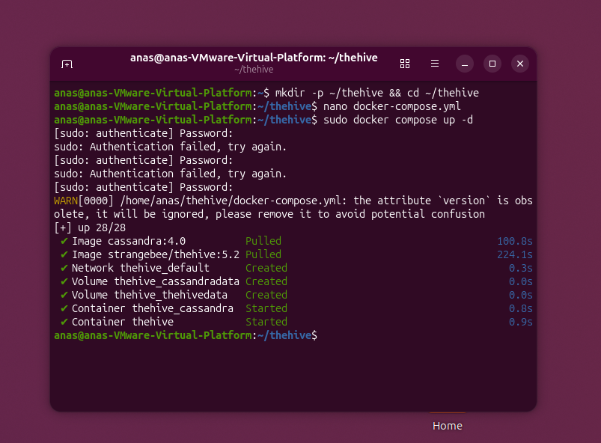
Figure 5.13 – TheHive deployment with Docker Compose (Cassandra 4.0 and TheHive 5.2 containers)
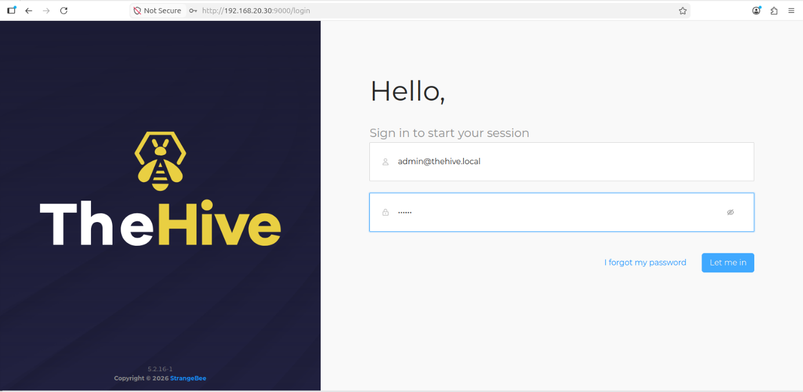
Figure 5.14 – TheHive login page served on port 9000
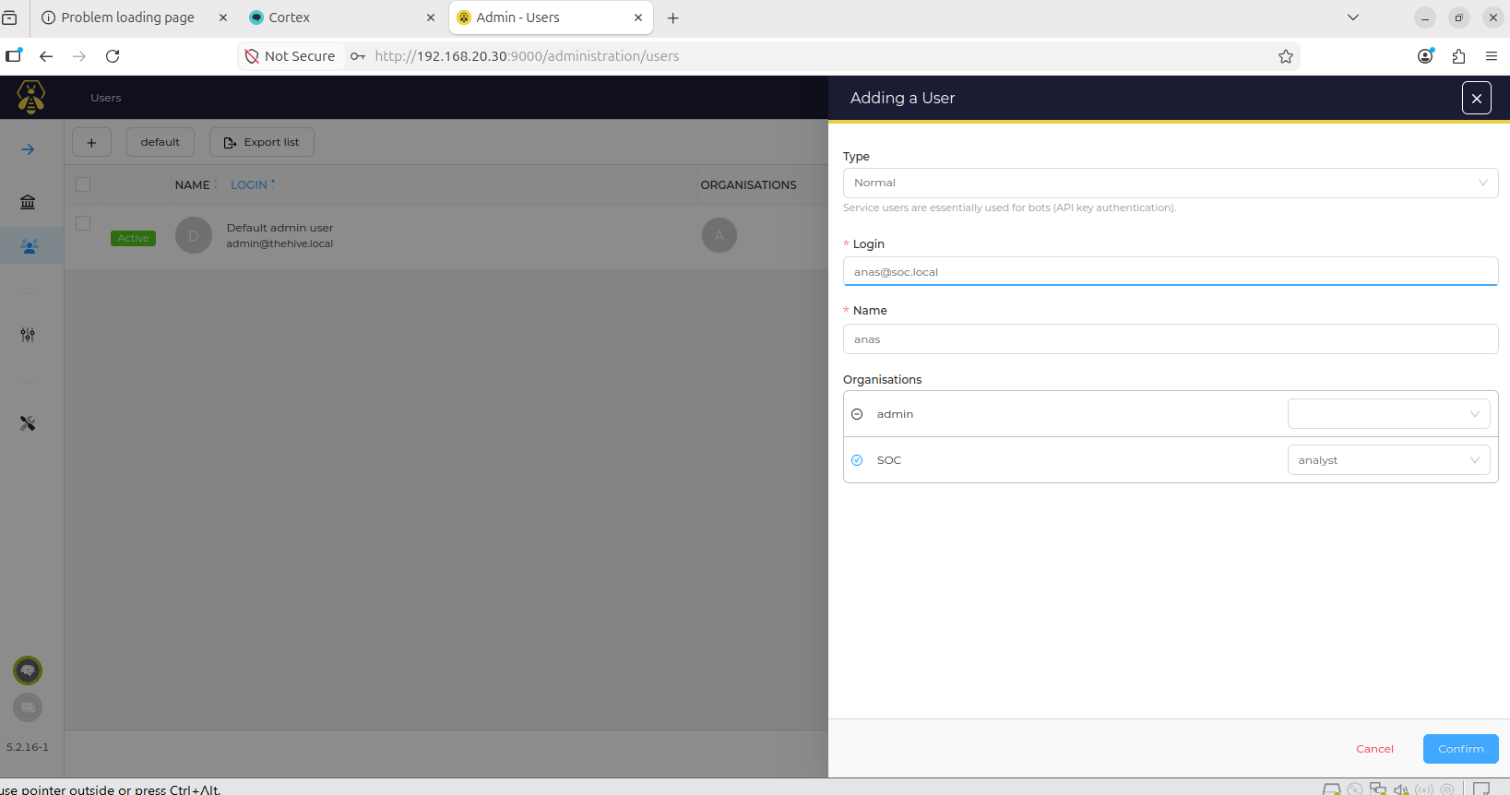
Figure 5.15 – TheHive administration: creation of a standard user account for analysts
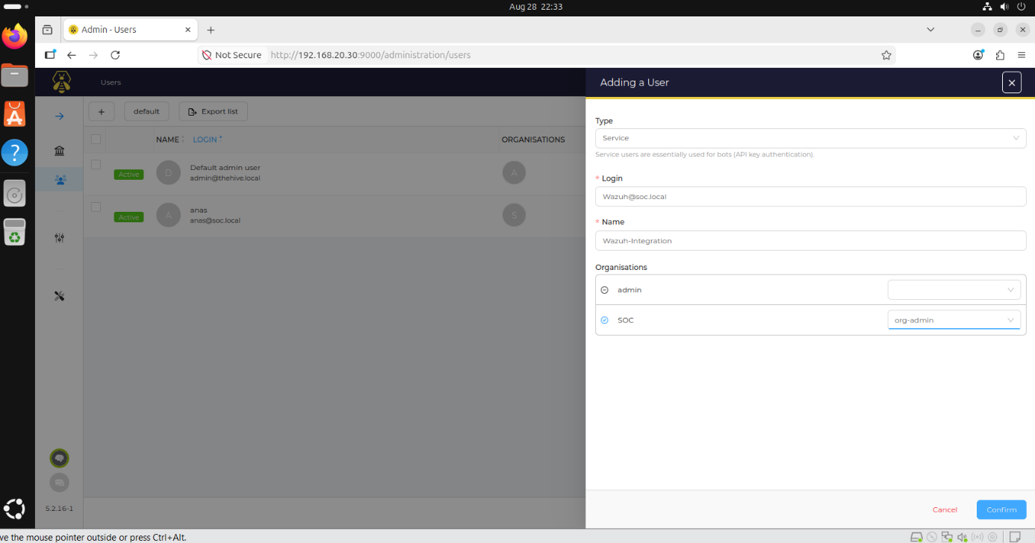
Figure 5.16 – TheHive administration: creation of a service account dedicated to the Wazuh integration
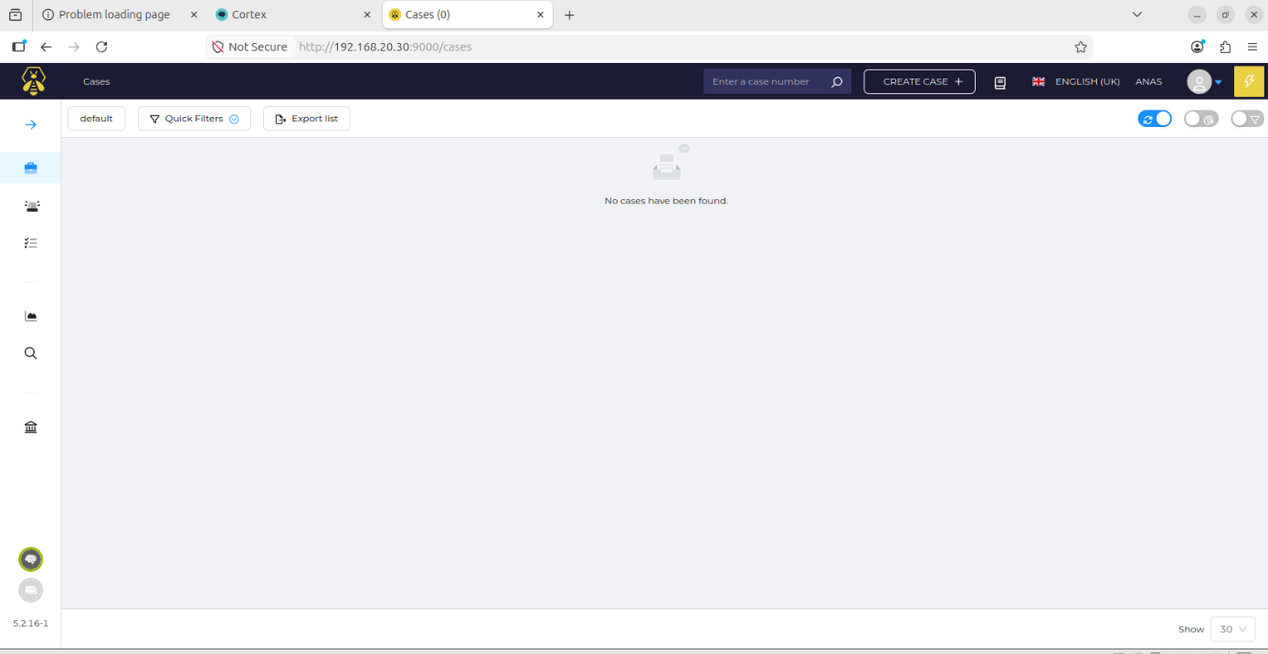
Figure 5.17 – TheHive case list immediately after deployment (no cases)

5.4 Cortex

5.4.1 Role
Cortex is the automated analysis and response engine of the ecosystem. Built by the TheHive team, it addresses a recurring problem for analysts – the time lost verifying observables by hand – by exposing analyzers (for IP addresses, domains, hashes and URLs) and responders behind a single API. If TheHive is the incident file on which the analyst works, Cortex is the automated laboratory to which samples are submitted for analysis.

5.4.2 Deployment
Objective. Run Cortex alongside TheHive and make it available as an analysis back end.
Implementation approach. Cortex was also deployed with Docker Compose: after editing ~/cortex/docker-compose.yml, the stack was started with sudo docker compose up -d.
Configuration details. The deployment pulled thehiveproject/cortex:3.1.1 and elasticsearch:7.17.9, created the network and the cortex_esdata volume, and started the cortex_elasticsearch and cortex containers (Figure 5.18). Cortex is served on port 9001.
Outcome. Both containers are running; the Cortex web interface is reachable and ready for the organisation and user setup.
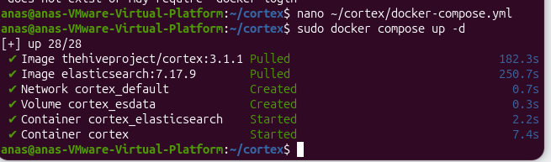
Figure 5.18 – Cortex deployment with Docker Compose (Cortex 3.1.1 and Elasticsearch 7.17.9)

5.4.3 Organisations and users
Cortex separates its administration from the analysis work through organisations. After the first start, only the default cortex organisation exists (Figure 5.19). A dedicated SOC organisation was created for the analysis work and linked to TheHive (Figure 5.20). Two users were defined (Figure 5.21): admin, a superadmin attached to the cortex organisation, and thehive, a service account attached to the SOC organisation with the roles read and analyze. This follows the principle of least privilege – TheHive can read analyzer results and run analyses, but cannot administer Cortex.
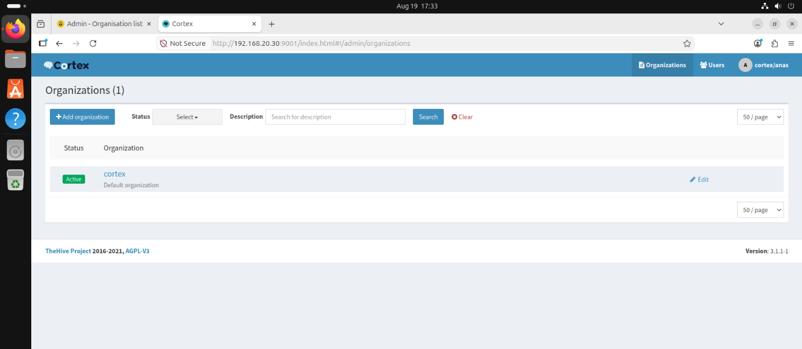
Figure 5.19 – Cortex organisation list after first start: default “cortex” organisation only
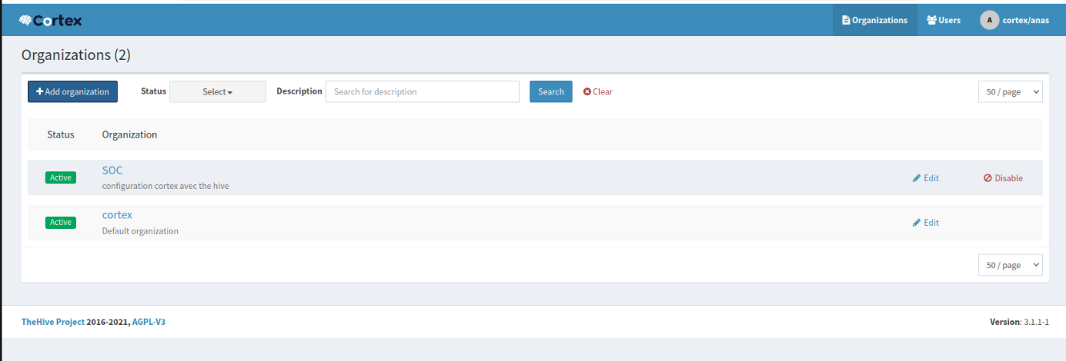
Figure 5.20 – Cortex organisations after creation of the dedicated “SOC” organisation
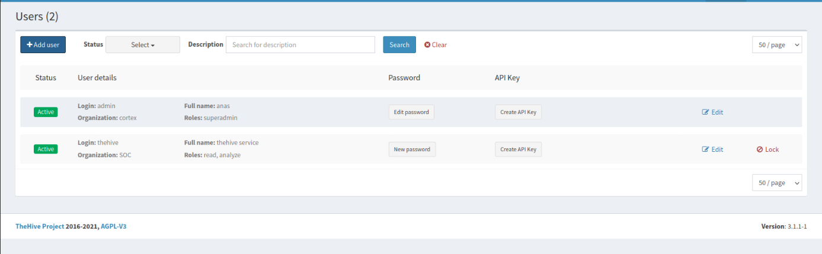
Figure 5.21 – Cortex users: superadmin “admin” and the “thehive” service account (SOC organisation, read and analyze roles)

5.4.4 Analyzer configuration
The VirusTotal analyzer was enabled in the SOC organisation and configured through its form (Figure 5.22). The main parameters are the VirusTotal API key, the polling interval between report requests, the antivirus engines to highlight, the age after which a hash is rescanned, and two options controlling the automatic download of samples. This analyzer is the one invoked from TheHive in the tests of Chapter 7.
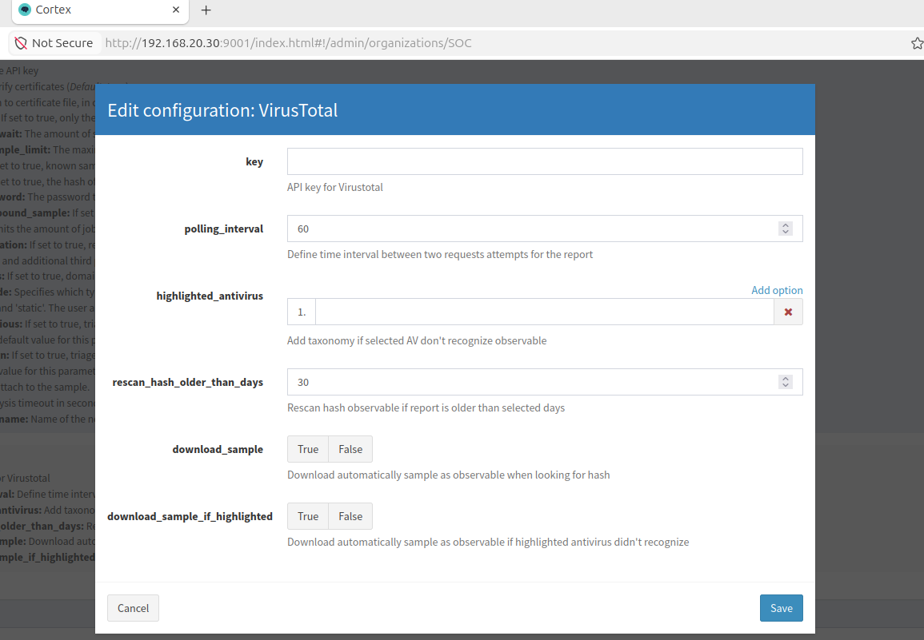
Figure 5.22 – Cortex: configuration form of the VirusTotal analyzer in the SOC organisation

6. Configuration and Integration
With the platforms deployed, this chapter documents the configuration that connects them into a single pipeline. Table 6.1 gives the overview; each integration is then described with its configuration.
Table 6.1 – Summary of the integrations configured
Integration | Direction | Mechanism | Purpose
pfSense → Wazuh | Network logs | Syslog UDP/514 + local rule 100100 | Turn firewall blocks into alerts
Endpoint → Wazuh | Host telemetry | Wazuh agent + syscheck (FIM) | Detect file changes in real time
Wazuh → MISP | IoC lookup | Custom integration script, HTTPS API | Check file hashes against threat intelligence
Wazuh → VirusTotal → Active Response | Reputation and containment | Built-in integration + remove-threat script | Delete files flagged as malicious
Wazuh → TheHive | Alert forwarding | Custom integration, REST API (level ≥ 7) | Create alerts for triage
TheHive ↔ Cortex | Analysis requests | Server definition + service API key | Run analyzers on observables
TheHive ↔ MISP | Indicator exchange | Server definition + API key | Import and export indicators

6.1 Custom Detection Rule for pfSense Events
Objective. Ensure that firewall block events received from pfSense are raised as alerts rather than only archived.
Implementation approach. Out of the box, the received syslog lines are archived but not necessarily surfaced as alerts. A local rule was added to /var/ossec/etc/rules/local_rules.xml (Figure 6.1) that builds on the parent rule for pfSense filter-log events (87700).
Configuration details. The rule below matches the keyword block in those events and assigns level 5:
<group name="local,pfsense,">
<rule id="100100" level="5">
<if_sid>87700</if_sid>
<match>block</match>
<description>pfsense: firewall blocked a packet</description>
<group>firewall_block,</group>
</rule>
</group>

Outcome. Every packet blocked by the isolation rule produces a searchable alert tagged firewall_block, linking network-level decisions with the host-level data collected by agents. The validation is described in Section 7.2.
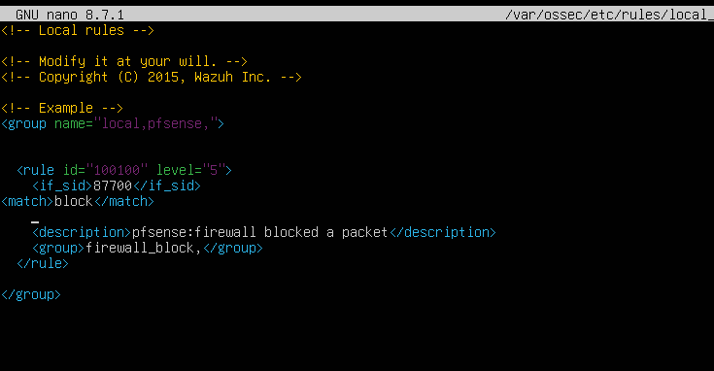
Figure 6.1 – Local rule 100100 in local_rules.xml, raising alerts on pfSense firewall block events

6.2 File Integrity Monitoring
Objective. Detect creation, modification and deletion of files on the monitored endpoint, and obtain their hashes for enrichment.
Implementation approach. The <syscheck> section of the agent configuration was edited so that FIM is enabled (Figure 6.2).
Configuration details. The default system directories remain monitored with a periodic scan (every 12 hours, and at start-up). A test directory, /home/kali/RH, is monitored in real time with full verification and change reporting:
<syscheck>
<disabled>no</disabled>
<frequency>43200</frequency>
<scan_on_start>yes</scan_on_start>
<directories>/etc,/usr/bin,/usr/sbin</directories>
<directories>/bin,/sbin,/boot</directories>
<directories check_all="yes" report_changes="yes" realtime="yes">/home/kali/RH</directories>
</syscheck>

Outcome. The directory acts as a controlled “drop zone” in which any file created by the tester triggers an immediate event carrying the file path and its MD5, SHA-1 and SHA-256 hashes. These hashes are the input of the MISP and VirusTotal integrations.
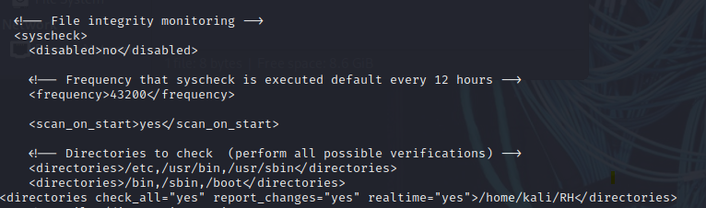
Figure 6.2 – syscheck configuration enabling real-time monitoring of /home/kali/RH

6.3 Wazuh–MISP Integration
Objective. Automatically check the hash of every file reported by FIM against MISP and record the detection in Wazuh.
Implementation approach. Wazuh includes an Integrator module that automates interactions with external services; it ships with integrations for Slack, PagerDuty, VirusTotal, Shuffle and Maltiverse. For MISP, a new script, custom-misp_file_hashes.py, was written on the model of the VirusTotal integration script and placed in /var/ossec/integrations on the Wazuh server. An <integration> block was then added to /var/ossec/etc/ossec.conf (Figure 6.3).
Configuration details. The block binds the script to the syscheck group and to rule 554 (file added), requests JSON alerts, and passes options for the timeout, the number of retries, the tags to apply and the sighting behaviour:
<ossec_config>
<integration>
<name>custom-misp_file_hashes.py</name>
<hook_url>https://YOUR_MISP_INSTANCE</hook_url>
<api_key>YOUR_API_KEY</api_key>
<group>syscheck</group>
<rule_id>554</rule_id>
<alert_format>json</alert_format>
<options>{
"timeout": 10,
"retries": 3,
"debug": false,
"tags": ["tlp:white", "tlp:clear", "malware"],
"push_sightings": true,
"sightings_source": "wazuh"
}</options>
</integration>
</ossec_config>

With push_sightings enabled, every positive match is reported back to MISP as a sighting attributed to the source wazuh, which allows the intelligence team to see which indicators are actually observed in the monitored environment. The API key belongs to the Wazuh credential created in Section 5.2 and is shown here as a placeholder.
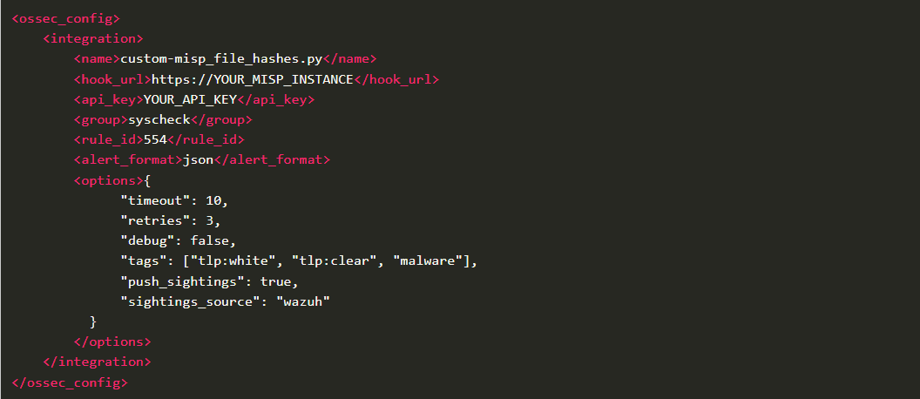
Figure 6.3 – Integration block of the custom MISP script in ossec.conf

6.4 Wazuh Active Response with VirusTotal
Objective. Automatically remove a file from the endpoint when VirusTotal identifies it as malicious.
Implementation approach. The design combines three Wazuh capabilities [2, 3]: File Integrity Monitoring tracks file additions or modifications and captures their hashes; the VirusTotal integration queries the VirusTotal API with the hash supplied by FIM; and Active Response executes an automated script – here remove-threat – when a defined alert fires.
Configuration details. The configuration in ossec.conf declares the command and binds it to the VirusTotal alert rule 87105 (Figure 6.4). The local location makes the script run on the agent that generated the event:
<command>
<name>remove-threat</name>
<executable>remove-threat.sh</executable>
<timeout_allowed>no</timeout_allowed>
</command>

<active-response>
<disabled>no</disabled>
<command>remove-threat</command>
<location>local</location>
<rules_id>87105</rules_id>
</active-response>

Detection chain. (1) A file appears in the monitored directory; (2) FIM generates an event with the file hashes; (3) the VirusTotal integration looks up the hash and, if engines flag it, raises an alert with rule 87105; (4) the manager instructs the agent to run remove-threat.sh, which deletes the file; (5) FIM records the deletion. The behaviour is verified in Section 7.5.
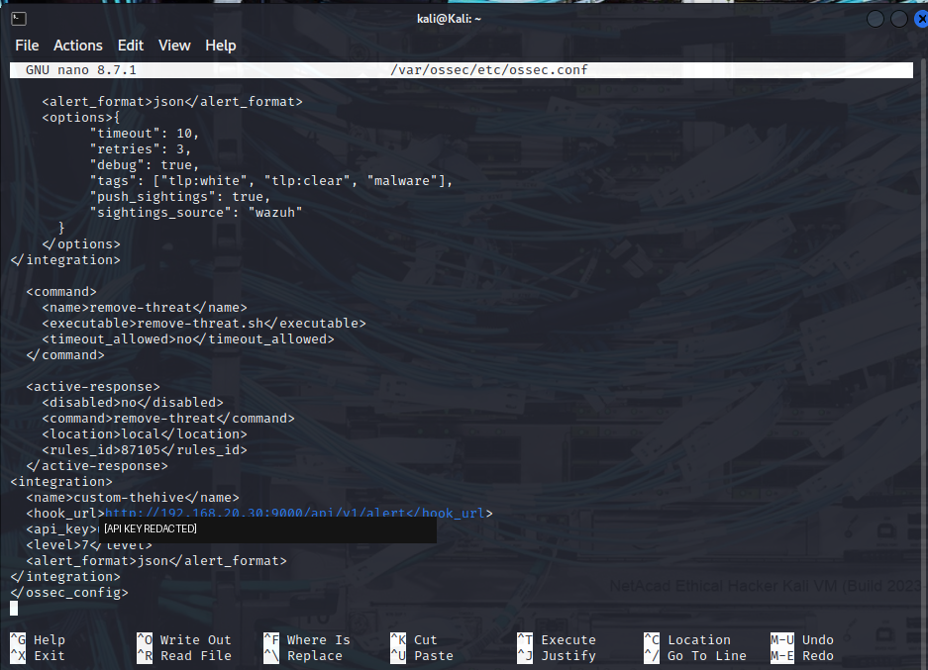
Figure 6.4 – ossec.conf excerpt: remove-threat command, active-response definition bound to rule 87105 and custom-thehive integration (API key redacted)

6.5 Wazuh–TheHive Integration
Objective. Forward significant Wazuh alerts to TheHive so that analysts can triage them in a case-management tool.
Implementation approach. A second integration block, named custom-thehive, was added to ossec.conf (visible at the bottom of Figure 6.4). It posts alerts in JSON format to the TheHive alert API and uses the credential of the Wazuh service account created in Section 5.3.
Configuration details. Only alerts of level 7 or higher are forwarded, which keeps low-severity noise out of the case queue:
<integration>
<name>custom-thehive</name>
<hook_url>http://192.168.20.30:9000/api/v1/alert</hook_url>
<api_key>REDACTED</api_key>
<level>7</level>
<alert_format>json</alert_format>
</integration>

Outcome. Wazuh alerts such as “File added to /home/kali/RH/ directory” and “File deleted” appear in the TheHive alert queue (Section 7.7).

6.6 TheHive Links to Cortex and MISP
Objective. Allow TheHive to run Cortex analyzers on observables and to exchange indicators with MISP.
Implementation approach. Both connections are declared in TheHive’s platform-management area as “servers”.
Configuration details. The Cortex server definition (Figure 6.5) combines the Cortex URL (port 9001 of the SOC host) with the API key of the thehive service account created in Cortex (Figure 5.21). The MISP server definition (Figure 6.6) specifies a name, the MISP URL and an API key, and a purpose – import only, export only, or import and export. The purpose controls whether TheHive may pull indicators from MISP, push observables to it, or both.
Outcome. TheHive confirms that the MISP configuration was saved (Figure 6.7). TheHive can now submit observables to Cortex and exchange indicators with MISP.
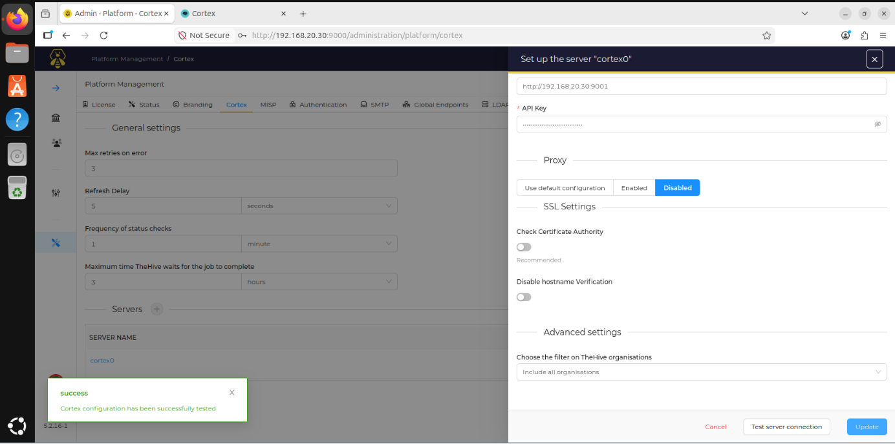
Figure 6.5 – TheHive platform management: server definition for Cortex
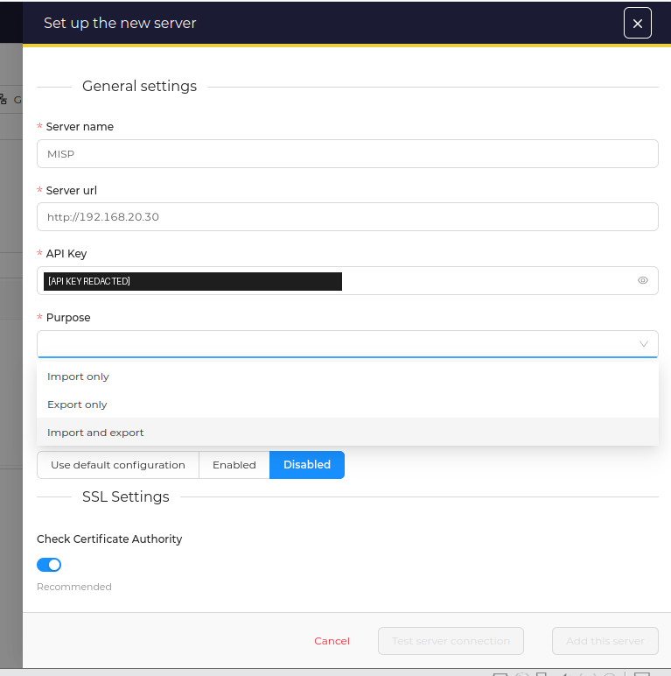
Figure 6.6 – TheHive platform management: new MISP server definition (API key redacted)
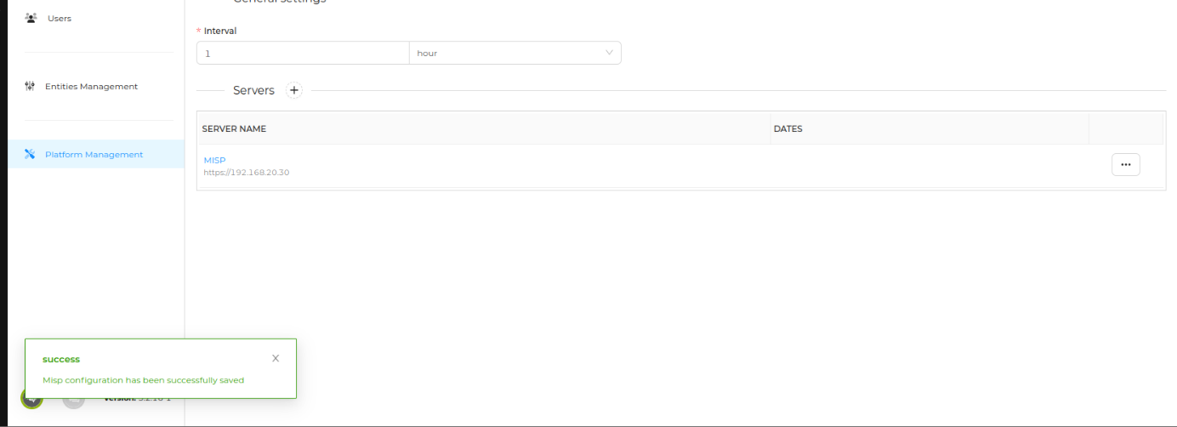
Figure 6.7 – Confirmation that the MISP server configuration was saved in TheHive
Good practice
The API keys used above are secrets. They were redacted from the screenshots of this report and, in a production environment, should be stored in a secrets manager, scoped to the minimum required role and rotated if they appear in logs, terminal sessions or screenshots. TLS should also be enabled on every endpoint that currently uses plain HTTP.

7. Testing and Results

7.1 Test Strategy
The tests follow the same philosophy as the build: each capability is exercised with a controlled stimulus and its effect is observed at every stage of the pipeline. The approach mirrors the scenario-based validation used in [1, pp. 52–65], where an attacker workstation generates malicious activity and the reaction of each SOC component is checked in turn. Table 7.1 lists the six test cases of this laboratory; the screenshots referenced in each section are the evidence.
Table 7.1 – Test matrix
ID | Capability under test | Stimulus | Expected result
T1 | Zone isolation and pfSense log ingestion | Ping from LAN endpoint to the Wazuh server | Ping fails; block events reach Wazuh
T2 | File Integrity Monitoring | Create, then delete, a file in /home/kali/RH | Added and deleted events on the dashboard
T3 | MISP enrichment | Drop an EICAR file whose hashes are stored in MISP | MISP is queried; “misp” alerts are raised
T4 | VirusTotal and Active Response | Drop an EICAR file in the monitored directory | Rule 87105 fires; file is deleted
T5 | TheHive–Cortex analysis | Add observable 8.8.8.8 to a test case and run VirusTotal | Analyzer job runs and a report is returned
T6 | Alert-to-case workflow | Forwarded Wazuh alert is converted into a case | Case enriched, tasked and closed

7.2 T1 – Zone Isolation and pfSense Log Ingestion
Procedure. From the LAN endpoint, ICMP echo requests were sent to the Wazuh server (192.168.20.10) in the SOC zone. Observation. The ping fails with 100% packet loss (Figure 7.1), demonstrating that the isolation rule is effective. On the Wazuh server, the archives log (Figure 7.2) contains the corresponding pfSense filterlog records – action block, direction in, protocol icmp, source in the LAN, destination 192.168.20.10 – as well as the configuration-change event generated when the rule was saved. The same log also shows Wazuh’s own self-monitoring events, confirming that the manager analyses its host as well as remote sources.
A wazuh-logtest session (Figure 7.3) was used to inspect how a sampled line is decoded. In that attempt the line captured by the search was the journal record of the grep command itself rather than a pfSense filterlog entry, hence the “No decoder matched” result; the lesson is to feed wazuh-logtest with a genuine filterlog line (see Chapter 8).
Result. Isolation validated; pfSense system and firewall events are received and archived by Wazuh.
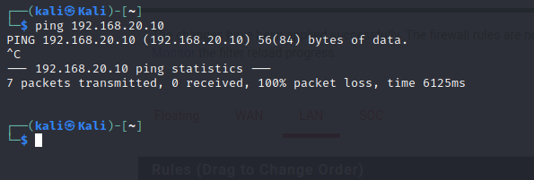
Figure 7.1 – Ping from the LAN endpoint to the Wazuh server (192.168.20.10): 100% packet loss
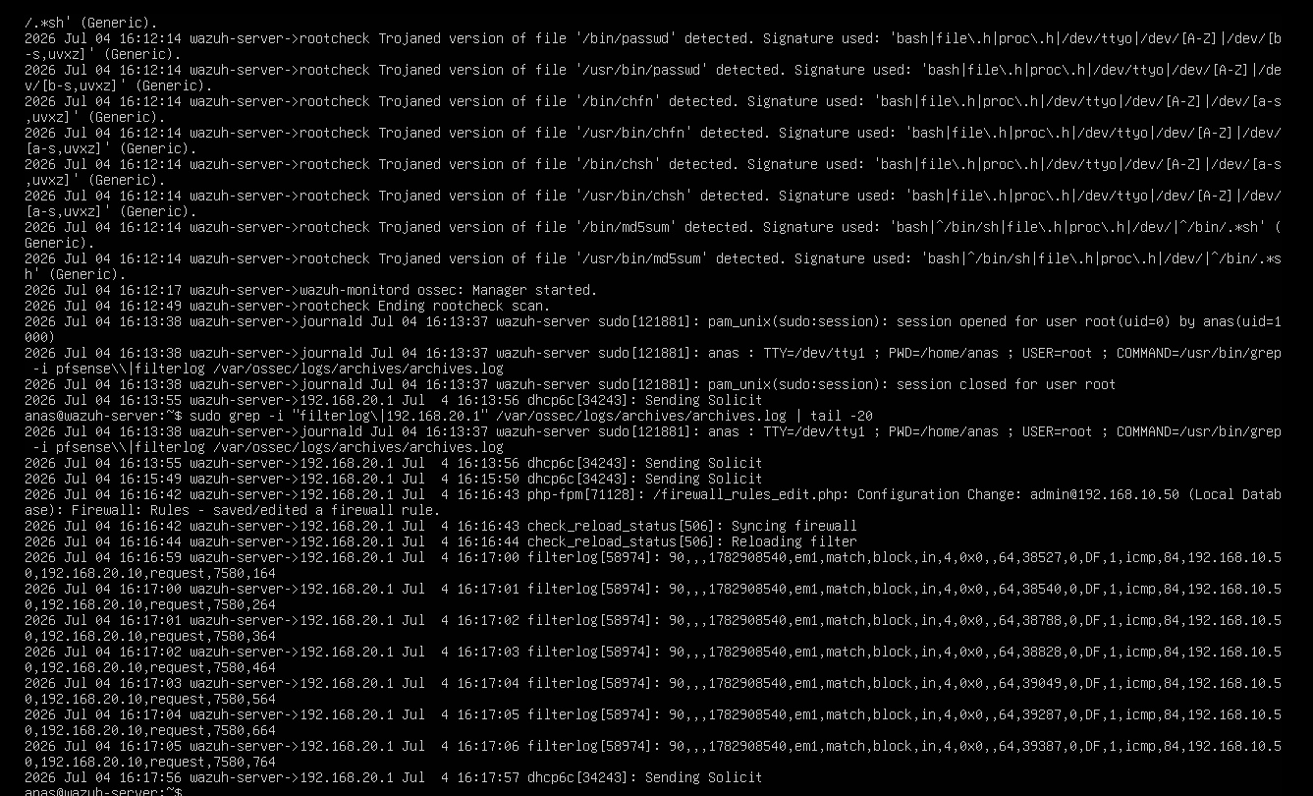
Figure 7.2 – Wazuh archives.log: pfSense configuration-change events and filterlog “block” records for the blocked ICMP requests
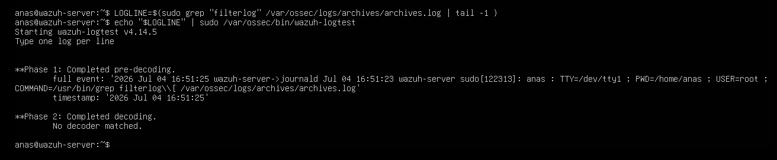
Figure 7.3 – wazuh-logtest session used to inspect the decoding of a sampled log line

7.3 T2 – File Integrity Monitoring
Procedure. A small test file was created in the monitored directory /home/kali/RH (Figure 7.4) and later removed. Observation. The FIM events view of agent LAN_kali (Figure 7.5) shows activity concentrated at the time of the test, and the event list (Figure 7.6) records the file path (/home/kali/RH/…), the event type (added, deleted) and the associated rule description and level. Because the directory is monitored in real time, events appear within seconds rather than at the next scheduled scan.
Result. FIM validated: creation and deletion of files on the endpoint are detected and reported to the dashboard.
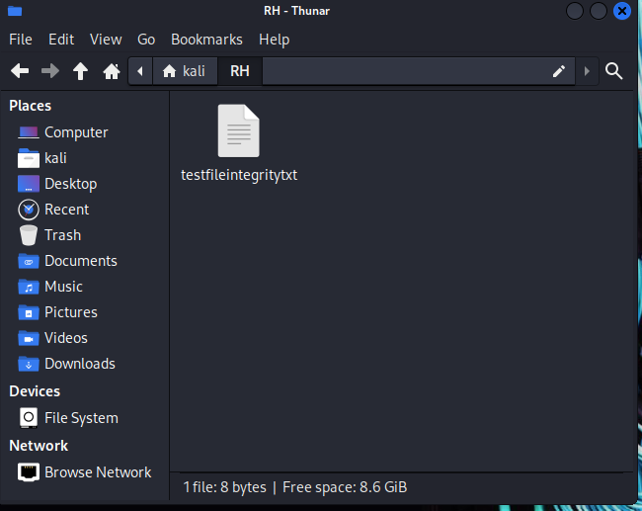
Figure 7.4 – Test file created in the monitored directory /home/kali/RH
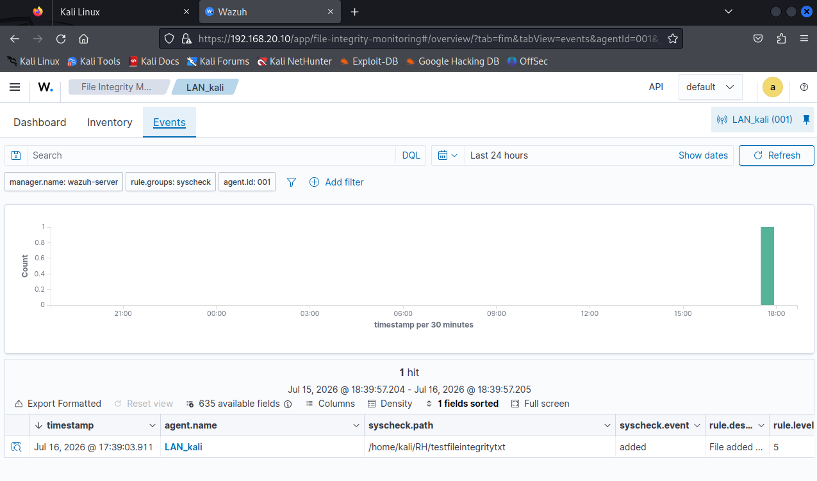
Figure 7.5 – FIM events view for agent LAN_kali
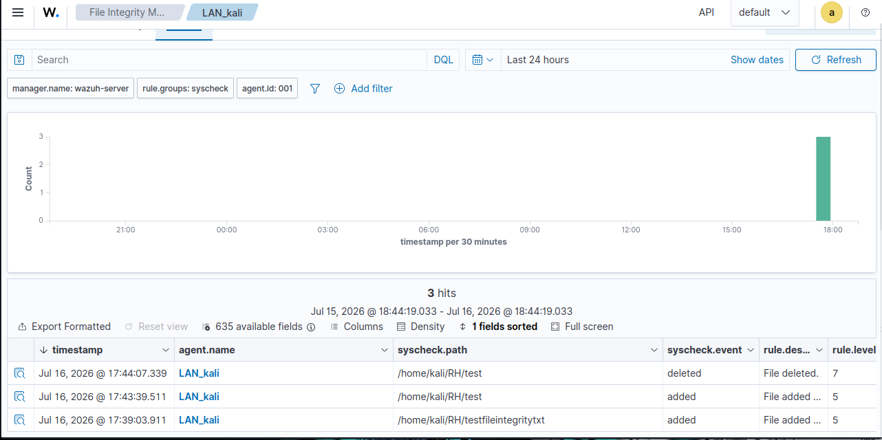
Figure 7.6 – FIM event list for /home/kali/RH: file added and file deleted events

7.4 T3 – MISP Enrichment
Procedure. An EICAR test file was placed in the monitored directory while the EICAR hashes were stored in MISP (Figure 5.12). Observation. The integration log on the Wazuh server (Figure 7.7) shows the custom script starting, receiving the FIM alert for /home/kali/RH/eicar-test6.exe and sending the MD5, SHA-1 and SHA-256 hashes to the MISP API; the MISP response is received and the match is processed, with sightings pushed back to MISP. In the dashboard, a Discover query on the rule group misp returns the resulting alerts (Figure 7.8), whose data fields carry the integration name misp_file_hashes and the matched hashes.
Result. MISP enrichment validated: a file whose hash is known to MISP is detected, logged and turned into a Wazuh alert.
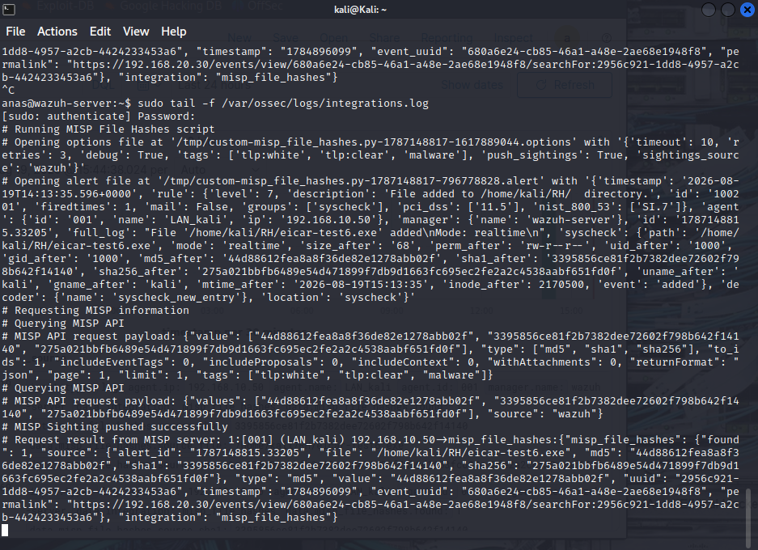
Figure 7.7 – Wazuh integrations.log: MISP lookup of the EICAR MD5, SHA-1 and SHA-256 hashes and the API response
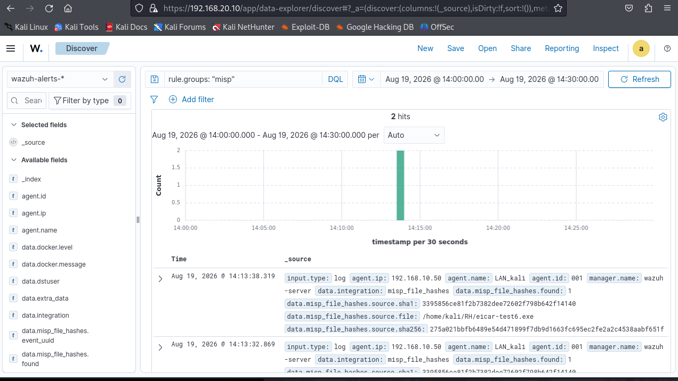
Figure 7.8 – Wazuh Discover: alerts of rule group “misp” generated for the EICAR file

7.5 T4 – VirusTotal Detection and Active Response
Procedure. EICAR samples (eicar-test*.exe) were downloaded into the monitored directory of the endpoint. Observation. The Malware Detection module (Figure 7.9) lists VirusTotal alerts of rule 87105 at a high severity level for the sample. Early runs of the active-response script logged that the file could not be found when the script was executed (Figure 7.10); the script /var/ossec/active-response/bin/remove-threat.sh was edited and the test repeated. The subsequent FIM events (Figure 7.11) show each sample being added and then deleted, and a Discover query on a given sample (Figure 7.12, Figure 7.13) shows the VirusTotal fields, the active-response data and the deletion event within the same alert trail.
Result. Active Response validated after correcting the script: a file flagged by VirusTotal is removed automatically from the endpoint, and the entire chain remains traceable in Wazuh.
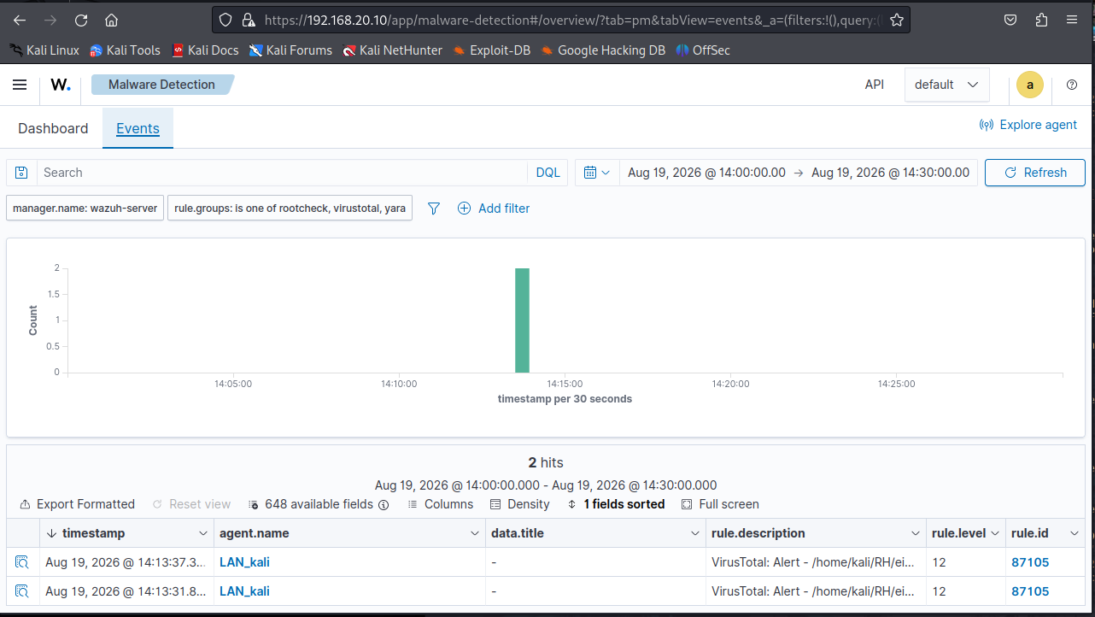
Figure 7.9 – Malware Detection module: VirusTotal alerts (rule 87105) for the EICAR sample
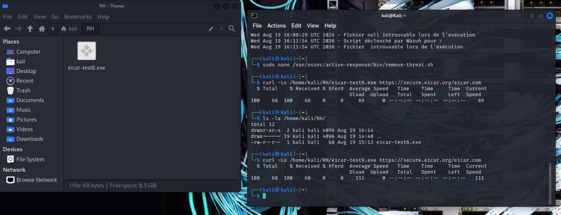
Figure 7.10 – EICAR sample download on the endpoint and troubleshooting of the remove-threat.sh active-response script
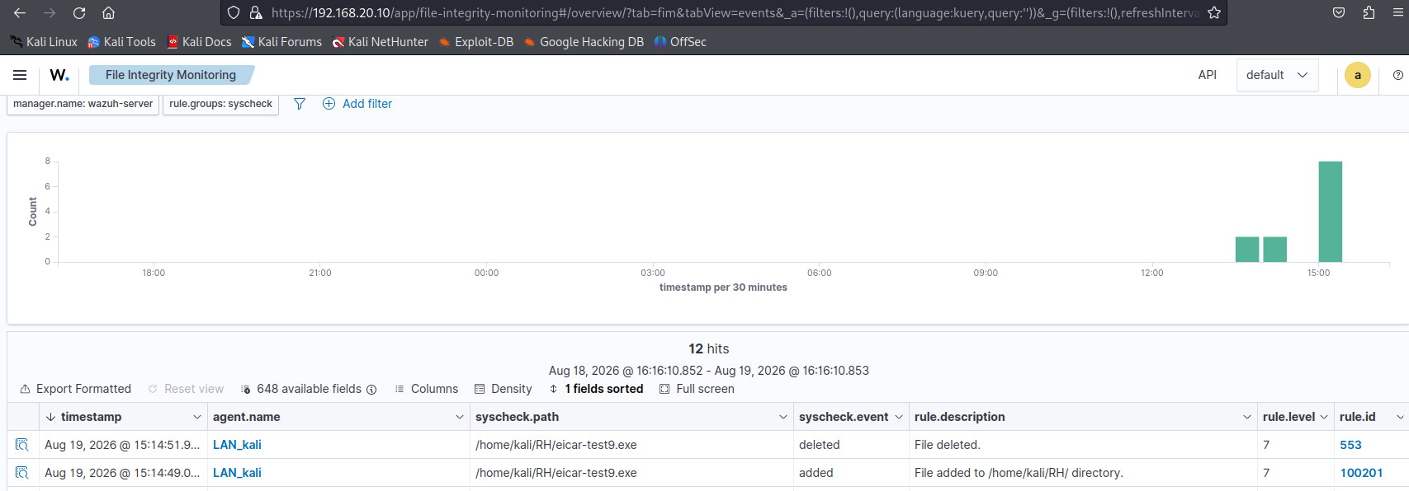
Figure 7.11 – FIM events showing the sample being added and then deleted
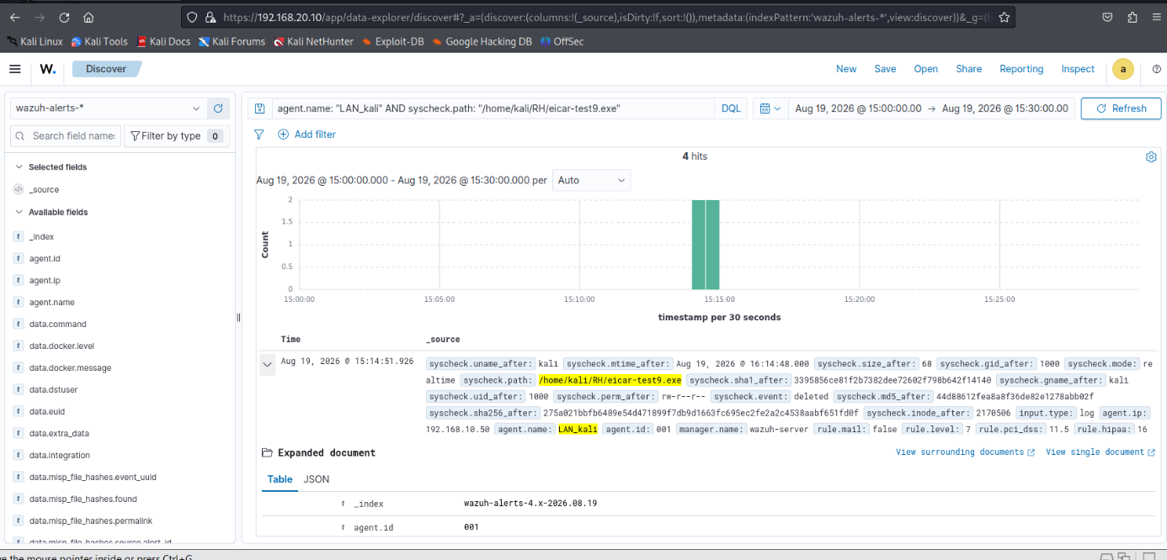
Figure 7.12 – Discover view filtered on the EICAR file, showing VirusTotal and active-response fields
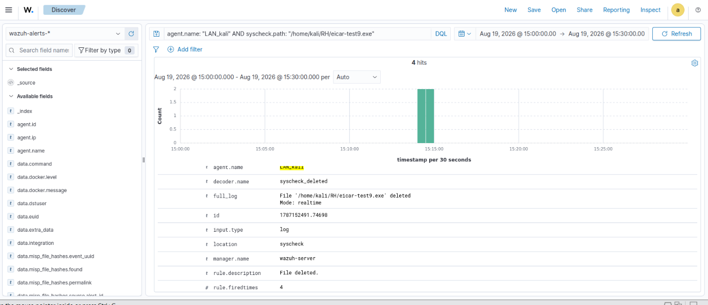
Figure 7.13 – Expanded alert document for the same file

7.6 T5 – TheHive and Cortex Analysis
Procedure. A test case (Figure 7.14, Figure 7.15) was created in TheHive, the public IP address 8.8.8.8 was added as an observable (Figure 7.16, Figure 7.17) and the VirusTotal analyzer was launched from TheHive. Observation. Cortex registers the job in its history (Figure 7.18): analyzer VirusTotal_GetReport_3_1, submitted by the SOC/thehive service account. The report returned to TheHive (Figure 7.19) contains a summary (0 malicious detections out of 91 for this well-known resolver) and the per-scanner results, which agree with the VirusTotal page of the same address (Figure 7.20).
Result. The TheHive–Cortex link works end to end: observables are submitted from the case, analysed by Cortex through the SOC organisation’s service account, and the report is attached to the observable.
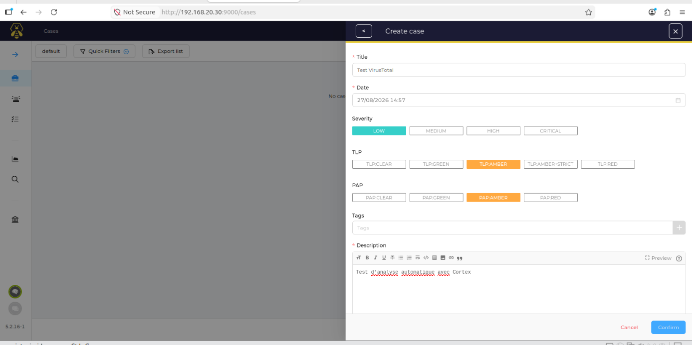
Figure 7.14 – TheHive: creation of the test case for automatic analysis with Cortex
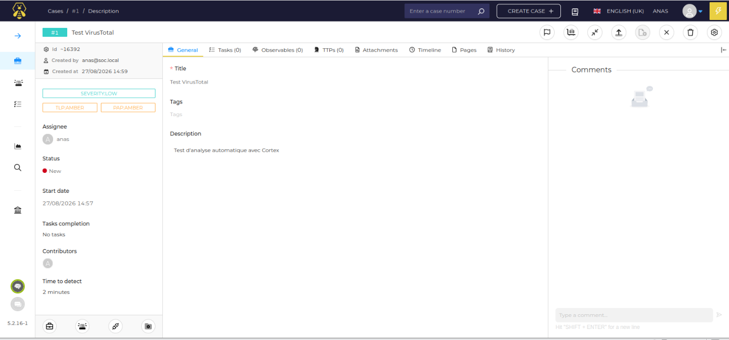
Figure 7.15 – Test case in TheHive before any observable is added
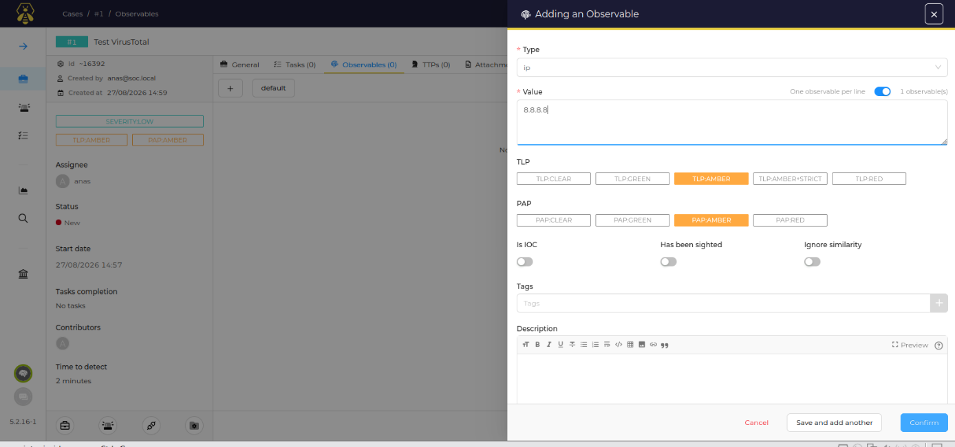
Figure 7.16 – Adding an observable to the test case
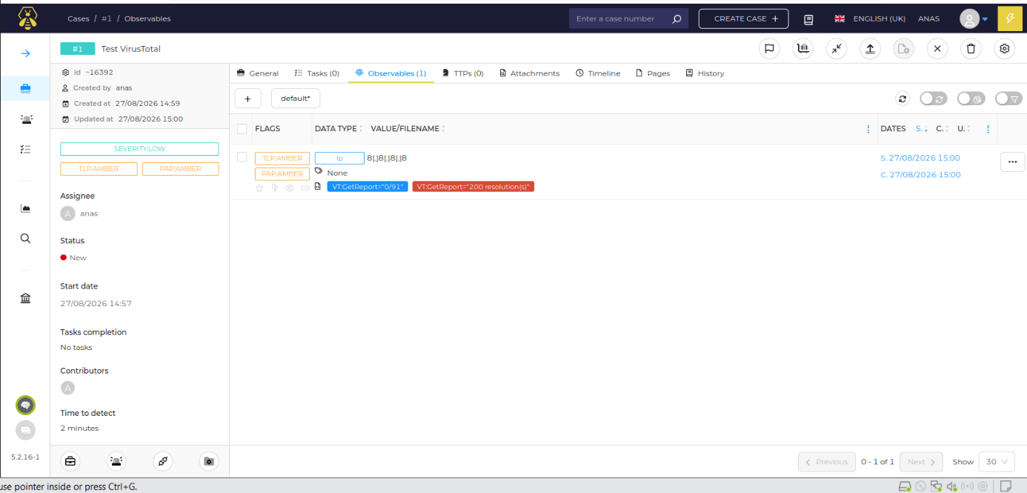
Figure 7.17 – Test case observables: IP address 8.8.8.8 tagged TLP:AMBER and PAP:AMBER
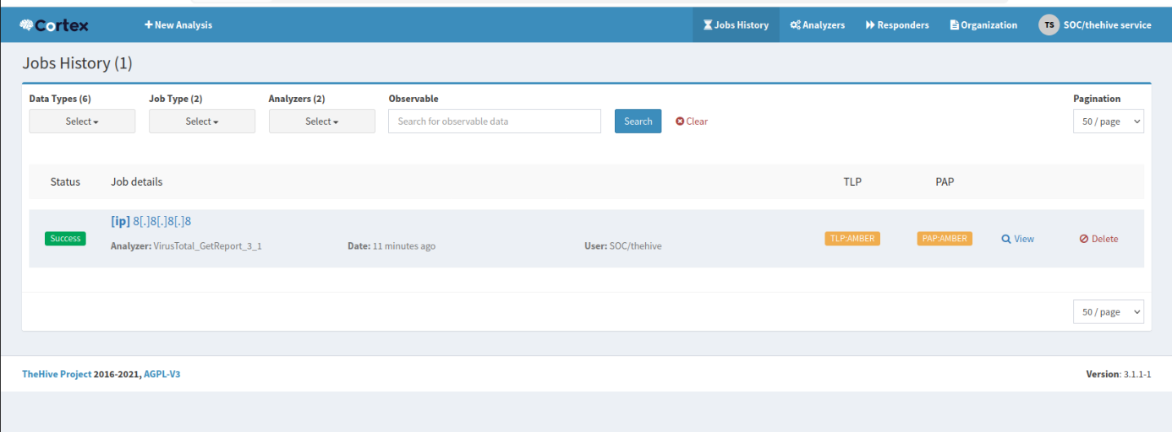
Figure 7.18 – Cortex Jobs History: VirusTotal_GetReport_3_1 job submitted by the “thehive” service account
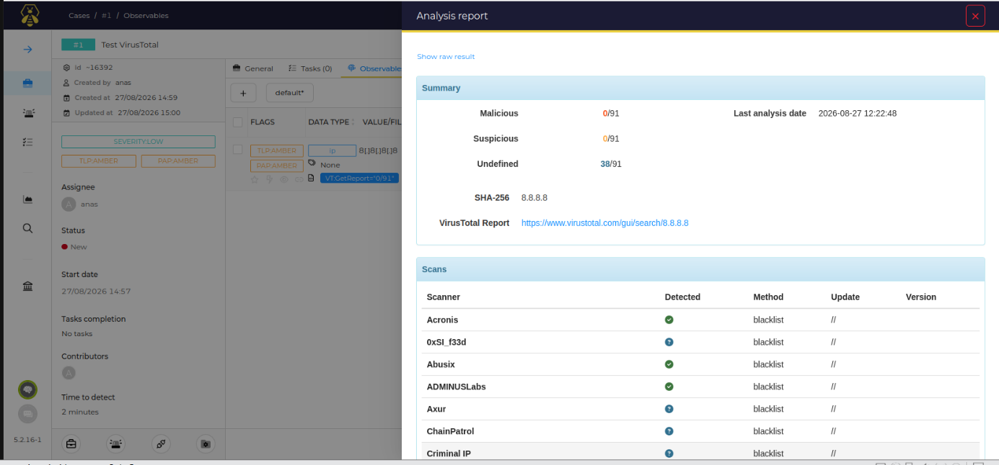
Figure 7.19 – Cortex analysis report for 8.8.8.8 returned to TheHive: summary and scanner results
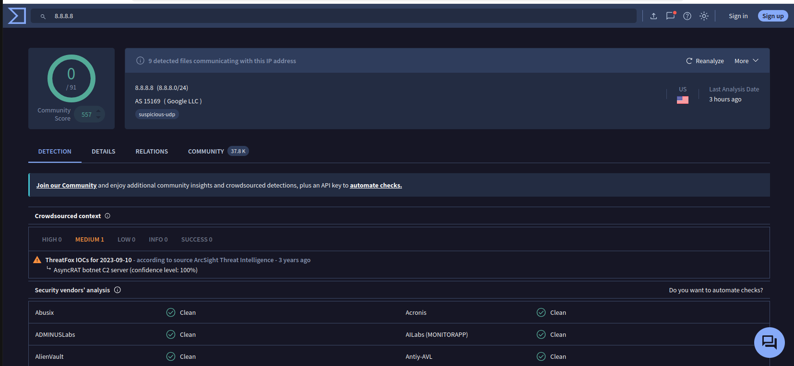
Figure 7.20 – VirusTotal page of the analysed IP address (cross-check of the report)

7.7 T6 – End-to-End Alert-to-Case Workflow
This final test exercises the complete detect–enrich–investigate–respond loop with the EICAR sample.

7.7.1 Alert reception and case creation
The Wazuh alerts generated by the test arrive in the TheHive alert queue (Figure 7.21), with the titles “Wazuh Alert: File added to /home/kali/RH/ directory” and “Wazuh Alert: File deleted” and the source wazuh. The analyst selects the first alert and chooses to create a case (Figure 7.22), either empty or from a template. The creation form is pre-filled from the alert (Figure 7.23): title, date, severity, TLP and PAP markings, and a description recording the agent (LAN_kali, 192.168.10.50), the rule, the level and the full log.
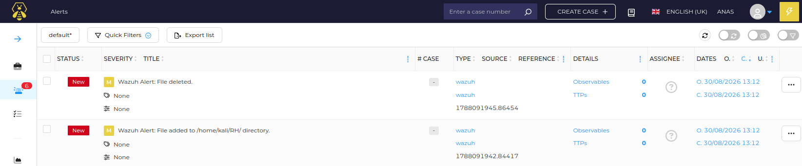
Figure 7.21 – TheHive alert list: Wazuh alerts “File added to /home/kali/RH/ directory” and “File deleted”
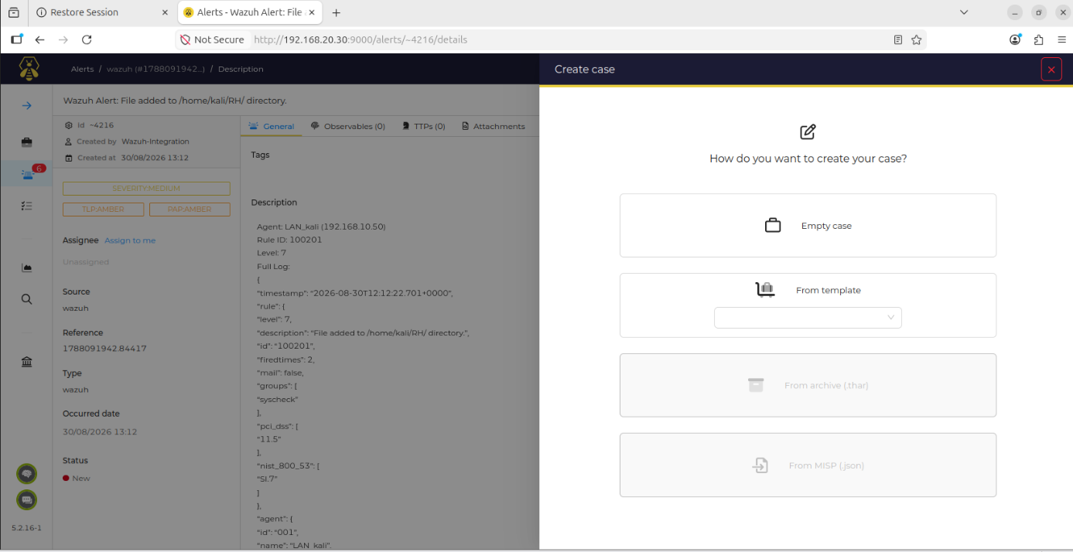
Figure 7.22 – Case creation from an alert: empty case or case template
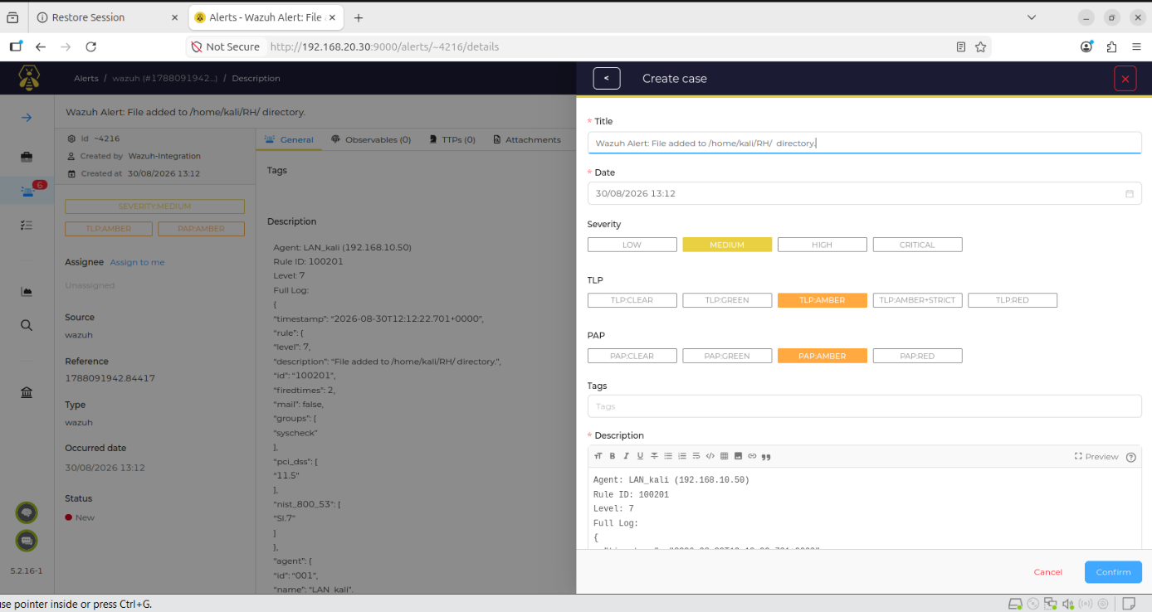
Figure 7.23 – Case creation form pre-filled from the alert (title, severity, TLP/PAP and alert details)

7.7.2 Observables and tasks
The analyst adds the agent’s IP address as an observable (Figure 7.24) and the EICAR MD5 hash, giving the case two observables (Figure 7.25), both marked with TLP:AMBER and PAP:AMBER to restrict further sharing. A task titled “File verification and host isolation” (originally written in French) is created (Figure 7.26) and assigned to the analyst; its preview (Figure 7.27) shows the status In Progress and the creation and update times, and the task list is updated accordingly (Figure 7.28).
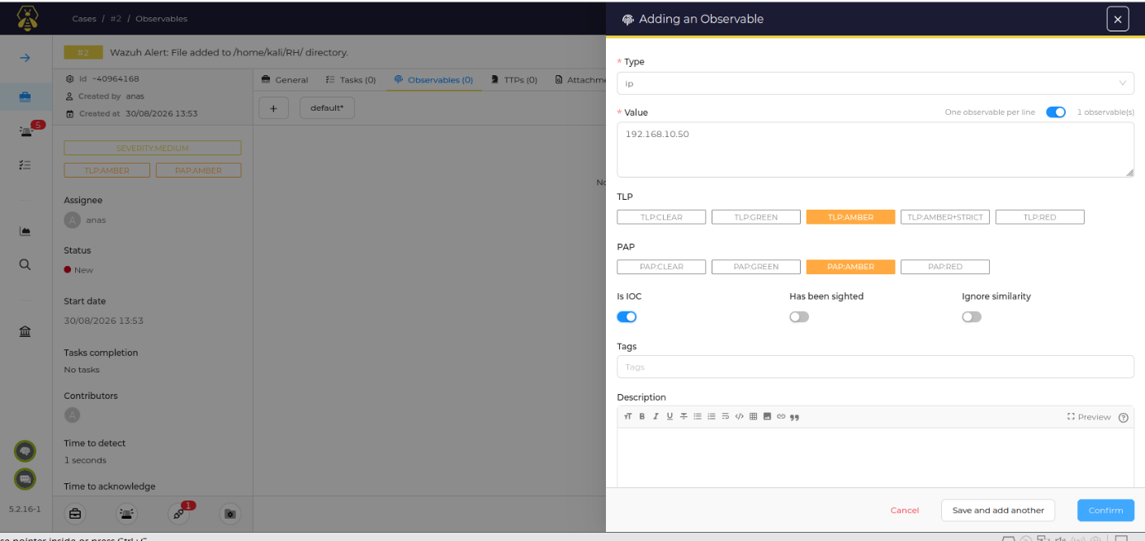
Figure 7.24 – Adding the agent IP address 192.168.10.50 as an observable
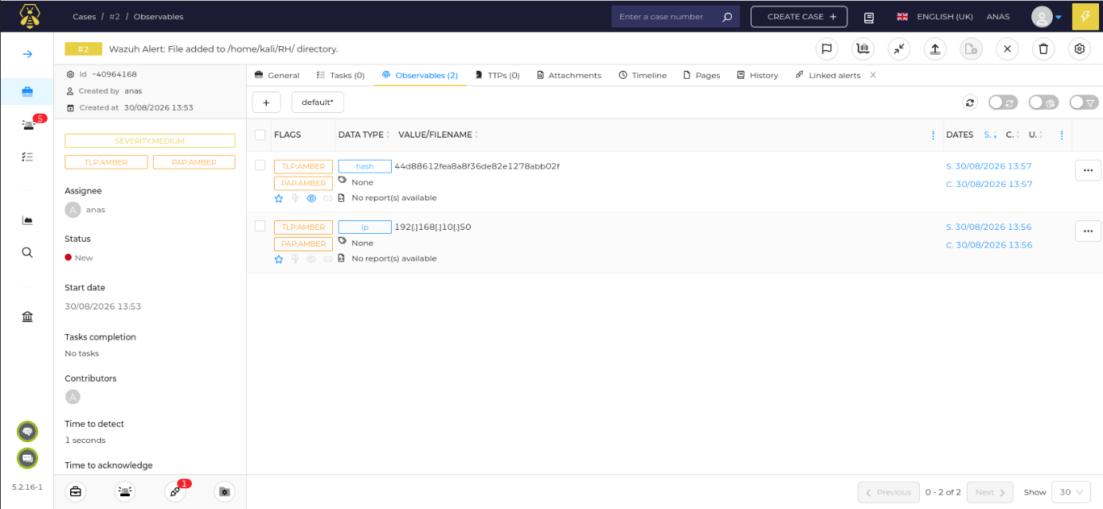
Figure 7.25 – Case observables: agent IP address and EICAR MD5 hash
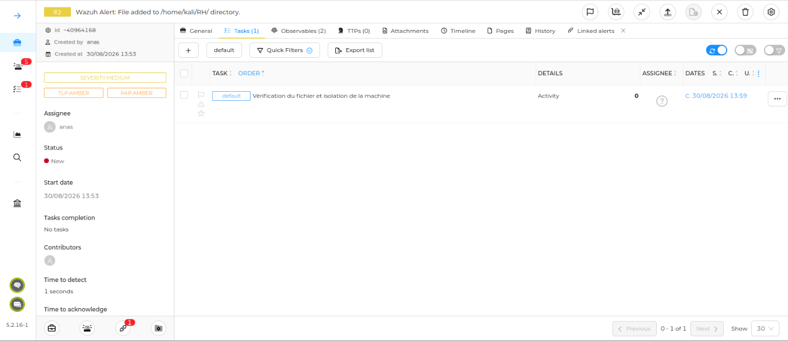
Figure 7.26 – Task list of the case
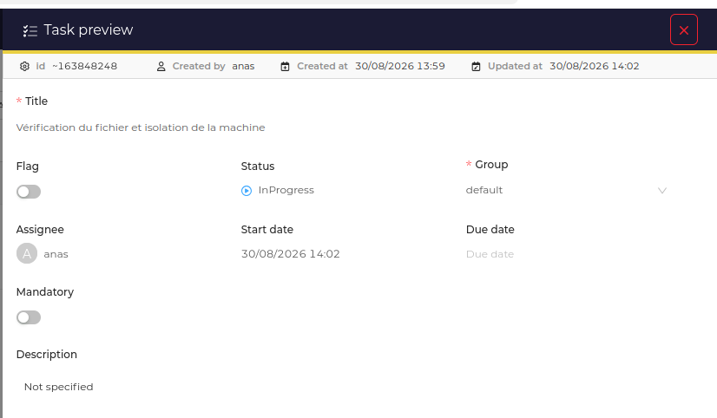
Figure 7.27 – Task preview: file verification and host isolation, assigned to the analyst, status In Progress
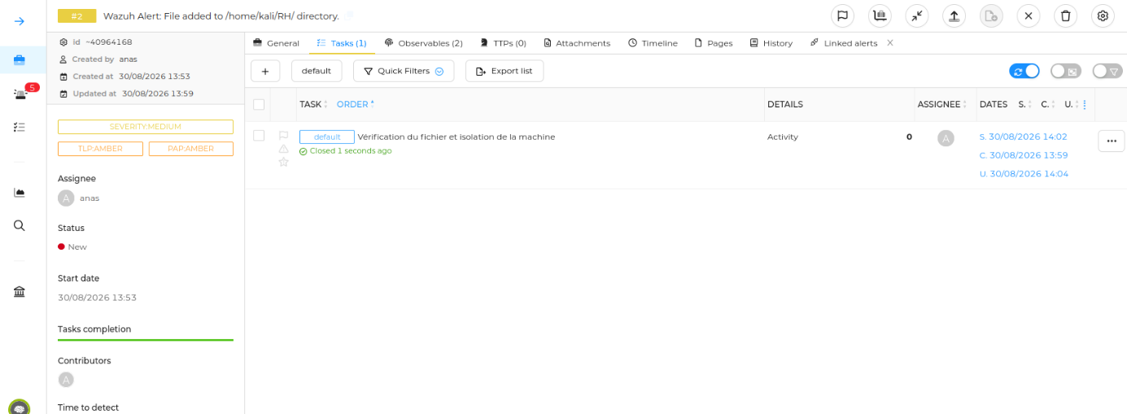
Figure 7.28 – Case task list after the task update

7.7.3 Analysis with Cortex
For the hash observable, the analyst opens the analyzer selection (Figure 7.29) and runs the VirusTotal analyzer. When the job completes, a report is available on the observable (Figure 7.30). The report (Figure 7.31) extracts new observables – YARA rule names such as MALW_Eicar and Multi_EICAR, and Snort rule references – and a summary in which the large majority of the 68 engines flag the sample as malicious. The detailed view (Figure 7.32) gives the SHA-256 of the sample, a link to the VirusTotal report and the crowdsourced YARA and IDS results. The file is thus confirmed as the EICAR test file.
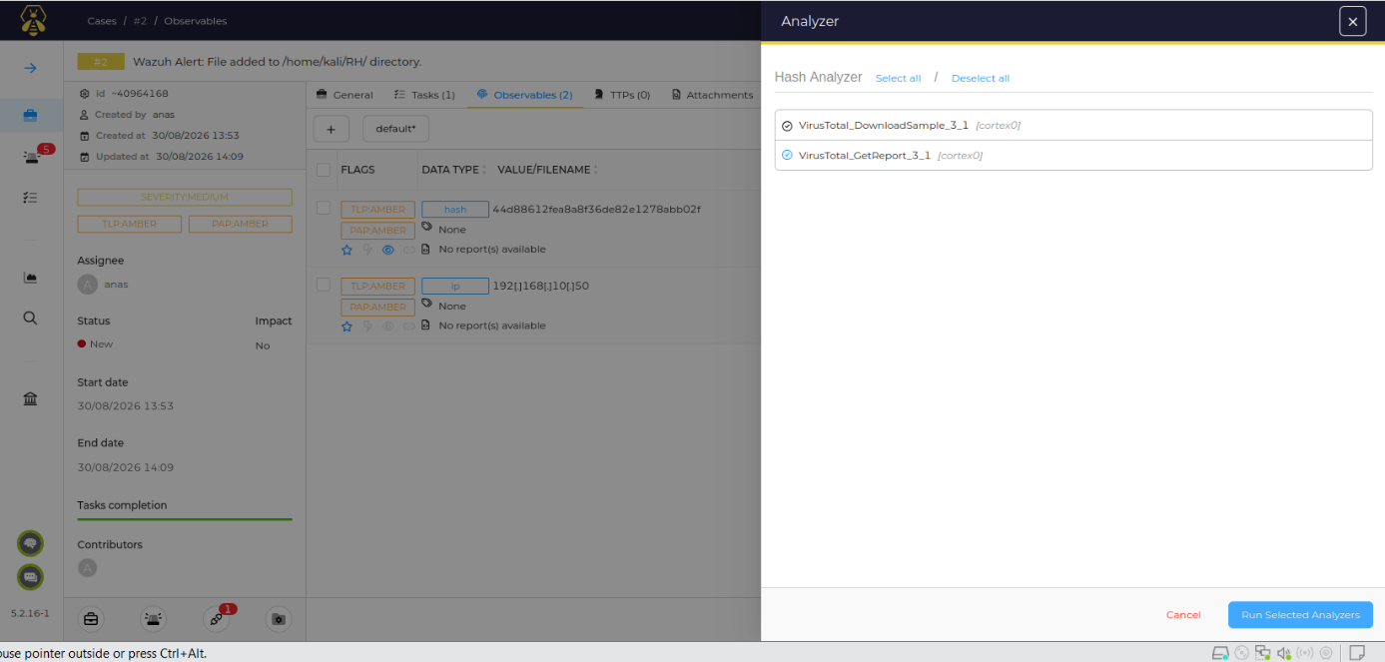
Figure 7.29 – Analyzer selection for the hash observable (VirusTotal GetReport)
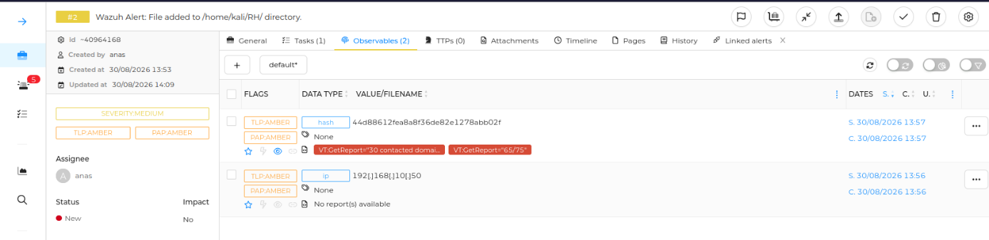
Figure 7.30 – Observables after analysis: report available for the hash observable
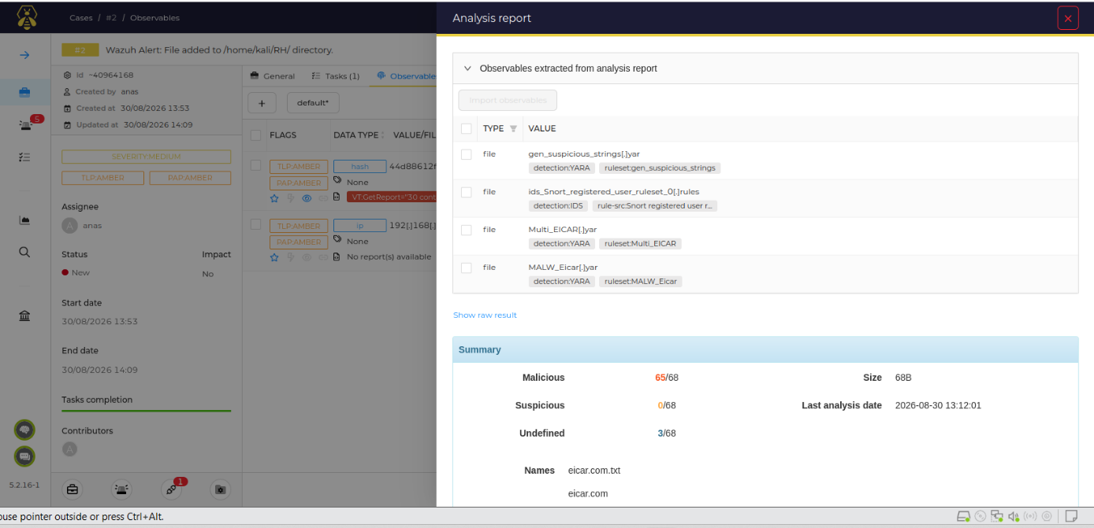
Figure 7.31 – Analysis report: observables extracted from the report (YARA and Snort rule matches) and VirusTotal summary
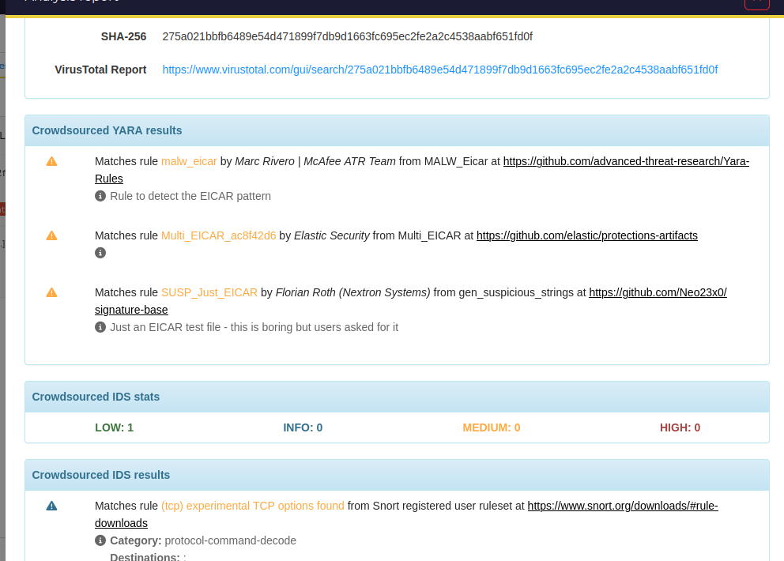
Figure 7.32 – Analysis report details: SHA-256 of the sample, VirusTotal link, crowdsourced YARA and IDS results

7.7.4 Case closure
The case is closed from the closure dialog (Figure 7.33), which records the status, the impact and a closing summary. The summary entered by the analyst states, in substance, that the FIM alert was validated, that the creation of the suspicious file was analysed, and that the observables were enriched and the tasks completed successfully. The closure summary gives the SOC a durable record of the investigation.
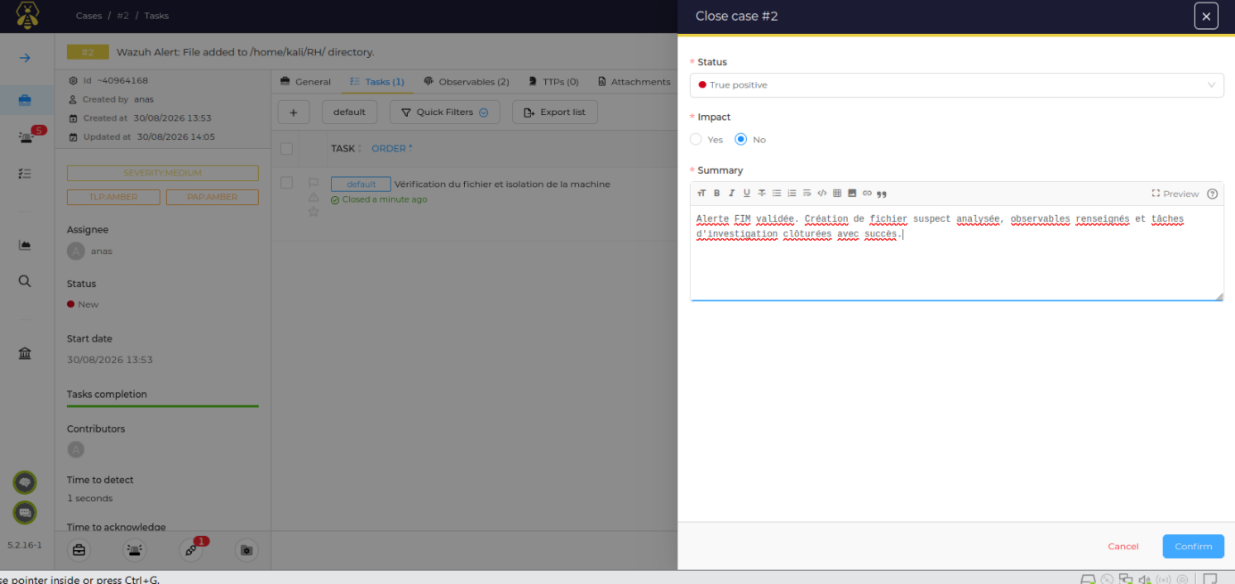
Figure 7.33 – Case closure dialog: status, impact and closing summary
Result. The workflow is validated: Wazuh detection, forwarding to TheHive, case creation, observable enrichment through Cortex and VirusTotal, task tracking and documented closure all function together.

7.8 Summary of Results
Table 7.2 – Summary of test results
Test | Result | Evidence
T1 – Isolation and pfSense logs | Validated – LAN→SOC blocked; block events archived in Wazuh | Figure 7.1, Figure 7.2
T2 – FIM | Validated – added and deleted events reported in real time | Figure 7.6
T3 – MISP enrichment | Validated – hash lookup performed, “misp” alerts raised | Figure 7.7, Figure 7.8
T4 – VirusTotal and Active Response | Validated after script correction – flagged file deleted | Figure 7.9, Figure 7.11
T5 – TheHive/Cortex analysis | Validated – analyzer job executed and report returned | Figure 7.18, Figure 7.19
T6 – Alert-to-case workflow | Validated – alert, case, enrichment, tasks and closure | Figure 7.21 to Figure 7.33

8. Challenges and Lessons Learned
Several obstacles were encountered during the project. Table 8.1 records each of them with its cause and the solution adopted; they also constitute practical recommendations for anyone reproducing the laboratory.
Table 8.1 – Challenges encountered and solutions implemented
Challenge | Cause | Solution and lesson
Wazuh installer refused to proceed | The virtual machine and operating system did not match the installer’s recommended requirements (Figure 5.1) | Re-ran the installer with the -i option for the laboratory. In production, size the host according to the requirements; the reference project used 8 GB RAM and 2 cores for Wazuh [1, p. 26].
pfSense events archived but not alerting | Received syslog lines are stored in the archives but only become alerts when a rule matches | Added local rule 100100 on top of parent rule 87700 (Figure 6.1).
“No decoder matched” in wazuh-logtest | The sampled line was the journal record of the grep command rather than a filterlog event (Figure 7.3) | Select a genuine filterlog line, or exclude the search command from the sample, before using logtest.
Active-response script did not find the file | The script’s first runs could not resolve the file path from the alert (Figure 7.10) | Edited remove-threat.sh and repeated the test with new EICAR samples until deletion events appeared (Figure 7.11).
Cortex access control | Cortex only had its default organisation, whose administrator cannot run analyses for TheHive (Figure 5.19) | Created the SOC organisation and a thehive service user with the read and analyze roles (Figure 5.20, Figure 5.21).
Secrets exposed in terminals and consoles | API keys are displayed in plain text in configuration editors and web forms | Redacted in this report; rotate any key that was displayed and store secrets in a vault.
Default credentials and plain HTTP | pfSense banner warns of the default password (Figure 4.7); several services run over HTTP | Change default passwords and enable TLS on all endpoints before any production use.

9. Conclusion and Perspectives

9.1 Conclusion
This project delivered a working open-source SOC laboratory that covers the full life cycle of a security event. pfSense segments the network into WAN, LAN and SOC zones and exports its logs; Wazuh centralises and analyses network and host telemetry; MISP and VirusTotal provide threat-intelligence context; Wazuh Active Response performs a first automated containment action; and TheHive with Cortex supports triage, investigation and closure. The six tests of Chapter 7 demonstrate that each integration works individually and that they operate together in the alert-to-case workflow.
The laboratory also highlighted practical lessons: the importance of firewall logging for network visibility, the need for local rules to turn archived events into alerts, the value of dedicated service accounts and organisations, and the care required with secrets and default credentials.

9.2 Perspectives
The reference project [1] suggests several directions to extend the laboratory:
- Orchestrated automation. Introduce a workflow orchestrator such as n8n between Wazuh and the response tools. In [1, pp. 40–46], an orchestrator receives and normalises alerts, enriches them with MISP, obtains an automated risk assessment and triggers a response; in [1, p. 54] it blocks the attacking IP address on pfSense through the firewall’s REST API and notifies the team by e-mail.
- Network-level prevention. Add Suricata as an IPS on the pfSense WAN interface. In the scan scenario of [1, pp. 60–61], host-level detection and automated blocking took 30 to 60 seconds, whereas Suricata blocked the scan within milliseconds; combining both layers provides defence in depth. Rate limiting on pfSense can complement them.
- Attack-driven validation. Extend the test plan with the representative attack scenarios of [1, pp. 52–65] – SMB brute force, aggressive Nmap reconnaissance and SQL injection against a web application – and measure detection and response times.
- More intelligence sources. Add further feeds, such as VirusTotal and AbuseIPDB in real time, to the MISP and Cortex configuration [1, p. 67].
- Broader coverage and robustness. Deploy agents on Windows endpoints and on the web server, add SOC metrics dashboards, enable TLS everywhere, and move to a clustered Wazuh indexer for high availability.

Appendix: List of Acronyms
Table A.1 – List of acronyms
Acronym | Meaning | Acronym | Meaning
API | Application Programming Interface | MISP | Malware Information Sharing Platform
DHCP | Dynamic Host Configuration Protocol | PAP | Permissible Actions Protocol
EICAR | European Institute for Computer Antivirus Research | SIEM | Security Information and Event Management
FIM | File Integrity Monitoring | SOAR | Security Orchestration, Automation and Response
IDS / IPS | Intrusion Detection / Prevention System | SOC | Security Operations Center
IoC | Indicator of Compromise | TLP | Traffic Light Protocol
LAN / WAN | Local / Wide Area Network | XDR | Extended Detection and Response

